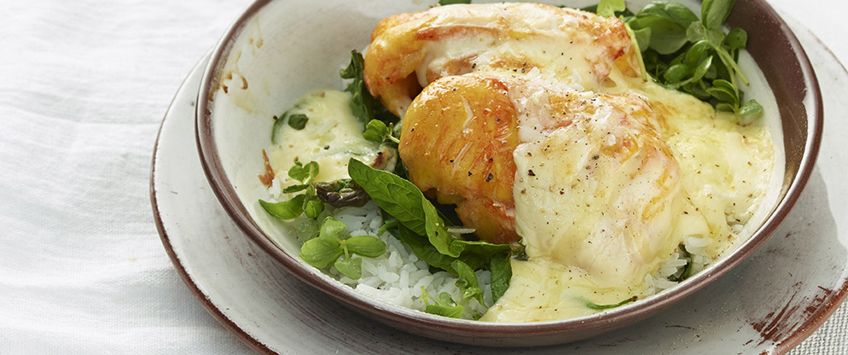
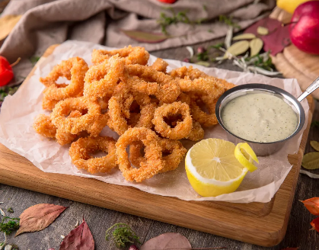








Wine list
Soldiers Block Chardonnay, Australia - £27.95/Bottle
An elegant easy drinking Chardonnay with a toasty vanilla finish

Douglas Green Cabernet Sauvignon, South Africa - £26.95/Bottle
A medium bottled wine with sublime flavours of cassis & ripe loganberries

Compass Point White Zinfandel, California - £24.95/Bottle
Ripe watermelon, strawberry & sweel red berry fruit flavours
Main Course
Haddock Mornay - £16.5
Haddock fillets smothered in mature cedar cheese sauce and tapped with crunchy cheese and breadcrumb topping. Served with creamy mushed potatoes and peas. Perfect wine pair: Soldiers Block Chardonnay

Penang Vegetarian Curry 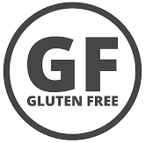  - £12.5
An aromatic coconut sauce with cauliflower, green beans, mango tout and peppers served with poppadum and rice in a Balti dish

Beef Burger - £11.5
100% beef burger served with lettuce, tomatoes, onions, and mayonnaise, served with chips

Steak & Ale Pie- £11.5
A delicious pie served with mush potatoes, veggies, and gravy

Chilli con Carne- £16.5
Homemade chilli, slowly simmered prime minced beef, chillies, tomatoes, and kidney beans, served with rice.
Perfect wine pair: Douglas Green Cabernet Sauvignon
Starters
Salt & Pepper Squid Rings - £7.5
Dusted seasoned squid, fried & served with garlic mayonnaise & slice of lemon

Box Baked Camembert - £7.5
Camembert cheese, baked with rosemary and garlic and served with a warm crusty bread roll

01206546748 – Contactless Delivery
The City Gates, Wind St, Swansea, SA1 1EE
Follow us of Facebook & Instagram
@TrinityHotelsSwansea
@TrinityHotelsSwansea

