
Application of Quality Tools & Root Cause Analysis

Student: Kodie Jack Higgins
ID: 2015799
Course ID: ACMA4004
Subject: Quality and Business Improvement

Introduction
At FSG, the coolant wastage is monitored so that they can be beneficial to themselves and the environment. In this report, findings will show what the source of the original problem was with coolant waste and how it was fixed when they previously encountered a coolant waste problem. The origin or source of the problem was the fact that too much coolant was put to waste so something needed to be done to improve efficiency, reduce the waste and save the company some money.
Findings
Lean principles- What is the meaning of lean and what are its principles?
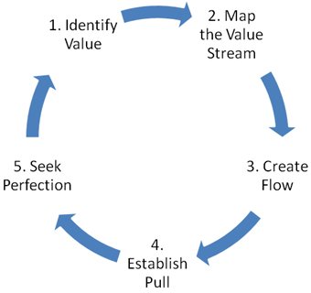
When researching, a paragraph was found and it outlined what lean was in a simple manner. The article itself came from an author known as Mark Crawford who worked for a company called ASME and their quote is “Setting The Standard.” It was found to outline the objective of lean and it included that “The goal of lean is to eliminate waste—the non-value-added components in any process. Unless a process has gone through lean multiple times, it contains some element of waste. When done correctly, lean can create huge improvements in efficiency, cycle time, productivity, material costs, and scrap, leading to lower costs and improved competitiveness.” (Mark Crawford, 5 lean principles every engineer should know about, March 9th 2016)
This image was also found in the article and it shows the circulation of lean and how it works in order to succeed in the workplace.
(The five-step thought process for guiding the implementation of lean techniques. Image copyright 2016, Lean Enterprise Institute)

For this report, the main lean principle that will be focused on is Waste reduction. In Manufacturing, waste is always one of the main factors whether that is material waste, time waste, or wastage of coolant etc. Companies use lean principles in order to reduce these types of waste. Bad Waste can come down to the fact that the process the company uses isn’t efficient enough due to misuse of waste systems or ineffective polices in waste systems.
Steps to reduce waste :
- Identify Waste. Managers need to be trained in how to deal with problematic employees. ...
- Classify the Types of Waste. ...
- Identify Workplace Waste. ...
- Perfect Tune-ups. ...
- Create Your Manufacturing Workflow. ...
- Train Your Employees. ...
- Create Inventories. ...
- Ensure Lasting Workplace Efficiency Through Lean Management.

(Mimeo, Steps to reduce waste with lean manufacturing, United States)

When carrying out this report, the main problem found was that when a machine on the CNC milling or turning section was using coolant, the flow would drop to the bottom of the conveyor belt and then follow through into the swarf container. When the swarf containers were then emptied, the larger swarf container that collects all swarf was filling up with stagnant coolant. This was seen as a big waste problem for FSG.
Due to health and safety requirements, the company was paying a coolant removal company to dispose of the stagnant coolant so a plan was put in place to tackle this problem and to find a less costly procedure in order to save money.
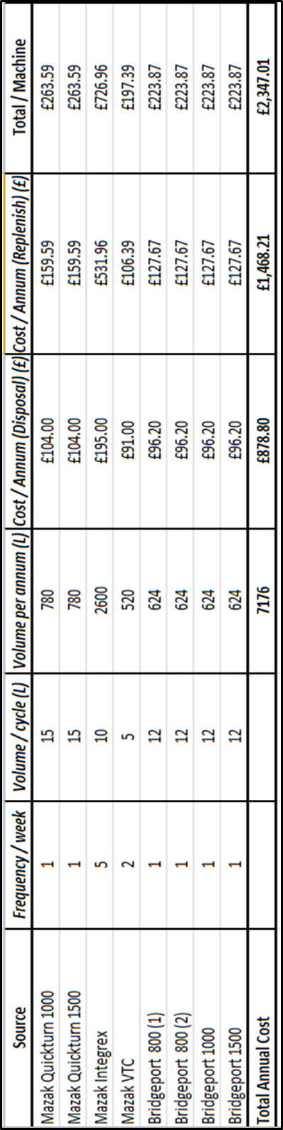
Data Collection- Below you will find a table that outlines the cost of waste disposal from the machines at FSG…
As shown in the table, the coolant disposal can prove to be costly. To solve this problem, the root cause needs to be figured out. This then leads on to ….
Root Cause Analysis
When analysing the root cause, the process is always started by finding out what happened. Then the second process is figuring out how it happened and why it occurred. The third process is to then come up with a solution on how to prevent the problem from reoccurring in the future.
When trying to understand what the causes are, it is necessary to take into consideration that there are levels of causes. The two main causes recognised are physical cause and system cause. A Physical cause could be seen as a something within a manufacturer’s workshop being damaged or worn such as a tool that has worn or a machine that needs to be fixed. A system cause could be seen as a problem which has become repetitive at a high frequency; therefore a change in the system becomes imperative.
A way to analyse the root cause would be through creating diagrams or charts. Choosing this type of process will help identify the potential causes to a problem. For this report, the diagram chosen to be used is the “Fishbone Diagram.”
The diagram being used is one that was created many years ago by Japanese theorist and professor, Kaoru Ishikawa hence why the diagram is also known as the “Ishikawa Diagram.”

Here is an explanation of the diagram found in an article produced by Adam Hayes, “An Ishikawa diagram is a diagram that shows the causes of an event and is often used in manufacturing and product development to outline the different steps in a process, demonstrate where quality control issues might arise and determine which resources are required at specific times.” (Adam Hayes, Ishikawa diagram, March 24th 2020)
An example of a fishbone diagram -
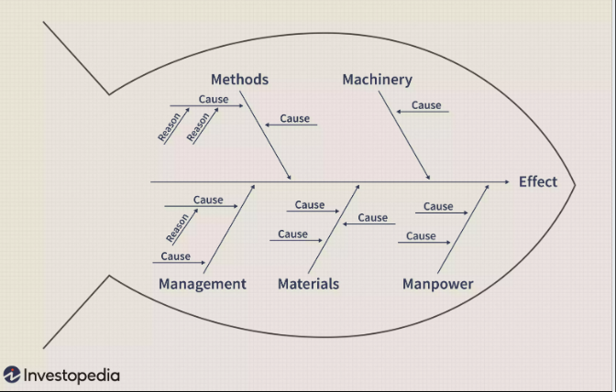
(Image by Julie Bang © Investopedia 2020)
In the diagram shown, the root/ effect is at the start of the diagram. Then there are the main causes followed by sub causes or reason.

The fishbone diagram for this report-
Equipment
Measurement

Coolant waste

Employees
Materials

Summary of the fishbone Diagram
From analysing the diagram, the main causes are the employees, material, machinery and measurement.
Employees- The employees in a workplace can be a reason to why coolant is being wasted. This is because they have received a lack of training, their ability may not be appropriate enough for the industry or maybe they aren’t really clear on the policies within the factory on Coolant waste
Materials- When machining different materials, it isn’t always mandatory to use coolant, for example when working with plastic, operators may not feel the need to run parts with flood coolant on. Therefore the operator may choose to use minimum coolant or none at all, depending on the quantity of production whether that be one off or batch production. If they choose to use no coolant then they are saving the company money but not wasting any. However, if they were to run parts that are steel/stainless steel/metal alloy then coolant and flood coolant is seen as mandatory because the parts will heat up and change in dimension. Also the coolant is necessary to help the tools operate without overheating or getting damaged.
Measurement- When filling up a coolant tank, a measurement or mark should be placed within it so whoever it filling it up knows how much to put in. This is helpful and effective because filling the tank with too much will then lead to wastage when it runs out. Over-filling is definitely common in most workplaces and it is most certainly a great tactic is keep the measurement of coolant at the same level each time instead of just filling it up to the brim.
Equipment- Depending on what equipment a company uses, the wastage of coolant could be down to things such as the old swarf containers that were in FSG. As mentioned, the company found that the flow of coolant was going directly from the swarf conveyor and into the swarf conatiners. There had to be another way the company could get around wasting as much coolant as they were so they came up with a modification to the swarf containers.

Action Plan
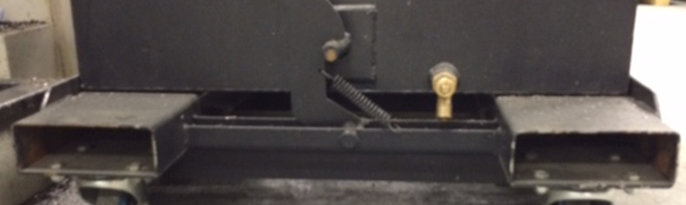
When investigating what the origin of the problem was, FSG found that the swarf containers were sitting too low for any sort of pipe to direct the coolant back into the tank in order to reuse it. So after some meetings, the company came up with the idea of modifying the containers by themselves in order to increase the height so that a tap could be connected to the drain plug. Seeing out this idea would allow the coolant to build up in the swarf containers and then when needed, it can be placed back in to the tank whilst it is still fresh and not stagnant.
In this image, it can be noticed that the container isn’t sitting very far off the ground making it too short to connect a tap with a pipe flowing back into the coolant tank.
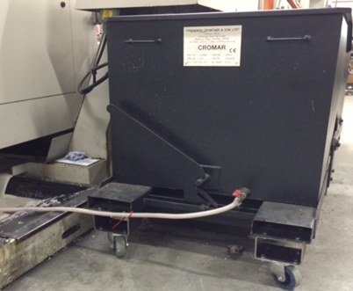
In this image, it shows where the container has been modified in order to increase the height and now the pipe can be attached in order to allow the coolant flow to go back into the tank. This is a great success because now FSG do not have to waste any coolant at all and they are gaining benefits to the company and also helping the environment in the long run.

When carrying out the action plan, the company decided that they would only spend money on purchasing material. There wasn’t much material needed and the overall cost was £100 for some mild steel. When machining the material to fit the specification, the company used their own equipment such as Bridgeport manual milling machines, end mills, drills and taps. Again this cost them nothing because they are all preowned by the company. The manufacturing cost of these modifications certainly had no bad impact on the company and it definitely helped them save money.
If the modifications were somehow ever damaged, the company would not need to spend money getting a third party repair company in, resulting in paying them to fix it because FSG would have the correct material and they could make a new part. Therefore they can fix it, allowing them to save money again.
Risk Management Considerations
When carrying out the action plan, the company carried out a risk assessment and outlined how they would manage the operation. When the material came into the stores, the transported it by forklift and ensured no unauthorised personnel were in the area. The next operation was to cut the material in order to fit the required quantity; this was done on the machine saw and the operator followed the mandatory health and safety protocols such as using PPE and using guards on the machine.
On the bench section, a machinist then used a Bridgeport to machine the parts and when the machinist is doing this, he must use the required guards on the machine and he also must use the correct PPE such as protective goggles, gloves, safety boots etc. The machinist must then get rid of any sharp edges, burrs and clean the swarf off the part so it is ready to use.
Once the parts are machined, an assembler who has been trained in use of cranes and gantries will attach the swarf container to a crane. He must also be wearing the correct PPE and he must make sure no personnel pass the unauthorised area. He will then attach the part to the swarf container correctly using the right tools. It must be attached firmly so it does not fall off.

The swarf container will then be transported over to the CNC sections where it will be ready to use. Overall there isn’t a high risk of this action plan because all members of staff have received the correct amount of training so all health and safety rules are always followed at all times at FSG.
Conclusion
Overall, the report has outlined the problem FSG had within their company due to coolant waste and the problem was addressed in the action plan. The action plan was carried out successfully and the risk assessment was followed accordingly. The action plan has saved FSG a lot of money which can be used elsewhere within the company.

Reference Page-
Mark Crawford’s article- https://www.asme.org/topics-resources/content/5-lean-principles-every-should-know#:~:text=%E2%80%9CSimply%20put%2C%20lean%20means%20creating,process%20that%20has%20zero%20waste.
Mimeo Team article- https://www.mimeo.com/blog/reduce-waste-lean-manufacturing/
Adam Hayes article- https://www.investopedia.com/terms/i/ishikawa-diagram.asp
Images of swarf contaiers- FSG tool and die ltd, December 2020

