Using a Research Approach in Human Resources
A review of the current issues faced by the Health and Social Care sector affecting the retention of staff and making recommendations to support the retention of staff within Pembrokeshire Care Ltd
By signing below, I confirm that the work/evidence presented is my own, unaided work. I understand the regulations pertaining to candidate malpractice and the action that may be taken as a result.

Signed: C V Tickle
Date: 29 June 2020

Chloe Tickle
CIPD Membership no:
Word count (maximum of 2250)

Executive summary

This research report was written to establish the barriers affecting Health and Social Care (HSC) recruitment and retention, and to establish how Pembrokeshire Care Ltd could improve their recruitment and induction processes.

The methodology included gathering both primary and secondary data. Primary data was gathered from a selection of 10 new employees that started work between June 2019 and July 2020, through the utilisation of a survey which was sent to them after the first month of employment.

The survey consisted of 10 new starters. This sample size represented 10% of the workforce. The new starters were selected randomly through the HR database and were based on their job roles and start date to ensure that the parameters of the research project were met.

Secondary data was gathered in the literature review, and by reviewing information and statistics held on HSC statistics in Wales and research in to current issues in relation to recruitment and retention across the sector.

Improvements for recruitment and retention were highlighted within the surveys. Some improvements for recruitment were highlighted as improved use of social media to advertise jobs, and more flexibility in terms of contracted hours and days to access a wider candidate pool.

Improvements for staff retention were widely demonstrated to include changes to the onboarding process incorporating training and shadowing prior to commencing employment within the community and lone working, more manager contact, and additional information prior to starting work.

Subsequently, recommendations will be made to Directors in relation to the recruitment and induction process to establish the necessary improvements and maximise its recruitment and retention strategies.

Contents
Using a Research Approach in Human Resources 0
1. Chapter 1: Introduction 0
1.1 Background 0
1.2 Organisation and Industry background 0
1.3 Research Aim 1
1.4 Research objectives 1
2. Literature Review 1
2.1 Key terminology 2
2.2 Recruitment to Induction 2
2.3 Induction checklist 3
2.4 Summary of review and gaps in research 3
3. Methodology 4
4. Findings/Discussion 5
4.2 Results and analysis on the previous induction process offered within Pembrokeshire Care Ltd 5
4.3 Results and analysis of previous onboarding process 6
4.4 Results and analysis of the reviewed onboarding process. 9
4.3.1 Findings on the previous job onboarding process and 9
5. Conclusions 9
6. Recommendations for change 9
Limitations 9
References 9
Appendices 11

Chapter 1: Introduction

1.1 Background

The struggle of the HSC to recruit and retain staff is widely documented, with ageing populations posing huge challenges to health and social care systems in the UK. It is likely that the UK faces major challenges in ensuring that its HSC systems are designed to deal with the demographic shift in age and life expectancy. By 2020, the number of individuals age 60+ will outnumber those aged below 5 (WHO, 2018).

The ability to provide a robust HSC procurement within the UK is extremely important given that the UK has an ‘ageing population’. Reports illustrate that there are over 12 million people in the UK aged over 65, with the ages of 85+ highlighted as the fastest growing age category. This figure is set to double to by 2041 and triple by 2066 (Age UK, 2019) .

This project will review the challenges faced by the HSC sector in the recruitment and retention of staff and aim to provide recommendations to Pembrokeshire Care Ltd to develop within these areas.

Organisation and Industry background

The HSC industry in Wales employs’ in the region of 53,000 carers. During 2018 there were 11,000 leavers and 13,000 joiners. There are 1,300 registered commissioned care providers in Wales with many of these care providers classed as SME’s recruiting 50 staff or less.

The social care workforce in Wales consists of public and private sector organisations, funded largely through various means including public and private funding. Local Authorities in Wales pay in the region of £550 million each year to fund health and social care (Holtman, 2018).

Pembrokeshire Care Ltd (PCL) was established in 1990 and was acquired by new owners in June 2019.PCL has 50 employees, including ancillary staff and carers. Recruitment and retention rates have varied dramatically over the years, with a noticeable decline in recruitment and in employees.

During 2016 PCL employed in the region of 200 carers which declined rapidly by 75% by 2019. Due to a loss of employees, PCL subsequently were not able to provide as many care hours.

PCL is a private sector care company and is regulated by Social Care Wales (SCW) and Care Inspectorate Wales (CIW). PCL is also influenced by directives by the Welsh Government and Local Authority (LA).

PCL continue to face challenges with the recruitment and retention of care workers, despite a marked improvement in recruitment rates with 28 employees since June 2019, retention rates are still high with an attrition rate of 20%. Through the understanding of factors affecting the recruitment and retention of care workers within this research project, PCL will be able to enhance their current recruitment and retention processes and strategies to tackle these issues.

1.3 Research Aim

This project aims to: ‘Review the current issues faced by the Health and Social Care sector affecting the retention of staff and making recommendations to support the retention of staff within Pembrokeshire Care Ltd’.

Determining the issues in relation to the recruitment and retention of health and social care workers will allow Pembrokeshire Care Ltd to gain a better understanding of the problems faced by the industry as a whole, and to make improvements to its own recruitment and retention strategies to support the recruitment of care workers and the retention of current staff.

1.4 Research objectives

The research objectives for this project are:

- To analyse the current issues in relation to recruitment and retention of social care workers in the UK.

- To identify the ways in which Pembrokeshire Care Ltd can make improvements to their recruitment and strategy to meet the increasing demand for care workers to staff the increase in care packages.

Literature Review

Through the process of research into induction and retention practices of social care workers, it is evident that there are very limited studies into these practices within the HSC industry. However, there are numerous research projects into the induction of Social Workers, an industry which also faces similar challenges in relation to the recruitment and retention of staff.
The struggles faced by the HSC sector to recruit and retain staff are widely acknowledged by government and independent bodies, as well as social care organisations. The vacancy rate is high at 8% in comparison to 3% across all other sectors with an increase in these figures each year (The Health Foundation, 2019).

In 2020 it was reported that there was the equivalent of 122,000 FTE vacancies in HSC in the UK, with 78% of these originating in private HSC settings. By 2030, it is estimated that there will be a shortage of 14.5 million workers (House of Commons Library, 2020) and by 2020 Wales alone will require an additional 20,000 care workers (BBC, 2020).

A report commissioned by the Welsh Government ‘A Healthier Wales: our plan for health & social care’ discuss a more integrated approach to health care provision enabling people to live longer and closer to home. The current shortage and demand for social care workers is increasingly alarming with future care models relying increasingly on social care settings rather than NHS and hospital facilities (Gov.uk, 2019).

2.1 Key terminology

An induction process can be defined as the process whereby new employees are introduced to an organisation within a set period (Croner-i, 2019). The induction process itself is designed to introduce new staff to an organisation’s cultures, values, rules and overall organisational objectives. Within this period the new employee will settle in and become accustomed to the organisation (Croner-i, 2019). The induction stage is particularly important as according to Schein, it allows the new employee to see ‘how we do things around here’ and really integrate with the organisation (Bremer, 2015).
It can be said that an effective induction process can also impact on the retention of staff, sickness absence and employer brand (CIPD, 2019). ACAS also recognise the importance of the induction process and state that it is vital in order to embed employees into any organisation (ACAS, 2020).
Onboarding is a term that is also used to describe the induction process, and describes the process of helping new recruits to adjust to the attitudes, knowledge and skills required by the business (Panopto, 2019).

Recruitment to Induction

A robust recruitment and induction process in essential to the longevity and success of any company. The recruitment and induction process are extremely costly to any organisation with the average cost per hire in the UK in the region of £3,000 (Glassdoor, 2020).
For high-turnover and low skilled and paying jobs earning under £30,000 per year, it is estimated that the cost to replace that member of staff would be in the region of £3,328. This figures correlates directly to the care industry, a low-skilled, low payed industry (Accounts & Legal, 2019).
A considerable amount of time is spent on the recruitment process with the average time taken from recruitment to induction taking around 42 days in total (Mark-Sabel, 2019).
The induction process is also known as the ‘onboarding’ process and forms a link between the recruitment of staff and the phase where employee commitment is shaped. It is thought that this phase has a great impact on the retention of staff (ACAS, 2020). A lack of a substantial onboarding process can have negative consequences to an organisation in several aspects ranging from financial implications to low staff morale. Interestingly a 2017 survey carried out by CIPD found that two fifths of organisations that are undertaking specific retention initiatives found that a robust induction process was not rated as an effective retention solution. This highlights that there may be many other factors affecting the retention of workers and that the period of induction may not have such a substantial impact on the retention of staff (CIPD, 2019). The benefit of an induction process are well documented but have not been empirically proven (Hendricks & Louw-Potgieter, 2012).

Induction checklist

The planning of an induction process should be carried out in conjunction with several other key people within an organisation such as senior managers, line managers, supervisors, and the HR department. The induction process is one of the most common types of organisational training programme and can be carried out either formally or informally depending on the nature of the organisation (Klein & Weaver, 1998). Work colleagues may also play a part through a ‘buddy’ system utilised to support the new employee through their first few weeks.
As well as mandatory training, which is regulated by CIW, our new employees shadow for a set time in their assigned area. This familiarises them with day-to-day activities, their area, and clients.
They are then required to complete induction training and job specific training in their own time, as well as familiarising themselves with company policies and procedures. It has been well documented that new recruits have faced a lot of uncertainty during their first few weeks of employment.
ACAS refer to a ‘planned programme’ of induction which should be created in conjunction with everyone involved to ensure that the new employee becomes ‘effective quickly’. ACAS also recognises that new recruits will be keen and eager to get off to a positive start, and a substantial induction process is key to ensuring that they form a positive impression and attitude to the job and to the organisation (ACAS, 2020).
Employees are often at their most vulnerable during their first few weeks of employment, despite their willingness to learn. The induction can be a very uncertain and unsettling time for an employee, who are faced with many new challenges, and lots of information in a short space of time (Wesson & Gogus, 2005).

2.4 Summary of review and gaps in research

In summary, the key findings are highlighted through ACAS, and CIPD literature into successful induction processes. ACAS highlight the need for a well established and planned induction process that involve different individuals within an organisation and are agreed throughout consultation with others. ACAS highlight the need for different departments to work simultaneously to support the induction process and the embedding of a new worker in to an organisation (ACAS, 2020).

However, there are gaps in research in relation to the induction of HSC workers. Many studies have been carried out in to the recruitment and retention of social workers, teachers and nurses, however there is extremely limited literature in to the retention and recruitment of HSC workers, despite a widely acknowledged shortage of staff now, as well as a projected future crisis. The lack of research is concerning despite the awareness of the situation.

3. Methodology

To ensure responses could be gathered, the methodology had to be considered. The staff completing the survey are working and subsequently the methodology needed to be timely.
The types of methodology that I considered can be seen in table 1. It was decided that a survey would be deployed to staff that began work between July 2019 to January 2020. I would then review these results to determine the recommendations to be made. I had prepared to carry out interviews with employees, however as a result of the Coronavirus pandemic, office restrictions and time restrictions as a result of an increased workload, the face to face interviews were not carried out and I relied on the information gathered within the survey.
A sample was collected from both groups. Table 2 details further information on sample sizes, recruitment rates and employee turnover.

Table 1 – Consideration of alternative research methods.

Research methodology | Strength | Weakness | Reason discounted
Case study | It can be argued that a case study can help us understand complex relationships (Hodkinson & Hodkinson, 2001). | It can be said that there is often too much data for an easy analysis, and ca therefore be a time consuming method (Hodkinson & Hodkinson, 2001). | Discounted due to time constraints and the availability of Carers to participate.
surveys | Easy to administrate and not very time consuming (De Franzo, 2012) | Potential for lack of participation and interpersonal communication. It also doesn’t provide the participant with the opportunity to expand upon any points in further detail. | N/A – decided that this method would be the best method to use.
Observation/participant observation | This method is able to provide two different types of date, both qualitative and quantitative. | This approach is very time consuming. Unable to do as a result of Covid restrictions. | Unable to carry this out at the end due to Covid restrictions.
Interviews | Provide a broad range of data and information. Ability for the participant to elaborate | Can be time consuming and difficult to encourage participation amongst remote working staff. Unable to carry out due to Covid restrictions. | Unable to carry out due to Covid, and difficulties in participation due to remote working staff.

Table 2 – Recruitment metrics and sample size

 | July 2019 – July 2020
New recruits | 55
Leavers | 20
% of surveys returned | 20%
Total number of surveys returned | 10

Consideration was given to any ethical issues which may have arisen. I completed a request form which was agreed in principal by UWTSD prior to the research being carried out. Whilst creating the survey consideration was given to the Universities policy on research, as well as the companies confidentiality policy and the GDPR policy. As a result of this the survey was carried out anonymously by all staff and will only be retained for the minimum required length of time (Pembrokeshire Care Ltd, 2019).

In conclusion a quantitative method was chosen to gather the data as it was quicker and allowed me to review how effective the improvements were on the induction process in a statistical fashion.

4. Findings

4.2 Results and analysis on the induction process offered within Pembrokeshire Care Ltd.

The current induction process within Pembrokeshire Care Ltd was highlighted as inadequate in January 2020 as a result of several issues which arose within the organisation in relation to staff training, staff retention issues, and concerns over the progress of staff within the 6 month probationary period.
The current induction process consists of the following steps:
- Staff are placed on shadow shifts with other members of the team for an unspecified period
- Staff are required to lone work after a short period of time on their own remotely
- Training is booked in and communicated to them via their Team Leader. The training may be several weeks after their start date.
- Staff are invited to attend an induction after an unspecified amount of time, as soon as there were enough new starters to warrant training.

4.3 Results and analysis of the onboarding process
Objective 1: To analyse the current issues in relation to recruitment and retention of social care workers in the UK.
Question 1: How do you identify?
The results highlighted that the majority of the respondents were female, with 60% of responses obtained from female participants and 40% from males, as seen in table 3. This was expected as Pembrokeshire Care Ltd employ more females than male care staff. Over all it is estimated that 18% of social care workers are male, which means that the remaining 82% are females (Skills for Care, 2019). Pembrokeshire Care Ltd face major issues in the recruitment of males, and across the whole company only 5% of workers are males.
Table 3: Statistics on employee gender

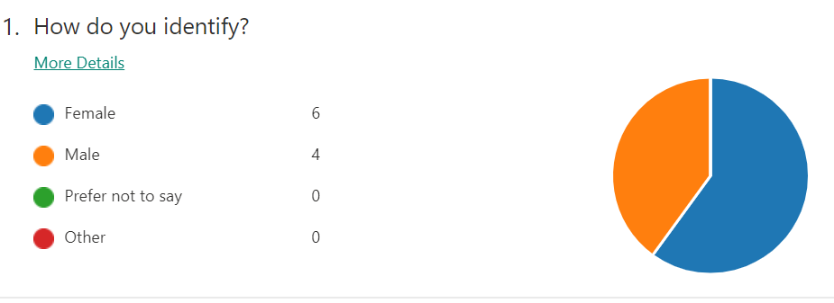

Question 3: How old are you?
Many of our new recruits are females between the age range of 18 – 40. Pembrokeshire Care faced challenges in recruiting staff as the positions were full time with very limited flexibility. Applicants often had childcare responsibilities and were unable to commit to long hours/days, or if they did commit they would quickly establish that the job was not suitable.
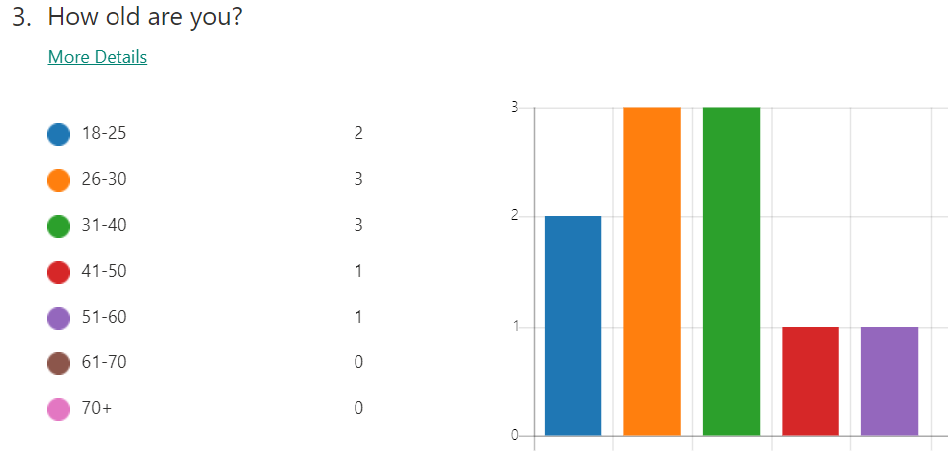

As a result of this review, a more structured induction process was implemented to try and ascertain if the lack of a structured induction process had an affect on the

Question 6: How did you apply for Pembrokeshire Care Ltd?
The results highlighted a need to increase advertising on social media. Indeed was used sporadically but not sponsored advertising was utilised and no specific audiences were targeted.
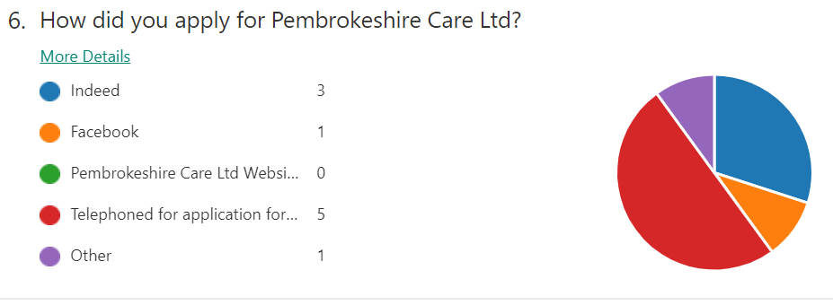

Question 16: The onboarding experience
The feedback from this question highlighted a need to improve the induction process. The majority of all responses documented some discontent with the process with most respondents stating that they strongly disagreed with the statements. The responses highlighted a need to provided more support and more manager contact to ensure a more streamlined transition from the recruitment stage.
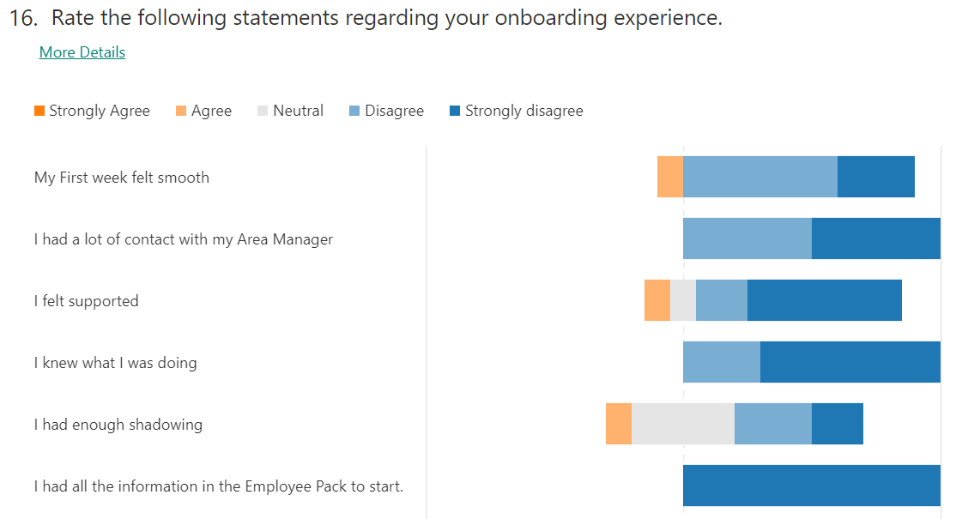

Question 17: How do you think Pembrokeshire Care Ltd could improve the onboarding experience for new starters?

We received a lot of valuable feedback from respondents on ways in which we could improve our induction process. Comments included:
“More information about the company and processes before you start. Do training quicker because I felt unsure about what to do when I started. I didn’t meet my manager until a while after”.
“Maybe do the training first and then do some shadowing after. I felt like I was thrown More information before starting work, meet my manager before I go out into the community. Do training before we start because I felt that I didn't understand what I was supposed to be doing and I didn't have my training until a couple of weeks after”.in at the deep end”.
The overarching theme highlighted a need for training to be delivered at an earlier stage, and more manager contact. The average rating for the overall employee experience of the induction process was 1.6/5 in comparison to the respondents rating of the recruitment process which was 3.5/5, therefore highlighting a clear need for adjustments to be made to the induction process rather than the application system. This allowed us to focus on this specific aspect of the process.
high levels of turnover and failure of new staff to understand and meet organisational objectives and integrate with the desired organisational culture. To try and establish the effectiveness of our induction process and highlight areas for further development, a survey was created to collate feedback from new starters that have started between January 2020 and July 2020. The response rate was 10% and the results were collated utilising Microsoft Forms. The survey was sent to all new starters that began with the company during July 2019 to January 2020.

5. Conclusions

The aim and objectives of this research report were to critically evaluate the issues faced by the HSC sector in relation to the recruitment of staff, and to evaluate the effectiveness of the induction processing assisting with retention.

Through the utilisation of a literature review it is evident that there are gaps in research, with much research and evidence in to the recruitment, retention and induction of social workers, teachers and nurses, but very limited information on the recruitment and retention of the HSC workforce. This is despite ample information and research in to the current and forecast HSC workforce crisis, and its inability to meet supply and demand as a result of an ageing workforce (BBC, 2020).

The CIPD and ACAS both offer ample advice and guidelines in relation to the recruitment and retention of staff, as well as information on induction processes.

The data collated within the surveys provided to staff show that Pembrokeshire Care Ltd require a review of their recruitment and induction processes.

In relation to recruitment, the survey highlighted that more up to date methods of recruitment need to be utilised, with the highest method of applications received via phone call to the office. Only 1 out of 10 respondents recorded that their application method was through social media. It was noted that a small target audience was also reached with very few applicants aged between 40-60 years. This will have implications for Pembrokeshire Care Ltd in terms of the experience and skill set that we are able to offer our customers. Overall, the recruitment process was rated as being 4.3 stars by respondents.

In terms of the onboarding process, the survey highlighted that there are many changes required. The induction process was rated as being 2.3 stars by the same respondents which highlights that there is a need to review the current induction process. The current process is extremely disjointed and uncoordinated. Comments such as “more information about the company required”, “lack of manager contact” and “training should be given before lone working”, highlight the actions that need to be taken to improve the current process.

The induction process needs to adopt an inclusive approach for it to be successful and include employees from different areas of the company such as training and development, HR, and members of the senior management team. The approach also needs to be more structured and coordinated, which should enable the new employee to feel more confidence prior to starting work.

To gain more clarity, further research should be carried out by respondents in the form of an interview to gain feedback ad proposals for improving the current processes.

Recommendations for change
Objective 2: To identify the ways in which Pembrokeshire Care Ltd can make improvements to their recruitment and strategy to meet the increasing demand for care workers to staff the increase in care packages.

6.1 Recommendation 1
To review the current recruitment and induction process in more detail with a larger sample of employees to validate the findings. It is also recommended that this survey is carried out with other types of employee such as ancillary staff and senior management over a longer period, for example an additional 12 months.
It is recommended that the HR department lead on this review and undertake in-depth interviews with respondents after the initial surveys are completed.
It is recommended that once any adjustments are made to the process that the survey is carried out again to establish the effectiveness of the new process.

Recommendation 2

As a result of ACAS advice to take an inclusive approach, it is recommended that a working group is established to support the creation of the revised recruitment and induction strategy. This should ensure the success of any future process. It is intended that the working group includes members of the HR department, such as the HR Advisor and HR Manager. The Health and Safety Officer, the Training Coordinator, Registered Manager, Area Managers a member of the Care staff and a Team Leader.
It is recommended that the working group is established for 12 months to ensure a robust approach is taken.

Recommendation 3

It is recommended that an increased use of technology and IT is adopted. For example, social media such as Facebook and Instagram should be used to increase recruitment rates and access a wider candidate pool. Audience targeting should be used to target those groups where application rates were lower, for example males and females in the 40-60 years category. An agreed budget should be agreed with the finance director as a result of recruitment metrics which are collated by the HR department.
In relation to recruitment, the induction process needs to be revised to ensure it is less disjointed and runs more smoothly. Contracts and company info can be provided prior to day 1 via email, and new starters should be able to access all of their required information in an electronic format in one area.
New recruits will also have access to their online training on day 1 and will be invited to complete a two week induction which consists of a weeks training within the office, where they will also meet key members of staff, and one out in the community where they will be able to shadow experienced members of staff.

7.0 Limitations

The survey sample size was small with 10 respondents out of a potential 50. The survey also offered limited feedback in terms of issues or recommendations.
The timeframe could have been longer, however was restricted due to the time constraints on the research report. Different methods of research could also have been utilised; however further research methods were prevented as a result of the ongoing pandemic which also severely imposed on time constraints.
The final constraint was also the length of tie after starting that the survey was issued. The survey was issued to all staff that were employed as of June 2020, however some staff may have been employed for a long time prior to filling out the survey, which may have impacted on the response rate, and their recollection of events.

References
ACAS, 2020. Induction: Getting the first few days right. [Online]
Available at: https://archive.acas.org.uk/index.aspx?articleid=3754
[Accessed 15 July 2020].
ACAS, 2020. Starting staff: Induction, s.l.: ACAS.
Accounts and Legal, 2019. Employee cost revealed: Average employee costs SMEs £12,000 to replace. [Online]
Available at: https://www.accountsandlegal.co.uk/small-business-advice/average-employee-cost-smes-12-000-to-replace#:~:text=Employee%20cost%20revealed%3A%20Average%20employee%20costs%20SMEs%20%C2%A312%2C000%20to%20replaceandtext=For%20businesses%20to%20thrive%20in,larger
[Accessed 15 July 2020].
Age UK, 2019. Later Life in the United Kingdom, s.l.: age uk.
BBC, 2020. 20,000 more care workers needed in Wales by 2030. [Online]
Available at: https://www.bbc.co.uk/news/uk-wales-47440774
[Accessed 20 June 2020].
Bremer, M., 2015. Edgar Schein on Culture. [Online]
Available at: https://www.leadershipandchangemagazine.com/edgar-schein-on-culture/#:~:text=%E2%80%9CCulture%20operates%20at%20many%20levels,things%20that%20are%20very%20visible.
[Accessed 15 July 2020].
CIPD, 2019. Induction: A look in to the induction process, and the purpose of induction for employer and employee.. [Online]
Available at: https://www.cipd.co.uk/knowledge/fundamentals/people/recruitment/induction-factsheet
[Accessed 15 July 2020].
Croner-i, 2019. Induction in Primary Care: In-depth. [Online]
Available at: https://app.croneri.co.uk/topics/induction-primary-care/indepth?product=154
[Accessed 15 July 2020 2020].
Glassdoor, 2020. How to Calculate your Cost-Per-Hire. [Online]
Available at: https://www.glassdoor.co.uk/employers/blog/calculate-cost-per-hire/#:~:text=Average%20Cost%20of%20Hiring%20an,lower%20recruitment%20costs%20%C2%A33%2C000.
[Accessed 15 July 2020].
Hendricks, K. and Louw-Potgieter, J., 2012. A theory evaluation of an induction programme. SA Journal of Human Resource Management, 10(3), pp. 1-9.
Holtman, G., 2018. Paying for Social Care: An independent report commissioned by the Welsh Government, Wales: Welsh Government.
House of Commons Library, 2020. The health and social care workforce gap. [Online]
Available at: https://commonslibrary.parliament.uk/social-policy/health/the-health-and-social-care-workforce-gap/
[Accessed 20 June 2020].
Klein, H. J. and Weaver, N. A., 1998. The Effectiveness of an Organizational-Level Orientation , Ohio: s.n.
Mark-Sabel, J., 2019. 8 Recruitment Metrics you should be tracking in 2019. [Online]
Available at: https://www.hirevue.com/blog/seven-recruitment-metrics-that-matter#:~:text=The%20average%20time%20to%20fill,the%20same%20day%20they%20open.)
[Accessed 15 July 2020].
The Health Foundation, 2019. Stemming the tide: retaining the social care workforce. [Online]
Available at: https://www.health.org.uk/news-and-comment/newsletter-features/stemming-the-tide-retaining-the-social-care-workforce
[Accessed 20 June 2020].
Wesson, M. J. and Gogus, C. L., 2005. Shaking hands with a computer: An examination of two methods of organizational newcomer orientation.. Journal of Applied Psychology, 90(5), pp. 1018 - 1026.
WHO, 2018. Ageing and health. [Online]
Available at: https://www.who.int/news-room/fact-sheets/detail/ageing-and-health
[Accessed 20 June 2020].

