

BMSW5013: CREATIVITY AND INNOVATION

Programme: BA (Hons) Developing Leadership and Management

Assignment Title: Critically detailing and discussing an innovative/creative solution to an operational problem

Student Name: Alexandra Maria Zara
Student ID: 2329733

Table of Contents
Part One 2
Introduction 2
Critical evaluation of innovation and creativity 3
Innovation Sunrise project: Community Time Bank Exchange 6
Creativity Process 8
Lewins Force Field Analysis 8
Part Two 11
Reproduction of the original idea 11
LLM (Prompts and Process) How I Used the LLM 11
AI Suggestions Criticism (Quality, Bias, Feasibility, Ethics) 12
Considering using AI and What I Learned to Future Practice 14
Conclusion 15
References 16
Appendices 22
Appendix 1 22
Appendix 2 23
Appendix 3 24
Appendix 4 26

Part One

Introduction
Seren Coffi: Company Synopsis
Seren Coffi is a freestanding coffee shop found close to the old docks in the city of Cardiff and opened in February this year by a small team of founders who believe in ethical practices and community-oriented tasks. The space is located in a former betting office and vape store redesigned as a narrow unit, which focuses on sustainability with reclaimed pews of the chapel, locally-made tables, and signage in English and Welsh. According to Xiang et al. (2021), advance information technology can play a crucial role in sustainability and growth of an enterprise. It procures its beans openly, putting their sources, shipping, and cooperatives on a chalkboard, and creating a lingering ambience by hosting such events as poetry recitations and pay-what-you-can nights.
Core Operational Issue
Although successful in the beginning, Seren Coffi is currently in dire need of operations in January 2026: persistent cashflow issues and resource drainage threatening to shut down operations, and 2,000 left in petty cash. The main problems manifest themselves as spiking coffee bean and energy bill, missing replacement of a broken grinder, fewer updates in the menu, discontinued poetry nights, and longer hours that brought minimal footfall amid the rivalry with one of the local chain cafes. The problem is failure in operations due to the inefficiency of internal processes in the context of the capitalistic pressure due to increases in expenses and rivalry, although the product demand and the model are sound. Upon the retention of current governance and suppliers, this report presents a creative value-creation solution for the 2,000 to revolutionise its operations with references to the 4Ps of innovation to sustainability.

Critical evaluation of innovation and creativity
Hospitality Innovation and Creativity
Creativity sparks new, unconventional thoughts that fascinate the ordinary, whereas innovation transforms those new, unconventional thoughts into real action and creates sustained value. As per Lee et al. (2020), innovation & creativity in workplace concerns with the procedure implemented when attempting to apply the new ideas. The two forces are critical in the hospitality industry, especially in the context of small cafes such as Seren Coffi, where they are necessary to manage inopportune pressure changes in price, customer demands, and cutthroat business competition within the local market.
The Untamed Rush of Capitalism
Simply put, capitalism is a driving force of development based on an insatiable search for profit, as strong competition motivated by this encouragement forces companies to tear down the old patterns of activity and find more abrupt and productive ways. According to Pitteloud et al. (2022), capitalism have facilitated the crucial evaluation of social and economic system with its focused features and origins. Seren Coffi represents this conflict in an acutely felt new situation: the raising coffee rates were inflicted by the supply upheavals far away, and the rampant energy demand in its old building necessitated immediate responses, such as scaling back portions, a rise in prices, or menu standardisation.
Local Sector Strains and Cultural Twists
The Welsh hospitality brings in the cultural fibres, varying the stakes: the sight of bilingual signs and docklands heritage helps to bedrock the locals with the haste of tourists, chokes the turnover rates, which are stagnating at the table. As per UKHospitality (2026), the Welsh sector employs almost many individuals by making it the second biggest employer in Wales and accountable for of jobs. The euphonium of capitalism, the same cups, the constant speed, assures us of scale, but scrapes away the habits which make independents what they are. Public events create the warmth and word of mouth with no dependable revenue, which reinforces the fact that artistic style does not guarantee your financial artillery. Chains that are close at hand flaunt slick apps and introductory offers, stealing traffic as desperate hour deals result in ghost-town nights.
Weaknesses of Rigid Capitalist Doctrine
Profit maximisation myopia rejects intangible riches; feasts of pennies having a great swell and slurry but meagre tills, dined in branded nonviable luxuries. Smarter pairing unites social cloth to capitalistic circulatory- commerce- popped- up alliances- developing repeat patronage in lieu of the temporary trade. According to Li (2021), the profitability of an organisation reflects to the capabilities within on the basis of their capital appreciation and assets. Nonetheless, streams of capital run to titans obtaining special conditions from suppliers and the best talents, leaving solos in the dust. The non-exchange rules of leadership or vendors taken by Seren Coffi require creative manoeuvres to get around the formulaic solutions and adopt off-road approaches that pay homage to tradition and infuse energy.
Immediate Comparisons of Seren Coffi
The cafe is supported by principles that avoid easy exits, such as size tricks, and inertia begs the keys to the landlord. To determine which innovation requires reformulation achievement not outburst, and that small cash planting seed tries in small units to test the soundings without, as it were, risking any vitality. As per Taques et al. (2021), no appearance of less effective systems of monitoring for the resources of innovation can limit the suitable analysis of project. Online pre-order suggestions or zone of peak time could melt service spirits devoid of vainness. Seated at noble roundtables, hypocrites of equity since they gum the machinery, the effort to crawl at a collaborative pace foam at the mouth.
Contrasts and Harmonies
Linear invention drives the engine of the corporate giants, as compared to collaborative ideation driving the engine of the ragtag crews, by recruiting their neighbourhood brain to help them create breakthroughs together. Power is tilted towards market leaders that feed directly on market share, but niche-marketing remain through ethos-hustle experimentation, which is morality moats used to trade. According to Razak (2024), niche marketing is sustained in from of a interesting approach in which organisations centralise to the particular segments of market with creative features. Capitalism breeds turbulence but alters its form to play massively, sidelining boutique brilliance. True benefit germinates in mongrels: pivots of value compared to trends.
Plotting Sustainable Horizons
In the case of haunts such as this, reinvention is as important as air. Balance requires the dissection of the workflows that do not involve the DNA disposal. Capitalism spurs expediency but influences decision, screaming in support of mongrel approaches in which value soars above vaults. This preparation sets the stage for the custom-made balm still under wrapping: a rescue of the capitalist redesigned with honour to the heart, venturing into hustle and hacking the survival into superiority.

Innovation Sunrise project: Community Time Bank Exchange
This innovation transforms the Seren Coffi into a cafe-time bank hybrid during the all-slow periods, where the customers will be able to trade skills, time or other minor services directly for coffee, pastry, or seat space without going through a cash crunch whatsoever.
4Ps Classification
Product Innovation
Product remains untouched--there is no menu messing around, there is no flavour bothering about, the supplier bonds, bean backgrounds and that reliable chalkboard appeal are locked up. According to Singh and Jena (2024), product is the goods & service facilitated to customer embedding characteristics with brand quality and innovation. Old familiar flat whites and treats hold on, and the processes are loosened to pour on with their latent war potential without a single ripple of recipe.
Price Innovation
Price dominates the procession in this, drilling out old transaction programs, cash-locked and smooth combinations of barter, and may well cut cash haemorrhage in dead traffic areas as much as it will squeeze the last bit out of idle seating, warm stock, and waiting lines. As per Kassab (2023), the pricing strategy of any company in market will be applied on the basis of research and analysis by providing assurance for competitiveness. Time-bank makes small calls to the customers directly, and leaders are set free to pursue larger strategies. A zero does not have to juggle hocks or providers--even clever redeploys of what is on hand, over the head, without a glitch past distant rises or failure of prices.
Place Innovation
Place is ahead of the curve, repositioning Seren Coffi as the pioneering time cafe in Cardiff--the literal heartbeat of the community, not a temporary depot of drinks, but building a sense of loyalty that the chain stores would never shake. As per Khairawati (2020), an effort for building loyalty of customer can also be applied by harmonic relationship with the customers. Hook "Trade your spark, savour our tale" binds it even better to the South Bank heritage, reeling in locals who laugh, populated by some more bargain signals. Pioneer cultural spaces re-took the spark on credit fuel, creating an inimitable environment, which in turn cannot be imitated or mass-produced by cookie-cutter restaurants.
Promotion Innovation
Promotion irrationalities underneath providing another rulebook: Cash or Bust with value thrown through the people power-value loop the one-way scarcity from tight-fisted to a phase of common plenty. Time becomes the actual currency rocking these walls, encouraging the spot to withstand the shock of unexpected bills of exchange or equipment breakdowns. According to Xia (2023), promotion is the strategy by which a company attracts their customer, facilitating them with the product and leveraging innovation. In the future, it maps an entire new survival outfit of independents, one that will outwit spreadsheets and lead to enduring relationships.
Day-to-Day Rollout Details
Money enhances cutting perfectly 500 makes ledger boards, QR systems, and exchange sheets 700 buys event accessories, white boards, time keepers, and swap cards 500 produces colourful posters, flyers, and handouts about the harbour trains, the founders on balanced checks. Walk-in stay cash; swap-heavy located in the afternoons. Evening ledger sweeps thwart vilification. Wasted credits trigger poetry resurgence or get minor extras.
What Sets This Hybrid Apart
Soul-killing shrinks or slash hours are mere dust in the wind to this, which borders on the intimacy and neighbourhood tug of Seren, the low-tech cord which goes to the skies with the connection. On the side of founder exhaustion, it fades away as the crowd participates, surreal expansion creeps through market experimentations or neighbour tie-ins. First, there are signals of simple tallies; a pleasant surprise attempts to confirm with strangers by means of signs that signify that cash is always welcome. It does not simply fill the gap--it moulds up the entire shop into something that can never be broken.

Creativity Process
The creation of the Community Time Bank Exchange was based on the brainstorming selected by Osborn to be done individually. As per Bonnardel and Didier (2020), the technique of brainstorming is classically utilised within the groups and needs a moderator. But was under the influence of Seren Coffi, in the crunch of January 2026 - broken grinder, chalkboards with writing fading, and empty afternoons of two thousand - actually experiencing the two thousand cash cliff was only seen as a motivating factor later. It was created by context that the exhaustion with the marathons of debate among founders screamed at the decentralised flow. According to Bodó et al. (2021), distributed and decentralised technical systems have provided the rise to some of the genuine creative economic and social practices. The dockside history and events reminded the community about the precious gold. Merging cold supplier, leadership abandoned menu, vendor-plays, low-cash jettisoned hires, tech-hacks repurposed cafe idleness with local horizons, valuing time as currency reoriented cash resonant capitalist gaps into loops of plenty. Lateral leap-frog cafe idleness mutually supported by local talents, flipping cash escapism-traps into loads of money Barns.
There was aeropathy in supposition. Feasibility Assessment Assessed 4ps marketing strategy baseline, no governance change, process increase fits two thousand. According to Wang and Karia (2024), the marketing strategy of four p’s is for the companies who want to meet with the needs of customer needs and generate profitability. This directive but fun process, which was made by crisis immersion, gave birth to grounded value-generating fix consistent with the soul of Seren.

Lewins Force Field Analysis
The Force Field Analysis by Lewin examines forces which are good to push the Time bank exchange idea and bad forces which pull it back to Seren Coffi.
Good forces (driving forces)
The people will be attracted to joining swaps because they like the community feel of the shop. The afternoons with no one around have space to be occupied. As per Team (2024), Lewin’s force field analysis is highly popular for change management mode which is established by Kurt Lewin. The concept is not very expensive to initiate using cash. It aligns to the desire of the founders to do things the right way. Word to mouth will take a short time to propagate. These are a good attraction to ensure the change occurs.
Bad forces (restraining forces)
There are those that could cheat on swaps or fail to trade fair. People who are new might not comprehend its functionality. The logs have to be checked by someone on a daily basis. Trades may not be counterbalanced. At least first-time regulars can wait to have a taste. These blocks are true yet not so difficult to work with.
Ultimately, the bad forces give way to the good forces and hence, the concept appears viable. Free swaps may play destruction with cash flow according to a business-only view. However, we can shift that mentality to think about more important things: swaps help develop close customer relationships that attract more of them in the future. According to Khan et al. (2022), the new customer attraction and retention for long run can accomplished by effective customer relationship. The afternoons become busier with regards to the buzz. Swap notes demonstrate the skillsets that are the best in events. This combination keeps a portion of cash flowing and value sharing, which makes Seren Coffi survive in a hostile world. According to Sánchez-Rebull et al. (2020), the accessibility of internal fundings via cash flow imply that companies will have less requirement to make the resources to outside debt. It reduces expenses during periods when there is low growth that is not necessarily rapid.
Innovation Climate in the Organisational Level
The work environment of Seren Coffi gives new ideas a hand in some areas and withholds them in others. according to Teo et al. (2020), any kind of bullying in workplace directly reflects to the bad work environment which is being seen as the negative consequences on health. There are good parts in the model created by Ekvall such as adventure through the trying events and trust through the open founder talks with employee. According to Gutterman (2023), founder’s role with respect to generating the culture of organisation which can be rendered as typical progression. It has neither energy nor fun of slow decisions and excessive exhaustion. Amabile’s keys suggest that the heart of the good values held by the team is the driving force of the team, but money is low and weak groups are the force that slows down things.
Good sides allow ideas to develop historical events such as flexible price nights are effective as it demonstrates that they enjoy tests of the community. As per Antsygina et al. (2024), various strategies of pricing can co-exist with some kind of chains to adjust their pricing in domestic markets with the utilisation flexible pricing. The wharf history impregnates independent thinking towards distinctive steps. These correspond to the concept of Time bank, whereby minor tasks are recommended to individuals and which suits their daring, trusting personality. According to Tanyi et al. (2025), trust is the aspect which is the heart of majorly all the interactions between and within the companies. Troubles as well as goods protracted meetings kill time, and one of the founders already works less because he is tired of it. They do not have employees, and this indicates a sign of care but prevents large attempts. This would prevent the initiation of new plans. Then the Time Bank takes advantage of the positive aspects of the system of swapping goods as it allows customers to lead swaps without lengthy discussions. It is like an extension of previous happenings. As per Azizan et al. (2025), time banks leverage the interdependence, promotion committee cohesion and influences active participation among members by making them specifically reliable in ageing societies. But old habits could slow it. Sell it as an easy extension of what they already adore, communal and just, to transform ambivalent sentiments into actual advocacy towards change.

Part Two

Reproduction of the original idea
My initial solution regarding Seren Coffi is based on the Community Time Bank Exchange, which is a practical and innovative solution given to the cash crunch and empty afternoons within the cafe. Customers of all levels during off-peak exchange everyday skills, such as storytelling, minor repairs, language practice, or even a moment with quick poetry readings, in exchange for coffee, pastries, or table space. According to Suryana (2024), storytelling allow for creating a in-depth emotional binding among the consumers and organisations. At the counter, a basic chalkboard Time Ledger and a piece of paper with a logbook allow people to write their own hours. Customers read a QR code so that they can be well-acquainted with simple rules and examples, and one of the founders rotates to ensure that things are even-handed. The high-value trades are rewarded with time credits that may be reserved or accumulated in a community coffer to get events such as poetry nights going again. The 2,000 petty cash fund essentials: signed in ledger boards, shop kit and posters, as well as a brief training of founders. According to Khan et al. (2021), training and development will have effective and desirable relationships with normative, affective and continuance commitment. To the tourists, mornings will remain cash only, maintaining the core menu, suppliers, and management thereof, no major changes there either. The effect of this process overhaul is that factories not needed cause a decrease in waste, creation of a durable customer loyalty locally, and the sale of no ethical soul. As per Vilkaite-Vaitone and Skackauskiene (2020), analysis of customer loyalty is the most significant situation for the development of customer loyalty in any business. It corresponds with the dockside legacy and the community of the cafe, making crisis its specific asset that cannot be emulated by chains.

LLM (Prompts and Process) How I Used the LLM
Having completed Part 1, I resorted to using Perplexity AI (LLM) to polish the concept. I gave them the summary of the case study and my pitch to Time Bank, requesting corrections.
Prompt 1: To enhance the level of engagement, AI offered self-serve QR timers to the trades and badges indicating a top contributor to others, called skill stars. According to Limna (2023), the utilisation of AI can enhance the experience of customer through decreasing the requirement for human personnel. Enhance this barter possibility at the Seren Coffi cafe case: Recommend process improvements at the small team, no supplier changes.
Prompt 2: Become more community-oriented at Welsh Dockire Cafe. Add credit ideas to events. Welsh storytelling circles/ harbour history shared: Shares pooled to take part in a free monthly "Coffi Sioe".
Prompt 3: Spot risks associated with cash-poor cafe and a time bank gives a cash-rich cafe and a cash-poor 30-day in advance spot contract. It raised a red flag of freeloader anxiety, to indicate trade buddy pairs and weekly founder audits.
Prompt 4. What really fits it better to 4s innovation -explain each. Most powerful, deepest position, and paradigm reframes with the AI mapping process.
Procedure Research: I completed prompts in two hours, writing down the responses. Initiated wide out of sparks, tightened to practicability. AI's wrong dominance state boosts brainstorming, unearths blind spots such as audits, yet I only selected the fits, no wild technology adds. As per Huang and Rust (2021), the more in-depth learning of ai will associate the thinking of human and feeling abilities. Clipping of chats and the entire prompt list can be seen in Appendices.

AI Suggestions Criticism (Quality, Bias, Feasibility, Ethics)
Generally, the quality of ideas presented by the AI was good, organised, practical ideas based on my idea, without violating the fundamental principles. As per Yang et al. (2024), the advent of advanced technology of AI has introduced the revolutions into various industries. QR timers: self-service to track swap time provided a good, smooth flow to the ledger system, ideal use by a small team refreshing the counters. According to Safaeimanesh et al. (2021), the system of self-service proves to be most successful servers within the delivery system to facilitate high-touch and high-tech experience. Frequent or standout contributor badges as skill stars added a game-like element to the site that reminded some of the poetry nights of the early cafe, which would attract returning locals to the site. But there was no perfection in quality. The same words as above stole in--almost every reply came around to scale in order to grow later, pushing pop-ups or apps, although this was the micro-cafe focus and was on a tight budget. This was favouritism to capitalist growth, although I said a small team, no big changes. As per Moranta (2022), the breakdown of socio-economic capitalism is being founded on ever-expanding growth of economy. Suggestions were made of prompts requesting angles on revenues, such as premium star sales, or credit cash-outs, which conflicted with the barter ethical purity and leadership locks. QR is also inclusive towards the majority, but exclusive to elders who do not own a smartphone. According to Ozturkcan and Kitapci (2025), the menus through QR codes evolved in from of a sustainable and popular resolution for decreasing the waste through improves experience of customer. Technologies cap and cheer-minded: Timers and buddy pairs were cheap, made of phone clocks or paper ticks, expectant 2k themselves acceptant unrealistic founders that were already exhausted.
Ethics raised flags, too. No spooky data grabbers, which was good, but suggestions ignored the power dynamic- power makers justify all trades, risks, favouritism or burnout of employees. According to Ali et al. (2022), the burnout of employees evolved proven to be one of the pressing challenges for many modern companies in all over the world. The open-door culture of the cafe could be challenged by the breeding cliques of the stars being unfriendly to shy new looks. Under one wild pitch, which was deciding to partner with the delivery apps in order to redeem the credit. According to HONG and KANG (2022), the applications of food delivery allows users to classify conveniently listed menus and hotels with the inclusion of orders. They disregarded the regulations of suppliers and commodified the feeling of the community. According to Raad et al. (2026), restaurants and cafes need to select the third-party members like suppliers who connect with sustainability and quality standards. My process focus was exaggerated at the expense of the paradigm depth by AI because it focuses on rapid operational victory instead of the radical value-loop reframing. According to Mingotto et al. (2021), Ai adoption with service robots within industry of tourism for frontline automation of service in creating a growing interest. Wins: I took on board timers, audits and cultural events- they hardened roll out without complication. Stars dropped and all computer rot. Suggestions: the optimism of AI was smeared all over the founder. human was more indicative of Welsh nuance. In general, it served as an ideal fuel sparring partner with a few guardrails, but required a lot of filtering to soul and constraints to represent a real-life mess.

Considering using AI and What I Learned to Future Practice
Applying AI changed my creative lifestyle, serving as an insatiable brainstorming collaborator in the solitude of a work environment. As per Demirović Bajrami et al. (2022), employees can receive appropriate support within workplace environment like desirable affectivity and self-efficacy. It set fire to new angles--like Welsh cultural hooks of which I had been hitherto insensible to--stretching my ways of thinking to their extremities. To implement the innovation, risk breakdowns necessitated convergence, revealing blind spots, which increased viability. As per Molina-Castillo et al. (2023), hospitality companies have high level of innovation earnings because of the less innovational efforts and outcomes. Wins had its way: Saved time allowed me to be able to iterate 4p’s fit: structured outputs had clarity. According to Karim et al. (2021), majority of the managers trust upon four p’s of marketing mix by implying it in the operations which are business-aligned. Balanced its issues--if capitalist tilt continued to thrust scale over soul, the lack of cafe handmade appeal; no feel-intuitive sense of the community heartbeat on for dockside wanted my local adjustments.
Lessons are struck with force to practice in future. Prime prompt- based on constraints to limit bias drift. Check-and-double: AI is obsessed with glittering technology, and cafes get in on human salvation; always reality-check. According to Zahidi et al. (2024), AI have the substantial to not only improve the experience of customer and streamline the operations but also disturbs the sector of hospitality desirably. The highest is hybrid, which is raw spark AI with risk maps, with grounding via walks-by-site or by-founder. Ethical lens issues: Be on the lookout for bridging inclusiveness voids that AI leaves.
This creates versatile skills in creativity/innovation work, the infinite idea mill, and the shrewd moulders as well. According to González-González and García-Almeida (2021), in current environment, the ability for innovation is paramount for the firms of hospitality to compete effectively and precisely. On real-world problems which are messy, such as the one that Seren has, it speeds up without substituting judgment.

Conclusion
Lessons are struck with force to practice in future. Prime prompt- based on constraints to limit bias drift. AI is obsessed with glittering technology, and cafes get in on human salvation and always reality-check. The highest is hybrid, which is raw spark AI with risk maps, with grounding via walks-by-site or by-founder. Be on the lookout for bridging inclusiveness voids that AI leaves. Suggestions of events around credits to the Welsh storytelling circles or dock history shares were culturally correct, and this cemented the role of a community centre in Cardiff. The risk breakdown reflected my personal Force Field issues, including solutions, such as Trade buddy, pairs of locals vouching to one another, and weekly audits, simple and low-effort measures.

References
Ali, A., Hamid, T.A., Naveed, R.T., Siddique, I., Ryu, H.B. and Han, H. (2022) ‘Preparing for the “black swan”: Reducing employee burnout in the hospitality sector through ethical leadership’, Frontiers in Psychology, 13, p.1009785. Available at: https://www.frontiersin.org/journals/psychology/articles/10.3389/fpsyg.2022.1009785/full
[Accessed 23 March 2026].
Antsygina, A., Kazakova, E. and Tarasov, A. (2024) Flexible or Uniform? Optimal Pricing Strategies of Chains (No. 11576)’, CESifo Working Paper. Available at: https://www.econstor.eu/handle/10419/312086 [Accessed 23 March 2026].
Azizan, N.S., Chin, C.C., Chan, C.M., Pin, T.M., Kek, P.Y. and Alavi, K. (2025) ‘Willingness, Motivators and Barriers to Time Bank Participation: A Scoping Review’, medRxiv, pp.2025-03. Available at: https://www.medrxiv.org/content/10.1101/2025.03.30.25324913.abstract
[Accessed 23 March 2026].
Bodó, B., Brekke, J.K. and Hoepman, J.H. (2021) ‘Decentralisation: A multidisciplinary perspective’, Internet Policy Review, 10(2), pp.1-21. Available at: https://www.econstor.eu/handle/10419/235966 [Accessed 23 March 2026].
Bonnardel, N. and Didier, J. (2020) ‘Brainstorming variants to favor creative design’, Applied ergonomics, 83, p.102987. Available at: https://www.sciencedirect.com/science/article/pii/S0003687018305520 [Accessed 23 March 2026].
Demirović Bajrami, D., Petrović, M.D., Sekulić, D., Radovanović, M.M., Blešić, I., Vuksanović, N., Cimbaljević, M. and Tretiakova, T.N. (2022) ‘Significance of the work environment and personal resources for employees’ well-being at work in the hospitality sector’, International Journal of Environmental Research and Public Health, 19(23), p.16165. Available at: https://www.mdpi.com/1660-4601/19/23/16165 [Accessed 23 March 2026].
González-González, T. and García-Almeida, D.J. (2021) ‘Frontline employee-driven innovation through suggestions in hospitality firms: The role of the employee’s creativity, knowledge, and motivation’, International Journal of Hospitality Management, 94, p.102877. Available at: https://www.sciencedirect.com/science/article/pii/S0278431921000207 [Accessed 23 March 2026].
Gutterman, A.S. (2023) ‘Founders and Organizational Culture’, Available at SSRN 4601553. https://papers.ssrn.com/sol3/papers.cfm?abstract_id=4601553 [Accessed 23 March 2026].
HONG, J. and KANG, E. (2022) ‘Food delivery applications becoming alligator of hotel supply chain: An empirical analysis’, Journal of Distribution Science, 20(9), pp.97-107. Available at: https://accesson.kr/jds/assets/pdf/50898/journal-20-9-97.pdf [Accessed 23 March 2026].
Huang, M.H. and Rust, R.T. (2021) ‘Engaged to a robot? The role of AI in service’, Journal of Service Research, 24(1), pp.30-41. Available at: https://journals.sagepub.com/doi/abs/10.1177/1094670520902266 [Accessed 23 March 2026].
Karim, R., Latip, N.A., Marzuki, A., Haider, S., Nelofar, M. and Muhammad, F. (2021) ‘The impact of 4ps marketing mix in tourism development in the mountain areas: A case study’, International Journal of Economics and Business Administration, 9(2), pp.231-245. Available at: https://www.researchgate.net/profile/Faqeer-Muhammad-2/publication/351746745_The_Impact_of_4Ps_Marketing_Mix_in_Tourism_Development_in_the_Mountain_Areas_A_Case_Study/links/60a7607245851522bc07151d/The-Impact-of-4Ps-Marketing-Mix-in-Tourism-Development-in-the-Mountain-Areas-A-Case-Study.pdf Kassab, A. (2023) ‘Emerging trends in marketing strategy: A comprehensive analysis of 4Ps’, Available at: https://www.theseus.fi/handle/10024/802512 [Accessed 23 March 2026].
Khairawati, S. (2020) ‘Effect of customer loyalty program on customer satisfaction and its impact on customer loyalty’, International journal of research in business and social science, 9(1), pp.15-23. Available at: https://pdfs.semanticscholar.org/6eee/7f856bd18822b971cf81e895291787b806ea.pdf [Accessed 23 March 2026].
Khan, A.J., Bashir, F., Nasim, I. and Ahmad, R. (2021) ‘Understanding affective, normative & continuance commitment through the lens of training & development’, iRASD Journal of Management, 3(2), pp.105-113. Available at: https://journals.internationalrasd.org/index.php/jom/article/view/302 [Accessed 23 March 2026].
Khan, R.U., Salamzadeh, Y., Iqbal, Q. and Yang, S. (2022) ‘The impact of customer relationship management and company reputation on customer loyalty: The mediating role of customer satisfaction’, Journal of relationship marketing, 21(1), pp.1-26. Available at: https://www.tandfonline.com/doi/abs/10.1080/15332667.2020.1840904 [Accessed 23 March 2026].
Lee, A., Legood, A., Hughes, D., Tian, A.W., Newman, A. and Knight, C. (2020) ‘Leadership, creativity and innovation: A meta-analytic review’, European Journal of Work and Organizational Psychology, 29(1), pp.1-35. Available at: https://www.tandfonline.com/doi/abs/10.1080/1359432X.2019.1661837 [Accessed 23 March 2026].
‌Li, J. (2021) ‘Research on the Methods of Maximizing the Profits of Enterprise Shareholders’, In 2021 3rd International Conference on Economic Management and Cultural Industry (ICEMCI 2021) (pp. 469-472). Atlantis Press. Available at: https://www.atlantis-press.com/proceedings/icemci-21/125966201 [Accessed 23 March 2026].
Limna, P. (2023) ‘Artificial Intelligence (AI) in the hospitality industry: A review article’, International Journal of Computing Sciences Research, 7, pp.1306-1317. Available at: http://stepacademic.net/ijcsr/article/view/337
Mingotto, E., Montaguti, F. and Tamma, M. (2021) ‘Challenges in re-designing operations and jobs to embody AI and robotics in services’, Findings from a case in the hospitality industry: E. Mingotto et al. Electronic Markets, 31(3), pp.493-510. Available at: https://link.springer.com/article/10.1007/s12525-020-00439-y [Accessed 23 March 2026].
Molina-Castillo, F.J., Meroño-Cerdán, A.L., Lopez-Nicolas, C. and Fernandez-Espinar, L. (2023) ‘Innovation and technology in hospitality sector: Outcome and performance’, Businesses, 3(1), pp.198-219. Available at: https://www.mdpi.com/2673-7116/3/1/14 [Accessed 23 March 2026].
Moranta, J., Torres, C., Murray, I., Hidalgo, M., Hinz, H. and Gouraguine, A. (2022) Transcending capitalism growth strategies for biodiversity conservation. Conservation Biology, 36(2), p.e13821. Available at: https://conbio.onlinelibrary.wiley.com/doi/abs/10.1111/cobi.13821 [Accessed 23 March 2026].
Ozturkcan, S. and Kitapci, O. (2025) ‘A sustainable solution for the hospitality industry: The QR code menus’, Journal of Information Technology Teaching Cases, 15(1), pp.2-7. Available at: https://journals.sagepub.com/doi/abs/10.1177/20438869231181599 [Accessed 23 March 2026].
Pitteloud, S., Ballor, G., Clavin, P., Perrone, N.M., Rollings, N. and Slobodian, Q. (2022) ‘Capitalism and global governance in business history: A roundtable discussion’, Available at: https://iris.unibocconi.it/handle/11565/4050025 [Accessed 23 March 2026].
Raad, J., Ruiz-Moreno, F. and Nicolau, J.L. (2026) ‘Supplier slip-ups: How malpractices can bite into restaurant market value’, Journal of Hospitality & Tourism Research, 50(2), pp.242-255. Available at: https://journals.sagepub.com/doi/abs/10.1177/10963480241311021 [Accessed 23 March 2026].
Razak, I. (2024) ‘Niche marketing: Strategies for creating influence in the market’, MAR-Ekonomi: Jurnal Manajemen, Akuntansi dan Rumpun Ilmu Ekonomi, 3(01), pp.9-15. Available at: https://jurnal.seaninstitute.or.id/index.php/marekonomi/article/view/511 [Accessed 23 March 2026].
Safaeimanesh, F., Kılıç, H., Alipour, H. and Safaeimanesh, S. (2021) ‘Self-service technologies (SSTs)—the next frontier in service excellence: Implications for tourism industry’, Sustainability, 13(5), p.2604. Available at: https://www.mdpi.com/2071-1050/13/5/2604 [Accessed 23 March 2026].
Sánchez-Rebull, M.V., Ferrer-Rullan, R., Hernández-Lara, A.B. and Niñerola, A. (2020) ‘Six Sigma for improving cash flow deficit: a case study in the food can manufacturing industry’, International Journal of Lean Six Sigma, 11(6), pp.1105-1126. Available at: https://www.emerald.com/ijlss/article/11/6/1105/134437 [Accessed 23 March 2026].
Singh, R.V. and Jena, D. (2024) ‘Role of 4PS in Marketing Mix’, World Journal of Pharmaceutical Research., 14(7), pp.1525-1543. Available at: https://wjpr.s3.ap-south-1.amazonaws.com/article_issue/51a912752081b1226affb0b0daa5de76.pdf [Accessed 23 March 2026].
Suryana, P. (2024) ‘Building a strong brand image: the role of storytelling in marketing’, Journal of Economics and Business (JECOMBI), 4(02), pp.107-115. Available at: https://jecombi.seaninstitute.or.id/index.php/JECOMBI/article/view/81 [Accessed 23 March 2026].
Tanyi, A., Cetin, F., Svenson, F. and Launer, M. (2025) ‘What Personality Has to Do with Trusting People Based on How They Make Decisions’, Available at: https://philarchive.org/rec/TANHDS-2 [Accessed 23 March 2026].
Taques, F.H., López, M.G., Basso, L.F. and Areal, N. (2021) ‘Indicators used to measure service innovation and manufacturing innovation’, Journal of Innovation & Knowledge, 6(1), pp.11-26. Available at: https://www.sciencedirect.com/science/article/pii/S2444569X19300605 [Accessed 23 March 2026].
Team, E. (2024) Lewin’s Force Field Analysis in Change Management. What, Why, and How. Available at: https://www.6sigma.us/six-sigma-in-focus/lewin-force-field-analysis-in-change-management/ [Accessed 23 March 2026].
Teo, S.T., Bentley, T. and Nguyen, D. (2020) ‘Psychosocial work environment, work engagement, and employee commitment: A moderated, mediation model’, International Journal of Hospitality Management, 88, p.102415. Available at: https://www.sciencedirect.com/science/article/pii/S0278431919303810 [Accessed 23 March 2026].
UKHospitality (2026) Serving Wales: a manifesto for growth. Available at: https://www.ukhospitality.org.uk/campaigns/serving-wales-a-manifesto-for-growth/ [Accessed 23 Mar. 2026].
Vilkaite-Vaitone, N. and Skackauskiene, I. (2020) ‘Service customer loyalty: An evaluation based on loyalty factors’, Sustainability, 12(6), p.2260. Available at: https://www.mdpi.com/2071-1050/12/6/2260 [Accessed 23 March 2026].
Wang, G. and Karia, N. (2024) ‘4Ps marketing strategy innovation of fresh food e-commerce in the background of big data’, Global Business & Management Research, 16. Available at: http://gbmrjournal.com/pdf/v16n4s/V16N4s-126.pdf [Accessed 23 March 2026].
Xia, Y. (2023) ‘The 4Ps of marketing and applications in various brands’, Journal of Education, Humanities and Social Sciences, 16, pp.165-170. Available at: https://pdfs.semanticscholar.org/0063/9e03801397b6d20ee1c059da83663e8ce065.pdf [Accessed 23 March 2026].
Xiang, S., Rasool, S., Hang, Y., Javid, K., Javed, T. and Artene, A.E. (2021) ‘The effect of COVID-19 pandemic on service sector sustainability and growth’, Frontiers in psychology, 12, p.633597. Available at: https://www.frontiersin.org/journals/psychology/articles/10.3389/fpsyg.2021.633597/full [Accessed 23 March 2026].
Yang, J., Blount, Y. and Amrollahi, A. (2024) ‘Artificial intelligence adoption in a professional service industry: A multiple case study’, Technological Forecasting and Social Change, 201, p.123251. Available at: https://www.sciencedirect.com/science/article/pii/S0040162524000477 [Accessed 23 March 2026].
Zahidi, F., Kaluvilla, B.B. and Mulla, T. (2024) ‘Embracing the new era: Artificial intelligence and its multifaceted impact on the hospitality industry’, Journal of Open Innovation: Technology, Market, and Complexity, 10(4), p.100390. Available at: https://www.sciencedirect.com/science/article/pii/S2199853124001847 [Accessed 23 March 2026].

Appendices

Appendix 1
Prompt 1: Enhance this barter possibility at the Seren Coffi cafe case: Recommend process improvements at the small team, no supplier changes. To enhance the level of engagement, AI offered self-serve QR timers to the trades and badges indicating a top contributor to others, called skill stars.
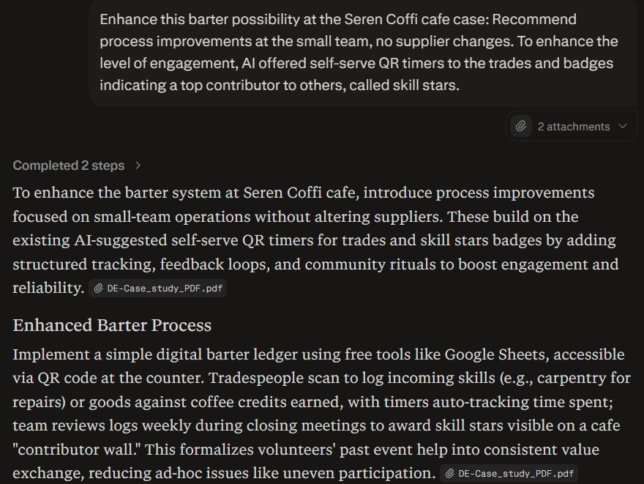
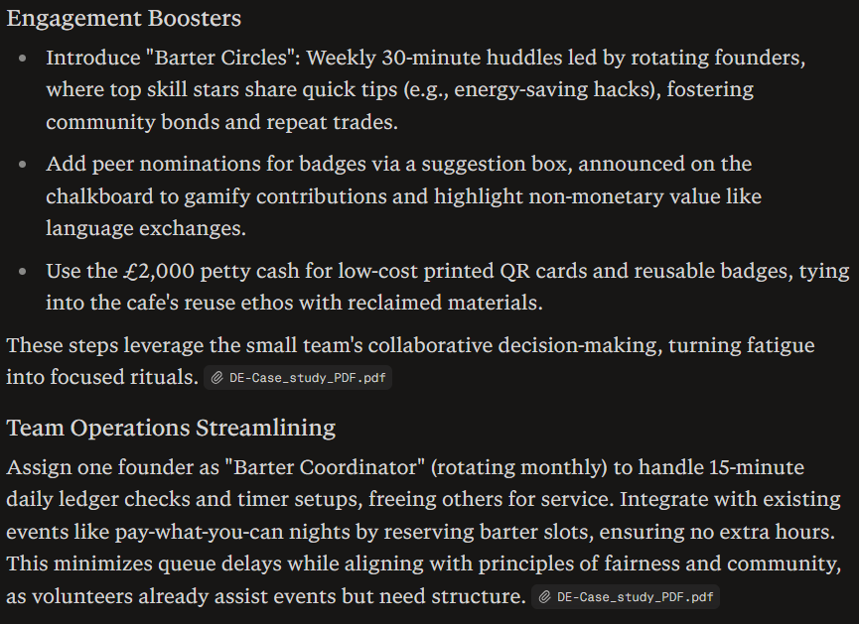

Appendix 2
Prompt 2: Become more community-oriented at Welsh Dockire Cafe. Add credit ideas to events. Welsh storytelling circles/ harbour history shared: Shares pooled to take part in a free monthly "Coffi Sioe".
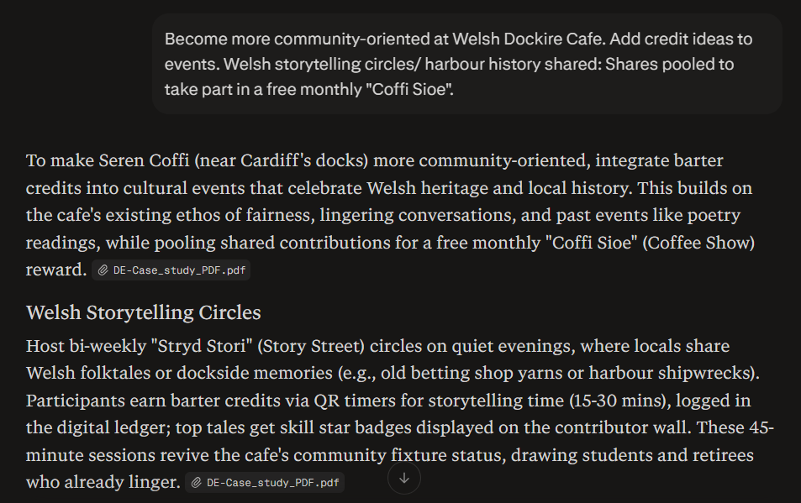
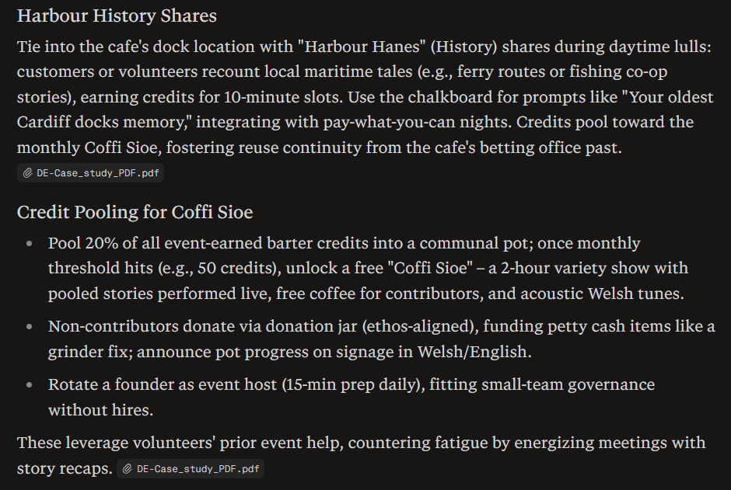

Appendix 3
Prompt 3: Spot risks associated with cash-poor cafe and a time bank gives a cash-rich cafe and a cash-poor 30-day in advance spot contract. It raised a red flag of freeloader anxiety, to indicate trade buddy pairs and weekly founder audits.
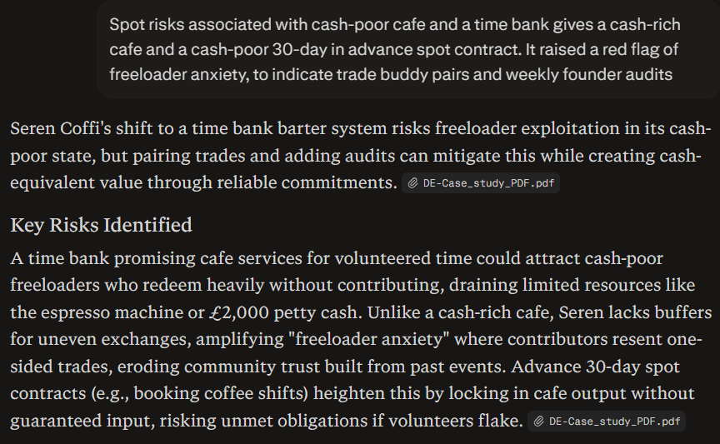
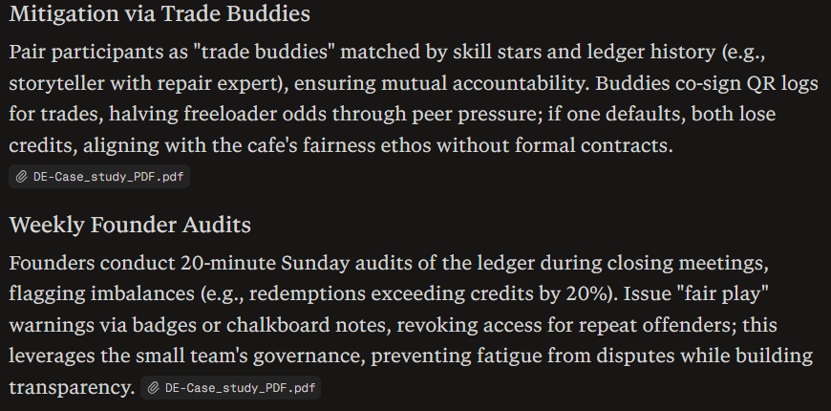

Appendix 4
Prompt 4. What really fits it better to 4s innovation -explain each. Most powerful, deepest position, and paradigm reframes with the AI mapping process.


