Business Report – Comparison of Corinthia Hotels and Ibis Hotels.

Financial Management for the Hotel Industry

Tristan Hawkins

BMIH5007
Alina Cristina Pruteanu, 2209886
Word count: 2193 words

Table of Contents
Executive Summary ……………………..3
Introduction ………………………………4
Comparative Analysis………………….. 4
- Total Revenue…………………… 4
- Market Positioning……………… 6
- Growth Potential………………… 8
- Commitment to CSR ……………10
Conclusion………………………………. 13
Recommendations ………………………13
References ……………………………….15

Executive Summary
This paper compares Corinthia with Ibis Hotels' strategies and performances, focusing on revenue trends, market positioning, development potential, and commitment to Corporate Social Responsibility (CSR). Corinthia has achieved amazing revenue growth by focusing on the luxury segment and expanding in key global locations, emphasising quality and exclusivity. Ibis, a member of the Accor Group, has exhibited stability and growth in the economy and midscale segments, attracting a bigger audience through digital innovation and a complete CSR strategy. The report emphasises the need to stay current with client preferences and sustainability developments in the competitive hotel business. Corinthia's strategic recommendations centre on improving its luxury offerings and sustainability efforts, whilst Ibis is urged to grow into developing countries and use digital marketing to attract environmentally concerned customers. Both companies' success depends on their capacity to respond to market circumstances and execute strategic planning efficiently.

Introduction
The study compares Corinthia with Ibis Hotels based on their financial performance, strategic market positioning, growth prospects, and CSR initiatives. The research attempts to provide insights into how each company has handled the obstacles and opportunities in the hospitality sector by examining revenue data, market strategies, and CSR initiatives in depth. The analysis also aims to understand how global economic conditions and consumer trends affect their operational and strategic decisions. By comparing these two dissimilar brands, we hope to emphasize the various ways to succeed in the hospitality business, as well as the essential aspects that determine their growth and sustainability.

Comparative Analysis
Total Revenue
- Overview
According to Morosan and Bowen's (2022) journal, revenue is a crucial metric in the hospitality sector that serves as a key predictor of a hotel's operational effectiveness and financial stability. Inversini et al, study (2020), illustrate a hotel's capacity to draw and hold onto customers, maximise revenue, and efficiently allocate resources. A hotel's market positioning, growth potential, and overall success can all be gained by analysing revenue trends, which are important in a sector marked by strong competition, fluctuating demand, and diverse customer preferences.
- Analysis
Corinthia Hotels
1Corinthia total revenue table, Annual Report, 2022
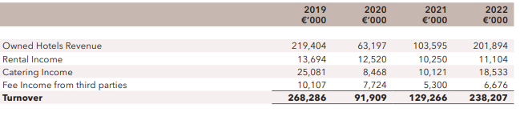
Corinthia's total revenue for 2022 showed a significant increase to €238.207 million, an 84% rise from the previous year and representing 89% of the 2019 revenue figures. This surge indicates a robust recovery and suggests effective strategies for overcoming pandemic-induced challenges. Key factors contributing to this growth include the expansion of their hotel portfolio, with several new projects in advanced stages of construction, and a focus on luxury offerings appealing to a high-value customer base (Corinthia Group, 2022).
Ibis Hotels (Accor Group)
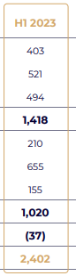
For the full year of 2023, Ibis Hotels, as part of the Accor Group, reported a consolidated revenue of €3,688 million. This figure includes €2,402 million from the first half of 2023 and an additional €1,286 million in the third quarter. The data demonstrates a significant trend of revenue growth and recovery, especially after 2020, likely influenced by the global economic recovery following the COVID-19 pandemic. This increase in revenue, along with a substantial rise in EBITDA and Recurring Free Cash-Flow in the first half of 2023, and the upward revision of EBITDA guidance for the full year, highlight the strong financial performance and resilience of the Accor Group, which encompasses Ibis Hotels​​. (Accor Group, 2023).
- Critical Discussion
Comparing Corinthia and Ibis Hotels uncovers varied growth patterns and strategies. Corinthia focuses on revenue growth through strategic expansions in major cities and luxury projects, targeting a niche market and emphasizing exclusivity, as Debattista (2022) notes. In contrast, Ibis adopts a broader approach, catering to different market segments with its Premium Midscale and Economy offerings, according to Westcott et al. (2012). While Ibis aims for accessibility and consistent quality across a wider audience, Corinthia prioritizes custom luxury experiences, with Chang et al. (2021) highlighting their distinct market positions.

Post-pandemic, both luxury and economy sectors show strong recovery trends, with luxury segments seeing a significant resurgence and economy sectors appealing to cost-conscious consumers, as suggested by Gowreesunkar et al. (2024). This diversity in recovery strategies underscores the importance of aligning with customer preferences and market dynamics to drive revenue growth in the hospitality sector, illustrating the varied paths Corinthia and Ibis Hotels take in achieving success.
Market Positioning
- Overview
According to Chang et al. (2021), market positioning in the hospitality industry is critical for defining a hotel's competitive edge. It involves establishing a brand's distinct market position, targeting specific customer segments, and distinguishing oneself from competitors. Effective market positioning, according to Westcott et al. (2012), influences customer preferences, drives loyalty, and affects financial performance. In a competitive industry, a well-defined position can significantly increase a hotel's visibility and appeal to its target audience.
- Analysis
Corinthia Hotels
2Premium Services at Corinthia, official website, 2024

Corinthia Hotels has positioned itself in the luxury segment, targeting high-end customers seeking premium experiences. Their market share is built around offering bespoke services, exclusive amenities, and upscale facilities. Customer demographics lean towards affluent travellers, business executives, and luxury-seeking tourists. The brand perception is closely tied to elegance, exclusivity, and exceptional service, aligning with the expectations of its upscale customer base (Debattista, 2022).

Ibis Hotels (Accor Group): Ibis Hotels, a subsidiary of the Accor Group, serves a broader market, including budget-conscious business and leisure travellers. Given their presence in the economy and midscale hotel segments, they have a sizable market share. Customers are diverse, including young travellers, families, and businesspeople looking for value without losing quality. Accessibility, consistency, and value for money are central to brand perception, which appeals to a diverse range of customers (Sakova et al., 2021).
3Ibis Styles Geneva, Booking.com, 2024

- Critical Discussion:

Corinthia and Ibis Hotels' marketing strategies seek to increase market share by targeting different market segments. According to Chang et al. (2021), Corinthia specialises in luxury, providing exclusive services and charging premium prices to increase profit margins. In contrast, Ibis targets budget-conscious customers with competitive rates and relies on high occupancy for profitability, as noted by Lopez Mateos et al. (2022). Both hotels tailor their strategies to their target demographics, demonstrating the importance of market positioning. Corinthia's opulence appeals to a wealthier clientele, whereas Ibis's emphasis on value attracts a broader audience, allowing both to achieve long-term growth in the competitive hospitality industry.
4Ibis meal compared to Corinthia meal, official websites, 2024.
Growth Potential
1. Overview
The potential for growth in the hospitality industry is essential for long-term sustainability and success. It includes the ability of a hotel to broaden its market reach, innovate its services, and adapt to changing market conditions. Assessing growth potential, according to Floričić (2020), requires looking at strategic expansions, investment in new markets, service diversification, and the ability to overcome industry challenges. In a rapidly changing industry, a solid growth strategy is critical for retaining a competitive advantage and financial health.

2. Analysis
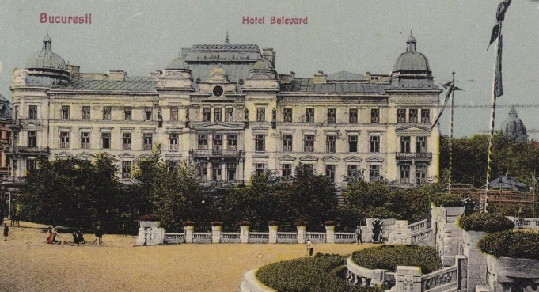
Corinthia Hotels: Corinthia Hotels has demonstrated significant growth potential, primarily by diversifying its luxury hotel portfolio. Corinthia is strategically positioning itself in high-value markets, according to IHI (2023), with projects in key cities such as Rome, Brussels, New York, and Bucharest set to open in 2024, as well as new ventures in Riyadh and Doha. This expansion, according to Lopez Mateos (2022), is consistent with its luxury brand identity and targets affluent demographics. However, obstacles such as economic fluctuations affecting luxury spending and the high operational costs associated with maintaining luxury standards may have an impact on growth. Furthermore, while the niche luxury market is lucrative, it is relatively small in size, making expanding significantly difficult (Chang, 2021).
5Old Picture of Hotel Boulevard in Bucharest, 1921
6Ibis Budget, KAYAK website, 2024
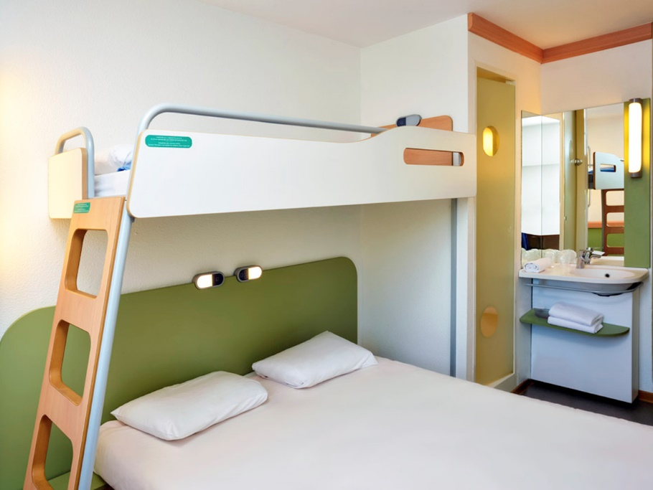
Ibis Hotels (Accor Group): Ibis Hotels, a division of the Accor Group, has a growth strategy that focuses on diversifying its presence across various market segments, including economy and midscale. According to Accor (2022), Ibis's growth is driven by its adaptability and broad market appeal, with a footprint in over sixty-five countries. According to Duha (2024), the introduction of innovative concepts such as "Ibis Styles" and "Ibis Budget" caters to different customer needs within the budget sector. However, challenges such as maintaining consistent quality across a diverse range of properties, as well as intense competition in the economy segment, may stymie growth (Nikolskaya et al., 2020). Furthermore, Aharon et al. (2021) sees the budget sector's sensitivity to economic downturns as a potential risk.
3. Critical Discussion
Corinthia and Ibis Hotels have distinct growth strategies that present unique challenges. Corinthia targets the luxury segment, focusing on quality with properties in key cities and striving for higher profit margins despite significant investments and small market size. Kim et al. (2022) argue that this strategy necessitates continuous innovation to appeal to its upscale clientele and justify premium pricing. In contrast, Ibis seeks to reach a broader audience in the economy and midscale sectors through geographic expansion and brand segmentation, as evidenced by its diverse properties. This approach, while providing broad market reach, operates on thinner margins and requires high occupancy for profitability, necessitating quality standardisation across locations in a competitive environment, according to Dogru et al. (2020).

Both brands have growth potential, but they face strategic challenges. Corinthia must maintain its luxury image and carefully select strategic locations, whereas Ibis must focus on operational efficiency and market adaptability. Corinthia and Ibis' contrasting strategies demonstrate the complexities of hospitality industry expansion, emphasising the importance of market understanding in addition to strategic execution (Kim et al., 2020; Dogru et al., 2020).
Commitment to CSR
1. Overview
Corporate Social Responsibility (CSR) has become a cornerstone of modern business practices for long-term and ethical operations. It demonstrates a company's commitment to positively impacting society, the environment, and the economy. CSR initiatives in the hospitality industry can have a significant impact on brand reputation, customer loyalty, and long-term financial performance.
2. Analysis
7Corinthia Annual Report, 2022
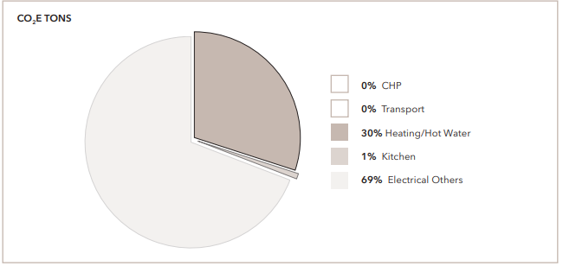
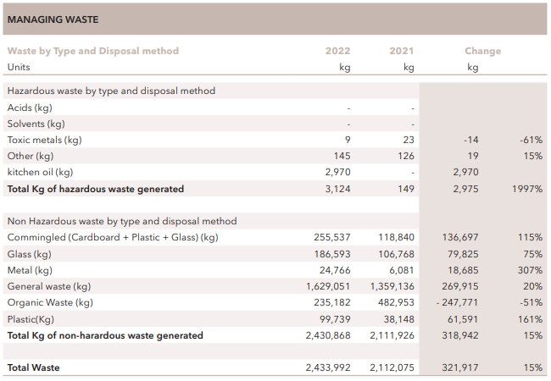
Corinthia Hotels: The CSR initiatives of Corinthia Hotels, focusing on environmental sustainability and social responsibility, include significant efforts like the implementation of energy-efficient lighting and water conservation systems within their properties (Xia et al., 2021). Based on Liu et al. (2020) study, these practices not only contribute to environmental protection but also align with customer and employee expectations for sustainable operations. For instance, the adoption of solar panels and rainwater harvesting systems represents a move towards renewable energy sources and water efficiency, leading to reduced utility costs and enhanced brand value over time (Yoon et al., 2022). However, integrating advanced green technologies such as geothermal heating or cooling systems poses financial challenges, particularly for luxury hotels where the initial investment and maintenance costs are substantial (Gang, 2016). According to Ahn et al. (2013), these sustainable practices, while beneficial in the long run, require significant upfront investment, making them a complex financial decision in the context of maintaining the high standards expected in the luxury segment.
8Corinthia Annual Report, 2022
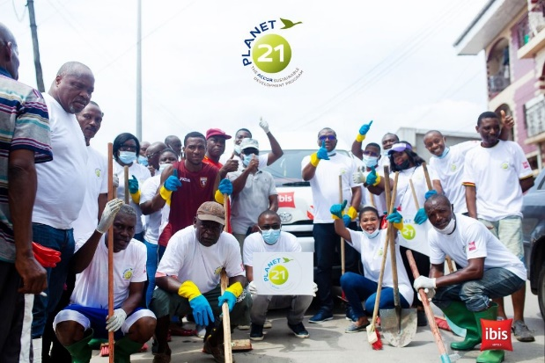
Ibis Hotels (Accor Group): According to Avasilioaei (2022), Ibis Hotels, part of the Accor Group, has implemented a comprehensive CSR strategy that focuses on areas such as sustainable development, diversity and inclusion, and community engagement. This commitment is exemplified by Accor's Planet 21 programme, which includes environmental, health, and social initiatives. The financial implications of the programme include potential operational cost savings from energy-saving measures and waste reduction. However, the initial investment in long-term infrastructure and training can be significant. CSR efforts by the brand increase its appeal to a growing segment of environmentally and socially conscious consumers, potentially driving revenue growth.
9Planet21 Campaign, Ibis website, 2024

3. Critical Discussion
10Corinthia CSR Campaigns, official website, 2024
In terms of CSR, Corinthia and Ibis Hotels have different scales and scopes of initiatives, reflecting their respective market positions. Corinthia's emphasis on high-end sustainability complements its luxury branding, potentially attracting wealthy, environmentally conscious guests. The financial ramifications are a trade-off between the high cost of sustainable luxury and the premium pricing it commands (Debattista, 2022).
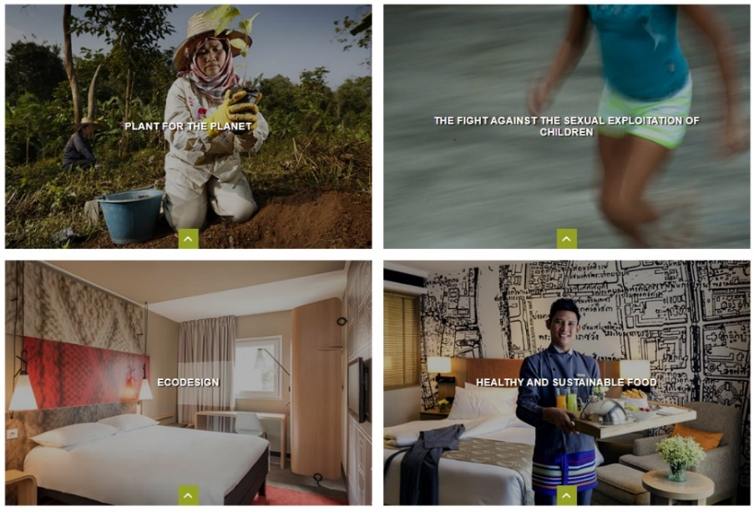
Ibis, on the other hand, caters to a broader audience through its broader CSR approach, which includes a variety of social and environmental initiatives. Ibis will benefit financially from operational efficiencies and an improved brand image, which will appeal to a diverse customer base that values ethical practices (Bacari et al., 2021).
11Ibis CSR Campaigns, Official website, 2024
Both strategies demonstrate that CSR is more than just a moral obligation; it is also a strategic tool that can improve financial performance and brand value. While the initial costs may be high, the long-term benefits of customer loyalty, brand differentiation, and operational efficiencies highlight the importance of CSR in the changing landscape of the hospitality industry.
Conclusion
The comparative report reveals Corinthia Hotels' luxury segment strength, with a focus on exclusive experiences and upscale amenities, indicating the potential for high-value market capture while also emphasising the need for sustainable luxury strategies. Ibis Hotels, part of the Accor Group, has a broad market appeal in the economy and midscale sectors, attracting a diverse clientele through digital innovation and CSR. Both brands face unique challenges, with Corinthia balancing exclusivity with sustainability costs and Ibis maintaining quality across a diverse portfolio of properties. Adopting these distinct strengths and addressing their respective challenges will be critical to their continued success in the fast-paced hospitality industry.

Recommendations
Corinthia Hotels:
Corinthia could enhance its luxury appeal by offering unique high-value experiences such as private yacht tours, exclusive culinary sessions with renowned chefs, and personalized wellness retreats in exotic locations. Personalized services might include bespoke travel itineraries, in-room spa treatments, and customized dining experiences (Lee, 2023). Partnering with eco-friendly brands, such as Ecolab for sustainable cleaning solutions or Tesla for electric vehicle transfers, can underscore its sustainability commitment while providing exclusive amenities like custom-designed eco-friendly guest rooms and private guided tours of local conservation efforts, further cementing its status in the luxury market (Milliman et al., 2012; Hagman and Langbroek, 2019; Gkaragkouni, 2019).
Ibis Hotels (Accor Group):
Expanding Ibis Hotels in developing countries like India, Brazil, and Nigeria, where there's a surge in demand for quality budget accommodations, could significantly boost its market presence (Berlin, 2013). Based on Kimilli (2023) study, for digital marketing strategies targeting millennials and Gen Z, Ibis can leverage social media campaigns, influencer partnerships, and interactive mobile apps offering personalized travel experiences. These strategies, coupled with strong CSR initiatives focused on environmental sustainability, can enhance brand loyalty and attract a broader customer base, leveraging the Accor Group's resources for broader market reach and appeal to eco-conscious consumers Srivastava and Singh, 2021).

References

- Accor Group, 2023. Interim Financial Report. https://group.accor.com/-/media/Corporate/Investors/Documents-financiers/2023/07-27-H1/Interim_Financial_Report_2023_Accor_vDef.pdf
- Aharon, D.Y., Jacobi, A., Cohen, E., Tzur, J. and Qadan, M., 2021. COVID-19, government measures and hospitality industry performance. PloS one, 16(8), p.e0255819.
- Ahn, Y.H. and Pearce, A.R., 2013. Green luxury: A case study of two green hotels. Journal of Green Building, 8(1), pp.90-119. https://pdfs.semanticscholar.org/a765/75120dd53950b9acb8f125a7aa21ba174bf8.pdf
- Avasiloaei, D., 2022. Reinventing the Business Model in the Tourism Industry based on Sustainable Circular Economy and Innovation. ENTRENOVA-ENTerprise REsearch InNOVAtion, 8(1). https://hrcak.srce.hr/ojs/index.php/entrenova/article/download/23873/12520
- Bacari, C., Séraphin, H. and Gowreesunkar, V.G., 2021. Sustainable development goals and the hotel sector: Case examples and implications. Worldwide Hospitality and Tourism Themes, 13(1), pp.9-21.
- Berlin, I.T.B., 2013. ITB World travel trends report. Berlín: Messe Berlin GmbH. https://sete.gr/_fileuploads/entries/Online%20library/GR/131213_ITB%20World%20Travel%20Trends%20Report%202013-2014.pdf
- Chang, H.F., Wu, S.H., Chen, J.H.Y. and Ke, C.H., 2021. Evaluating business model for hotel industry by grey-TOPSIS. Journal of Risk and Financial Management, 14(12), p.606. https://www.mdpi.com/1911-8074/14/12/606
- Corinthia Group, 2022. Annual Report & Financial Statement. INTERNATIONAL HOTEL INVESTMENTS P.L.C. https://www.corinthiagroup.com/wp-content/uploads/2023/06/37547-CORINTHIA-ANNUAL-REPORT-2022_WEB-min.pdf
- Corinthia Group, 2022. Annual report & Financial Statements 2022. INTERNATIONAL HOTEL https://www.corinthiagroup.com/wp-content/uploads/2023/06/37547-CORINTHIA-ANNUAL-REPORT-2022_WEB-min.pdf
- Debattista, D., 2022. MALTA, THE POSSIBILITIES OF SUSTAINABLE LUXURY TOURISM ON A MEDITERRANEAN ISLAND MEGALOPOLIS. The Online Open Access Repository of the Institute of Tourism Studies (Malta). https://futouristic.scholasticahq.com/article/90636-malta-the-possibilities-of-sustainable-luxury-tourism-on-a-mediterranean-island-megalopolis/attachment/188099.pdf
- Dogru, T., McGinley, S. and Kim, W.G., 2020. The effect of hotel investments on employment in the tourism, leisure and hospitality industries. International Journal of Contemporary Hospitality Management, 32(5), pp.1941-1965.
- Duha, O., 2024. Think Human: The Customer Experience Revolution in the Digital Age. Kogan Page Publishers.
- Floričić, T., 2020. Sustainable solutions in the hospitality industry and competitiveness context of “green hotels”. Civil Engineering Journal, 6(6), pp.1104-1113. https://scholar.archive.org/work/7hl237oyurevnk4zlcm7w7ctfa/access/wayback/https://www.civilejournal.org/index.php/cej/article/download/2171/pdf
- Gang, W., Wang, S., Xiao, F. and Gao, D.C., 2016. District cooling systems: Technology integration, system optimization, challenges and opportunities for applications. Renewable and Sustainable Energy Reviews, 53, pp.253-264. https://doi.org/10.1016/j.rser.2015.08.051
- Gkaragkouni, T., 2019. Environmental Management: A factor of tourism competitiveness. http://erepository.uonbi.ac.ke/bitstream/handle/11295/97102/Irungu_Adoption%20of%20Green%20Design%20in%20the%20Hospitality%20Industry%20in%20Kenya%20-a%20Case%20Study%20of%20Serena%20Group%20of%20Hotels,%20Lodges%20and%20Resorts.pdf?sequence=1
- Gowreesunkar, V.G., Maingi, S.W. and Cooper, C., 2024. Tourism policies for the next normal: Trends and issues from global case studies. In Routledge Handbook of Trends and Issues in Global Tourism Supply and Demand (pp. 271-285). Routledge. https://www.taylorfrancis.com/chapters/edit/10.4324/9781003260790-28/tourism-policies-next-normal-vanessa-gowreesunkar-shem-wambugu-maingi-chris-cooper
- Hagman, J. and Langbroek, J.H., 2019. Conditions for electric vehicle taxi: A case study in the Greater Stockholm region. International Journal of Sustainable Transportation, 13(6), pp.450-459. https://doi.org/10.1080/15568318.2018.1481547
- International Hotel Investments, 2023. Financial Analysis Summary. https://www.corinthiagroup.com/wp-content/uploads/2023/09/IHI_2023-Bond-Issue_Financial-Analysis-Summary.pdf
- Inversini, A., De Carlo, M. and Masiero, L., 2020. The effects of customer-centricity in hospitality. International Journal of Hospitality Management, 86, p.102436. https://arodes.hes-so.ch/record/5711/files/Author%20postprint.pdf
- Kim, J., Kim, S.I. and Lee, M., 2022. What to sell and how to sell matters: Focusing on luxury hotel properties’ business performance and efficiency. Cornell Hospitality Quarterly, 63(1), pp.78-95. https://journals.sagepub.com/doi/pdf/10.1177/19389655211020254
- Kimilli, G., 2023 " The impact of instagram travel influencers on Gen Z's tourism consumption. https://dial.uclouvain.be/downloader/downloader.php?pid=thesis%3A40525&datastream=PDF_01&cover=cover-mem
- Lee, D.C., 2023. David’s Guide. Experience Ultimate Luxury: Innovative Wellness Offerings at Premium Retreats with Private Jets, Designer Fashion, and Five-Star Hotels. https://davidsguide.com/wellness-private-jet/
- Liu, Q. and Ren, J., 2020. Research on the building energy efficiency design strategy of Chinese universities based on green performance analysis. Energy and Buildings, 224, p.110242. https://doi.org/10.1016/j.enbuild.2020.110242
- Lopez Mateos, D., Cohen, M.C. and Pyron, N., 2022. Field experiments for testing revenue strategies in the hospitality industry. Cornell Hospitality Quarterly, 63(2), pp.247-256. https://journals.sagepub.com/doi/pdf/10.1177/19389655211014470
- Milliman, J., Gonzalez‐Padron, T. and Ferguson, J., 2012. Sustainability‐driven innovation at Ecolab, Inc.: Finding better ways to add value and meet customer needs. Environmental Quality Management, 21(3), pp.21-33. https://www.academia.edu/download/73536139/tqem.2032420211024-22244-sjg4h0.pdf
- Morosan, C. and Bowen, J.T., 2022. Labor shortage solution: redefining hospitality through digitization. International Journal of Contemporary Hospitality Management, 34(12), pp.4674-4685. https://doi.org/10.1108/IJCHM-03-2022-0304
- Nikolskaya, E.Y., Lepeshkin, V.A., Kulgachev, I.P., Matveev, A.A. and Lebedeva, O.Y., 2020. Perfection of quality management of hotel services. Journal of Environmental Management and Tourism, 11(2 (42)), p.417. https://journals.aserspublishing.eu/jemt/article/download/4739/2458
- Press Accor, 2022. Accor signs ibis hotel in Chiang Mai, Tailand. https://press.accor.com/middle-east-africa-turkey-asia-pacific/accor-signs-ibis-hotel-in-chiang-mai-thailand/?lang=en
- Srivastava, S. and Singh, N., 2021. Do Corporate Social Responsibility (CSR) initiatives boost customer retention in the hotel industry? A moderation-mediation approach. Journal of Hospitality Marketing & Management, 30(4), pp.459-485. https://doi.org/10.1080/19368623.2021.1841705
- Westcott, M., Bird, G., Briscoe, P., Freeman, R., Glazer, K., Henry, K., Hood, T., Knowles, H., McCartney, M., Owens, D. and Robinson, L., 2012. Introduction to Tourism and Hospitality in BC Introduction to Tourism and Hospitality in BC. http://solr.bccampus.ca:8001/bcc/file/97fbe2f6-c09b-4391-b981-d4416d902515/1/Introduction-to-Tourism-and-Hospitality-in-BC-2nd-Edition-1626811967.html
- Xia, X., Wu, X., BalaMurugan, S. and Karuppiah, M., 2021. Effect of environmental and social responsibility in energy-efficient management models for smart cities infrastructure. Sustainable Energy Technologies and Assessments, 47, p.101525. https://doi.org/10.1016/j.seta.2021.101525
- Yoon, H., Sauri, D. and Rico, A., 2022. The water-energy nexus in hotels and recreational activities of a mass tourism resort: the case of Benidorm. Current Issues in Tourism, 25(4), pp.592-610. https://doi.org/10.1080/13683500.2021.1893283

