
Digital Skills for Personal Development and Business Growth (BMSW4008_CARD) Evidence of Learning (E- Portfolio)

Name: Rosalina Ivanova
Student ID: 2326076.

Table of Contents. Page no
Cover Page .................................................................................................................Page 1
Contents Page ...........................................................................................................Page 2
SnapGrocery Questionnaire Analysis
introduction......................................................................................................Page 3
Delivery Time Expectations..............................................................................Page 4
Delivery Fees: Keeping It Affordable ............................................................Page 6
Local Product Preferences: Fresh and Local Win.......................................Page 8
Service Usage Patterns: Building a Loyal User Base .................................. Page 10
Top Survey Questions .................................................................................. Page 12
Conclusion: Turning Insights into Action ........................................................ Page 14
How Questionnaire Data Shaped My Website and Marketing Materials Introduction ................................................................................................... Page 16 Segmentation: Knowing My Audience ....................................................... Page 17
SEO: Getting Found Online ..................................................................... Page 19 Website: Clean, User-Friendly Design ..................................................... Page 21 Marketing Materials: A Visual Story .................................................................. Page 23 Adapting to Trends ......................................................................................... Page 25 Conclusion: From Insights to Action ............................................................... Page 27
A Versatile Tool for Data Management and Analysis Spreadsheet Design and Features.......................................................................Page29
Excel’s Role in Data Management ................................................................. Page 31
Enhancing Productivity and Education with Excel ........................................... Page 33
3-Minute Video Advertising My Brand
Introduction ............................................................................................ Page 35
Storytelling Techniques ............................................................................ Page 36
Conclusion .................................................................................................... Page 37
Marketing Materials
Screenshots and Examples .......................................................................... Page 38
References .................................................................................................. Page 40
SNAP-GROCERY QUESTIONNAIRE ANALYSIS

introduction
The SnapGrocery questionnaire provided valuable insights into what our target audience values most when it comes to grocery delivery. It helped uncover critical preferences, from how quickly people expect their groceries to arrive to their willingness to pay for delivery. This analysis focuses on four key areas of the data: delivery time expectations, pricing sensitivity, preferences for local products, and service usage patterns. These findings will guide improvements in SnapGrocery’s service and ensure the business meets customer needs. As Sandhu (2020) explains, understanding customer expectations is the foundation for building loyalty and trust.

Delivery Time Expectations: Speed Matters
Picture this: you are preparing dinner and realise you are missing a key ingredient. How long would you be willing to wait for a grocery delivery? For 54% of our respondents, the answer is “30 minutes or less.” Another 36% said they could manage with same-day delivery, while just one respondent was willing to wait until the next day. This demonstrates how important speed is, particularly for younger customers managing hectic schedules.
As Sandhu (2020) highlights, convenience and speed are vital factors in the online shopping experience. For SnapGrocery, this means prioritising faster delivery options. One way to achieve this is by setting up micro-fulfilment hubs with local stores, ensuring items are nearby and ready to go. Additionally, implementing route optimisation tools could improve delivery efficiency during high-demand times. The message is clear: when customers say, “I need it now,” we must be ready to deliver.
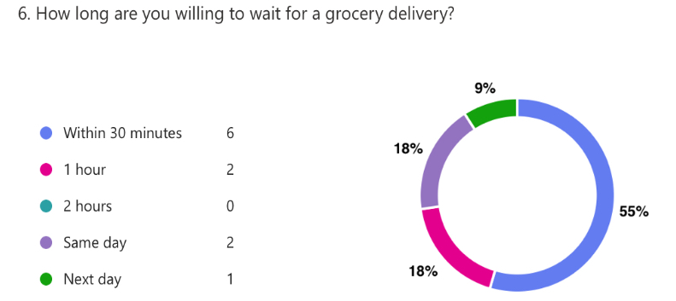

Delivery Fees: Keeping It Affordable

Let’s face it: nobody enjoys extra charges, and delivery fees are no exception. The majority of respondents (73%) indicated they would only pay under £3 for delivery, with the remaining respondents willing to stretch to £5–£8. Striking a balance between affordability and profitability is essential.

Byrd (2021) explains that offering value through perks such as free delivery for larger orders or loyalty rewards can mitigate concerns about fees. SnapGrocery could introduce a subscription plan that provides unlimited deliveries for a flat monthly rate. Another idea is to offer discounts to first-time users or regular shoppers. These small gestures can have a significant impact, showing customers that we are not only delivering groceries but also delivering value.
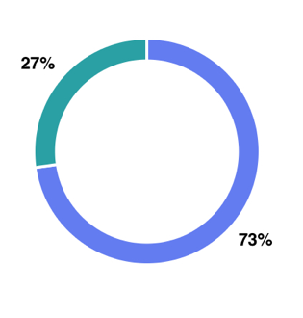
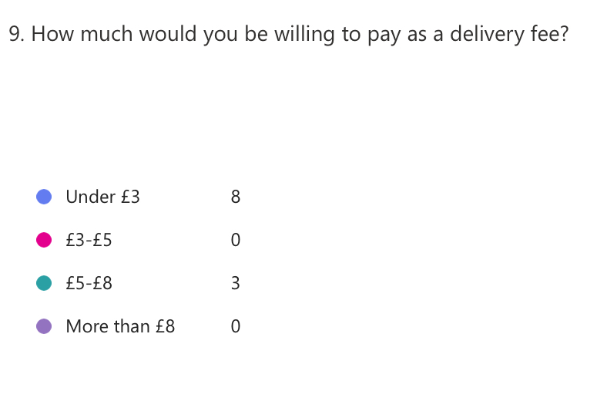

Local Product Preferences: Fresh and Local Wins

Imagine opening a delivery bag to find freshly baked bread from a nearby bakery or locally sourced vegetables harvested that morning. That is the experience many of our respondents are seeking. Fresh produce, dairy, and bakery items were the most popular choices, highlighting a clear preference for high-quality, local products.

Pinto and Guarda (2020) observe that today’s consumers care deeply about quality and sustainability. For SnapGrocery, this means partnering with local farms and bakeries to ensure the freshest items. Promoting these partnerships in our marketing—using phrases like “supporting local” and “farm-to-table freshness”—could set us apart from larger competitors. By focusing on local sourcing, we are not only meeting customer expectations but also fostering stronger community connections.
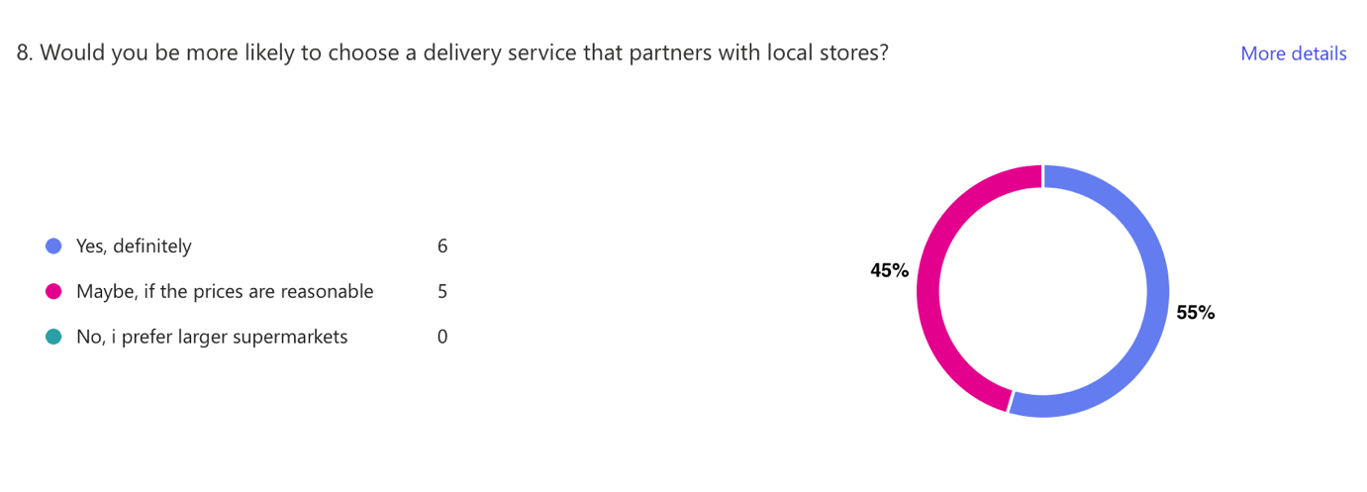

Service Usage Patterns: Building a Loyal User Base

The survey revealed an even split between frequent (45%) and occasional (45%) grocery delivery users, with only one person new to the concept but curious to try it. This suggests there is potential to convert occasional users into loyal customers.

Reedy and Parker (2017) emphasise the importance of personalisation in cultivating customer loyalty. SnapGrocery could introduce a rewards programme that offers discounts or freebies after a certain number of orders. Another idea is to run educational campaigns highlighting the benefits of regular deliveries, such as saving time and accessing fresh, high-quality groceries without leaving home. By making customers feel valued and understood, we can transform occasional users into loyal advocates.
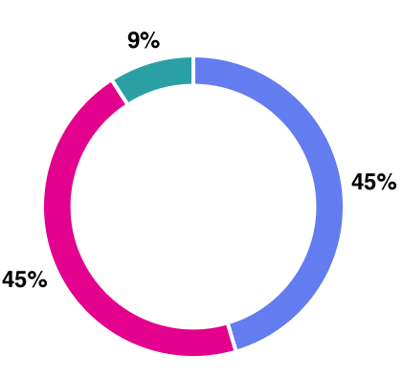
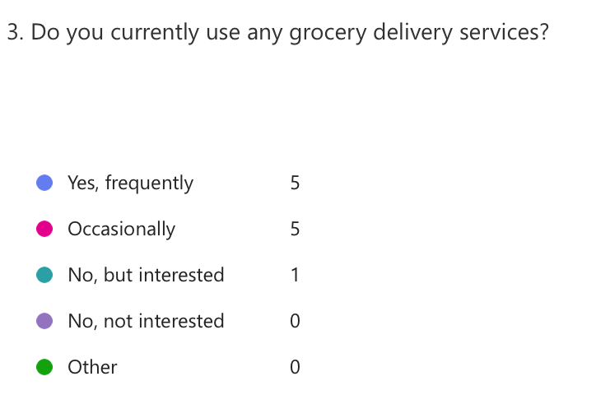

Top Survey Questions

The most revealing questions from the questionnaire and their insights include:

Delivery Time Expectations: With 54% wanting delivery in 30 minutes, speed is a non-negotiable priority.

Delivery Fee Sensitivity: The willingness to pay under £3 underscores the importance of competitive pricing strategies.

Local Product Preferences: Respondents value fresh, local items, confirming the need for partnerships with nearby suppliers.

Service Usage Patterns: The split between frequent and occasional users indicates significant potential for growth with the right incentives.

Conclusion: Turning Insights into Action

The survey results clearly show that SnapGrocery customers prioritise fast delivery, affordable fees, and fresh, local products. By acting on these insights and implementing targeted strategies, SnapGrocery can enhance its services and build a loyal customer base. As Sandhu (2020) suggests, businesses that listen to their customers are the ones that thrive. These findings mark the beginning of what is possible when we put our customers at the heart of every decision.

Questionnaire insight links:
https://uowtsd-my.sharepoint.com/:x:/r/personal/2326076_student_uwtsd_ac_uk/Documents/SnapGrocery__%20Questionnaire%201.xlsx?d=w6f519bf3433d411ba7a089d6bea762fe&csf=1&web=1&e=exj3O1&nav=MTVfezAwMDAwMDAwLTAwMDEtMDAwMC0wMDAwLTAwMDAwMDAwMDAwMH0
https://forms.office.com/Pages/AnalysisPage.aspx?AnalyzerToken=SjO0nbWriGPMYDW177UevbYUyVlpnYid&id=-REPTm4EBUWcuNshUjEeIXFP7g-IlD9HtXUEBC6IZLJUOVpRRDc4S1JCTDFJNkhPMlFJSFdGMDhIVC4u

How Questionnaire Data Shaped My Website and Marketing Materials

Introduction
Designing a website and marketing materials that resonate with an audience starts with understanding who they are and what they value. The SnapGrocery questionnaire provided invaluable insights into the preferences of potential customers, particularly around convenience, sustainability, and affordability. This section explores how these insights guided the design of my two-page website and marketing materials. By tailoring these elements to customer needs, I ensured that the brand message was not only clear but also relatable and engaging. As Reedy and Parker (2017) emphasise, understanding your audience is key to creating impactful digital content.

Segmentation: Knowing My Audience
The questionnaire results revealed distinct audience segments, which helped shape the website and marketing materials. For instance, the majority of respondents were aged between 25 and 40, a demographic that prioritises convenience and efficiency. Many participants highlighted their busy lifestyles and the need for time-saving services.
To address this, the website prominently features benefits such as “same-day delivery” and “track your order” options on the homepage. The marketing materials also focus on ease and speed, using slogans like, “Fresh groceries at your doorstep—fast!” This aligns with Reedy and Parker’s (2017) observation that tailored content improves engagement by speaking directly to audience priorities.
Another key segment identified was eco-conscious shoppers. Many respondents expressed interest in sustainability, preferring locally sourced and environmentally friendly products. To meet this expectation, the website emphasises SnapGrocery’s commitment to reusable packaging and partnerships with local suppliers. These features are highlighted through green visuals and a dedicated “Our Eco Promise” section. As Sandhu (2020) notes, aligning with consumer values builds trust and loyalty in an increasingly sustainability-focused market.

SEO: Getting Found Online
Search engine optimisation (SEO) played a vital role in the website’s design. The questionnaire revealed what potential customers are searching for, such as “fresh grocery delivery” and “local organic produce.” These keywords were incorporated strategically across the website, including in headings, meta descriptions, and image alt texts.
For example, the homepage headline, “Quick and Fresh Grocery Delivery,” directly addresses common search queries. Pinto and Guarda (2020) explain that using targeted keywords not only improves visibility in search engine results but also ensures the website aligns with customer expectations.
Another SEO strategy was creating a FAQ section based on common concerns identified in the questionnaire. Questions like “How does SnapGrocery ensure fast delivery?” and “What sustainable practices do you follow?” provide valuable information while boosting the website’s ranking. Dadwal (2020) notes that relevant content not only improves SEO but also builds credibility with users.
The website was also optimised for mobile users, as the questionnaire showed that a significant portion of respondents browse on their phones. Google’s algorithms favour mobile-friendly sites, making this adjustment a win-win for both usability and SEO rankings (Sandhu, 2020).
The Website: Clean, User-Friendly Design
The questionnaire results made it clear that users wanted a straightforward and seamless online experience. To deliver this, the website features a clean layout with intuitive navigation. Large buttons like “Shop Now” and “Track Order” ensure that key actions are easily accessible.
Bright greens and yellows dominate the colour scheme, reflecting freshness and sustainability—two values highlighted by respondents. Visual elements, such as images of fresh produce and eco-friendly packaging, were designed using Canva to create a polished yet relatable aesthetic. As Soltanifar, Hughes, and Göcke (2021) point out, clarity and simplicity in design enhance user engagement, keeping visitors on the site longer and encouraging conversions.
Marketing Materials: A Visual Story
The marketing materials, created using Canva, were designed to complement the website and reinforce SnapGrocery’s brand values. Flyers and social media graphics focus on the three pillars of the business: speed, freshness, and sustainability.
For instance, one flyer showcases a family enjoying a meal with the tagline, “Fresh groceries, fast delivery—SnapGrocery delivers happiness to your doorstep.” According to Byrd (2021), visuals should tell a story that resonates with the audience, and this was the goal behind every element.
The materials also highlight SnapGrocery’s eco-friendly approach by featuring green accents and images of reusable packaging. These design choices were inspired by the questionnaire data, which revealed that many customers value sustainability.

Adapting to Trends
The questionnaire didn’t just highlight current customer preferences; it also revealed areas where SnapGrocery could innovate. For example, several respondents mentioned wanting subscription options for regular deliveries. Adding this feature positions SnapGrocery ahead of competitors while catering to evolving customer needs. Paulus and Nijstad (2003) highlight the importance of collaboration and customer input in driving innovation, which was a guiding principle throughout the design process.

Conclusion: From Insights to Action
By integrating findings from the questionnaire, I was able to create a website and marketing materials that are not only visually appealing but also deeply connected to what customers value. The focus on segmentation and SEO ensures that SnapGrocery reaches the right audience while delivering a message that resonates. As Sandhu (2020) emphasises, businesses that adapt to customer needs and values are the ones that succeed. These efforts lay a strong foundation for building a loyal and engaged customer base.

Link to my website:
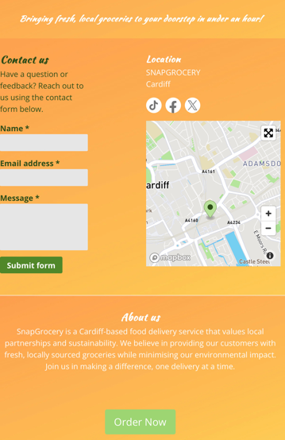
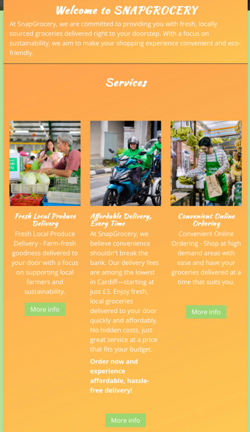
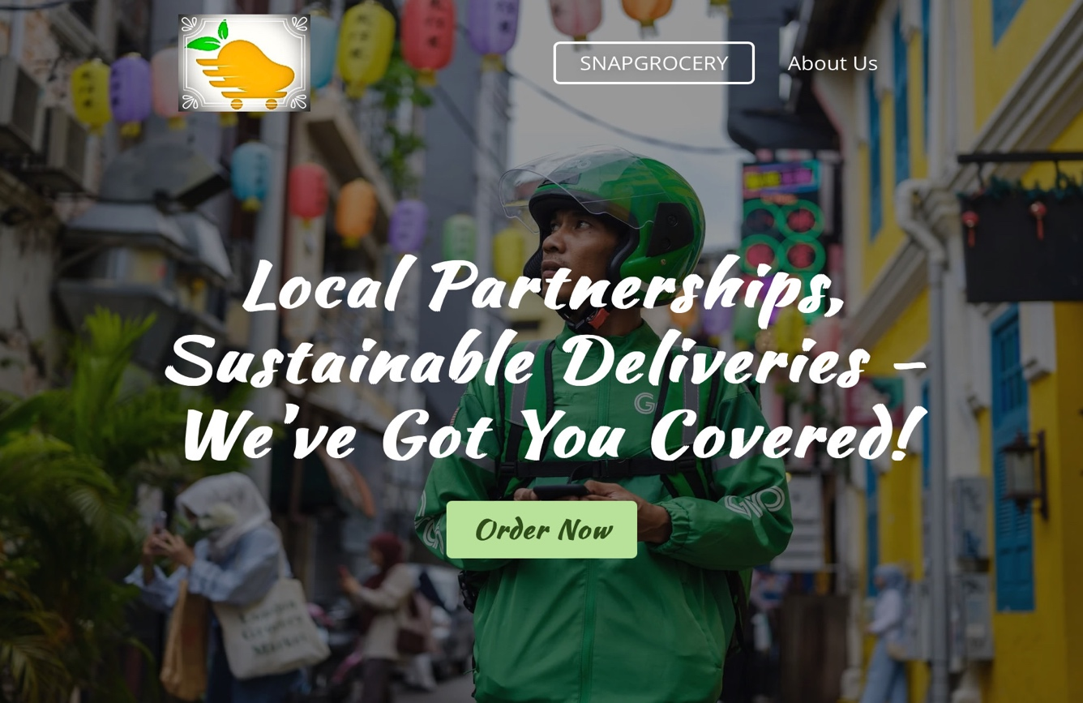
https://www.snapgrocery.net

A Versatile Tool for Data Management and Analysis
Introduction
In today’s digital era, tools like Microsoft Excel are indispensable. From managing personal budgets to analysing complex business data, Excel’s versatility makes it a critical asset across various industries. For this task, I created a spreadsheet projecting the finances of a small business over a three-month period. This spreadsheet included income, expenses, and profit calculations, along with a chart for visualising trends. Additionally, this section explores the broader significance of Excel in data management and its role in enhancing productivity in the modern workplace.
Spreadsheet Design and Features
To design the spreadsheet, I began by creating a clear layout with intuitive column headers representing income, expenses, and profit for each of the three months. By using simple formulas such as =SUM for totals and B4-B11 for profit, I ensured the calculations were accurate and easy to update. These formulas are essential for monitoring financial performance, offering quick insights into how a business is performing month-to-month.
To enhance the spreadsheet’s functionality and readability, I applied:
Formatting: Bold headers, currency formatting, and colour-coding for income (green) and expenses (red) to distinguish key figures easily.
Visual Representation: A bar chart was added to compare income and expenses across the three months. This visualisation makes it easier to identify trends at a glance, such as which month was the most profitable or when expenses were unusually high.
User-Friendliness: The spreadsheet is designed to be dynamic. Changes to the data automatically update totals and charts, ensuring it is adaptable to new information.
By structuring the spreadsheet this way, I created a practical tool for tracking and managing finances. Soltanifar, Hughes, and Göcke (2021) highlight the importance of clear data presentation, noting that well-designed spreadsheets support effective decision-making.
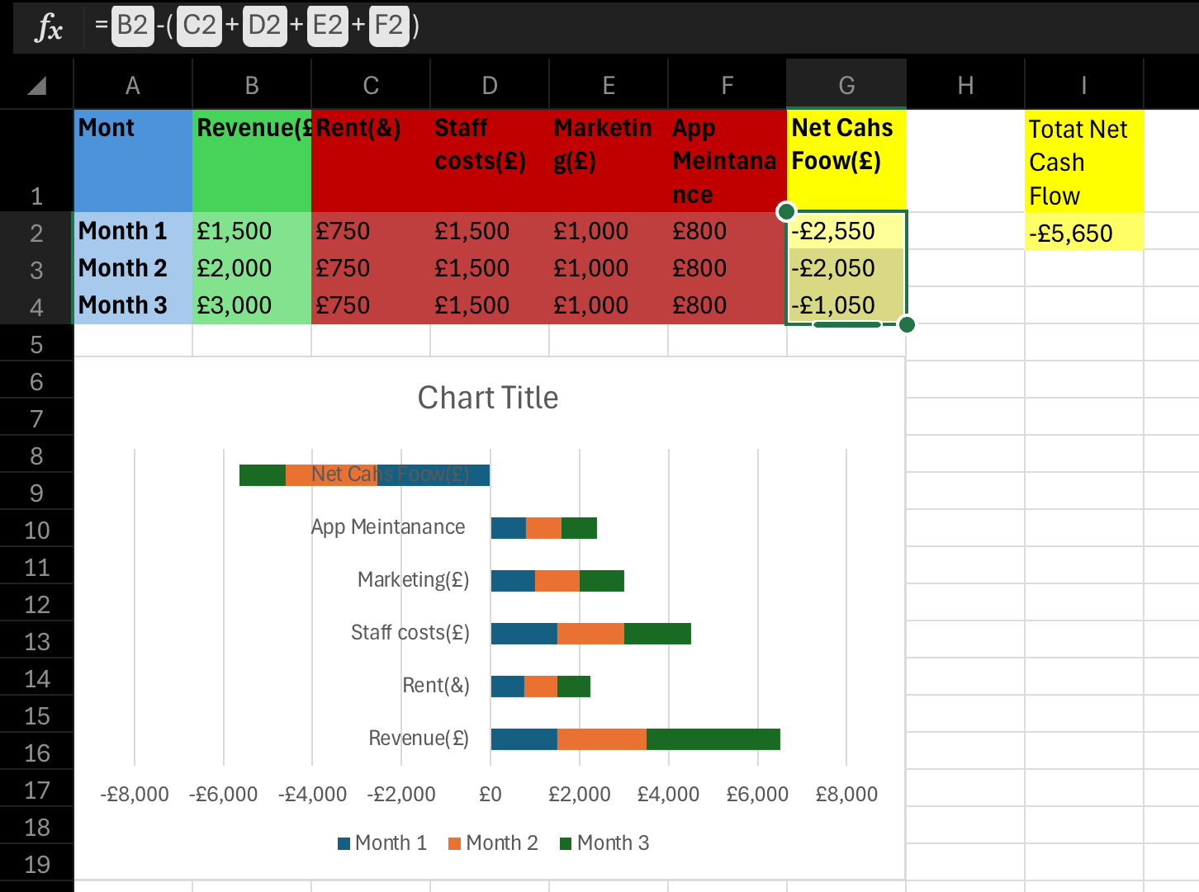
Spreadsheet link:
https://uowtsd-my.sharepoint.com/:x:/r/personal/2326076_student_uwtsd_ac_uk/Documents/3%20Month%20CashFlow%20Forecast%20Philipa.xlsx?d=w79e12037fbb2433f961ad453449ce9e4&csf=1&web=1&e=Z2sxos

Excel’s Role in Data Management

Microsoft Excel is more than just a tool for numbers; it is a platform for organising and analysing information. In a business context, Excel helps convert raw data into actionable insights. For example, small business owners can use Excel for budgeting, forecasting, and evaluating performance.

One standout feature is Excel’s ability to handle large datasets through pivot tables and conditional formatting. These tools allow users to summarise complex information and spot trends with ease. As Hughes (2020) explains, Excel’s adaptability makes it an ideal choice for data management in industries ranging from retail to research.

In my spreadsheet, the use of simple formulas and clear formatting was tailored to suit a small business. However, Excel also supports more advanced features, such as regression analysis and automation through macros. These capabilities demonstrate its potential for scaling alongside a business’s growth.

Enhancing Productivity and Education with Excel
Excel’s real-time data capabilities make it indispensable for tasks like project management, inventory tracking, and scheduling. It simplifies complex processes and reduces errors, such as tracking stock levels in retail and highlighting low inventory with conditional formatting (Johnson, 2021). Automating calculations and visualising trends with charts can save time and improve decision-making.

Excel also plays a crucial role in education, helping students and teachers solve equations, analyse survey data, and create interactive learning materials. Its statistical tools, such as regression analysis, are widely used in fields like psychology and economics (Jensen, 2019).

Conclusion
Excel’s versatility makes it a vital tool for managing finances, enhancing productivity, and supporting education. Even basic features like formulas and charts provide actionable insights. Hughes (2020) notes that Excel empowers individuals and organisations to make informed, data-driven decisions, ensuring efficiency and adaptability in a competitive world.

3-MINUTE VIDEO ADVERTISING MY BRAND
Introduction
For this task, I created a 3-minute promotional video for SnapGrocery using storytelling techniques to engage viewers. The video highlights the brand’s values, focusing on convenience, freshness, and sustainability.
Storytelling Techniques

Relatable Characters: The video follows Lucy, a busy mum who struggles to find time to shop. This character connects with viewers who share similar challenges. Reedy and Parker (2017) argue that relatable characters create a personal connection with the audience.
The Hero’s Journey: Lucy discovers SnapGrocery, which saves her time by delivering fresh groceries quickly. This classic storytelling structure makes the brand the "hero" in her busy life (Burgess et al., 2018).
Emotional Appeal: The video taps into emotions by showing Lucy’s relief and her family enjoying fresh, local food. Sandhu (2020) points out that emotional appeal is key in making services feel personal and valuable to customers.
Conclusion
The video uses storytelling to highlight SnapGrocery’s key selling points—speed, quality, and sustainability—while connecting with the audience emotionally. By focusing on relatable experiences, it strengthens brand recognition and customer engagement.

Link to my YouTube video:
https://youtu.be/MuwK_m1z8MY

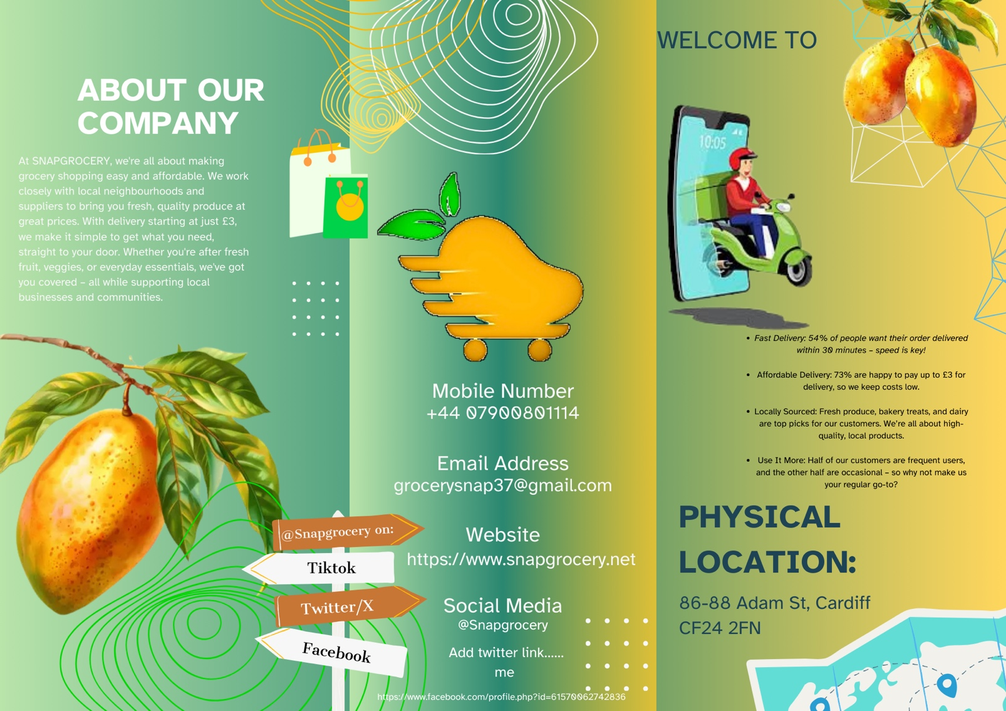
Marketing materials I have created using and Word Canva.

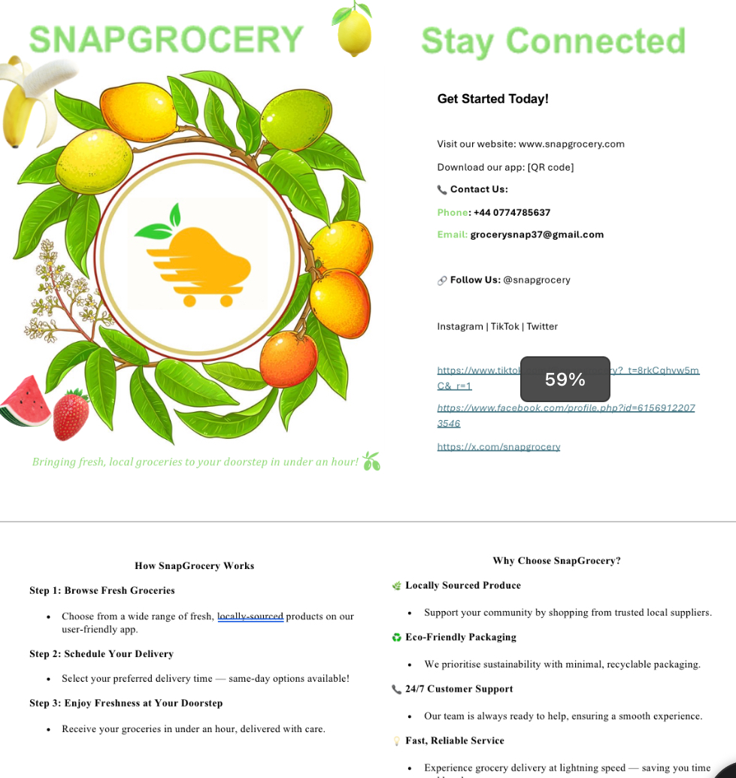

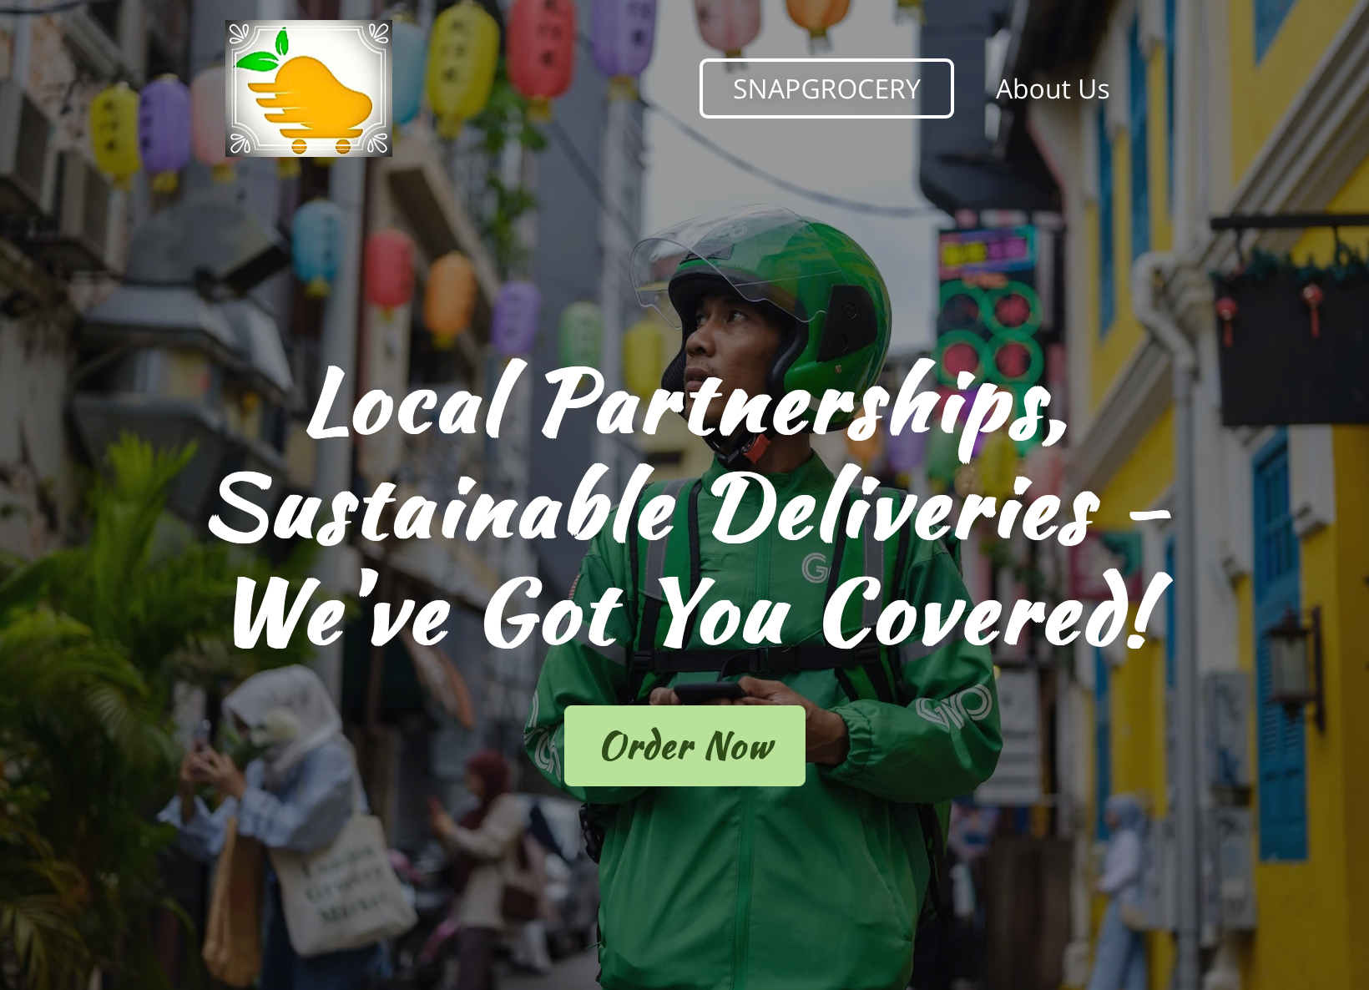
Website screenshots:
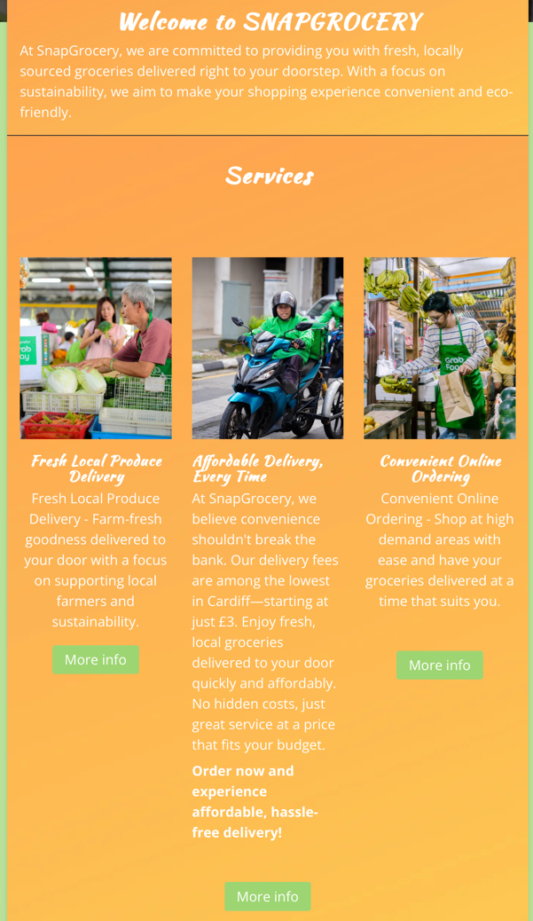
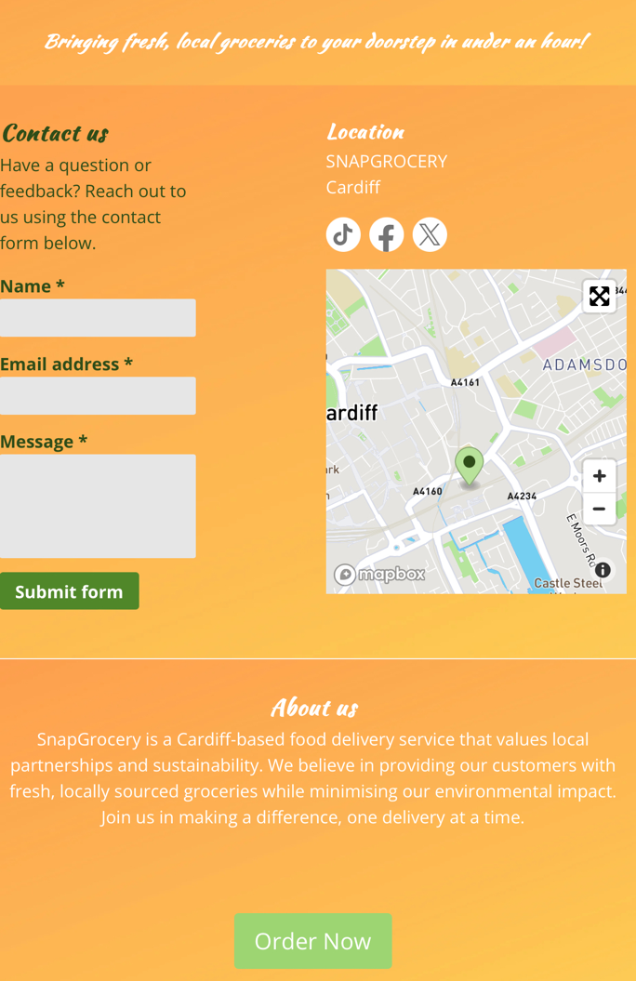

References:
- Burgess, J., Marwick, A. and Poell, T. (2018). The SAGE Handbook of Social Media. SAGE Publications Ltd. Available at: http://doi.org/10.4135/9781473984066 [Accessed 6 Dec 2024].
- Bencsik, A. (2017). Knowledge Management Initiatives and Strategies in Small and Medium Enterprises. IGI Global. Available at: http://doi:10.4018/978-1-5225-1642-2 [Accessed 6 Dec 2024].
- Byrd, L.S. (2021). Cultivating Entrepreneurial Changemakers Through Digital Media Education. IGI Global. Available at: http://doi:10.4018/978-1-7998-5808-9 [Accessed 6 Dec 2024].
- Dadwal, S.S. (2020). Handbook of Research on Innovations in Technology and Marketing for the Connected Consumer. IGI Global. Available at: http://doi:10.4018/978-1-7998-0131-3 [Accessed 6 Dec 2024].
- Pinto, F.M. and Guarda, T. (2020). Digital Marketing Strategies and Models for Competitive Business. IGI Global. Available at: http://doi:10.4018/978-1-7998-2963-8 [Accessed 6 Dec 2024].
- Paulus, P. and Nijstad, B. (2003). Group Creativity: Innovation through Collaboration. Oxford University Press. Available at: https://oxford-universitypressscholarship-com.ezproxy.uwtsd.ac.uk/view/10.1093/acprof:oso/9780195147308.001.0001/acprof-9780195147308 [Accessed 6 Dec 2024].
- Reedy, K. and Parker, J. (2017). Digital Literacy Unpacked. Facet Publishing. Available at: https://ebookcentral.proquest.com/lib/trinity/detail.action?docID=5490897 [Accessed 6 Dec 2024].
- Sandhu, K. (2020). Digital Transformation and Innovative Services for Business and Learning. IGI Global. Available at: http://doi:10.4018/978-1-7998-5175-2 [Accessed 6 Dec 2024].
- Soltanifar, M., Hughes, M., and Göcke, L. (2021). Digital Entrepreneurship. Springer. Available at: http://doi:10.1007/978-3-030-53914-6 [Accessed 6 Dec 2024].
- Moz (2024). Beginner's Guide to SEO. Available at: https://moz.com/beginners-guide-to-seo [Accessed 6 Dec 2024].
- Chaffey, D. (2022). Digital Marketing: Strategy, Implementation and Practice. 8th edn. Pearson Education.
- Kotler, P. and Keller, K.L. (2020). Marketing Management. 16th edn. Pearson.
- Smith, P.R. and Zook, Z. (2020). Marketing Communications: Offline and Online Integration, Engagement and Analytics. 7th edn. Kogan Page.
- Ryan, D. (2020). Understanding Digital Marketing: Marketing Strategies for Engaging the Digital Generation. 5th edn. Kogan Page.
- Statista (2024). Global Mobile Usage Statistics. Available at: https://www.statista.com/statistics/mobile-usage[Accessed 6 Dec 2024].
- Cialdini, R.B. (2021). Influence: The Psychology of Persuasion. Harper Business.
- HubSpot (2024). SEO Trends 2024. Available at: https://blog.hubspot.com/marketing/seo-trends [Accessed 6 Dec 2024].
- Nielsen, J. (2020). Usability Engineering. Elsevier Science.
- McKinsey & Company (2024). The State of Digital Marketing in 2024. Available at: https://www.mckinsey.com/digital-marketing [Accessed 6 Dec 2024].
- Canva (2024). Design Tips for Marketers. Available at: https://www.canva.com/learn/design-marketing [Accessed 6 Dec 2024].
- Google (2024). Search Engine Optimisation (SEO) Starter Guide. Available at: https://support.google.com/webmasters/answer/7451184 [Accessed 6 Dec 2024].
- Clark, R.C. and Mayer, R.E. (2016). E-Learning and the Science of Instruction: Proven Guidelines for Consumers and Designers of Multimedia Learning. Wiley.
- Tuten, T.L. and Solomon, M.R. (2020). Social Media Marketing. 4th edn. Sage.
- Kaplan, A.M. and Haenlein, M. (2020). Rethinking the Digital Marketing Strategy: A Cross-Cultural Perspective. Business Horizons.
- Adobe (2024). The Future of Digital Design and Marketing. Available at: https://www.adobe.com/creative/design-future [Accessed 6 Dec 2024].

