University of Wales Trinity Saint David

Ordnance Munitions & Explosives BEng Apprenticeship



An Investigation on the Use of Water Liners in Fragmenting Munitions Affecting Fragmentation Performance.

Project Submitted as part of the Requirements for the Award of BEng (Hons) OME

Adam Mayo

2112088

06/2025

Supervisor:
Contents
List of Figures 4
List of Tables 5
List of Equations 6
Abbreviations 7
AI Acknowledgement 8
1.0 Introduction 9
2.0 Background to the Proposed Research 10
3.0 Aims & Objectives 12
3.1 Aims 12
3.2 Objectives 12
3.3 Project Structure 13
4.0 Research Methodology 14
4.1 Introduction 14
4.2 Research Overview 14
4.3 Research Methodologies 14
4.4 Outline of Experimental Procedure 15
4.4.1 Variables 18
4.5 Data Collection 19
4.6 Risks & Limitations 20
4.6.1 Risks 20
4.6.2 Limitations 20
4.7 Ethical Issues 21
5.0 Resources & Planning 22
5.1 Resources Required 22
5.1.1 Physical Resources 22
5.1.2 Human Resources 24
5.1.3 Additional Resources 24
5.2 Gantt Chart 25
6.0 References 27
7.0 Appendix 29
Appendix A 29
Appendix B 30
Appendix C 31

List of Figures
Figure 1 - Trial setup overview. 15
Figure 2 - Trial setup Top-Down View. 15
Figure 3 - 10mm Water-lined munition, with the top removed. 16
Figure 4 – Fragmentation data processing flow chart [16]. 18
Figure 5 – Project Gantt chart. 25

List of Tables
Table 1 - Trial variables. 17
Table 2 – Instrumentation list. 18
Table 3 - Physical resources list. 21
Table 4 - Human Resources. 23
Table 5 - Additional resources 23

List of Equations
Equation 1 – Gurney equation for an open-ended cylinder [12]. 11

Abbreviations
CL-20 - Hexanitrohexaazaisowurtzitane
COTEC – Cranfield Ordnance Test and Evaluation Centre
FPS – Frames Per Second
HE – High Explosive
HSDV – High Speed Digital Video
IM – Insensitive Munition
NEQ – Net Explosive Quantity
OME – Ordnance, Munitions and Explosives
PE4 – Plastic Explosive 4
RPS – Radiation Protection Supervisor
SC – Shape Charge
SIT – Senior Instrumentation Technician
SMART – Specific, Measurable, Achievable, Relevant and Time-bound
TBC – To Be Confirmed
TCO – Trials Conducting Officer
TNT – Trinitrotoluene
UWTSD – University of Wales Trinity Saint David
XO – X-ray Operator

AI Acknowledgement
I acknowledge the use of Grammarly (https://www.grammarly.com/) on 13 June 2025 to check my work using the prompt(s):

- Please check the following text for readability, grammar and syntax.

I confirm that I have not presented any AI generated text as my own work. I confirm I have copies of my drafts, notes, and other resources I used before, and after the use of AI tools which I may be asked to provide in evidence.

1.0 Introduction
The effectiveness of munitions is crucial in military applications, but it also poses an inherent safety challenge that demands continuous innovation to address. The pursuit of operational safety has driven the development of IM, which are designed to withstand various stimuli [1]. A key strategy for risk mitigation involves NEQ management in a munition [1]. This is often achieved through the development and application of insensitive high-performance explosives, which offer equivalent munition effectiveness with a reduced energetic footprint and lower sensitivity [2]. This project will explore a way to enhance an explosive’s performance, contributing to munitions that are both safer and more operationally capable.

While extensive research has investigated the use of water with explosives, the predominant focus has been on mitigating destructive effects, specifically the suppression of blast overpressure and fragmentation [3] [4]. However, a notable research gap exists concerning the enhancement of fragmentation munitions through the incorporation of water-liners. Although studies have examined the use of water in SC liners for water jet formation in disruptors [5], it’s application in fragment characteristics remains largely unexplored.

2.0 Background to the Proposed Research
Research into water liners for fragmentation enhancement is limited, necessitating a focus on the fundamental principles of explosive and water interactions. High detonation velocity explosives, such as CL-20, exhibit increased brisance that directly correlates to more numerous and faster fragments when compared to TNT [6]. The incorporation of a water-liner aims to exploit this relationship by increasing the intrinsic effectiveness of an explosive.

Water is widely used in explosive applications due to its efficient momentum transfer capabilities, notably generating high-velocity water jets for precision disruptions [7]. The rapid expansion of detonation gases accelerates a column of water, generating a high-velocity jet [8]. Despite its common utilisation, the dynamics of explosively driven water jets are not fully understood, due to the complexity of the material properties of incompressible fluids in extreme conditions [5]. While research has demonstrated water jet efficacy in demolition, the findings do not directly extend to optimising casing fragmentation for enhanced fragment velocities [9].

However, previous work demonstrates that explosively driven water jets utilise water as a medium to enhance the efficiency of explosive devices, particularly in applications such as demolition and boulder fragmentation [10]. This project directly addresses this gap by investigating the enhancement of an explosive leveraging the incompressibility and density of water to optimise the energy transfer from the explosive, resulting in increased effectiveness [11].

$$V_{0}= \sqrt{2E}{(\frac{M}{C}+\frac{1}{2})}^{-\frac{1}{2}}$$
Equation 1 – Gurney equation for an open-ended cylinder [12].

To quantify the water-liner’s influence, fragment velocities will be compared against theoretical predictions derived from Gurney's theory for cylindrical charges (Equation 1) [12]. A predicted disparity between theoretical and experimental results will signify the water’s direct influence on fragment velocities.

While using non-live targets precludes direct harm to living beings, rigorous ethical scrutiny is vital. Primary concerns focus on safety and risk management, mandating stringent protocols to protect all stakeholders (personnel, public and environment) from potential risks [13]. Furthermore, the environmental impact of explosive trials encompasses noise, waste materials, air and soil pollution [14], requiring mitigation. Finally, the dual-use nature is acknowledged despite positive intentions; the knowledge from explosive research inherently carries the potential for misuse [15]. Therefore, a responsible dissemination of findings and strong accountability are necessary. The project will address the above points to ensure research is conducted with the highest ethical integrity.

3.0 Aims & Objectives

3.1 Aims
This project aims to quantitatively assess the efficacy of varying water-liner thicknesses for optimising the performance of fragmentation munitions. This directly supports the OME industry’s drive toward IM compliance by reducing a munitions NEQ without compromising effectiveness, thereby enhancing safety.

3.2 Objectives
Following the SMART framework, the objectives are to:
- Utilise HSDV and still photography to correlate velocity timings with expected strikes.
- Determine the velocity of fragmentation (ms⁻¹) of each munition tested during the trial.
- Record the depth of penetration (mm), geometry (mm) and mass (g) of fragmentation of each munition.
- Critically analyse data sets produced by the trial and establish a quantitative relationship between the thickness of the water-liner and the resultant fragmentation performance of the munition.
All objectives are to be completed within a timeframe of 3 weeks after the trial’s completion.

3.3 Project Structure
The project is structured into three phases:
- Theoretical validation, confirming existing theories and supporting approaches made within this research.
- Experimental data acquisition, generating quantitative results from trials.
- Analytical interpretation, culminating in a comprehensive summary of key findings.

4.0 Research Methodology

4.1 Introduction
This section outlines the research strategy, which will take guidance from ARSP-03 Volume II, to address the project’s objectives [16]. A robust, structured methodology ensures the reliability and validity of data. This research adopts a quantitative approach to gather and interpret data, designed to yield credible and relevant results to the project’s aims.

4.2 Research Overview
The proposed research will quantitatively investigate the impact of water-liners on fragmentation munition performance. Data collected through experimental trials will be analysed comparatively against a baseline data set/test. The direct comparison will allow informed conclusions, addressing the research title, aims and informing future work in this field.

4.3 Research Methodologies
The research will employ a comparative research approach for all experimental trials.

4.4 Outline of Experimental Procedure
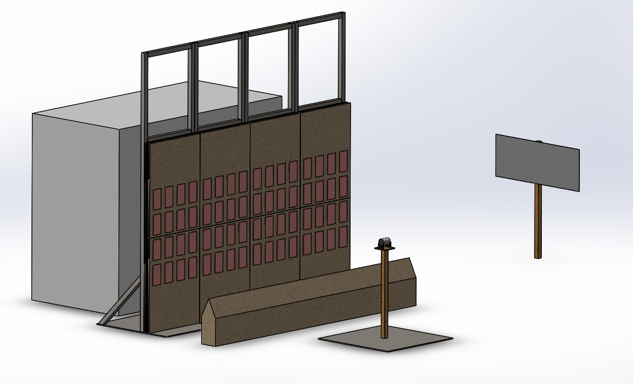Figure 1 - Trial setup overview.
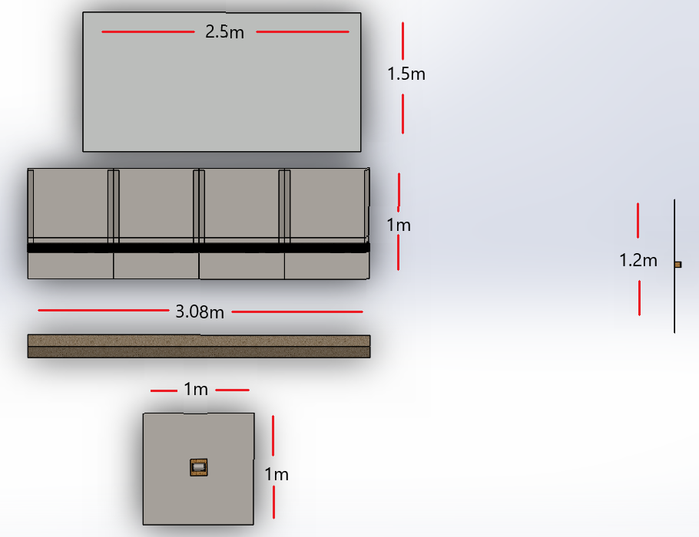
Figure 2 - Trial setup Top-Down View.
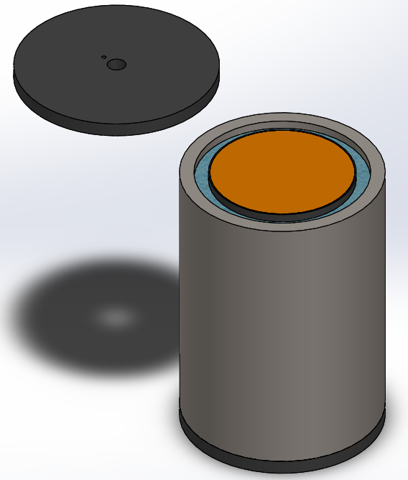Figure 3 - 10mm Water-lined munition, with the top removed.

The trial setup will aim to replicate the trial arena seen in Figures 1 and 2, by achieving the following points:
- Hand-stemming 3D-printed liners with PE4, each weighed for each munition.
- The stemmed munitions will be radiographed.
- Assembling munitions to mirror the configuration presented in Figure 3.
- Establishing a baseline performance with the first serial using no water-liner (0mm). This will provide fragmentation timings and penetration depths for immediate reference, enabling informed adjustments throughout the trial.
- Following serials will have water-liners of varying thicknesses (5mm, 7.5mm and 10mm) positioned against the HE liner.

4.4.1 Variables
Table 1 - Trial variables.
Type | Variables
Independent | Water-liner thickness.
Dependant | Fragmentation velocity.  Fragmentation size.  Depth of penetration.
Control | Explosive type (PE4).  Water.  Mass of HE.  Munition length.  Munition height above ground.  Soft-capture medium.  Detonator position and angle.  Shot height at 1.026m.

Variables to consider for this trial are displayed in Table 1.

4.5 Data Collection
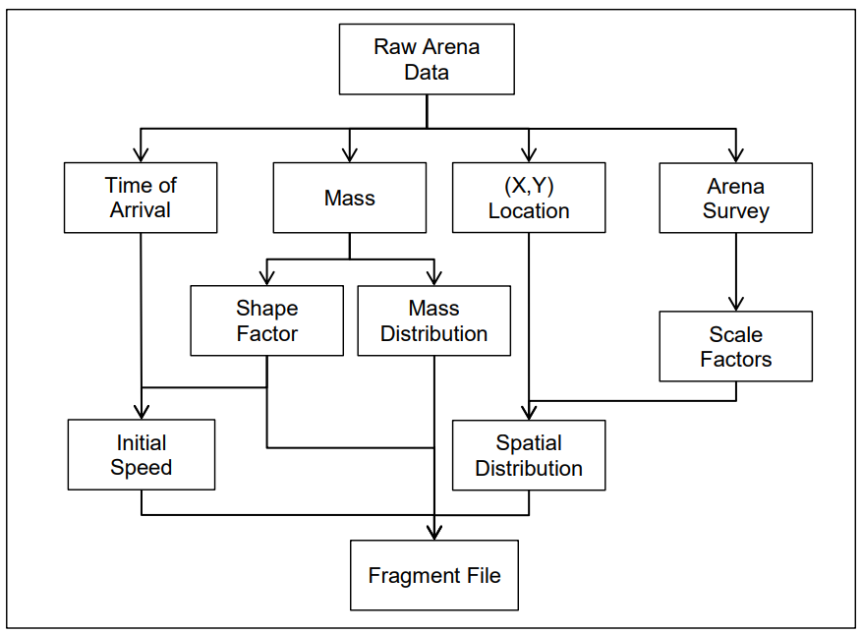
Figure 4 – Fragmentation data processing flow chart [16].
Table 2 – Instrumentation list.
Instrumentation | Description
Ionisation probes | Providing a time ‘zero’ to use as a reference for make-foil timings.
Make-foil timings | Allowing the time of flight of fragments to be known, and a subsequent average fragment velocity to be calculated over a known distance.
Depth of penetration | A Soft-capture medium will arrest fragments, and the depth of penetration will correlate to the impact energy of fragments.
Recovered fragmentation | The size, mass and geometry of fragments will provide information about the case break-up.
HSDV | This will show close-up images of the munition and flight path of some fragments, confirming approximate fragment velocities. However, there is a possibility of the camera being overexposed and suffering from a ‘white out’.
Static X-Rays | Allowing analysis of the hand-stemmed munitions to check for voids and uniformity of the HE density.

The trial will use instrumentation detailed in Table 2 and data processing will follow a similar procedure to the one outlined in Figure 4.

4.6 Risks & Limitations

4.6.1 Risks
There is the opportunity for significant physical harm to the investigator and associated personnel, as the trial involves the risks of handling explosives and the use of ionising radiation. However, comprehensive trial documentation will be adhered to mitigate the identified risks and comply with industry regulations for each activity.

4.6.2 Limitations
A key limitation is the non-homogeneous HE within the munitions. This is due to hand-stemming being used over costly melt-casting methods. A minor limitation is the likelihood of overexposing the HSDV, compromising analysis.

4.7 Ethical Issues
The research is classified as low ethical risk. No live subjects will be tested, nor will any personnel or sensitive data be collected or stored (Appendix C).

5.0 Resources & Planning
In this section, the resources described in Tables 3, 4 and 5 have been approved to progress with the proposed research.

5.1 Resources Required

5.1.1 Physical Resources
Table 3 - Physical resources list.
Equipment | Description
Explosives | PE4 (1.18kg)
Munition Assembly (Figure 3) | Comprised of: Plastic base, 10mm steel fragmentation jacket, water liner, 3D-printed HE liner, HE, Plastic top (4 munitions).
Strawboard Stands (Appendix A) | To suspend soft-capture mediums at the correct height and position (0.77mx1mx3m) (4 stands).
Baseplate (Appendix B) | Protecting the ground directly beneath the munition from fragment strikes. (1mx1mx0.01m steel) (1 baseplate).
Munition Stands | To position the munition at the arena centre at a height of 1.026m (4 stands).
Sandbags | Enabling a ricochet stop to be constructed from absorbing materials (100 sandbags).
Camera hide | Protecting the HSDV camera from fragmentation and environmental effects. Additionally, housing the logic analyser system (1 hide).
Mirror | Which allows the HSDV camera to be operated out of ‘line-of-sight’ to the munition. A front surface mirror will be used to reduce parallax errors (1.2mx0.45m) (4 mirrors).
HSDV camera | An HSDV camera capable of 100’000 FPS (Phantom TMX 6410) (1 camera).
X-Ray system | To check for voids and uniformity in HE density (XR200 Pulsed X-ray system) (1 X-Ray system).
Logic analyser | To capture and record ionisation probes and fragment strikes, providing timing information (1 logic analyser).
Make-foils | A5-sized make-foils, when a fragment strikes and closes an electrical circuit, allowing +5v to pass through the wires back to the logic analyser (170 foils).
Ionisation probes | This enables the ionisation cloud to be detected, which is characteristic of an explosive event (4 probes).
Soft-capture medium (Strawboard) | Facilitates the capture of fragments, providing spatial, energy, mass, size and geometry information of individual fragments (640 sheets).

5.1.2 Human Resources
Table 4 - Human Resources.
Staff | Responsibilities | Duration
Trials conducting officer | Oversee the safe conduct of the trial’s activities. | 2 Days
Senior instrumentation technician | Set up data capture equipment, capture associated data and provide data processing. | 2 Days
X-Ray operator | Ensuring the safe operation of ionising radiation to capture data. | 2 Days
Range staff | Construct the trial set-up and provide range ‘sentry’ duties during firings. | 2 Days

5.1.3 Additional Resources
Table 5 - Additional resources
Resource | Duration
Range Hire | 2 Days

5.2 Gantt Chart
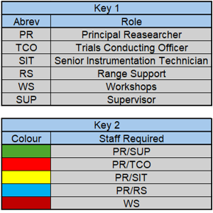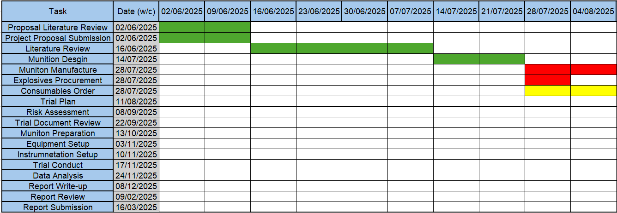
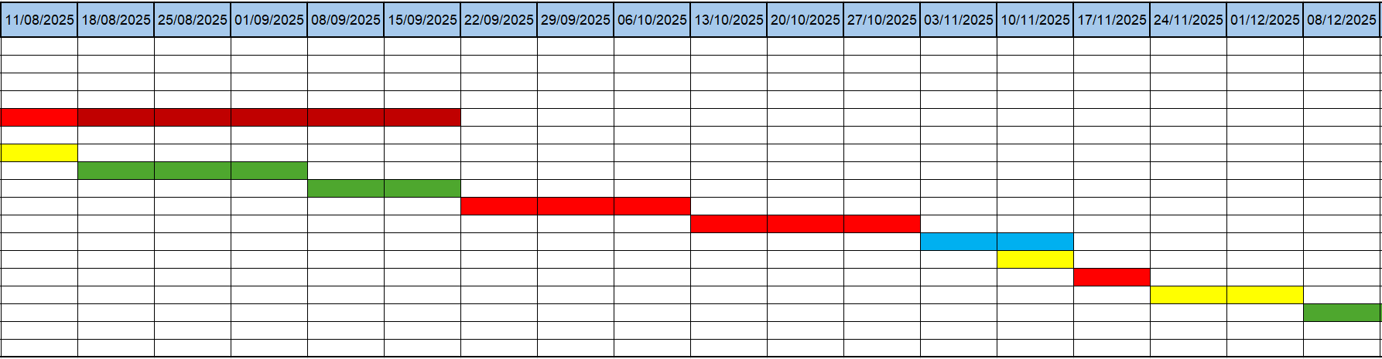
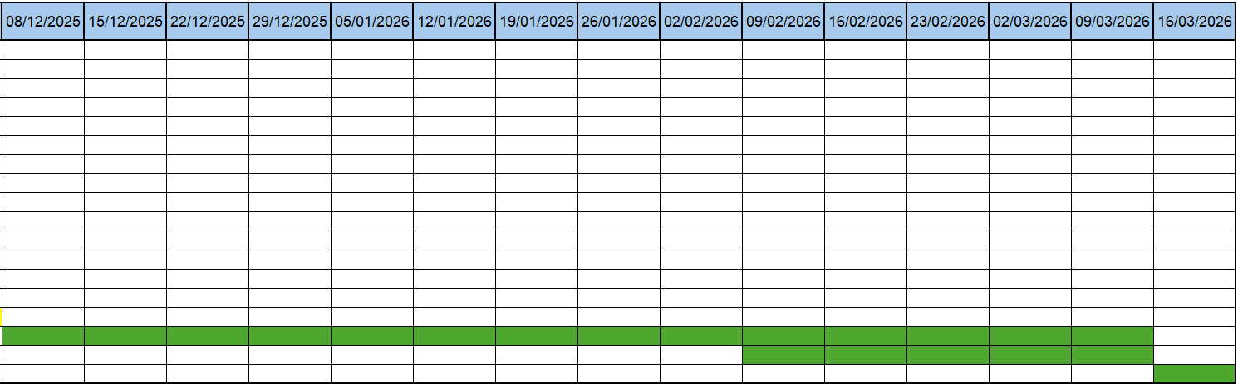
Figure 5 – Project Gantt chart.

The timeline of this project is displayed in the above (Figure 5).

6.0 References

[1] | NATO, AOP-39, Policy For Introduction and Assessment of Insensitive Munitions (IM), D ed., NATO Standardization Office (NSO), 2022.
[2] | NATO Standardization Office (NSO), NATO Standardization Agreement (STANAG) 4439, Policy for Introduction and Assessment of Insensitive Munitions (IM), Brussels, 2010.
[3] | L. Chen, L. Zhang, Q. Fang and Y.-m. Mao, “Performance based investigation on the construction of anti-blast water wall,” International Journal of Impact Engineering, vol. 81, pp. 17-33, 2015.
[4] | h. Bornstein, S. D. Placido, A. C. Orifici and A. P. Mouritz, “Effect of Standoff on Near-Field Blast Mitigation Provided by Water-Filled Containers,” in Design and Analysis of Protective Structures (DAPS), Melbourne, 2017.
[5] | R. L. Bauer, T. B. Friedrich and C. E. Johnson, “Application of Gurney and Flight of Fragment Calculations for Water Jet Velocities in Explosive Applications,” Defence Technology, 2025.
[6] | J. Simon, “The Effect of Explosive Detonation Characteristics on Shaped Charge Performance,” 1974.
[7] | S. Alford, “Device and Methid for Generating A Liquid Jet of Very High Velocity”. GB Patent 2292445: GB2292445B, 1982.
[8] | R. Alford, R. Hazel and R. Critchley, “Are Low-Yeild Explosive Ordnance Disposal Methods Viable?,” IMCSE Technical Publication Series , Swindon, 2022.
[9] | R. L. Bauer, P. Pitzel, E. M. Johnson and C. E. Johnson, “Water-Cased Kicker Charges for Use in Explosive Demolition,” Buildings, vol. 13, no. 378, 2023.
[10] | S. Salter and J. Parkes, “Why is Water so Efficient at Suppressing the Effects of Explosions?,” The Journal of Conventional Weapons Destruction, vol. 22, no. 6, pp. 56-59, 2018.
[11] | R. H. Cole, Underwater Explosions, Princeton University Press, 1948, pp. 5-10.
[12] | R. W. Gurney, “The Initial Velocities of Fragments from Bombs,” Army Ballistic Research Laboratory, 1943.
[13] | Department of Homeland Security, IED Attack - Improvised Explosive Devices, 2024.
[14] | D. Corredor, J. Duchicela, F. J. Flores, M. Maya and E. Guerron, “Review of Explosive Contamination and Bioremediation: Insights from Microbial and Bio-Omic Approaches,” Toxics, vol. 12, no. 4, 29 March 2023.
[15] | H.-J. Ehni, “Dual use and the ethical responsibility of scientists,” Institute of Ethics and History of Medicine, 30 May 2008.
[16] | ARSP-03 Volume II, Guidance On the Development of Weapon Danger Areas/Zones - Data Acquisition and Analysis - Fragmenation Data, Brussels: NATO Standardization Office (NSO), 2020.

7.0 Appendix

Appendix A

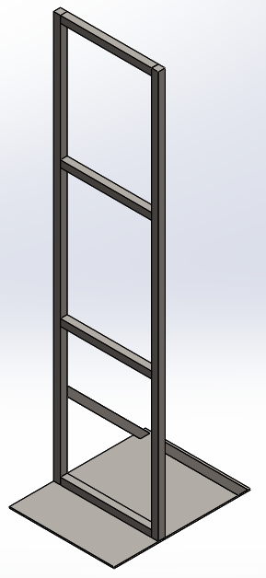
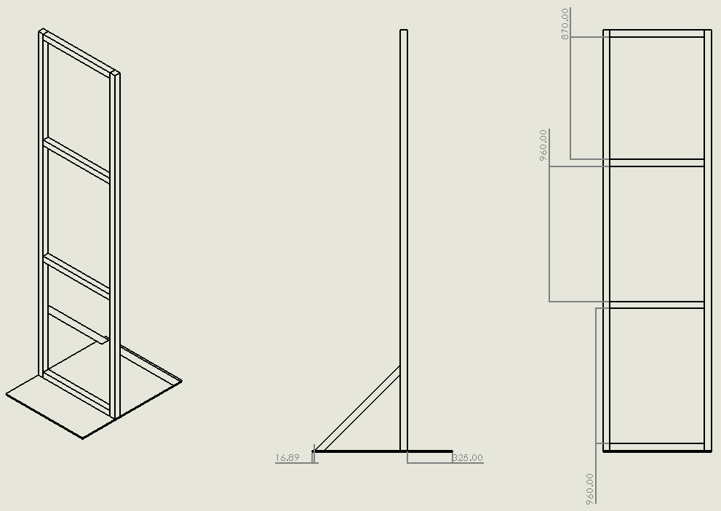

Appendix B
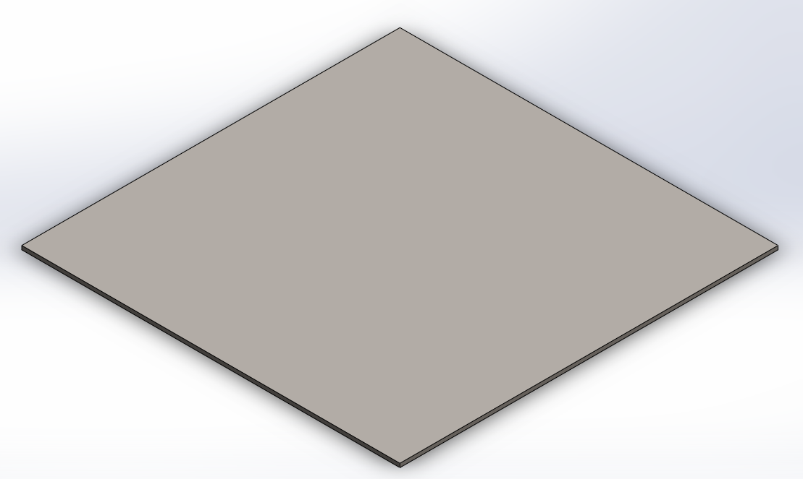

Appendix C


