DS 1 Template

My Screenshots/Photos
- Please add 4–6 screenshots or photos of your digital life.
- You can use your phone or laptop.
- For each screenshot, write one or two sentences explaining what it shows.

Screenshot/Photo 1
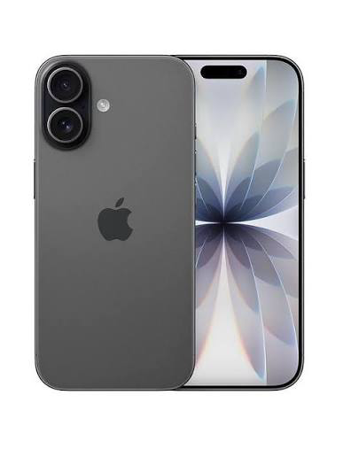
This is my phone I use it as a communication, taking photos, looking up things on the internet, I also can use it to pay for stuff whenever I want.

Screenshot/Photo 2
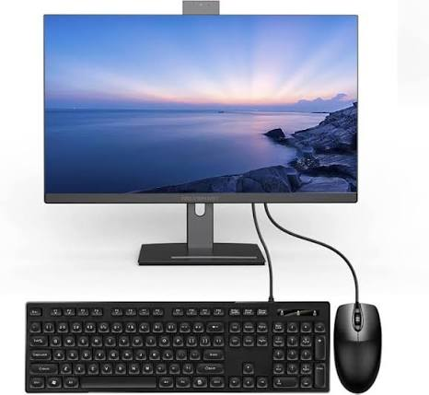
This is my pc which I use for helping with my work and playing games.
On my pc I create invoices and quotes for customers.

Screenshot/Photo 3
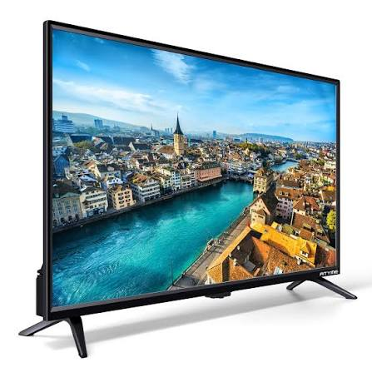
This is my tv which I use for entertainment for my children and for myself.
On this smart tv I have apps like bbc iPlayer, itv hub and Netflix

Screenshot/Photo 4
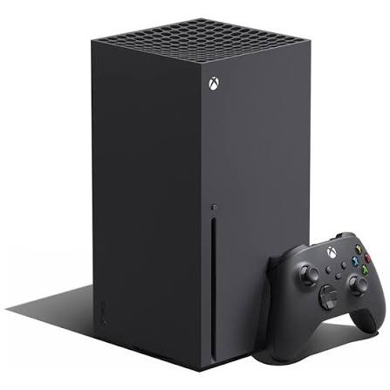

This is my Xbox I use this for fun.
I play fifa, call of duty and gta on it and also has other apps to watch things like Netflix, Disney+ and prime video.

[Insert Photo/Screenshot below]
[Write what this shows of your digital life]

Screenshot/Photo 6
[Insert Photo/Screenshot below]
[Write what this shows of your digital life]

My Short Reflection
- Write 5–8 simple sentences about your digital life.
- You can use the sentence starters below if helpful.
I use digital skills everyday in my normal life for organising my day and communicating with people. I feel confident with my digital skills because I have been using computers and phones for years. I am always using my phone everyday to communicate and playing games. Digital skills are very important in my life as without them I woudnt be able to sort my work out write invoices for customers. I hope this module will help me be quicker and more efficient than I already am at using my skills

Sentence starters
- I use digital tools to …
- I feel confident when I …
- I want to improve …
- I often use these tools: …
- I sometimes feel nervous about …
- I hope this module will help me …
- Digital skills are important for me because …
You can write more if you want.

Submission Checklist
Before you submit, please check:
​​​ ☐ I added 4–6 screenshots
☐ I wrote short sentences for each screenshot
☐ I wrote my short reflection
☐ My work is my own
☐ My file opens correctly
​​☐ My file opens correctly

