

Application of CAE Processes

Oliver Moss
2204624

Module Code: ACHA6010
Submission Deadline: 15/12/2024 (22:00)
Lecturer: Andrew Noble
Word Count: 2779
1. Contents
1. Contents…………………………………………………………………..1
2. Introduction………………………………………………………………3
3. Methodology……………………………………………………………...4
3.1. Project Methodology………………………………………………4
3.2. FEA Methodology…………………………………………………5
3.2.1. Engineering Data…………………………………………...5
3.2.2. Rigid Dynamics…………………………………………….5
3.2.3. Steady-State Thermal………………………………………6
3.2.4. Static Structural…………………………………………….7
4. Ansys FEA Validation……………………………………………………8
4.1. Bimetallic Strip……………………………………………………8
4.2. Point Load on Cantilever Beam………………………………….11
4.3. Pressure Load on Cantilever Beam………………………………12
5. Piston Mesh Study………………………………………………………15
5.1. 0.1m Mesh Study…………………………………………………15
5.2. 0.001 Mesh Size………………………………………………….17
5.3. Varied Mesh Size………………………………………………...17
6. Material Selection……………………………………………………….18
6.1. Material Strength…………………………………………………19
6.2. Material Thermal Conductivity…………………………………..19
6.3. Material Density………………………………………………….19
6.4. Material Choices…………………………………………………19
6.5. Aluminium 6061…………………………………………………24
6.6. Aluminium 2618…………………………………………………24
7. Altering Piston Design………………………………………………….25
8. FEA Limitations………………………………………………………...27
8.1. Validation………………………………………………………...27
8.2. Prediction………………………………………………………...27
8.3. Modelling Complexity…………………………………………...27
8.4. Computing Process……………………………………………….27
8.5. Simplified Geometry……………………………………………..28
8.6. Human Error……………………………………………………...28
9. Conclusion………………………………………………………………29
10. References………………………………………………………………30
11. Appendix………………………………………………………………..32

Table 1 - Validation Scenarios 5
Table 2 - Bimetallic Strip Data 9
Table 3 - Bimetallic Strip Deformation for Different Mesh Sizes 10
Table 4 - Point Load Cantilever Beam Deflection 11
Table 5 - Pressure Load on Cantilever Beam Data (Dlubal,2022) 13
Table 6 - Deflection & Stress on Cantilever Beam for Pressure Load 13
Table 7 - Properties of Aluminium 6061 (Ansys Granta, 2022) 20
Table 8 - Properties of Aluminium 2618 (Ansys Granta, 2022) 22

Figure 1 - Bimetallic Strip Load Case (Dlubal,2018) 5
Figure 2 - Point Load Cantilever Beam Load Case (Dlubal, 2015) 5
Figure 3 - Pressure Load Cantilever Beam Load Case (Dlubal, 2022) 5
Figure 4 - Piston Assembly 6
Figure 5 - Rigid Dynamics Scenario in Workbench 7
Figure 6 - Thermal Study Boundary Conditions 8
Figure 7 - Fixed Supports Applied to Pin Bore 8
Figure 8 - Full Workbench Layout for Simulations 8
Figure 9 - Bimetallic Strip Deformation Difference to Dlubal Valid Results for Different Mesh Sizes 10
Figure 10 - Bimetallic Strip Deformation - 0.0001m Run 11
Figure 11 - Bimetallic Strip Example (University of Cambridge, n.d.) 11
Figure 12 - Deflection Difference for Point Load on Cantilever Beam 12
Figure 13 - Point Load Cantilever Z Deflection - 0.005m 12
Figure 14 - Point Load Cantilever X Deflection - 0.005m 12
Figure 15 - Difference to Valid Results for Different Mesh Sizes for Cantilever Beam with Pressure 14
Figure 16 - 0.1m Mesh Size - Isometric View 15
Figure 17 - 0.1m Mesh Size - Front View 15
Figure 18 - 0.1m Mesh Deformation - Isometric Top View 16
Figure 19 - 0.1m Mesh Deformation - Top View 16
Figure 20 - 0.1m Mesh Deformation- Isometric Bottom View 16
Figure 21 - 0.1m Mesh Stress - Isometric Top View 16
Figure 22 - 0.1m Mesh Stress - Bottom View 16
Figure 23 - 0.1m Mesh Stress - Isometric Bottom View 16
Figure 24 - 0.001m Mesh Size - Isometric View 16
Figure 25 - 0.001m Mesh Size - Front View 16
Figure 26 - 0.001m Mesh Deformation - Isometric Top View 17
Figure 27 - 0.001m Mesh Deformation - Top View 17
Figure 28 - 0.001m Mesh Deformation - Isometric Bottom View 17
Figure 29 - 0.001m Mesh Stress - Isometric Top View 17
Figure 30 - 0.001m Mesh Stress - Bottom View 17
Figure 31 - 0.001m Mesh Stress - Isometric Bottom View 17
Figure 32 - Varied Mesh Size – Isometric Top View 17
Figure 33 - Varied Mesh Size - Isometric Bottom View 17
Figure 34 - Varied Mesh Deformation - Isometric Top View 18
Figure 35 - Varied Mesh Deformation - Top View 18
Figure 36 - Varied Mesh Deformation - Isometric Bottom View 18
Figure 37 - Varied Mesh Stress - Isometric Top View 18
Figure 38 - Varied Mesh Stress - Bottom View 18
Figure 39 - Varied Mesh Stress - Isometric Bottom View 18
Figure 40 - Aluminium's 6061 Young's Modulus for Varying Temperatures (Ansys Granta, 2022) 21
Figure 41 - Aluminium's 6061 Fatigue Strength for Varying Temperatures (Ansys Granta, 2022) 21
Figure 42 - Aluminium 2618 Young's Modulus for Varying Temperature (Ansys Granta, 2022) 22
Figure 43 - Aluminium 2618 Fatigue Strength for Varying Temperatures (Ansys Granta, 2022) 23
Figure 44 - Aluminium 2618 Deflection - Isometric Top View 23
Figure 45 - Aluminium 2618 Deflection - Top View 23
Figure 46 - Aluminium 2618 Deflection - Isometric Bottom View 23
Figure 47 - Aluminium 2618 Stress - Isometric Top View 23
Figure 48 - Aluminium 2618 - Bottom View 23
Figure 49 - Aluminium 2618 - Isometric Bottom View 23
Figure 50 - Section View of Stresses Overlayed onto CAD Model 24
Figure 51 - Altered Piston 24
Figure 52 - Altered Piston Head Deformation - Isometric Top View 24
Figure 53 - Altered Piston Head Deformation - Top View 24
Figure 54 - Altered Piston Head Deformation - Isometric Bottom View 24
Figure 55 - Altered Piston Head Stress - Isometric Top View 24
Figure 56 - Altered Piston Head Stress - Top View 24
Figure 57 - Altered Piston Head Stress - Isometric Bottom View 24
Figure 58 - Metals Properties Graph 32

2. Introduction
Material properties are a crucial factor to any assembly of a part, and this is why extensive time has been spent researching and testing these materials as they become the main contributor to both the part’s, fatigue/life cycle and its performance. This is where Finite Element Analysis (FEA) becomes a crucial part to the development of a part as it can help to analyse the best material for the environment it will experience. Before the development of Finite Element Analysis engineers had to use specific equations as well as physical testing to measure the likelihood of failure which was both time consuming and costly whereas FEA was a cheaper, quicker alternative that was also more reliable as it reduced the likelihood of human error. Once the material was chosen, FEA could be used to correct the part itself to, usually, either increase performance or reduce risk of failure.

3. Methodology
3.1. Project Methodology
This report aims to highlight the importance and effectiveness of FEA as well as its reliability. This will be done by, firstly, validating FEA results to handwritten equations, that are fundamentally used, for common load case scenarios. These include:
Load Case Scenario | Validation | Image
Bimetallic Strip | Validates Thermal Load Cases | 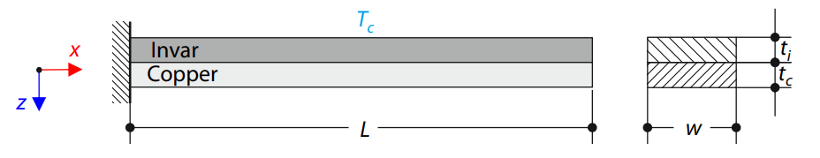  Figure 1 - Bimetallic Strip Load Case (Dlubal,2018)
Point Load Cantilever Beam | Validates Static Structural Load Cases for Point Loads | 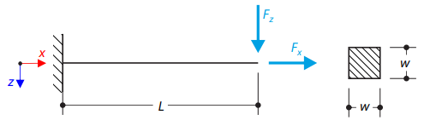  Figure 2 - Point Load Cantilever Beam Load Case (Dlubal, 2015)
Applied Pressure Cantilever Beam | Validate Static Structural Load Cases for UDL Pressures | 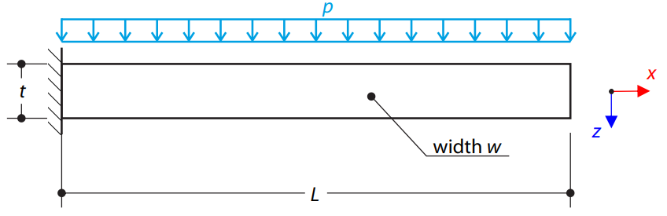  Figure 3 - Pressure Load Cantilever Beam Load Case (Dlubal, 2022)
Table 1 - Validation Scenarios
From this FEA can then be reliably used to optimise a piston head as part of a 2L Ford Duratec piston assembly as shown in Figure 4.
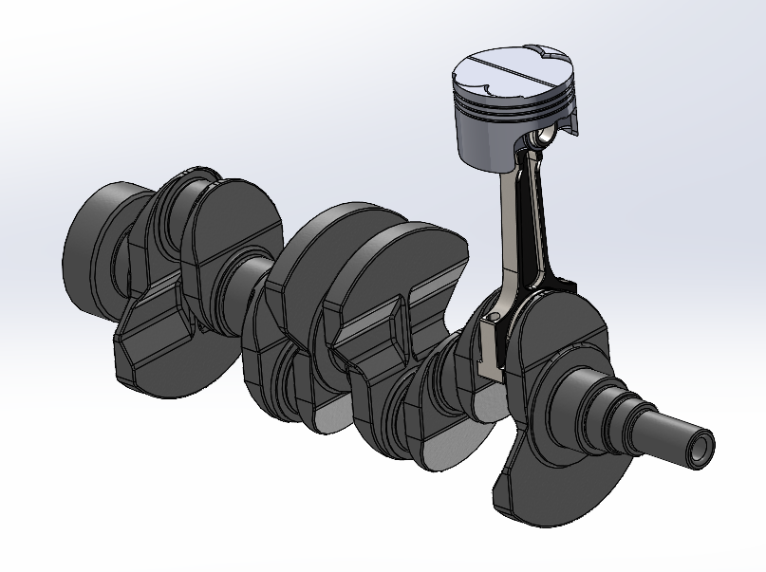
Figure 4 - Piston Assembly
3.2. FEA Methodology
The overall aim is to analyse the stress and deformation that the piston head produces when under common engine loadings. These forces can be split into 3 different load cases:
- Rigid Dynamics – Forces applied due to motion
- Steady-State Thermal – Temperatures due to Thermal Loadings
- Static Structural – All forces applied to the piston
3.2.1. Engineering Data
Before any load case can be simulated, all engineering data of each material can be inputted because, in each load case, it only requires the data needed for that load case and not the other load cases. All the material data used was sourced from Ansys Granta,(2022), which is a reliable material database made by Ansys so it is easily transferable to an Ansys Workbench.
3.2.2. Rigid Dynamics
This scenario calculates all the forces that the pin bore will experience due to the rotation of the crankshaft. After linking the engineering data to the rigid dynamics, as shown in Figure 5, the geometry can be imported as a step file. Once the model is opened, materials are assigned to each part, making sure all parts are rigid, and the joints are made. Then an angular velocity, which in this case is 6500rpm, is input onto the crankshaft and the forces on the pin bore, for a set time, is recorded. The peak force the pin bore experiences is then exported as a motion load and imported into a static structural study. In this case the angular velocity is 6500rpm as this is where peak pressure was taken at, and it is peak engine speed for a 1.6L Ford Sigma which this assembly is similar to. The peak force is exported.
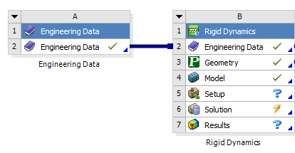
Figure 5 - Rigid Dynamics Scenario in Workbench
3.2.3. Steady-State Thermal
This simulation focuses on the temperatures throughout the piston when a thermal load is applied to the crown. Linking the engineering data and geometry, every part excluding the piston head is supressed and the piston is made flexible. Then, using the boundary conditions shown in Figure 6 which was found by taking an average from multiple sources, the heat transfer coefficient and corresponding temperature are input onto the model. This is where an actual mesh is required which in this case is 0.0005m for the crown and bottom of the piston head and then 0.005m for the rest of the piston. Then the simulation is run and the temperature throughout is recorded.
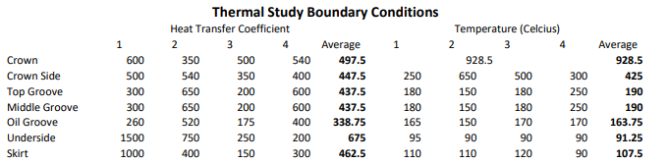
Figure 6 - Thermal Study Boundary Conditions
3.2.4. Static Structural
This is where all forces are applied to the piston head along with extra load cases. With the motion loads already imported, the thermal results can be attached as well as a fixed support, shown in Figure 7, and a pressure of 6.7914x10⁶ Pa applied to the crown, which is peak pressure at 6500rpm.
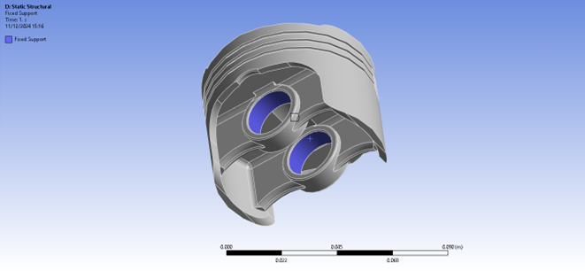
Figure 7 - Fixed Supports Applied to Pin Bore
The workbench should look like Figure 8 and then the simulation can then be run. Total deformation and equivalent stress can be recorded and used to analyse the piston’s behaviour.
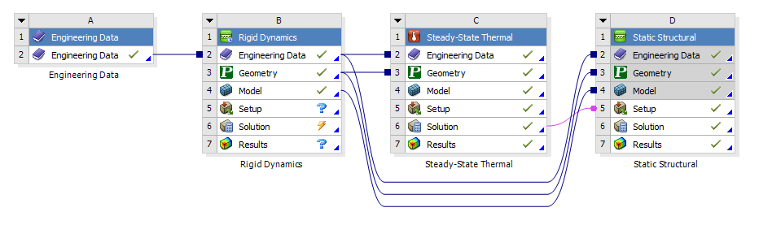
Figure 8 - Full Workbench Layout for Simulations

4. Ansys FEA Validation
Each load case was simulated and compared to Dlubal’s verification examples as they are a reliable source for validation.
4.1. Bimetallic Strip
In this scenario, 2 different materials are bonded together, Invar, an alloy of Iron, and Copper, and then this strip is fixed at one end. Then a temperature is applied all-round and, due to Invar having a lower coefficient of thermal expansion, The Invar has more mechanical deformation resulting in the beam bending as shown in Figures 10 & 11. This max deflection can be calculated and compared to Ansys’ results as shown below. While stress throughout the beam can be calculated using Ansys, it is hard to validate against handwritten equations as it is very complex. Therefore, to create any simple calculations, many assumptions have to be made as stated by Chen, F (2018).
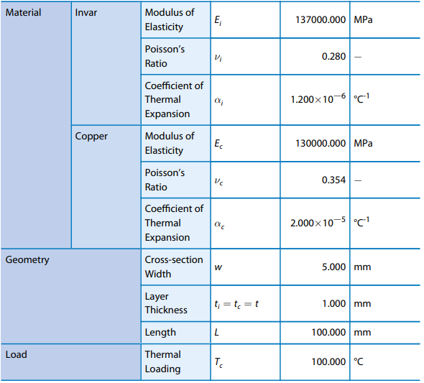
Table 2 - Bimetallic Strip Data
Dlubal, (2018) Deflection Calculation
$K_{1}=4+6\frac{t_{c}}{t_{i}}+4{\left(\frac{t_{c}}{t_{i}}\right)}^{2}+\frac{E_{c}}{E_{i}}{\left(\frac{t_{c}}{t_{i}}\right)}^{3}+\frac{E_{i}t_{i}}{E_{c}t_{c}}$
${u_{z}}_{max}=\frac{6\left(α_{i}-α_{c}\right)\left(t_{i}+t_{c}\right)T_{c}}{t_{s}^{2}K_{1}}×\frac{L^{2}}{2}$
${u_{z}}_{max}≈-7.049mm$
Dlubal results are compared to Ansys’ results below.
Mesh Size | Deflection (m) | Delta %
0.0025 | 7.1219 | 1.034
0.002 | 7.1224 | 1.041
0.0015 | 7.1228 | 1.047
0.001 | 7.1233 | 1.054
0.0009 | 7.1239 | 1.063
0.0008 | 7.1237 | 1.060
0.0007 | 7.1235 | 1.057
0.0006 | 7.1233 | 1.054
0.0005 | 7.123 | 1.050
0.0004 | 7.1221 | 1.037
0.0003 | 7.1215 | 1.029
0.0002 | 7.121 | 1.021
0.0001 | 7.1203 | 1.011
Table 3 - Bimetallic Strip Deformation for Different Mesh Sizes
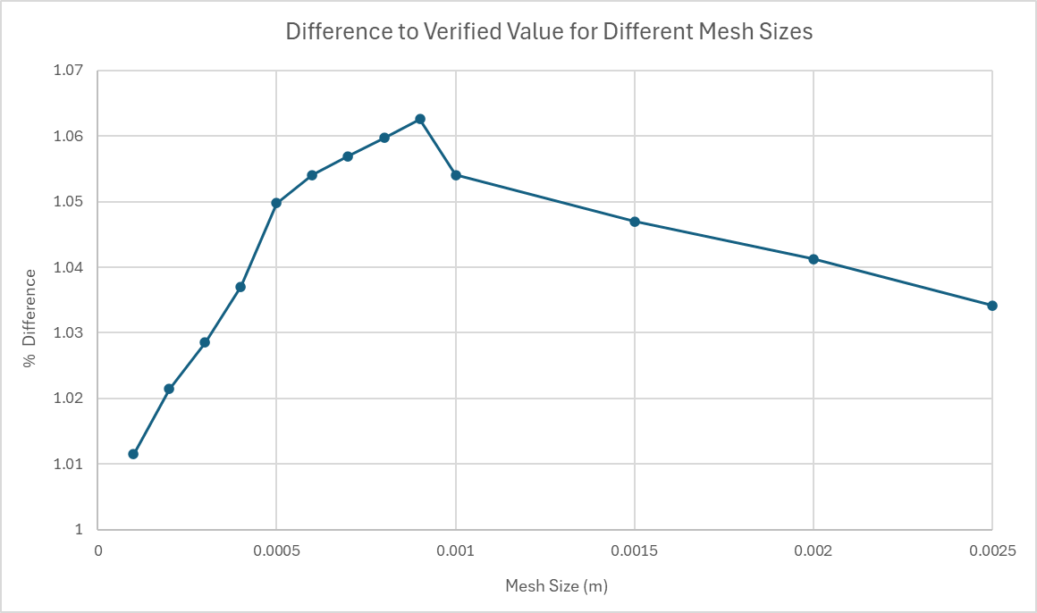
Figure 9 - Bimetallic Strip Deformation Difference to Dlubal Valid Results for Different Mesh Sizes
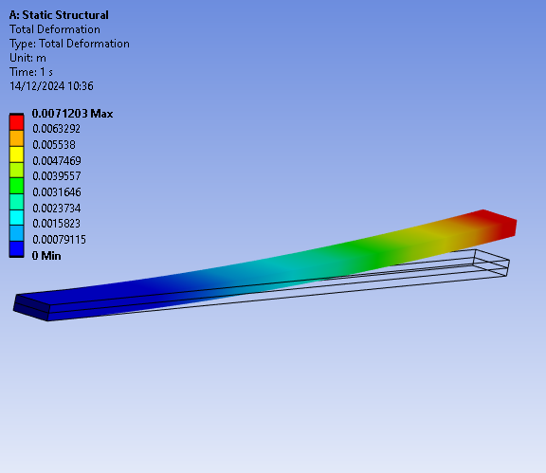  Figure 10 - Bimetallic Strip Deformation - 0.0001m Run | 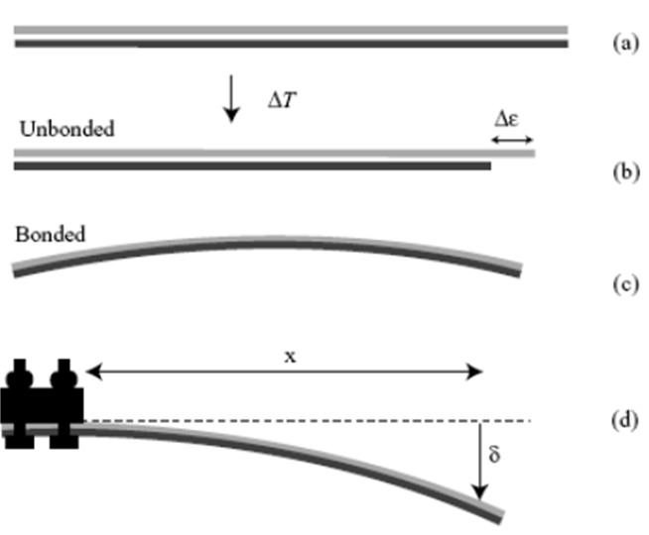  Figure 11 - Bimetallic Strip Example (University of Cambridge, n.d.)
4.2. Point Load on Cantilever Beam
For this a long steel beam is fixed at one end and then, at the other end, a force is applied down on the beam of 7650N as well as a pulling force of 1600N in the X direction to stretch the material as seen in Figure 2. A validation can then be made for deflection in the Z and X axis. It is important to note an average deflection in the X axis was used as the end face will pivot, as seen in Figure 14, meaning resultant deflection will be in the center of the face which is the average between maximum and minimum deflection.
${u_{x}}_{max}=\frac{F_{x}L}{EA}=\frac{1600×10}{2.1×{10}^{11}×{\left(0.08\right)}^{2}}=1.2×{10}^{-5}m=0.012mm$
$I_{y}=\frac{w^{4}}{12}=\frac{{\left(0.08\right)}^{4}}{12}=3.143×{10}^{-6}$
${u_{z}}_{max}=\frac{F_{z}L^{3}}{3EI_{y}}=\frac{7650×{\left(10\right)}^{3}}{3×2.1×{10}^{11}×3.143×{10}^{-6}}=3.5575m=3557.5mm$
Mesh Size (m) | Z Deflection (m) | Delta % | X Deflection (m) | Delta %
0.079 | 3.555 | 0.069656 | 1.2152x10⁻⁵ | 1.266667
0.05 | 3.5549 | 0.072467 | 1.2135x10⁻⁵ | 1.125
0.025 | 3.5555 | 0.055601 | 1.21x10⁻⁵ | 0.833333
0.01 | 3.5556 | 0.05279 | 1.2064x10⁻⁵ | 0.533333
0.0075 | 3.5557 | 0.049979 | 1.2045x10⁻⁵ | 0.375
0.005 | 3.5558 | 0.047168 | 1.2028 x10⁻⁵ | 0.233333
0.079 | 3.555 | 0.069656 | 1.2152x10⁻⁵ | 1.266667
Table 4 - Point Load Cantilever Beam Deflection
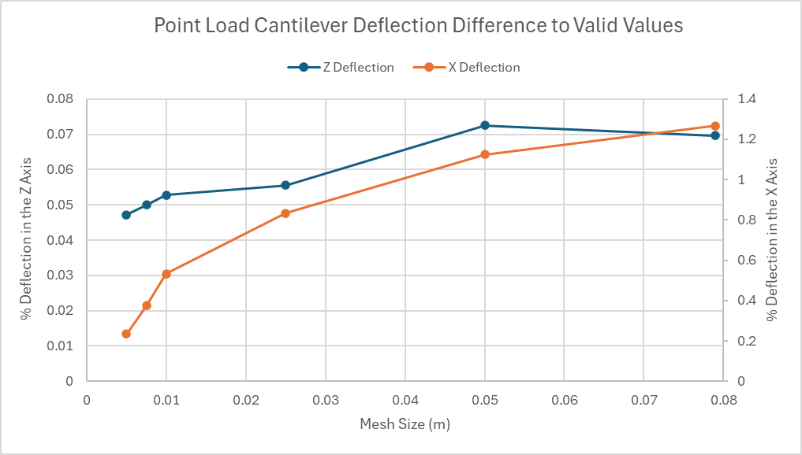
Figure 12 - Deflection Difference for Point Load on Cantilever Beam
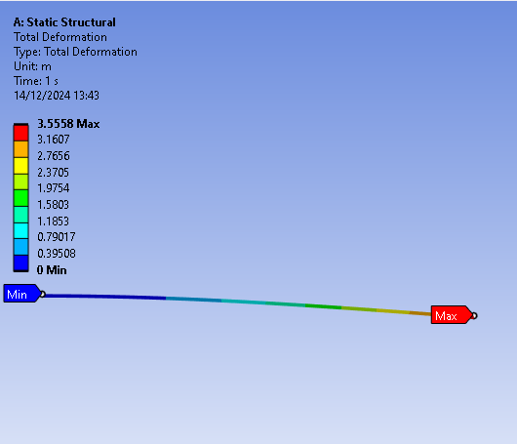  Figure 13 - Point Load Cantilever Z Deflection - 0.005m | 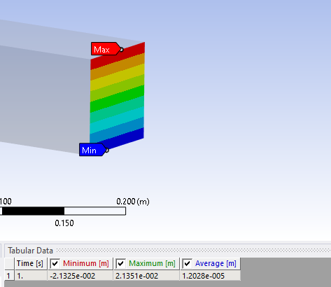  Figure 14 - Point Load Cantilever X Deflection - 0.005m
4.3. Pressure Load on Cantilever Beam
For this a thin plate of Elastic-Plastic material is fixed at one end and free at the other with a pressure applied along the whole beam. The max deflection and max stress through the material can then be calculated for different mesh sizes as it can affect the accuracy of the results as shown in Table 4 & Figure 12. This is an important validation as it validates pressure loading similar to that a piston’s crown experiences.
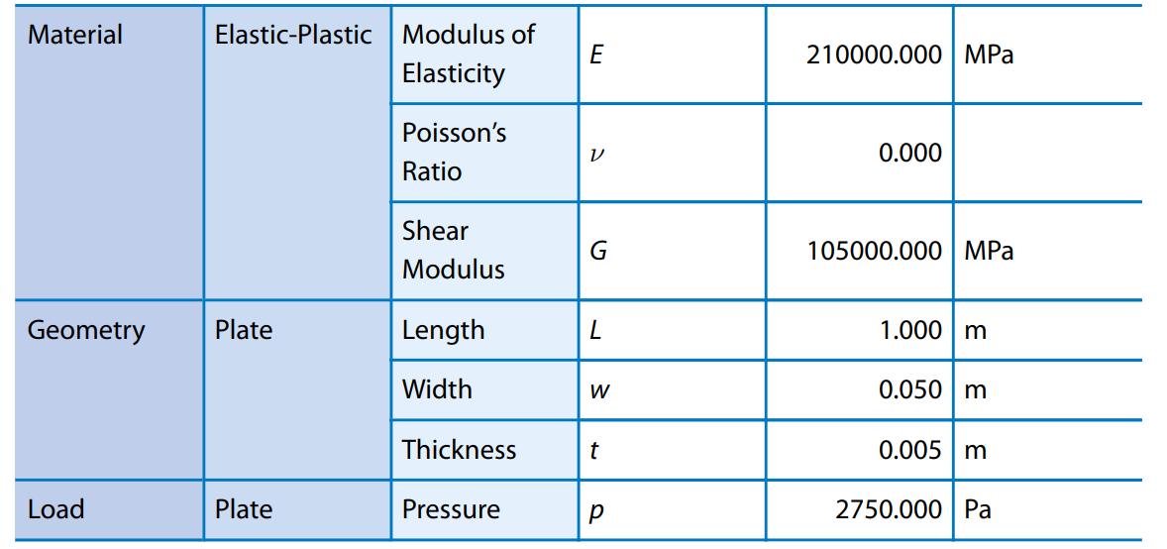
Table 5 - Pressure Load on Cantilever Beam Data (Dlubal,2022)
Max stress will occur at the fixed end of the plate meaning that;
$M_{max}=-\frac{pwL^{2}}{2}=-\frac{2750×0.05×{\left(1\right)}^{2}}{2}=-68.75Nm$
$I_{y}=\frac{wt^{3}}{12}=\frac{0.05×{\left(0.005\right)}^{3}}{12}=5.208×{10}^{-10}m^{4}$
$y=\frac{t}{2}=\frac{0.005}{2}=0.0025m$
$σ_{max}=\frac{M_{max}×y}{I_{y}}=\frac{-68.75×0.0025}{5.208×{10}^{-10}}=-3.3×{10}^{8}N/m$
Max Deflection can be calculated using;
$M=EI_{y}\frac{d^{2}u_{z}}{dx^{2}} → \iint{M} →{ u}_{z}\left(x\right)=\frac{pwx^{2}(6L^{2}-4Lx+x^{2})}{24EI_{y}}$
${u_{z}}_{max}=\frac{pwL^{4}}{8EI_{y}}=\frac{3pL^{4}}{2Ew^{2}t}=157.143mm$
Mesh Size | Deflection (m) | Delta % | Stress (N/m) | Delta %
0.01 | 0.15586 | 0.81645 | -3.3 x10⁸ | 0
0.005 | 0.15715 | 0.00445 | -3.3 x10⁸ | 0
0.004 | 0.15715 | 0.00445 | -3.3 x10⁸ | 0
0.003 | 0.15715 | 0.00445 | -3.3005 x10⁸ | 0.015
0.002 | 0.15715 | 0.00445 | -3.303 x10⁸ | 0.091
0.001 | 0.15715 | 0.00445 | -3.306 x10⁸ | 0.182
0.0005 | 0.15715 | 0.00445 | -3.309 x10⁸ | 0.273
Table 6 - Deflection & Stress on Cantilever Beam for Pressure Load
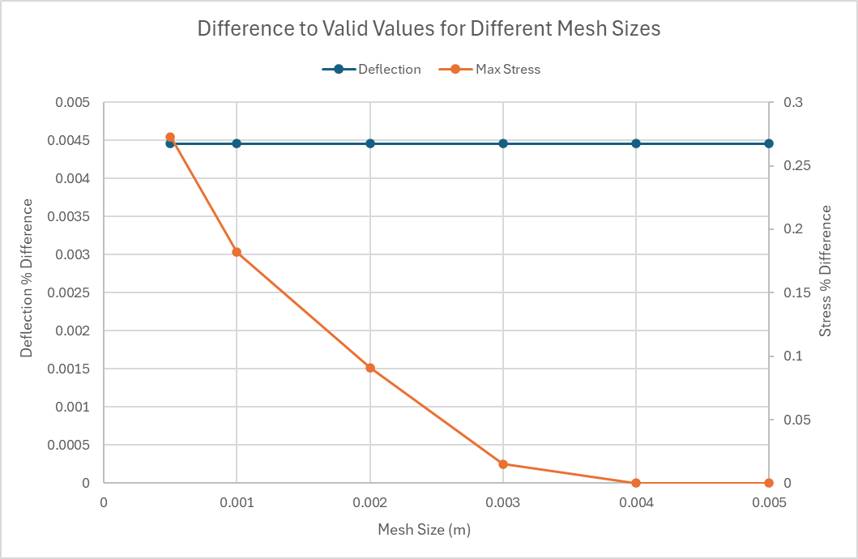
Figure 15 - Difference to Valid Results for Different Mesh Sizes for Cantilever Beam with Pressure
Interestingly, Figure 15 shows that a mesh can be too small and result in greater error. This is because, as the mesh gets finer, while the deflection stays constant, the max stress deviates further from the true value and the reason for this is explain in the next chapter.

5. Piston Mesh Size Study
Mesh sizing is a crucial part to FEA as it affects the reliability and quality of the results. A mesh size refers to the size of elements that make up a part and with each element having multiple mathematical equations being complete. Therefore, more elements results in more accurate data but a longer process time as the same equations are calculated for more elements. As well as that, a mesh can be too small and result in inaccurate data due to slight errors at each element being carried across resulting in an overall, significant deviance to actual results. This means that, there is a trade-off to find a mesh that is small to be accurate but not to small that processing time is too long for significant progress to be made.
The effect of mesh size can be applied to the piston head as well. For this, 3 mesh sizes were analysed
- 0.1m
- 0.001m
- 0.0005m
5.1. 0.1m Mesh Size
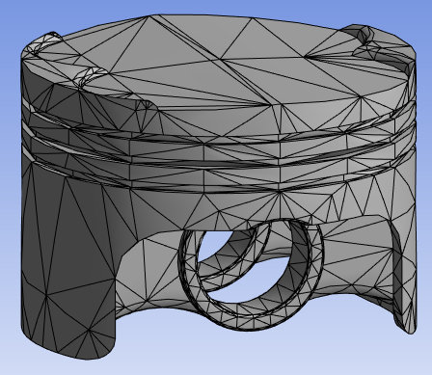  Figure 16 - 0.1m Mesh Size - Isometric View | 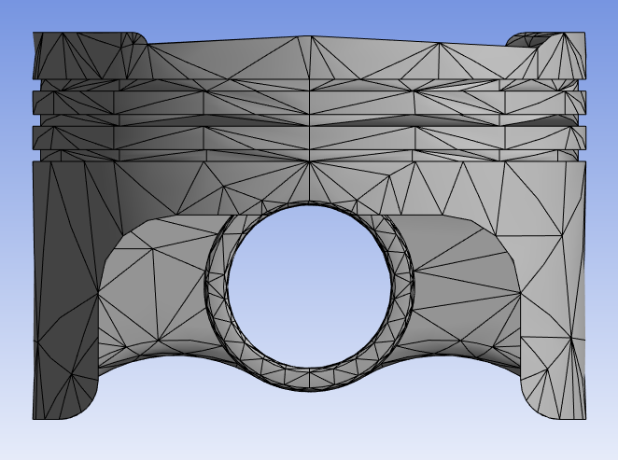  Figure 17 - 0.1m Mesh Size - Front View
From the mesh, there are already signs of problems due to the curves being jagged instead of smooth. This means that the piston isn’t being truly modelled. As well as that, with a large mesh size, each section is a lot bigger resulting in small differences in geometry being ignored. Therefore, an abundance of these could result in larger assumption being made causing a noticeable difference in overall results.
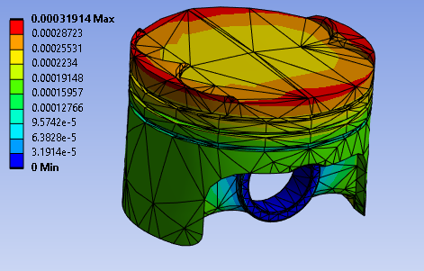  Figure 18 - 0.1m Mesh Deformation - Isometric Top View | 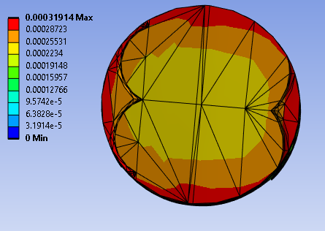  Figure 19 - 0.1m Mesh Deformation - Top View | 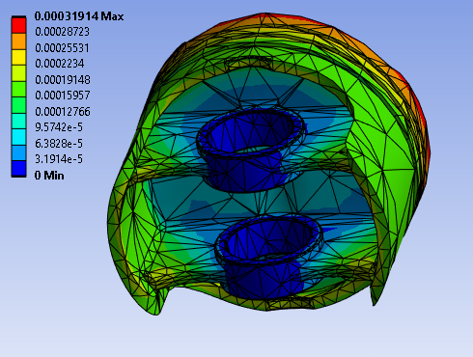  Figure 20 - 0.1m Mesh Deformation- Isometric Bottom View
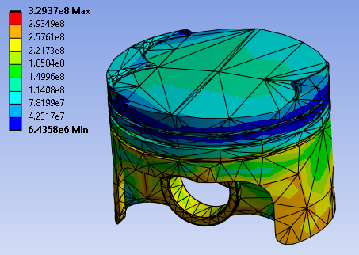  Figure 21 - 0.1m Mesh Stress - Isometric Top View | 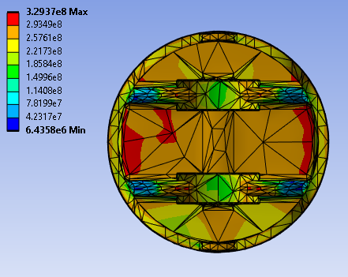  Figure 22 - 0.1m Mesh Stress - Bottom View | 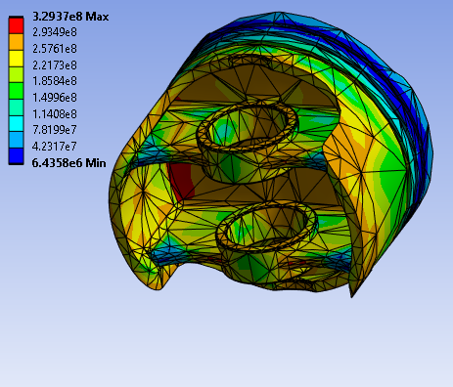  Figure 23 - 0.1m Mesh Stress - Isometric Bottom View
5.2. 0.001 Mesh Size
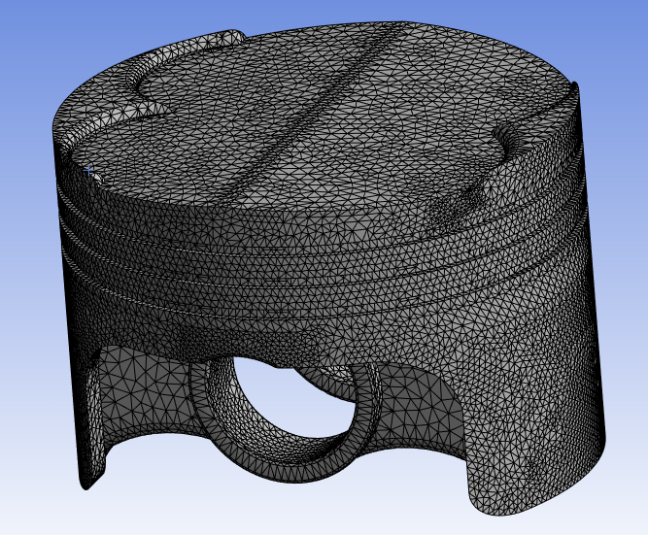  Figure 24 - 0.001m Mesh Size - Isometric View | 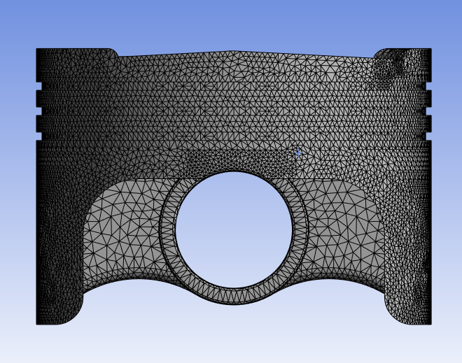  Figure 25 - 0.001m Mesh Size - Front View

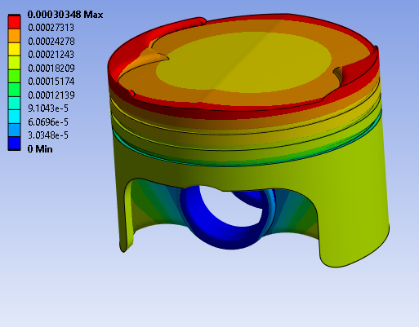  Figure 26 - 0.001m Mesh Deformation - Isometric Top View | 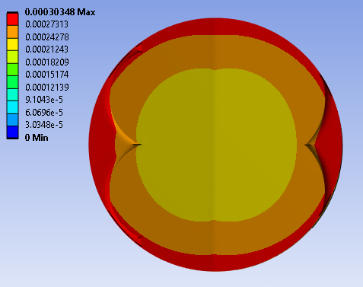  Figure 27 - 0.001m Mesh Deformation - Top View | 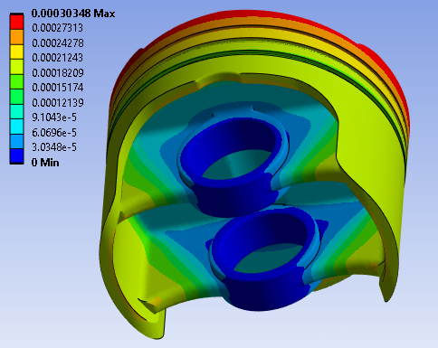  Figure 28 - 0.001m Mesh Deformation - Isometric Bottom View
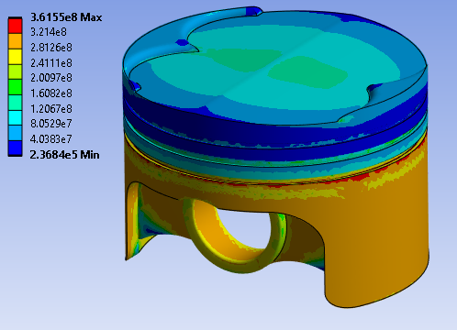  Figure 29 - 0.001m Mesh Stress - Isometric Top View | 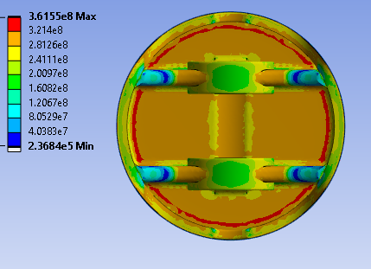  Figure 30 - 0.001m Mesh Stress - Bottom View | 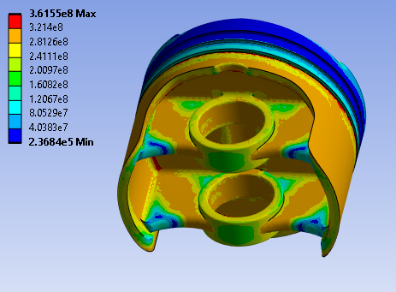  Figure 31 - 0.001m Mesh Stress - Isometric Bottom View
5.3. Varied Mesh Size
Using figures from Chapters 5.1 & 5.2, the highest deflection is around the edges of the crown, as shown in Figures 19 & 27 and the largest stresses experienced are around the underside of the piston as shown in Figures 22 & 30. This means that, the top and bottom of the piston’s head are crucial for maximum results whereas the sides are less important. Therefore, the top and bottom of the piston can have a small mesh size to increase accuracy, chosen to be 0.0005m, while the rest of the piston can have a larger mesh to decrease processing time, taken to be 0.005m.
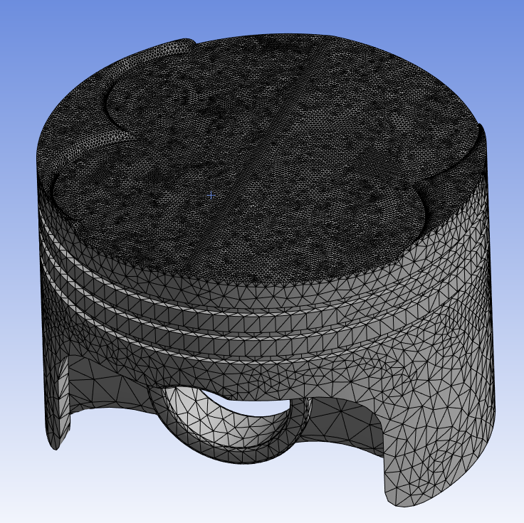  Figure 32 - Varied Mesh Size – Isometric Top View | 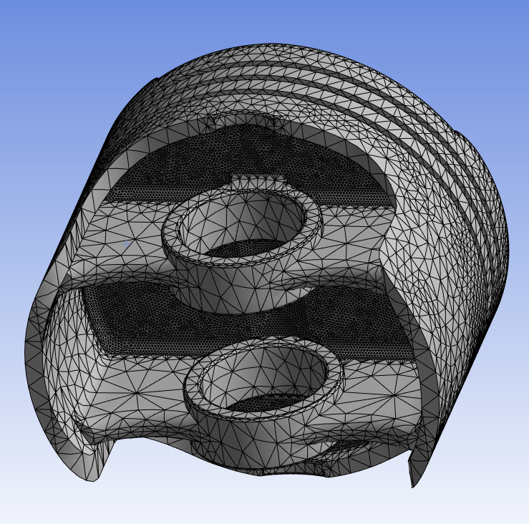  Figure 33 - Varied Mesh Size - Isometric Bottom View

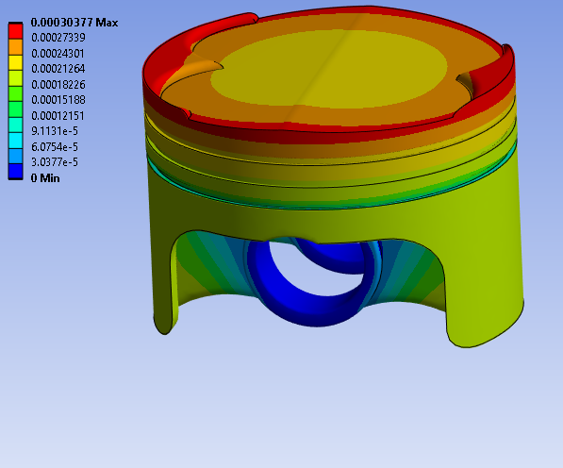  Figure 34 - Varied Mesh Deformation - Isometric Top View | 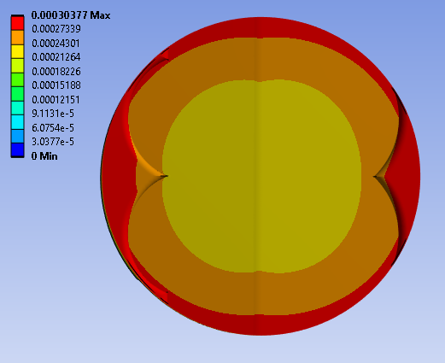  Figure 35 - Varied Mesh Deformation - Top View | 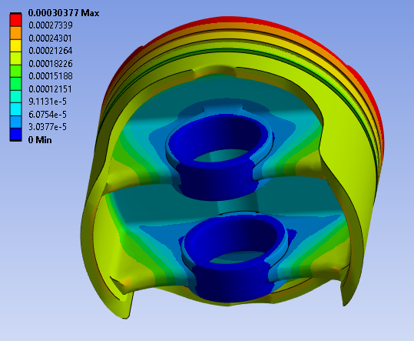  Figure 36 - Varied Mesh Deformation - Isometric Bottom View
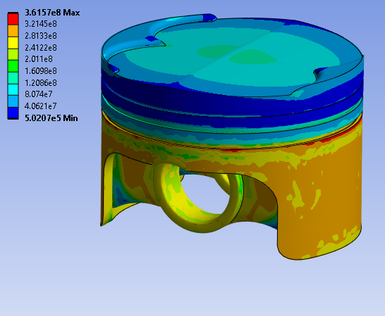  Figure 37 - Varied Mesh Stress - Isometric Top View | 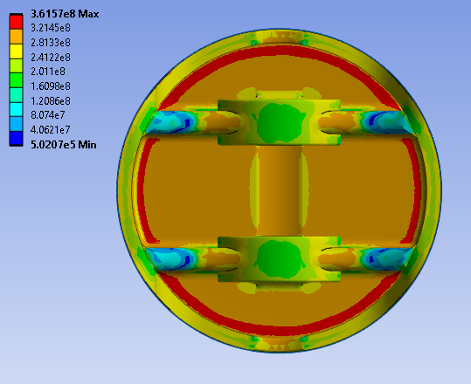  Figure 38 - Varied Mesh Stress - Bottom View | 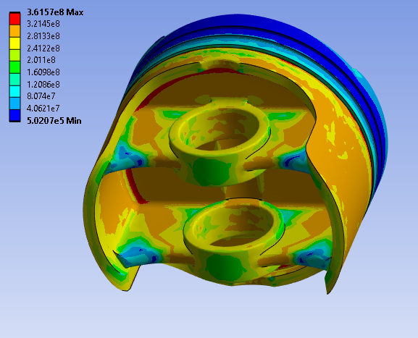  Figure 39 - Varied Mesh Stress - Isometric Bottom View

6. Material Selection
Piston material plays a crucial role in the performance of a piston. Mahle explains, in Piston and Engine testing (2016), that besides design, there are 3 important variables to a piston’s performance:
- Material Strength
- The Thermal Conductivity
- Density
6.1. Material Strength
A material’s strength can be split into static and dynamic strength, with both being an essential aspect to a piston because, as Mahle (2016) states, it can control the behaviour of the material under isothermal conditions. This is because piston’s experience changing thermal stresses due to it being exposed to heavily fluctuating temperatures. This means that piston must be able to withstand these stresses along with the constant dynamic loadings due to the engine’s cyclical motion by having a high wear resistance.
6.2. Material Thermal Conductivity
Thermal conductivity is a measure of how easy heat is transferred, therefore, Mahle (2016) believes a high thermal conductivity is desired as it causes the temperature distribution to be uniform within the piston. This is because, with a lower temperature all round benefits the filling ratio and knock limit but most importantly means greater loads can be placed on the engine because the thermal stresses experienced is decreased.
6.3. Material Density
The density of a material is always crucial for any part on a car, especially for motorsport vehicles, as a lower density, for the same sized part, results in a lower mass due to the equation below. For a piston a lower mass is beneficial as it reduces the weight of the car but more importantly reduces the inertia of the piston, reducing the stresses on the connecting rod.
$$M=ρV$$

6.4. Material Choices
Considering these variables, aluminium is the best fit for a piston’s material as it is light weight with a high thermal conductivity. Turning it into an aluminium alloy by using precipitation hardening, discovered by Wilm in 1906, helps to increase the strength of the material.
Aluminium 6061, T6 is the most commonly used material for a piston, especially for the motorsport industry, due to it meeting the requirements stated above the best, as seen in its properties in Table 7. As well as that, engine cylinders contain larger amount of oxygen and as Henan Mingtai Technology Development Co stated in 2024, 6061 is suitable for environments with high oxygen content.
Aluminium 6061 Properties
Composition Properties
Aluminium, Al | 95.8 – 98.6 %
Chromium, Cr | 0.04 – 0.35 %
Copper, Cu | 0.15 – 0.4 %
Iron, Fe | 0.15 – 0.4 %
Magnesium, Mg | 0.8 – 1.2 %
Manganese, Mn | 0 – 0.15 %
Silicon, Si | 0.4 – 0.8 %
Titanium, Ti | 0 – 0.15 %
Zinc, Zn | 0 – 0.25 %
Other | 0 – 0.15 %
Mechanical Properties
Density | 2.69x10³ – 2.73x10³ Kg/m³
Young’s Modulus, E | 66.6 – 70 GPa
Yield Strength | 240 – 280 MPa
Tensile Strength | 290 – 338 MPa
Poisson’s Ratio | 0.325 – 0.335
Thermal Properties
Melting Point | 580 – 650 ˚C
Thermal Conductivity | 152 – 169 W/m˚C
Specific Heat Capacity | 878 – 914 J/kg˚C
Thermal Expansion Coefficient | 22.7 – 23.9
Table 7 - Properties of Aluminium 6061 (Ansys Granta, 2022)
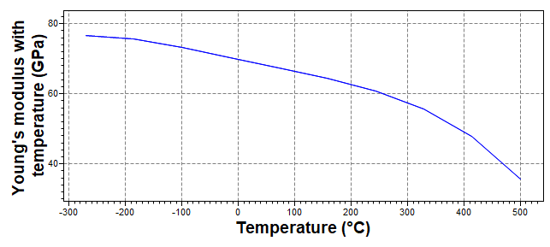
Figure 40 - Aluminium's 6061 Young's Modulus for Varying Temperatures (Ansys Granta, 2022)
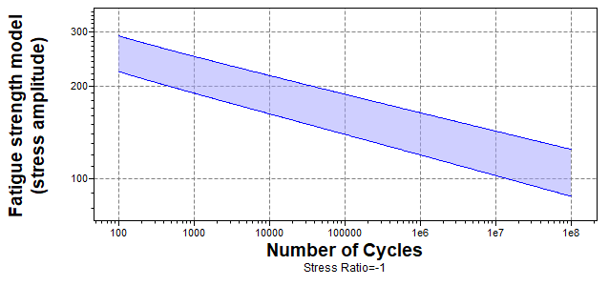
Figure 41 - Aluminium's 6061 Fatigue Strength for Varying Temperatures (Ansys Granta, 2022)
To prove this, Aluminium 2618, T6 is simulated through the same conditions to show the difference in stress and deformation, which its properties can be seen in Table 8. 2618 was chosen as it is a commonly used alloy of aluminium but is mostly used in the automotive industry however, another material that could have been used is Aluminium 4032 as it is also a popular material for automotive piston heads. This is because it contains a lot more silicon, at around 12%, resulting in the material being lighter and more durable as the coefficient of thermal expansion decreases causing the ductility of the material to decrease.

Aluminium 2618 Properties
Composition Properties
Aluminium, Al | 92.4 – 94.9 %
Chromium, Cr | 1.9 – 2.7 %
Copper, Cu | 1.9 – 2.7 %
Iron, Fe | 0.9 – 1.3 %
Magnesium, Mg | 1.3 – 1.8 %
Nickel, Ni | 0.9 – 1.2 %
Silicon, Si | 0.1 – 0.25 %
Titanium, Ti | 0.04 – 0.1 %
Zinc, Zn | 0 – 0.1 %
Other | 0 – 0.15 %
Mechanical Properties
Density | 2.72x10³ – 2.78x10³ Kg/m³
Young’s Modulus, E | 72 – 76 GPa
Yield Strength | 320 – 380 MPa
Tensile Strength | 400 – 440 MPa
Poisson’s Ratio | 0.325 – 0.335
Thermal Properties
Melting Point | 560 – 650 ˚C
Thermal Conductivity | 148 – 154 W/m˚C
Specific Heat Capacity | 858 – 893 J/kg˚C
Thermal Expansion Coefficient | 21.5 – 21.4
Table 8 - Properties of Aluminium 2618 (Ansys Granta, 2022)
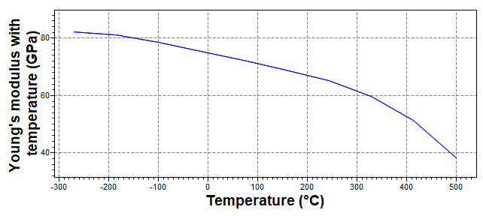
Figure 42 - Aluminium 2618 Young's Modulus for Varying Temperature (Ansys Granta, 2022)
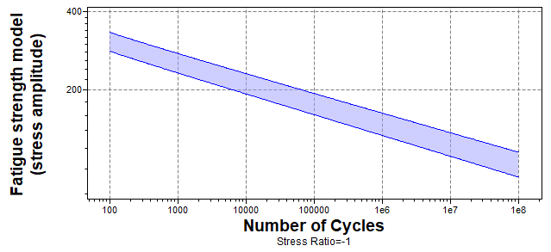
Figure 43 - Aluminium 2618 Fatigue Strength for Varying Temperatures (Ansys Granta, 2022)
6.5. Aluminium 6061
This run was done in Chapter 5, and the results can be seen in Figures 34-39.
6.6. Aluminium 2618
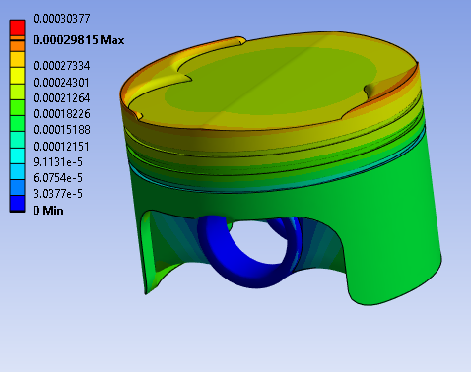  Figure 44 - Aluminium 2618 Deflection - Isometric Top View | 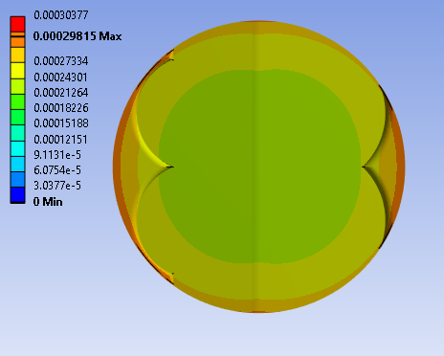  Figure 45 - Aluminium 2618 Deflection - Top View | 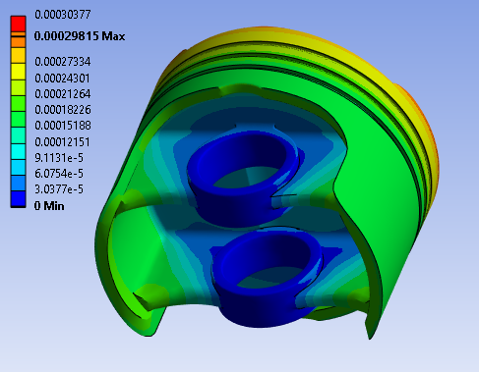  Figure 46 - Aluminium 2618 Deflection - Isometric Bottom View
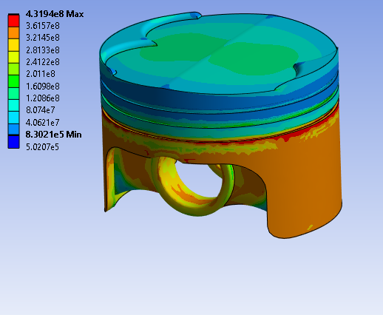  Figure 47 - Aluminium 2618 Stress - Isometric Top View | 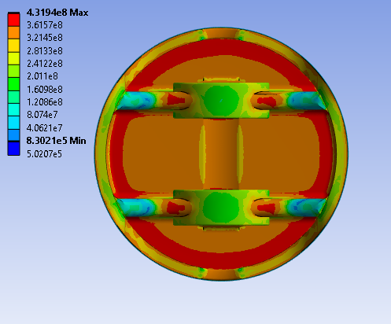  Figure 48 - Aluminium 2618 - Bottom View | 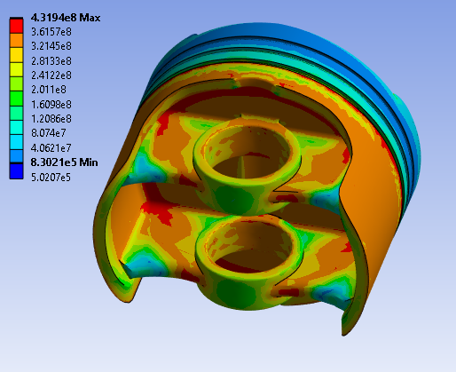  Figure 49 - Aluminium 2618 - Isometric Bottom View
Comparing the 2 materials shows that while 6061 deforms more, Aluminium 2618 experiences a lot more stress all over the piston especially in the already high stress areas like the bottom surface of the piston. This may be due to Aluminium 2618 being a stiffer and stronger material than Aluminium 6061 as seen in Tables 7 & 8. Aluminium 2618 has a higher Young’s Modulus as well as yield and tensile strength. This means that, it is a stiffer material so will experience more stress however it can withstand these higher stresses due to it being a stronger material. With Aluminium 2618 being stiffer this also means it will experience less deformation as it is less ductile.
7. Altering Piston Design
FEA can also be used to redesign a part, commonly with the intention of reducing material to decrease mass or having to add or redesign material to spread or reduce stress and other variables. To understand this, material was taken out of the pin bore supports to try and spread the orange stresses, highlighted in Figure 50, around the whole supports. To do this, a section view of the piston was placed on the CAD Model and holes were cut, as shown in Figure 51.
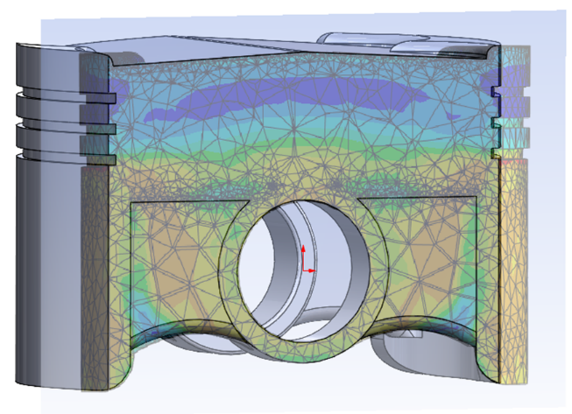  Figure 50 - Section View of Stresses Overlayed onto CAD Model |  | 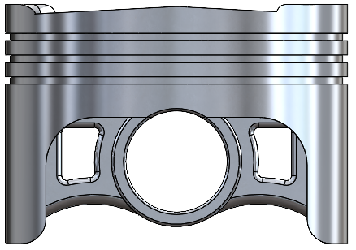  Figure 51 - Altered Piston
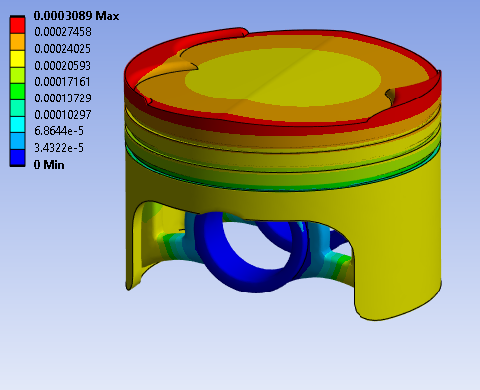  Figure 52 - Altered Piston Head Deformation - Isometric Top View | 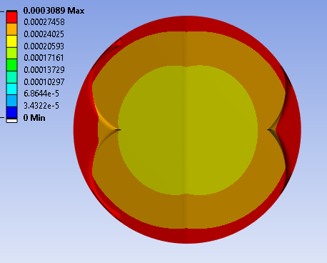  Figure 53 - Altered Piston Head Deformation - Top View |  | 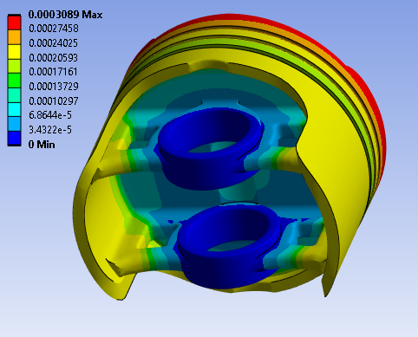  Figure 54 - Altered Piston Head Deformation - Isometric Bottom View
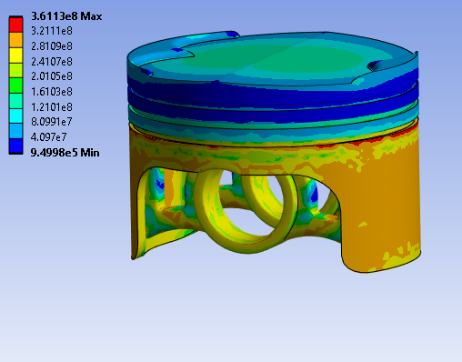  Figure 55 - Altered Piston Head Stress - Isometric Top View | 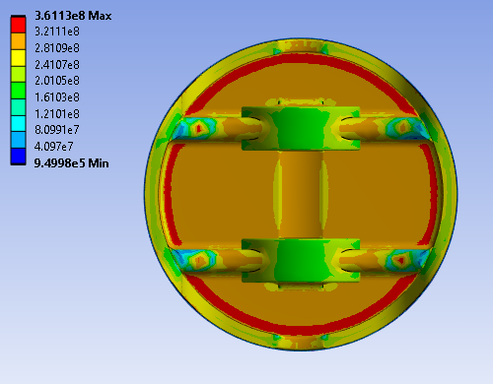  Figure 56 - Altered Piston Head Stress - Top View |  | 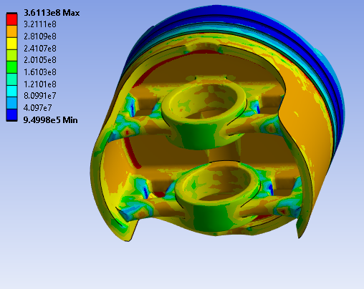  Figure 57 - Altered Piston Head Stress - Isometric Bottom View

When removing the sections as stated, it reduces the mass by 4g to 251.6g for each piston head. Comparing Figures 52-57 to the standard piston’s deformation and stresses, the reduction in mass doesn’t affect the deformation or stresses experienced significantly enough to notice apart from 4 small high stress zones on the bottom of the supports as seen in Figure 56.

8. FEA Limitations
Clearly, FEA is a useful tool as it can be used for multiple purposes and offers as a quicker solution for research and development of a part. However, there are still limitations to FEA that make it less effective than real-life testing.
Some of these limitation include;
- Validation
- Prediction
- Computing Process
- Simplified Geometry
- Modelling Complexity
- Human Error
8.1. Validation
One significant problem with FEA is that most simulations, like this one, are hard to validate against. While simple load cases can be validated, as shown in Chapter 4, more complex scenarios, like a piston, become harder to validate as putting sensors into a working engine’s cylinders is a lot easier said than done. This means that, when a complex scenario is simulated, results become less reliable as FEA may miss certain factors that aren’t in a simple model but are in a more complex model.
8.2. Prediction
Most computer aided engineering (CAE) process are a prediction because they use equations to calculate and predict results. This results in there always being a chance of mathematical error arising.
8.3. Modelling Complexity
Even if the mesh is fine enough to model all parts of the geometry, Nkuleon (2022) believes the geometry itself needs to be accurate. This is because FEA is commonly used for complex models however these complex models can be hard to replicate in CAD (Computer Aided Design). This means that, if the model isn’t exactly accurate to the part, then results may differ from actual values.

8.4. Computing Process
FEA heavily depends upon the computing power of the computer being used. The finer the mesh is and the more complex the geometry and load case is, the more demand there is on the computer. This can result in long processing times to gain accurate results meaning that engineers may simplify the scenario to decrease processing time, resulting in less accurate results.
8.5. Simplified Geometry
When FEA meshes a part, if the mesh isn’t fine enough then important geometry could be missed or ignored. This could result in a different part being simulated and results not correlating to the model desired.
8.6. Human Error
With most things in life there is human error and FEA is no exception. It relies upon data and models being input by someone to complete calculations and if any mistakes are made when doing so, it can sway the results significantly.

9. Conclusion
Overall, FEA is a very useful tool to see how a part behaves under certain loads as it can, overall, shorten the time and cost to optimise a part for its intended purpose. However, due to its limitations, especially with validation of results, using FEA alone isn’t enough to confidently optimise a part. Instead, FEA should be used alongside physical, real-life testing and material analysis to effectively optimise a part for the environment it will experience.

10. References
Dlubal, (2015), Verification Example: 0042 – Bending Cantilever with Axial Force, [Online], Available at: https://www.dlubal.com/en/downloads-and-information/examples-and-tutorials/verification-examples/000042, Accessed 05/12/2024.
Dlubal, (2018), Verification Example: 0078 – Bimetallic Strip, [Online], Available at: https://www.dlubal.com/en/downloads-and-information/examples-and-tutorials/verification-examples/000078, Accessed 05/12/2024.
Dlubal, (2022), Verification Example: 0016 – Elastic Bending - Continuous Load, [Online], Available at: https://www.dlubal.com/en/downloads-and-information/examples-and-tutorials/verification-examples/000016, Accessed 05/12/2024.
MAHLE International GmbH, (2016), Pistons and engine testing, Second Edition, Springer Fachmedien Wiesbaden, https://doi.org/10.1007/978-3-658-09941-1.
Chen.F, (2018), What is the nature of the resultant stresses in a bimetallic strip which is heated up if it is allowed to bend and in the case it is not allowed to bend?, Quora, [Online], Available at: https://www.quora.com/What-is-the-nature-of-the-resultant-stresses-in-a-bimetallic-strip-which-is-heated-up-if-it-is-allowed-to-bend-and-in-the-case-it-is-not-allowed-to-bend, Accessed 09/12/2024.
University of Cambridge, (n.d.), Thermal Expansion and the Bi-material Strip (all content), [Online], Available at: https://www.doitpoms.ac.uk/tlplib/thermal-expansion/printall.php#:~:text=When%20a%20component%20made%20up,up%20stresses%20and%20associated%20distortions. Accessed 09/12/2024.

Costen.E, (2019), FEA vs Hand Calculations | Predicting Performance Before Prototyping, ASR Engineering design & Analysis, [Online], Available at: https://asrengineering.com/2019/04/02/fea-vs-hand-calculations/#:~:text=Prior%20to%20FEA%2C%20engineers%20were,hand%20calculations%20and%20physical%20testing, Accessed 13/12/2024.
Thermtest Instruments, (2018), What is Thermal Conductivity?, [Online], Available at: https://thermtest.com/what-is-thermal-conductivity, Accessed 12/12/2024.
Malik.M, Bhattacharyya.S.K, Sudhirkumar.B.V, (2021), Thermal and mechanical properties of concrete and its constituents at elevated temperatures: A review, Indian Institute of Technology, ScienceDirect, [Online], Available at: https://www.sciencedirect.com/science/article/pii/S0950061820334024, Accessed 14/12/2024.
The Aluminium Automotive Manual, (2011), Applications – Power train – Pistons, [PDF], Available at: https://european-aluminium.eu/wp-content/uploads/2022/11/aam-applications-power-train-1-pistons.pdf, Accessed 12/12/2024.
Smiths High Performance, (2019), 4032 Aluminium Alloy – Product Data Sheet, [PDF], Available at: https://www.smithshp.com/pdf/4032-aluminium.pdf, Accessed 11/12/2023.
JE Auto, (2022), 2618 vs. 4032 Piston Material Differences, [Online], Available at: https://www.jepistons.com/je-auto-blog/2618-vs-4032-piston-material-differences/?srsltid=AfmBOor4oqIWYvPKzWRvHwLvR3XlpdFoZYB168o4T952x2WZOxwd6Sf7, Accessed 12/12/2024.

Metalex, (2020), About aluminium 6061 – Ideal for engineering and structural applications, [Online], Available at: https://metalex.co.uk/about-6061-aluminium-ideal-for-engineering-and-structural-applications/, Accessed 11/12/2023.
Henan Mingtai Technology Development Co, (2024), Aluminum 6082 vs 6061 for Engine Piston, [Online], Available at: https://www.linkedin.com/pulse/aluminum-6082-vs-6061-engine-piston-juzzc/, Accessed 11/12/2024.
Belmont, (2018), Silicon: Increasing the Properties of Aluminum and Copper Alloys, [Online], Available at: https://www.belmontmetals.com/silicon-increasing-the-properties-of-aluminum-and-copper-alloys/#:~:text=When%20it%20is%20added%20to,as%20there%20is%20no%20brittleness, Accessed 13/12/2024.
Young.W.C, Budynas.R.G, (2023), Roark’s Formulas for Stress and Strain, Seventh Edition, McGraw-Hill, [PDF], Available at: https://jackson.engr.tamu.edu/wp-content/uploads/sites/229/2023/03/Roarks-formulas-for-stress-and-strain.pdf, Accessed 11/12/2024.
Nklueon, (2022), FEA Limitations In Mechanical Engineering, [PDF], Available at: https://www.nkuleon.com/FEA-LIMITATIONS/, Accessed 14/12/2024.
Ansys Granta, 2022, Granta EduPack 2022 R2, [Software], Ansys.

Tim Tudor. (2024). 23_24 Stress Analysis. [OneNote]. University of Wales Trinity Saint David. Swansea.

Andrew Noble. (2024). Structural Design Fluid Analysis – Semester 1 – FEA – Tutorial Videos, University of Wales Trinity Saint David. Swansea.

11. Appendix

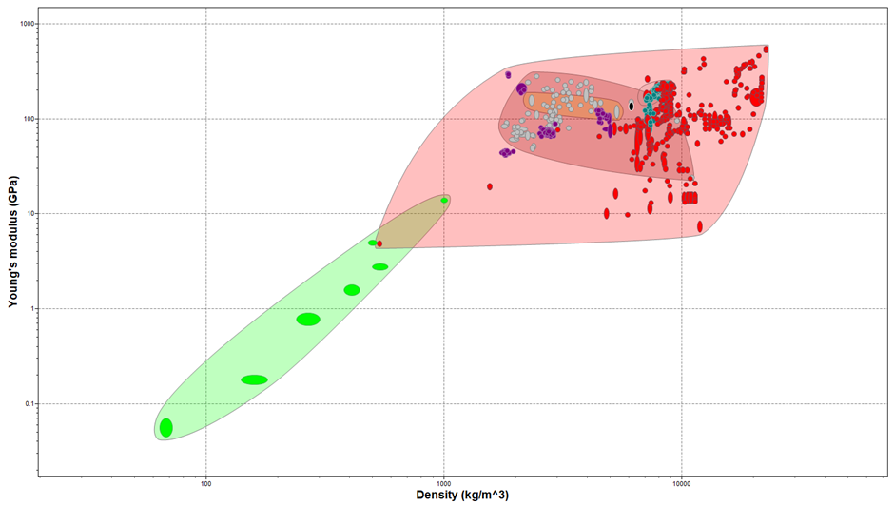
Figure 58 - Metals Properties Graph

