20/11/2022

Assignment Title: Component 2, Major health issue
Student name: Ms. Abeer Ishal
Student Number: 2128229
Module code: LCHS4004_Birm
Module name: Introduction to Public Health
Lecturers Name: Dr. Muhammad Hossain

Multiple Sclerosis

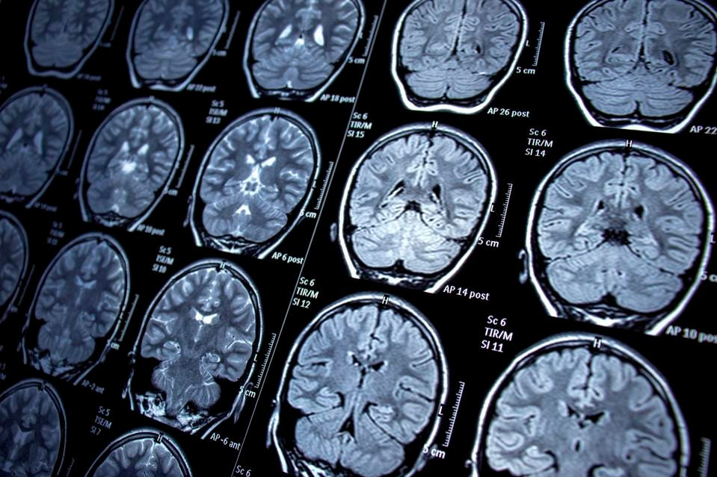

Contents
1. Introduction......................................................................................... Page 3.
2. Monitoring Multiple Sclerosis.............................................................. Page 4.
3. Measuring Multiple Sclerosis.............................................................. Page 5.
4. Controlling Multiple Sclerosis.............................................................. Page 5-6.
5. What causes Multiple Sclerosis.......................................................... Page 6.
6. Who is at Risk of Getting Multiple Sclerosis....................................... Page 7.
7. Short-term consequences of having Multiple Sclerosis…………….... Page 7.
8. Long-term consequences of having Multiple Sclerosis....................... Page 7- 8.
9. Conclusion…………………………………………………………………. Page 8.
10. Reference List……………………………………………………………. Page 8-10.

Introduction
Multiple sclerosis (MS) is a neurological disorder that causes central nervous system inflammation, according to public health England, approximately 110,000 people in the UK have multiple sclerosis with 5,200 new cases diagnosed each year (public health England, 2020). The annual cost of MS treatments is estimated to be £1.4 billion in the UK (public health England, 2020).
MS is estimated to affect almost 3 million people worldwide, and the average age of diagnosis is between 20 years old and middle age, the youngest patient diagnosed with multiple sclerosis in literature was a toddler (Fletcher et al., 2010). Equal numbers of boys and girls are diagnosed with multiple sclerosis before puberty, but after puberty women are twice as likely as men to be diagnosed with multiple sclerosis (Murakami et al., 1998).
Multiple sclerosis is a neurological disease that causes nerve damage in the brain and spinal cord, the term 'sclerosis' means scarring and refers to the nerve damage caused by MS. The word ‘multiple’ is used because lesions can occur in more than one spot in the brain and the spinal cord and it could be detrimental to the nervous system central (Palladino et al., 2021). Since 2013, the global prevalence of multiple sclerosis has increased. Good surveillance data is not standardized worldwide, multiple countries must collaborate together to close gaps in knowledge (Walton et al, 2021).
The global burden of the disease (GBD) multiple sclerosis has on the world is hard to measure as each patient is impacted differently by this disease, it all depends on where the lesions flare up in the brain or the spinal cord. Furthermore, because MS is a difficult disease to diagnose, many patients go undiagnosed (Magyari et al., 2021).
The aim of choosing this disease is to have a deeper understanding of the impact it has on individuals and society and how public health England prevents, protects, and promotes multiple sclerosis.

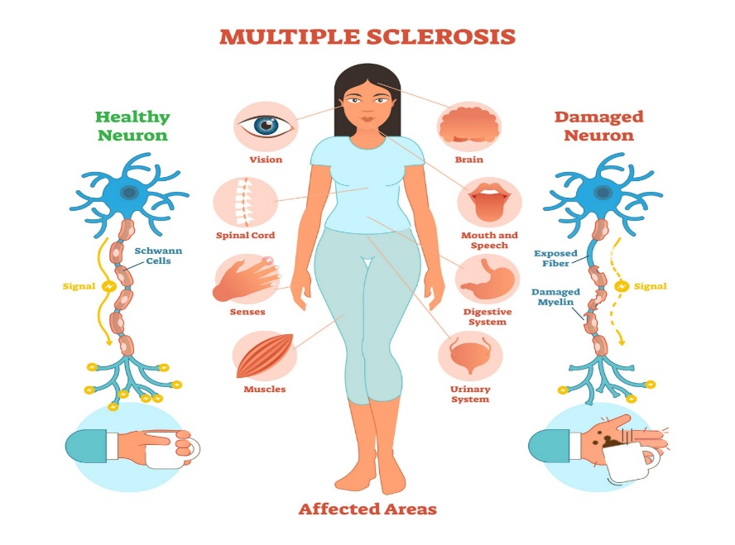

Monitoring of multiple sclerosis
Diagnosing the disease starts before monitoring it, multiple sclerosis is a difficult disease to diagnose because there is no single test that can detect it (Ascherio & Munger, 2007). Instead, a diagnosis usually necessitates a series of tests to rule out other conditions that cause similar symptoms. Doctors start by taking the history of the patient and then making them share the symptoms they are experiencing. Taking blood tests to eliminate other diseases, deficiencies, or abnormalities comes after that (Morris & Yiannikas, 2012).
Patients that have multiple sclerosis have usually multiple random symptoms that come and go. Doctors take that into consideration and order an MRI scan and if the MRI does not show any abnormality, they finally order a lumbar puncture (Morris and Yiannikas, 2012).
A lumbar puncture or a spinal tap can aid in diagnosing MS, as the analysis of cerebrospinal fluid obtained during a lumbar puncture commonly has a higher number of immunoglobulins in the cerebrospinal fluid. This means that antibodies (T and B cells) cross the blood-brain barrier and attack the myelin sheath as a result (Morris and Yiannikas, 2012).


Multiple sclerosis is monitored by taking regular blood tests, especially at the beginning of the diagnosis and the start of new medication, and depending on the results the neurologist finds, that will be the determent factor on what action to take next (Carbonell et al., 2014).
According to Carod-Artal (2021), the majority of disease-modifying therapy available today that is approved by the government for Multiple Sclerosis is known to cause damage to the liver and blood cells. That is why blood tests must be taken monthly until the test shows some stability; if they do not, medication must be changed because different medications work for different people. The blood result will show the liver enzyme function, white blood cells, and red blood cells, this is essential to rule out any complications (Tempest et al., 2017).
There are also neurological examinations that must be performed to look for any weaknesses in the limbs, vision, balance, cognitive function, orientation reflex, or speech. By monitoring the condition of the patient closely neurologists can determent which stages the disease is at and there are three types of stages, relapsing-remitting MS, secondary progressive Ms, and primary progressive MS (Ratzer et al., 2013).

Measurement of multiple sclerosis
The major outcome measures in MS clinical trials are relapsed rate reductions, and reduction in disability accumulation is harder to reach especially in early MS because not that many people at that stage have developed enough disabilities to be measured (Christensen et al., 2013).
One of the main measurements for progressive MS is disability progression, and one of the main goals is to reduce disability progression (Schmierer et al., 2019). In the past, the goal was in progressive MS studies on how to lessen the worsening of MS, but now more studies are aiming at how to improve MS (Fulgenzi et al., 2012).
According to Schmierer et al., (2019) data, it shows that MRI metrics show how progressive MS changes the brain volume as well as the grey and white segmented volume. MRI measurements are more accurate than any other scans, and it shows how advanced the MS is in a patient (Schmierer et al., 2019).
The MRI metrics show decreasing numbers of gadolinium-enhancing lesions, decreasing numbers of T2 lesions, and also decreasing rate at which the brain volume is lost (Schmierer et al., 2019). Then there are tests that measure MS, such as the expanded disability status Scale (EDSS), which measures the severity of the disease as well as the severity of the disability. Other evaluation tests, such as a cognitive assessment for MS, are also required and available (Li et al., 2022).

It is important that patients with MS get MRI scans annually to determine if their condition and cognitive abilities are stable or worsening because that will determine if doctors need to change medications (The Oxford Handbook of Adult Cognitive Disorders, 2019).
The measurement of MS is different in every patient as this disease affects everyone differently as some might have a more suppressed immune system than others, and body mass and age is also a factor some patients might even have more than one disease. consumption of alcohol and smoking cigarettes is also another factor and it will make the disease advance quicker (Moravejolahkami et al., 2020).
The measurement must include how frequently the relapse happens, and how severe the physical disability is. Once patients get started with medication many different factors can determent how their body responds to treatment (Li et al., 2022). Studies show that some patients have more endurance, some may be able to walk further than usual others might be able to continue working (Carod-Artal, 2021).
Morden day neurologists have three major measurement methods that assist them to assess how advanced MS is in a patient: frequency of relapse, physical disability, and the biological marker (MRI) (Wildner et al., 2020).

Controlling multiple sclerosis
It is very important for patients with multiple sclerosis to have a healthy diet and lifestyle. It is detrimental that they exercise regularly it is important that it is at their own pace as people with MS tend to get easily exhausted. It is equally important for MS patients to eat healthy food more vegetables, fruits, and lean meat.
It is equally important for their health to stay away from processed food, smoking, and excessive drinking of alcohol public health England, (2020). The government provides physiotherapy for patience with Ms to help with muscle spasms, stiffness, and stress. Stress is one of the leading causes of MS deterioration; therefore, it is critical to exercise on a regular basis.
Vision complications are common in MS patients, such as blurry vision, and uncontrollable eye movement which usually improves on its own or with the help of cortisol medications; however, in more advanced MS, the optic nerve is damaged beyond repair due to recurring lesions in the same location in the brain the part that controls the vision. That is rare but in some cases, there is no improvement and that can lead to blindness (Balcer et al., 2015).
Not every country has the resources to assist people with multiple sclerosis, in some countries, the patient must have good health insurance that covers the medication or have their own money to cover it (Alroughani et al., 2021).

What causes multiple sclerosis
Multiple sclerosis is an autoimmune neurological disorder that causes central nervous system inflammatory reactions. Exacerbations, also known as relapses, occur when an old lesion worsens, or a new lesion develops in the patient’s brain or spinal cord. In patients who have multiple sclerosis, their T cells become activated in the lymph system and enter via blood vessels through the nervous central system (NCS). T cells release inflammatory and harmful chemicals. This causes myelin and the cells that make myelin to be compromised.
T cells are also necessary and essential for activating B cells and recruiting the immune system to participate in an immune system attack. T cells and B cells join forces to produce antibodies, which explains why MS is an autoimmune disease that damages and jeopardizes the central nervous system (Fletcher et al., 2010).



Who is at risk of developing multiple sclerosis, and what is the primary cause of the disease?
According to Carod-Artal (2021), there is no single environmental factor known that leads to multiple sclerosis, but several factors are believed to contribute to the overall risk.
The Geographic factors identified by Burton and Costello (2015), reveal that multiple sclerosis is more prevalent in places farther from the equator and it is highest among Caucasian women and men. This explains why data shows that there is mounting evidence that vitamin D deficiency plays a crucial role in developing multiple sclerosis. Some researchers believe that the lack of sunlight exposure: a natural source of Vitamin D may help to explain the north-west distribution of Multiple sclerosis Burton and Costello, (2015).
People who live closer to the equator have higher levels of natural sources of vitamin D as they have sunlight throughout the year. A warmer climate and frequent sunlight support immune functions and may aid in the prevention of autoimmune diseases such as multiple sclerosis.
The social factor is that countries with higher incomes have a significantly greater prevalence and incidence data of MS than countries with low income, they are also better at promoting multiple sclerosis awareness and providing their citizens easier access to diagnostic facilities. Higher-income countries like the UK have some data and resources to help MS patients, they are obliged by the law to meet these patients’ basic human needs as they know the effect this disease has on them mentally and physically (The Oxford Handbook of Adult Cognitive Disorders, 2019). Some patients require more assistance than others, and it costs the government a lot of money to adjust their homes and public places to meet their basic human needs as many MS patients are in wheelchairs or have difficulty walking so they need an elevator (the Equality Act 2010).
There are some genetic factors according to Parnell and Booth (2017) which lead to increased prevalence of MS. It is not the sole determinant factor, however, the existing findings have not been fully exploited and there is nothing that indicates that MS is a hereditary disease.

Short-term consequences of having multiple sclerosis
Data shows Tempest et al., (2017) patients may experience mild symptoms such as fatigue and numbness in various parts of the body, most commonly the arms and legs. Some MS patients will have a blurry vision as well as sharp neck, shoulder, and back pain. Doctors will provide pain relief medications as well as an infusion therapy to slow disease progression. In this stage, patients can live and work normally as these symptoms are usually short-lived at the beginning of this disease, it’s a matter of days or weeks (Tillema & Pirko, 2013).

Long-term consequences of having multiple sclerosis
According to Carbonell et al., (2014) data, it indicates that the long-term consequences that MS has on its victims are severe complications such as difficulties with coordination and balance, permanent vision impairment, severe weakness in arms and legs, bladder and bowel incontinence, cognitive impairment issues, sharp nerve pain, burning sensations that can occur randomly in the body, or even respiratory failure.
The long-term impact MS has on society is overwhelming and expensive for the NHS. Patients will need more doctor visits, more scans, blood work, physiotherapy, more medication, and more equipment that will assist them to be able to move around. Patients who have more advanced MS are more dependent on family members and healthcare professionals as their disabilities might limit them physically, mentally, and financially (Marrie et al., 2016).
There is no cure for MS at the moment, but there are some disease-modifying therapies that can slow or prevent the condition from worsening.

Conclusion
In summary, what was discovered is that multiple sclerosis is a disease that will significantly disrupt the patient’s life in the long run and they will need lifelong treatments. That is why it is important for patients to have regular MRI scans, blood tests, and a healthy lifestyle. As the data indicates, people were prone to die much quicker from MS complications 40 years ago than today. There is no cure for multiple sclerosis but there are some medications that can help control the condition and alleviate some of its symptoms. Every MS patient experiences unique symptoms, therefor they get different medical treatments.
People who have intermittent blurry vision or who change prescription glasses numerous times in a few months should be referred to a neurology unit as that could lead to an early diagnosis of MS.
Multiple sclerosis patients require extensive medical, physical, mental, and social help from the government and that’s where the care act 2015 and the equality act 2010 come in. The British government is doing its best to develop a cure and bring awareness to this disease which is still unknown to many people.

References
Alroughani, R., AlKawi, Z., Hassan, A., al Otaibi, H., Mujtaba, A., al Atat, R., Riachi, N., Akkawi, N., Koussa, S., Inshasi, J., Alsaadi, T., Ahmed, S. F., Al-Aasmi, A., Zakaria, M. & el Fadally, H. (2021). Real-world retrospective study of effectiveness and safety of FINgOlimod in relapsing remitting multiple sclerosis in the Middle East and North Africa (FINOMENA). Clinical Neurology and Neurosurgery, 203. https://doi.org/10.1016/j.clineuro.2021.106576
Ascherio, A. & Munger, K. L. (2007). Environmental risk factors for multiple sclerosis. Part II: Noninfectious factors. Annals of Neurology, 61(6).
Balcer, L. J., Miller, D. H., Reingold, S. C. & Cohen, J. A. (2015). Vision and vision-related outcome measures in multiple sclerosis. In Brain (Vol. 138, Issue 1). https://doi.org/10.1093/brain/awu335
Burton, J. M. & Costello, F. E. (2015). Vitamin D in multiple sclerosis and central nervous system demyelinating disease-a review. Journal of Neuro-Ophthalmology, 35(2). https://doi.org/10.1097/WNO.0000000000000256
Carbonell, C. F., Benson, L., Rintell, D., Prince, J. & Chitnis, T. (2014). Functional relapses in pediatric multiple sclerosis. Journal of Child Neurology, 29(7). https://doi.org/10.1177/0883073813501873
Carod-Artal, F. J. (2021). The epidemiology of multiple sclerosis in the Scottish Highlands: Prevalence, incidence and time to confirmed diagnosis and treatment initiation. Multiple Sclerosis and Related Disorders, 47. https://doi.org/10.1016/j.msard.2020.102657
Christensen, J. R., Börnsen, L., Ratzer, R., Piehl, F., Khademi, M., Olsson, T., Sørensen, P. S. & Sellebjerg, F. (2013). Systemic Inflammation in Progressive Multiple Sclerosis Involves Follicular T-Helper, Th17- and Activated B-Cells and Correlates with Progression. PLoS ONE, 8(3). https://doi.org/10.1371/journal.pone.0057820
Fletcher, J. M., Lalor, S. J., Sweeney, C. M., Tubridy, N. & Mills, K. H. G. (2010). T cells in multiple sclerosis and experimental autoimmune encephalomyelitis. In Clinical and Experimental Immunology (Vol. 162, Issue 1). https://doi.org/10.1111/j.1365-2249.2010.04143.x
Fulgenzi, A., Zanella, S. G., Mariani, M. M., Vietti, D. & Ferrero, M. E. (2012). A case of multiple sclerosis improvement following removal of heavy metal intoxication. BioMetals, 25(3). https://doi.org/10.1007/s10534-012-9537-7
Haseltine, W. (2022) What Brain Scans Reveal About the Consequences of Covid-19
.URL https://www.forbes.com/sites/williamhaseltine/2022/03/28/imaging-the-brain-what-brain-scans-reveal-about-the-consequences-of-covid-19/?sh=3db05bd520ea (Accessed: 20 November 2022).
Li, R., Tang, H., Burns, J. C., Hopkins, B. T., le Coz, C., Zhang, B., de Barcelos, I. P., Romberg, N., Goldstein, A. C., Banwell, B. L., Luning Prak, E. T., Mingueneau, M. & Bar-Or, A. (2022). BTK inhibition limits B-cell–T-cell interaction through modulation of B-cell metabolism: implications for multiple sclerosis therapy. Acta Neuropathologica, 143(4). https://doi.org/10.1007/s00401-022-02411-w
Magyari, M., Joensen, H., Laursen, B. & Koch-Henriksen, N. (2021). The Danish Multiple Sclerosis Registry. Brain and Behavior, 11(1). https://doi.org/10.1002/brb3.1921
Marrie, R. A., Miller, A., Sormani, M. P., Thompson, A., Waubant, E., Trojano, M., O’Connor, P., Fiest, K., Reider, N., Reingold, S. & Cohen, J. A. (2016). Recommendations for observational studies of comorbidity in multiple sclerosis. In Neurology (Vol. 86, Issue 15). https://doi.org/10.1212/WNL.0000000000002474
Moravejolahkami, A. R., Paknahad, Z. & Chitsaz, A. (2020). Association of dietary patterns with systemic inflammation, quality of life, disease severity, relapse rate, severity of fatigue and anthropometric measurements in MS patients. Nutritional Neuroscience, 23(12). https://doi.org/10.1080/1028415X.2019.1580831
Morris, K. & Yiannikas, C. (2012). Treatment update in multiple sclerosis. Current Allergy and Asthma Reports, 12(3). https://doi.org/10.1007/s11882-012-0256-5
Murakami, Y., Matsuishi, T., Shimizu, T., Yamashita, Y., Nagamitsu, S., Kojima, K., Kato, H. & Tabira, T. (1998). Balo’s concentric sclerosis in a 4-year-old Japanese infant. Brain and Development, 20(4). https://doi.org/10.1016/S0387-7604(98)00025-4
Palladino, R., Marrie, R. A., Majeed, A. & Chataway, J. (2021). Management of vascular risk in people with multiple sclerosis in England: A population-based matched cohort study. Multiple Sclerosis Journal, 27(2 SUPPL).
Parnell, G. P. & Booth, D. R. (2017). The Multiple Sclerosis (MS) genetic risk factors indicate both acquired and innate immune cell subsets contribute to MS pathogenesis and identify novel therapeutic opportunities. In Frontiers in Immunology (Vol. 8, Issue APR). https://doi.org/10.3389/fimmu.2017.00425
Public Health England. (2020). Multiple sclerosis: prevalence, incidence and smoking status - data briefing. GOV.UK.
Ratzer, R., Søndergaard, H. B., Christensen, J. R., Börnsen, L., Borup, R., Sørensen, P. S. & Sellebjerg, F. (2013). Gene expression analysis of relapsing-remitting, primary progressive and secondary progressive multiple sclerosis. Multiple Sclerosis Journal, 19(14). https://doi.org/10.1177/1352458513500553
Schmierer, K., Campion, T., Sinclair, A., van Hecke, W., Matthews, P. M. & Wattjes, M. P. (2019). Commentary: Towards a standard MRI protocol for multiple sclerosis across the UK. In British Journal of Radiology (Vol. 92, Issue 1101). https://doi.org/10.1259/bjr.20180926
Tempest, M., Bougeard, C., Harrington, A. & Xaplanteris, L. (2017). The Cost-Effectiveness of Daclizumab Beta Vs Fingolimod for The Treatment of Relapsing-Remitting Multiple Sclerosis Patients With Inadequate Response To Prior Treatment In Scotland. Value in Health, 20(9). https://doi.org/10.1016/j.jval.2017.08.1950
The Oxford Handbook of Adult Cognitive Disorders. (2019). In The Oxford Handbook of Adult Cognitive Disorders. https://doi.org/10.1093/oxfordhb/9780190664121.001.0001
Tillema, J. M. & Pirko, I. (2013). Neuroradiological evaluation of demyelinating disease. Therapeutic Advances in Neurological Disorders, 6(4). https://doi.org/10.1177/1756285613478870
Walton, C., King, R., Rechtman, L., Kaye, W., Leray, E., Marrie, R. A., Robertson, N., la Rocca, N., Uitdehaag, B., van der Mei, I., Wallin, M., Helme, A., Angood Napier, C., Rijke, N. & Baneke, P. (2020). Rising prevalence of multiple sclerosis worldwide: Insights from the Atlas of MS, third edition. Multiple Sclerosis Journal, 26(14). https://doi.org/10.1177/1352458520970841
Wildner, P., Stasiołek, M. & Matysiak, M. (2020). Differential diagnosis of multiple sclerosis and other inflammatory CNS diseases. In Multiple Sclerosis and Related Disorders (Vol. 37). https://doi.org/10.1016/j.msard.2019.101452

