PORTFOLIO ASSIGNMENT
Emergent Leadership Skills in the Workplace
BMSW 6101

STUDENT: Andrei Amzulescu
STUDENT ID: 2124638

Table of Contents
Part 1-Academic Report 3
Introduction 3
Effective leadership skills and its contribution 4
Effective leadership styles and its contribution 6
Tackling the barriers 9
Importance of ethical leadership 11
Recommendations 13
Conclusion 15
Part 2-Reflective Essay 17
Introduction 17
Reflection using Gibbs reflective model 17
Conclusion 20
References 21
Part 1-Academic Report 21
Part 2-Reflective Essay 24

Part 1-Academic Report

Introduction
ABC Inc., being the market leader, has always been a favourite organisation to lead. But currently, it is facing an acute leadership crisis. The firm has recently witnessed the appointment of five CEOs in the last three years. Such a high level of turnover creates instability. Low employee morale, erratic strategies, and unimplemented changes are the immediate fallouts of such an environment. Employees have experienced frequent disruptions, leading to a lack of motivation, trust, and productivity. Stakeholders, including shareholders, regulators, trade unions, and customers, have also expressed concerns about the company’s future direction and stability. The challenges experienced by ABC Inc. point out the need for effective leadership at critical times. Effective leadership is pivotal to setting a clear vision, building trust, and a positive organisational culture (Dubey, Pathak and Sahu, 2023). Confident leadership inspires accountability and ensures that plans are implemented effectively to overcome uncertainties and propel growth. Poor leadership leads to disengagement, communication gaps, and operational inefficiencies, as in the case of ABC Inc.
This report critically analyses the leadership challenges facing ABC Inc. and assesses how effective leadership styles and ethical practices can revamp the workplace. The paper explores strategies to overcome the challenges to leadership, with a special emphasis on the role of ethical and transformational leadership in building a stable and productive environment. Moreover, the report provides actionable for the Chairman and board members regarding how to handle the crisis and choose a CEO who would lead the company towards sustainable growth. The findings and recommendations intend to enable ABC Inc. to restore trust, enhance employee engagement, and regain its status as a market leader. With an established leadership approach, the company is able to stabilise, regain stakeholders' confidence, and achieve long-term success.

Effective leadership skills and its contribution
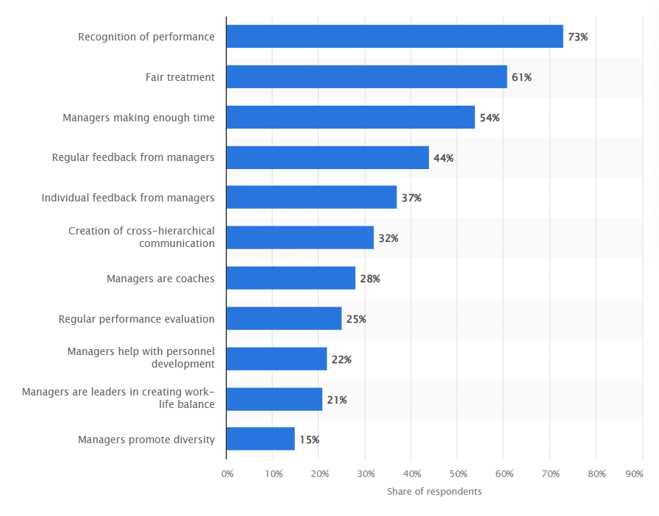
Figure 1.1: Leadership to Employee retention
(Source: Davies, 2024)
Effective leadership is a foundation of a successful organisation, particularly during times of uncertainty and instability (Colasante, 2023). Leaders are very important in the development of organisational culture, motivation of employees, and sustainable growth. In the case of ABC Inc., which has experienced five CEOs in three years, leadership instability is a challenge that calls for effective leadership skills. The firm's current challenges, that is, low morale, unhealthy workplace culture, and declining productivity, highlight the critical role that a strong leadership can play in stabilising and fostering a healthy work environment.
1. Establishing Stability and Direction
Clarity, vision, and stability are fundamental requirements for navigating uncertainty. With frequent changes in leadership in ABC Inc., employees seem confused and uncertain about what the company wants to do. A good leader can help by creating a clear strategic vision and explaining how an employee's work is tied to the goals of the organisation. Stable leadership promotes confidence in the employees and the external environment about the direction that the organisation will follow.
2. Fostering Employee Engagement and Motivation
Leadership is directly proportional to the engagement and motivation of employees (Singh et al. 2023). Employees at ABC Inc are demotivated because of various changes within the organisation and differing leadership approaches. Effective leaders make changes that ensure the comfort and feelings of being cared for and heard by employees. They cultivate an open communication channel by encouraging the employees to share their ideas and concerns.
Transformational leaders are skilled in motivating employees to do their best (Leithwood and Jantzi, 2005). The establishment of specific objectives, acknowledging of achievements, and feedback can reignite the passion of employees at ABC Inc. Increased engagement also means greater morale, increased productivity, and decreased turnover-all good for a stable and healthy workplace.
3. Promoting Trust and Transparency
Trust is the foundation of effective leadership. In this trying time, employees want to hear assurance that leaders are actually making decisions in their interests, decisions that reflect the values the organisations have. The frequent change in CEO at ABC Inc. has been so damaging that trust has been lost, and future initiatives could hardly be embraced.
4. Building a Collaborative and Inclusive Culture
Healthy workplaces thrive on collaboration and inclusivity, which is supported by strong leadership (Jha, Pal and Sarkar, 2024). In the case of ABC Inc., the management styles are inconsistent and change processes have been abandoned, resulting in an unhealthy workplace culture. Strong leaders can be instrumental in changing this, such as promoting teamwork and knowledge sharing, while ensuring each employee is involved in making decisions.
5. Managing Change Effectively
Organisational change failure by ABC Inc. has led to instability and resistance from employees. Successful leaders understand that change management is a thoughtful process, which requires planning, communication, and execution. Structured approaches, such as Kotter's 8-Step Process, help leaders implement changes in phases while addressing the concerns of employees.
6. Enhancing Employee Well-Being and Mental Health
An unhealthy workplace can cause stress and burnout and low productivity (Ismail and Owaida, 2023). "ABC Inc." has had ongoing chaos and lack of clear direction that has worn off the employees' well-being. Good leaders ensure well-being and mental health is prioritised by supporting work-life balance, wellness programs in place, and having easy conversation about stress management with their employees.
7. Strengthening Stakeholder Confidence
The leadership crisis in ABC Inc. has affected not only the employees but also external stakeholders, such as shareholders, regulators, and trade unions. Effective leaders communicate with stakeholders by showing progress, answering concerns, and showing accountability. Stakeholders will support an organisation more if they see strong, reliable leadership at the helm.

Effective leadership styles and its contribution
Leadership is one of the most critical factors influencing an organisation's success, especially during uncertain and unstable times. The best leadership styles form a foundation for organisational stability, employee engagement, and long-term growth (Nanjundeswaraswamy and Swamy, 2014). In the case of ABC Inc., which has experienced a leadership crisis with five CEOs in three years, the right leadership styles must be adopted to regain trust, rebuild morale, and create a healthy workplace. The inconsistent management approaches and deserted change initiatives by the firm have confused employees and made them disengaged. Thus, it's an urgent time to think about effective leadership.
1. The Role of Leadership Styles in Organisational Stability
Leadership styles explain the kinds of leadership decision-making approaches, methods of communication, and interaction methods between the leader and workers (Albejaidi, Kundi and Mughal, 2020). At ABC Inc, inconsistent leadership has been behind the broken-up strategies leading to numerous distractions hence no stability. Proper styles of leadership like transformational, democratic, and servant can reconstruct stability since it helps outline direction and direct workers into organisational objectives.
- Transformational Leadership: This style motivates employees to go above expectations by vision, motivation, and innovation (Jensen, Potočnik and Chaudhry, 2020). The role of a transformational leader at ABC Inc. can be portrayed articulating a clear vision, energising the employees, and achieving organisational change while ensuring continuity.
- Democratic Leadership: Involving employees in decision-making makes them feel included and cooperative (Anwer et al. 2022). In ABC Inc., where employees have faced sudden changes, this style can rebuild trust by valuing their input and empowering them to contribute to solutions.
2. Enhancing Employee Morale and Motivation
Employee morale and motivation are critical factors that are affected adversely by the lack of leadership styles at ABC Inc., which has resulted from non-uniform management and given up initiatives. Transformational and democratic leaders motivate teams the best through recognition, rewards, and shared goals (Hilton, Arkorful and Martins, 2021).
3. Promoting Transparency and Trust
One of the significant challenges at ABC Inc. is erosion of trust due to frequent changes in leadership and incomplete transformation. Trust is a significant component of a healthy workplace, and leadership styles like authentic and democratic leadership work best in rebuilding trust (Sethuraman and Suresh, 2014).
- Authentic Leadership: It focuses on transparency, ethical decision-making, and open communication (Fox, Davis and Baucus, 2020). Leaders who embrace this style ensure that the employees are informed about organisational changes and decisions, which reduces uncertainty and scepticism.
- Democratic Leadership: Encourages teamwork and discussion of change efforts with the involvement of employees, reinforcing trust in democratic leadership (Anwer et al. 2022). This means that respect for the employees' views is demonstrated through the involvement of employees.
4. Supporting Effective Change Management
The abandoned change initiatives by ABC Inc. prove the need for selecting leadership styles that support effective transition. Transformational and coaching leadership styles are more effective in handling change.
- Transformational Leaders build confidence and resilience in employees through the transition process by keeping a focus on the bigger picture and dealing with employees' concerns (Chen et al. 2022).
- Coaching Leaders provide customised guidance and skill development, which enables employees to transition through change and enhance their performance (Gardner et al. 2021).
5. Building a Collaborative and Inclusive Culture
An unhealthy workplace is usually characterised by a lack of teamwork and inclusiveness, as in the case of ABC Inc. The opposite can be achieved through democratic and servant leadership styles, which promote teamwork and inclusiveness.
- Democratic Leadership inspires employees to speak out and encourages teamwork and mutual respect (Hilton, Arkorful and Martins, 2021).
- Servant Leadership focuses on the needs of employees, ensuring they feel supported and valued (Canavesi and Minelli, 2022).
6. Prioritising Employee Well-Being and Work-Life Balance
ABC Inc.'s unhealthy culture is probably the reason for stress, burnout, and lower productivity. Servant and authentic leadership styles tend to maintain employees' welfare through a balance between work and personal life, provision of supportive systems, and issues on mental health.
7. Strengthening Stakeholder Relationships
External relations with stakeholders, which include customers, shareholders, and regulators, also have something to do with leadership styles. ABC Inc. should rebuild trust and credibility, and this can be done through authentic and transformational leadership styles.
- Authentic Leaders are concerned with accountability and ethics, ensuring stakeholders that the company is committed to transparency and stability (Fox, Davis and Baucus, 2020).
- Transformational Leaders build confidence by sharing a compelling vision for the future of the company and demonstrating a commitment to performance.

Tackling the barriers
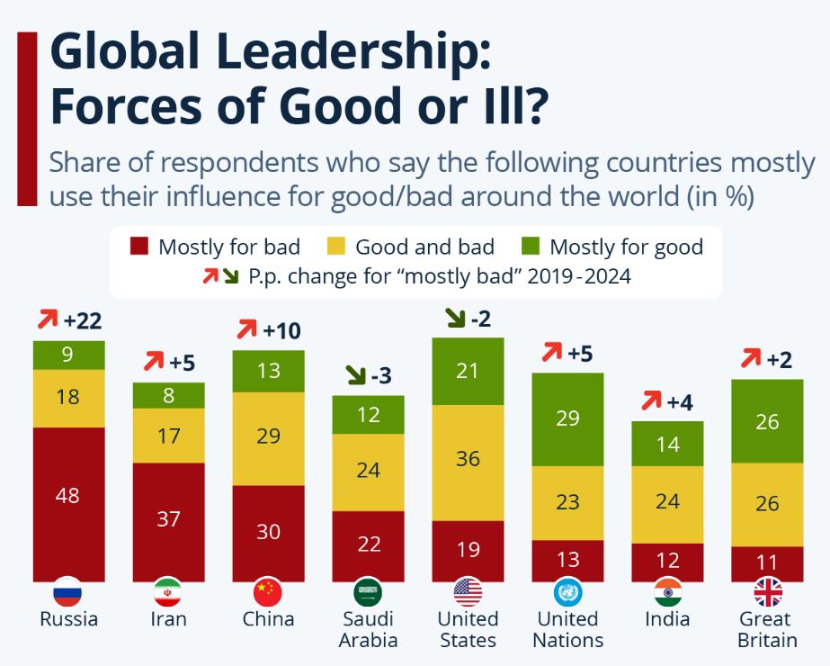
Figure 1.2: Leadership globally
(Source: Fleck, 2024)
Effective leadership is very important to the success of an organisation, especially in times of uncertainty and instability. In the case of ABC Inc., the company's leadership crisis, evident through five CEOs in three years, has led to dissatisfaction among employees, low morale, and reduced productivity. These challenges call for management to address barriers that may hinder effective leadership.
1. Addressing Lack of Vision and Strategic Clarity
This would, therefore be a major factor impeding effective leadership in ABC Inc., as change of leadership and frequent shifting causes lack of a persistent vision. There is lack of organisational objectives among the employees, creating confusion and demotivation.
Solution:
Management should create and clearly communicate a single vision and long-term strategy that aligns with the company's core values and objectives. The vision should be constantly communicated to employees to let them know their role in the success of the organisation. A strategic roadmap will reduce uncertainty and provide clarity and direction (Butt, 2020).
2. Building Trust and Credibility
Repeated leadership changes have broken the trust of employees and stakeholders in ABC Inc. This distrust is the cause of resistance to change and disengagement.
Solution:
The management needs to regain trust through open communication and accountability. Leaders need to engage employees in decision-making processes, openly address their concerns, and keep promises. An authentic leadership style will enable leaders to act with integrity and fairness and regain employee confidence (Gardner et al. 2021).
3. Improving Change Management Processes
ABC Inc. has seen several failed change initiatives that caused employee frustration and instability. Many people resist and disengage in the face of poor change management.
Solution:
Toward that goal, implementing Kotter's 8-Step Change Model or Lewin's Change Management Process would be suitable. These models focus more on the planning, communication, and reinforcement during the change process (Laig and Abocejo, 2021). Without involvement by leaders, employees will become active only once convinced with their management of the reasons for a change, clear steps about them, and small wins to celebrate at each step.
4. Enhancing Leadership Development and Training
The second main obstacle to overcome at ABC Inc. is the absence of homogenous leadership styles and competencies across the company. Lack of stable leadership has denied staff from gaining a more coherent direction and support.
Solution:
Management needs to invest in leadership development programs aimed at building skills such as emotional intelligence, adaptability, and conflict resolution. These could be through mentoring, coaching, and workshops. Developing leaders who inspire confidence to drive positive change may result in internal promotion, leading to continuity and stability (Schiuma et al. 2022).
5. Fostering Employee Engagement and Collaboration
ABC Inc. has had its collaboration reduced and employee dissatisfaction increased because of poor leadership leading to an unhealthy culture of work.
Solution:
Management needs to work toward establishing a culture of inclusion and teamwork. The democratic and servant styles of leadership help in listening and being accountable to the employees. Employee participation in decision-making is highly valued, along with providing for their wellness (Saks, 2022). Some other ways that improve morale and teamwork include reward schemes, team building, and work flexibility.
6. Managing Resistance to Change
At ABC Inc, due to previous failures of changes initiated by new management, people may resist any further attempts.
Solution:
Management should involve employees at the front end of the decision-making process so that resistance is reduced. Preparing training programs, giving continuous support, and maintaining feedback channels will prepare and involve employees in the organisation's change process (Viterouli et al. 2024).
7. Promoting Accountability and Performance Metrics
Lack of accountability tends to be the primary hindrance to leadership effectiveness. In ABC Inc., there has been inconsistency in follow-through on initiatives, thus causing frustration and scepticism.
Solution:
Management needs to set performance measures to assess the effectiveness of leadership. Performance reviews, employee surveys, and feedback mechanisms can help track progress and identify areas for improvement. Leaders should be held accountable for results, and employees should see tangible outcomes from initiatives (Ford et al. 2020).

Importance of ethical leadership
Ethical leadership is the bedrock of building trust, accountability, and integrity in any organisation. At ABC Inc., where the lack of stability in leadership has been characterised by low morale, poor communication, and an unhealthy culture, the adoption of ethical leadership practices is imperative to restoring stability and confidence. Ethical leaders will portray fairness, transparency, and responsibility as the starting point for a positive organisational culture and sustainable growth.

1. Rebuilding Trust and Credibility
This change in leadership has led to the lack of trust between the workers, stakeholders, and even customers of ABC Inc. Ethical leadership will thus solve this by setting a high regard for honesty, fairness, and accountability (Knights, 2022). An ethical leader explains what is decided, involves workers in finding solutions to problems, and shows accountability for what is done. This transparency allows employees to regain trust with them. A good leader who leads ethically can bring credibility back into the company, hence creating a common vision among workers.
2. Promoting Employee Well-Being and Fair Treatment
Low morale and dissatisfaction among employees in ABC Inc. are as a result of the instability. Ethical leaders advocate for fairness, respect, and inclusiveness, which enables employees to feel valued and cared for (Dang, Volpone and Umphress, 2023). They handle grievances fairly, provide opportunities for growth, and promote work-life balance. Ethical leadership can reverse the trends of low motivation among employees at ABC Inc. because it fosters a culture of fairness and compassion.
3. Encouraging Accountability and Responsibility
The abandoned initiatives and inconsistent strategies of ABC Inc. point to a lack of accountability. Ethical leadership clearly outlines expectations and holds leaders and employees accountable for achieving the objectives. Accountability ensures that commitments are followed through and that projects are not left half-finished, and resources are not wasted. A responsible ethical leader at ABC Inc. would encourage openness, set measurable goals, and ensure performance is measured regularly, creating a culture of responsibility.
4. Managing Ethical Challenges and Decision-Making
In times of uncertainty, firms face decisions that affect different stakeholders. Ethical leadership in decision-making considers long-term effects, legality, and fairness rather than short-term gains (Páez Gabriunas, 2023). For ABC Inc., this is crucial because it needs to regain stakeholders' confidence and avoid further reputational damage due to poor decision-making in the past. Ethical leadership can help guide ABC Inc. through uncertainties by prioritising sustainable practices and ethical business strategies.

5. Enhancing Organisational Reputation
The leadership crisis at ABC Inc. must have already impacted its reputation among stakeholders, regulators, and the public. Ethical leadership can mend this damage through corporate social responsibility and ethical governance. Integrity-driven leaders attract talent, investors, and customers and position the organisation as a trusted and responsible entity.

Recommendations
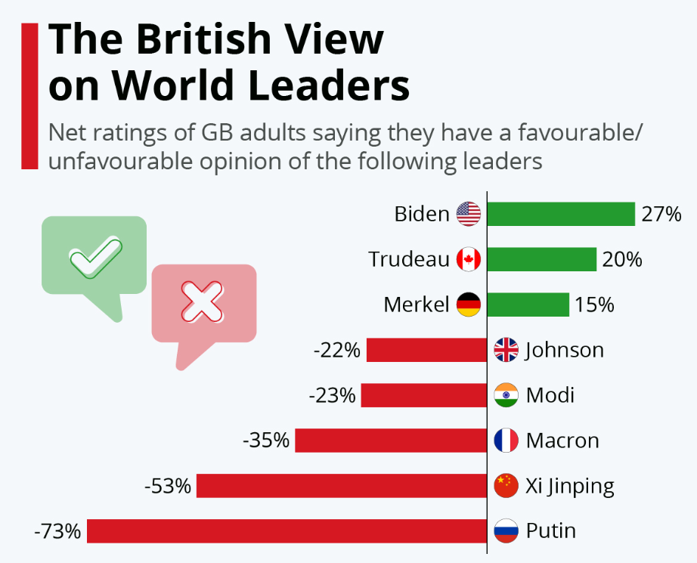
Figure 1.3: Leadership view of Britishers
(Source: Armstrong, 2021)
ABC Inc. is struggling with a serious leadership crisis, as it has selected five CEOs in the last three years. This volatility has made the employees feel low on morale, with an inconsistent strategy, abandoned change initiatives, and low productivity (Larasati and Martono, 2020). Considering these issues and the need for the selection of an appropriate and stable CEO, it is recommended to do the following:
1. Develop a Clear Leadership Vision and Strategic Alignment
The next CEO of the company must be selected based on a clear vision and strategic objectives that align with the company's mission and values. ABC Inc. needs to assess its long-term goals and challenges in order for the new CEO to have all the skills and expertise required to implement such a vision. A strategic alignment framework should be created, highlighting specific competencies required in the role, such as adaptability, emotional intelligence, and transformational leadership qualities (Volk and Zerfass, 2020).
2. Establish a Comprehensive Recruitment and Selection Process
The recruitment process must emphasise quality, thoroughness, and appropriateness over expediency. ABC Inc. should:
- Consult with an executive search firm specialising in such assignments to identify candidates with a history of stability and proven leadership.
- Administer behavioural and situational interviews that assess the candidate's style of leadership, problem-solving abilities, and crisis management capabilities.
- Utilise psychometric and personality tests that measure emotional intelligence, ethical decision-making, and cultural fit (Wijsen, Borsboom and Alexandrova, 2022).
- Incorporate stakeholder panels (board members, senior managers, and employee representatives) in the assessment to ensure diversity.
3. Prioritise Ethical and Transformational Leadership Qualities
However, because of the leadership and cultural problems with ABC Inc., the succeeding chief executive officer must exhibit character traits such as integrity, transparency, and accountability, which will restore confidence between the employees, stakeholders, and customers. A CEO's transformational leadership would instil innovation, proper management of change, and stimulate employee engagement (Jensen, Potočnik and Chaudhry, 2020).
4. Implement a Structured Onboarding and Transition Plan
The failure of the previous CEOs may have been partly due to inappropriate onboarding processes and vague expectations. ABC Inc. should:
- Develop a 90-day integration plan including clear performance metrics and priorities, as well as engagement strategies with stakeholders.
- Assign a mentor or advisor from the board to support the new CEO during the transition period.
- Set up periodic review of progress in terms of performance, challenges faced, and adjustments made (Seeling et al. 2021).
5. Foster Organisational Stability and Employee Engagement
The new CEO must focus on relationship building and communication improvement within the organisation to reduce employee anxiety and resistance to change.
- Host town hall meetings to share visions of the company and obtain concerns of employees.
- Feedback channels to encourage transparency and collaboration.
- Promoting a culture of recognition to motivate employees and reinforce shared values (Paais and Pattiruhu, 2020).
6. Monitor and Evaluate Leadership Effectiveness
ABC Inc. should have a leadership performance framework that monitors and evaluates the performance of the CEO regularly. This would include setting some KPIs, for example, employee engagement, project completion rates, and financial performance. The company should also conduct annual leadership reviews to ensure continuous improvement in alignment with organisational goals. ABC Inc. needs to first identify a CEO with ethics, strategic vision, and transformational leadership to put an end to its leadership crisis. The structured recruitment process, proper onboarding, and transparent performance monitoring will enable the new CEO to navigate through uncertainty, rebuild trust, and make the workplace productive again (Biea et al. 2024). By implementing these recommendations, ABC Inc. can restore stability and position itself for long-term success.

Conclusion
ABC Inc. has a critical leadership crisis that has been characterised by instability, low morale, and low productivity levels. The frequent change of CEOs in the last three years has created a lot of mistrust, has derailed strategic initiatives, and created an unhealthy work culture. To solve the problems, there is need for effective and ethical leadership to restore stability, rebuild trust, and spur sustainable growth. The analysis concludes that adopting leadership styles, which focus on transparency, accountability, and collaboration, is highly important. Transformational and ethical leadership approaches are best suited for ABC Inc., as they can inspire the employees, manage change effectively, and create a culture of fairness and respect. The implementation of structured change management processes and the emphasis on employee engagement will help the company to overcome resistance and achieve productivity. The need to overcome barriers to effective leadership will make ABC Inc. concentrate more on clear vision-setting, robust communication, and more programs of leadership development. Overcoming the present problems will require trust by transparent decision-making, accountability, and encouraging employee participation.
The recommendation for choosing the next CEO should be based on extensive recruitment processes that consider values and strategic alignment, in addition to transformational leadership abilities. Structured onboarding, continuous performance evaluation, and employee involvement will also help ensure the success of the CEO. Adopting the above strategies will help ABC Inc. overcome leadership issues, build an integrated vision, and shape a healthy organisational culture. The above strategies will ensure that the company stabilises and also sets it to grow long-term, be resistant, and competitive in its industry. Leadership will give ABC Inc. a conducive workplace to attract talent and innovation while delivering value to stakeholders and help regain leadership status in the industry.

Part 2-Reflective Essay

Introduction
From the whole module on leadership, I have learned valuable insight on different leadership traits and styles, especially emergent leadership. Emergent leadership suggests the development of leadership through group settings by being adaptable, emotionally intelligent, and collaborative rather than authority-related (Drysdale and Gurr, 2017). This reflection explores the extent to which these concepts have shaped my perception of leadership and, hence, my personal leadership journey. Reflecting on my experience and incorporating the leadership theories learned, I will discuss how my leadership skills have evolved and what aspects still need development in both academic and professional settings.

Reflection using Gibbs reflective model
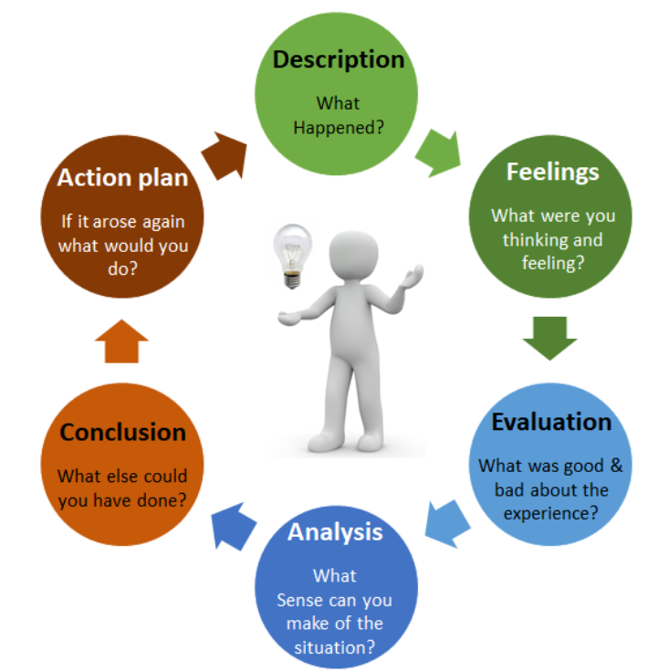
Figure 2.1: Gibbs reflective model
(Source: Dutta, He and Tsang, 2023)
1. Description
Through this module, I covered different leadership traits and styles that really affected my knowledge about leadership. Traits discussed include adaptability, emotional intelligence, and decision-making ability (Alzoubi and Aziz, 2021). I covered styles, ranging from transformational to transactional. One of the very interesting concepts I came to learn was emergent leadership, which is the phenomenon when leaders naturally emerge in the group setting through the manner in which they solve issues, influence others, and make appropriate decisions. As such, I reflected with these concepts in mind over my experiences, especially over my previous leadership roles in the customer service and teamwork settings.
2. Feelings
When I started the module, I was not sure how these theories on leadership would play out in my personal experiences. I had seen leadership in a more traditional manner, where formal authority and hierarchy were key. However, as we moved into emergent leadership, I started to feel a sense of confidence in my own ability to recognize leadership potential in informal settings. It was particularly appealing to me how emergent leadership allowed me to understand that leadership can come from qualities such as empathy, initiative, and collaboration rather than through positional power.
3. Evaluation
Looking back, I realise that what I have been developing - the leadership traits - would have had positive impacts. For instance, my high emotional quotient, which the module discussed, enables me to understand and control my feelings as well as those of others. This aspect has made me effective in group settings, especially when there is diversity in the group. On the other hand, I also understand that sometimes I have difficulty with delegation, which is a core competency for effective leadership because I tend to overdo things. This can cause burnout and missed opportunities for growth within the team (Speicher and Francis, 2022). Leadership skills learned in this module highlighted areas where I need to further develop, especially trusting others to take on more responsibility.
4. Analysis
In consideration of the leadership styles presented within the module, I can say that transformational and servant leadership have made me shift my approach. Prior to this, I leaned toward more directive, transactional types where clear tasks were defined, with outcomes strictly measured. Emergent leadership is actually being able to be flexible and facilitating collaboration. For instance, during the last group project, I made sure to motivate my fellow mates, listen actively to their ideas, and encourage them to contribute. This made for a more harmonious team environment and allowed us to complete the project more efficiently (Chen et al. 2021). This experience taught me that leadership does not necessarily have to be about control but empowering others. As another realisation about leading, the importance of awareness and self-reflection would be significant. I think that the emergent role of a leader is something that calls for not just ability to influence others but at the same time, assessment with feedback or ways to better oneself. Becoming open to change and an effective leader in different aspects due to making use of feedback and understanding action.
5. Conclusion
In summary, this module has deeply impacted my personal leadership development. I have learned to understand more deeply the different traits and styles of leadership, particularly emergent leadership, which puts so much emphasis on flexibility, emotional intelligence, and teamwork. Indeed, while I have come a long way, I know that the art of leadership is not static. I still need to improve in certain areas such as delegation and building trust among members of my team. Applying forward, these lessons I will apply to my projects at school and future roles in the professional world with an emphasis on promoting teamwork, listening actively, and allowing others to lead when it is appropriate.
6. Action Plan
In order to develop my leadership further, I intend to do the following:
- Ask my peers and mentors to provide feedback regarding areas of improvement, specifically delegation and team management.
- Be an active listener in all team engagements to get a better sense of the other people's perspectives and create a more inclusive environment (Jonsdottir and Kristinsson, 2020).
- Take on leadership roles outside of the classroom, such as student organisations or charity work, to further develop my emergent leadership skills in different settings.

Conclusion
In a nutshell, this module has been instrumental in enhancing my understanding of leadership, especially in relation to emergent leadership. The experience gained so far has shown me that leadership does not have to be defined through authority; instead, it arises through empathetic tendencies, self-awareness, and collaborative work. In general, I can attest to making a better understanding of myself on matters like delegation and building trust with others. Moving forward, I'll be using these leadership skills in other areas of life, looking for feedback as often as possible, and seeking to challenge myself within the realm of academic and professional life by taking on additional leadership roles.

References

Part 1-Academic Report
Albejaidi, F., Kundi, G.M. and Mughal, Y.H. (2020) ‘Decision making, leadership styles and leadership effectiveness: An amos-sem approach’, African Journal of Hospitality, Tourism and Leisure, 9(1), pp.1-15. Available at: https://www.ajhtl.com/uploads/7/1/6/3/7163688/article__23_vol_9_1__2020_saudi_arabia.pdf
Anwer, S.A., Mohammad, A.J., Abdulrahman, B.S., Qader, K.S., Jamil, D.A., Gardi, B. and Khalid, K. (2022) ‘Leading Project teams: The role of leadership styles in dynamic work environment’, International Journal of English Literature and Social Sciences, 7(6), pp.022-028. Available at: https://dx.doi.org/10.22161/ijels.76.4
Armstrong, M. (2024) The British View on World Leaders. Available at: https://www.statista.com/chart/25648/gb-net-favourability-world-leaders/
Biea, E.A., Dinu, E., Bunica, A. and Jerdea, L. (2024) ‘Recruitment in SMEs: the role of managerial practices, technology and innovation’, European Business Review, 36(3), pp.361-391. Available at: https://www.emerald.com/insight/content/doi/10.1108/ebr-05-2023-0162/full/html
Butt, J. (2020) ‘A strategic roadmap for the manufacturing industry to implement industry 4.0’, Designs, 4(2), p.11. Available at: https://doi.org/10.3390/designs4020011
Canavesi, A. and Minelli, E. (2022) ‘Servant leadership and employee engagement: A qualitative study’, Employee responsibilities and rights journal, 34(4), pp.413-435. Available at: https://doi.org/10.1007/s10672-021-09389-9
Chen, J., Ghardallou, W., Comite, U., Ahmad, N., Ryu, H.B., Ariza-Montes, A. and Han, H. (2022) ‘Managing hospital employees’ burnout through transformational leadership: the role of resilience, role clarity, and intrinsic motivation’, International journal of environmental research and public health, 19(17), p.10941. Available at: https://doi.org/10.3390/ijerph191710941
Colasante, P. (2023) ‘Effective leadership of intergovernmental relations’, In Global Encyclopedia of Public Administration, Public Policy, and Governance (pp. 3649-3654). Cham: Springer International Publishing. Available at: https://doi.org/10.1007/978-3-030-66252-3_3597
Dang, C.T., Volpone, S.D. and Umphress, E.E. (2023) ‘The ethics of diversity ideology: Consequences of leader diversity ideology on ethical leadership perception and organisational citizenship behavior’, Journal of Applied Psychology, 108(2), p.307. Available at: https://psycnet.apa.org/doi/10.1037/apl0001010
Davies, K. (2024) Contribution of leadership to employee retention in Germany, Switzerland, and Austria in 2023. Available at: https://www.statista.com/statistics/1414760/leadership-employee-retention-gsa-region/
Dubey, P., Pathak, A.K. and Sahu, K.K. (2023) ‘Assessing the influence of effective leadership on job satisfaction and organisational citizenship behaviour’, Rajagiri Management Journal, 17(3), pp.221-237. Available at: https://www.emerald.com/insight/content/doi/10.1108/RAMJ-07-2022-0108/full/html
Fleck, A. (2024) Global Leadership: Forces of Good or Ill?. Available at: https://www.statista.com/chart/33310/views-on-which-countries-use-their-influence-for-good-or-ill/
Ford, T.G., Lavigne, A.L., Fiegener, A.M. and Si, S. (2020) ‘Understanding district support for leader development and success in the accountability era: A review of the literature using social-cognitive theories of motivation’, Review of Educational Research, 90(2), pp.264-307. Available at: https://journals.sagepub.com/doi/abs/10.3102/0034654319899723
Fox, C., Davis, P. and Baucus, M. (2020) ‘Corporate social responsibility during unprecedented crises: the role of authentic leadership and business model flexibility’, Management Decision, 58(10), pp.2213-2233. Available at: https://www.emerald.com/insight/content/doi/10.1108/md-08-2020-1073/full/html
Gardner, W.L., Karam, E.P., Alvesson, M. and Einola, K. (2021) ‘Authentic leadership theory: The case for and against’, The Leadership Quarterly, 32(6), p.101495. Available at: https://doi.org/10.1016/j.leaqua.2021.101495
Hilton, S.K., Arkorful, H. and Martins, A. (2021) ‘Democratic leadership and organisational performance: the moderating effect of contingent reward’, Management Research Review, 44(7), pp.1042-1058. Available at: https://www.emerald.com/insight/content/doi/10.1108/mrr-04-2020-0237/full/html
Ismail, F. and Owaida, N.I. (2023) ‘Addressing Workplaces Burnout’, Advances in Humanities and Contemporary Studies, 4(1), pp.116-125. Available at: https://penerbit.uthm.edu.my/periodicals/index.php/ahcs/article/view/11290
Jensen, M., Potočnik, K. and Chaudhry, S. (2020) ‘A mixed-methods study of CEO transformational leadership and firm performance’, European Management Journal, 38(6), pp.836-845. Available at: https://doi.org/10.1016/j.emj.2020.05.004
Jha, I.N., Pal, D. and Sarkar, S. (2024) ‘Unlocking the secret to happiness at work: the power of inclusive leadership, organisational justice and workplace inclusion’, Journal of Management Development, 43(2), pp.200-221. Available at: https://doi.org/10.1108/JMD-04-2023-0136
Knights, J. (2022) ‘Ethical leadership: How to develop ethical leaders’, In Transpersonal Leadership in Action (pp. 35-46). Routledge. Available at: https://www.taylorfrancis.com/chapters/edit/10.4324/9781003150626-5/ethical-leadership-john-knights
Laig, R.B.D. and Abocejo, F.T. (2021) ‘Change management process in a mining company: Kotter’s 8-step change model’, Journal of Management, Economics, and Industrial Organisation, 5(3), pp.31-50. Available at: https://doi.org/10.31039/jomeino.2021.5.3.3
Larasati, A.P. and Martono, S. (2020) ‘Increase employee morale through transformational leadership, employee relation, and work environment’, Management Analysis Journal, 9(1), pp.1-7. Available at: https://doi.org/10.15294/maj.v10i1.34088
Leithwood, K. and Jantzi, D. (2005) ‘Transformational leadership’, The essentials of school leadership, 31, p.43. Available at: https://www.torrossa.com/en/resources/an/4913596#page=54
Nanjundeswaraswamy, T.S. and Swamy, D.R. (2014) ‘Leadership styles’, Advances in management, 7(2), p.57. Available at: https://www.researchgate.net/profile/Dr-Nanjundeswaraswamy-2/publication/272509462_Leadership_styles/links/5b5e8707458515c4b25226d6/Leadership-styles.pdf
Paais, M. and Pattiruhu, J.R. (2020) ‘Effect of motivation, leadership, and organisational culture on satisfaction and employee performance’,The journal of asian finance, economics and business, 7(8), pp.577-588. Available at: https://doi.org/10.13106/jafeb.2020.vol7.no8.577
Páez Gabriunas, I. (2023) ‘Ethical Leadership’, In Encyclopedia of Business and Professional Ethics (pp. 760-765). Cham: Springer International Publishing. Available at: https://doi.org/10.1007/978-3-030-22767-8_55
Saks, A.M. (2022) ‘Caring human resources management and employee engagement’, Human resource management review, 32(3), p.100835. Available at: https://doi.org/10.1016/j.hrmr.2021.100835
Schiuma, G., Schettini, E., Santarsiero, F. and Carlucci, D. (2022) ‘The transformative leadership compass: six competencies for digital transformation entrepreneurship’, International Journal of Entrepreneurial Behavior & Research, 28(5), pp.1273-1291. Available at: https://doi.org/10.1108/IJEBR-01-2021-0087
Seeling, M.X., Kreuter, T., Scavarda, L.F., Thomé, A.M.T. and Hellingrath, B. (2021) ‘Global sales and operations planning: A multinational manufacturing company perspective’, PloS one, 16(9), p.e0257572. Available at: https://doi.org/10.1371/journal.pone.0257572
Sethuraman, K. and Suresh, J. (2014) ‘Effective leadership styles’, International Business Research, 7(9), p.165. Available at: https://pdfs.semanticscholar.org/d2a2/528ddffc694b43fd5bcf3c68826de4da2eb3.pdf
Singh, A., Lim, W.M., Jha, S., Kumar, S. and Ciasullo, M.V. (2023) ‘The state of the art of strategic leadership’, Journal of Business Research, 158, p.113676. Available at: https://doi.org/10.1016/j.jbusres.2023.113676
Viterouli, M., Belias, D., Koustelios, A., Tsigilis, N. and Papademetriou, C. (2024) ‘Time for change: Designing tailored training initiatives for organisational transformation’, In Organisational Behavior and Human Resource Management for Complex Work Environments (pp. 267-307). IGI Global. Available at: 10.4018/979-8-3693-3466-9.ch014
Volk, S.C. and Zerfass, A. (2020) ‘Alignment: Explicating a key concept in strategic communication’. Future directions of strategic communication, pp.105-123. Available at: https://doi.org/10.1080/1553118X.2018.1452742
Wijsen, L.D., Borsboom, D. and Alexandrova, A. (2022) ‘Values in psychometrics’, Perspectives on Psychological Science, 17(3), pp.788-804. Available at: https://journals.sagepub.com/doi/full/10.1177/17456916211014183

Part 2-Reflective Essay
Alzoubi, H.M. and Aziz, R. (2021) ‘Does emotional intelligence contribute to quality of strategic decisions? The mediating role of open innovation’, Journal of Open Innovation: Technology, Market, and Complexity, 7(2), p.130. Available at: https://doi.org/10.3390/joitmc7020130
Chen, S., Fan, Y., Zhang, G. and Zhang, Y. (2021) ‘Collectivism-oriented human resource management on team creativity: Effects of interpersonal harmony and human resource management strength’, The International Journal of Human Resource Management, 32(18), pp.3805-3832. Available at: https://doi.org/10.1080/09585192.2019.1640765
Drysdale, L. and Gurr, D. (2017) ‘Leadership in uncertain times’, International Studies in educational administration, 45(2), pp.131-159. Available at: https://www.academia.edu/download/59405559/Leadership_in_Uncertain_Times_Lawrie_Drysdale_David_Gurr20190527-61251-nu11qz.pdf
Dutta, S., He, M. and Tsang, D.C. (2023) ‘Reflection and peer assessment to promote self-directed learning in higher education’, Journal of Educational Research and Reviews, 11(3), pp.35-46. Available at: http://www.sciencewebpublishing.net/jerr/archive/2023/March/pdf/Dutta%20et%20al.pdf
Jonsdottir, I.J. and Kristinsson, K. (2020) ‘Supervisors’ active-empathetic listening as an important antecedent of work engagement’, International Journal of Environmental Research and Public Health, 17(21), p.7976. Available at: https://doi.org/10.3390/ijerph17217976
Speicher, L.L. and Francis, D. (2022) ‘Improving employee experience: reducing burnout, decreasing turnover and building well-being’. Clinical Gastroenterology and Hepatology, 21(1), p.11. Available at: https://doi.org/10.1016/j.cgh.2022.09.020

