Kichka Koleva
Student Number 1817698
M4X01917 – Business Skills
Lecture Dale Clarke


Table of Contents
Introduction...................................................................................................2
Analysis and Discussion..................................................................................2
Data Protection...........................................................................................2
Health and Safety........................................................................................3
Food Hygiene...............................................................................................3-4
Risk Management........................................................................................4
Licensing.......................................................................................................5
Including key provisions within Hotel Proprietors Act 1956........................6
Conclusion........................................................................................................6-7
References........................................................................................................7

Introduction
Before you to become a hotelier you will need to discuss quite a few laws, adjustments and codes. You will encounter the dangers of bureaucracy pertaining to the various licenses, rules to food hygiene and fire regulations. It is not easy to manage a hotel under the pressure of all these lows and rules, provided that if there is a mistake, then there is no excuse in the eyes of the law. When we talk about data security, there are a few sections to which the people in hotel industry need to pay attention. The constant use of a passport as well a personal and credit card in hotels is currently one of the most important for violating the protection of personal data. Personal data should be gather for particular and allowable purpose. Personal data such as email address provided during the reservation cannot be used for contradictory purpose and subsequently used without later consent by the email marketing client at a later stage.

Analysis and Discussion

Data Protection

(2000) Boella, M. J., Boella, M. and Pannett, A. “The Data Protection Act 1988 (following the 1984 Act) protects individuals from the misuse or unauthorized use of personal data, including expressions of opinion about him which is stored on computers or in some other form, e.g. paper-based records.”
Storing customer and partner data must be comply with the new requirement from May 2018. The requirements for the storage of personal data, entered with GDPR (General Data Protection Regulation), are related to organizational and technological measures as well as measures for storing information.

Health and Safety

According to Health and Safety at Work Act 1974 (HASAWA) employers must ensure a safe and healthy working environment of all their employees. The rules set up minimum requirements, including general principles for:
-Prevent/eliminate the risk and the accident factors
-Providing adequate information and training for employers and employees
-Introducing measures to prevent dangerous situations such as providing First Aid
-Appointing one or more trained staff members to monitor compliance with these measures
Although the author Hunt (2018) “Guidance notes have no legal status and are not generally, admissible as evidence in criminal proceedings.” we need to consider those Guidance notes (HSE) that are issued in six specific ranges:
*General safety
*Chemical safety
*Environmental hygiene
*Medical
*Plant and machinery
*Health and safety

Food Hygiene

Foot hygiene and treatment is a pretty serious topic that affects our lives. Whether we work at place where food is processed, or we are guests at an institution where they serve us dishes, the good food quality is essential. The reason is that guests and all consumers as well as those who offer food can be protected from food poisoning and malnutrition.
Foot hygiene consists of three parts:
-Personal hygiene- Maintaining a high level of personal hygiene such as clean clothes, clean nails, and good hand hygiene is a must for everyone who works with food.
-Hygienic trainings-It is desirable that all staff handling food must be well trained in occupational hygiene appropriate to the work they do.
-Accommodation- proper food hygiene guarantees that the food provided to customers will be safe to eat. Results from serious illness and poisoning enable hotels to comply with the law and therefore protect the reputation of their businesses.
Gordon-Davis, L. (1998) “The Health Act regulates all aspects of the hygienic handling of food by stipulating how people should be clean, the clothing to be worn, provision of washing facilities, soap and nail brushes, and when smoking is allowed, among other aspects.”

Risk Management
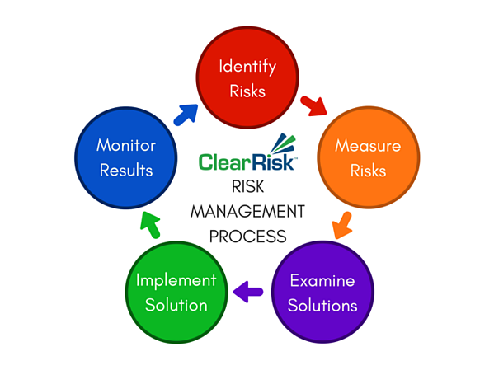
Hopkin, P. (2013) “Risk management is a set of activities to ensure the best possible outcome after the event and/or achieve the most predictable consequences.”
According to the author hazards are future terms or occasions beyond the oversight of the project team that could have a negative influence on the project should they occur. Risk management policy should ensure information of the methods taken to risk allowance and management schemes.
Risk management is a process. As Wolke ( ) says “Risk management is a dynamic process and not a one-time event (static).” We can spread the management risk in several stages:
-Risk identification-(Here are included all the economic risks).
-Risk measurement/Risk analysis (Volatility, Sensitivity)
-Risk controlling (Planning, Control, Information, Coordination)
-Risk control/steering (Provision, Shifting, Compensation, Diversification)
-Risk mitigation (Monitoring, Risk mitigation presses, Risk prevention tactics, Contingency plans)

Licensing
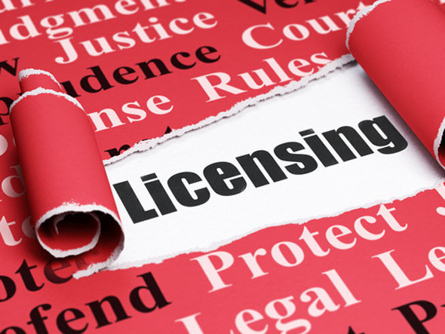
There is various state and local authorities in the hotel business, for which complex and detailed licensing is required. Due to public health and safety concerns, enterprises in this industry need to be closely monitored by checking the controls and law enforcement. Every hospitality institution has to be correctly licensed before to be opened. We will look on few types of licensing in Hotel Industry:
-TV licensing
Hotels, hostels, mobile units and campsites, who can offer television viewing, must have a valid TV Licence.
-Alcohol and entertained license
“Businesses, organisations and individuals who want to sell or supply alcohol in England and Wales must have a licence or other authorisation from a licensing authority - usually a local council.” (Alcohol licensing.gov.uk 2019)
We can define different type of licensing: Premises license, Personal license, Club premises certificate
-Food license
“You must register every premise where you carry out food operations, including your home, and mobile or temporary premises such as stalls and vans.” ( Food business registration-gov.uk 2019)
Food activities include: Selling food, Cooking food, Storing or handling food, Preparing food, Distributing food. In order to ensure citizen’s health and safety we need to have suitable food room, proper instructions on how to prepare the food and sewerage.

Including key provisions within Hotel Proprietors Act 1956.
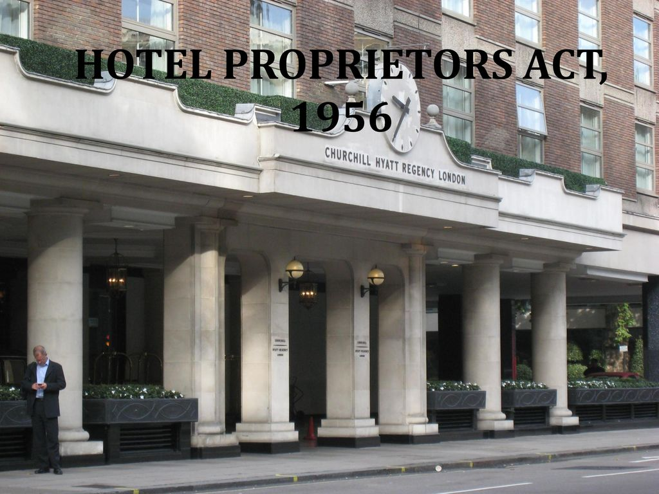
“Under the Hotel Proprietors Act 1956, an hotel proprietor may in certain circumstances be liable to make good any loss of or damage to a guest’s property even though it was not due to any fault of the proprietor or staff of the hotel.” (Legislation.gov.uk, 2019)
According to this Act the meaning “hotel” is institution where the owner suggest food, drink and if is necessary accommodation and there is no need to have a special contract for each passenger who seems capable and ready to pay acceptable sum for the services supplied by the establishment.
The Hotel Proprietors act 1956 is being presented to exchange previous legislation and to restrict the responsibility of hotels in case of loss or damaged to property belonging to citizens. It is significant to keep in mind that this law restricts the responsibility of the hotelier, but does not protect them from guarantee insurance for loss or damage to residence properties. Securing this insurance enables the prevention of claiming that can result in significant financial losses for the hotelier.

Conclusion:
Summarizing what has been said so far, we come to conclusion that the increased consumption of information technology and the internet ensure that data protection is one of the most important laws that online business should be guided by. The internet is all about sharing information and this information we need not only to use but also to collect it. Therefore, organizations must consider how they collect and store personal data in compliance with the law and thereby protect customers and prevents information from leaking in the wrong direction. The same time we must not forget about the health and safety on the workplace. Employers must take care of appropriate working conditions providing protect from hazards and accidents of their employees accordingly, for everyone else who is in direct contact with their business.
Every hotelier must guarantee food safety. Only if we share the responsibility with everyone who has a professional to consumer relationship we can guarantee quality food and service. The best way to control food safety is to have the right information about the origin of food such as natural processes and especially the dangers of chemical foods-both naturals and environmental.

References
Alcohol licensing.gov.uk. (2019).(online) Available at https://www.gov.uk/guidance/alcohol-licensing (Accessed 09 AUG 2019 6pm)
Boella, M. J., Boella, M. and Pannett, A. ( 2000 ) “Principles of Hospitality Law”, United Kingdom: Cengage Learning EMEA
Food business registration-gov.uk. ( 2019) (online). Available at https://www.gov.uk/food-business-registration ( Accessed 11 AUG 2019 11.30pm.)
Hopkin, P. (2013) “Risk Management”, United Kingdom: Kogan Page Publishers
Hunt, G. (2018) “Health and Safety Pocket Book”, United Kingdom: Routledge
Gordan-Davis, L. (1998) “The Hospitality Industry Handbook on Hygiene and Safety”, United Kingdom: Juta and Company Ltd
Legislation.gov.uk. (2019). Hotel Proprietors Act 1956. [online] Available at: http://www.legislation.gov.uk/ukpga/Eliz2/4-5/62, (Accessed 09 AUG 2019, 1pm)
Wolke, T. (2017) “Risk Management”, United Kingdom: Walter de Gruyter GmbH & Co KG

