

Advanced Diploma in Logistics and Transport

M3X9408
Leadership & Strategic Management In Logistics & Transport

Student: P121168 Adrian Carruthers

Lecturer: Guy Edwards

I declare that this assignment is all my own work and that I have acknowledged all materials used from the published or unpublished works of other people. All references have been duly cited.
Introduction

The conceptual area of the business in that it is aimed to path the way to a market, to analyse the needs of the consumer. A main point of the model is not that which concerns the value proposition, revenue and costs, however outlines the architecture in these areas (Teece 2010). We start by discussing the need for the Business model, when we talk about the model we can refer this closely linked to the organisations dimension, innovation and interlinking this to a varied of activities within cross functioning.

Moreover, strategy a key concept in the process, i.e. what, where, when and why do we need innovation. We need then to consider the varies types of strategy, where can we see ourselves in the next few years? Time, trends, technology, resources and above all local and global economies change, and because time cannot be realised immediately we therefore need to look at the direction and or destination direction based on the competitive advantage and destination based on a value proposition, (providing a unique benefit for a product, service). Within this formulating a strategy/model should offer uniqueness together with business plan fitting to the organisations capability and environmental opportunities.

In short, the model aims to take technological characteristics and potential together with economic value creation to reconfigure current dynamics in strategic management. Creating innovation provides a framework through its customers and markets to create value through inputs and outputs and a device to mediate and capture development and investment (H. Chesbrough, R.S. Rosenbloom).

This business model aims to bring about the induction solely in the electric transportation methods of which are in part are currently available to a level. Within the cycle industry that in cases can reduce and encourage environmental awareness, reducing congestion and encourage alternative methods to that of distance travel around major cities.

The issue

Today we see the ever decreasing in areas of parking, this can be due to congestion, property ownership, more and more commercial areas being developed and further housing needs for more growing populations. Japan already have plans to develop raised public roads, this to enable more speed at ground level in public transport such as buses and trams.

The same problem exists in the London, United Kingdom where population levels are set to increase. Over the last decade this increased by 80 000 per year 2013 and according to Val Shawcross of the Rockefeller Foundation, set to increase a further 20 000 thus reducing regulated public transport further to covering just 20% more at 20 miles where it stood at 109 miles previous approx. Straight away we can identify a 39% increase in 5 years 2013 – 2018, 7.7 million to 10.657 million where forecast identified this at 100 000 per year. An increase of 2.96 million, so the estimate of 8.2 million 2018 has an error of 23%.

Currently there is a major problem in the UK in terms of transport ownership, everyone needs to get somewhere quicker and as easy as possible. Whilst the growth in roads are low compared to the increase in cars and public transport, it could be feasible to assume to ban cars within a 5-mile radius of town centres, increase cyclists’ access and prevent unnecessary fatalities and injury within busy urban environments such as London. If we compare Amsterdam with a lower density per square KM and higher cycle ownership and usage it could be a factor in the Lower fatalities with almost triple the fatalities in London. Furthermore, we could increase/encourage cycle innovation to push the need for more access and less noise and environmental pollution.

For this reason, I suggest the business model built around the increase of electric driven cycle to work scheme and charging units.

The business models

Evans cycles is a main leading promoter/seller of alternate methods of travel in the UK, and unlike the continent where increases in sales of e-bikes are evident, currently more bikes in the Netherlands than there are population, and at least 40% use this method of travel to work. In the US this increased from 2006-2013 by 40% also in the UK this does not have the same effect however according to sources the UK are expecting a boom in sales over the next few years, which will possess further problems particularly in city centres and for many reasons. The convenience of the car, lack of infrastructure for cycles and what is most surprising is that only 1.9% use the cycling as a means of traveling to and from work.

To aid in challenging this we the model presented needs to consider variables in all aspects of heading and subheadings to start I have created a Business to
Costs

To set the model good leadership on the current situation, in that tactfulness awareness and situation awareness, tactfulness being the need for change over a 5-year period say. This allows a culture change, hard to imagine considering owning a vehicle in the UK most consider this a necessity and more a means of distance usage. Agreeable in the short term however we only need to look at the like of Germany, Holland and the like. So, pushing the idea through parliament via advertising and contact with potential partners like Transport, Environment and HSE through. As mentioned previous culture is already changing, but vehicles are also, and yet roads aren’t at the same figure. Analysis of Cycling Potential Policy Analysis Research Report 2010.

A cultural transformation comes about by being one of the following leadership styles or a mix:

- Coercive
- Authoritative
- Affiliative
- Democratic
- Coaching
- Pace-setting

But the model is also asking for a culture change, for this model we would consider the visionary (Authoritative) leadership style. This because the effective change over a period requires policy makers and visionaries which can only be done time and regular feedback from public bodies and public. A means of assessing this through leadership of change and not transactional, (making things happen) through slowly alignment of behaviour, policy and implementation and strong political leadership. Esther Cameron & Mike Green 2008. Through time analysing variables such as:

- Discomfort (Resisting Prevailing wisdoms)
- Buy-in (Motivation and engage in seminars and public opinion, commanding interest and shared visions)
- Connectivity (understanding and sharing a common value (environment)
- Projects (consistency and reliability through control system to monitor and evaluate at each stage in the plan)
- Design (supply chains structure, loyalty programmes and enhanced cycle to work schemes)

Internally we ask ourselves why we are here, whom we serve and our future. To achieve and influence strategic thinking and adopting the Model we continuously reinforce Vision, Mission and Value. Our Ethical value in the UK is to seek the rights thing under conditions such as climate and economy, culture and society however providing enough space for all is a task, but also getting all to use a friendlier environmental mode of transport (the right thing to do). Although introduced already we need to encourage more stakeholders like TFL to partner their own idea with the concept of helping those less able to use the e-cycle concept.

This done by specific tangible to aspirational concepts we use action on and in Key Performance Indicators (KPI). Setting objectives and progression sequencing to setting progression areas, market trends focus points and of course capabilities. A key area is where we wish to be the vision. Focussing in on the current plan of TFL we bring the added technology that encourages not only urban use, but because of the concept of e-cycle will allow less confident and fit persons to use. This again is encouraging the buy in aspect, although more expensive in the short term, long term will indeed in particular London provide a means of saving commuters monies.

Economics and benefits

Looking at some in CO2 emissions measurements, Government data 2017 states that on average a car new puts out 122.1g per KM to the environment, a bike has nil.

An average of 253 days per year commuting =927kg of CO2

The average e-cycle cost 1000-4000 pounds pending type and Battery cell, battery cell 3-5years lifespan. 2500/4 = 625/253 =2.47 per day.
Car and fuel of a new car = average distance of 30 km a day @ 1.50 litres a day and 253 commuting days in a year equal to 380 litres - At £1.30 average litre we find a total of £570 per year on fuel. Then the price of the cheapest car, service, tax and faults we can see the e-cycle is a good alternative. As for train annual tickets in cities, these are averaged at £5000 in London alone@ nearly £20 per day and rising (Merlin Cycles).

Communication channels

A key area of the model also is moral values and communication channels. For the model to work we need to effectively communicate, this will build moral, customer loyalty, but also if things go wrong, doing the right thing will reduce criticism but overall inform the community. In creating a standard subject to criticism within brings growth and future empowerment to youth but also a means of creating cohesion to the end outcome.

Ethically we could assume that all will to buy into the model and that all will conform to any standard publicised over the years, however it would be unethical to only consider only cycle lanes, morally it could not be accepted unless Law a is created. The problem lies when morality does not conform to one’s ethical thoughts. So, for the nature of the model the cooperate responsibility would be to say morally we are going to aid in the full endorsement of cycling to work via an enhanced payment scheme, but ethically we cannot presume all have the means to adopt this. In a law possibly made it is ethically correct to pass a law make it happen, morally commuters may not like this particularly car users.

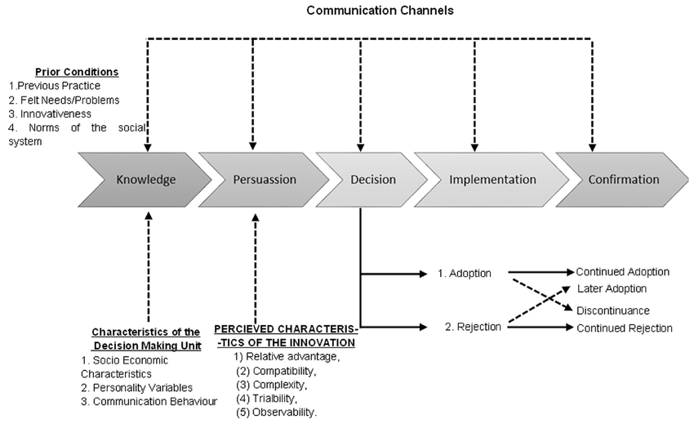
Fig.1

https://www.researchgate.net/figure/A-Model-of-Five-Stages-in-the-Innovation-Decision-Process-Source-Diffusion-of_fig3_281060763

So, it is of highest importance that the model communicates to all communities and effectively, building over time and input allows variables in human perception to adjust through a leadership strategy, Fig.1. In terms of trust within the importance to any change, the empowering through the conceptual framework, the five stages on innovation and decisions process. This creates openness to dissent, accepting minority views and creates unity improving decision making, aids in the innovation and clarity of the forward route to take.

Empowering to meet the objective, as before whilst being Autocratic to push the model to the relevant parties within the establishment/business it is important to remain a mixture of certain areas of leadership where required. Charismatic in the perhaps transformation of the adaptive business, bureaucratic in terms of following rules such as the health and safety, the implementation and advertising of the product and democratic, where encouragement evolves through unity of specific areas such as ethical values in attaining the common goal. This type allows for a higher job satisfaction because of the input put forward from all employees.

Varies ways to measure and monitor this externally via a five stage of the decision innovation process (Fig.2). To target the consumer or stakeholder, promotion through advertisement and trials, we do this through e-commerce through employee development seminars, where each major retailer already mentioned would trial from government funding as discussed in TFL analysis of cycling potential to be realised 2026.

The incentive to the stakeholder/commuter is a trial based on a 2-year period where anyone owning a car, using public transport other than train and bus to either:

Option one: have current cycle modified to accompany the e-cycle revolution at a cost of 60%@£700 average@£420 where the current cycle to work scheme hire the units, the unit in this case would be to keep saving the customer £420-£570 on fuel alone on a car £150, and thousands on a travel warrant by train.

Option two would be to purchase hire purchase to keep again the entire unit, this comes with aftersales services, warranties, promotion to brand names etc. Currently 10% is save by the company on the Cycle to work scheme on £800, however the average e-cycle is £2500. This over a two-year period interest free @24/2500=£104 if we compare this to 253 commuting days@253/12=21 days per month, on average @£20 per day on public travel, 21*20 = £420 per month, then the incentive here apart from a better health is of by far price on the pocket and the environment. Furthermore, the input from government could have far more of an impact where the recycling of old unit offers a better discount.

The government incentive as pointed out in the report would offset the deficit in part modifications.

To provide commitment from the retailers to the stakeholder interest free period would be available on e-cycle promotional periods, ore over an acceptance model would be monitored and evaluated. The hypothesis in this would be:

- The perceived usefulness
- The perceived ease of use
- The perceived enjoyment

Which could use later to discuss, and data analyse the question if this was of perceived positive use and the consumer intention.

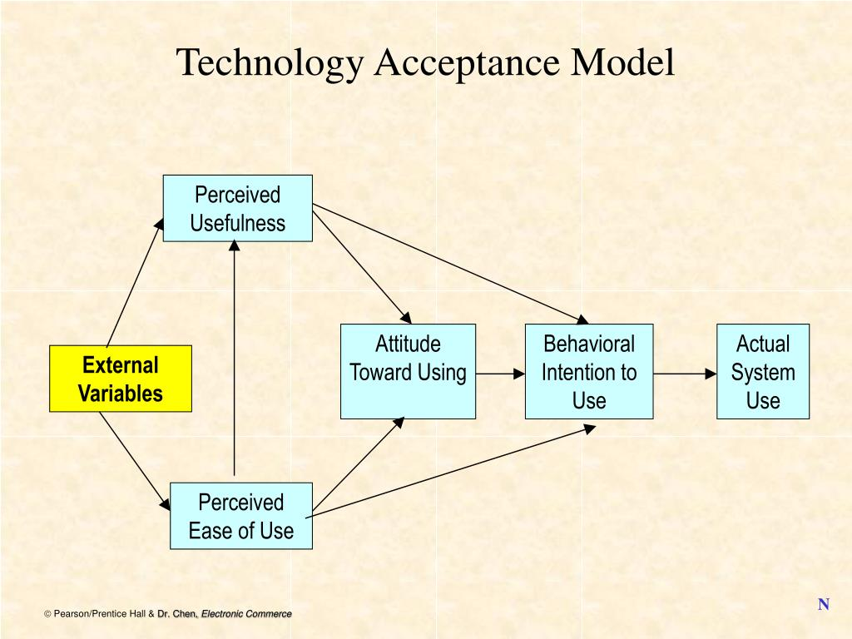

Fig.2.

http://www.slideserve.com/Rita/chapter-14-e-commerce-strategy-and-global-ec

The impact and social aspect

The change curve

Employing the correct method of leadership is key to any transactional occurrence whether be it policy at the highest level to a structure suitable to be able to carry out the tasks explained. Kurt Lewin’s three-step procedure:

- Unfreezing
- Moving
- Refreezing

In this scenario Egan 1998 describes this as

- Diagnosing (Current, preferred and strategy for the preferred scenario)
- Visioning (Transition, Tactics employed)
- Planning (Consolidation and implementation)

The human acceptance however can be seen by using Kotter’s change curve and the emotional aspect socially. By analysing at each stage in any process over time change exists by acceptance by setting target dates for implementation and the building bricks for the change timeframe. This of course comes with its own problems for example the Brexit Campaign (Fig.3). Over the last 2 years we have seen a decline in promises made by leaders in what people thought was. However, the partners in this right or wrong have accepted varied change offers where others have been misled and or rejected nevertheless recently we have seen strong optimism and a realisation that time s the key factor, pulling together, stakeholders’ values, policy practicalities are of some concern also. Having said this I think that time, value and above all a leadership core strength will prevail or will have to, to achieve the final goal of the stakeholder. (John Hayes. 2002)

We can see this through Kotter’s change curve (Fig.4) internally acceptable externally the span of control and effectiveness may take more time to adjust or indeed diminish.

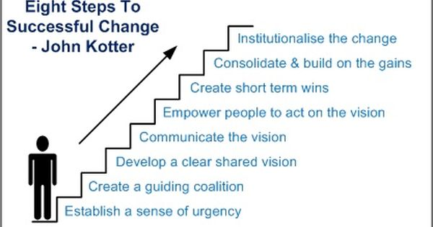

Fig.3

https://www.pinterest.com/pin/130393351681955003/

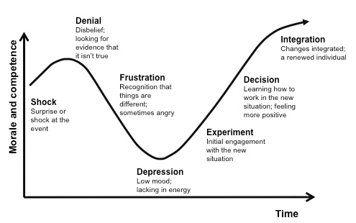
Fig. 4

http://keywordsuggest.org/1298-kotter-change-curve.html

Conclusion

Throughout the essay I have tried to build the model in Fig.5 around the idea and similar aspect that TFL vision for the future, not a direct immediate model or product but a future scenario and personal vision on the way major cities are heading or rather must head to sustain. The model is intended to perceive and encourage amicable views to aid in the decision-making process before policy is address and or changed. Reflection on ideals and the real-world, however in reality is designed to take time and bring in the views of trials slowly. By addressing what is already happening in other major cities I feel London will struggle to achieve this however, a strong leadership strategy and buy will aim to change perceptions although a vast experimentation plan would have to address further aspects and areas for example access and road restructuring.

KEY PARTNERS  Department for Transport  HSE  Environment agency  Department for Digital, Culture, Media & Sport  Chain reaction  Evans  Wheelbase  Department for Education  Department of Health & Social Care  Ministry of Housing, Communities & Local Government  Government Legal Department  Finance | KEY ACTIVITIES  Advertisement/product promotion  Set seminars  Emails/Contacts  Commercials  Consulting  Training  Regulations  Network Management  Service trials  Databases running  Integration | VALUE PROPOSITIONS  Simple to use  Fast & safe  Financial gain/inexpensive  Health gains  Environmentally friendly  Variety  Tailored to use  Movement around town  Risk reduced  Loyal services  Warranties  Repairs | CUSTOMER RELATIONS  Interaction  Communities  Switching costs  Dedicated sales consultants  Technical support  Discounts  Self service via apps  Trial  Rentals (try before you buy)  Help in configuration  Press coverage | CUSTOMER SEGMENTS  Brands  Providers  Internet users  Enterprises  Proximity  Inspiration  Families and children  Existing markets  Design
 | KEY RESOURCES  Partnerships  Funding  Supply chains  Deliveries service  Staffing  Expertise  Stock  Credit  Experience |  | CHANNELS  B2B  Hotel/travel  Websites  Word of mouth  Media  Advertising/green  Flyers /leaflets  Live feeds/set up DIY  Product awareness  FB/YT
COST STRUCTURE REVENUE STREAMS

Strategic partners Direct sales
Marketing Online sales
Brands Configurations
Events Complete sales
Initial costs Pricing mechanisms
Operating cost existing and future if any Trade in/Trade offs
Returns Revenue/Margins/life time value
Development Payment models

Fig 5. Business Model canvas: E-Cycle by Adrian Carruthers

Word count: 2588

Reference:

Chesbrough, Henry; Rosenbloom, Richard S. Industrial & Corporate Change. Jun2002, Vol. 11 Issue 3, p529-555.

COLIN WHITE., 2004. Strategic Management. GB: Palgrave Higher Ed M.U.A.
TEECE, D.J., 2010. Business Models, Business Strategy and Innovation. Volume 43, Issues 2–3, April June 2010, Pages 172-194

ESTHER CAMERON & MIKE GREEN., 2008. Making Sense of Leadership. GB: Kogan Page Ltd.

JOHN HAYES., 2002. Theory and Practice of Change Management. GB: Palgrave Higher Ed M.U.A.

Masanell R C, Ricart, J A 2009, The business model (the logic of the firm)

TONY KIPPENBERGER., 2002. Leadership Styles. US: Capstone Publishing Ltd.

Major Problems in the Public Transport System in Large Cities in China. 2002. Beijing: Development Research Centre of the State Council of the People's Republic of China.

http://content.tfl.gov.uk/cycle-safety-action-plan.pdf
http://content.tfl.gov.uk/analysis-of-cycling-potential.pdf
https://cycling-intelligence.com/fatal-cycling-accidents-in-london/
https://johnrchildress.files.wordpress.com/2015/06/3-levers.jpg?w=498&amp;h=393
http://www.bakfiets-en-meer.nl/2008/10/16/bicycle-death-statistics-in-amsterdam-and-the-netherlands/
http://www.bbc.com/capital/story/20161206-is-cycling-to-work-really-cheaper-than-public-transport
https://www.cyclinguk.org/resources/cycling-uk-cycling-statistics
https://www.licencebureau.co.uk/wp-content/uploads/road-use-statistics.pdf
https://www.merlincycles.com/blog/economics-cycling-work/
https://www.onstride.co.uk/blog/cost-commuting-train-uk/
https://www.theguardian.com/environment/green-living-blog/2009/oct/29/car-free-cities-neighbourhoods
https://www.theguardian.com/local-government-network/2013/oct/31/tfl-london-buses-boris-johnson

