  Component One:  What are the key skills required when working in the housekeeping team? 750 words (+/- 10%)  Contribution to Overall Module Assessment: 25% | Student No: | 2122252
 | Module Title: | Operating Hotel Facilities
 | Module Code: | BMIH4006
 | Lecturer: | Tristan Hawkins
The housekeeping team is a critical department in the hospitality industry,
responsible for ensuring guest satisfaction by maintaining cleanliness, hygiene,
and order in guest rooms and public spaces (Alen, 2023). This essay will explore
the key skills required when working in the housekeeping team.
Housekeeping is an essential department in the hospitality industry, responsible
for maintaining cleanliness, hygiene, and order in guest rooms and public spaces.
It is a challenging job that requires a range of skills, including attention to detail,
time management, and effective communication. In this learning journal, I will
summarise my understanding of the key skills required when working in the
housekeeping team and discuss how I can apply theoretical knowledge in the
industry (Huuam, 2022).
One of the essential skills required for working in the housekeeping team is
attention to detail. Housekeepers must be meticulous in their work, paying
attention to every nook and cranny in a guest room to ensure that it is clean and
tidy (Nishishiba, 2017). Attention to detail also means that housekeepers must be
able to spot areas that require additional cleaning or maintenance, such as stained
carpets or malfunctioning equipment. During my experience as a housekeeping

assistant, I have learned that paying attention to detail is critical in providing
guests with a comfortable and hygienic environment.
Another critical skill required in the housekeeping team is time management.
Housekeepers are typically given a set of rooms to clean and must complete them
within a designated time frame. Time management requires housekeepers to
prioritise their tasks and allocate their time effectively. For example, housekeepers
must ensure that they spend more time on deep cleaning tasks, such as changing
the bed linens and sanitising bathroom fixtures, while still completing routine tasks,
such as dusting and vacuuming. Time management is vital in ensuring that the
housekeeping department runs smoothly and that guests are not inconvenienced
by delayed room service (Norris, 2016).
Effective communication is also essential in the housekeeping team.
Housekeepers must be able to communicate effectively with their colleagues and
supervisors to ensure that tasks are completed efficiently. For example, if a
housekeeper discovers a faulty appliance, they must communicate this to
maintenance personnel to ensure that the issue is resolved promptly. Additionally,
housekeepers must communicate with guests if they require additional amenities
or if there is a delay in room service (Zamni, 2019).
In addition to the skills mentioned above, housekeeping personnel must possess
physical stamina and endurance. Housekeeping is a physically demanding job that
requires individuals to be on their feet for extended periods, lift heavy objects, and
engage in repetitive tasks. Physical stamina and endurance are critical in ensuring
that housekeepers can perform their duties effectively and efficiently (Ceeyu,
2020).
From a personal reflection perspective, I believe that I possess some of the skills
required in the housekeeping team, such as attention to detail and effective
communication (Ahhley, 2023). However, I acknowledge that there is room for
improvement, particularly in time management and physical stamina. During my
time as a housekeeping assistant, I struggled with managing my time effectively,
particularly when I encountered unexpected challenges, such as a particularly dirty
room or a malfunctioning appliance. Additionally, I found that I would often feel
physically exhausted after a day of cleaning rooms, particularly when I had a large
workload.

However, I believe that I can apply theoretical knowledge to improve my
performance in the housekeeping team. For example, learning about time
management techniques, such as the Eisenhower Matrix, can help me prioritise
my tasks and manage my time more effectively. Additionally, learning about
ergonomic cleaning techniques and using appropriate equipment, such as vacuum
cleaners with adjustable handles, can help reduce physical strain and improve my
stamina (Feako, 2019).
The topic of key skills required in the housekeeping team is critical in the
hospitality industry as it directly impacts guest satisfaction and, ultimately, a hotel&#39;s
reputation. A clean, hygienic, and comfortable room is one of the primary factors
that guests consider when choosing a hotel. Thus, the housekeeping team plays a
critical role in ensuring that guests have a pleasant and comfortable stay.
Additionally, housekeeping personnel often interact with guests directly, making
effective communication skills crucial in creating a positive guest experience. A
housekeeping team that possesses the necessary skills can also improve
operational efficiency, reducing the time and resources required to clean and
maintain rooms.
Furthermore, the importance of the housekeeping team has become even more
pronounced during the COVID-19 pandemic. The housekeeping department plays
a crucial role in maintaining cleanliness and hygiene in guest rooms and public
spaces, helping to reduce the spread of the virus. Housekeeping personnel must
follow strict protocols and guidelines to ensure that all areas are thoroughly
cleaned and sanitised, and they must be vigilant in identifying and reporting any
potential health hazards (Caplan and Upshur, 2020).
In conclusion, the housekeeping team plays a crucial role in ensuring guest
satisfaction and maintaining the reputation of the hospitality industry (Semoa,
2023).

Word Count | 806

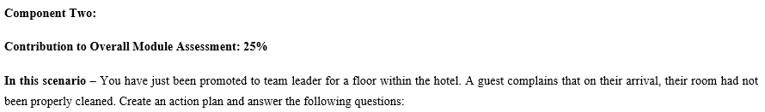
Problem | Why did it happen? | What are you going to do? | How will you prevent this from happening in the future? | What measures would you introduce to improve team effectiveness?
Poor room cleanliness | Poor room cleanliness in hotels can be caused by a number of factors. One of the most common is inadequate training for housekeeping staff. If employees are not trained properly on the correct cleaning procedures, the quality of cleaning can suffer (Alex, 2014). Another factor is understaffing, which can lead to rushed and incomplete cleaning processes. Additionally, the limited time frame for cleaning each room can result in surfaces being left uncleaned, especially if the room is heavily soiled. | it is important to provide adequate training to housekeeping staff on proper cleaning techniques and procedures. This can include regular training sessions and check-ins to ensure that staff are following cleaning protocols which can be arrange by me. | One of the effective ways is to establish a comprehensive housekeeping checklist that outlines all the cleaning tasks required for each room, including regular maintenance and deep cleaning procedures (Antony et al., 2014). | Providing the team with clear goals and objectives will help them understand what they are working towards and keep them motivated. This will also help measure their progress effectively
Limited amenities | The hotel management may not have planned properly for the number of guests they were expecting, resulting in a shortage of amenities in the rooms (Arora, 2010). | I need to arrange a training program for the housekeeping staff so that they will know to check and restock the amenities in the room on a regular basis | The hotel can conduct regular surveys to understand the amenities guests value the most and ensure that they are always available in the rooms (Bridger, 2022). | As a leader I should ensure that there is clear communication between team members regarding their roles and responsibilities in maintaining the inventory of amenities in the hotel rooms
Bathroom sink is not working | There may be a problem with the water supply, such as low water pressure or a disruption in the water supply. | I can development a process where guests to report any issues with the sink or other amenities in their room so that they can be promptly addressed and resolved. | I should arrange a regular maintenance schedule for plumbing systems and hire professional plumbers to inspect the sinks and other plumbing fixtures periodically. | The hotel staff can be provided with regular training and development programs to improve their technical knowledge and skills in handling plumbing-related issues, such as fixing a bathroom sink
Room Ac is not working | The air conditioning (AC) system in a hotel room may stop working for various reasons (Chibili, 2019). It could be due to a faulty unit, improper installation, lack of maintenance, or a power outage | I need to prioritise addressing the issue as quickly as possible to ensure that guests are comfortable during their stay | To prevent the issue of AC not working in hotel rooms, regular maintenance and inspection of the AC units should be carried out by trained technicians. | I should ensure that the AC units in each room undergo regular maintenance to prevent issues from arising in the first place (Chibili, 2019). This includes routine cleaning, filter replacement, and inspection of the AC system

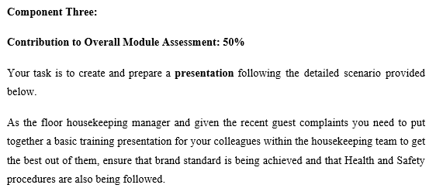
Introduction
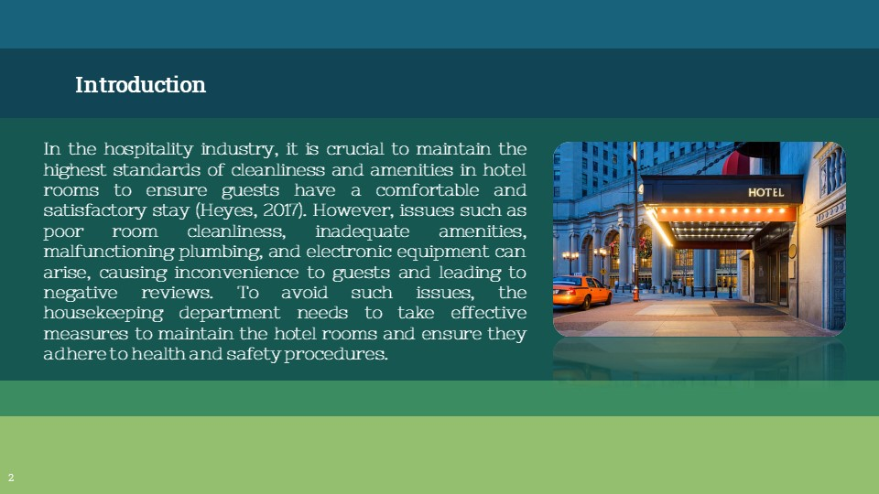
In the hospitality industry, it is crucial to maintain the highest standards of cleanliness and amenities in hotel rooms to ensure guests have a comfortable and satisfactory stay (Heyes, 2017). However, issues such as poor room cleanliness, inadequate amenities, malfunctioning plumbing, and electronic equipment can arise, causing inconvenience to guests and leading to negative reviews. To avoid such issues, the housekeeping department needs to take effective measures to maintain the hotel rooms and ensure they adhere to health and safety procedures.
Proper Room Cleanliness
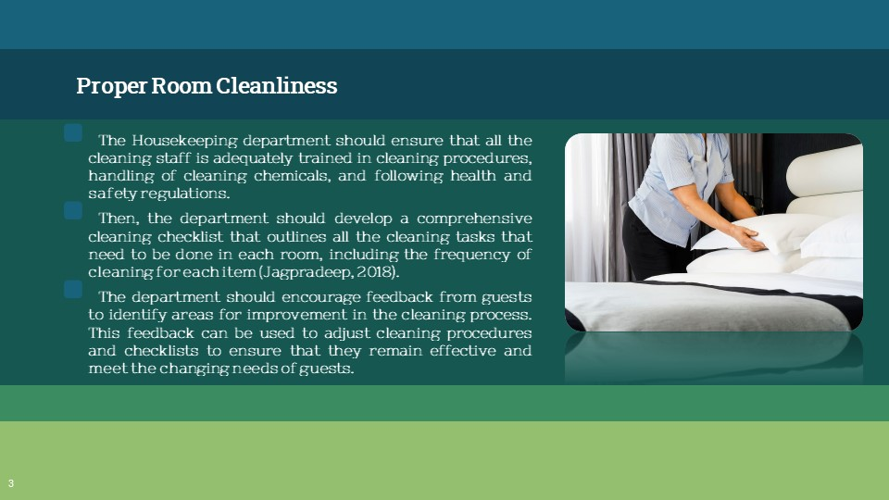
The Housekeeping department should ensure that all the cleaning staff is adequately trained in cleaning procedures, handling of cleaning chemicals, and following health and safety regulations. This training can include sessions on the proper use of cleaning equipment and products, handling of dirty linen, and proper waste disposal. Then, the department should develop a comprehensive cleaning checklist that outlines all the cleaning tasks that need to be done in each room, including the frequency of cleaning for each item (Jagpradeep, 2018). This checklist should be regularly reviewed and updated as needed to ensure that it meets health and safety standards.
Further, the department should ensure that all the cleaning products used are safe for both the cleaning staff and the guests. This can involve using non-toxic, environmentally friendly cleaning products that are less harmful to the environment. A rigorous inspection program to ensure that all rooms are properly cleaned and inspected before guests arrive. This can include regular inspections by supervisors or other senior staff members to ensure that all cleaning tasks have been completed to the required standards (Josephi and Melissen, 2017). Finally, the department should encourage feedback from guests to identify areas for improvement in the cleaning process. This feedback can be used to adjust cleaning procedures and checklists to ensure that they remain effective and meet the changing needs of guests.
Management of Proper Room Amenities
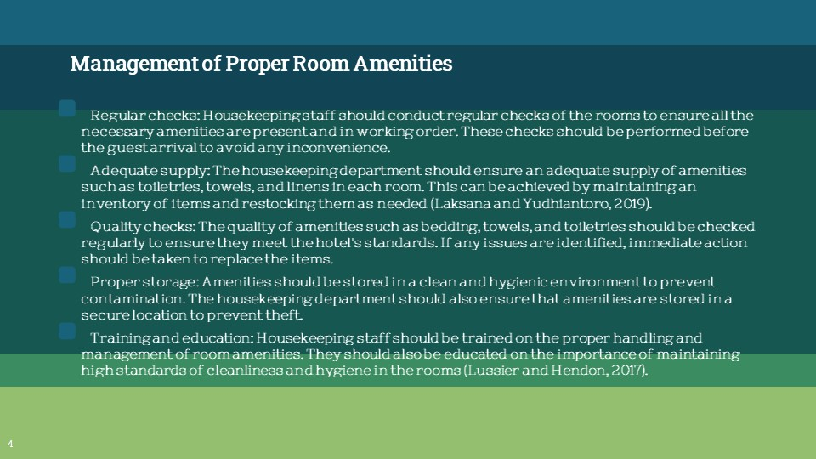
To ensure the management of proper room amenities, the housekeeping department should take the following measures while following health and safety procedures:
Regular checks: Housekeeping staff should conduct regular checks of the rooms to ensure all the necessary amenities are present and in working order. These checks should be performed before the guest arrival to avoid any inconvenience.
Adequate supply: The housekeeping department should ensure an adequate supply of amenities such as toiletries, towels, and linens in each room. This can be achieved by maintaining an inventory of items and restocking them as needed (Laksana and Yudhiantoro, 2019).
Quality checks: The quality of amenities such as bedding, towels, and toiletries should be checked regularly to ensure they meet the hotel's standards. If any issues are identified, immediate action should be taken to replace the items.
Proper storage: Amenities should be stored in a clean and hygienic environment to prevent contamination. The housekeeping department should also ensure that amenities are stored in a secure location to prevent theft.
Training and education: Housekeeping staff should be trained on the proper handling and management of room amenities. They should also be educated on the importance of maintaining high standards of cleanliness and hygiene in the rooms (Lussier and Hendon, 2017).
Proper Plumbing Maintenance
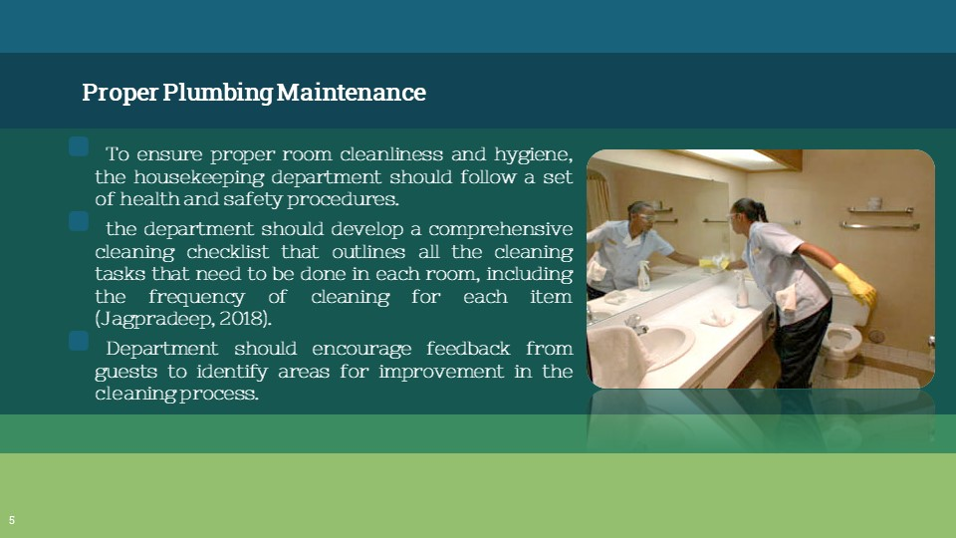
To ensure proper room cleanliness and hygiene, the housekeeping department should follow a set of health and safety procedures. This includes providing adequate training and resources to staff, such as using appropriate cleaning materials and equipment. Regular inspections should also be conducted to ensure that cleaning standards are maintained. To manage proper room amenities, the housekeeping department should ensure that all necessary items are stocked and available in each room. This includes toiletries, towels, and other essential items. They should also regularly check and replace any faulty or missing amenities to ensure guest satisfaction.
For proper plumbing maintenance, the housekeeping department should conduct regular checks of bathroom fixtures, including sinks, showers, and toilets (Riley et al., 2022). They should also promptly respond to any guest complaints related to plumbing issues and have a maintenance team available to quickly address any problems that arise.
In all cases, effective communication and collaboration between housekeeping staff and other departments, such as maintenance and front desk, is essential for ensuring a smooth and efficient operation. Regular training and feedback sessions can help to identify areas for improvement and promote a culture of continuous improvement.
Maintenance of Electronic equipment
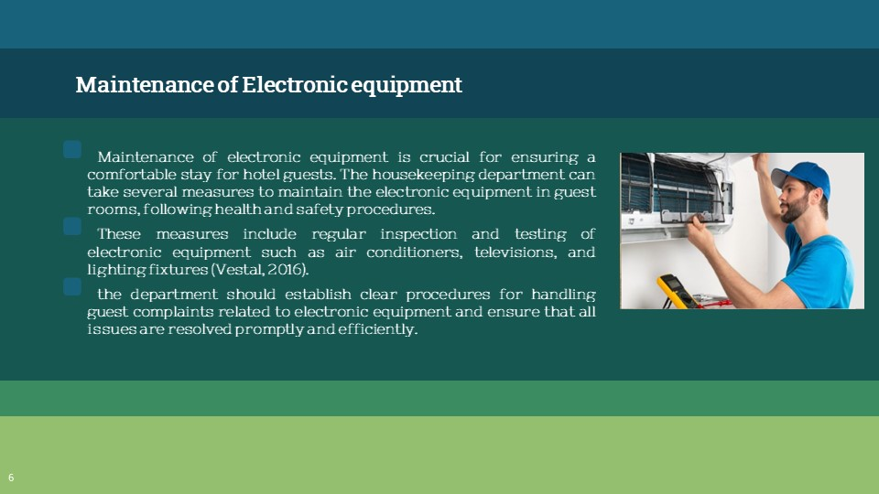
Maintenance of electronic equipment is crucial for ensuring a comfortable stay for hotel guests. The housekeeping department can take several measures to maintain the electronic equipment in guest rooms, following health and safety procedures. These measures include regular inspection and testing of electronic equipment such as air conditioners, televisions, and lighting fixtures (Vestal, 2016). The department should also ensure that all electrical outlets and switches are in proper working condition and meet safety standards. Additionally, housekeeping staff should be trained to handle electronic equipment properly and report any malfunctions or damage immediately. The department can also implement a preventive maintenance program to identify and address potential issues before they become major problems. This program can include regular cleaning and servicing of electronic equipment, replacement of damaged parts, and timely repair of any malfunctions. Finally, the department should establish clear procedures for handling guest complaints related to electronic equipment and ensure that all issues are resolved promptly and efficiently. By implementing these measures, the housekeeping department can maintain electronic equipment in excellent condition, providing a comfortable and safe experience for hotel guests.
Conclusion
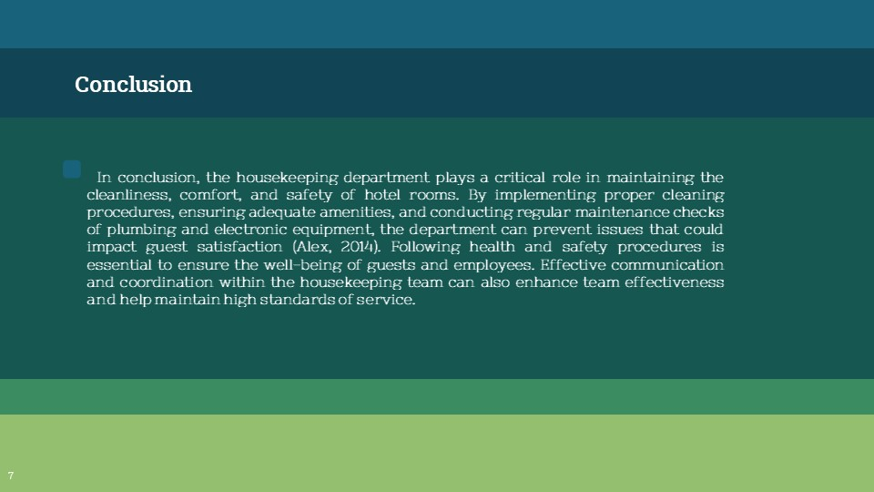
In conclusion, the housekeeping department plays a critical role in maintaining the cleanliness, comfort, and safety of hotel rooms. By implementing proper cleaning procedures, ensuring adequate amenities, and conducting regular maintenance checks of plumbing and electronic equipment, the department can prevent issues that could impact guest satisfaction (Alex, 2014). Following health and safety procedures is essential to ensure the well-being of guests and employees. Effective communication and coordination within the housekeeping team can also enhance team effectiveness and help maintain high standards of service.

References
Alex, A. (2014) “Agency-Hired hotel housekeepers: An at-risk group for Adverse Health Outcomes,” Workplace Health & Safety, 62(2), pp. 86–86. Available at: https://doi.org/10.3928/21650799-20140121-07.
Antony, J., Jiju Antony, F. and Ghosh, S. (2014) “Evaluating Service Quality in a UK hotel chain: A case study,” International Journal of Contemporary Hospitality Management, 16(6), pp. 380–384. Available at: https://doi.org/10.1108/09596110410550833.
Arora, D. (2010) Hotel Management. Maxford Books.
Bridger, E. (2022) Employee engagement: A practical introduction. London ; New York, NY ; New Delhi: KoganPage.
Chibili, M.N. (2019) “Hotel management – viewed from above,” Modern Hotel Operations Management, pp. 92–117. Available at: https://doi.org/10.4324/9781003022329-3.
Chibili, M.N. (2019) “Managing safety and security issues,” Modern Hotel Operations Management, pp. 376–409. Available at: https://doi.org/10.4324/9781003022329-10.
Heyes, A. (2017) “Hotel Front Office Management,” Hotel Accommodation Management, pp. 57–69. Available at: https://doi.org/10.4324/9781315169965-5.
Jagpradeep, I. (2018) Hotel Management. New Delhi: Murari Lal & Sons.
Jamadar, J. and Zade, A. (2022) “Post pandemic protocols & practices adopted by housekeeping in Five Star Hotels,” International journal of health sciences, pp. 10345–10357. Available at: https://doi.org/10.53730/ijhs.v6ns6.12740.
Josephi, S. and Melissen, F. (2017) “Hotel Revenue Management,” Hotel Accommodation Management, pp. 126–137. Available at: https://doi.org/10.4324/9781315169965-10.
Laksana, D.H. and Yudhiantoro, D. (2019) “Effect of service quality and company image on customer loyalty through customer satisfaction at pt. pos Indonesia (Persero) Yogyakarta,” Proceedings of the International Conference of Business, Economy, Entrepreneurship and Management [Preprint]. Available at: https://doi.org/10.5220/0009960601870192.
Lussier, R.N. and Hendon, J.R. (2017) Fundamentals of Human Resource Management: Functions, applications, Skill Development. Los Angeles: Sage.
Riley, M., Ladkin, A. and Szivas, E. (2022) Tourism Employment: Analysis and Planning. Clevedon England: Channel View Publications.
Vestal, A.J. (2016) “Housekeeping services: Ten steps in organizing the Housekeeping Department: First in a Series,” Hospital Topics, 44(2), pp. 97–98. Available at: https://doi.org/10.1080/00185868.1966.12083122.
References
Ahhley (2023) What is effective communication? skills for work, school, and life,
Coursera. Available at: https://www.coursera.org/articles/communication-
effectiveness (Accessed: March 9, 2023).
Alen (2023) Take online courses. earn college credit. Research Schools, Degrees &amp;
Careers, Study.com | Take Online Courses. Earn College Credit. Research Schools,
Degrees &amp; Careers. Available at: https://study.com/learn/lesson/housekeeping-
hospitality-industry-role-functions-standards.html (Accessed: March 9, 2023).
Caplan, A.L. and Upshur, R. (2020) “Panic prescribing has become omnipresent
during the COVID-19 pandemic,” Journal of Clinical Investigation, 130(6), pp.
2752–2753. Available at: https://doi.org/10.1172/jci139562.
Ceeyu (2020) What are the 3 qualities a housekeeper should possess? , Cleaning
Business Boss. Available at: https://cleaningbusinessboss.com/what-are-the-3-
qualities-a-housekeeper-should-possess/ (Accessed: March 9, 2023).
Feako (2019) “A team-based approach to improve knowledge and judgment
performance in electronic fetal monitoring,” Case Medical Research [Preprint].
Available at: https://doi.org/10.31525/ct1-nct04040257.
Huuam (2022) “The role of Housekeeping Department towards guest satisfaction in
Isola Sacra Hotel, Italy,” Journal of Hospitality and Tourism Management, 5(2), pp.
1–10. Available at: https://doi.org/10.53819/81018102t5133.
Nishishiba, M. (2017) “Working in a multicultural team,” Culturally Mindful
Communication, pp. 127–150. Available at: https://doi.org/10.4324/9781315277349-
7.
Norris, E.M. (2016) “Managing conflict in a time critical environment—a neglected
non-technical skill submission for special edition—team management,” Open Journal
of Applied Sciences, 06(02), pp. 123–130. Available at:
https://doi.org/10.4236/ojapps.2016.62013.

Semoa (2023) Take online courses. earn college credit. Research Schools, Degrees
&amp; Careers, Study.com | Take Online Courses. Earn College Credit. Research
Schools, Degrees &amp; Careers. Available at:
https://study.com/learn/lesson/housekeeping-hospitality-industry-role-functions-
standards.html (Accessed: March 9, 2023).
Zamni (2019) How communication and training builds housekeeping professionals,
Cleaning &amp; Maintenance Management. Available at:
https://cmmonline.com/articles/how-communication-and-training-builds-
housekeeping-professionals (Accessed: March 9, 2023).

