Connor Osborne (1800742)

Project initiation document
Project management Sue Maw
In this document, the writer is going to be writing about the group project for an e-recite that automatically is placed in their bank in a dedicated place. The main concept is that when a person buys an item with their card, they can go onto their bank and get the recite if they need to return the item. This is mainly used to allow a person to provide prove of purchase on the item that they bought.

The main objectives for the project is for the e-receipts to be stored on a database linked to said person account. This would allow for a person to open up the app, go to receipts and find the item listed in the correct order. To be accessible by multiple people with the server crashing and to store data of multiple users.

Another objective is to remove the use of paper with receipts as all of it will become digital. As tons of trees are cut down each year, our app is developed to reduce the use of paper receipts with everything going digital.9.6 million trees are cut down per year for paper receipts [1]

Another objective is to put labels next to purchases. This will allow a person to view where they made purchases and what items they spent it on. This will also allow for alerts to be made on suspicious purchases such as £200 for a pencil. This would allow for reports to be made on such purchases.

One part of the project scope is for the app to use some part of receipts stored in the app. As the end goal of the project is for the system to be connected to the bank so each payment made will generate a receipt for said purchase. For the current app to be a success is for the app to scan a receipt and make a digital copy. A similar product to ours is receipt tracker that works directly likes ours. [2]

Another part of the scope is the budget. As the project will mainly be built in the university and on home computers, the cost of the project will be kept down. The only cost that would need to be made are for two servers. This is for hosting a web server and a server to house a database for the app.

What the app will not have is a functioning bank to demonstrate the end goal. As the main goal is to allow the app to just scan receipts and save them, no bank is needed to be made to keep the prototype simple and to avoid the project running out of time.

Another thing that the app will not have is trends in spending done by the person. One feature that everyone in the group wanted was to be able to view spending habits in a graph. This would have been done by showing how much a person sent each day and then be able to view on that day where they spent their money and how they can save.

Another constraint is that we are all on different courses. As all the group are on different courses, it can be difficult to find a time for everyone to meet. This has made it difficult as only certain days people are in and some aren’t. this has caused some minor inconveniences to people

One constraint is time. As time is limited to develop the app, most of the features that the developers want to add are limited. As mentioned about with the app not being integrated into a bank system. As such, the app will only be able to do the bare minimum which is scanning receipts.

Another constraint is the ability of everyone on the team. As most of the team only know basic coding, it can be difficult to add some more advanced features. Such as the trends and integrating a bank into the systems.as most people in the group have only basic knowledge with programming.

Next, we have authority figures. The main stakeholders are everyone on the project team. This includes the app developer, marketing, web development and design. Some of the other stakeholders include the shops and banks who may integrate the system and the users

The team manager for the group is James. As the idea for the project came from him. His responsibility is mainly to decide who does what task in the group. This doesn’t cause many problems with the development of the app as he understands everyone's skill level.

Some problems the group have encountered is how the app will function. As the main idea came from the group leader, many compromises have been made to make an app that can be made by the group. This has in term limited what the app can do.

Another issue with the stakeholder is the website they want with the app. As the website can only use html at the moment and not php, a database cannot be made and linked together to bring a universal platform for the product. At the moment the website will only have basic functions so people can get information.

Finally, we have resources. For the project, the main tool needed is a server to store the data base on. As the app can be made on any computer and the same with the website. This means that not much is needed for the except the server and maybe someone to maintain it.

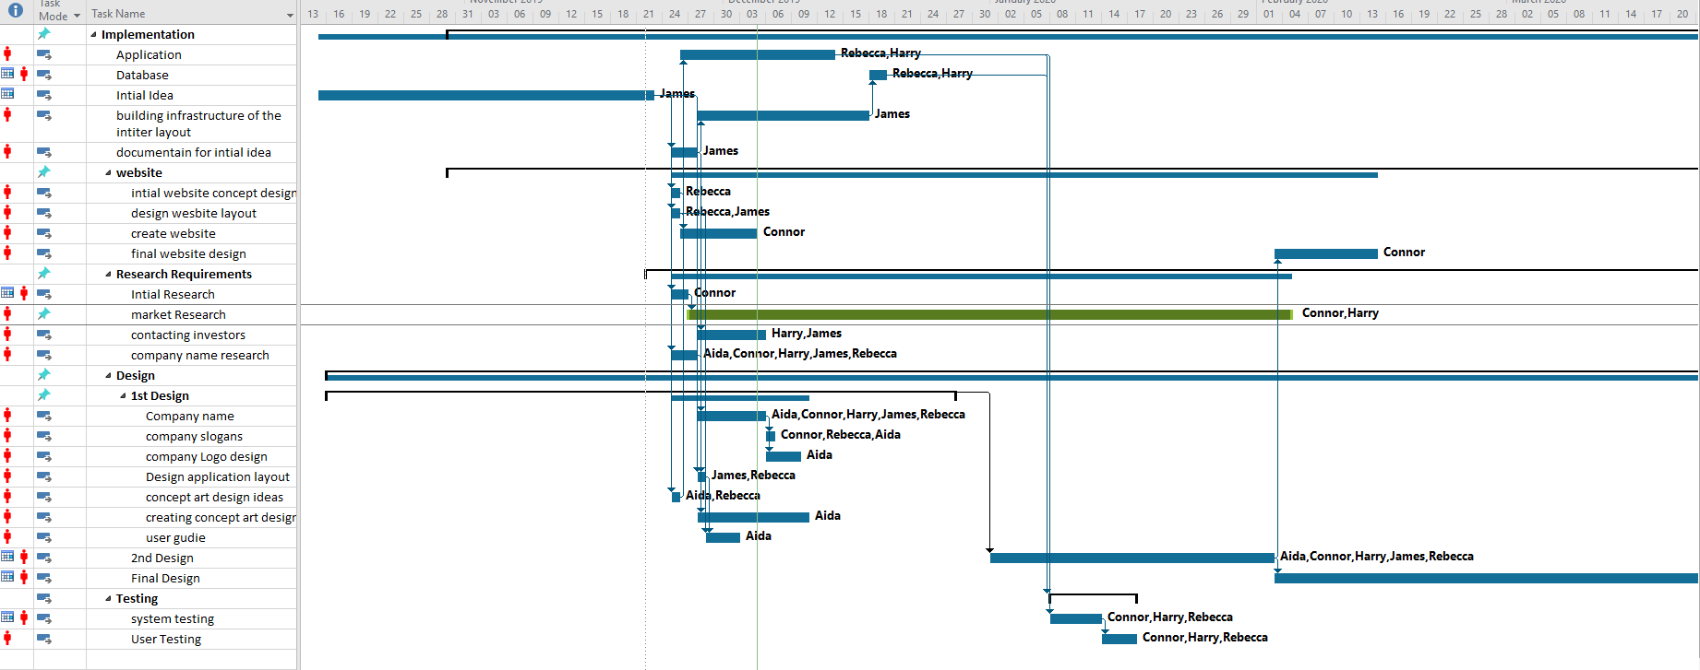
Here we have a Gantt chart showing all the tasks that need to be done.as it can be seen that the stages of the project have been split up with the design and building the app take the most time. This is done and the design needs to be okay and it will take time to make the app.
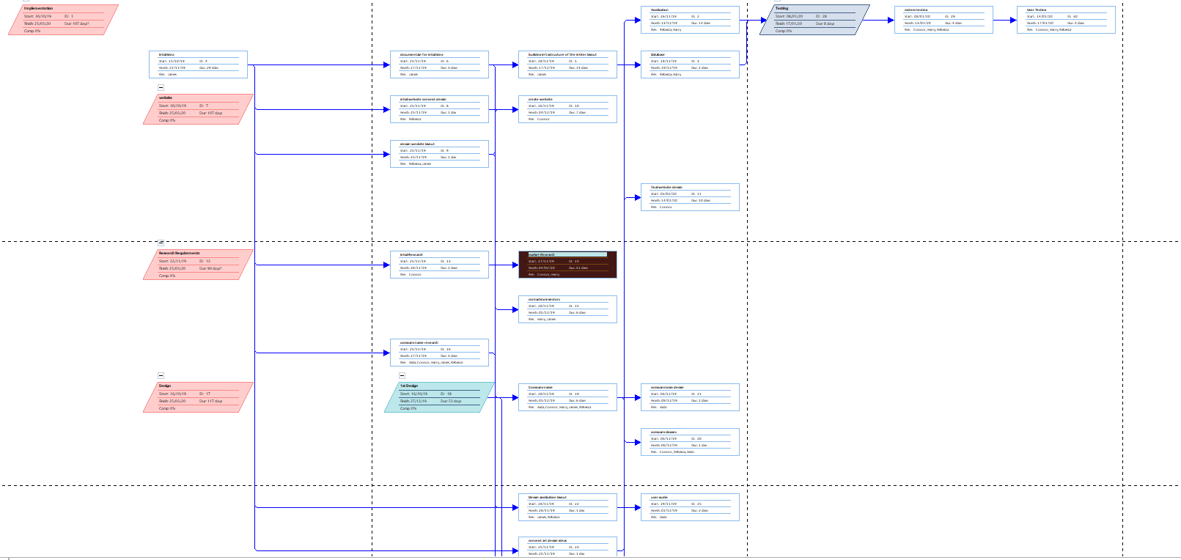
Next, we have the network diagram. As we can see from the diagram, all the tasks link together, meaning that if one task is delayed then the entire project will also be delayed.

In conclusion, the project will be a success if the app allows for a photo of a receipt and store the receipt in a database on the phone. This is the bare minimum for the project to be a success as it will mostly take time and at everyone skill level to make an app with just the base function.

Bibliography

[1] | "https://www.ran.org/the-understory/how_many_trees_are_cut_down_every_year/," flex engage, [Online]. Available: https://www.flexengage.com/all-posts/blog/the-environmental-impact-of-the-paper-receipt-and-why-you-should-go-digital. [Accessed 1 12 2019].
[2] | "reciept tracker," [Online]. Available: https://www.receipttracker.co.uk/. [Accessed 1 12 2019].

