Analytical methods and Study Skills - Connecting Rod
Asad Naqvi - 1907788
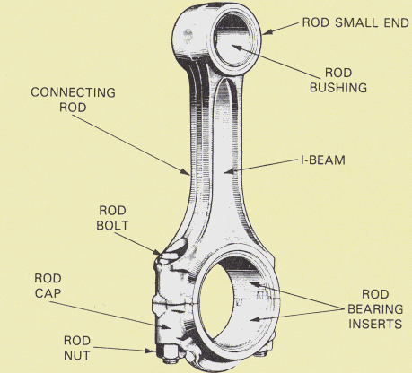

Abstract:
This report will is on a connecting rod from a Ford Fiesta 1.0l EcoBoost engine and the varying forces the conrod undergoes constantly. This is to show the different forces. The report will show how varying RPM loads, conrod length, crank radius and mass of piston affect the forces exerted on the conrod. The report will cover how the engine behaves at different engine RPM levels.

Contents
Page 1. Abstract
Page 2. Contents
Page 3. List of Figures
Page 4. Introduction
Page 5. Research
Page 6. Methodology - how to measure connecting rod length
Page 7. Methodology - How to measure the crank radius
Page 8/9. Analysis
Page 9. Maximum Tensile force on conrod

List of figures:
Figure 1: Ford Fiesta 1.0l EcoBoost
Figure 1.1: Connecting rod
Figure 1.2: conrod dimensions
Figure 1.1: Ford Fiesta connecting rod
Figure 2: Connecting rod inner length
figure 2.1: Connecting rod small end diameter
Figure 2.2: Connecting rod big end diameter
Figure 3.0: Crankshaft on V-block
Figure 3.1: heigh gauge on the main crankshaft bearing
Figure 4.0: Acceleration vs. force Graph
Figure 4.1: Acceleration vs. Force Graph 2 w/ lighter conrod
Figure 5.0: Velocity vs. Time Graph
Figure 5.1: Velocity vs. Time Graph - cruising RPM

Introduction
A connecting rod (conrod) is one of the essential components in a combustion engine as that is the piece that is pushed down during the ignition phase which then turns the crankshaft propelling the vehicle forward. There are a few components of a conrod. These include gudgeon pin, the piston head and piston rings.
This report will analyse the changes that a connecting rod undergoes at different forces in a 4 stroke 1.0 Ford EcoBoost engine. The report will cover a range of factors like the mass of the piston, crank radius, conrod length and engine speed and how they impact forces acting on the conrod.
The report will use an excel spreadsheet which contains variables such as crank radius, RPM, conrod length and mass of piston/gudgeon pin. this report will cover changes in RPM and changes in weight of crankshaft and gudgeon pin. The report will also look at changes in tensile strength in relation to RPM.

Research
The vehicle that from which the conrod is from is a Ford Fiesta 1.0 EcoBoost which is a 4 stroke engine. The engine produces around 100bhp and around 6000 RPM. The vehicles gross weight is 1555kg.
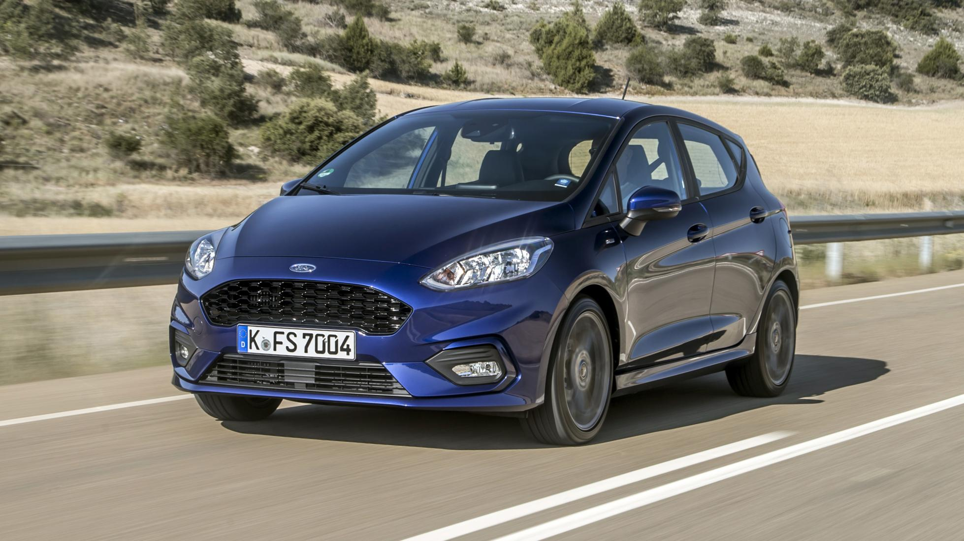
Figure 1.0
Gross Vehicle weight = 1555kg
Max RPM = 6000
Engine torque = 170Nm
Top speed = 112MPH
Piston weight = 0.2905kg
Connecting Rod length = 120.24mm
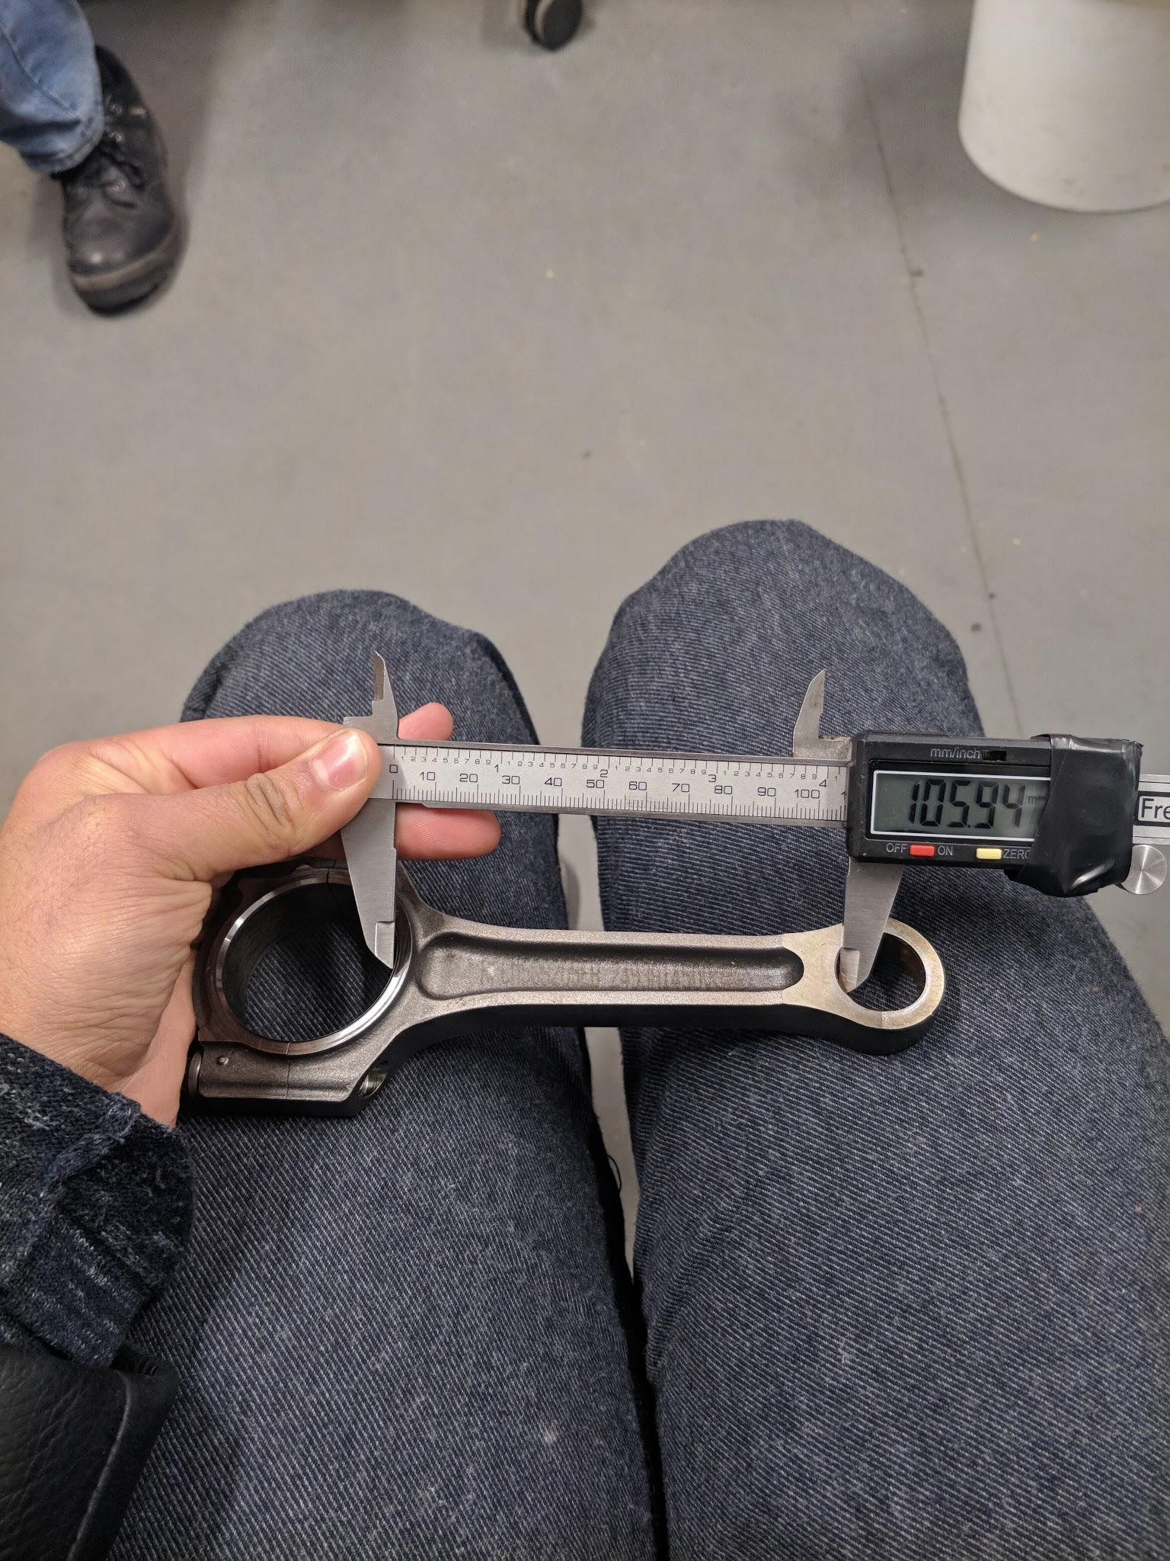
Figure 1.1
Conrod weight without piston = 225.5g
Gudgeon pin = 67g
Total piston weight = 290.5g

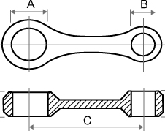
Figure 1.2
A = 26mm
B = 2.6MM
C = 120.24MM

Methodology
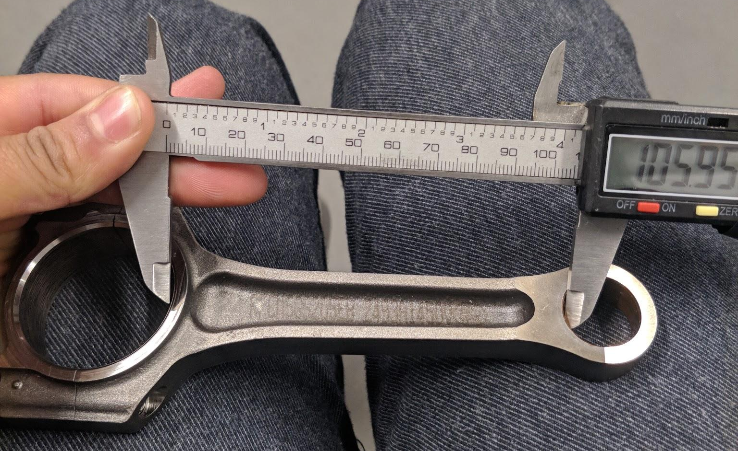
how to measure connecting rod length:
Figure 2.0
First, make sure that the correct connecting rod being measured comes from a Ford 1.0L EcoBoost. Then use a vernier caliper and measure from one end to another.
To get the correct length of the connecting rod the measurement is taken from the centre point of each of the holes. First, measure the length as in the picture, then measures the diameter of each hole and divide by 2 to get exactly half and then add onto the measurement earlier.
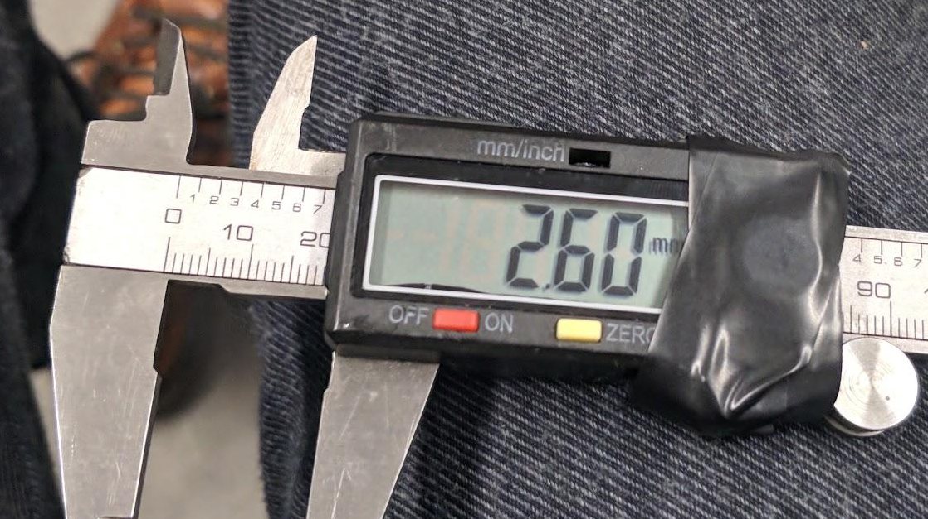
Figure 2.1
The diameter of the small end

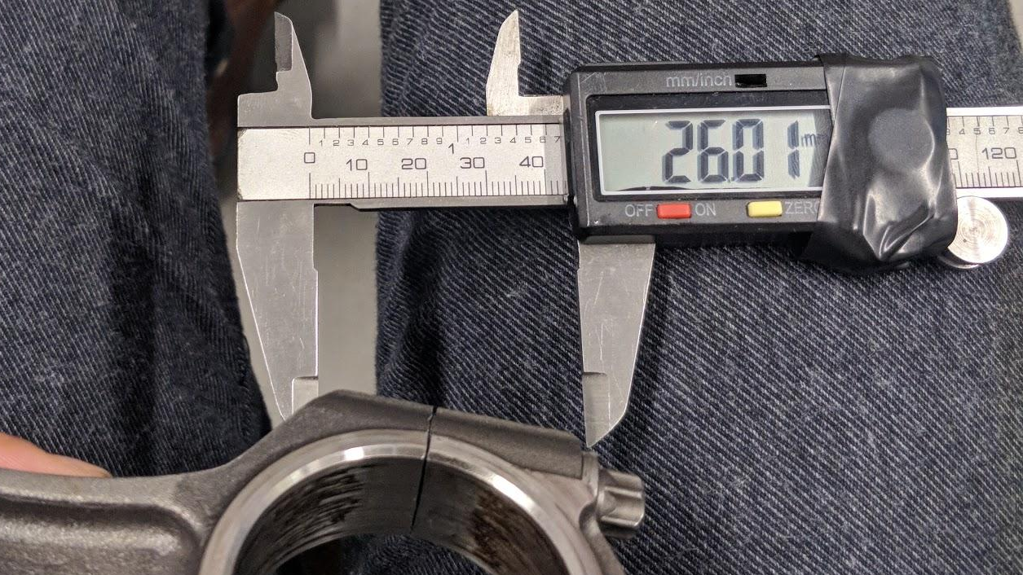

Figure 2.2
The diameter of the crank end

Conrod length - (105.94)+(13)+(1.3) = 120.24mm

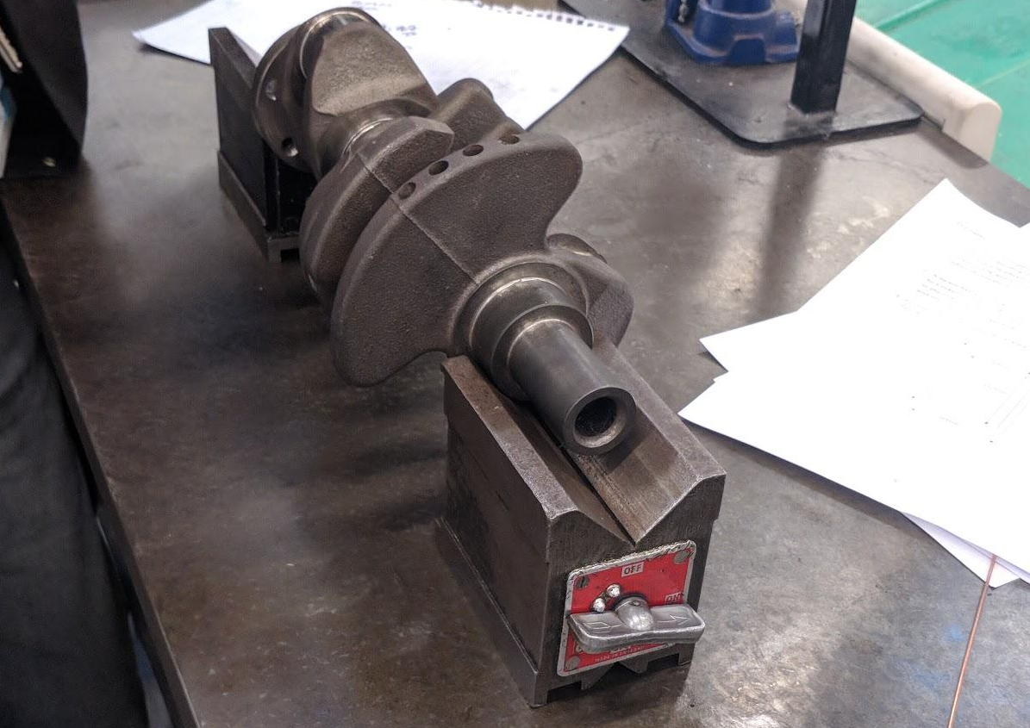
How to measure the crank radius:
Figure 3.0
First, get the correct crankshaft and place it a pair of v-blocks which are specifically designed to measure the crank radius. Make sure that the crankshaft has been sat on the v-blocks properly as if they would be laid in a car.

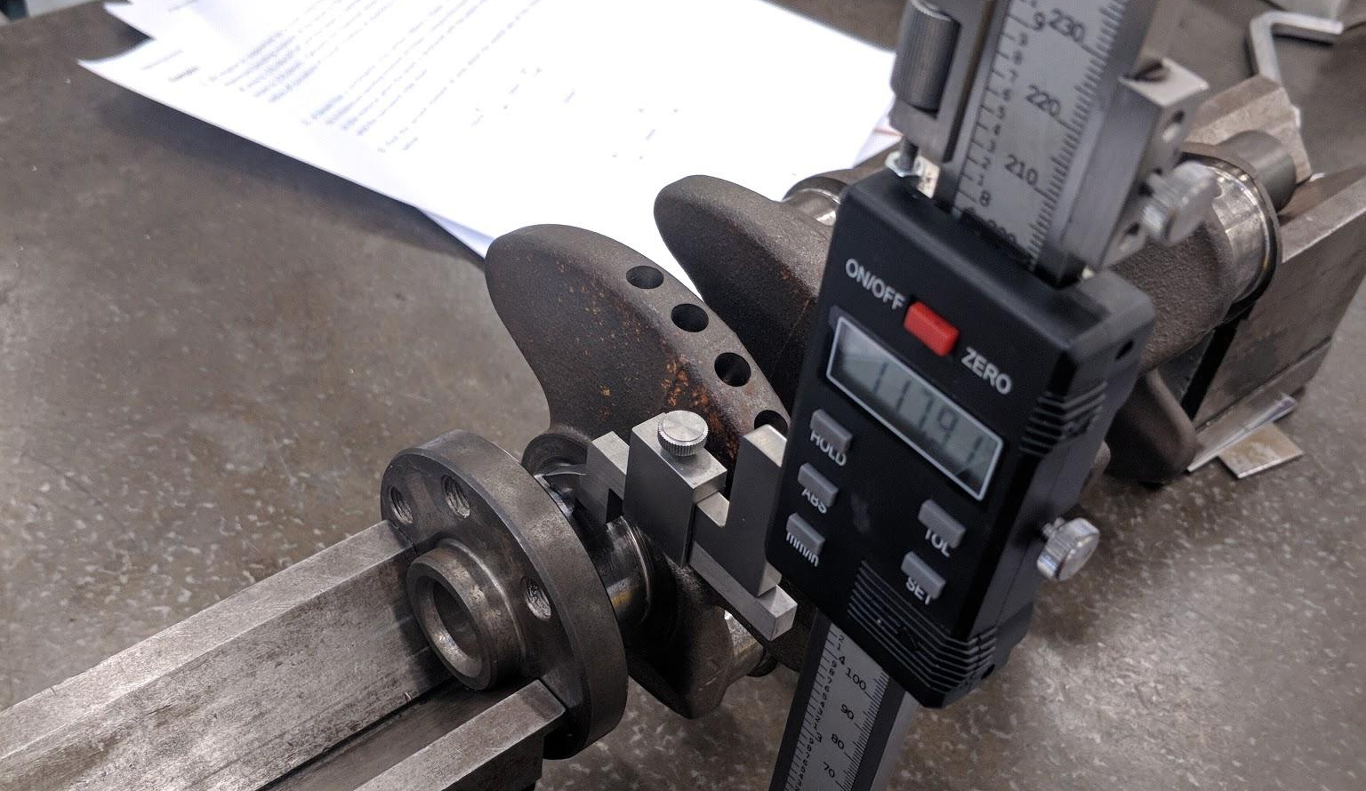
Figure 3.1
Use a height gauge, zero it to the bench surface and then measure the height of the crank at top dead centre.
Then measure the height of the main bearing along with the height of the second bearing.

Use a vernier caliper and measure the diameter of both the main bearing and second bearing and the divide by 2 to get the centre point of the crank.
Height of main bearing = 117.91mm / Main bearing diameter = 44.21mm
Height of second bearing = 76.24mm/ second bearing diameter = 40.25
crank radius = (117.91) - (76.24) = 41.67mm

Analysis
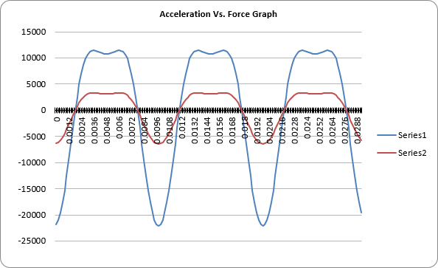
Ford Fiesta 1.0l EcoBoost engine at ‘MAX RPM’:
Figure 4.0
Series 1 = Acceleration
Series 2 = Force
This is a force/acceleration graph with the Ford engine at max RPM. The max tensile force on rod is 6420.87N/m

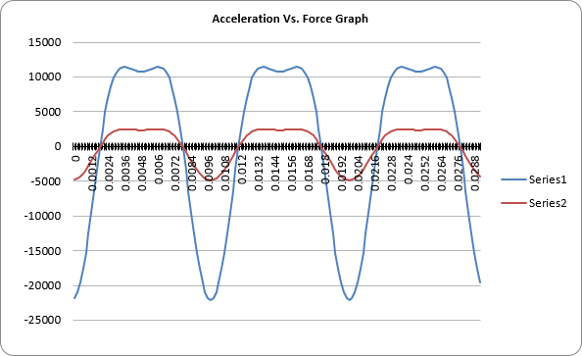
Figure 4.1
This graph refers back to graph in figure 4.0, this graph shows changes in forces and acceleration of the Ford with a lighter connecting rod at 220g. a reduction of 70.5g. This can be observed by looking at the red line In Figure 4 and Figure 4.1

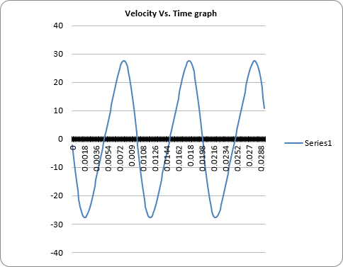
Figure 5.0
Series 1 = Velocity
The velocity can be observed by the frequency and amplitude of the wave on the graph. This graph shows the velocity of the Ford Fiesta at maximum (6000) RPM. The 70.g change in the weight of the connecting rod and gudgeon pin made no difference in the vehicle’s velocity.
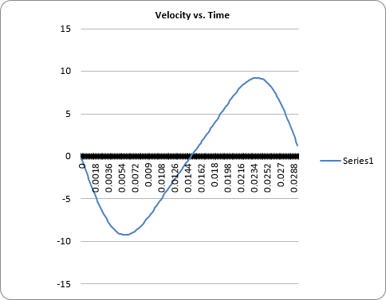
Figure 5.1
This velocity/time graph shows the Ford at a cruising RPM range of 2000. As can be observed from the graph, decreased frequency in wave and decreased amplitude as well. At 2000rpm the Max tensile force on rod 713.7807N/m.

Maximum Tensile force on conrod
- 6000RPM = 6420.87N/m
- 4000RPM = 2857.23N/m
- 2000 RPM = 713.7807N/m

Conclusion:
The report has covered a few different aspects of the Ford 1.0l and how the car behaves at different RPM ranges. From the data collected, one can see that the change in mass of conrod and piston has the most effect on the amount of force is being acted down upon it during different RPM. The graphs show, higher engine speeds equate to higher tensile forces acting on the conrod. A light conrod will also have a similar effect when the mass of the conrod was decreased by 70.5g the amount of force acting on the conrod also decreased.

Recommendations for further study
Look into different conrod designs and different car manufacturers of the same engine and conrod size compare with the one from the Ford 1.0 and see how they differ.

References:
BOSCH, R. (2018). BOSCH AUTOMOTIVE HANDBOOK. 10th ed. WARRENDALE: SAE SOC OF AUTOMOTIVE ENG

Hillier, V. (2012). Hillier's fundamentals of motor vehicle technology. 6th ed. Oxford University Press

Top Gear. (2019). Ford Fiesta 1.0 EcoBoost Zetec 5dr. (online) Available at: https://www.topgear.com/car-reviews/ford/fiesta/10-ecoboost-zetec-5dr/spec [Accessed 9 Dec. 2019].

