5,796 words
Julia Lockheart
ADAD6001 Independent Inquiry
Automotive Design
Joshua W. Dodsley 1702608

An inquiry between design and landscape

2019
Table of Contents
Introduction 3
Creative seed 3
How can we preserve the landscape? 4
Improving current alternative energy 4
Current market 5
Changing method 6
Making different approachable 7
Neri Oxman 8
Regenerative interior 8
Interior layout and driving experience 9
Initial idea 10
Integration of original idea 10
Carbon scrubbing 11
Barbra Hepworth: 11
External design influence 12
Henry Moore: 13
Putting the car in the landscape 13
Why Hepworth and Moore 14
Balance 14
scenario (ideology) 15
Liminal space 16
Bibliography 17

Introduction
For my manifesto, I am looking at the relationship between design and landscapes. Provoked primarily by the Amazon forest fires, exploring how as designers we can invent ourselves out of environmental situations. Leading to research in how as Automotive designers we can create vehicles which generate less of an impact on our environment and landscape, this has led me to investigate into sustainable approaches to vehicles and how they can enhance and preserve the landscape of the future. Exploring new ways to power, design and protect to make the vehicles of the future more meaningful to what they are today.

Creative seed

August 2019 arose a large environmental calamity, with a wide spread fire consuming large quantities of the Amazon rain forest. The reasoning behind is believed to be “started by farmers and loggers clearing land for crops or grazing”. Widely known of its importance of carbon storage and oxygen production, this disaster has accrued a knock-on effect to global warming. Through the event it has been discovered the main problem to global warming is actually logging deforestation “By the end of August, most of the deforestation in the current year had already happened.” (Hughes R. 2019) Resulting in less oxygen production and carbon storage being taken in each passing year. Responding to this I plan to design a vehicle which will relive the burden on the remaining ecosystems, creating a traveling source of carbon filtration and oxygen production. Whilst using renewable energy sources to power and sustain the prospect of mobility, whilst retaining its purpose to transport it occupancy in a comfortable and calming way. Reducing the carbon footprint for future and past vehicles allowing nature and the landscape to recuperate and flourish.

How can we preserve the landscape?
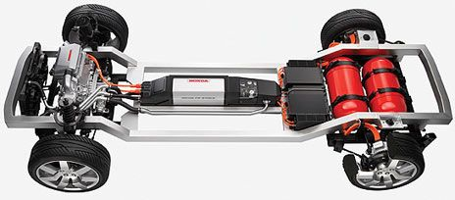
Looking at the landscape as a whole and not just the Amazon and what it could be 30 to 40 years, the vehicle I purpose will need to encompass a variety of self-sustaining and environmental enhancing features to combat current and future climates. Integrating renewable methods such as hydrogen, solar, tidal, geothermal and wind to no longer be dependent on fossil fuels. Currently in 2019 as a society we are in a phase of transition moving away from the independency of fossil fuels to renewable energy, with the new source anticipated to be electric. To be fully eclectic would require more power than what can currently be produce, with some changing to a “vision of a sustainable, hydrogen-based mobility.” Utilizing the power possibilities of hydrogen with the byproduct being only water, supporting the initiative of a zero-emission future. Current engines could also be seen in the future with hydrogen acting like a diesel system, helping with the transition from a fully fossil to fully hydrogen based power, “chemical similarities to diesel. Thus, LOHCs could make use of the existing energy infrastructure” This could mean the soon to be phased out combustion engine could be seen in the future, resulting in the cars of the past and high value vehicles of the current period be configured to an electric of hydrogen future. (Teichmann D. Arlt w. Wasserscheid p. Freymann R. 2011) Current stumbling blocks preventing a hydrogen future is the process off extracting the hydrogen, requiring more energy to separate the atoms to what it can give back resulting in an energy negative. However, in my scenario by 2050-2060 the world will have advanced its methods and have a system in place to efficiently separate hydrogen to give a positive ratio.

Improving current alternative energy
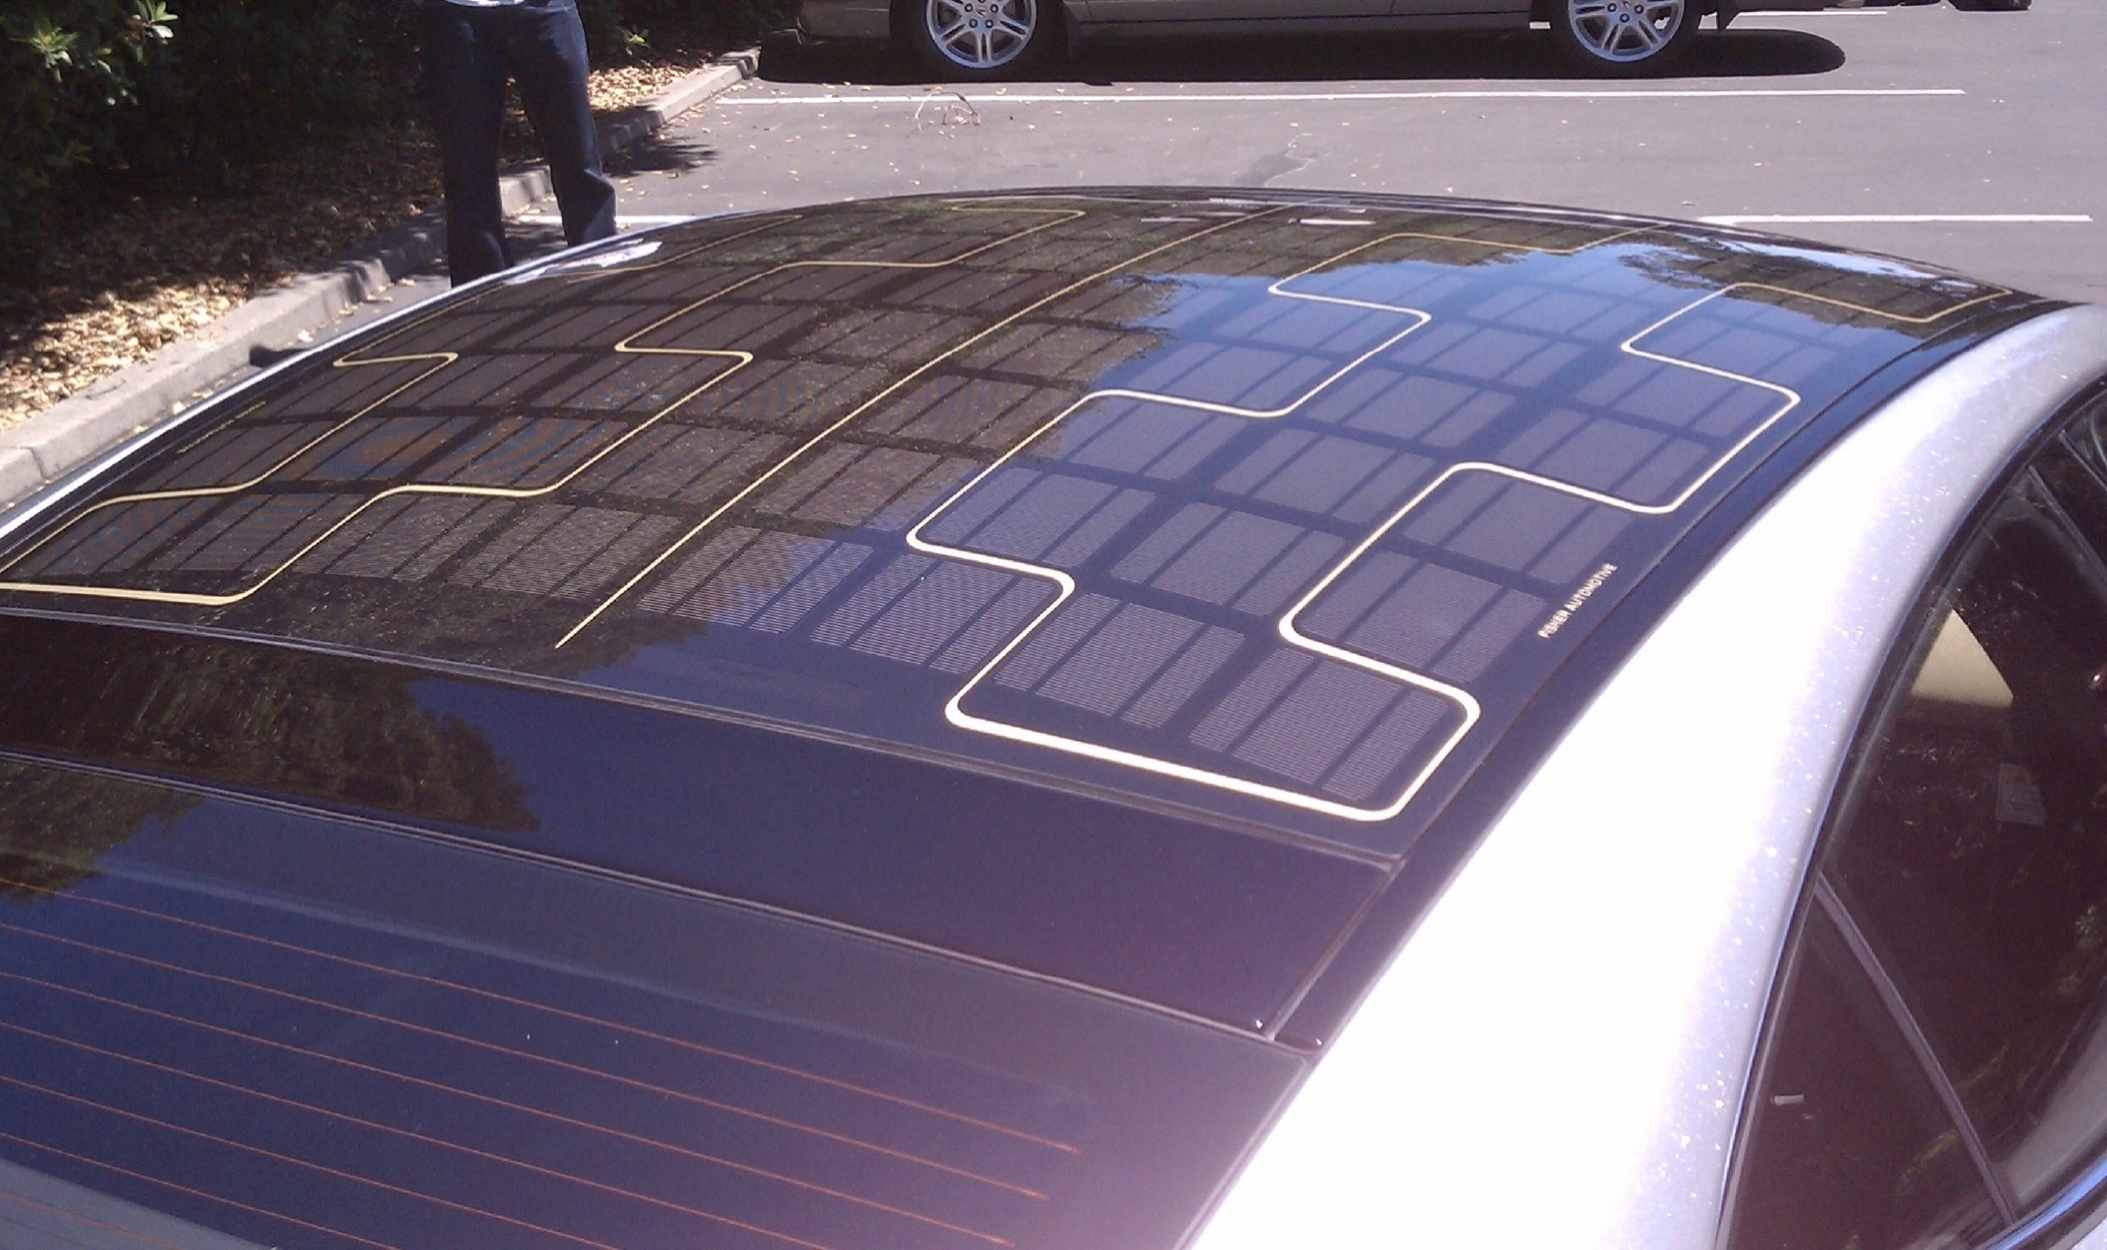
Taking encouragement to how we currently create renewable energy, the automotive industry currently produces vehicles with the integration of turbines and solar panels utilizing solar and wind energy. However, as designers we need to invasion a future where advances will be made, anticipating creative solutions to modern problems with future advancements. Meaning seeing how current solutions may advance, envisioning how solar panels and turbines may look in 2050/2060 then how they may be incorporated with vehicles of the future. Merging this with the public perception and growing knowledge of their carbon footprint, “Consumers are also increasingly aware of their carbon “footprint” and seek ways of lowering their carbon dioxide output.” The automotive industry must be at the forefront of new and innovative ideas to reduce the footprint of their vehicles and ways of production. “solar power would be large enough to supply many commuters’” Dunbar B. (2009). Looking at what we currently have with a hybrid, petrol and electric systems, building on this structure and combining a vehicle with solar and hydrogen. Bringing the idea of generating energy while stationary or moving, solar could be a way to combine with the efficacy of a hydrogen with its byproduct being water. “Renewable hydrogen produced using solar energy to split water is the energy fuel of the future.” Using the water created by the hydrogen cell to be heated by the solar panel to then produce more hydrogen, in theory creating a fully sustainable vehicle. (Pagliaro M. Konstandopoulos A. Ciriminna R. Palmisano G. 2010). This system would only work in the day as the power generated to convert the wasted water back to hydrogen requires solar rays, as most of the population travels in the day on a 9am too 5pm slot this would not be a problem. Theoretically only ever needing to refill at night when the hydrogen could not be topped up by the conversion created by the panels and other generative systems, relieving the burden on the user by reducing the amount of time spent refueling.

Current market
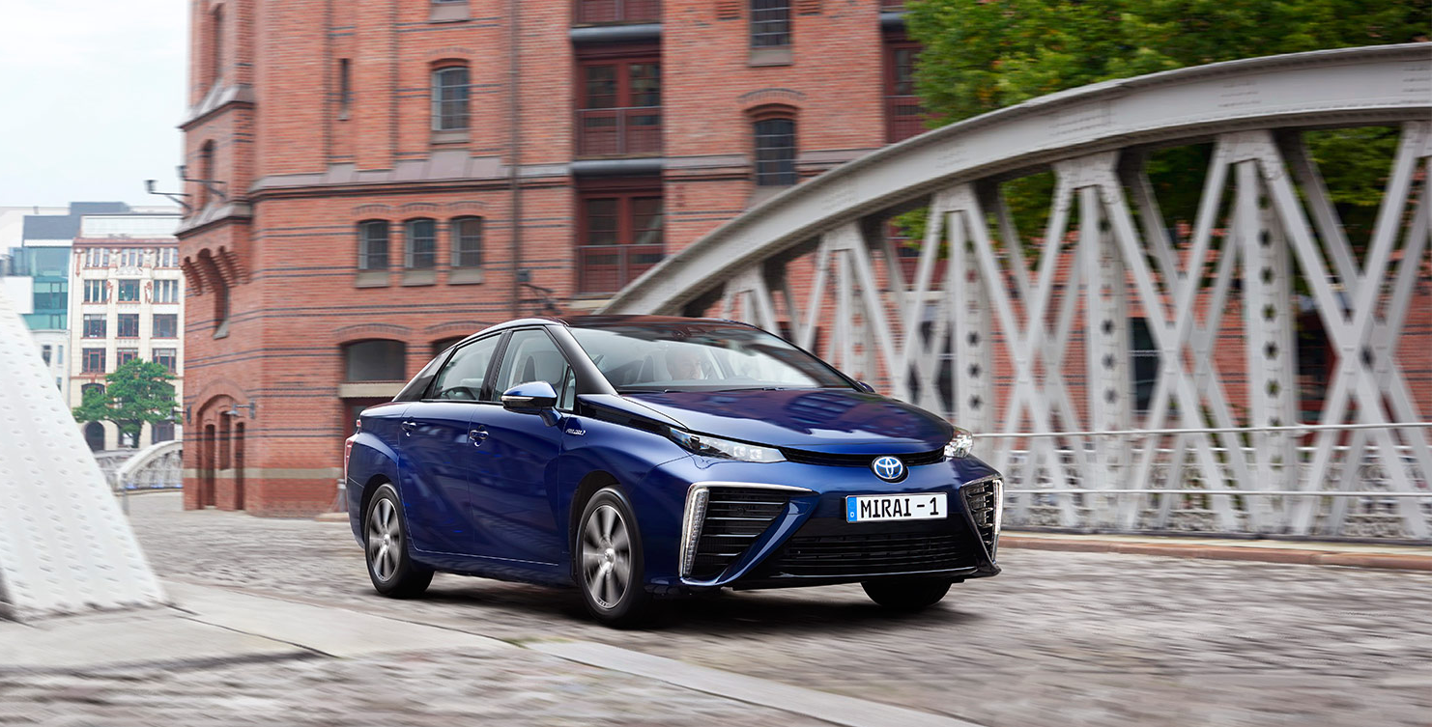
Currently in the Automotive market both electric and hybrid vehicles stand out amongst the common combustion vehicle, with electric styling becoming viewed as a more (anti-car) approach toward interior and exterior design. Acting as an in-between solution is the hybrid, incorporating the advances in technology alongside conventional design associated with current vehicle stereotypes. Exterior and interior of most hybrid cars appearing like the expected normality of a petrol or diesel vehicle, giving the client what he perceives the car should look and feel like whilst doing its part to reduce its carbon footprint. Leading me to wonder if 2050-2060 hybrid vehicles are to enter the market will the system reflect the design like an electric with its own distinct style, or follow a more accepted design like the current hybrids. Manufactures such as Toyota have tried to introduce the idea of a fully hybrid car with the Mirai, in this case the Miari fits in a category of trying to fit to what consumers expect similar to a hybrid. Toyota describe the hybrid design philosophy as “flexible hybrid architecture” (Toyota 2019), I interpret this as them saying because the concept is so new there are no design restrictions which is why its flexible. The vehicle works by using the hydrogen cell to power the battery to drive the vehicle requiring the need to incorporate ventilation to cool the battery and take oxygen to mix with the hydrogen, exhaust to allow the bi product of water and heat to leave the vehicle. This arrangement contributes itself more to how current combustion systems work with an intake for cooling and outtake to allow the waste to exit, contrasting an all-electric where only ventilation is needed to control the temperature of the battery and motor.

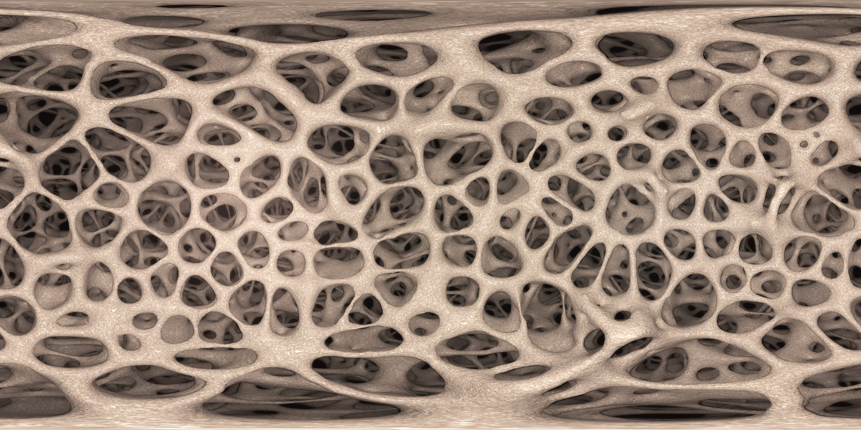
Changing perceptions
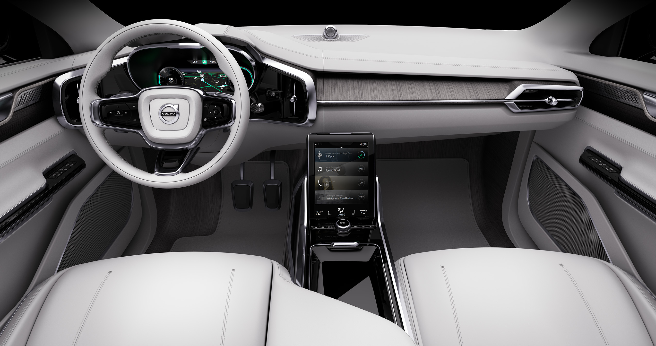
Giving importance of how the vehicle will be powered to save the future of the worlds landscape is only a piece of preservation, how the car will adopt a role to help combat further climate changes and preserve materials is an even greater part. Exploring new materials could be a way to help to preserve, by using none traditional fabrics this may reduce the need to dig for precious metals, deforest for grazing needed for the leather and adopting innovative materials to eradicate the demand for plastics. Looking at the car industry in its current condition it become stagnant in its creativity, sticking with a similar formula of metals, leathers and plastics. This could be due to many variables, one being an unaccepting market where the intended target for the vehicle wouldn’t like the unconventional. Industry resisting change could be an issue with the increase in cost which is stopping the transition to the latest materials. By changing textiles this would result in transformations to the factory and production cost, which when a product is already successful can be hard to warrant such a dramatic change. “The automotive industry operates in a very competitive market which requires controlling product cost”. To warrant such changes would require data, proposals to swap materials which no one has integrated before is difficult, with no data to support if on a mass scale it would be successful and accepted. “Cost estimation requires quality data and information, therefore this research project identified several issues” (Roy R. Souchoroukov P. Shehab E. 2011). Trials to see which replacement material would coincide as cost effective and sustainable product replacement. Increasing pressure on the automotive industry to make changes in ever present, the added pressure may cause few companies to take the leap and try new resources causing the rest to follow if successful.

Changing method
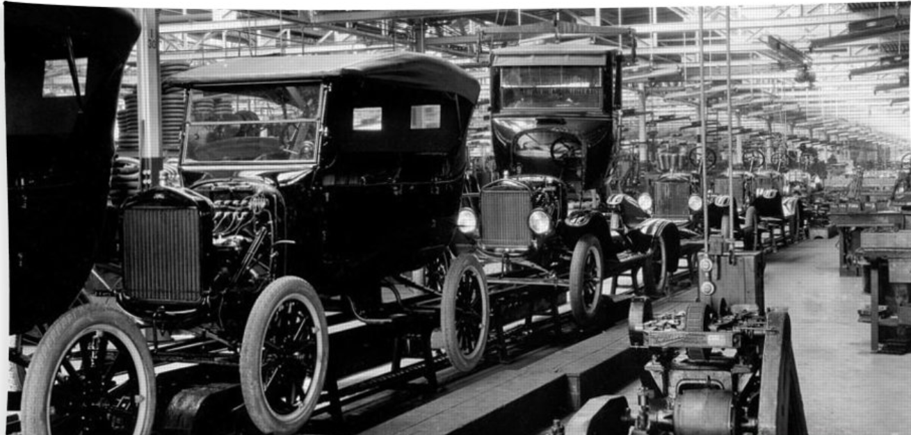
The automotive industry has controlled people’s perceptions that newer is better, with a vehicles age suggesting its worth and appeal. This is encouraged further by manufacturers offering plans where you pay a fee every month and over a specific time frame at the end you get the next newest model, meaning every time your plan ends you can have the newest form of your vehicle. This supports over production and drops the value we place over quality products because it’s not the newest version. This does not apply to the entire industry, however the larger more dominate manufacturers such as Volkswagen, Ford and Toyota will put value in quantity to appease shareholders and be seen as being successful. Contrasting companies such as Bugatti, Ferrari and Rolls Royce put value in their products by simply producing less to a superior standard, seeing their value in making a product to last and not till the next generation is released. Originally cars were limited and only were available for the wealthy, then came the car for the masses by reducing costs allowing the everyday man the possibility to have his own personal vehicle. This has yet to change with there being more and more cars being produced while still having the pervious car from before, this cannot be sustained as it takes too many of the planets recourses. I propose to begin increasing the monetary worth of newer vehicle reducing numbers but retaining profits to charge more, this will put a greater value to what we produce whilst reducing the impact on the planet. Raising the quality and cost of new vehicles would also raise the value we placed on the current vehicles overall improving the state or the industry, valuing what we already have and increasing the quality of product that replaces, never just equating but to always surpassing what can currently be achieved.

Making different approachable
The reason why as society we have traditional and none traditional method is because conventional is what we have become surrounded by and perceive to be accepted, where none traditional is widely less accepted and its integration is rejected. This makes it difficult for manufacturers to incorporate none traditional aspects within their products. Changing perceptions and making the none traditional more approachable would help spark more experimentation in the automotive industry. Putting this into context of the automotive industry we are accustomed to the traditional two at the front and two and a half in the rear, made up of plastics and leathers that are a mix of tonal shades and predominantly either blacks or neutrals. Seeing naturally accruing tones, textures and pigments as unusual or unconventional, I wish to alter perceptions and embrace the change of materials and environments and see the beauty in nature. Accepting core materials in unaltered forms will not only reveal the beauty of the material but reduce the vehicles carbon footprint, requiring less energy to transform the materials to conform to current expectations. Meaning less harmful chemicals and processes needed to make parts by simply accepted the perceived impurities. As humanity, we need to change the way we see, because something has imperfections or unconformity doesn’t mean it’s not appealing and unusable.
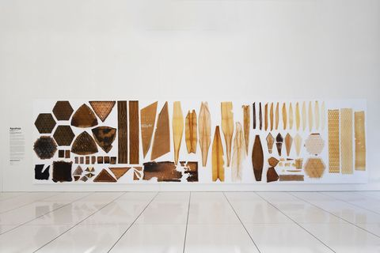

Neri Oxman
Looking at the forefront of new material research, architect, designer and inventor, Oxman is the “Development Professor and Associate Professor of Media Arts and Sciences at the MIT Media Lab”. Working alongside nature by creating pieces of works using synthetic biology, with generated materials contrasting from garments to pavilions. Her work is expanded to using “digital fabrication, materials science and synthetic biology” to create work which in her own word is to achieve the goal to “augment the relationship between built, natural, and biological environment”. A term to describe her portfolio is “biologically informed and digitally engineered”, using the already successful design created by nature and applying that using modern techniques to solve current and future dilemmas (Oxman N. 2018).

Regenerative interior
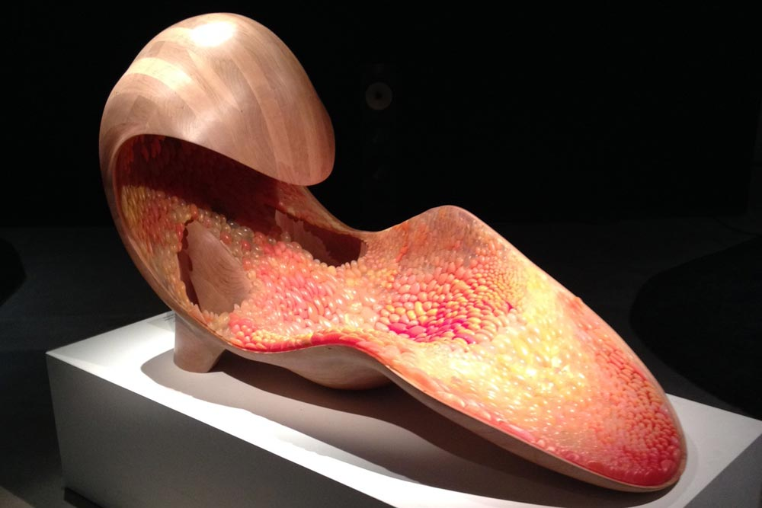
I have chosen Oxman for her use of biomimicry, to create materials which if integrated into the automotive industry could change our perception and interaction of the future. Looking at creating materials out of biological structures from pectin and chitin to replace current plastics. Currently her work has yet to enter this field of automotive design however has entered furniture, Oxman’s 2014 Gemini project brings together forward thinking within the interior space. Gemini is a chair exploiting “natural and synthetic materials, hard and soft sensations, as well as subtractive and additive fabrication”, Incorporating within its structure her work involving biomimicry to create a product without any use of harmful plastics. By showing that her work is capable to be unified within other disciplines, I believe the next step of the Gemini project would to create a vehicles interior using the same philosophy. The philosophy being is to create a “semi-enclosed space surrounding the human with a stimulation-free environment, recapitulating the ultimate quiet of the womb as it echoes our most inner voices.” (Oxman N.20 18) That statement Is transferable to an automotive interior setting, as within vehicles you are in an enclosed space and for my particular vehicle the goal could be to create a stimulant free environment to isolate the occupants from the outer world. Where the potential lies I believe is not in the capabilities of sound absorption and isolation but on a regenerative scale, if instead the individual cells that make up the chair could be kept dormant and when they degrade over time due to wear could be activated to regenerate itself. This would mean the owners of the vehicles would always have a high-quality finish within the vehicle as the interior space would never degrade, this would mean less materials would be used to make replacement parts like we currently do when interiors of our vehicles as they start to diminish. This reduction in wasted materials would also help with over production as there would never be a need to make more pieces of the interior, increasing cost effectivity for the manufacture, instead of having to stock pile it could create an alternative way to make money by innovating new interior options per generation of the vehicle, as an offset for the reduction of interior replacements. This could also act as a unique selling point to the vehicles, with each generation having a specific interior making even passing generations valued more for their specific layout and design.

Interior layout and driving experience
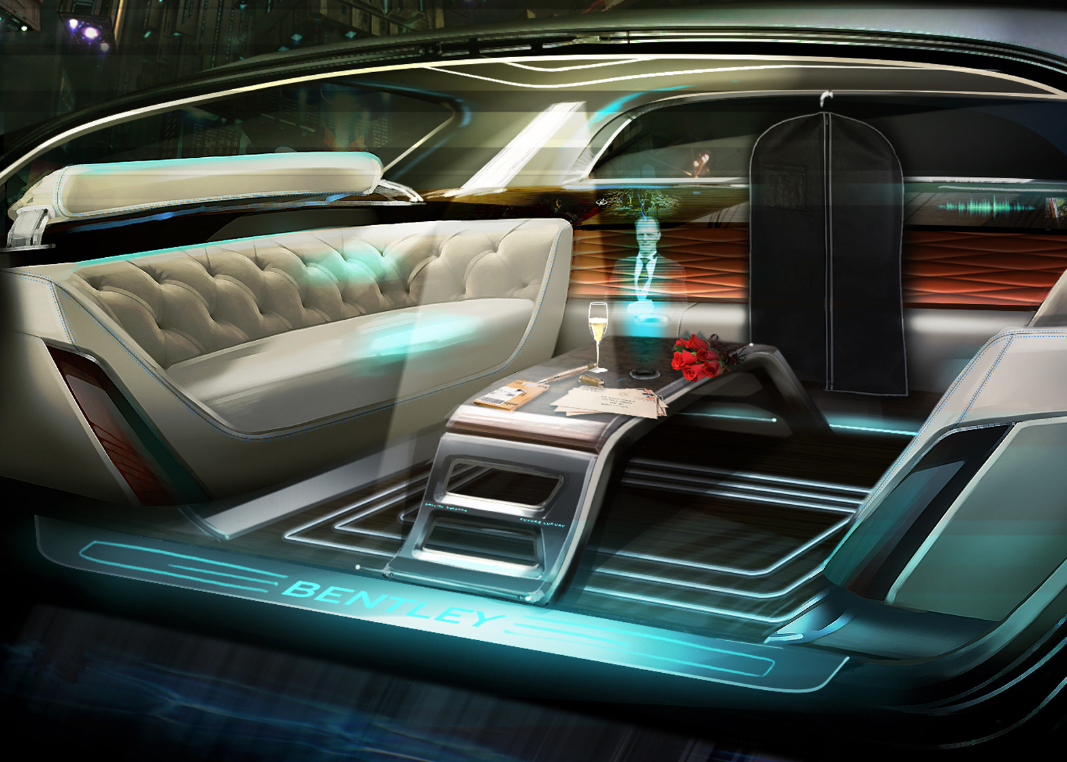
Layout and how you experience the vehicle will be important, fitting with my non-conformist approach I want to remove the traditional seat format with a three-seated configuration. The three seats wont will be made from two chairs and built in wall seat, this is to reflect the cars personality and driving experience. The advancements in driving experience has led to the integration of autonomy, with the idea of allowing the car to drive itself so you can either relax or do work until you arrive at your destination. “Autonomous vehicles can reduce driver stress and tedium. Self-driving cars can be mobile bedrooms, playrooms and offices”, with such possibilities this lends itself to alternative layouts. “Manufactures will probably produce vehicles with seats that turn into beds and mobile offices” (Litman T. 2019), why can’t the interior adapt to the occasion? I propose that the interior can adapt to what is needed, giving three scenarios of a solo, duo and trio configuration with the solo acting as a driver’s mode, duo for a luxury and relaxing experience and the trio for work or conversation. The layout would be a chair either side with integrated padding acting as a third when combined with the leg rest of the rear seat to create a bench, allowing the front chair to rotate to be able to drive the vehicle whilst semi-autonomous, and the rear to pull back and all three seats in an upright position allowing conversation and work to be done fully autonomously. Entering the vehicle, I want to make an experience by having a single embracing entry, the integrated bench seat results in having a single entry and exit point, using this to my advantage I want the way you enter to be acting like the car is embracing you into its interior like a mother embracing her child. This will adapt to the country the vehicle will be placed in so depending on the side of the road you drive will dictate the side the doors will be placed.

Initial idea
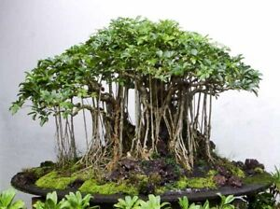
Initially my concept was to integrate the idea of oxygen production, responding to the loss of oxygen produced with the deforestation and fires in the Amazon. Integrating within the interior a living tree, modified genetically to produce the maximum amount of oxygen, developed to thrive within the climate of the interior to the release the optimal amount of oxygen with excess being released in the atmosphere acting like a traveling amazon rainforest. “A human breathes about 9.5 tones of air in a year” so for a fully-grown tree to produce the equal amount of oxygen “which is, very roughly, seven or eight trees” Villazon L. (2019). Complications in bringing a living object within the interior set the concept back, questions to how would the tree be watered and how far can you genetically modify a tree. An average trees whey tones in weight and meters in height, having a tree no bigger than a bonsai is it plausible that could ever equal a twelve meter two tone tree in oxygen production?

Integration of original idea
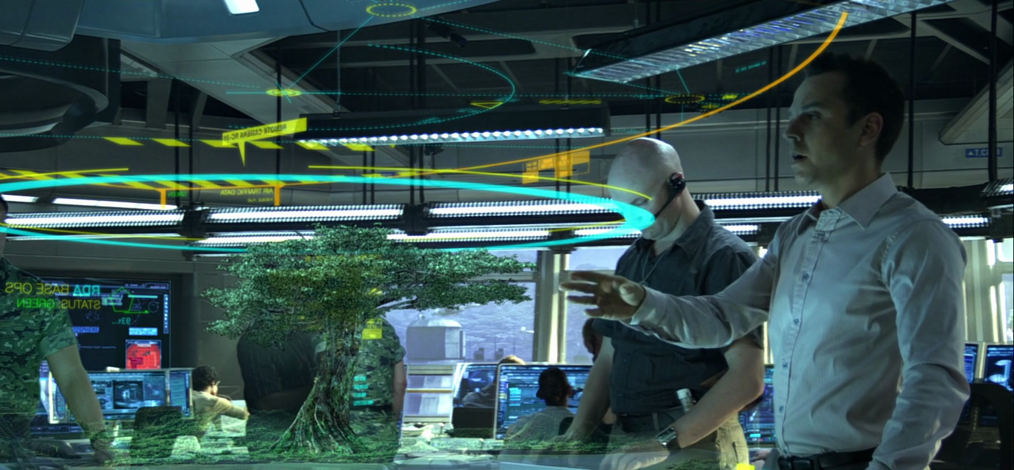
Responding to the plausibility of having a living tree within the cabin, I have adopted an alternative approach to bring the soul of the deforest Amazon trees in the interior. Inspired by a scene in the movie Avatar, incorporating a holographic tree which will act as a focal point in controlling the infotainment system. The idea is to utilize the tree and main platform which you can select features, then that information will transfer down a holographic root to the center console activating the feature you selected. Relating this idea to a scenario, when in the vehicle you select satellite navigation through the holographic tree, a graphic animation of a light going down a root goes down to the floor and too the center console, where then the dash will begin to transform opening up showing a holographic display of your journey. Combining together the future and conceptual ideas of what an interior can be with a solid reason, this could be the way to commemorate the devastation of the Amazon whilst creating a new infotainment platform.

Carbon scrubbing
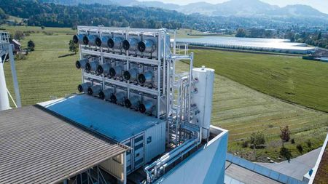
Adapting my initial concept to produce oxygen, corresponding to the levels of oxygen production loss from the overwhelming fires in the Amazon. Proposing to create a travelling carbon scrubber, purifying the air by removing the carbon dioxide. “In Switzerland, a giant new machine is sucking carbon directly from the air” indirectly purifying the air in the vicinity, with results that claim, “the plant will capture about 900 tons of CO2 annually — or the approximate level released from 200 cars”. Futurizing the technology and reducing the scale without compromising efficiency to be placed in vehicles, creating a traveling carbon scrubbing filtration system. Current negatives to the technology is that it’s an added expensive, building onto PowerStation’s or machines to counteract the carbon pollution. Reducing scale and increasing the quantity by placing them into the car would be an ideal solution for multiple reasons, having a personal scrubber will cost less to manufacture compared to a factory and counteract the vehicles personal carbon footprint. A byproduct produced from the scrubbers is a buildup of carbon, a solution used by the Swiss is to use the carbon to feed crops “The gas is then sent through an underground pipeline to a greenhouse operated by Gebrüder Meier Primanatura AG to help grow vegetables, like tomatoes and cucumbers.” (Marshall C. E&E News 2017). Turning the vehicle into a way to purify air quality and store carbon, indirectly linking back into what I sort out to do to help with carbon storage and purification because of the Amazon forest fires.

Barbra Hepworth:
“Barbara Hepworth was a British sculptor, who was born in Wakefield, Yorkshire in 1903. She was a leading figure in the international art scene throughout a career spanning five decades.” Known for her abstract sculptures Hepworth’s work developed as her career evolved, becoming more abstract and incorporating new materials which effected the work she produces. Early works used predominantly wood and depending on the logs scale restricted her pieces, which is why earlier works were smaller as the sizes of wood she could obtain were limited. Later moving to metals such as Bronze as the medium allowed her to create larger more commanding works as she was no longer restricted by the former mediums limits of scale. “Hepworth’s art was primarily about relationships: not merely between two forms presented side-by-side, but between the human figure and the landscape”. This balance between humanity and the natural landscape can be seen when seeing her sculptures outside, blending in becoming one with their surroundings by harmoniously fitting in with the landscape similarly to Henry Moore (Tate 2019).

External design influence
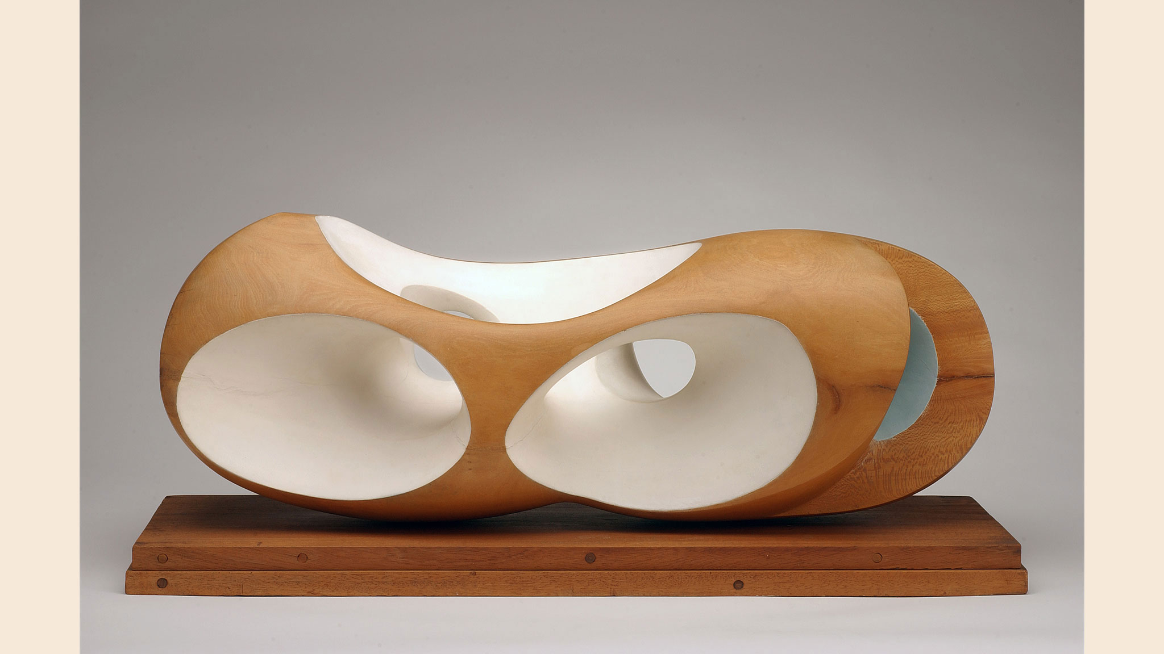
Hepworth and her work is comparable to how I wish to see the future of automotive design, with vehicles today becoming more and more alien to what they originally were intended be. Contrasting I propose to have a vehicle to imitate that the work of Hepworth, by creating a design which if left in the landscape would not seem out of place but could be viewed as a moving sculpture. Integrating more organic forms, using Biomimicry to replicate the designs in nature and or the landscape. Not to directly use the work that she has created but to influence mine, rather use her methodology and ideas to inspire my own way of viewing. Bringing together my vision of how we are directly changing the landscape and how nature itself changes it with erosion, looking at how wind erosion changes the scenery by using the sheer power and repetitiveness to alter stone, sand or ice. Erosion can be seen as both natural beauty but also for its aerodynamic flow, two areas key in automotive design, to make a car both aesthetically pleasing and efficient at directing and controlling air flow. Similarly, with the work with Hepworth using the Cornish coast and humanity to define her pieces, I intend to incorporate the landscape and wind erosion to define the exterior of the vehicle. To emulate much like Hepworth’s designs, communicating a “strong and expressive” view of nature to reflect the same found in the landscape. When working on her pieces Hepworth talks about the importance of touch, “sculpture differs from painting is that the former invites touch on the part of the viewer and this provides the communication” (Robert R. Nicholas R. 1988). Studying the surfacing and how the user will interact via touch is important, using the idea of erosion and communicate that by simply feeling the form of the vehicle. To blindly touch and feel the transition of surfaces and textures, feeling the form then in your mind relate that to my stimulus. This in turn will allow me to see if I am successful in communicating my ideology.

Henry Moore:
Moore was a twentieth century British artist, predominantly known for his sculptures with many regrading him as the catalyst to start the awareness to British sculptures of the period “Moore is considered as the catalyst of the British sculptural renaissance”. Working both for himself creating work he wanted to create, alongside commissions as a world-renowned artist he had many prestigious commissions working with architects and governments “In 1946 the Labour government passed the New Towns Act prompting the creation of 11 new towns. As the most prominent sculptor of the day, the work of Moore was called upon to enhance these towns and other modernist sites.” Looking at his lasting legacy Moore will widely be remembered for bringing sculpture to the landscape, with places like the Yorkshire sculpture park showing how his work was intended to be experienced “the artist preferred his sculptures to be seen in natural landscapes. Whether natural scenery or the built environment, Moore’s works have peppered landscapes around the world since the 1950s.” The use of landscape to present his work is why I feel Moore will greatly influence how I design, coming from an abstract approach the car is a sculpture which moves in altering landscapes. (Henry Moore Foundation (2019)

Putting the car in the landscape
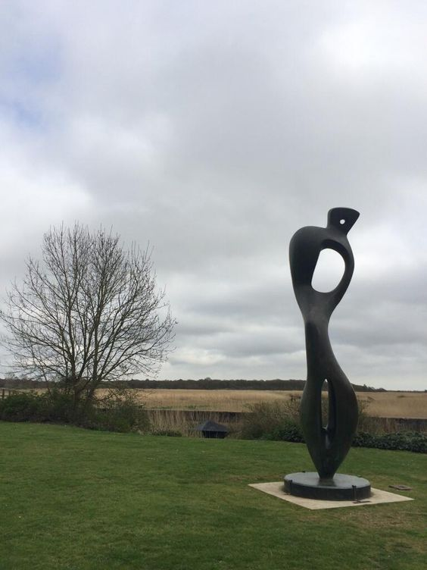
“I often found that by taking formal ideas from landscape, and putting them into my sculpture I have, as it were, related a human figure to a mountain”. Understanding how Moore deciphers the landscape will allow myself to deconstruct the forms seen in landscapes and blend with the concept of erosion and relating that to my proposal. “Break up the whole elements of the landscape, separate all the elements.” By segmenting the landscape and breaking it to what actually interest me, this will help me to decipher what elements I need to break down to influence the work. By over analysing and studying elements which might not relate to my subject, this won’t advance what I try to communicate with the visual form of the design. Equally importance is to select a landscape to match the form, “nature of the landscape brings out the skelatonic”. In an aim to have a sculpture that fits all landscapes will act as a detriment, by selecting a specific layout will give a more relatable design. Reconsidering my aim of matching a universal design to the landscape may improve if I choose specific, that in turn will produce a design which visually will be pure. (Moore H. 2002)

Why Hepworth and Moore

By combining both influences of Hepworth and Moore the philosophy and design language will echo the beauty of the landscape, utilising the form and understanding of landscape by Moor and the balance of design from Hepworth I will create a shape to all encompassed what I visually wish to communicate to the user. Combining the visual language of erosion looking at how wind can sculpt the differing landscapes of stone, sand and ice to create a design which supports the surrounding landscape. Restrictions of aerodynamics and creating a vehicle which is still efficient to control the air will constrain how far I can explore. Encouraged by how Hepworth can create a design to visually show the combination of humanity and landscape will help balance my design, infusing the efficiency of aerodynamics with the infusion of the landscape. Within my design key features will influence the designs form and scale, utilising features which work with the engineering of the vehicle. Incorporating features such as a solar tail which purpose is to generate solar energy so will be a large and naturally unbalanced, air intakes which will need to be methodically placed to efficiently cool the internal systems. The vehicle still needs to move and maintained with mobility and interior restraint with internal footprint of the cabin, as the vehicles main purpose is to drive and take occupants and do it in a luxury fashion so not encroach into the interior space is key. Combining the key fundamentals with my chosen proposal encompassing influences to effectively create a design influenced by the changing landscape, this will be the bar to judge my work to be successful or not. Using the investigation of Hepworth and Moore to help with this process.

Balance
Balance seems to be integral to any successful design, the balance to create something which is both visually stunning and to work effectively and efficiently. Giving a design a structural stability visually and emotionally will affect how the user will interact with the vehicle. Giving the evenness between art and engineering will affect the visual and technical performance, finding a compliment between form and function as by leaning to far one way may lead to a vehicle showing different qualities, one which may be beautiful but technically flawed or technically brilliant but visually disappointing. Bauhaus was a school and art direction that embraced the idea of form and function with the function dictating the form. “Their aim was not to style or applied art, but form appropriate to function”, to reflect that statement in my work must have incorporate the philosophy of ever groove, line and crease is to be purposeful, however in sculpture this might not be the case working more from emotion than functionality. Design to follow function however can have many outcomes with each possibility solving one problem in multiple solutions, meaning how I interpret a design restriction will have many outcomes, described in s segment in Bauhaus 1919 – 1933 describing a cream jug and sugar pot “since each of them satisfies our requirements without disturbing the other, their combinations create our style.” (Magdalena D. Bauhaus-Archiv pg79 2002). Adapting how I integrate design influence to achieve the basic requirements to establish the form, will dictate my style and overall arrangement of the vehicle, resulting in the balance of the vehicle by satisfying the structure needed to be an effective vehicle whilst using the landscape to design the desired solutions. streamlining this method and simplifying it rather to each action will have a design solution dictated by my inspiration. The vehicle I propose will require a large surface area to adequately create solar energy, a sizable interior footprint to house occupants in comfortable manor, together with a form which can effectively punch through the air so the vehicle is efficient in its purpose to travel the occupant. Of which all will be solved using forms in the landscape, solving design solutions while creating an organic form which if placed in its designed landscape would enhance the surroundings much like the sculptural work of Henry Moore and Barbra Hepworth.

scenario (ideology)
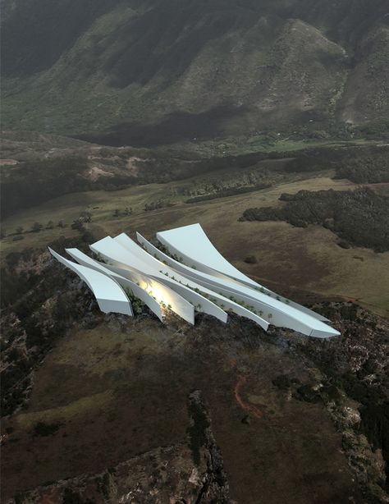
To ideologies my concept, explain what I propose as a design and how I see it in a future setting and what I have set out to accomplish. Explaining the vision of the landscape and how the vehicle will react to its surroundings, interaction and experience it gives the occupants and how it combats predicted future problems. Articulating what I have said and what I propose through a set out scenario, giving a who what where why approach to what I propose to create.

The year is 2060, the idea of a petrol and eclectic combination failed, deciding to work with hydrogen alongside electric for a sustainable power source. The car industry is working to a different structure, no longer over producing and lowering the quality each year by producing limited numbers to appreciate the products they produce. A plastic free future, cars incorporating natural accruing elements using bio mimicry to create structures stronger than the plastic of the past. Furthering what a car can be incorporating features to make the vehicle more than just a mode of transportation, incorporating carbon scrubbers to purify the air flowing through and around the vehicle and store the carbon to later used to improve crops kept at a personal family green house, making the car and the home self-sustaining. A future based on reducing carbon footprints and sustainability, especially in remote towns and villages hidden within the landscape. Vehicles needing to combine features to extend the vehicles functions whilst minimizing energy used, incorporating energy generating features like a solar tail to generate energy by convert waste back into the vehicle. Cities becoming larger and larger, the appeal to live outside becoming more alluring, resulting in vehicles to adapt making the interior a multi-functional space. With populations rising the use of regenerative materials to make what we produce last has become integrated into the automotive industry, using regenerative materials to increase longevity of the product used on a personal and public use. To try limit overpopulation families are limited to a single child, reflected in vehicles using a three-seat configuration allowing small vehicle to be smaller and larger vehicles to value the added space. Valuing the exterior equally to the interior with limited number of each vehicles being made each year how the design looks and efficiently works is what will attract audiences, playing either to a value of landscape to appeal to those out the city or small compact designs to reflect the futuristic cities. My design relating more to the sculptural form on a larger scale to transport families who our self-sustaining outside the city, working to add comfort with the technology to put back to purify the footprints create by the larger cities.
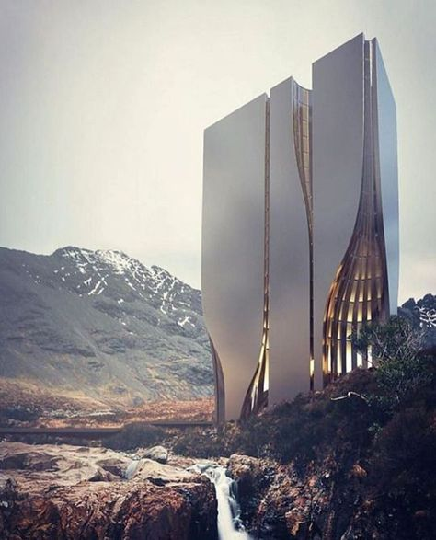

Liminal space
What I propose is something that takes what we currently know and how I perceive the world to become, working in the liminal space of design to anticipate and take the chance to what could be next. “The word liminal comes from the Latin word limen, meaning threshold”, in the words meaning summarizes the time and moment what I’m working towards conceptually and visually. Looking at what was and what I recognize to be next works to no specific guidelines, as the area of my work fits in the space with endless possibilities so if I can back it by reasoning it can’t be said to be wrong “Liminal space is where all transformation takes place”. Where we are as an industry were at a tipping point where we can accept and make the change or become stagnant and reject the inevitable evolution, “We often miss the real potential of ‘in-between’ places – we either stand paralyzed or we flee” (liminal space finding life between chapters 2019)

Bibliography:
Dunbar B. (2009) Solar-to-vehicle (S2V) systems for powering commuters of the future
[online journal] Available: https://www.sciencedirect.com/science/article/abs/pii/S0378775308018946 Viewed: 18th October 2019
Hughes R. (2019) Amazon fires: What's the latest in Brazil?

[online] Available: https://www.bbc.co.uk/news/world-latin-america-49971563
Viewed: 12 October 2019

Henry Moore Foundation (Unknown author) (2019) Henry Moore’s Legacy
[Online] Available: https://www.henry-moore.org/about-henry-moore/henry-moores-legacy
Viewed: 28th October 2019

Litman T. (2019) Autonomous Vehicle Implementation Predictions Implications for Transport Planning
[Online pdf] Available: https://www.vtpi.org/avip.pdf
Viewed 30th October 2019

liminal space finding life between chapters (2019) what is liminal space?
[Online] Available: https://inaliminalspace.org/about-us/what-is-a-liminal-space/
Viewed 30th October 2019

Magdalena D. (Bauhaus-Archiv) (2002) Bauhaus, 1919-1933
Pg79
[Book] Available: https://books.google.co.uk/books?hl=en&lr=&id=ZXB8rX5AsgUC&oi=fnd&pg=PA91&dq=bauhaus+&ots=_nKDSb3Dpg&sig=QeokbDBmRwe_M1tpC0nwfqz3KSQ&redir_esc=y#v=onepage&q=form&f=false
Viewed: 28th October 2019

Marshall C. E&E News (2017) In Switzerland, a giant new machine is sucking carbon directly from the air
[Online website] Available: https://www.sciencemag.org/news/2017/06/switzerland-giant-new-machine-sucking-carbon-directly-air
Viewed: 30th October 2019

Moore H. (2002) Henry Moore-- Writings and Conversations
Pg 126, pg 127, pg 275
[Book] Available: https://books.google.co.uk/books?hl=en&lr=&id=pzqg4l-ce7oC&oi=fnd&pg=PA7&dq=henry+Moore&ots=m8bFc2kWUb&sig=cVv_CuaWMcqEplS75LqOK1pvSZI&redir_esc=y#v=onepage&q=landscape&f=false
Viewed: 29th October 2019
Oxman N. (2018) Neri Oxman(official webpage)
[Online] Available:
https://neri.media.mit.edu/neri-oxman.html
Viewed: 19th October 2019
Pagliaro M. Konstandopoulos A. Ciriminna R. Palmisano G. (2010) Solar hydrogen: fuel of the near future
[Online journal] Available:
https://pubs.rsc.org/en/content/articlelanding/2010/ee/b923793n/unauth#!divAbstract
Viewed:18th October 2019
Robert R. Nicholas R. (1988) Hands and the Artist — Barbara Hepworth
[Online journal] Available: https://journals.sagepub.com/doi/abs/10.1016/0266-7681_88_90067-8?journalCode=jhsb
Viewed: 26th October 2019
Roy R. Souchoroukov P. Shehab E. (2011)
Detailed cost estimating in the automotive industry: Data and information requirements
[Online journal] Available: https://www.sciencedirect.com/science/article/abs/pii/S0925527311002350
Viewed: 18th October 2019
Tate (unknown author) (2019) Who is Barbra Hepworth?
[Online website] Tate Available:https://www.tate.org.uk/art/artists/dame-barbara-hepworth-1274/who-is-barbara-hepworth
Viewed 26th October 2019
Teichmann D. Arlt w. Wasserscheid p. Freymann R. (2011)
A future energy supply based on Liquid Organic Hydrogen Carriers (LOHC) [online] Energy and Environmental Science
[online journal] Available: https://pubs.rsc.org/en/content/articlelanding/2011/ee/c1ee01454d/unauth#!divAbstract
Viewed: 16 October 2019

Toyota (2019) Hydrogen-powered Miari
[Online] Available: https://www.toyota.co.uk/new-cars/new-mirai/
Viewed 29th October 2019

Villazon L. (2019) How many trees does it take to produce oxygen for one person?
[Online] Available: https://www.sciencefocus.com/planet-earth/how-many-trees-does-it-take-to-produce-oxygen-for-one-person/
Viewed 29th October 2019

Images:

1] Nagesh A. (2019) BBC News
Accessed november 2019
Available: https://www.bbc.co.uk/news/world-latin-america-49497857
2] Richard M (2005) Treehugger
Accessed November 2019
Available: https://www.treehugger.com/cars/more-details-on-hondas-2006-fcx-fuel-cell-car.html
3]Murphy T. (2011) Gigaom
Accessed November 2019
Available: https://gigaom.com/2011/11/29/how-practical-is-a-solar-powered-car/
4]Toyota (2019) Toyota official
Accessed November 2019
Available: https://www.toyota.co.uk/new-cars/new-mirai/meet-mirai#1
5] Yabusaka (2019) artstation
Accessed November 2019
Available: https://www.artstation.com/artwork/q3D9L
6]Multivu 2019
Accessed November (2019)
Available: http://www.multivu.com/players/uk/7694951-volvo-cars-unveils-concept-26/
7 Science source (2019)
Accessed November 2019
Available: https://pixels.com/featured/ford-model-t-assembly-line-1920s-science-source.html?product=bath-towel
8] Shen Y (2014) Archdaily
Accessed November 2019
Available: https://www.archdaily.com/894979/neri-oxman-and-mit-develop-programmable-biocomposites-for-digital-fabrication
9] Figuet M (2014) Neri Oxman
Accessed November 2019
Available: https://neri.media.mit.edu/projects/details/gemini.html
10] Bryant R (2016)
Accessed November 2019
Available: https://www.dezeen.com/2016/03/17/bentley-design-chief-stephan-sielaff-luxury-autonomous-driverless-cars-could-offer-faster-routes-crowded-cities/
11] Purebonsai (2019)
Accessed November 2019
Available: https://purebonsai.com/juniper-bonsai-tree-seeds-20pcs/
12] Camron J (2019) Fandom
Accessed Novemberv2019
Available: https://james-camerons-avatar.fandom.com/wiki/Ops_Halo_Station
13] CLIMEWORKS (2017) Sciencemag
Accessed November 2019
Available: https://www.sciencemag.org/news/2017/06/switzerland-giant-new-machine-sucking-carbon-directly-air
14] Stalsworth L (2015) Barbara Hepworth: a life told in six works
Accessed November 2019
Available: https://www.theguardian.com/artanddesign/2015/jun/07/barbara-hepworth-life-in-six-works-tate-retrospective-exhibition-sculpture-for-a-modern-world
15] Henry Moore studios and gardens (2019) Pinterest
Accessed November 2019
Available: https://www.pinterest.co.uk/pin/263953228134826458/
16] a10’s News and Views (2019)
Accessed November 2019
Available: https://a10shelyn.weebly.com/slow-changes.html
17] Googleapis (2019) Pinterest
Accessed November 2019
Available: https://www.pinterest.co.uk/pin/647533252657222683/
18] Behance (20190 Pinterest
Accessed November 2019
Available: https://www.pinterest.co.uk/pin/647533252656877558/

