

Programme: BA (Hons) Business Management
Module name: Independent Project
Module code: LCBB 6014
Student name: Corina Seni
Student ID: 2217836
Assignment Title: Component 1- Research Proposal
The Impact of Hybrid Working on Employee Engagement in UK Organisations
Supervisor name: Dr Ibrahim Rufai

Table of Contents
1. Introduction 2
2. Research Aim, Objectives and Research Questions 3
Research Aim 3
Research Objectives 3
Research Questions 3
3.Literature Review 4
4. Research Methodology 6
5. Potential Implications 7
6. Conclusion 8
References 9

Research Proposal
Title: The Impact of Hybrid Working on Employee Engagement in UK Organisations

1. Introduction
One of the main changes to work patterns because of the COVID-19 pandemic is the adoption of Hybrid working by many organizations around the world as the new normal and this allows their staff to work from the office and any other location. Hybrid working provides employees with the benefits of work life balance, reduced travel time between meetings, increased productivity and improved health. However, there are also many concerns relating to Hybrid working and its impact on employee engagement. Employee engagement is key to any organization and to them performing at their best and achieving their goals in terms of productivity, job satisfaction and retention.
This research is important because hybrid working has become a long-term way of working in many organizations across the UK. Little is known about other effects of hybrid working on employee engagement. What does exist provides a mixed picture and therefore requires further exploration.
This study is a qualitative study that examines the impact of hybrid working on employees’ levels of engagement in UK organizations. The secondary data used in this study is sourced from a variety of places including on-line journal articles, books, UK Government reports and organizational and industry studies.
This study addresses the current knowledge gap as to the long- and short-term effects of hybrid working on employee engagement in UK organizations.
The findings from this research will enable managers, HR practitioners and policy makers to develop strategies which will increase employee engagement and enhance organizational performance through the implementation of hybrid working.

2. Research Aim, Objectives and Research Questions

Research Aim
An exploratory study into the effects of hybrid working on employee engagement in organizations in the UK.

Research Objectives
1. Hybrid working in UK organisations has several key characteristics.
2. To explore the factors which affect employee engagement because of employees working hybrid working patterns.
3. What are the key organizational practices that support employee engagement in hybrid working environments?

Research Questions
RQ1: What are the dominant dimensions or characteristics of hybrid working currently in practice in UK organizations?
RQ2: How does hybrid work influence employee engagement?
RQ3: How do organizations practice increasing employee engagement in hybrid working environments?

3.Literature Review
The adoption of hybrid working by organisations across the UK has increased at a rapid rate over the last year, with hybrid working becoming the long-term way of working, where employees can go to a variety of different locations to work as well as going to the organisation’s headquarters at times to suit, (Allen, Golden and Shockley, 2021). Initially put in place as an emergency measure during the COVID-19 pandemic to try and stop the spread of the virus and to keep employees safe, hybrid work has proven to be so beneficial that employees value the ability to work from a number of different locations, as it enables them to have a better work-life balance, saves time travelling to and from work and gives them greater autonomy at work, (Barrero, Bloom and Davis, 2023).
Work engagement is a positive psychological state of vitality, dedication, and absorption (Schaufeli et al., 2002). The engaged employee is motivated, committed to the job, and brings energy to work to make sure that the organization is successful and that they are doing the best job they can with the discretionary effort that they bring to work. As organizations around the world have moved to hybrid ways of working, there are many benefits to employee motivation and satisfying jobs, with several key factors including autonomy. As Choudhury, Foroughi and Larson (2021) found, location flexibility can increase commitment from employees as it allows working practices to be designed that take account of employees’ best work times as well as other personal factors.
While much of the organizational work on hybrid work is positioned to enhance employee engagement by enabling employees to work in the way that is most effective, the evidence to date is patchier. There are a few studies that highlight the way in which hybrid workers are unable to engage in on an ongoing basis face-to-face with their colleagues and as a result experience a few detriments including social isolation, communication problems and lack of access to informal support (Wang et al., 2021). These in turn have the potential to impact on several dimensions, including collaboration, organizational identification and workplace relationships and hence negatively impact on employee engagement (Waizenegger et al., 2020). However, as with any organizational policy or practice, the impact on employee engagement will depend on the organization managing the benefits and drawbacks to develop an optimal hybrid work environment.
From a theoretical perspective, the differences between this study and other studies can be explained by means of the Job Demands-Resources (JD-R) Model. This model explains how the well-being of and the engagement of employees are determined by the balance between job demands and job resources.
In addition to potential job demands, hybrid work can also bring many job resources. These include flexibility, autonomy, support from managers and colleagues, access to digital tools, and a good work-life balance (Bakker and Albrecht, 2018). One key job resource for employees is autonomy at work, because it enables them to work in ways that best suit them (Knight, Patterson and Dawson, 2019). Another example, employees may experience social isolation and communication problems, struggle to ‘switch off’ from work, and have an increased reliance on technology (Wang et al., Wang, 2021).
Recent studies which tested the Job Demands-Resources (JD-R) model in the context of hybrid work confirmed the hypotheses. Employees’ engagement at work increases when they have autonomy at work and when they perceive organizational support. Conversely, engagement at work decreases when there is technostress and when there is a high level of workload at work (Molino et al., 2020). As for digital tools at work, they can support or undermine engagement at work, depending on the way in which this is managed. In fact, while good communication can prevent strain caused by digital tools, bad communication can increase the sense of strain (Van Zoonen and Sivunen, 2022).
Most research on work and its employee outcomes is focused on the employees’ well-being and work performance while at work. There is limited research which investigates the impact that work has on employee engagement.

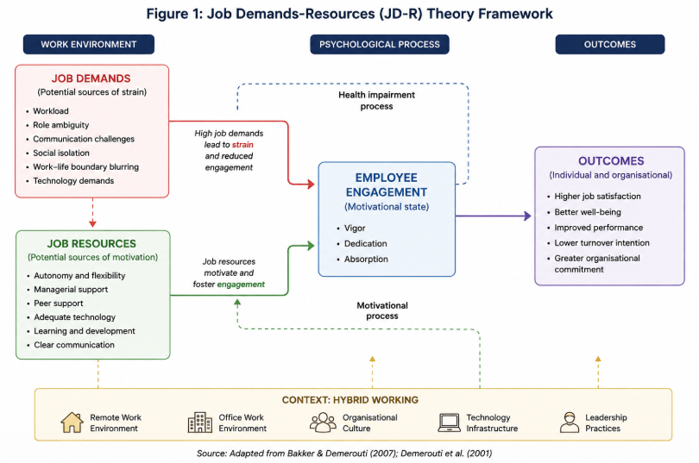
Figure 1: Job Demands-Resources (JD-R) Theory Framework
(Source: Created by author)

4. Research Methodology
This research shall employ qualitative methodology to examine the effects of hybrid working on employee engagement within UK organizations. Given the research’s objective to uncover employees’ experiences, perceptions, and behaviours whilst working in a hybrid working environment, the qualitative approach shall be most appropriate (Saunders, Lewis and Thornhill, 2019).
Mark Saunders’ Research Onion was used to guide this research. The research employed an interpretivist philosophy and an inductive approach. As stated earlier, the organizational context as well as individual experiences of employees, affect complex concepts such as hybrid working and employee engagement, and these can be studied better with an inductive approach (Saunders, Lewis and Thornhill, 2019).
The data collected from secondary sources will be analysed using the thematic analysis approach (Braun and Clarke, 2006). The six stages of thematic analysis will be used to identify the themes developed from the articles studied. The stages are familiarization, coding, themes generation, themes review, themes definition and reporting. Using these stages, recurrent themes of job demand, job resources and employee engagement will be identified in the context of hybrid work environments.
The findings from this research will be presented using the framework of the Job Demands (JD-R) of work, in terms of the demands that are placed upon employees and the resources that are available to them to complete their jobs (Bakker and Demerouti, 2007). The main challenges and opportunities that have been presented by hybrid working in terms of employee engagement at work will be discussed.
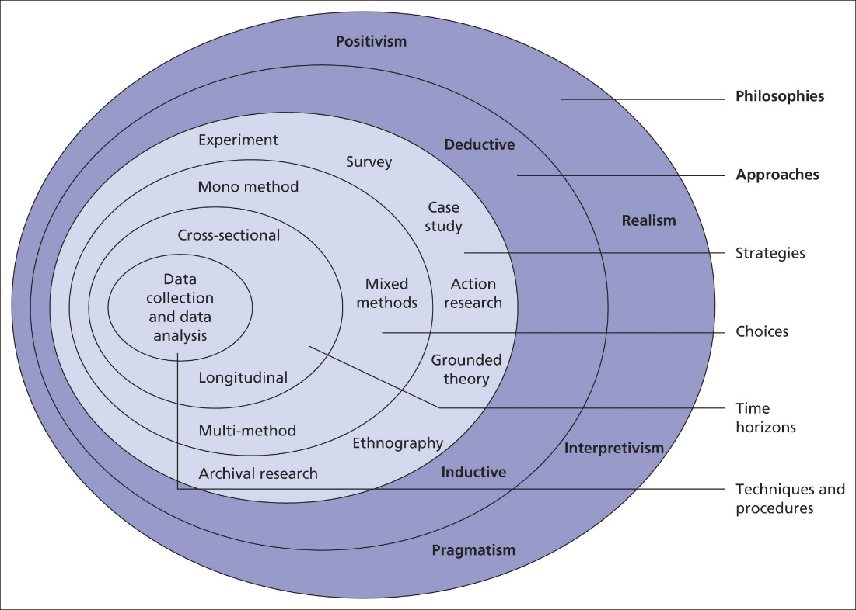
Figure 2: Research Onion
(Source: Saunders et al., 2019)

5. Potential Implications
Research into work aspects of employee engagement is underdeveloped when compared to a wealth of studies in relation to work wellbeing and work performance. Much of the research relating to employee engagement in hybrid work environments is currently increasing and the findings are mixed and may not be relevant to practice within individual UK organizations. The purpose of this research is to critically evaluate most current studies and provide practice relating to increasing employee engagement within hybrid work environments.
The research addresses the current knowledge gap within existing academic literature, in relation to hybrid working and Employee Engagement within organizational contexts, set within the UK. The research will benefit managers and HR professionals within organizations that currently operate or are planning to adopt hybrid working. The research will aid these organizations in designing effective working practices that increase Employee Well-being and organizational performance. The research could also inform future workplace policies from government and other policy makers, with the aim of supporting flexible working whilst ensuring Employee Engagement, Productivity and mental wellbeing are protected. In the long-term, the research aims to aid sustainable working practices within organizations that are beneficial to Employees, Organizations and wider society.

6. Conclusion
This research proposal aims to explore the impact of hybrid working on employee engagement in UK organizations with a focus on both the advantages and disadvantages of hybrid working for employee engagement in the post-pandemic environment. A mixed of findings from previous studies were identified regarding the impact of hybrid working arrangements on employee engagement. To gain more insight in the impact of working conditions on employee engagement, the Job Demands-Resources (JD-R) model will be used in this research.
The analysis of the data collected in this research will be of a qualitative nature. Secondary data analysis and thematic analysis will be used to arrive at an in-depth exploration of the themes that emerge from the analysis of the data collected in this research. A Gantt chart has been produced to manage the overall research. This chart will also be used to plan and organize the time required to complete each aspect of the research. When completing the final work dissertation, the literature will be selected using the PRISMA framework in a transparent and systematic way.
The findings from this research will contribute to current knowledge on employee engagement in the workplace and offer organizations from across the UK practical ideas on how to increase levels of employee engagement in Hybrid work environments.

Figure 3: Gantt Chart
(Source: Created by author)

References
Allen, T.D., Golden, T.D. and Shockley, K.M. (2021) ‘How effective is telecommuting? Assessing the status of our scientific findings’, Psychological Science in the Public Interest, 22(3), pp. 40–68.
Bakker, A.B. and Albrecht, S.L. (2018) ‘Work engagement: Current trends’, Career Development International, 23(1), pp. 4–11.
Bakker, A.B. and Demerouti, E. (2007) ‘The Job Demands–Resources model: State of the art’, Journal of Managerial Psychology, 22(3), pp. 309–328.
Barrero, J.M., Bloom, N. and Davis, S.J. (2023) ‘The evolution of work from home’, Journal of Economic Perspectives, 37(4), pp. 23–50.
Braun, V. and Clarke, V. (2006) ‘Using thematic analysis in psychology’, Qualitative Research in Psychology, 3(2), pp. 77–101.
Choudhury, P., Foroughi, C. and Larson, B. (2021) ‘Work-from-anywhere: The productivity effects of geographic flexibility’, Strategic Management Journal, 42(4), pp. 655–683.
Galanti, T., Guidetti, G., Mazzei, E., Zappalà, S. and Toscano, F. (2021) ‘Work from home during the COVID-19 outbreak: The impact on employees’ remote work productivity, engagement and stress’, Journal of Occupational and Environmental Medicine, 63(7), pp. e426–e432.
Knight, C., Patterson, M. and Dawson, J. (2019) ‘Work engagement interventions can be effective: A systematic review’, European Journal of Work and Organizational Psychology, 28(3), pp. 348–372.
Molino, M., Ingusci, E., Signore, F., Manuti, A., Giancaspro, M.L., Russo, V., Zito, M. and Cortese, C.G. (2020) ‘Wellbeing costs of technology use during COVID-19 remote working’, Sustainability, 12(15), pp. 1–15.
Page, M.J. et al. (2021) ‘The PRISMA 2020 statement’, BMJ, 372, p. n71.
Saunders, M., Lewis, P. and Thornhill, A. (2019) Research Methods for Business Students. 8th edn. Harlow: Pearson.
Schaufeli, W.B., Salanova, M., González-Romá, V. and Bakker, A.B. (2002) ‘The measurement of engagement and burnout’, Journal of Happiness Studies, 3(1), pp. 71–92.
Van Zoonen, W. and Sivunen, A. (2022) ‘The impact of remote work and mediated communication on employee engagement’, New Technology, Work and Employment, 37(1), pp. 44–58.
Waizenegger, L., McKenna, B., Cai, W. and Bendz, T. (2020) ‘An affordance perspective of team collaboration and enforced working from home during COVID-19’, European Journal of Information Systems, 29(4), pp. 429–442.
Wang, B., Liu, Y., Qian, J. and Parker, S.K. (2021) ‘Achieving effective remote working during the COVID-19 pandemic: A work design perspective’, Applied Psychology, 70(1), pp. 16–59.

