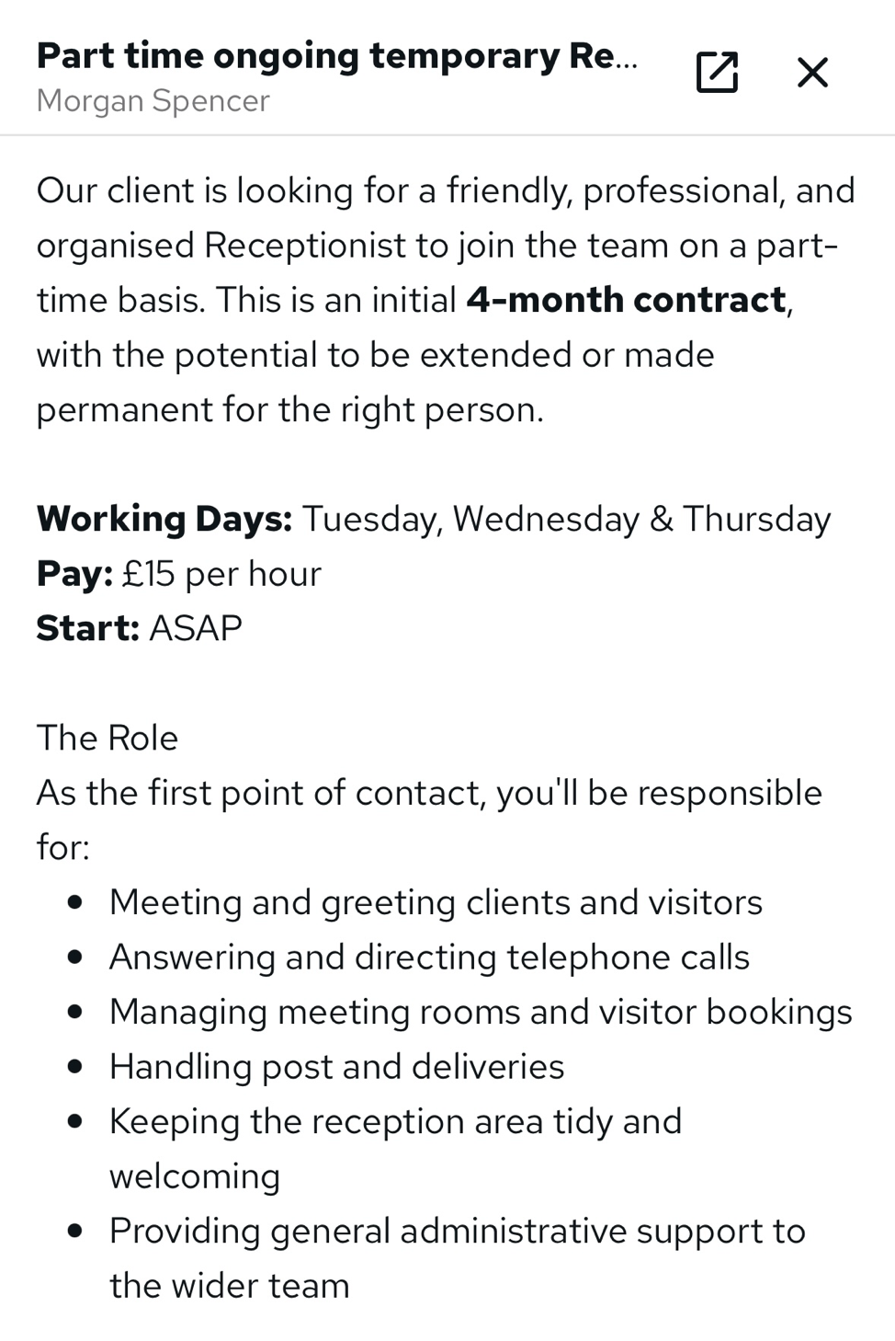
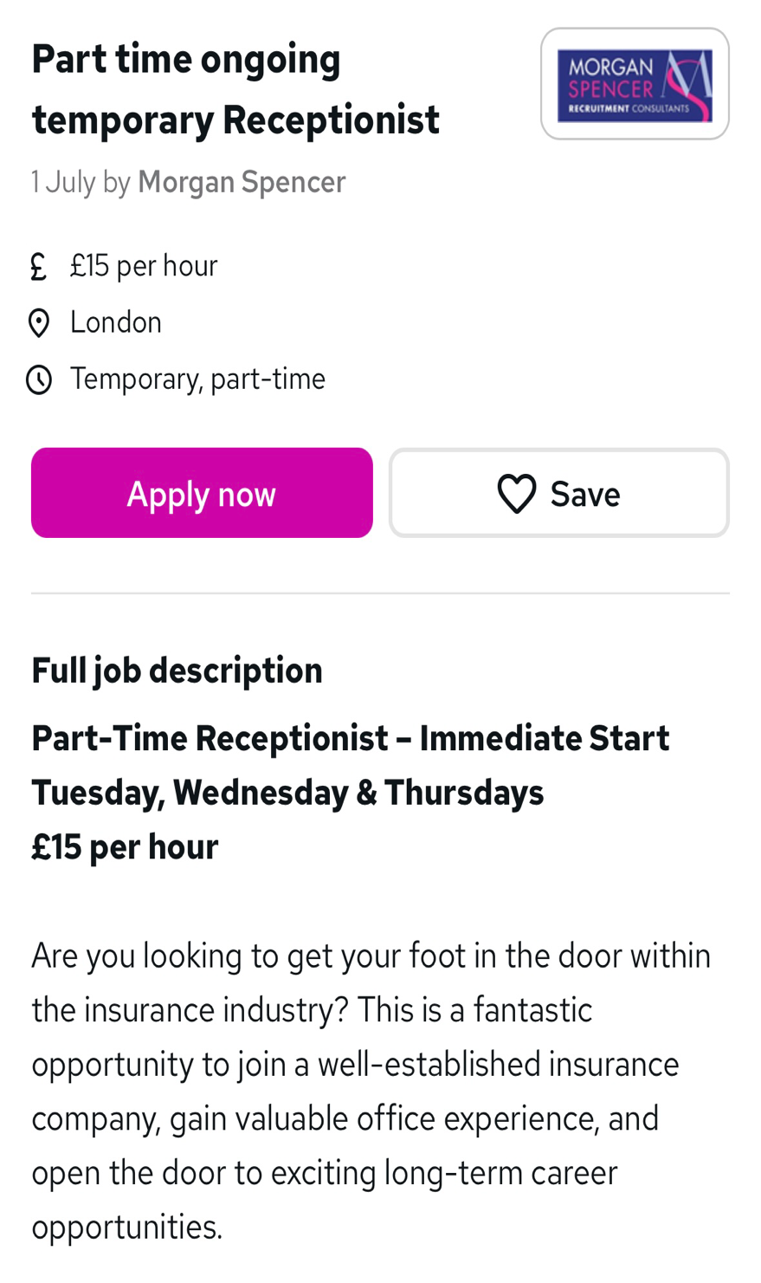

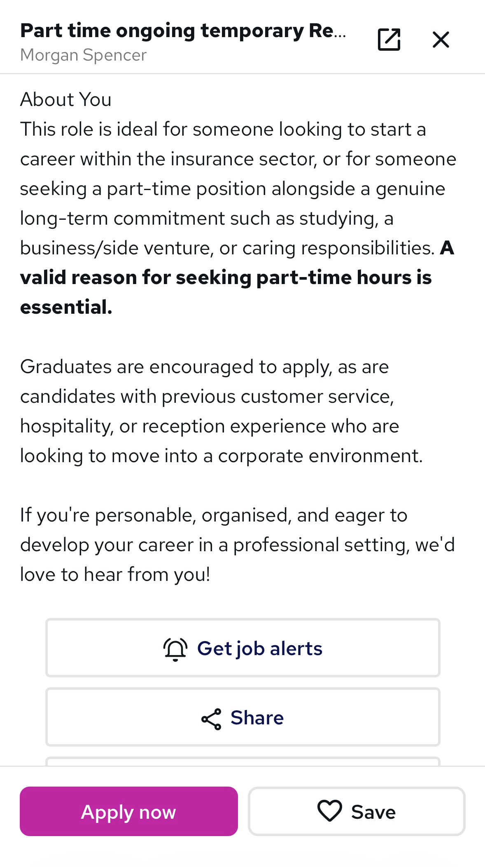

Aiyana Vaughan-Canas

Aiyana Vaughan-Canas

London

aiyanacanas123@gmail.com

Re: Receptionist role at Morgan Spencer
Dear to whom it may concern,
I was excited to learn of the current opening at Morgan Spencer for a Receptionist, and I would like to be considered for this position. I am currently studying business and working in a customer facing job and this role would allow me to utilize and further improve my skills to the best of my ability
Throughout my history, I've worked hard to develop essential skills in areas such as communication and interpersonal and build a wide range of skills related to customer service and system work. I feel energised by connecting and interacting with others which is why I feel a receptionist role would be a great fit.

I consistently manage competing responsibilities and giving guests and customers top quality support. At bravissimo I learnt organisation and coordinating skills by working with my management team and my coworkers which has been especially useful, and I look forward to putting my expertise to good use in a challenging but rewarding position.
Please reach out with any questions about my work history and capabilities. I'll be happy to expand on any experience, skills and how I can meet your needs and I appreciate you taking the time to review my cv linked below for the open position and hope to speak soon for a phone chat or to set up an interview.
Sincerely,
Aiyana Vaughan-Canas

AIYANA Vaughan-Canas

Mobile: 07383686766
Email: aiyanacanas123@gmail.com
Summary

I am a Bilingual Customer Service consultant experienced in executing a personalised support and service in a fast-paced retail setting. I developed strong communication and organizational skills while managing sensitive consultations, booking appointments, and processing customer records. I am currently studying a CertHe in business skills in the work place and balancing a customer facing job and I am eager to learn and grow in my professional day to day life by applying communication skills and by learning new skills in my jobs and in my education .
Experience
Bra Fitting Consultant 04/2025 to Current
Bravissimo
- Conducting one-to-one bra fittings, creating a welcoming and confidential environment for customers.
- Assisting customers in understanding their needs and providing a tailored service to deliver an effective solution
- Delivering face-to-face customer service, establishing trust and rapport with customers during consultations.
- Demonstrated empathy and active listening while supporting customers through sensitive conversations.
- Answer telephone enquiries, book appointments using the company booking system and assist customers with product enquiries and order queries.
- Creating customer accounts, register customers for marketing communications and maintain accurate customer information using internal systems.
- Processing purchases, returns and exchanges through the system.
- Completing stock recalls and maintain accurate inventory using company systems.
- Receiving and processing FedEx deliveries, checking stock against delivery documentation
- Working with colleagues to maintain high store standards and to deliver an excellent customer experience.
- Recruited as a summer temporary employee and offered a permanent position

Volunteer 02/2021 to Current
CCL Pimlico Church
- Volunteer as a Sunday School teacher for children aged 3–6 years.
- Interpreting between English and Spanish for bilingual and Spanish-speaking children and families.
Helping organise community events, focusing on children's activities to encourage participation .
- Further Developed strong communication, teamwork and organisational skills while working with a range of members of the community.
- Supporting outreach projects by distributing food, clothing and essential supplies to those in need
Education
The Diana Award - Mentoring Programme September 2022 - December 2022
- Worked collaboratively with team members on a community project to achieve shared goals.
- Developed leadership, teamwork and communication skills.
- Built confidence in planning, organisation and project delivery.

GCSEs: English Language, English Literature, Mathematics, Combined Science, French, Spanish, Sociology, History, Music September 2017- July 2022
City of London Academy

CertHE: Business Skills in the Workplace October 2025 – current
University of Wales Trinity Saint David (UWTSD)
- Developing practical IT skills to be confident in using Microsoft Word, Excel, PowerPoint
- Strengthening academic writing, research, presentation and referencing skills.
- Gaining knowledge of business communication, teamwork, problem-solving and workplace professionalism.
- Improving my written and verbal communication through presentations, group work and coursework
- Analysing business scenarios and applying practical solutions helped my development of critical thinking and analytical skills
- Balancing higher education alongside a permanent customer-facing role taught me organisational skills time management and commitment
Spear Programme: Personal and Career Development January 2025-February 2025
Spear Hammersmith & Fulham (resurgo trust)
- Developed confidence in professional communication and networking.
- Delivered presentations and worked collaboratively within teams.
- Participated in workshops focusing on communication team building and problem solving
- Developed IT and CV writing skills
- Responded positively to feedback and demonstrated adaptability.
- Strengthened organisational, reliability and employability skills.

Skills
- Excellent customer service and relationship building  - Appointment booking and telephone handling  - Customer account management  - Order processing  - Stock control  - Inventory management  - Microsoft Word  - Microsoft Excel  - Time management | - Organisation  - Teamwork  - Active listening  - Empathy  - Strong verbal and written communication  - Problem solving  - Bilingual communication (English and Spanish)
Interests
- Keeping up to date with politics, national and international news.
- Enjoy discussing social political issues
- Following football and new beauty trends
- Interested in marketing, consumer behaviour and social media trends.
- Community volunteering and supporting local initiatives through church activities.

