Name: Mathis

Student Number: 2501611

WORKSHEET 2 – TESTING (Tiles)

- Original code:

[Copy and paste your original code from Moodle into this box. Do not change it.]

import math

print ("Please enter the height of the wall")
userinput1 = int(input())

while userinput1 <= (0):
print ("not valid input")
print("try again")
userinput1 = int(input())

print ("Please enter the width of the wall")
userinput2 = int(input())

while userinput2 <= (0):
print ("not valid input")
print("try again")
userinput2 = int(input())

heightlengh = 20

calc1 = userinput1 / heightlengh
calc1 = math.ceil(calc1)

calc2 = userinput2 / heightlengh
calc2 = math.ceil(calc2)

cacl3 = calc1 * calc2

print ("In your case your will need", cacl3, "tiles")

- Code Testing

For each test below (i – vii), run your code and enter the values provided. Present a screenshot of the of what happened when the programme ran. Did the programme behave correctly or did it do something unexpected, and if so, why?

Input:

- Enter dimensions of wall: Width 40 Length 45
- Enter dimensions of wall: Width 100000 Length 200000
- Enter dimensions of wall: Width -16 Length -20

Logic:
- Enter dimensions of wall: Width 80 Length 80. The result should be 16 tiles
- Enter dimension of wall: Width 40 Length 45. The result should be 6 tiles
- Enter dimensions of wall: Width 85 Length 90. The result should be 25 tiles.
- Enter dimensions of wall: Width 15 Length 15. The result should be 1 tile.

Note: If you decided to include logic within your program to allow a tile to be cut such that 2 pieces can be used from the same tile where possible (therefore reducing the total number of tiles required), your results may differ from the above. In this case, explain your logic as part of your answer. If you did not, consider adding this logic to your final code.

Fill in a box for each test above. You should present 7 separate boxes, 1 for each test. (Note: the first box is provided as a template)

Test i:
Input i. - Enter dimensions: Width 40 Length 45

Screenshot(s) of output:
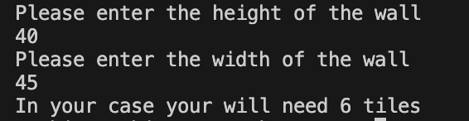

After testing and entering the height value of 40 and width value of 45 the programme behaved as expected and provided us the correct answer of 6 tiles. This therefore shows that the programme works as intended so far.
Result: Did the programme behave as expected ie syntactically and logically correct?
YES

Continue the rest of the tests below. (Copy and paste a box for each one)

Test: Enter dimensions of wall: Width 100000 Length 200000

Screenshot(s) of output:
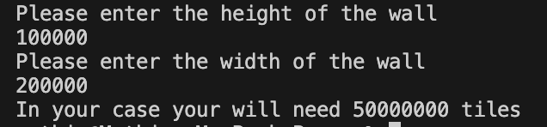

After entering two large values of 100000 and 200000 the programme still worked as intended and tells that user that they will need 5000000 tiles. While some field validations could be added with regard to the number of tiles allowed, it could inhibit large companies who want to place a larger order. Some companies do cover very large surfaces therefore suggesting no validation for large numbers is needed for this.
Result: Did the programme behave as expected ie syntactically and logically correct?
YES

Test: Enter dimensions of wall: Width -16 Length -20

Screenshot(s) of output:
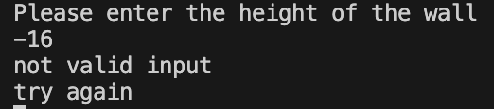

After entering the first value of -16, the code does not allow the user to proceed any further and tells the user that the following is not a valid input. This is due to the validation set in place which does not allow the user to enter a value under 0. Therefore, this shows that the programme behaved as expected and nothing went wrong

Result: Did the programme behave as expected ie syntactically and logically correct?
YES

Logic:

Test: Enter dimensions of wall: Width 80 Length 80. The result should be 16 tiles

Screenshot(s) of output:
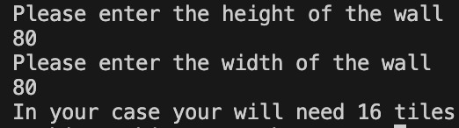

Yes, the output was correct
Result: Did the programme behave as expected ie syntactically and logically correct?
YES

Test: Enter dimension of wall: Width 40 Length 45. The result should be 6 tiles

Screenshot(s) of output:
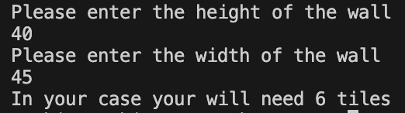

Yes, the output was correct
Result: Did the programme behave as expected ie syntactically and logically correct?
YES

Test: Enter dimensions of wall: Width 85 Length 90. The result should be 25 tiles.

Screenshot(s) of output:
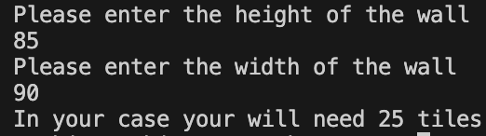

Yes, the output was correct
Result: Did the programme behave as expected ie syntactically and logically correct?
YES

Test: Enter dimensions of wall: Width 15 Length 15. The result should be 1 tile.

Screenshot(s) of output:
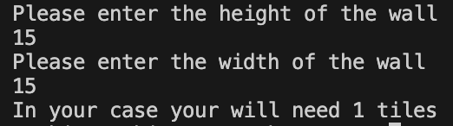

Yes, the output was correct
Result: Did the programme behave as expected ie syntactically and logically correct?
YES

- Consider the results of the above tests and revisit your code in order to solve any problems discovered at the testing phase. (Note: you may not be able to solve all of them, but solve as many as you can.)

Paste your revised code here:

[Copy and paste your revised code here – note, do not use a screenshot]

import math

print ("Please enter the height of the wall")
userinput1 = int(input())

while userinput1 <= (0):
print ("not valid input")
print("try again")
userinput1 = int(input())

print ("Please enter the width of the wall")
userinput2 = int(input())

while userinput2 <= (0):
print ("not valid input")
print("try again")
userinput2 = int(input())

heightlengh = 20

calc1 = userinput1 / heightlengh
calc1 = math.ceil(calc1)

calc2 = userinput2 / heightlengh
calc2 = math.ceil(calc2)

cacl3 = calc1 * calc2

print ("In your case your will need", cacl3, "tiles")

