University of Wales Trinity St David

Embedding Sustainability within Organisations
BMGM5000 – Report
Evaluating sustainability: Case Study Analysis: Silo London.
Level 5
Ruth Taylor-Davies BA (Hons), MSc., MA, AHI

Ayesha Amir
2306141
Word Count:

I acknowledge the use of ChatGPT (www.chatgpt.com) on 22 Dec 2024 to check my grammar and spelling, as well as to help me understand the assessment requirements in a simplified way to guide my research.

I used the following prompt(s):

- Please check my text for grammar and spelling errors.
- Explain the main points of the assessment in simpler terms to aid my research.

I confirm that I have not presented any AI generated text as my own work. I confirm I have copies of my drafts, notes, and other resources I used before, and after the use of AI tools which I may be asked to provide in evidence.

Table of Contents
Executive Summary 1
Introduction 2
Principles and Pillars of Sustainable Gastronomy 3
Compliance with Sustainability Principles 3
Environmental Sustainability 3
Social Sustainability 3
Economic Sustainability 3
Relevant Regulations and Legislation 4
Circular Economy and Its Relevance to Silo London 5
Conclusion 6
Recommendations 7
Reference 8
Appendices 9

- Executive Summary

The aim of this report is to evaluate Silo London’s incorporation of sustainable practices, focusing on the principles of sustainable gastronomy. It assesses the restaurant’s compliance with important rules and regulations, examines how it applies the principles of the circular economy, and proposes ways to enhance its sustainability. The report also highlights Silo’s innovative techniques for achieving a zero-waste dining experience, its efforts to improve the environment, its role as a model in the restaurant industry, and other related aspects.

- Introduction
Silo London is a groundbreaking zero-waste restaurant located in the heart of London, founded by the passionate Douglas McMaster. From its inception, the restaurant has dedicated itself to sustainability, striving not only to provide exceptional food but also to minimise its environmental impact. At the heart of its mission is the idea of sustainable dining, where every dish is made from responsibly sourced ingredients, and a strong focus is placed on minimising the restaurant’s carbon footprint. What truly sets Silo apart is its commitment to creating a dining experience that doesn’t just delight the senses but also helps protect the planet. By fully embracing a zero-waste philosophy, the restaurant doesn’t simply avoid waste; it actively upcycles materials wherever possible and composts organic waste. This means that everything that can be reused or recycled is thoughtfully processed in the most environmentally conscious way.
Silo’s approach is deeply rooted in the broader principles of sustainable development. It prioritises ethical sourcing, the reduction of waste, and the creation of a circular economy within the restaurant’s operations. This report will look at how Silo London embodies these sustainable values, exploring the regulations and laws that shape its operations, as well as the role of the circular economy in its business practices. In doing so, we will see how Silo London is not just a pioneer in the world of sustainable dining but also a beacon of innovation within the broader hospitality sector. Through its efforts, the restaurant is paving the way for others to follow, showing that it’s possible to create dining experiences that are not only eco-friendly but also socially responsible (Silo London, 2024).

- Principles and Pillars of Sustainable Gastronomy

Sustainable gastronomy has principles and pillars which are directly derived from the sustainability dimensions, and these are the Environmental, Social and Economic dimensions. Each dimension in this case, however, addresses a different aspect of sustainability in addressing food production and consumption systems.
3. Environmental Sustainability
The first pillar ‘Environmental sustainability’ entails the aim of minimising adverse impacts caused due to human undertakings on the earth. This comprises a range of practices intended to reduce the environmental burden posed by the food sector. For example, waste reduction, improving energy efficiency in food systems, and taking extra measures to conserve water which is a scarce commodity. Transportation and production carbon emissions are also on blacklist. We can help the environment by building businesses that use sustainable raw materials and recycled materials, including packing paper (Enel, 2024; European Vegetarian Union, 2024).
3. Social Sustainability
The second pillar, social sustainability, is based on the social justice and well-being of people involved in the food system. It focuses on the necessity of ensuring that food producers and farmers, and everyone along the supply chains, has fair working conditions. Fair terms of employment, including ensuring that an employee is paid enough to make ends meet and that he is provided with sensible working hours, are essential. Social sustainability also means creating opportunities and providing justice for people in the community and defeating food production systems that abuse the society (Enel, 2024; European Vegetarian Union, 2024).
3. Economic Sustainability
The third pillar, economic sustainability, focuses on the growth and sustainability of different businesses in the food industry. To be said to have attained economic sustainability, it indicates making decisions that are conducive to the survival of an organization. This also includes effective deployment and utilization of resources, maintaining adequate sources of revenue, and minimizing expenditures. It equally requires making sure that the business models do not become rigid and affect the business with economic changes allowing conducting business and protecting the means of existence of every person involved in the industry (Enel, 2024; European Vegetarian Union, 2024).

3. Compliance with Sustainability Principles
Silo London is a restaurant in the UK that focuses on creating a no-waste, sustainable dining experience. It strives to adhere to sustainability practices in every aspect of its operations. Silo London complies with the three pillars of sustainability through the following principles:
- Environmental Sustainability:
Silo London adopts a zero-waste philosophy by implementing a closed-loop system to eliminate waste (Silo London, 2024). It utilises materials from recycled products that can be reused rather than discarded, as illustrated in Figures 1 to 5, (Levy, N. 2020). Silo avoids the use of single-use plastics and employs a commercial-grade composter to recycle food waste into compost (Vimeo, 2019). Another key practice is sourcing locally and seasonally from local farmers, which includes vegetables, fruits, wheat, milk, and more (Wesleyan Argus, 2023). This approach helps to reduce carbon footprints, supports biodiversity, and promotes the use of seasonal products. Additionally, Silo London prioritises energy efficiency by using renewable energy sources.
3. Social Responsibility:

Silo actively engages with the local community by working with local suppliers and promoting education on sustainability. This is achieved through workshops for the public and staff, raising awareness about sustainability and its importance. Another way Silo demonstrates social responsibility is by treating staff fairly, ensuring they receive fair pay and additional compensation for hard or extra work (Silo London, 2024).

3. Economic Responsibility:

Silo achieves financial viability, meaning it makes a profit through its zero-waste approach. The prices are higher to cover the cost of sustainable ingredients and operations in the restaurant. However, customers are happy to pay these amounts to receive the quality and sustainability they value.

Silo also faces cost challenges, as maintaining a zero-waste approach and adhering to strict sustainability standards is expensive. This makes it much harder for Silo to operate on a larger scale or in less specialised markets.

- Relevant Regulations and Legislation

Every business in the UK follows these laws of food Safety Acts 1990 as its compliance with regulation and legislation, this law ensures that all food that served in the restaurant is safe and made in hygienic and correctly labelled but for silo London, following those rules is important because the ingredients that silo uses are environment friendly. Silo make sure that food isn’t only best and safe but also meet the standards and cleaned (Legislation Gov, 2024a).

Another regulation that silo follows is food hygiene regulations 2006. this law ensures that silo follows the law by focus on the proper processes to prevent food containment that means. how the food is stored, prepared and disposed Figure 11, (Wakeham, A, 2024). Silo focus is the unpackaged item and local sourced ingredients. silos are very strict on hygiene practices throughout every step of Food handling to maintaining customers safety and trust (Legislation Gov, 2024b).

Silo follows the Waste Regulation 2011, that reduce, reuse and recycle their waste. Silo London has zero waste as that approach perfectly with the requirements. however, silo waste their composted or reused. this helps minimise that waste and help with the environmental impact (Legislation Gov, 2024c).

Silo follows another regulation that is Mandatory Food Waste separation 2025, that by 2025 all business must follow separate food waste to reduce waste landfill usage. silo have already compliant with this law by using composting system and aligns with their commitment to a circular economy (Food Manufacture, 2024).

Silo last regulation that they follows is plastic packaging tax 2022, that is designed to use recycled material instead creating a pile plastic. this will help with reduce plastic waste and environmental harm. Silo London are already ahead of this regulation because they don’t use disponible plastic item instead they use reusable materials for tableware and packaging (Gov,2021). so many others regulation and legislation that Silo London follows.

- Circular Economy and Its Relevance to Silo London

The circular economy is about how we use the resources, that focuses on reducing wastage, using reusing materials and regenerating natural systems to create a sustainable cycle figure 12, European Parliament, 2023).
However, Silo London uses the philosophy as the UK first zero waste restaurant, by stopping single use of packaging, sourcing local ingredients and turning food scraps to compost. Silo London minimise its carbon footprint to environmental to support a closed loop system. it’s design to ensures ingredients are fully utilised and furniture are created from recycled material, figure 1 to 5, (Levy, N. 2020). Silo are charging higher cost and education opportunity for customer to keep the standards. however, it will also inspire other restaurant to follow for eco friendly dinning (Silo London, 2024).

6. Conclude

Silo London restaurant hold a bold experiment to experience from the dining experience and helps planets with less wastage or zero waste philosophy that focus on the local sourcing, however silo provides the great food experience along the environment. What makes the silo truly special is that turning sustainability into tangible and not just regulation but having the creation of a space where every choice from the menu to furniture has a reflects and a deep respect from world. Silo make sustainability affordable and accessible to work and progress and scaling the kind of operation but in different way to show the changes in possible ways in the tough hospitality industry. In the end, Silo London has more than a place to eat but also to enjoy and thinks of future. where the restaurant can be a good for planet and for people who visit it inspiration reminder from a meal to the vibes.

7. Recommendations

For Silo to make access more inclusive, it should investigate introducing tiers by providing pricing options or partnerships with local community initiatives. In this way, their services could be available for a wide range of customers without giving up on the goal of being ethical. Moreover, in cooperation with industry organisations,

Silo may contribute to the process of changing regulations that would contribute to the development of a circular economy and make sustainability more mainstream. To continue building trust with customers, putting digital tools in place that trace ingredients from farm to table will give customers greater transparency into the full impact of their choices. Finally, Silo can go a step further to invest in renewable energy solutions such as solar panels or biogas systems to further reduce carbon footprint and set an even higher bar for restaurants to set the pace.

8. Reference

Enel. (2024). Three pillars of sustainability. Available at: https://www.enel.com/company/stories/articles/2023/06/three-pillars-sustainability [Accessed 22 Dec. 2024].
Europe Vegetarian Union. (2024). Three pillars for a sustainable European food system. Available at: https://www.euroveg.eu/three-pillars-for-a-sustainable-european-food-system/ [Accessed 22 Dec. 2024].
European Parliament. (2023). Circular economy: Definition, importance and benefits. Available at: https://www.europarl.europa.eu/topics/en/article/20151201STO05603/circular-economy-definition-importance-and-benefits#:~:text=What%20is%20the%20circular%20economy,cycle%20of%20products%20is%20extended [Accessed 22 Dec. 2024].
Food Manufacture. (2024). Food waste separation law to be enforced from March next year. Available at: https://www.foodmanufacture.co.uk/Article/2024/09/06/food-waste-separation-law-to-be-enforced-from-march-next-year/ [Accessed 22 Dec. 2024].
GOV.UK. (2022). Check if you need to register for plastic packaging tax. Available at: https://www.gov.uk/guidance/check-if-you-need-to-register-for-plastic-packaging-tax#:~:text=Packaging%20should%20only%20contain%20recycled,tonne%20from%201%20April%202023 [Accessed 22 Dec. 2024].
Levy, N. (2020). Silo restaurant interiors: A sustainable approach to design. Available at: https://www.dezeen.com/2020/04/23/silo-restaurant-interiors-sustainable/ [Accessed 22 Dec. 2024].
Legislation Gov. (2024a). Food Safety Act 1990. Available at: https://www.legislation.gov.uk/ukpga/1990/16/contents [Accessed 22 Dec. 2024].
Legislation Gov. (2024b). The Food Hygiene (Wales) Regulations 2006. Available at: https://www.legislation.gov.uk/wsi/2006/31/contents [Accessed 22 Dec. 2024].
Legislation Gov. (2024c). The Waste (England and Wales) Regulations 2011. Available at: https://www.legislation.gov.uk/uksi/2011/988/contents [Accessed 22 Dec. 2024].
Silo London. (2024). Zero waste philosophy. Available at: https://www.silolondon.com/pages/zero-waste-philosophy [Accessed 22 Dec. 2024].
Vimeo. (2019). Silo London: A journey through zero waste. Available at: https://vimeo.com/375646424 [Accessed 22 Dec. 2024].
Wakeham, A. (2024). Silo London restaurant review. Available at: https://www.countryandtownhouse.com/food-and-drink/reviews/silo-london-restaurant-review/ [Accessed 22 Dec. 2024].
Wesleyan Argus. (2023). Dinner at Silo London: The world’s first zero-waste restaurant. Available at: http://wesleyanargus.com/2023/09/25/dinner-at-silo-london-the-worlds-first-zero-waste-restaurant/ [Accessed 22 Dec. 2024].

9. Appendices

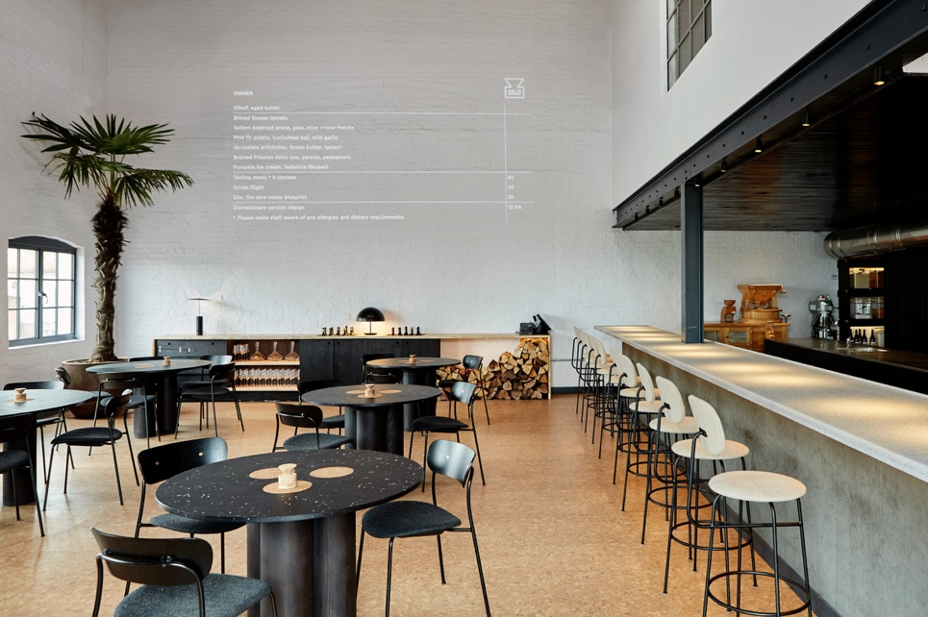

Figure 1, Silo Restaurant Sustainable chairs, tables and other items (Levy, N, 2020).


Figure 2, Silo Restaurant Sustainable chairs, tables and other items (Levy, N, 2020).



Figure 3, Silo Restaurant Sustainable chairs, tables and other items (Levy, N, 2020).


Figure 4, Silo Restaurant Sustainable chairs, tables and other items (Levy, N, 2020).
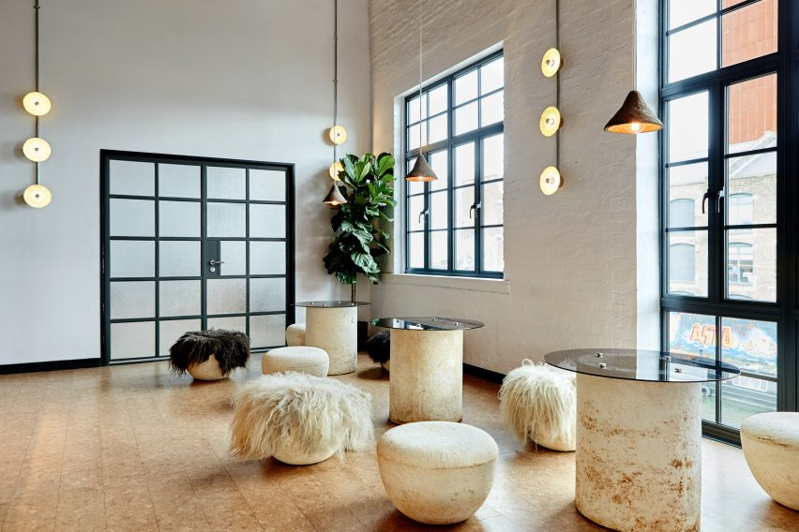

Figure 5, Silo Restaurant Sustainable chairs, tables and other items (Levy, N, 2020).

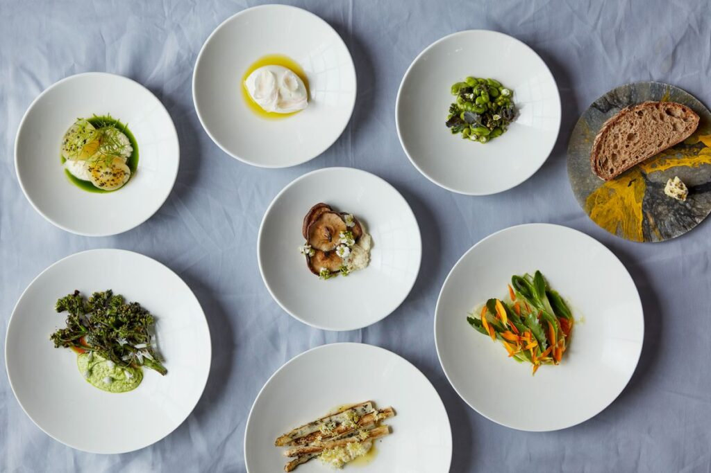

Figure 6, Sustainable food from the menu (Silo London, 2024).

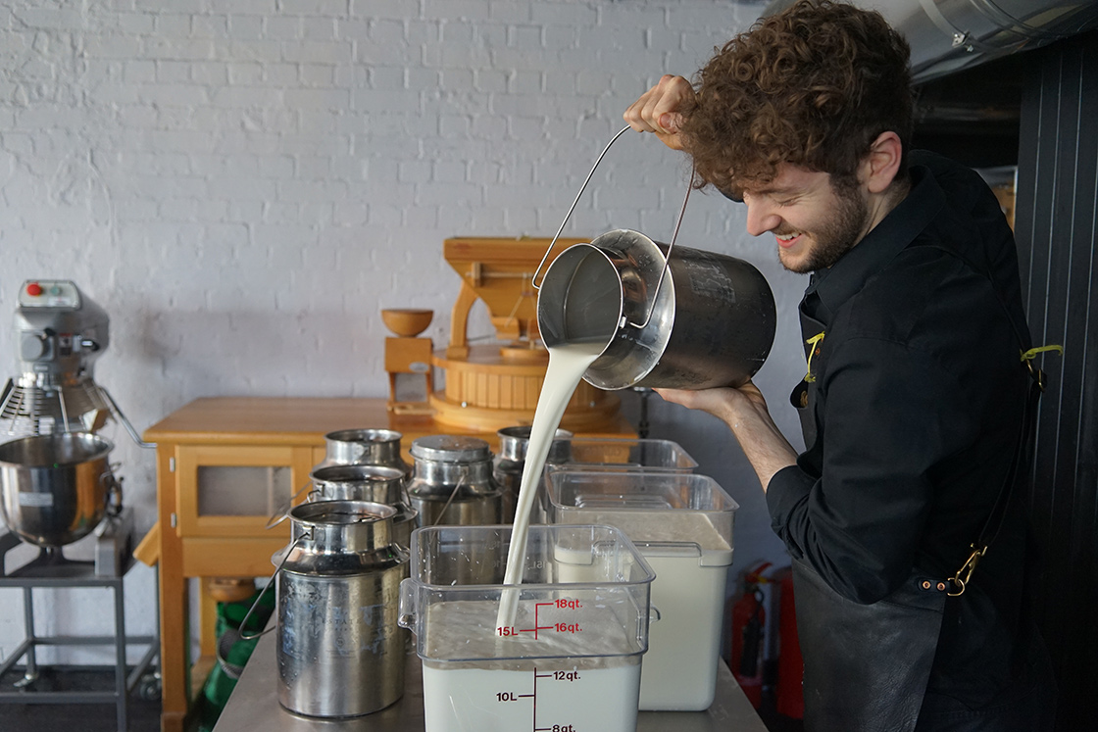
Figure 7, Fresh Milk from the cows (Silo London, 2024).

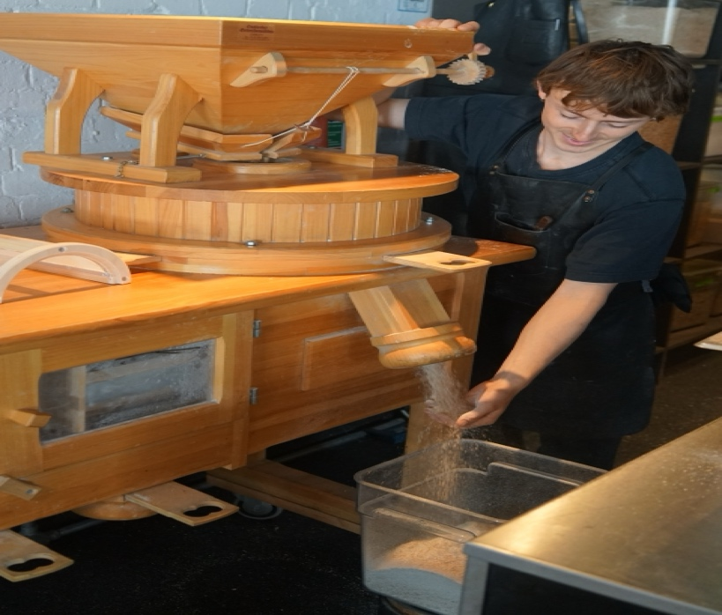

Figure 8, Fresh Wheat vaterites processing into flours from (Silo London, 2024).
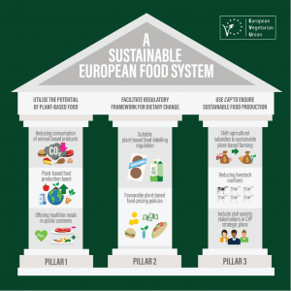

Figure 9, 3 Pillar of Sustainable (European Vegetarian Union, 2024).
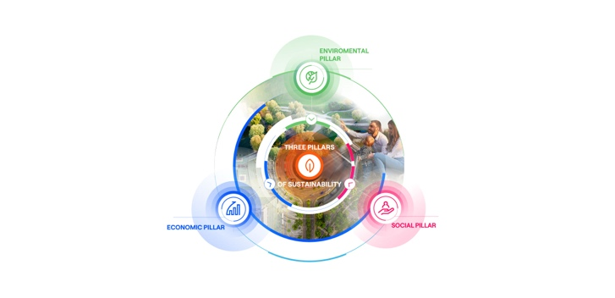

Figure 10, 3 Pillar of Sustainable (Enel, 2024).
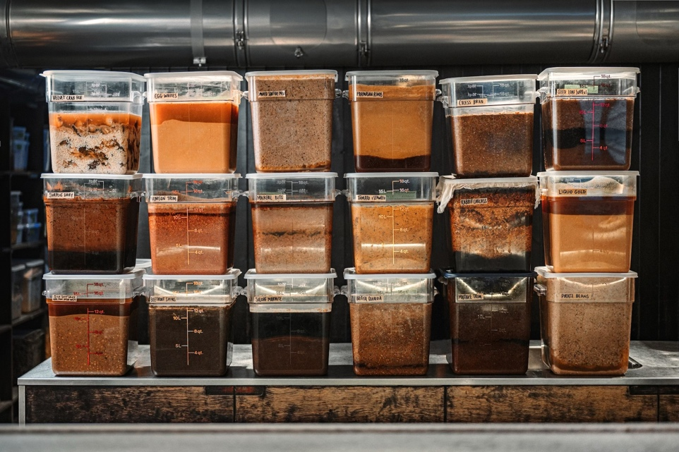

Figure 11, Food Storage (Country and Town House, 2024).
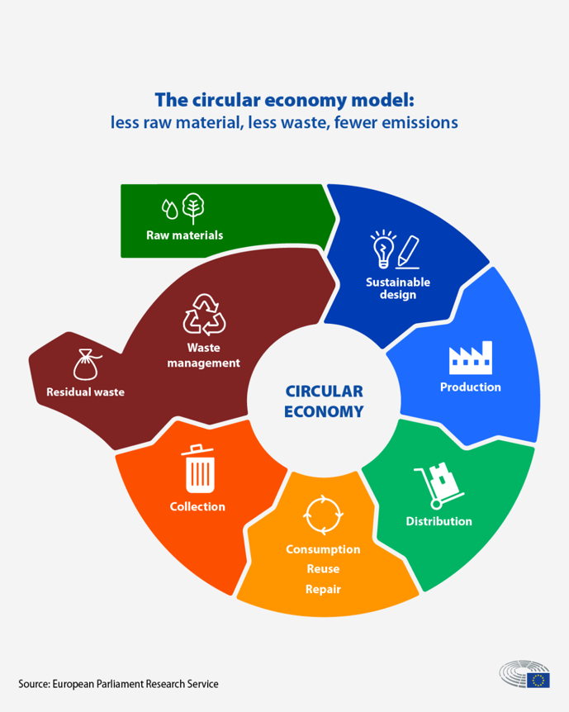

Figure 12, Circular Economy (European Parliament, 2023).

