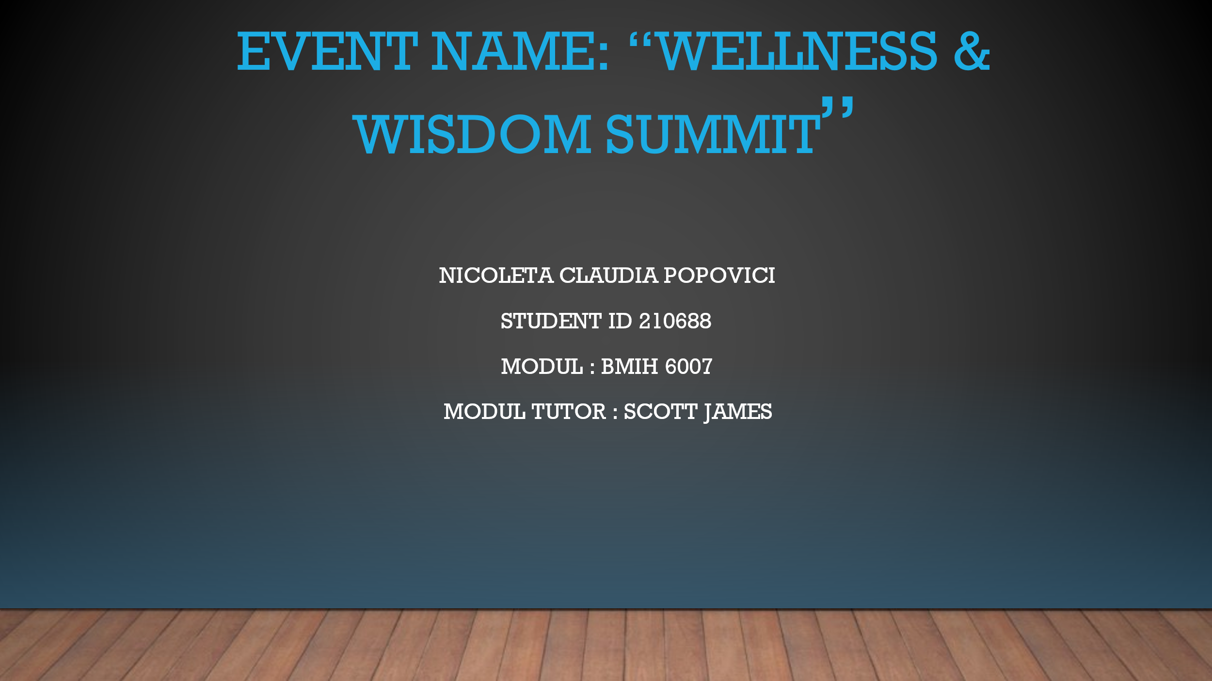

https://uowtsd-my.sharepoint.com/:v:/g/personal/2107688_student_uwtsd_ac_uk/ET6QzsWW74dEjrLFZllOV1ABmdOGb0mH0KBNJXo26IFJew?referrer=Teams.TEAMS-ELECTRON&referrerScenario=MeetingChicletGetLink.view.view

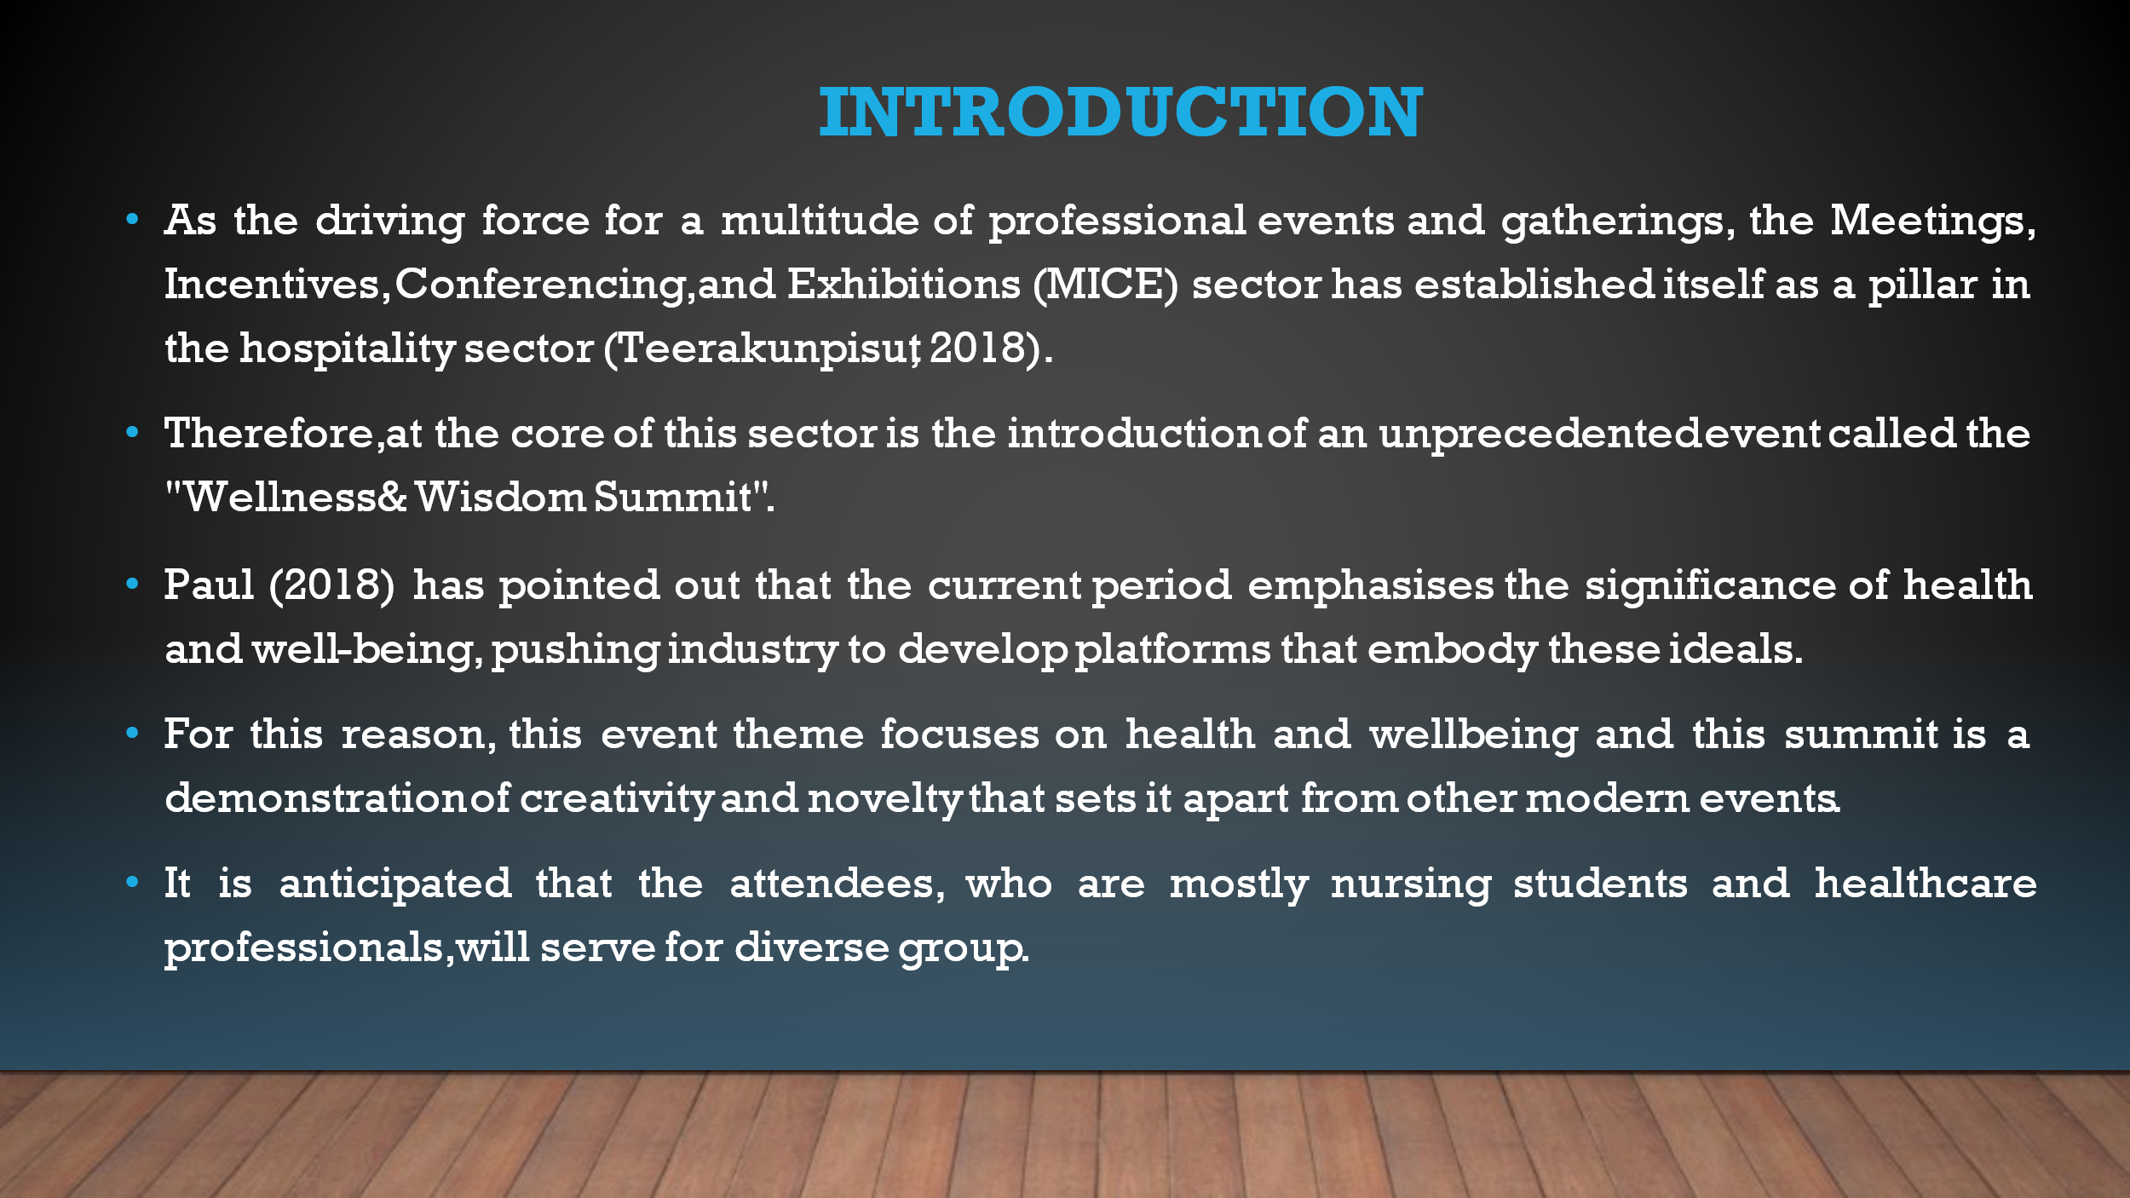

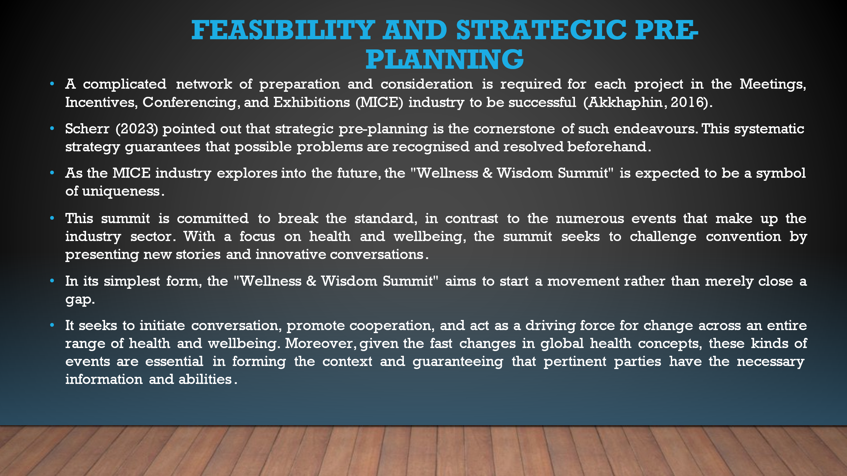

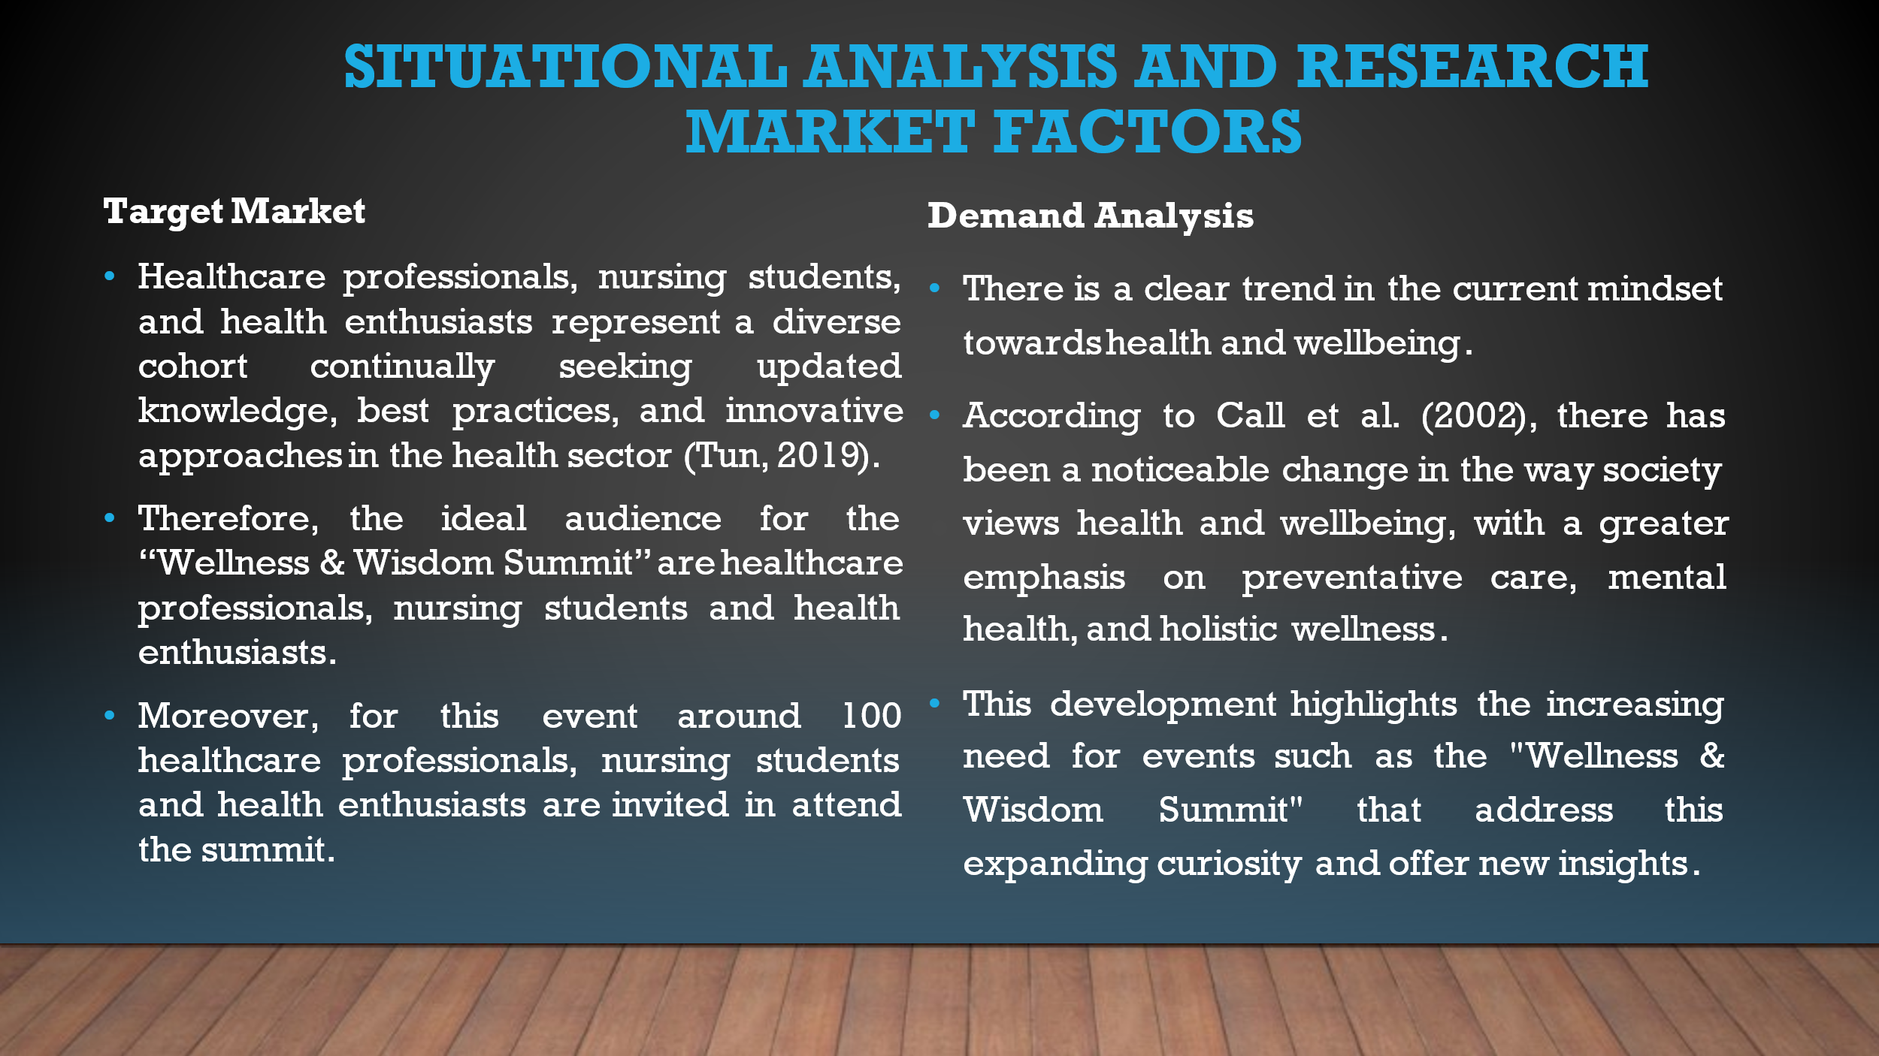

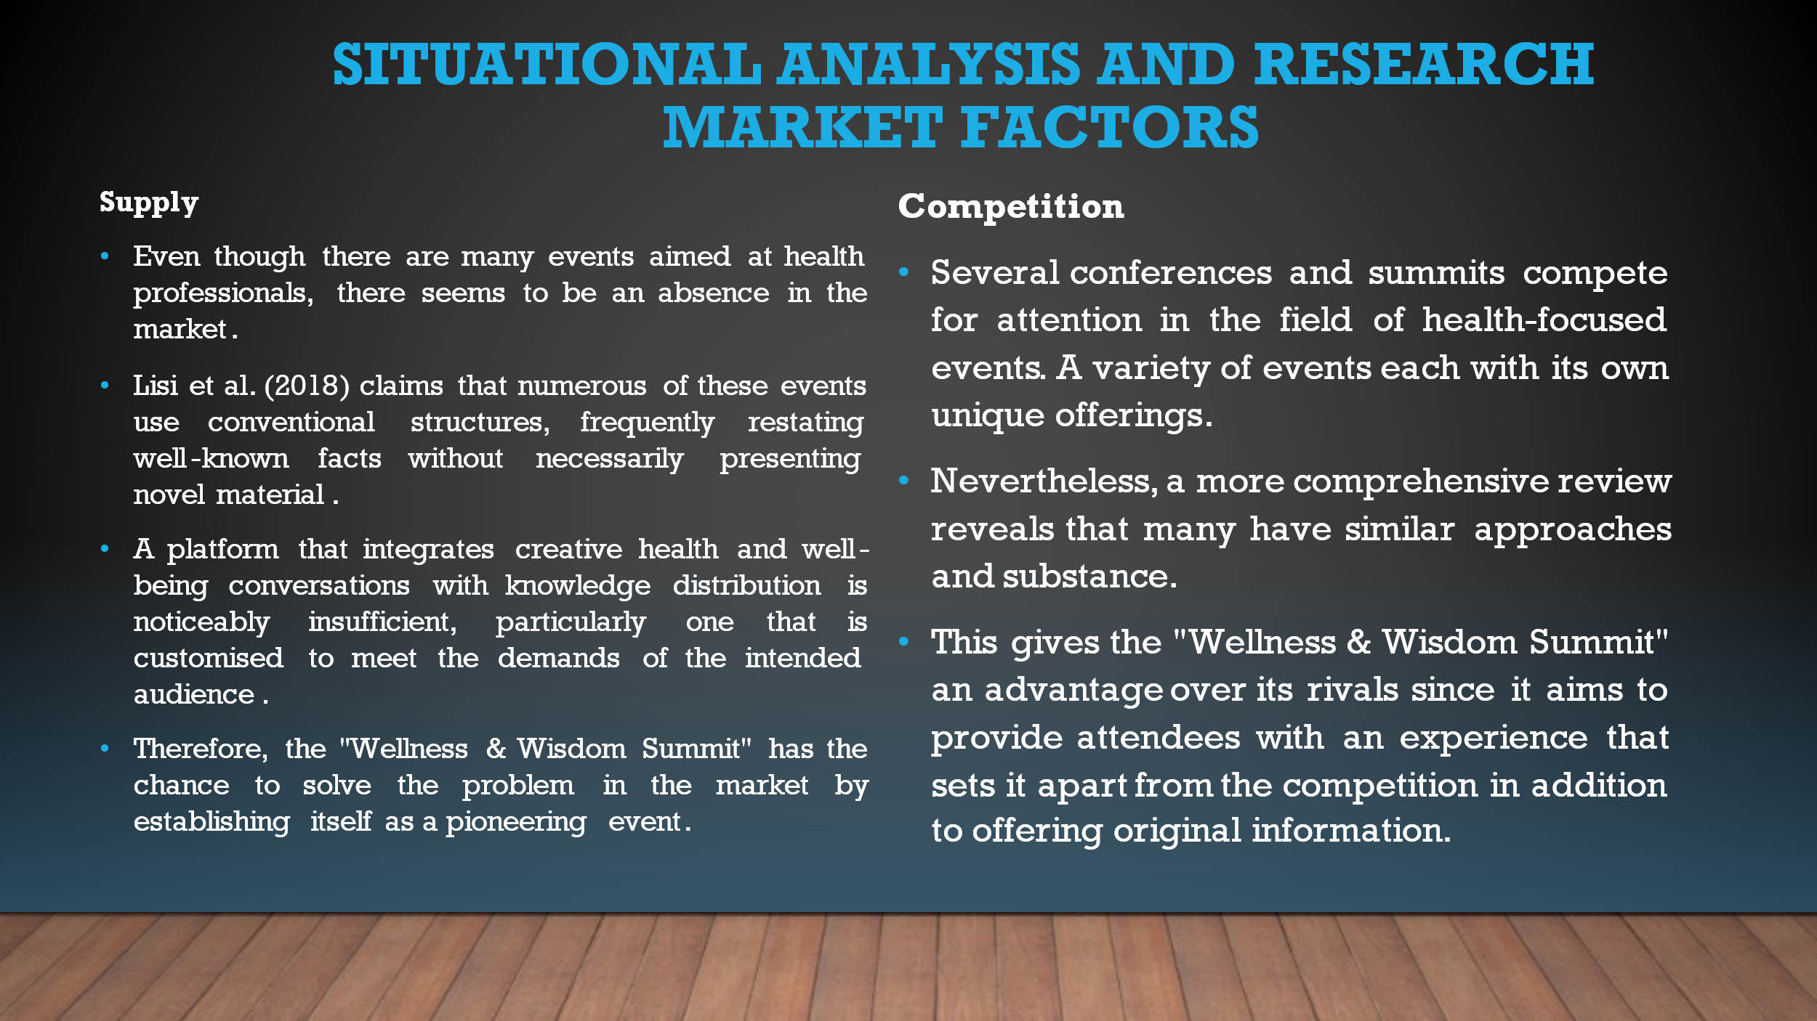

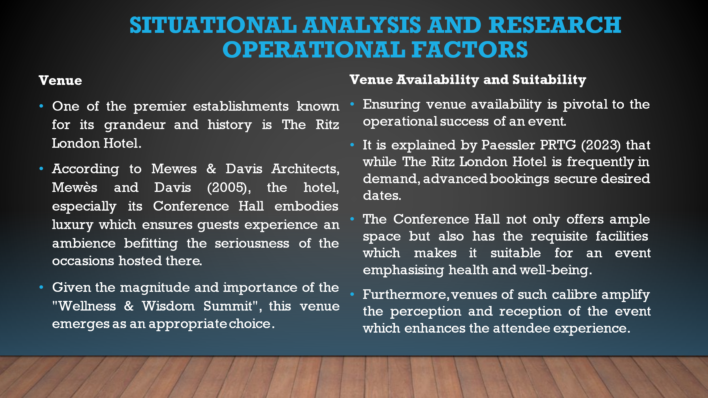

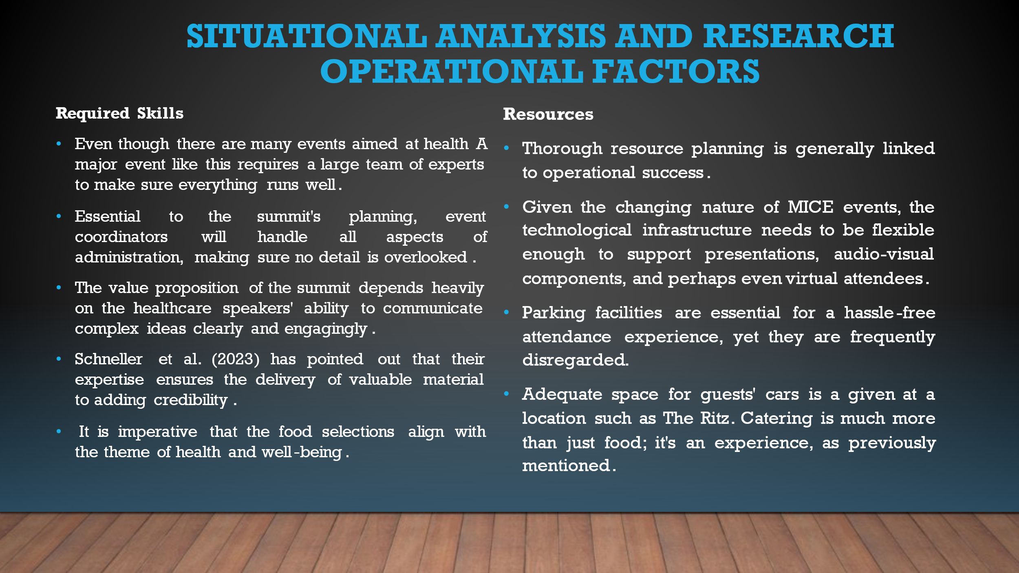

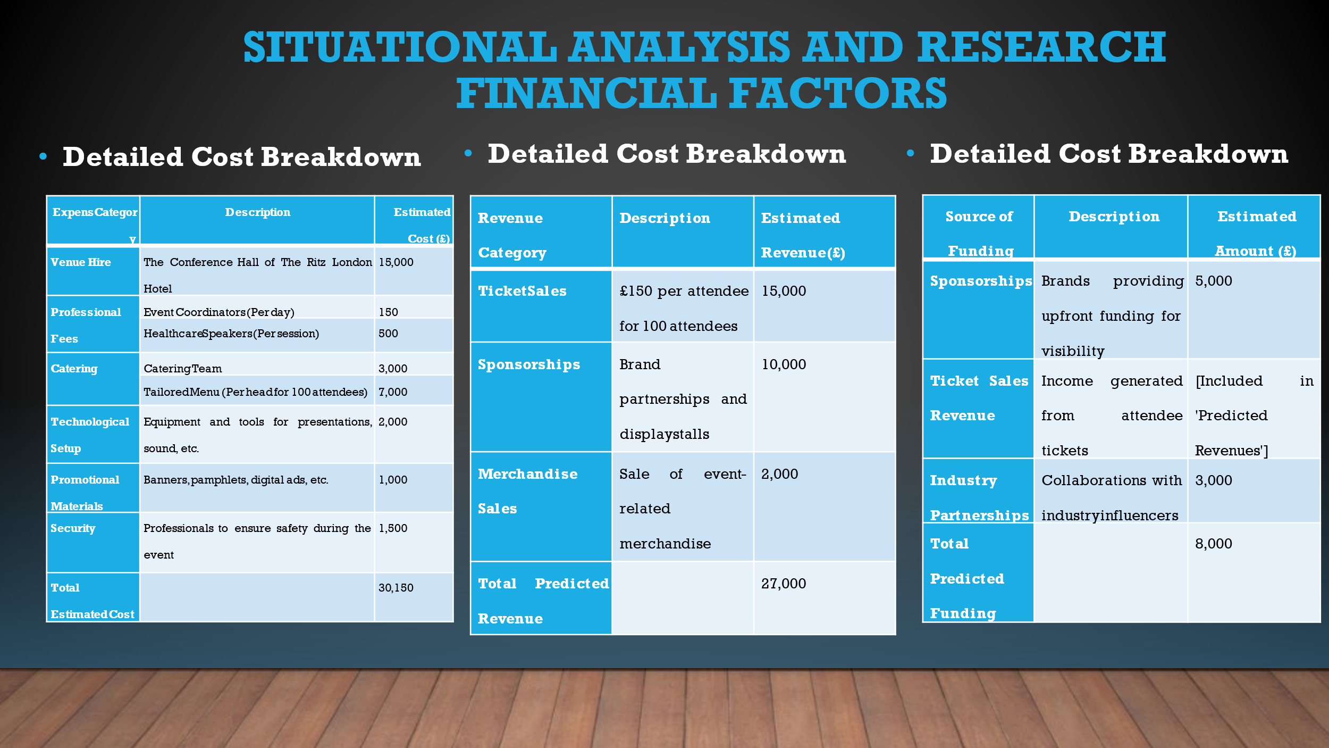

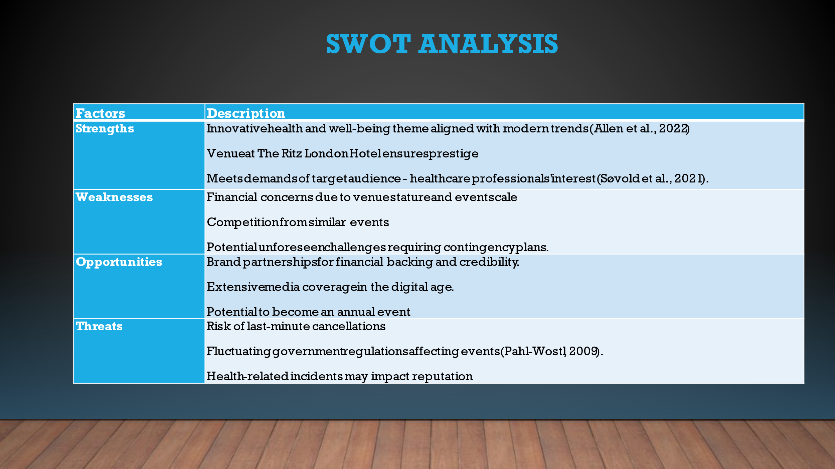

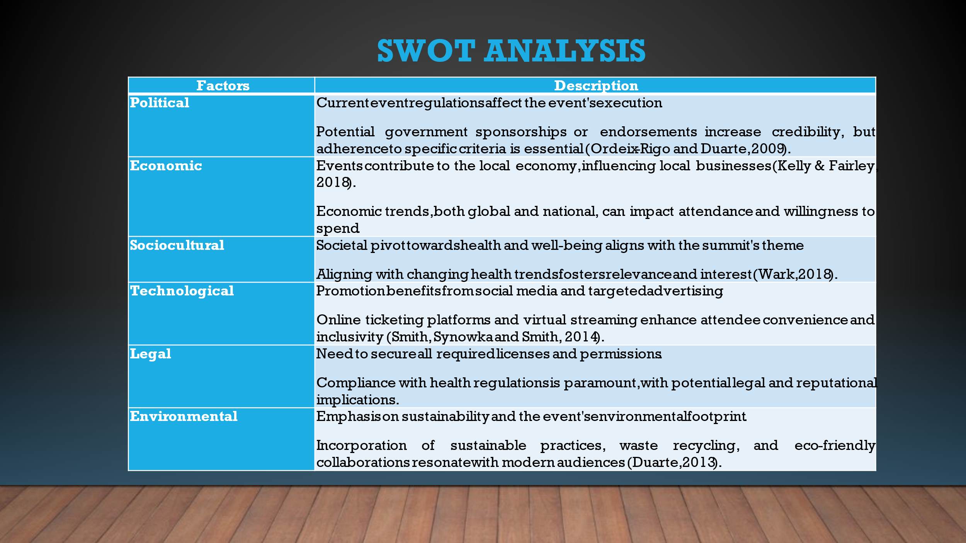

References

Akkhaphin, S., 2016. An Evaluation of the Potential of Thailand as a MICE* Industry Hub for the International Convention Industry in Asia (* Meeting, Incentives, Conventions, and Exhibitions) (Doctoral dissertation, Liverpool John Moores University (United Kingdom)).
Allen, J., Harris, R., Jago, L., Tantrai, A., Jonson, P. and D'Arcy, E., 2022. Festival and special event management. John Wiley & Sons.
Call, K.T., Riedel, A.A., Hein, K., McLoyd, V., Petersen, A. and Kipke, M., 2002. Adolescent health and well‐being in the twenty‐first century: a global perspective. Journal of research on adolescence, 12(1), pp.69-98.
Duarte, N., 2013. Resonate: Present visual stories that transform audiences. John Wiley & Sons.
Duarte, N., 2013. Resonate: Present visual stories that transform audiences. John Wiley & Sons.
Halfon, N., Larson, K., Lu, M., Tullis, E. and Russ, S., 2014. Lifecourse health development: past, present and future. Maternal and child health journal, 18, pp.344-365.
Hiebel, N., Rabe, M., Maus, K., Peusquens, F., Radbruch, L. and Geiser, F., 2021. Resilience in adult health science revisited—a narrative review synthesis of process-oriented approaches. Frontiers in Psychology, 12, p.659395.
Hinton, K.E., 2012. A practical guide to strategic planning in higher education (Vol. 7). Ann Arbor, MI: Society for College and University Planning.
Kelly, D.M. and Fairley, S., 2018. What about the event? How do tourism leveraging strategies affect small-scale events?. Tourism Management, 64, pp.335-345.
Lisi, A.J., Salsbury, S.A., Twist, E.J. and Goertz, C.M., 2018. Chiropractic integration into private sector medical facilities: a multisite qualitative case study. The Journal of Alternative and Complementary Medicine, 24(8), pp.792-800.
Mahapatro, B.B., 2022. Human resource management. PG Department of Business Management.
Masterman, G., 2012. Sponsorship: for a return on investment. Routledge.
Mewes & Davis Architects, Mewès, C.F. and Davis, A., 2005. Ritz Hotel, London. University of Nebraska-Lincoln, Libraries.
Nembhard, I.M. and Edmondson, A.C., 2006. Making it safe: The effects of leader inclusiveness and professional status on psychological safety and improvement efforts in health care teams. Journal of Organizational Behavior: The International Journal of Industrial, Occupational and Organizational Psychology and Behavior, 27(7), pp.941-966.
Ordeix-Rigo, E. and Duarte, J., 2009. From public diplomacy to corporate diplomacy: Increasing corporation’s legitimacy and influence. American Behavioral Scientist, 53(4), pp.549-564.
Paessler PRTG., 2023. The Ritz London benefits from clearer visibility 24 hours a day with Paessler PRTG. Retrieved from https://www.paessler.com/company/casestudies/ritz-london
Pahl-Wostl, C., 2009. A conceptual framework for analysing adaptive capacity and multi-level learning processes in resource governance regimes. Global environmental change, 19(3), pp.354-365.
Paul, C.S., 2018. The architecture of digital labour platforms: Policy recommendations on platform design for worker well-being. ILO future of work research paper series, 3.
Scherr, N,, 2023. Strategic Planning: Why is it Important? Retrieved from https://www.clearpointstrategy.com/blog/the-benefits-of-strategic-planning
Schneller, E., Abdulsalam, Y., Conway, K. and Eckler, J., 2023. Strategic management of the health care supply chain. John Wiley & Sons.
Smith, A.A., Synowka, D.P. and Smith, A.D., 2014. E-commerce quality and adoptive elements of e-ticketing for entertainment and sporting events. International Journal of Business Information Systems, 15(4), pp.450-487.
Søvold, L.E., Naslund, J.A., Kousoulis, A.A., Saxena, S., Qoronfleh, M.W., Grobler, C. and Münter, L., 2021. Prioritizing the mental health and well-being of healthcare workers: an urgent global public health priority. Frontiers in public health, 9, p.679397.
Teerakunpisut, S., 2018. An examination of the influence of Islam on hospitality and customer service standards in the Meetings, Incentives, Conventions and Exhibitions (MICE) industry in southern Thailand (Doctoral dissertation, Western Sydney University (Australia)).
Tun, S., 2019. Fulfilling a new obligation: teaching and learning of sustainable healthcare in the medical education curriculum. Medical Teacher, 41(10), pp.1168-1177.
Walsh, R., 2011. Lifestyle and mental health. American Psychologist, 66(7), p.579.
Wark, N., 2018. Shifting paradigms: A critical pragmatic evaluation of key factors affecting learner-empowered emergent technology integration.
World Health Organization, 2004. Promoting mental health: Concepts, emerging evidence, practice: Summary report. World Health Organization.

