Name | Kallum Doyle
Student Number | 2237962

Module | Introduction to Web and Database Concepts
Assignment | Database Analysis and Design

INITIAL FINDINGS

Type of users who might access the DBMS:
Multiple users may need to access the DBMS. These users include staff members such as the finance team, administrative team, marketing team, branch managers/department head, clients/patrons, and suppliers. The administrative team would need access to the DBMS to add, retrieve and view data in the database, whereas the managers would also need this access but would primarily view the database for analysing data, alongside the marketing department.
The finance team would need to view all data regarding finances, the clients would need to view data regarding the event and how much it is going to cost them, the patrons also need to view the event details, whereas the suppliers need to view what products are requested by the company.

Departments each branch might require:
The departments each branch might require include:
- Finance department, for any financial matters, including payroll, ticket pricing, and budgeting for every department.
- Marketing department, for advertising the company and its services, analysing event data to improve their events in the future and researching the best equipment and practices for the company.
- Event management department, for planning all event matters and ensuring the event goes smoothly on the day, solving any problems that do arise.
- Administration department, for providing administrative support for every department that needs it.
- Maintenance department, for maintaining and cleaning general event and company equipment.
- Technical department, for maintaining the company database and software alongside maintaining any other technical equipment required for the event and company duties.
- Customer service department, for conversating with customers on the day of the end and for planning the event, alongside dealing with any queries, complaints, or suggestions.
Can all required users query & view the database and can the relevant department view, record and generate invoices for the transactions:
All users who need to require the query and view the database will be able to do so depending on their access level. For example, clients will be able to view ongoing events via query and a report, and general staff will be able to view multiple queries and reports such as queries/reports relating to invoices, orders, suppliers, event patrons, and branch & department head details. The finance department will have the required admin access to perform queries and view the database, alongside recording and generating the invoices for any transactions made in the company.

ENTITY RELATIONSHIP DIAGRAM

See next page for image of ERD.
Within this Entity Relationship Diagram, we have eleven entities all with a specific purpose and relationship to each other. The tables include the following entities with the following attributes:
- Branch: branchID, branchName, branchAddress, branchManagerID
- Branch Manager: branchmanagerID, branchID, staffID
- Department: departmentID, departmentName, departmentDescription, branchID, departmentManagerID and branchManagerID
- Department Head: departmentManagerID, departmentID, staffID
- Staff: staffID, staffName, staffPhoneNumber, departmentID, staffSalary, staffEmail
- Order: orderID, orderDate, eventID, supplierID, orderAmount, branchID
- Supplier: supplierID, supplierName, supplierProducts, supplierEmail, supplierAddress
- Event: eventID, eventType, branchID, patronID, eventAddress, eventDuration, eventStartDate, eventEndDate
- Event Patron: patronID, patronName, patronType, patronRequirements, branchID, patronEmail
- Customer: customerID, customerAddress, customerType, customerName, customerEmail
- Invoice: invoiceID, invoiceDate, eventID, invoiceAmount, customerID
They all have their respective relationships set up and the relationships between the entities can be viewed via the ERD. The ERD shows the cardinality of the relationship and gives a brief description of the relationship between the two entities. For example, for the branch-to-branch manager relationship, the cardinality of the relationship is 1:1 and the branch is managed by the branch manager. Overall, the results achieved in Visio are a suitable display of the company’s data requirements and the entity relationship diagram can be used to create a sustainable and efficient database that will allow the company to have an increased online presence in their goal to increase the number of customers.
The entity relationship diagram also contains several types of attributes, such as key attributes, multi-valued attributes, and simple attributes. A multi-valued attribute could have also been used here for an attribute such as staffName, to create two simple attributes for staff First Name and staffLastName. This was decided against in order to maintain a simple yet efficient design. Derived attributes could also be used here if the company wanted to include a staffDOB [Staff date of birth] attribute and derive the staff’s age from it. Once again, staff age does not have much relevance in day-to-day applications of the database, so this was emitted from the ERD alongside the DOB.

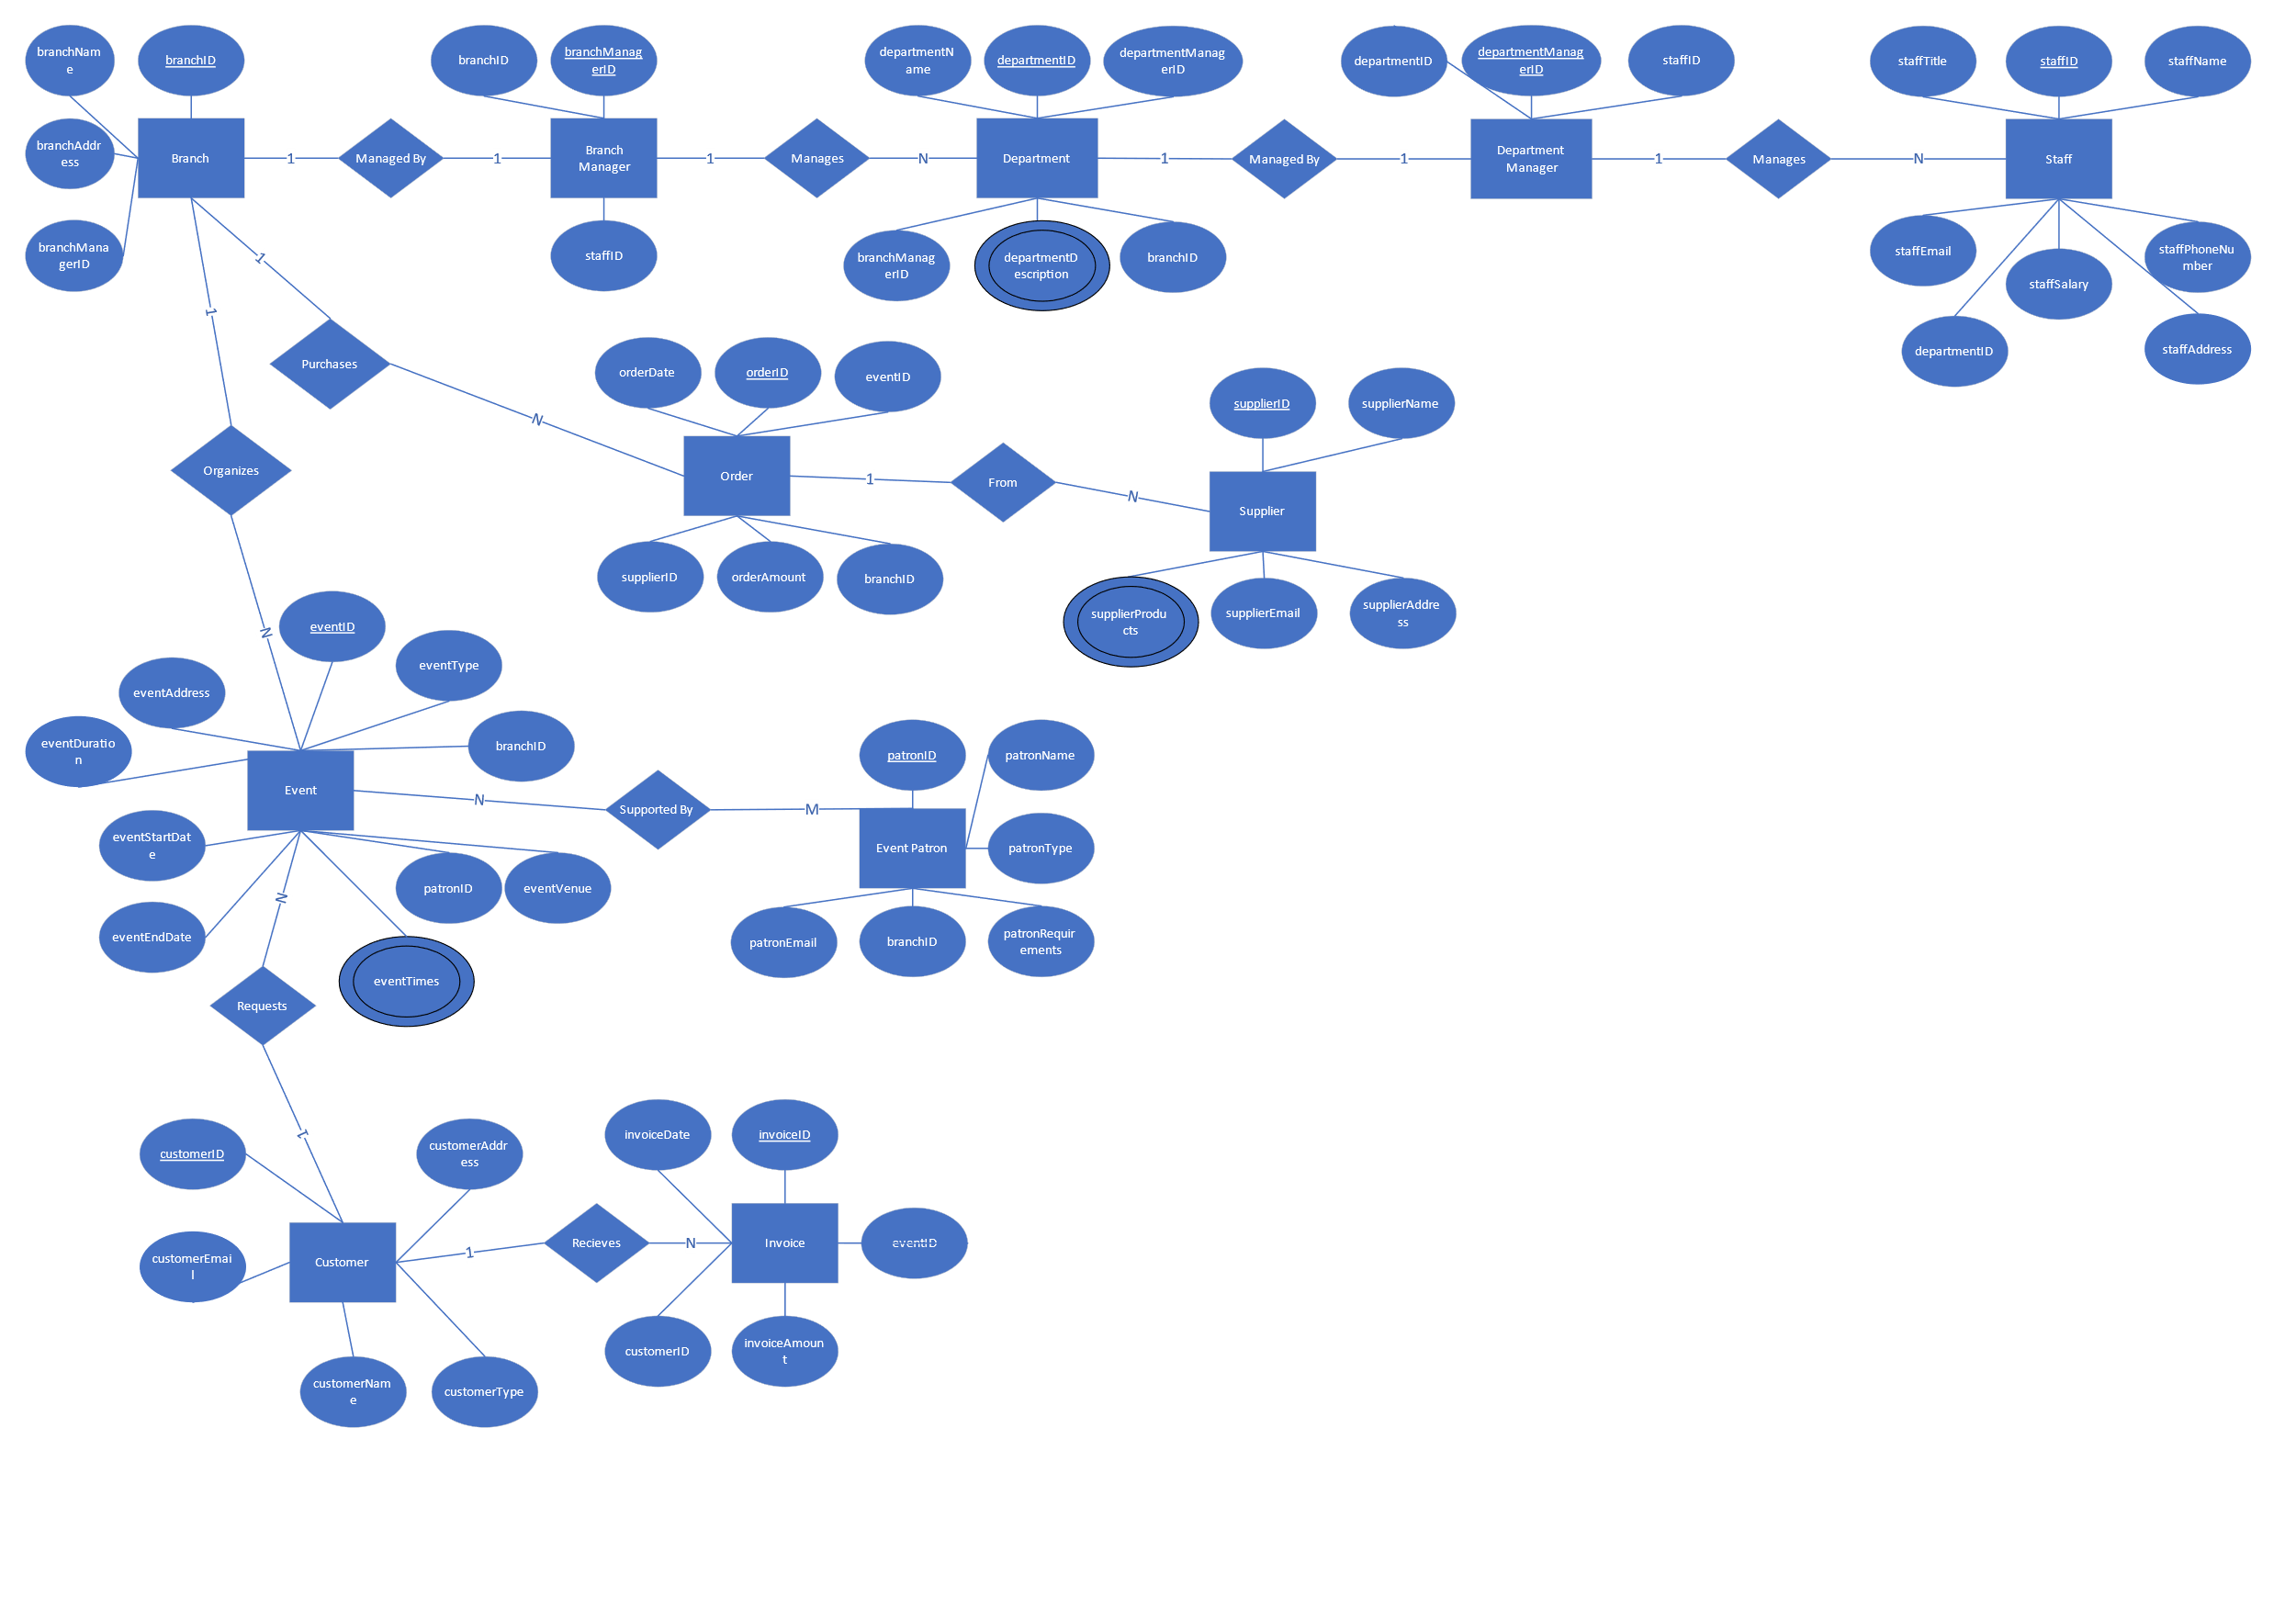

DATABASE DOCUMENTATION

Firstly, this is an image of the relationships between our entities created within our DBMS:
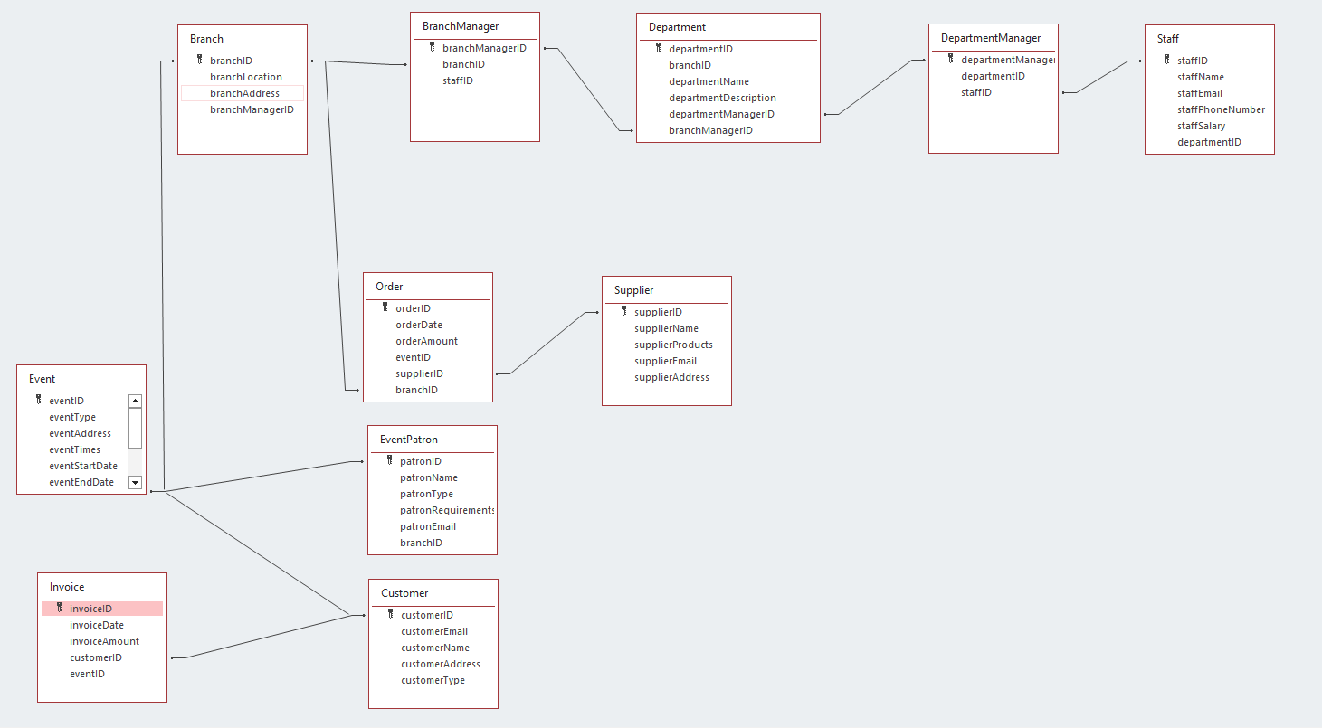
These tables have been created with respect to the ERD created earlier. These entities are all suitable for the database environment as they all have a link to the company’s daily duties and data requirements. For each of these entities, we have a diverse number of fields for each entity which describe the entity in detail and allow for appropriate data analysis and storage.
Every table with a foreign key has that foreign key for an appropriate reason, for example using a supplierID foreign key within the Order entity allows for efficient data management between the Orders entity and the Supplier entity. This is replicated between multiple entities such as the Branch and BranchManager entities, the Department and DepartmentManager entities, and more. Furthermore, this also means we have suitable relationships created as the relationships between the entities allow for correct and suitable data analysis. This will be shown later in the document via queries, forms, and reports the company creates from these entities and their relationships. All entities have been reviewed to determine their relationship suitability to each other and the result is what I believe to make the most logical sense from the information provided to us from the task description to meet all the user requirements while also meeting the rules of third normal form.
Here are examples of the entities with data inputted into all fields:

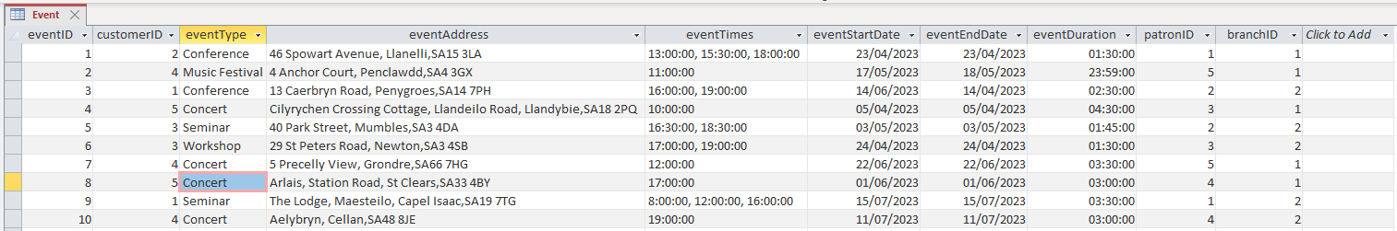
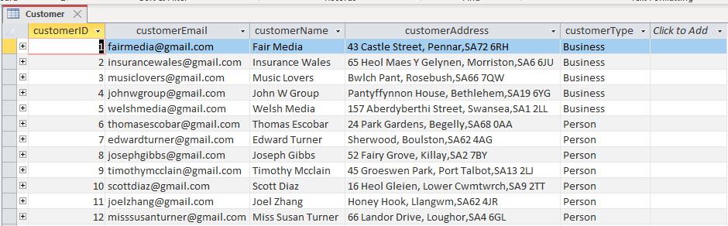
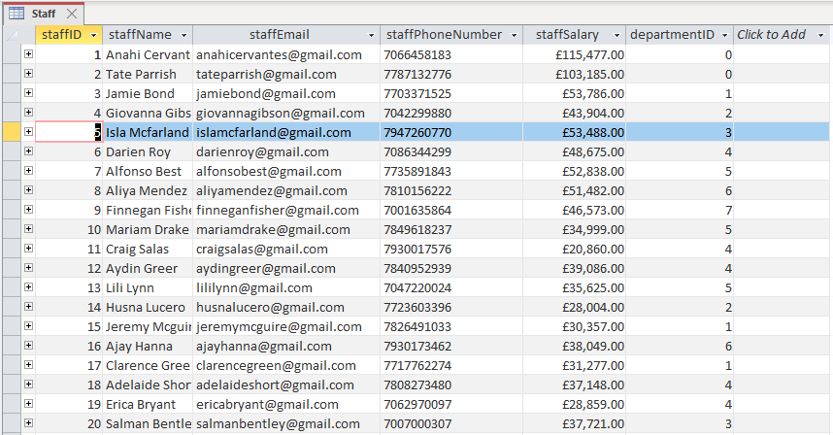

ACCESS FUNCTIONALITY

Following the guidance for this assignment and the needs of the company, I have briefly displayed design techniques used within the dataset and have shown part of the solution for the scenario provided to the student. To further follow the guidance, I have implemented:
- The ability for specific users to have the ability to add or delete information from any table:
  - This was done by creating a specific staff menu for creating, deleting, and indexing data from tables by using forms, an example of both is shown below. This also makes significant use of Macros within the DBMS, allowing for efficient data management for staff:
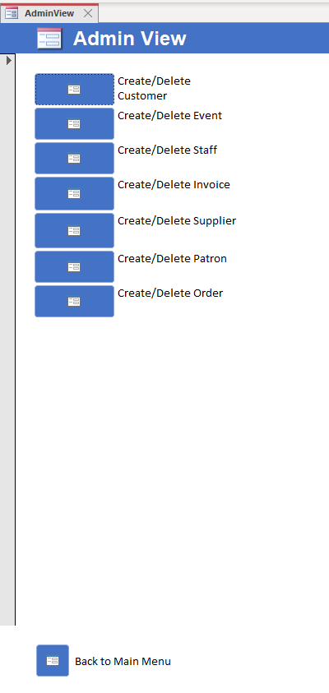

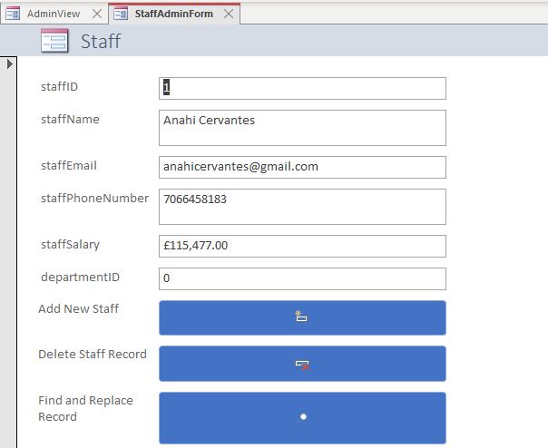
- Users can view ongoing event orders:
  - Like the above example, the database has a general staff form that allows for quick access to relative queries/reports, such as ongoing event orders. The report shown below was also created from a query that was accessed using a Macro in the non-staff view, which will be shown later in the document. This provides a good example of additional MS-Access functionality requested:
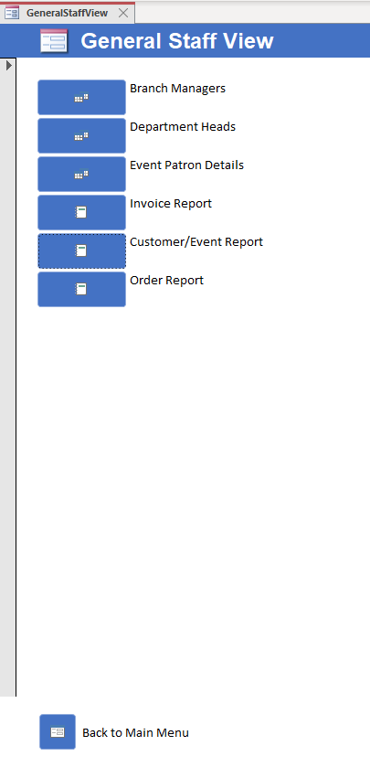

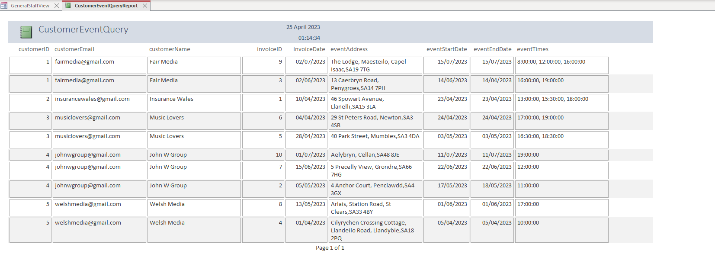
- Users should be able to view and update the order and customer details:
  - Specific users will be able to view and update the order and customer details. Staff with admin privileges will be able to update the entities alongside viewing them, whereas regular staff can access the data for viewing via reports:
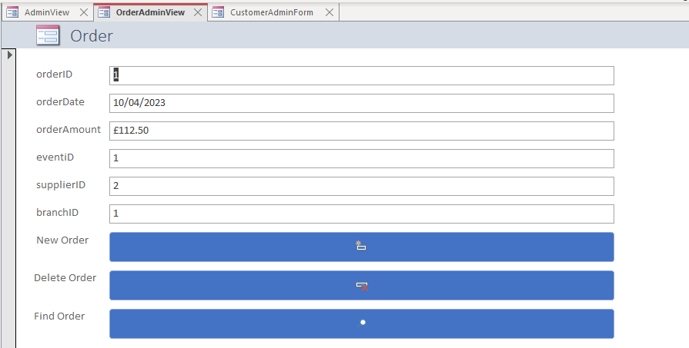
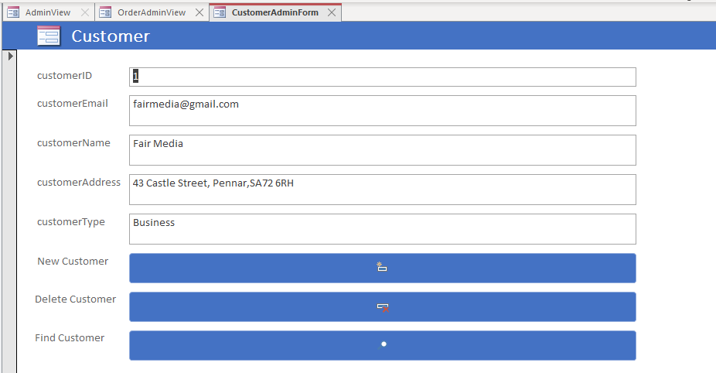
- User should be able to query the system and view relevant reports:
  - Both admin users and staff have access to specific queries such as branch & department head and event patron details, whereas non-staff can query the current events ongoing, query and report wise.
  - Staff can also view invoices, order,s and customer/event reports. To add on to the section on additional functionality, the Invoice Report includes a calculation of returning a sum of all values within the invoiceAmount attribute to get the total amount to be paid to the company:
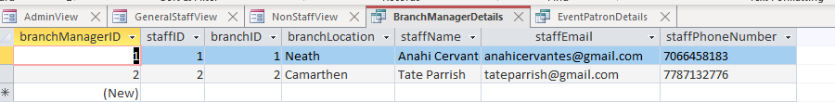
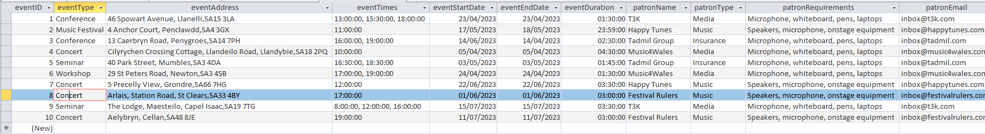
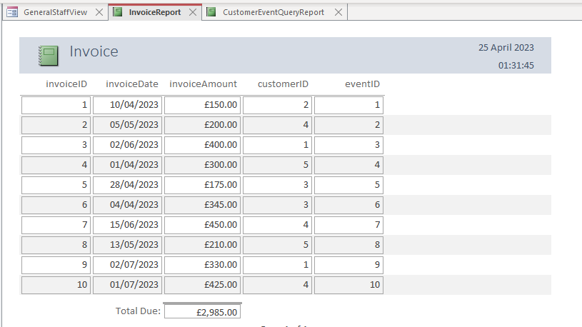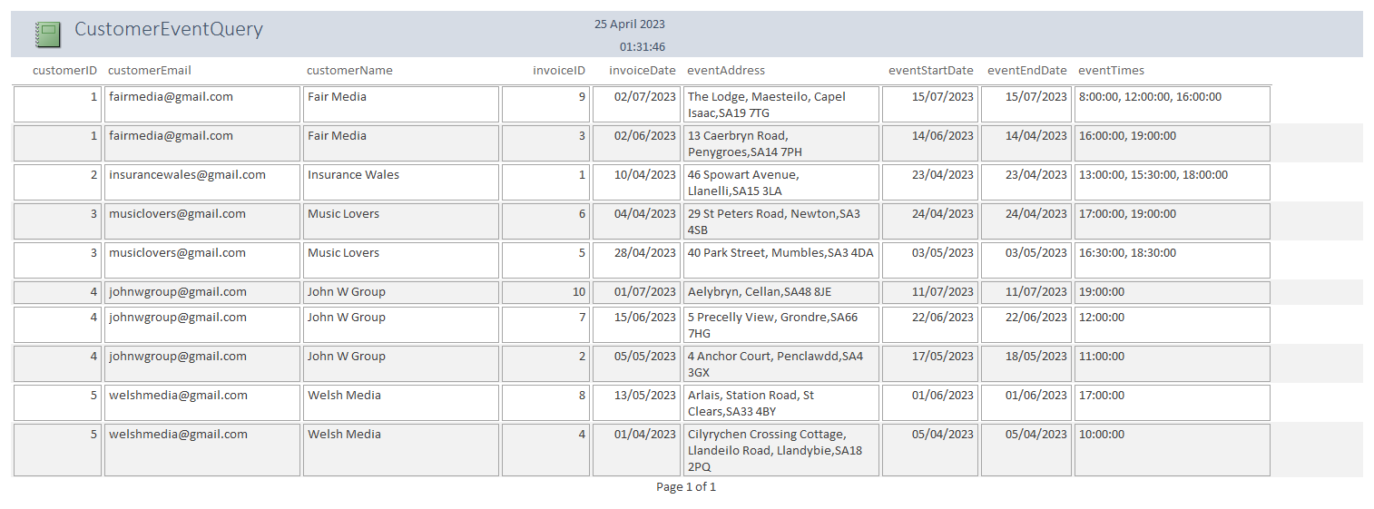
- Lastly, within the database, I have included a menu to be displayed immediately after the database opens that allows a user to choose their view of the database depending on their privilege level, such as administrative, general staff, or non-staff, to ensure database security & to improve efficiency. Master and embedded forms have also been included to give a better visualisation of the data available to the user, which was suitable for the Event Patron administrative form to provide a clear view of the events the patron is supporting:
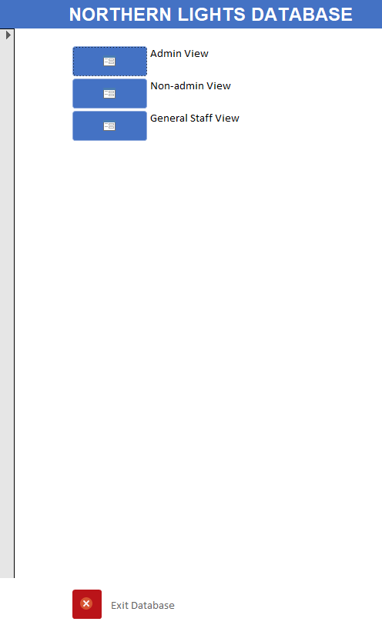

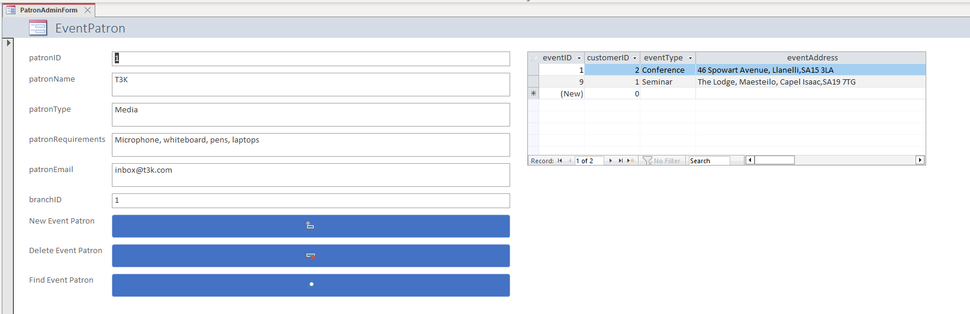

A BRIEF USER GUIDE

Upon entering the database, the user is presented with a main menu providing three choices:
- Admin view
- Non-admin view
- General staff view
Alongside the option to quit the database when they have completed their tasks. If the user is an admin and needs to perform some sort of administrative task such as adding or deleting a record from the customer, event, staff, invoice, supplier, patron, or order entity, they will go to the admin view where they can click on the respective macro to take them to the form to perform the task they need to be completed. The main menu views have a back-to-main menu button at the bottom for quick access to other pages.
Next on the general staff view, the user can access queries and reports on items of interest to personnel. The queries include details on their branch manager and department head, alongside the details of event patrons if they need to contact them. The reports give an overview of the invoice, order, and a mixture of customer / event entities. Finally, the non-staff view allows for simple access to a query and report regarding the ongoing events for customers/clients to attend.

