Reflection on Learning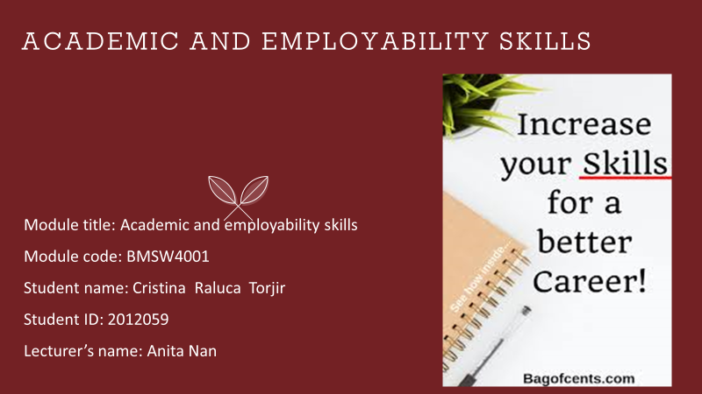

Table of Contents

- Introduction
- Time management/ Organising study
- Academic Writing
- Summarising
- Reflection
- Conclusion

- Introduction
In this essay, I will be discussing my learning experience so far, reflecting on what I have learned and what knowledge I had before I commenced the academic and employability module.
Specifically, I will focus on four elements of the above model - time management, academic writing, summarising, and reflective writing - using Kolb’s experiential learning cycle (Kolb, 1984) to analyse and reflect on my learning so far.

According to Kolb’s ground- breaking book, Experiential Learning: experience as the source of learning and development (Englewood Cliffs, Prentice Hall, 1984), experiential learning theory (ELT) provides a holistic model of the learning process and is a multi-linear model of adult development. ‘It is called "Experiential Learning" to emphasize the central role that experience plays in the learning process’. (www.le.ac.uk, 2020)

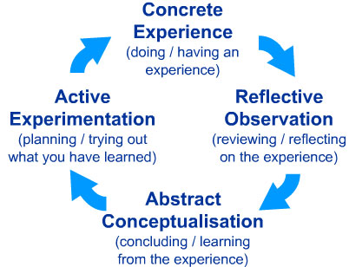
Image source: http://cei.ust.hk/files/public/simplypsychology_kolb_learning_styles.pdf

The learning cycle consists of four stages:
Concrete experience- Active involvement of individual or group in a task. You cannot learn by simply watching or reading about something, you must get involved.
Reflective observation – Reviewing what has been done and experienced
Abstract conceptualisation – Making sense of the experience. This involves interpreting events and understanding the relationships between them. The learner makes comparisons between what they have done and what they already know.
Active Experimentation - Putting what you have learnt into practice, taking action to refine or revise the way a task is done. (www.le.ac.uk, 2020)
I chose the above-mentioned topics because those are the ones I either learned the most from or found most challenging, or both. As a result, I have had to reflect on, and research them intensively in order to broaden my understanding and incorporate those skills into not only my learning, but also my day -to -day life.
- Time Management
Time management is the process of organizing and planning how to divide your time between specific activities (www.mindtools.com, 2020)
Although that appears to be straight forward, it can be difficult to know how to prioritize your time between activities to gain the best results and accomplish goals. Good time management is important in any job or course of study and being able to plan your time efficiently is the key to achieving better results in a shorter time. There are many ways to manage your time but most are based on the 80/20 rule or the Pareto principle, so called because it was conceived by Italian economist, Vilfredo Pareto, in 1895. Essentially, it states that 20% of your activities account for 80% of your results (Tracy, 2001-2020). This theory can apply to any activity, but when specifically applied to time management, it makes sense that by managing your time so that you focus on the most important aspects of a task, you will achieve good results.

Examples of effective time management include:

Organization- helps you maintain a clear picture of what you need to complete. For example, maintaining an up-to-date calendar, having a tidy environment and taking detailed, diligent notes.

Prioritization- assessing each of your responsibilities for priority. For example, completing simple tasks first to allow time for longer, more complex ones, or starting with the most time sensitive.

Goal setting - allows you to understand your end goal. Setting both short and long-term goals will give you a sense of accomplishment throughout the task.

Planning- planning a schedule for the day or a task makes it clear what you need to accomplish and helps you stick to your schedule.

Stress management – dealing with stress positively. For example, including short breaks in your schedule, or rewarding yourself when you reach a goal. (www.indeed.com, 2020).

I have found that my incorporating some of these skills into my study, I have become more efficient at completing assignments without procrastinating or getting overwhelmed with the amount of work I have to do. It also affords me time to spend with family and helps me be more efficient at work.

When I started this course, I found it very difficult to make time to study and complete assignments, life just seemed to get in the way. Whether it was looking after my son, keeping the home or juggling shift work, I always seemed to be rushing around and tired, but still never hit my deadlines.

As I began learning about how to manage my time more efficiently, I was unsure whether it would make a difference or if I understood it enough to try some of the skills, and I was unsure where to begin.

With encouragement from tutor and peers, I started to try out some skills, starting with note taking as this allowed me to review what was said in class, and organise my tasks according to what the tutor prioritised.

I was pleasantly surprised at how effective that simple thing was, so I slowly incorporated more time management skills such as goal setting and planning, and I began to find it easier to complete projects on time without becoming stressed or overwhelmed.

- Academic Writing

An academic essay is a formal piece of written English that addresses a particular topic and produces a response which indicates to the marker that the student understands the question (www.learningsupport.utas.edu.au, 2020)

It follows therefore that Academic writing should be clear, concise, focussed, structured and backed up by evidence. This means that it should be:
- Planned and focused- answers the question and demonstrates an understanding of the subject.
- Structured- coherent, written in a logical order, and brings together related points and material.
- Evidenced- demonstrates knowledge of the subject area, supports opinions and arguments with evidence, and is referenced accurately.
- Formal in tone and style- uses appropriate language and tenses, and is clear, concise and balanced (www.mindtools.com, 2020)

I had no experience in academic writing when I started this course, and this was by far the most challenging subject for me. I found it difficult to understand especially as English is not my first language, so although I can communicate well with spoken English, I struggle with writing.

When first presented with the prospect of academic writing, I was reluctant to address it, as I felt I would not be able to grasp the basics, much less write an essay to the required standard. As a result, I resisted studying it and found myself falling behind my peers.

However, it is a requirement of the course, so I had to start doing some research, talking with peers and eventually attempted my first academic writing via power point slides. This was a group task, which meant the burden of the entire task was not on me, so I felt more relaxed and able to contribute. Additionally, as the slides only required short sentences, I was less intimidated.

The success of my first attempt at academic writing showed me what was possible for me to achieve with hard work, so I have continued to improve my skills. I still have a way to go particularly regarding referencing and sentence structure, but I am proof reading my work, sourcing references easily, and well on my way, I feel, to being a competent academic writer. I even enjoy presenting to the class now.

- Summarising

A summary is a shortened version of a text that highlights its key points (www.thoughtco.com, 2020)

It is important in academic writing in order to demonstrate that the student understands the topic and can communicate the key points in a clear and concise way. According to Susan Doyle (Doyle, 2013), good summaries are valuable because they keep busy readers informed without demanding more time than necessary to get the information they need.

Summarising was another topic I found difficult, as it is a key part of good academic writing. Things to consider when writing a summary include identifying key ideas, taking clear notes, organising notes in a logical order, and linking ideas concisely.

Additionally, a summary should be:

Complete- include all the ideas that are essential to the author’s thesis,

Concise- considerably shorter than the passage,

Accurate- not distort the author’s views,

Objective- recapitulate the author’s points, coherent- make sense to someone who has not read the original, and

Independent- written in your own words (www.iue.edu, 2019)

When I began learning about academic writing, I found it difficult to distil articles or even my notes into a coherent summary of the main ideas. I tended to want to include everything I had read which made me repeat the text rather than communicate the central idea.

Again, creating power point slides helped me to understand the process better as I had to write short sentences that none the less explained the key point(s) of the topic being discussed.

By also applying other academic skills to summarising such as structure and planning, I am now able to summarise better. Planning what I want to write and structuring it before- hand are the two things that helped me the most. As well as understanding the topic, because without understanding, it would be impossible to summarise. This has had a positive effect on my learning by encouraging me to read carefully and with intent, and to take concise and legible notes that I can refer to when writing a summary.

- Reflection

Reflection or reflective writing refers to writing in a way that ‘expresses what you know and how it relates to your experience. It helps you to think about the process of learning and make it more useful to you’ (library.leeds.ac.uk, 2020)

It is important, particularly in academic writing, but also in employment, because it allows you to analyse your work objectively and identify areas for improvement, and things you are doing well. It also enables you to track your progress, identify your learning styles so you can study more efficiently, and can boost confidence. I my opinion, this model was very god for knowing how to write academic English and how important to now to write a presentation in Power Point, also I believe now I’m more confident I writing and know how to do a presentation and how to manage my time.

Some questions to consider when writing a reflective essay include what have you learned about yourself from this experience? How have you developed because of it? What would you have done differently? What specific skills or perspectives did you acquire as a result? (The Oxbridge research group ltd, 2020)

This correlates with Kolb’s learning theory. I first had to have concrete experience of reflection, which is something I was taught in class and then had to practice. I found it very challenging as it is not something I was used to doing in my job as a warehouse operative.

However, when I did start to reflect on my learning, I realised that it helped me to focus in on the important ideas, and see where my understanding fell short, so I was able to do further research to bolster my understanding. This was extremely useful for essay writing, as it allowed me to waffle less and stick to topic. Further, I found myself starting to reflect on my day at work and noticing areas I could improve on- vital to my goal of gaining a managerial promotion.

As a result, the standard of and engagement with my work has improved, as has my essay writing which has boosted my confidence to apply for a managerial position. I communicate better with my colleagues and fellow students and although I am still learning, I feel I now have the tools to continue to improve my reflective skills.

- Conclusion

I began this essay with the intention of sharing my learning experience so far. I have touched on time management, summarising, academic writing and reflection to give the reader an idea of the kind of topics I am studying, and used Kolb’s experiential reflective practice model to analyse my engagement with the aforementioned topics.

Although I have found some topics particularly challenging, overall, I feel I have gained a lot from studying them and incorporating the techniques learned into my academic study and daily life.
Since starting this course, I feel I have grown in my understanding of both employability and academic skills, particularly the latter. I had no previous experience of writing academic essays or indeed the academic approach to writing, whereas I have been in employment for many years so have gained skills necessary to gain and maintain employment, though, I have hopefully, improved those skills due to my current study. I believe this module help me allot I’m more confident in academic writing and manage my time better, for me it is a big opportunity an a big challenge to be in University also learning it is very important in our life.

Further, I have gained confidence in writing, reading and research, and I am able to communicate better with friends, colleagues and other students.

References

- Kolb, D. (1984) Experiential Learning: experience as the source of learning and development. 2nd edition. Pearson FT Press, 2015
- www.Le.ac.uk (2019) David Kolb. [Online] Available from

https://www2.le.ac.uk/departments/doctoralcollege/training/eresources/teaching/theories/kolb (Accessed on 14th November 2020)
- www.mindtools.com (2020) What is time management? [Online] Available from https://www.mindtools.com/pages/article/newHTE_00.htm (Accessed on 14th November 2020)
- Tracy, B. (2001-2020) The 80/20 Rule explained [Online]Available from https://www.briantracy.com/blog/personal-success/how-to-use-the-80-20-rule-pareto-principle/ (Accessed on 14th November 2020)
- www.indeed.com (2020) Time management [Online] Available from https://www.indeed.com/career-advice/career-development/time-management-skills (Accessed on 16th November 2020)
- www.learning support.utas.edu.au (2020) [Online] Available from www.learningsupport.utas.edu.au/Resources/e_w_glossary.htm (cited in university of Wales teaching slides (2020) (Accessed on 16th November 2020)
- www.thoughtco.com (2020) What is a Written summary? [Online] Available from https://www.thoughtco.com/summary-composition-1692160 (Accessed on 16th November 2020)
- Doyle, S. (2013) Importance of Summary in Management. Cited in web.uvic.ca (2020)[Online] Available from https://web.uvic.ca/~sdoyle/E302/Notes/SummaryNotes.html (Accessed on 17th November 2020)
- www.iue.edu (2020) Summary Writing. [Online] Available from

https://www.iue.edu/hss/writingcenter/documents/SummaryWriting.pdf (Accessed on 17th November 2020)
- Library.leeds.ac.uk (2020) Reflective Writing. [Online]Available from

https://library.leeds.ac.uk/info/14011/writing/113/reflective_writing (Accessed on 17th November 2020)
- The Oxbridge research group ltd (2020) Complete Guide to Writing a Reflective Essay.[Online] Available from https://www.oxbridgeessays.com/blog/complete-guide-to-writing-a-reflective-essay/ (Accessed on 17th November 2020)

