Trends, Patterns And Sustainabilty
An Exploration Of Colour

Tutor : Julia Lockhart

By Madeline Hearne

Surface Pattern Design , University of Wales Trinity Saint Davids

13.12.2017

Word Count : 6,215

CONTENTS

Introduction 6
Modernism in colour and through pattern 6
Vantablack 7

Chapter 1 8
Emotion and colour 8
How colours make people feel? 12
The colour red 12

Chapter 2 15
Why do we make colour choices every day in relation to fashion and interior? 15
Print, pattern and colour responses 18
The camouflage print, disruptive pattern and colour 18
Today’s botanical motifs compared to Identifiable patterns from 1860? 22

Chapter 3 25
Sustainability in textile and colour 25

Conclusion 28

LIST OF TABLES

Table 1 :
Harris.M (1766), Colour Circle. Available at: http://royalens.com/wp-content/uploads/2015/05/Moses-Harris-own-color-wheel-Newtons-format.jpg
Goethe. W(1779), colour wheel. Available at:https://designshack.net/articles/graphics/the-science-behind-color-and-emotion/ )
Table 2:
John Radcliff Hostpital with Dulux paint (2014), The Psychology of colour. Available at:https://www.buildingbetterhealthcare.co.uk/technical/article_page/The_psychology_of_colour/95179
Bond .K (2015 ), Proposed design for bier cover. Available at: http://www.willisnewson.co.uk/university-hospitals-bristol-textiles-and-watercolour.html
Forster.K (2016), Worlds ugliest colour. Available at: http://www.independent.co.uk/news/world/australasia/worlds-ugliest-colour-revealed-pantone-448c-a7076446.html

LIST OF FIGURES

Figure 1: Mattise.H (1937) Woman in a purple coat.
Available at :https://www.henrimatisse.org/woman-in-a-purple-coat.jsp
Figure 2: Kappor.A (2016) Surrey Nano Systems
Available at: https://news.artnet.com/art-world/new-photos-vantablack-906158
Figure 3: Miyake.I (1999), A piece of cloth. Available at : https://theredlist.com/wiki-2-23-1249-1258-view-1970s-profile-issey-miyake-3.html
Figure 4: Zelanski and Fisher (1991: 47) Depressions Bread Line(detail), Sidney Janis gallery. Book. (Colour)
Figure 5 :Jones.Owen (1858) Persain Sprig wallpaper. Available at: http://collections.vam.ac.uk/item/O119449/persian-sprig-print-jones-owen/
Figure 6: Wallpaper® (2017) La selva fiorita.
Available at : http://www.wallpepper.it/trend/en/90-news-eng/310-wallpepper-the-greenery-trend-is-a-real-way-to-live
Figure 7: Marine Fogg , 2006:56 Maharishi ‘Bonsai Forest ‘Camouflage cotton tussar blazer. Book. (Print Fashion)
Figure 8:Marnie Foff (2006:58) Maharshi ‘culture DPM: British Bonsai ‘camouflage print book -(print fashion)
Figure 9: Missguided online store, Womens wear camo trouser, Available at : https://www.missguided.co.uk/pink-camo-printed-cargo-trousers-10073685
Figure 10: Morris. William (1883) strawberry thief wallpaper. Available at https://martineclaessens.com/blog/2015/10/19/the-revival-of-william-morris-decorative-arts
Figure 11: Victoria and Albert Museum, Jan Van Huysum, flowers in a terracotta vase 1736), taken by Madeline Hearne on 17th august 2017
Figure 12: Varvara Stepanova, sports clothes, (1923) Available at: https://lfeffortposts.wordpress.com/2010/11/25/art2
Figure 13: Stella McCartney highlights waste in new ad campaign ,Danielle Wightman-Stone (Wednesday, 19 July 2017) Available at https://fashionunited.uk/news/fashion/stella-mccartney-highlights-waste-in-new-ad-campaign/2017071925235
Figure 14: Mara Hoffman,Spring/Summer 2015 , ready to wear swimsuit collection Available at: https://www.pinterest.co.uk/pin/443182419572830069

Summary

An exploration in colour towards the practice, surface pattern design will enhance a better understanding and communication through print processes, digital printing , screen printing ,painting, sewing , collaging and dying fabrics.

Introduction

This dissertation is an attempt to explore colour by the different terms of trends, patterns, and sustainability. This may be useful for new designers , especially studying surface pattern and textiles. The dissertation has been written to prove that colours effect people’s emotion with the use of language. To acknowledge and understand sustainable fashion matters. It will discuss the effect of pattern trends and seasonal change that they have with colour palletes. Certain colour theorists help examine what colour means, such as Goethe and Moses Hariss, through the colour wheels they produced. Other designers and artists allow the depth and conversation to create an eye opening perception, due to their personal styles and colour responses.
The way that colour is created in the surface pattern design practice is interesting and you can see people have their own styles and individual tastes. When people buy clothes they are more attracted to the colour, shape, or pattern however we don’t examine the quality. This is because, many people want to keep up with the fast trends to make them feel good about themselves, but it can be so quick that you’re not fully satisfied the next week. Once you see something more trendy, the garment you bought may feel old. This decision people make has a subconciousness process. This may leave people to wonder why. It is a process which I think could change people for the better and of course can save time and money.

Modernism in Colour and through Pattern
Modernism in colour and through pattern is now existing everywhere in design as it creates a colour perception; Sonia Delaunay said that “The new art will really begin when we understand that colour has an existence of its own, that the infinite combinations of colours have a poetry and a poetic language much more expressive than anything before” (Ball ,2001: 343). This tells us that all colours can be expressive with using the correct language. Pure patterns, structured line and colour create a perception to the eye; for example, Henri Mattise creates modernism by using bold colours and variations towards reality. Figure 1 shows a woman in a purple coat with a background of patterns, thick black lines and pop colour. The use of colour creates a busy colour palette, which makes it bright and eye catching. This is because of how the colours lie next to each other, for example the purple next to the yellow are both complementary colours meaning that they are opposites in the colour charts (see figure 3 to view a colour chart). The yellow draws the eye in and makes the purple coat makes it stick and last longer, making it a pleasure to look at.

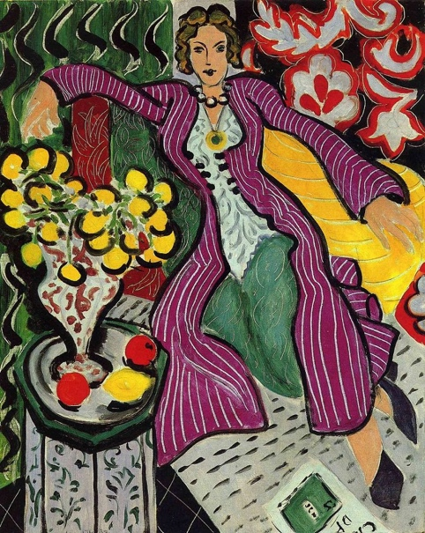

Figure 1, Matisse, H. (1937) The woman in the purple coat.

Vantablack
The artist Anish Kappor uses the new colour black and is the only artist that’s seems to have used it. This has made the artist more recognisable through a colour. The colour is something extraordinary that no one has seen or come across before. The black colour is composed of microscopic vertical tubes and has been named ‘Vantablack’. The colour can absorb 99.96 percent of light and reflect no light off it at all, making the substance ‘non-reflective’. This black can cause a high demand of emotion making you feel almost lost and confused. As you can see in figure 2 the structure of the face has been disguised with the colour showing no depth, just the silhouette. The gold face compared to the black, makes the non -reflective element more noticeable because a lot of light is bouncing off the gold, giving it more energy. This proves that the Vantablack can make you feel different to any other colour and suggests the interest of colour and its emotional effects.
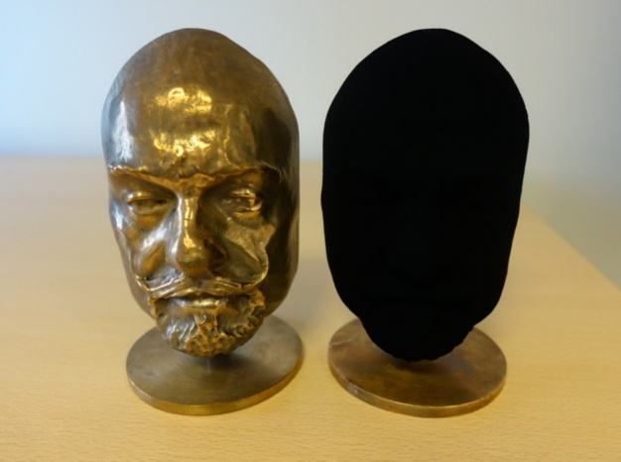

Figure 2, Kappor.A (2006), Surrey Nano systems.

Chapter 1

Emotion and Colour

This chapter will explore how colour can effect people’s feelings and emotions. What influences the choices that people make about colour and style? According to Hans Hoffman, “Colour is an expressive force in itself – a language in itself” (Zelanksi and Fisher,2006: 11). This statement suggests that there are many reasons for studying colour. By exploring its charactersitcs and potentials, you can identify how colour works. A certain colour, such as black, may symbolise a number of things to different people. For example, the artist Georgia O’keeffe, used a balance of motif and colour to convince people colour relationships matter, she said that “theres something about black, you feel hidden away in it” (Eicher, Evenoson, 2015: 371). This may explain a number of things to do with everyday life choices for our individual tastes in fashion and interiors. We may wear black to make ourselves feel comfortable and to blend in with everyone else, or on sad occasions like funerals which goes back to the days of the Roman Empire, to show a symbol of mourning. As evidence shown “By wearing black mourning clothes when a family member dies, women become highly visible symbols of mourning, thus of the kinship relations between the deceased and the living” (Håland.J. Eyy,2014: 271). This may also refer to how sucessful a painting would sell and why many artists don’t enjoy working with black as it could create a sad language.
Emotion can bring out the best quality in design. Surface pattern designer’s will show emotion in their work as it will have colour. As an independent individual, you have your own personality and background which makes you your own character. This character consists of your personal feelings and passions, your certain likes and dislikes. According to a textile specialists, Josephine Steed and Frances Stevenson “ we have very strong cultural and emotional relationship with colour ” (Steed,Stevenson, 2012: 93). An emotion inside a character can be happy, sad, excited, loved, scared, and nervous because every colour has a meaning. People can understand the language through design if you examine it carefully. Colour therapist Suzy Chiazzari associates emotion to particular hues…
“Red: Vitality, Strength , warmth , sensuality, assertion, anger, impatience
Pink : calmness , nurturance, kindness, unselfishness love
Orange / peach: joy , security , cretivity, stimulation
Yellow: happiness, mental stimulation , optimism, fear
Green : harmony, relaxation, peace, calmness, sincerity , contentment, generosity
Turquoise: mental calmness , concentration , confidence, refreshment
Blue:peace, spaciausness, hope, faith , flexability , acceptance
White: peace, purification, isolation, spaciousness “ (Zelanksi and Fisher, 2006: 44-45).
Colour has its own metaphorical language, due to how people respond to them . As once discussed by George Lackoff “Since communication is based on the same conceptual system that we use in thinking and acting, language is an important source of evidence for what that system is like” (Lackoff and Jonson, 2003: 8). Therefore, where Chiazzari associates black with emotional aspects such as “femininty, protection [and] restriction” (Zelanksi and Fisher, 2006: 45), metaphorically it would tend to symbolise death and something that’s hidden (Steed & Stevenson 2012: 94). They also note that “Black is a mysterious colour assoicated with fear and the unkown (black holes).” Using a particular colour in a design, artists should consider the matter of metaphorical language to create a better understanding of how people would react towards it. Colour has that particular effect in language which creates a relationship with peoples feelings.
A colour can be made into a substance like dye, pigments and paint, which are used to make a piece of cloth more appealing or make something have more value. Making colour as a solution to create an object makes it look complete and finished. Colour is a starting point that may be pre-determined by a specific colour palette which is in trend for the season or it’s just a personal colour scheme from our own visiual resources, which people take on to begin an interior or textile collection.
Surface pattern designers should demonstrate an understanding of the different colour aspects, including cultural and historical evidence as well as personal taste and aesthetic. The relationship between colours have been the subject of investigation for at least 250 years. Theorists like Moses Harris produced a colour circle in 1766 (see illustration below) that allow you to observe and narrow down people’s visual responses in original, sophisticated ways. Humans have a strong cultural and emotional connection with colour which means that people respond to colours in different situations, in different places, in different surroundings. “The actual emotional effect of a specific colour in an artwork depends partly on its surroundings and partly on the ideas expressed by the work as a whole” (Zelanski and Fisher, 2006: 45). This suggests that colour can create identity and can become a universal symbol, expressing mood, cultural identity, and seasonal change. You will see a trend during autumn, for example the leaf colours- green, mustard yellow, deep orange and red. Wearing a mustard yellow jumper will then symbolise autumn through its colour.
As evidence shown “psychologists are studying the impact of various colours on our emotions and health, but they find that individuals tend to differ in their responses” (Zelanski and Fisher,2006: 13). This means that humans will always respond differently for unknown reasons. Colour charts have been created and developed over the years and in surface pattern design colour can be very subjective. For people to understand colours and its terms, you look at the hue, saturation, shades, and different tones so that you can be selective and create something beautiful. A colour wheel helps see these properties and will also help understand what happens when a colour will be mixed with a material such as paint. The colour wheels designed are made up of three primary colours such as blue, red and yellow and holds secondary colours which are the green, orange and purple sections. The chart below has been designed to review and analyse colour meaning through the history of colour wheels. This aims to analyse colour more effectively and briefly look at physical properties of what we see as colours. As one writer states, “our sensations of colour are within us and colours cannot exist unless there is an observer to perceive them. Colour does not exist even in the chain of events between the retinal receptors and the visual cortex, but only in the information as finally interpreted in the consciousness observer” (Brett ,2005: 56).

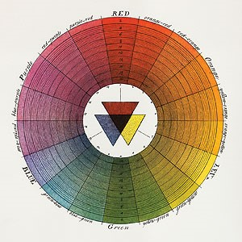 | “color circle from the natural system of colours” (Harris ,1766)  History of Moses Harris works with colour and developed the first model of pigment primaries. The chart shown creates 18 hues, shaded with black in the middle to create depth. This demonstrates the first illustration and symbolism that all hues could be reduced to mixtures of yellow, red and blue pigments.
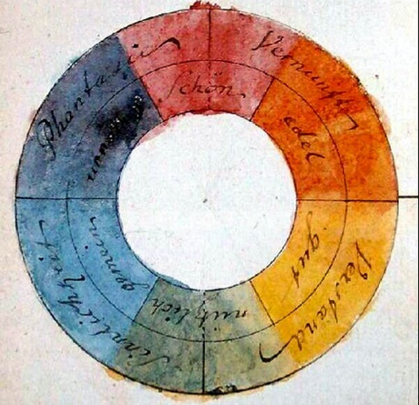 | Johann Wolfgang von Goethe 1779-1832 designed one of the main and first colour wheels showing impact and hue. He had a strong theory of what and how colour impacts people’s emotions and thoughts which is used today. For example, he defines red “The effect of this colour is as peculiar as its nature. It conveys an impression of gravity and dignity, and at the same time of grace and attractiveness…History relates many instances of the jealousy of sovereigns regarding the quality of red. Surrounding accompaniments of this colour have always a grave and magnificent effect.”
Table 1 Table by Hearne. Madeline, 2017

 | The John Radcliff hospital in oxford shows a colour combination of lime green, orange and pastel purple. This is an example of how light colours in interior design can help create healing environments. For example, with the colour orange its known to stimulate mental activity and therefore would be avoided in a mental health unit. The Dulux trade Brochure suggests “Excessive use of bright colours can interfere with visual diagnosis and lead to overstimulation.” This means it is best to use calmer colours so that the patient is comfortable and happy.
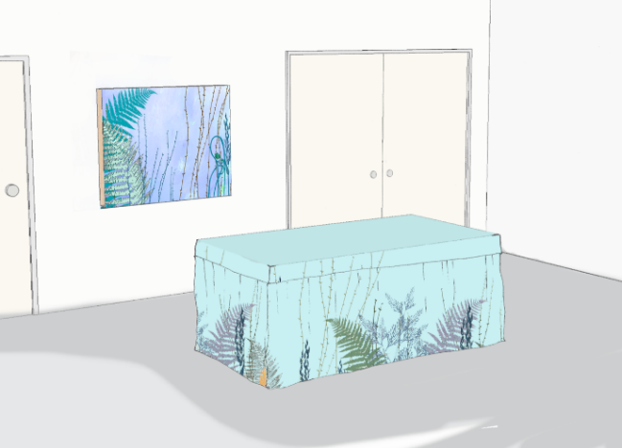 | Willis Newson tries to create the opposite vibe as Dulux paints idea at the john Radcliff hospital because they are interpreting student’s illustration work and hands on skills designers such as Kate Bond to fill in blank spaces. The idea is to “create a calm, respectful oasis for quiet contemplation, which can be divided to accommodate smaller spaces for prayer or discussion.”
 | The worlds ugliest colour “Pantone 448 C, also known as ‘opaque couché’, is the shade chosen as most likely to put smokers off, a group of academics and market researchers decided after three months of research”
This chart below has been designed to show how colour in a room or on an object can create a mood or feeling. This will help develop the reason of this topic and should demonstrate a better understanding of lifestyle colour.
Table 2 ,By Hearne. Madeline, 2017

From this you can understand that certain colours wouldn’t work in specific areas like a primary school, spa or a sports centre. They all have specific colours on the walls that can make you feel welcome and at peace. If the colour was wrong, the customer would feel on edge and unsure about how to feel. When you think of a leisure centre you will think of blue and greens because they are sporty, energetic colours. If the walls were white it would be boring and unfinished, like something was missing. An interesting example of pattern- inducing propensity of human vision, “sit opposite a blank white wall or a large sheet of white card; it is important that the white is embellished and large enough to fill your vision. Sit for a while, concentrating your eye upon the unbroken ‘field’ if whiteness as steadfastly as you can. After a while it becomes difficult. The focus of the eye ‘glazes’, or the vision is disrupted by a sense of movement which is both actual and virtual. If persisted in, the experience becomes unpleasant, even painful, and for some slightly nauseating, as if in seasickness” (Brett 2005: 57).

How colours make people feel?

Maitlains Grave defined symbolism, “the use of colour by religions, cults, nations, political parties, etc, to signify, represent, or express particular qualities, attributes, or characteristics” (Graves ,1951 :421). Designers have experimented with colour to create specific effects. The designer Issey Miyake said, “make me a fabric that looks like poison” (Steed, Stevenson ,2012:119) to one of his textile engineers, Makiko Minagawa. This involved the use of material and texture; however, if this piece was in pastel pink why would it not work out? Colours convey deep emotions and it’s so easy to create something extremely powerless with the wrong colour. Textures on fabric surfaces will create dissimilar densities of colour within a surface. Repeated patterns can also make it have a wide variety of shades. Figure 3 uses the material that Issey Miyake designed to symbolise poison (See figure 3). The dark red shade and texture created a feeling of sadness. The way the cloth is draped in the window display makes it have a real life meaning within movement, travel and length. It may represent blood.
The collection was called ‘a piece of cloth’; the material is in fact draped by the weaving technique, making it unique and strange. It’s almost like an experiment for different reactions. Layers and overlapping suggest the women in the cloth may be trapped and scared, making the viewer feel sad and worried. Creatively using the colour red can help attract buyers to this product or even just encourage them to view it and share it. It’s not just the colour that effects the way people feel, Issey Miyake has managed to show depth. “The actual emotional effect of a specific colour in an art work depends partly on its surroundings and partly on the ideas expressed as a whole.” (Batchelor, 2007: 45) Therefore, to be surrounded by red with a certain movement, you think of blood because of its unusual structure and form.

The colour red

The colour on its own will mean something different to everyone in a personal way “Symbolism and Associations. Red in general symbolizes the more primitive passions and emotions. It is associated with rage and strife, danger, courage, virility, and sex” (Graves, 1951: 405). To a lot of people red is important, for example “of all the colours, red has the strongest chroma and the greatest power of attraction. It is positive, aggressive and exciting. It is the most popular colour, particularly with women.” (Brett, 1951: 404). This suggests a theory that women may be more sensitive to colour than men. Some women may feel more warm and confident in red than something that is blue. Also, investigators claim that “ten times as many men as women are colour blind” (Graves, 1951: 401). Overall red has a wide language and affects us powerfully, allowing us to develop mood and develop the feeling people wish to demonstrate.

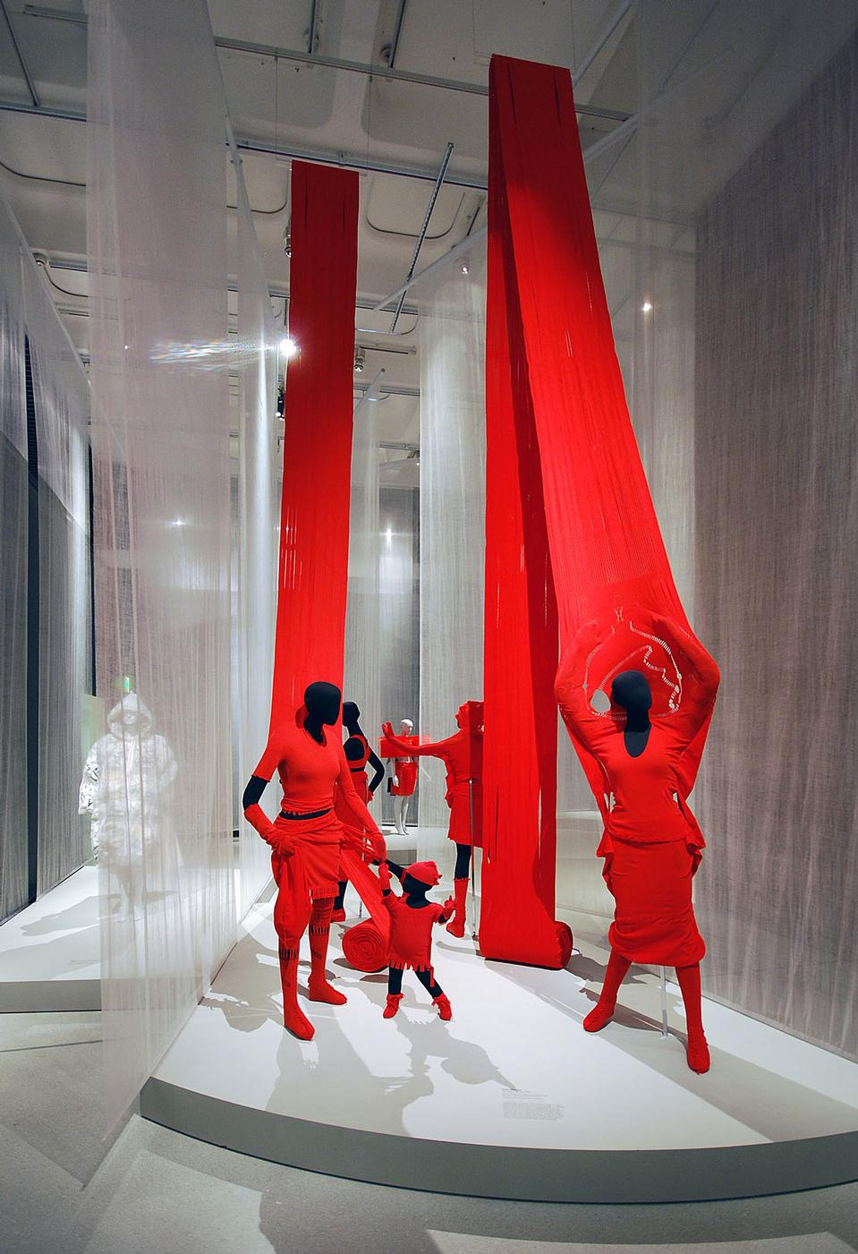
Figure 3 ,Miyake (1999), A piece of cloth

George Segal created a piece of art (see figure 4) which makes great expressionistic amount of the colour green. The green creates a “sickly, depressing impression of their solitude, social embarrassment, and unaccustomed poverty” (Zelanski and Fisher, 2006: 44). This is a great example of how a colour tone can symbolise a feeling. The figures of men have sad facial expressions but why are they green? “The darker and the more neutralized yellows and greenish yellows, such a Y8/1, y5/4, and y2/2, are the most unpopular and disliked of all colours. These yellows are associated with sickness and disease, indecency, cowardice, jealousy, envy, deceit, and treachery.” (Graves, 1951 :403) If the faces were a bright yellow it would change a lot about what the piece of art was conveying. When we think of bright yellow we think of a sun or a banana which relates to summer and warm tones. This dull green has symbolised human skin to be dead and old and the black helps make it more depressing, dark and scary. Because “black has always signified sorrow, gloom and death.” (Graves, 1951: 408). The men are made from a mixture of materials like plaster which have created a dusty- type- texture. Lesley Millar said” Surface can mean texture, the outer layer, a membrane. Through the surface can mean something emerging or beyond the immediately visible” (Steed, Stevenson 2012:101) This tells us that texture is important and noticeable when applied to an object with colour.
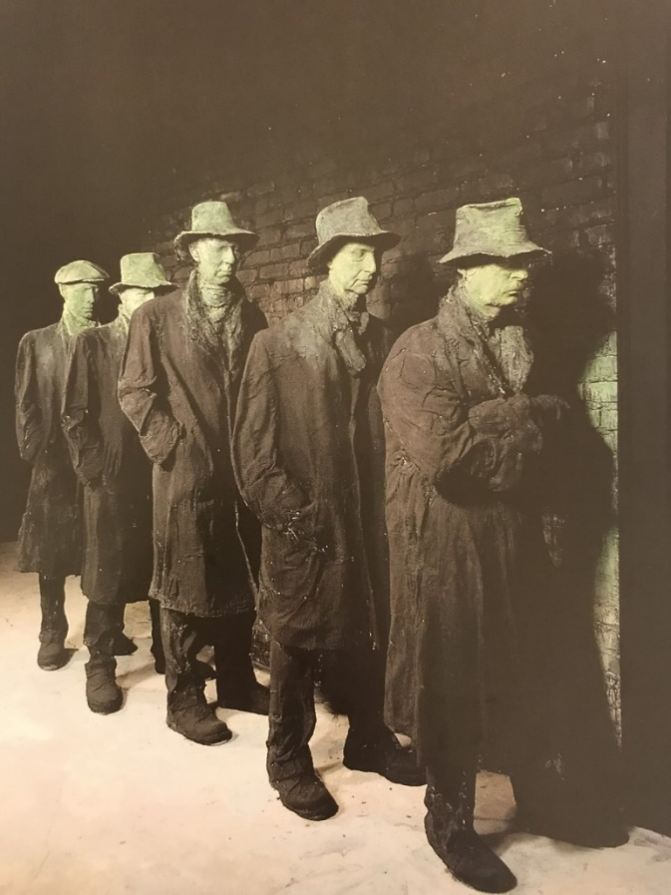

Figure 4, Segal. G( 1992:47)( Zelanski and Fisher)

Chapter 2

Why do we make colour choices every day in relation to fashion and interior?

A colour choice is a personal response with emotion. Following a trend makes you think you like a certain colour but really you have been persuaded to like a colour that’s perhaps fitted in with the season or the colour palette, pattern and materials. Wallpapers are a great example of seasonal interior choice. Owen Jones said that “colours should be blended so that from a distance they would present a neutralised bloom”. He uses great tones in the Persain Sprig wallpaper (see figure 5) created in 1858. Using a repeated floral design, he shows his skill of design precepts with the spacing and sizes. The light colours show a calm and peaceful flow, with a feminine feel towards nature. Colour therapist, Suzy Chiazzari suggests that pink gives an emotion effect of “calmness, nurturance, kindness and unselfish love” (Zelanski, Fisher ,2006: 44). Therefore, this wallpaper would be a specific choice in emotion because of the hues and balanced background of white, making your home feel calm and pretty.
Analysing colour with interior will affect your perceptions of space- “colour choices may be based as much upon on perceptions of space unity and emphasis as upon the artists desire for realism or psychological suggestion.” (Zelnanski and Fisher, 2006: 49) This means that the emotional influence starts from colour. Andrea Malavolti’s article “When green is truly a philosophy” (Malavolti, Collezioni Trends,Wallpaper®) implies that having green imagery can immerse yourself in nature (see figure 6) The natural wallpaper has brilliant shades in various hues of green. The wallpaper design ‘La selva Fiorita’ is full of birds and buds like a floral forest. The idea of having such a bold pattern in green, allows you to picture yourself somewhere new and fresh which is why new trends come in all the time. Most normal humans want to feel in trend with the seasons and want to have a fresh feel in your home, almost like bringing the outside in. This can be influenced by the environment. Designers like William Morris have managed to stay in fashion for many years and he’s recognised for detailed pattern. Although his designs are vintage they still attract people’s attention today!

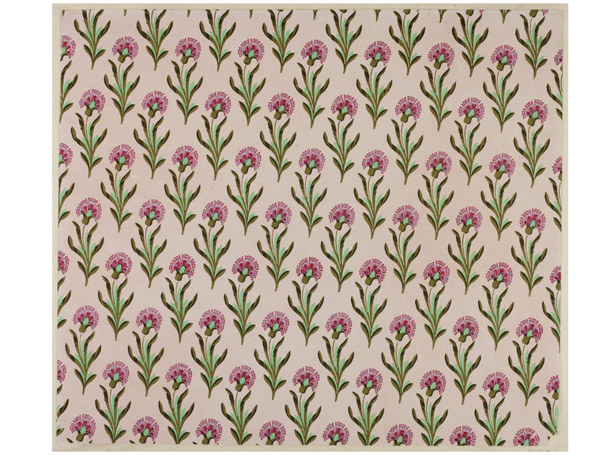
Figure 5, Jones.O (1858), Persain Sprig Wallpaper

Seasonal change is important when it comes to trends because your emotion changes and people will have a specific taste in colour palette due to the rapid fashion industry circle. Fashion designer Dries Van Noten said that “one season I’m inspired by a picture, the next one by a complete exhibition. It is more an evolution in the mind than a fixed process…” (Clarke,2004: 33) This tells us that being inspired depends on where you are and what you’re doing, how much information you process and what attracts you personally. He also says that “There are also things or colours that I don’t like or that I think are ugly, and I force myself to discover why I think those things are ugly or why I don’t like them.” This is a great way for a designer to develop and learn from style and to perhaps understand why it doesn’t work for them.

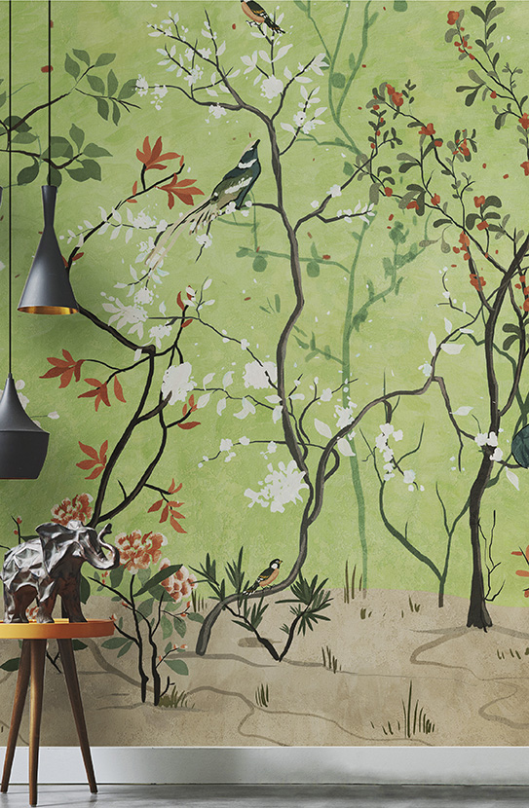
Figure 6, Wallpaper ® (2016) La Selva Florita

Print, pattern and colour responses

The terms colour perception, colour psychology, colour trend and trend forecasting, involve the way people respond with colour. Designers should be aware of how colour influences men and women differently. This can be similarly applied to patterns. Patterns create different responses for certain reasons for example, the striped pattern is more of a male print to wear than it is for a woman. Gloria moss studied the reason of women preferring polka dots as “less harsh, softer, and less busy and more feminine than stripes” (Moss ,2014). This tells us that stripes respond differently to men and women. The themes that encapsulate these patterns may also influence certain choices. How designers and design companies respond to this starts from an observation of high street trends and the innate psychological reactions to colours, on different materials and surroundings. Fashion historians investigate detail through different feelings being conveyed through the clothes people wear and the design inside people’s homes. This form of expression remains in the present digital age. This chapter explores the different types of colour in print and the expressive nature it plays upon print patterns by a different variety of materials and combinations of textiles.

The camouflage print, disruptive pattern and colour

Trend prediction is an important role for any designer. You should be up to speed with the trends by looking on the internet, fashion shows, galleries and more. Fashion forecasting is used today to create concepts for the fashion and interior markets. Most brands will rely on this information to make further collections and plans. The camouflage trend can always be popular because designers re-invent the idea with little touches of development for example, the designer label ‘Maharishi’, founded in 1994. Maharishi Demonstrates the international military development in an all over repeat pattern on a blazer (see figure 7), in a modern way by adding little extra motifs and shapes.
Maharishi also used pastel colours (see figure 8) to re-invent the mood. Pastel colours are the opposite to dark, khaki greens and were inspired by pastel chalks. A dye researcher ‘Chervreul’ suggested in 1864 “The expression “pastel tone” indicates a soft pale colour, such as that found in a pastel drawing” (Delamare & Guineau, 1999 :117), meaning colours were found by drawing through the material. Colour theorist, Bride M. Whelan said that “what’s in today may be out tomorrow. Trendy colour schemes can be pleasantly shocking in combination with other colours” (Whelan ,1994 :66). This suggests that many colours can surprisingly look great together when worn successfully and can fit in with the right season. A monochrome outfit may not work as much as a complementary outfit due to attraction results. The importance of colour forecasts and colour trends are demonstrated through both printed garments (figure 7 and 8). This is because of the colour palette change. Whelan also mentions that “A new colour or colour scheme gives new life to old product”. (Whelan, 1994: 131). Meaning that the original camouflage colours (figure 7) are completely different in comparison to the other colours, making the product more unique and engaging. What’s interesting is the aesthetic reaction by the way people can wear it every day without acknowledging the real performance behind camouflage and its history meaning.

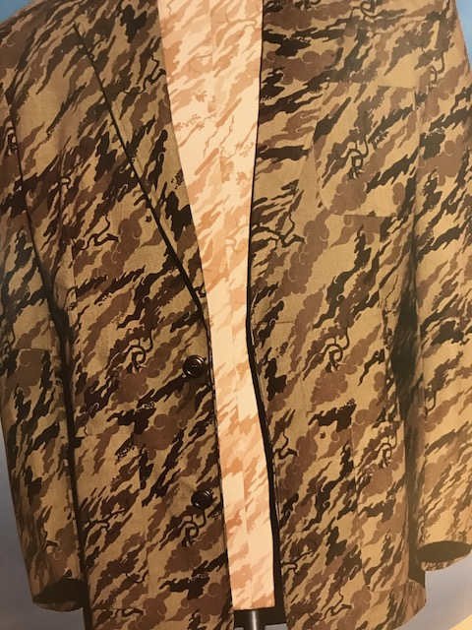

Figure 7, Fogg , 2006: 56, Maharishi ‘Bonsai Forest ‘Camouflage cotton tussar blazer.

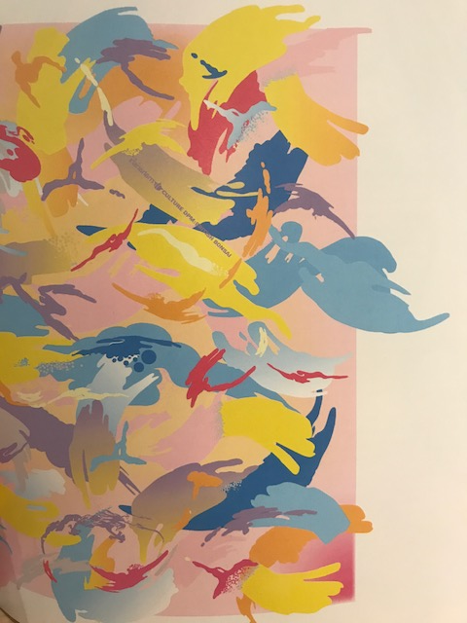

Figure 8, Fogg, 2006: 58, Maharshi ‘culture DPM: British Bonsai ‘camouflage print

Today, this certain camouflage print on the combat trousers is mainly worn by women (see figure 9). This could be because of the dramatic change in colour, Jay Calderin and Laura Volpintesta suggested “A good example of how the perceptions change is the colour pink. Present it as a colour option for a man today and he might shy away, because modern day men have been trained to link the colour with all things feminine” (Calderin, Volpintesta,2013: 111). The label; Missguided have created a camouflage look using a lot of pink, turning the look very feminine (see figure 9). This is because the khaki colour is becoming too repetitive and perhaps fading out of trend? Many designers are now trying to re-invent the idea, making it more energetic and exciting to wear. The khaki green is so popular but this year it must be time for a change as most products perhaps weren’t selling enough! Using a different colour for this type of print can have a massive impact on trend, showing the importance of trend forecasting.
Colour theorist Whelan said that “the world economy depends on product viability as well as product ‘buy ability’. If the product sells, it is certain that the colour is forecasting and therefore colour trends played a large part in that sale and perhaps may have defined the colour trends for the decade” (Whelan,1994: 131). This means that as customers have worn the original look in the khaki colour and perhaps become too comfortable in it, designers and analysts looked for a newer combination in selecting colour schemes that will stimulate the persons emotions. An important start to the design process consists of adapting to a personal preference, making it more likable. The number of pink tones will suggest that the women will feel excited, colourful, fresh and up to date with the trends. Jay Caldering discussed the definition of pink, “understanding the connotations that a colour carries from culture to culture and for different social groups can clarify and enhance the designers thinking” (Calderin, Volpintesta, 2013: 111).

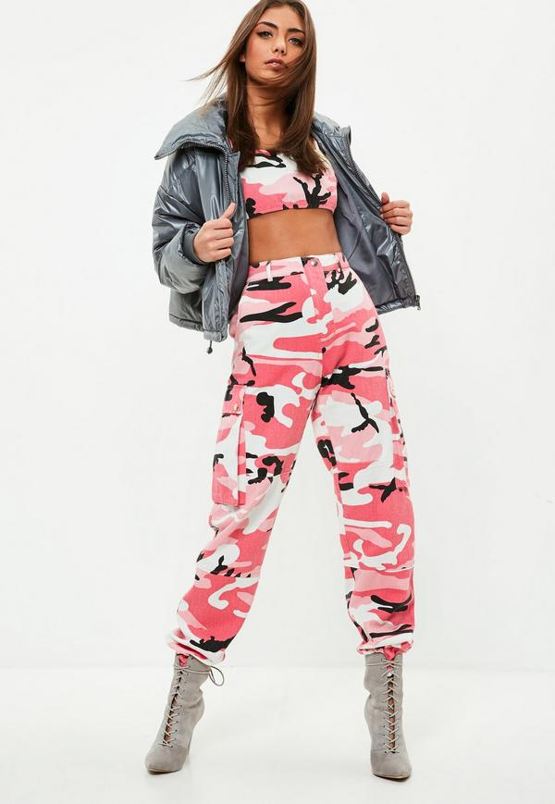
Figure 9, Missguided Camo Trousers 2017

Today’s Botanical motifs compared to Identifiable patterns from 1860?

William Morris, a well-known English textile designer, has been a great inspiration towards new designers for a long period of time due to his British richness and quality in pattern, motif and colour (see figure 10). His unique style of nature botanicals allowed him to create many designs for a range of people’s tastes. The theme ‘nature’ is by far one of the most popular and most liked decoration of all time. The wallpaper ‘Strawberry thief’ (see figure 10), holds a variety of shades close to colour palettes back from the medieval period. The colours they used are strong, dark and warm toned because they symbolise wealth. He does this by capturing inspiration from British gardens and changing the colours of flora and fauna to make it more unrealistic to us today. This is what makes the designs stand out and become bolder to the eye, almost like a fantasy, for example his wallpaper design has a lot of blue thorns, but they should be green. Linda Cluckie suggests that “the Morris look was probably the first to become instantly identifiable by a large sector of the population” (Cluckie,2008: 76). This may be because of the unusual colour choices- if the designs were just two tones and in normal form, he may not have been so recognisable for his style?
He started designing his wallpapers in 1860, when most wallpapers were usually repeated pattern all over. Simon Clarke mentions, “what seems certain is that the fashion print is not a passive aesthetic: it is active in enhancing the material world, in raising visual consciousness and acting as a conduit through which to cultivate and nurture change on a variety of social, ethical and political fronts while holding on to this tradition” (Clarke,2014: 11). This makes the design exciting and never ending, Morris is a great example of how a traditional pattern can be kept the same through rich tones, colour and style.
There is a painting by Jan Van Huysum’s in the Victoria and Albert Museum (see figure 12). The painting was done in 1736 and has a similar effect as the Strawberry thief wallpaper. Nature journalist, Philip Ball said “Jan Van Huysum’s flowers in a terracotta vase seems to depict strange blue leaves. They were once green, but the yellow has faded” (Ball, 2001: 290). The artist Merimee commented on the colour blue, that “one sees, in several Flemish paintings, leaves of trees have become blue, because the yellow lake, mixed with ultramarine has disappeared” (Ball ,2001: 302). This was because ‘Prussian blue’ paint was likely to fade in the early eighteenth century, due to sunlight. Colour theorist, Robert Dossie mentioned, “the lighter, brighter and most attractive varieties of Prussian blue (which contain a white alumina) are ‘extremely subject to fly or to turn to a greyish green” (Ball,2001 :302). Overall this could perhaps suggest William Morris painted in blue purely to keep that process known with the colour green, rather than his personal choice. Making his colour have a historic significance, which is very important and attracting to customers. Colour theorists such as Goethe blue meant “cool, serene, passive, and tranquil” (Graves,1951: 406). This suggests blue can symbolise different things when created in a certain year.
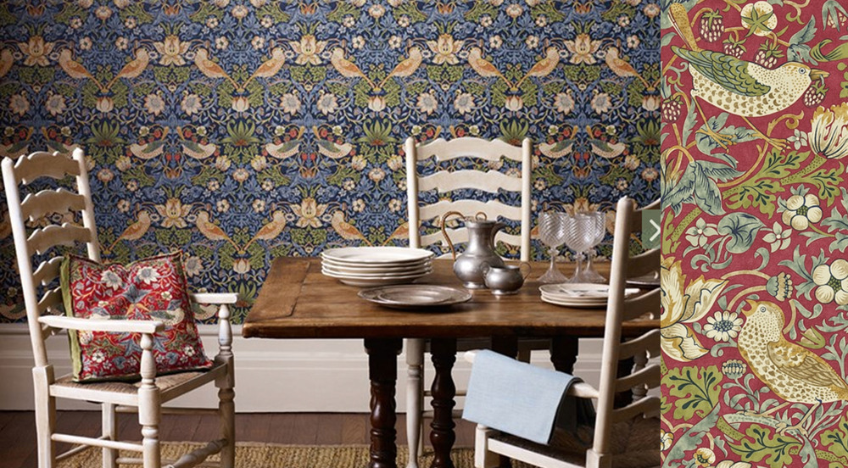
Figure 10, Morris.W, (1883) Strawberry theif wallpaper

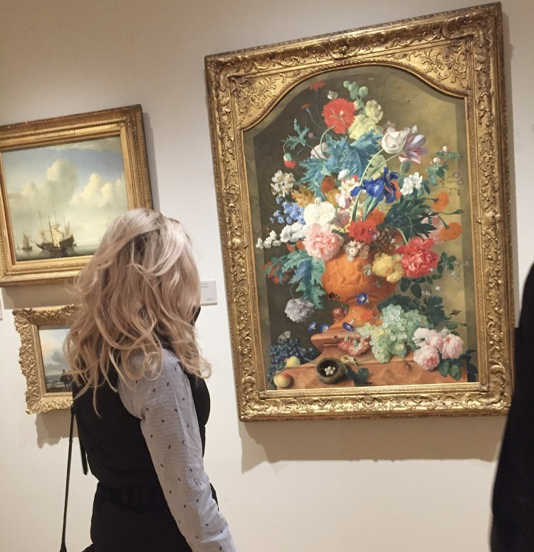
Figure 11, Photographed By Hearne.M (2017) V & A Museum, Huysusm.V.J (1736)

Chapter 3

Sustainability in textile and colour

This chapter will explore how bringing a sustainable change will make people realise the process and function of what clothes go through. An important aspect to acknowledge as a designer is that, dying fabrics to create a colour can have an impact on water waste through contamination and further material waste. People will decide on an individual material and a colour dye process to have a thriving outcome of product. Kate fletcher said, “clothing is a material production; fashion is a symbolic production” (Fletcher, 2008: 119). This could suggest that in the excitement of feeling ‘trendy’ we ignore both the function of the garment and how it has been produced. Therefore, perhaps designers could produce clothes that are based on meeting personal needs such as, protection and substance instead of meeting the non-material needs like, affection, identity, freedom, creation and participation, just for a cheap trend collection that will get thrown away next season.
Kate Fletcher suggests that “This overlaying of emotional needs on physical goods fuels resource consumption, generates waste, and promotes short- term thinking as we turn our glaze from one silhouette, hemline and colour palette to the next in search of the next new experience” (Fletcher,2008: 120). This would suggest that rather than forever looking for something new, attention should be applied to mindfully appreciating the qualities in the product. Some eco designers and brands inspire and succeed with their own ways of doing this such as, Vivienne Westwood, Stella Mcartney, Prada and Martina Spetlova.
Textiles can be dyed as fabric, yarn or fibres which is one of the most common process within sustainability. Erin Caddigan implies, “How and when the textile receives its colours can affect the cost, sustainability, colour pattern, permanence and penetration of dye. Dye factories must be at the forefront of fashion trends, starting their predictions for colour and dye effects as early as three years before the coloured textiles are offered” (Caddigan, 2014: 70). This confirms that there are reasons for new designers to learn more on the process, but you need the determination and plan beforehand. It can also confirm how people care for garments that have colour, detail and quality. Miguel Gardetti and Ana Torres suggest there are many ways of creating by, “a better colour trend forecasting system for consumers, the fashion industry and the environment” (Gardetti, Torres, 2013: 6).
The brand ‘Ipeker’ created the “world’s first vegan collection” (Collezioni trends, A/w 2018-19). They have invented a vegan textile process which is “combining speciality firbers like cupro, acrylic recycled premium polyester” which all ensure no animal products are used. This process may help prevent animal protein contamination to the skin and is of course cruelty free (see article in Notes). Eco designers have a challenge to inspire and motivate other new designers for example, Martina Spetlova suggests, “The more useful a garment is, the more likely we will keep it, repair it, sustain it” (Mquilten ,2014, Sublime design). This process depends on the quality of the garment. This is what Varvana Stepanova did as the unisex sportswear (1923) (see figure 12), it shows depth and personal needs. The designs were made to represent “how a body moves in space”. It also had specific fabrics, designed for sports to create better movements. She also had printed lines which “emphasised the garments structure including the seams, pockets, buttons, fabric bias and weave” (Mquilten,2014, Sublime design). This suggests that the designer has taken into consideration of how long the garment will last, protect, move and perform when being worn. It also shows that the bold colour prints have been formed together by geometric lines, which create flex movements to the eye. These designs have been planned for a certain customer, so she has thought about movement before designing. People should then understand how much care is needed towards this product, making it more special and much more functional in the long-term usage.

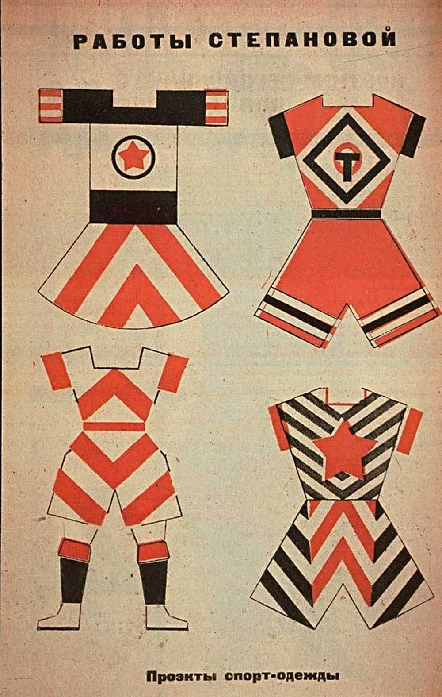
Figure 12, Stepanova.V(1923), Sports Clothes
The ‘vegetarian label’, Stella Mcartney Produced a campaign to make people more aware of waste in 2017 (see figure 13). Mcartney suggested "Our man-made constructed environments are disconnected and unaware of other life and the planet, which is why there is waste” (Stone.W.D ,2017,Fashion United) .This is referring more to the waste on the floor and why they photographed the collection where they did. It makes it more concerning to the viewers and something more meaningful towards the collection. It is an expressive message of ‘waste’. The materials used are very important, explained by Stone in an article “53 percent of the womenswear collection comes from sustainable materials including sustainable viscose, regenerated cashmere, organic cotton and denim, recycled nylon, sustainable wood and cork, and eco alter napa “(Stone,2017, Fashion United). This tells us that her materials are all effective and sustainable. The colour palette is suited for the season and very trendy which is an inspiring collection for people who wish to be sustainable and fit in with the ‘nude’ trend. The aim of the collection is to encourage people to be more aware of what’s happening with waste and how improvements need to be made to reduce the rubbish for a better way of living. The garments have an earthy and natural feel to them which is very modern and beautiful and defines a person in a more natural colour.
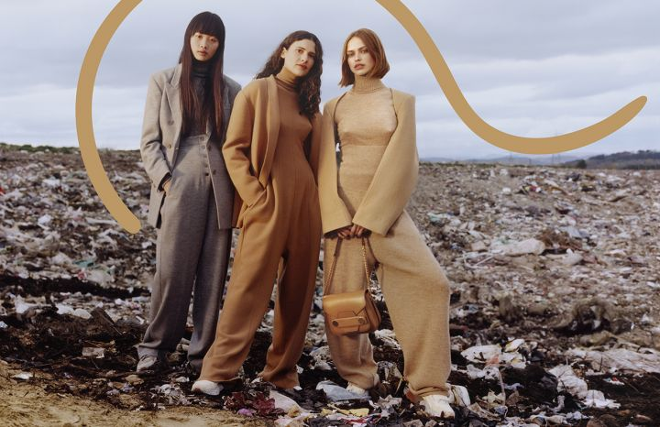
Figure 13, Mcartney.S (2017) Waste Campaign
Pattern and colour creates a relationship when combined. The fashion designer Mara Hoffman creates fun and sustainable swimwear and suggests that the brand itself is, “focused on using more sustainable materials and continuously evolving on its journey towards being a more sustainable and more responsible brand” (Dufault, 2017, Positive Impact Awards). The swimsuit design shown in (figure 14) proves that sustainable fashion can be colorful and bold without looking too washed out against a variety of pattern. However, the color palette of summer doesn’t influence the term sustainability, due to the digital print look and perhaps it complex pattern design. Usually sustainable colors have more of a washed out vintage feel (see notes) which may be why designers do not want to develop the manufacturing process. This means that to be sustainable you don’t have to use natural dye pigments, you can use eco-friendly fibers such as recycled nylon and polyester.

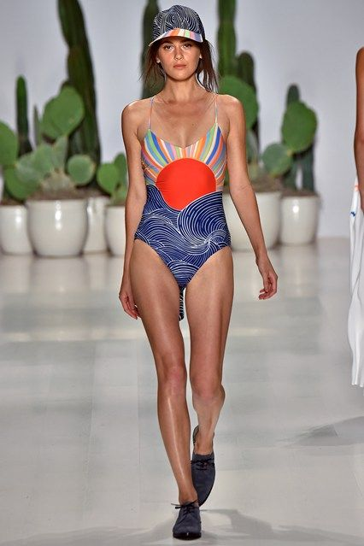
Figure 14 Hoffman.M (2015) Swimsuit collection

Conclusion

Colour is an interesting aspect of today’s life style which involves the importance of sustainability, trend changes and textile. There could be a new vision towards fashion instead of what its like today, for example people’s conscious choices instead of their blind consumption towards fast pace trends, which go to waste. This is a reflective break down of how we can live better with a good understanding of colour, and its emotional effects. Fletcher suggests, “Designing and making fashion clothes that help us ‘flourish’ would transform the textile industrial system at root” (Fletcher, 2008: 123. This suggests more designers should transform into a better process for the best outcome.
The idea of clothing having more story creates a better structure of a garment, this makes it more beautiful which will be carefully worn and admired for example, Fletcher discusses value, “We will see beauty and greatness in garments that value process, participation and social integration, in pieces that advance relationships between people and the environment” (Fletcher,2008 :125). Some people can create their own trend instead of everyone looking so similar and wearing such repetitive prints all the time. This should demonstrate a variety of understandings between colour effects and recognition, as well as the importance in colour hues in its process.
Caddigan explored, “By examining the ‘why’? a designer can extend the usefulness of lifecycle of a fashion item through innovative design, quality materials and emotional value. In turn a highly fashion piece can help save us from drowning in a sea of throwaway, fast fashion “(Caddigan, 2014: 33) This shows that designers can have emotional value through choice, this is concluding these points to be an eye opener for new designers.

Bibliography

Books
Brett, (2005) Rethinking Decoration, Cambridge
Clark, Simon, (2014) Print: Fashion, Interiors, Art. London
Calderin, Jay and Volpintesta Laura (2013) The Fashion Design Reference & Specification Book, China
Delamak francios & Guuineau Bernard, (1999) colour, London, Thames & Hudson
Fletcher, Kate (2008) Sustainable Fashion and textiles, London: Earthscan
Fogg, Marnie (2006) Print Fashion, United Kingdom, Anova
Graves Maitland (1951) The art of colour and design, London, second edition
Håland, Johanne Eyy (2014) Rituals of Death and Dying in Modern and Ancient Greece, Newcastle
Steed Josephine and Stevenson Frances (2012) Sourcing ideas, Switzerland, Thames & Hudson
Whelan, Bride, (1994) Colour Harmony 2, America ,Thames &Hudson
Zelanski, Paul and Fisher, Mary (2006) Colour, Fith edition

Websites
Briggs David, (2017) The dimensions Of Colour, Available at http://www.huevaluechroma.com/077.php accessed 10th November 2017
Claessens, Martine, (2015) The Revival of William Morris Decorative Arts. Available at https://martineclaessens.com/blog/2015/10/19/the-revival-of-william-morris-decorative-arts ,Accessed 15th November 2017
Caddigan Errin (2014) Sourcing and Selecting Textiles for Fashion: Sourcing and Selection .Available at https://books.google.co.uk/books?id=ZWrgAAAAQBAJ&pg=PA70&dq=sustainability+in+colour+textile&hl=en&sa=X&ved=0ahUKEwj60NeuovrXAhVIJ8AKHdWHB1QQ6AEINzAD#v=onepage&q=sustainability%20in%20colour%20textile&f=false ,Accessed 15th November 2017
Dufault, Amy (2017) POSITIVE IMPACT AWARDS: Mara Hoffman Wins Brand Leadership in Advancing Sustainability. Available at: https://bkaccelerator.com/positive-impact-awards-mara-hoffman-wins-brand-leadership-in-advancing-sustainability/ ,Accessed 10th December 2017
McQuilten Grace,(2014) Sublime design: Varvara Stepanova’s unisex sports uniform Available at ttp://theconvehrsation.com/sublime-design-varvara-stepanovas-unisex-sports-uniform-27587 , Accessed 2nd December 2017
‘Landan Peoples’ (2017) Why is it normal that Stella Mcarneny;s campaign was shot in landfill. Available at http://www.refinery29.com/2017/07/164161/stella-mccartney-fall-2017-collection-sustainable, Acessed on 8th December 2017
Ipeker (2014) Available at http://www.ipeker.com/ Acessed on 2nd Decemeber 2017
Håland Evy (2014) ( p271) Rituals of Death and Dying in Modern and Ancient Greece, Available at https://books.google.co.uk/books?id=XC9QBwAAQBAJ&pg=PA271&dq=Black+may+shows+a+symbol+of+mourning&hl=en&sa=X&ved=0ahUKEwjdkLzGgYfYAhUGvhQKHXqQCx8Q6AEIJzAA#v=onepage&q=Black%20may%20shows%20a%20symbol%20of%20mourning&f=false , Acessed on 12th December 2017
Moss,Gloria ,2014 , Why Men Like Straight Lines and Women Like Polka Dots: Gender and Visual Psychology . Available at https://books.google.co.uk/books?id=8ijtBAAAQBAJ&printsec=frontcover&dq=how+colour+affects+men+and+women+differently&hl=en&sa=X&ved=0ahUKEwjHh_WK1JPYAhVDJsAKHUcEBc8Q6AEIMjAC#v=onepage&q=stripes&f=false, Accessed on 10th December ,2017
Morris William,( 2017) Strawberry theif , Available at https://en.wikipedia.org/wiki/Strawberry_Thief_(William_Morris) Accessed 2nd December 2017
Gardetti.M, TorresL. A Sustainability in Fashion and Textiles: Values, Design, Production and Consumption (2017) Available at https://books.google.co.uk/books?id=oqk0DwAAQBAJ&pg=PT138&dq=Miguel+Gardetti+and+Ana+Torres+suggest+there+are+many+ways+of+creating+by,+%E2%80%9Ca+better+colour+trend+forecasting+system+for+consumers,+the+fashion+industry+and+the+environment%E2%80%9D&hl=en&sa=X&ved=0ahUKEwjwh-nJkJbYAhVJK8AKHVD_Da8Q6wEIKDAA#v=onepage&q=Miguel%20Gardetti%20and%20Ana%20Torres%20suggest%20there%20are%20many%20ways%20of%20creating%20by%2C%20%E2%80%9Ca%20better%20colour%20trend%20forecasting%20system%20for%20consumers%2C%20the%20fashion%20industry%20and%20the%20environment%E2%80%9D&f=false , Acessed on 10th December 2017
Video
Mcartney Stella (2017) Waste campaign Available at ,https://www.youtube.com/watch?v=P7up1bG5d00 Acessed on 11th December, 2017
Blog
Givden Alice,2017 Designer Martina Spetlova discusses fashion, fabric and scienceAvailable at https://www.wgsn.com/blogs/martina-spetlova-on-fashion-fabric-and-science/# , Acessed on 17th November 2017
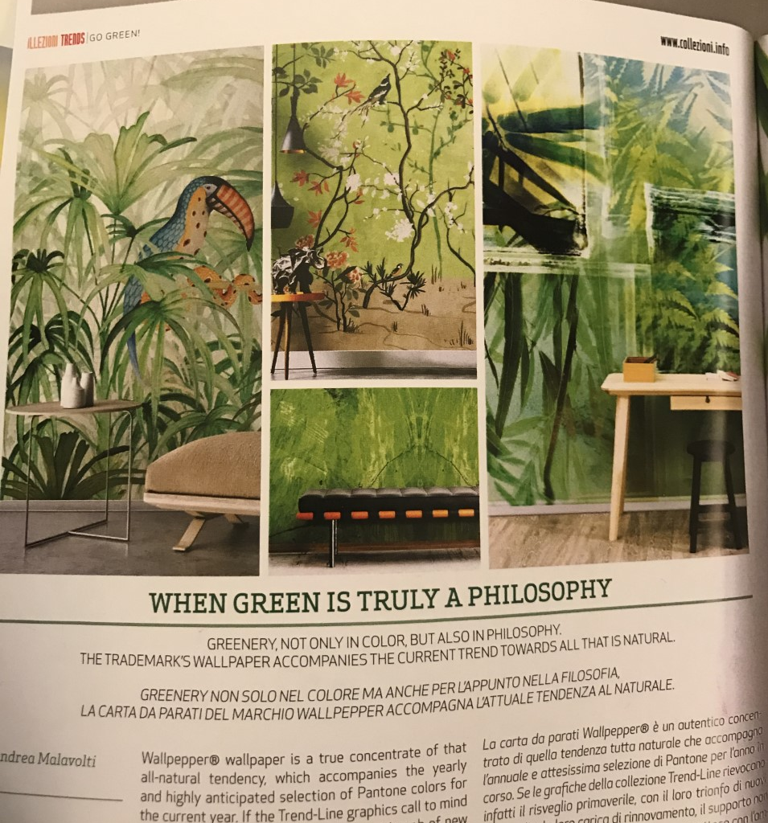
Notes (Article Research)

When Green is truly a philosophy Article - Collzeni Trends, A/W 2018-19
Worlds First Vegan Collection, Fabric (deep purple) – www.ipeka.com


