INTERCULTURAL COMPETENCE REPORT

Student Name
Catalina Gabriela Dumitru
Student ID number
2209716
MODULE
FOREIGN LANGUAGE & CULTURAL AWARENESS BMIH5003
Lecturer
LISA-MARIE BASSLER
Wordcount : 1151 words

Content Table
- Content table 2
- Introduction 3
- Content Comparison 4
Cultural intelligence and sensitivity 4
Leadership 5
Comparison chart 6
- Conclusion 8
- Recommendations 9
- References 11

1 Introduction

Soon, Diversity Hotel & Spa will open a branch in Medelin. New hotel will open with same offer and activities as in London, a part of management will be from England, at least for beginning; the rest of staff will be hired by local agencies exclusively of local offer. This fact will have some implications, some differences in many aspects. Different people, different culture and education, different perception and conduit rules. For managers who will lead the branch, have to study the differences and similarities between these two cultures, to be able to understand characteristics and particularities of people to hire for a succesful activity. The purpose of this analysis is to juxtapose English and Colombian cultural norms, with investigations grounded in findings from GLOBE project mainly, research for intercultural competences and leadership (Globe Project, 2004). This exploration yields a series of suggestions to hotel manager about the key elements highlighted through this case study.

2 Comparison
The Globe Project, with data from 2004, explores these dynamics across six fundamental dimensions and nine distinct directions, offering a more contemporary perspective. The data presented for England and Colombia, as on the website globeproject.com, reflects these cultural contrasts (Globe Project, 2004).
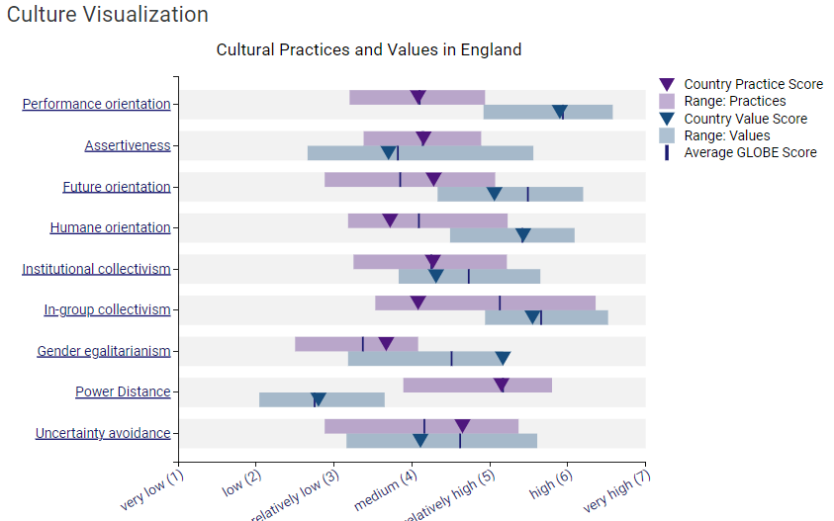
(Globe Project, 2004)
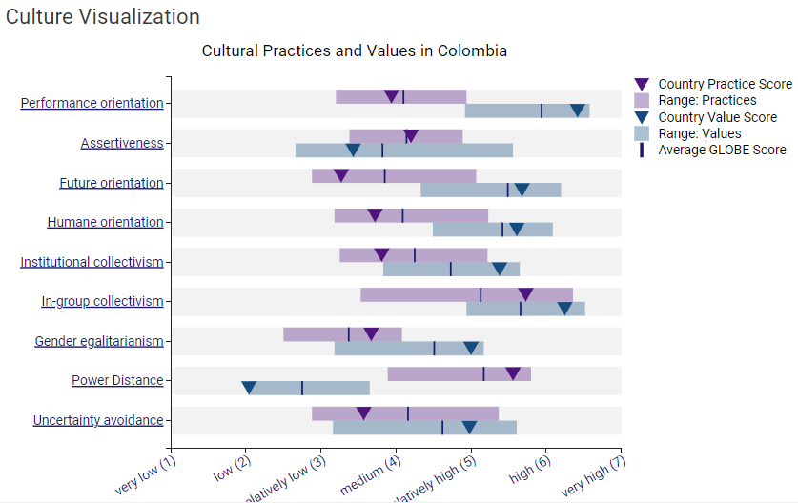
(Globe Project, 2004)
Another aspect is leadership directions, data presented from GLOBE project study from 2004, data for England and Colombia from site (globeproject.com)
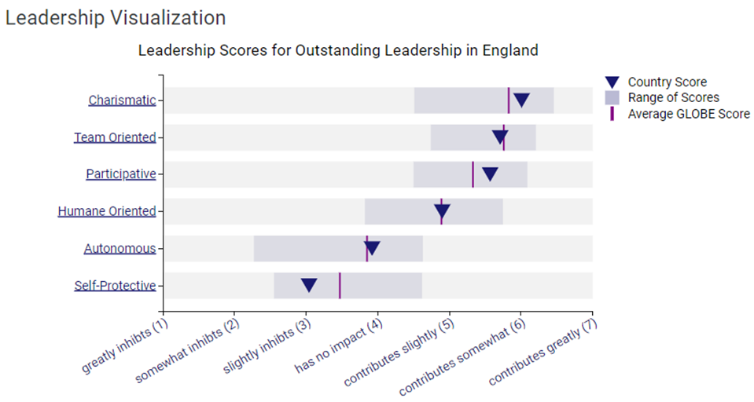
(Globe Project, 2004)
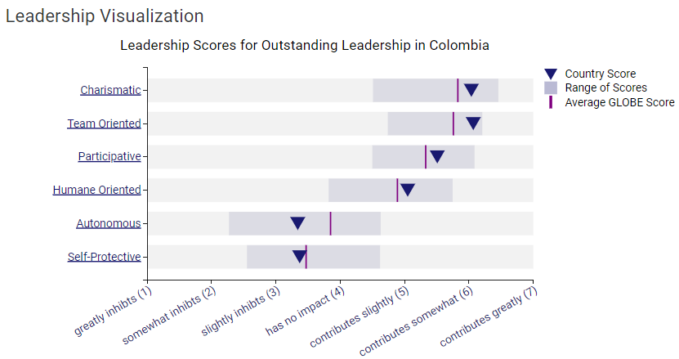
(Globe Project, 2004)
Comparing all the data, as shown in next chart, a part of the scores are similar for both countries, the other part highlights the differences between cultures and people.

Comparison chart England vs. Colombia on 9 dimensions (Globe Project, 2004):
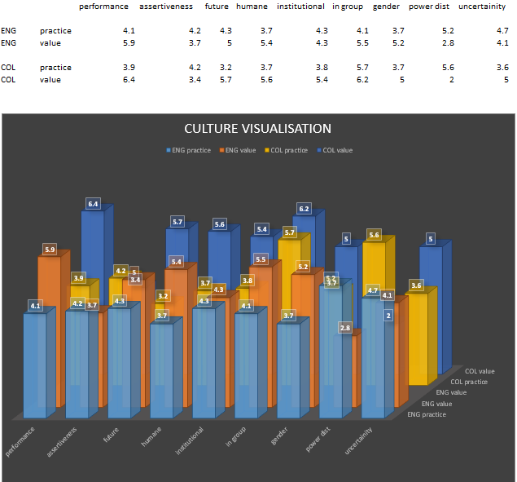

Here are further cultural insights into the distinctions between England and Colombia:
Social Etiquette: Social interactions in England tend to be more restrained and formal, with an emphasis on politeness, queuing, and respect for personal space. Conversely, Colombian social etiquette is characterized by warmth and informality, with people being more overtly expressive and less concerned about personal space.
Food and Dining: Traditional English cuisine features dishes like fish and chips, roast dinners, and afternoon tea, with a strong emphasis on punctuality and dining etiquette. In Colombia, the culinary culture is central to social life, highlighted by local foods, with meals often shared among family and friends as a gesture of hospitality.
Work Ethic: In England, there is a notable emphasis on punctuality and a professional manner, with work serving as a means to achieve a balanced lifestyle. Colombian work culture values diligence and commitment, albeit with a more relaxed stance on work hours and a significant focus on fostering personal relationships within the workplace.
Religion: Christianity, particularly Anglicanism and other denominations, predominates in England amidst a backdrop of religious diversity. In Colombia, Roman Catholicism is the most practiced religion, with religious festivities and traditions deeply ingrained in daily life.
Festivals and Celebrations: England celebrates events such as Christmas, Easter, and the Queen's birthday, alongside various local festivals. Colombia is known for its vibrant celebrations like Carnival, featuring music, dance, and colourful parades.
Sports and Hobbies: Popular sports in England include football (soccer), rugby, and cricket, with gardening and television watching being common pastimes. Football is also beloved in Colombia, along with a passion for dance and outdoor activities like hiking and cycling.
Social Hierarchies: In England, social standing is often determined by education, occupation, and class. Colombian social hierarchies are more likely to be influenced by family background and connections.
Family Values: English cultural norms often encourage individual autonomy, with young adults typically moving out on their own. In contrast, Colombian society places a high value on family, with extended families frequently living together or nearby, offering substantial emotional and financial support to each other.
Understanding these cultural variances is crucial for successfully establishing and managing a subsidiary in Colombia. Adapting to local customs and maintaining open lines of communication can significantly enhance the prospects of your business endeavour in this distinct cultural setting.

Conclusion

The objective of this analysis is not to put in evidence differences between nations but rather to underscore aspects that might lead to misunderstandings or negatively impact the operational success of a new hotel venture. By enlightening the entire team—including the manager and other staff members who are relocating from London to work in the new establishment in Medellín—about these nuances, and by boosting their willingness for the Colombian market, to facilitate a smooth transition and establishment of the new subsidiary in Colombia. This approach is designed to foster positive interactions with local stakeholders, ensuring the venture's success and promoting harmonious relations within the community. “Cultural values and traditions affect the attitudes and behaviours of rulers in many different ways. The values that the ruler, who was raised in a certain culture, adopts in essence, affect his attitudes and behaviours” ( Christiansen, 2020, p. 34).

Recommendations
Prior to the deployment of staff to Colombia for training employees at the new subsidiary, it's imperative to equip them with essential information and guidance:
Cultural Sensitivity and Adaptation: Motivate the employees being sent to Colombia to exhibit cultural sensitivity and an open mindset. They should adapt to local customs, ways of communication, social practices and business protocols.
Language Proficiency: Urge all expatriates from England to acquire basic Spanish knowledge or to engage a local interpreter/translator for assistance in communication. Although English might be spoken by many Colombians.
Building Relationships: Highlight the significance of robust personal connections with colleagues, partners, and clientele. In Colombia, such relationships contribute to business achievements.
Punctuality and Time Management: While timeliness is valued in England, prepare them for a more relaxed approach to schedules in Colombia. Anticipate potential delays and adjust expectations accordingly.
Hierarchy and Respect: Acknowledge that Colombian corporate culture may exhibit a more pronounced hierarchical order. Employees are expected to respect their superiors and cultivate rapport with pivotal decision-makers.
Market Understanding: Ensure that the management team gains a comprehensive understanding of the Colombian market dynamics, including the competitive landscape and also market trends.
Business Planning and Strategy: Devise a detailed business plan and strategy tailored to the Colombian environment, market entry approaches, target demographic and marketing initiatives.
Local Partnerships: Explore the establishment of local partnerships and connections within the market to strengthen business operations.
Adaptability and Patience: Advocate for adaptability and patience among team members. Being prepared to face and address unforeseen challenges flexibly is essential.
Cultural Awareness Training: Guarantee that team members bound for Colombia undergo cultural awareness training to facilitate a smoother entrance to the new working environment and culture.
Properly preparing the team for these aspects can significantly enhance the likelihood of a successful establishment and operation of the new subsidiary in Colombia, ensuring smooth interactions and integration into the local business ecosystem.

References

Christiansen, B., Branch, J.D. and Karmowska, J. (2020) Cultural Factors and Performance in 21st Century Businesses. Hershey : IGI Global.
Maheshkar, C. and Sharma, V. (2018) Handbook of Research on Cross-Cultural Business Education. Hershey: IGI Global.
Miller, T. (2020). INTRODUCTION: The Persistence of Violence. In The Persistence of Violence: Colombian Popular Culture (pp. 1–43). Rutgers University Press.
Hampden-Turner, C. and Trompenaars, F. (2020) Riding the Waves of Culture. 4th Ed. London: John Murray Press
Abramson, N.R. and Moran, R. (2018) Managing Cultural Differences: Global Leadership for the 21st Century. 10th Ed. Abingdon: Routledge.
Fandiño Parra, Y.J. (2014) ‘Teaching culture in Colombia Bilingüe: From theory to practice’, Colombian applied linguistics journal, 16(1), pp. 81–92.
Hofstede, G., Hofstede, G.J. and Minkov, M. (2010) Cultures and organizations: software of the mind. 3rd Ed. New York: McGraw-Hill.
Deresky, H. (2017) International Management: Managing Across Borders and Cultures: Text and Cases. 9th Ed. Harlow: Pearson Education Ltd.
Globe Project, (2004) Cultural Practices and Values in Colombia, Leadership Visualisation available at: https://globeproject.com/results/countries/COL?menu=country#country
Globe Project, (2004) Cultural Practices and Values in United Kingdom, Leadership Visualisation available at: https://globeproject.com/results/countries/GBR?menu=country #country

