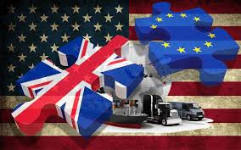

Brexit Strategies: And What It Means for The Supply Chain

Daniel Stokes | Logistics and Supply Chain Management | Date
1.Introduction
What is strategy? The Oxford English Dictionary describes strategy as “A plan of action designed to achieve a long-term or overall aim” (Oxford English Dictionary, 2017). But how does this help a logistics organisation. Strategy in logistics is a set of procedures, incentives and basic views that help set objectives and arrangements between businesses across the supply chain (Lexicon.ft.com, 2017).
However, how can companies prepare a strategy for something, when they are not clear of what impact current events might bring? That is what this report is going to try and answer. Although a big topic in current affairs, the British public are still uncertain about post-brexit. Will it be a hard Brexit or a soft Brexit? Will there be border tariffs to trade to mainland Europe? This report has strategies to help UK companies try and hold down a steady supply chain and cause minimum impact to the company’s net profits, but also how some companies have already started to act in the fears that Brexit has caused.

2.Brexit and Supply Chain Strategies
In June 2016, the British public voted to leave the European Union (Fox, 2017). Currently, Britain is part of the EU single market*, which in brief means free movement of goods, people, and services (Chapman, 2017). This gives Britain the rights to distribute goods across Europe without any additional tariffs. However, after Brexit, this could all change. If Britain leaves the single market, then companies would have to pay a Customs Tariff. This could mean a multi-Billion pound loss in trade between Britain and the rest of the EU (Chapman, 2017). In his report for the Independent Ben Chapman wrote “the cost to Britain’s exporters -- in extra tariffs alone -- would be at least £4.5bn per year. This conservative estimate does not include the difficult-to-measure costs of non-tariff barriers, such as the enforcement of different market standards and regulations”.
2.1. Post-Brexit Strategies
So how can businesses plan for what’s ahead? In an article for Forbes titled ‘How To Build A Post-Brexit Business Strategy’, David Lancefield wrote a six step guide (see figure.1) to on how to “build a post-Brexit business strategy”. Lancefield states that this will help businesses “will gain new insight into the strengths” of the company, and also claims that “one of the surprising long-term results of Brexit may be a higher level of connectivity among citizens, government, business, the environment, and society at large” (Lancefield, 2017).
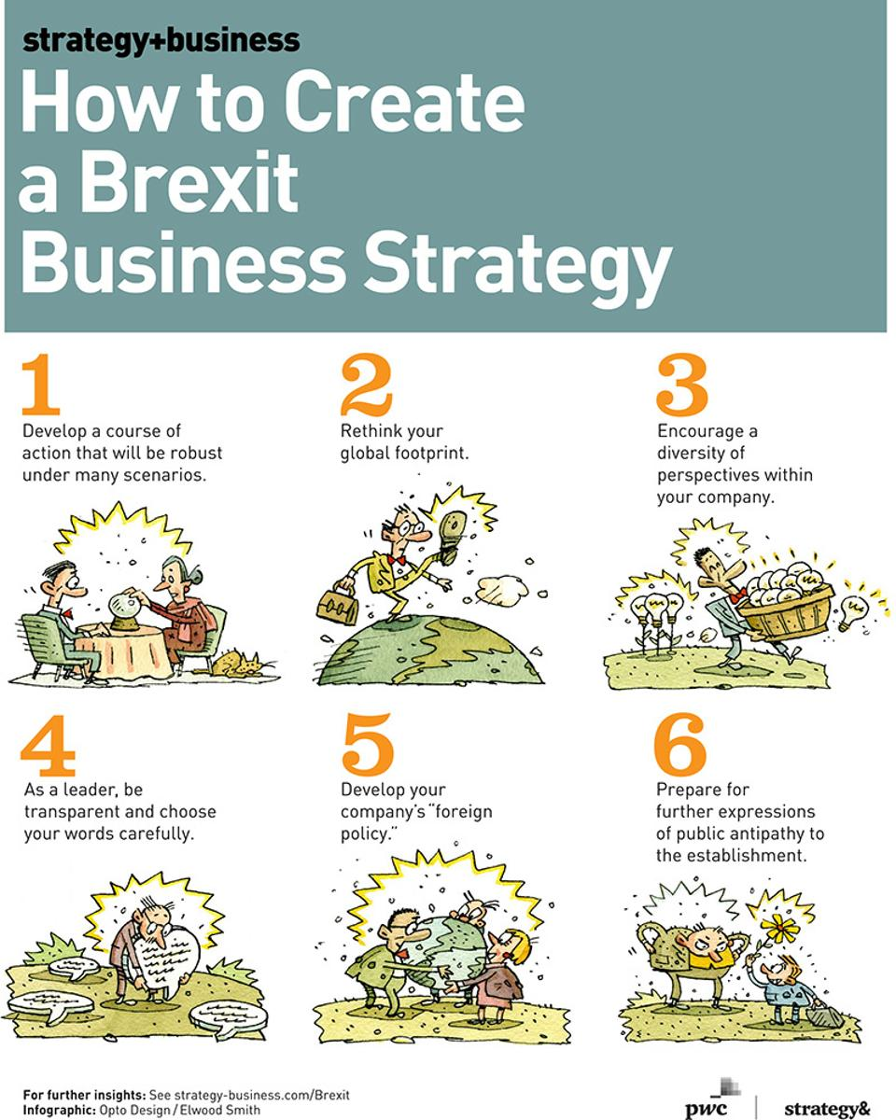
Figure.1 How to Create a Brexit Business Strategy.
Forbes.com, How to Build a Post-Brexit Business Strategy, Dec 12 2016

2.1.1. Post-Brexit Economy
Although showing a “strong performance” (Giles, 2017) in late 2016, Britain’s economy post-Brexit has been in an uphill struggle since early 2017 (See figure.2). With prices of goods increasing in Britain due to the decrease in the value of the pound (See figure.3), people in Britain seem to be spending less per-quarter, due to less expenditure per household (See figure.4). But how does this affect logistics operations in the UK? Currently, according to Lloyds Loading List, 13% of HGV drivers and 26% of warehouse operatives in the UK are European. Although not a big percentage, these two parts of the logistics industry bring in an estimated £121billion in GVA (Gross Value Added) contributions to the UK economy (Waters, 2017). Written in Waters blog, James Hookham, FTA’s deputy chief executive, stated, “Logistics is so important to the British economy; if we want to ‘Keep Britain Trading’ then we need to be finding ways to solve the existing skills shortage and not exacerbating the problem. Without these proposed restrictions, there’s already an acute shortage of around 30,000 HGV drivers”.
Helen Dickinson, Chief executive of the BRC, British Retail Consortium, spoke to BBC News about British businesses and their European staff, and said, “It is not right that 16 months after the referendum these people still don't have the security they need to continue their lives” (BBC News, 2017). With this information it is not surprising that the majority of EU drivers working for UK firms are “looking back to the continent” (Fox, 2017).
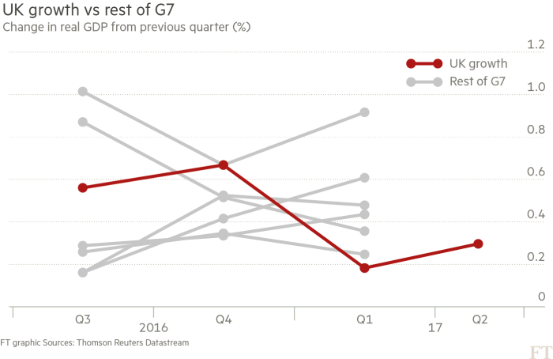
Figure.2 UK Economic Growth
The UK economy since the Brexit vote, Chris Giles, 26 July 2017
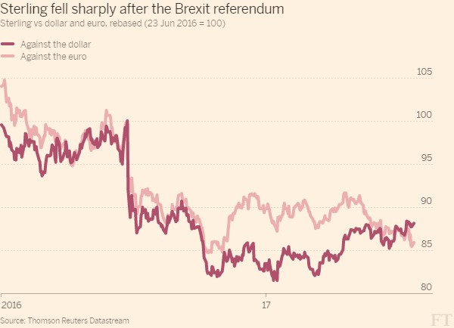
Figure.3 Value of the pound
The UK economy since the Brexit vote, Chris Giles, 26 July 2017
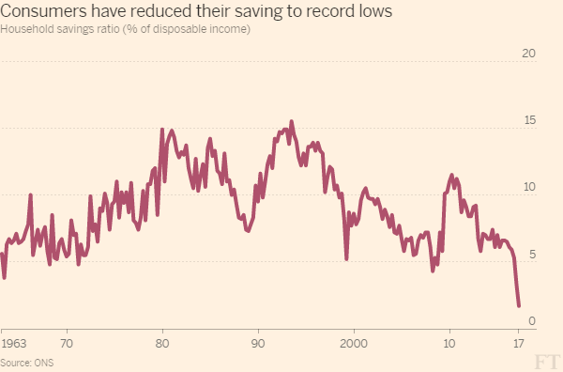
Figure4. Household Savings
The UK economy since the Brexit vote, Chris Giles, 26 July 2017

2.1.2. Tackling UK Driver Shortages
With the average price for obtaining a Category C1 license, the license needed to drive a vehicle between 3,500kg and 7,500kg, ranging from £900 to £1100 (Professional Driver Training, 2017), it is easy to see why there is a shortage in UK LGV drivers. However, in order to tackle the shortage some companies, like LBS, offer to put staff through the training (Harris, 2017). Although doing this puts a cost on the company, it also gives them the assurance of having drivers to use.
There are however, training companies that offer driver training through finance. For example, a company called Specialised HGV offer a two-year payment plan of £29 a month, for people to do their training without the struggle of paying £1000 in a lump sum. They also help their customers find a job after training is complete (HGV Training, 2017).

2.2. Supply Chain Strategies
European companies have been working toward a trade regime, that requires minimal paperwork for over 40 years (Kwasniok, Guarraia and Gartska, 2017; Forbes.com, 2017). However, with Brexit around the corner this “low cost, low friction” system could be flipped upside down. What is being called a ‘hard Brexit’, could potentially damage the profits of UK companies. If the supply chains, that include the UK, get disrupted, the overall profits of five of the main UK manufacturing industries by as much as £3 billion, a loss of around 30% (Kwasniok, Guarraia and Gartska, 2017) (See figure.4). Out of the five industries, the hardest hit is likely to be food, technology and automative, as these are the three industries that would see the biggest effect on profits due to tariffs on imported and exported goods. On its own, the food industry could expect profit drops ranging from £6 billion and £20 billion, although most companies would be likely to increase prices to tackle that potential hit (See figure.5).
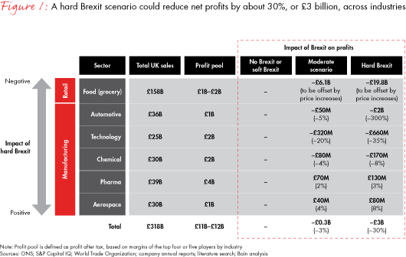
Figure.4 Impact of a Hard Brexit
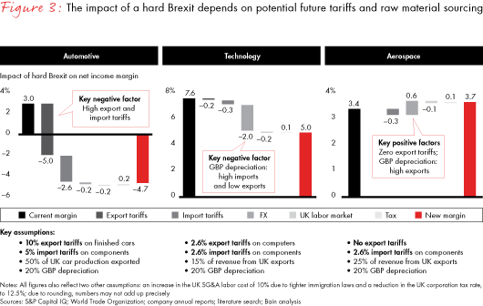
Is Your Supply Chain Ready for Brexit, Bain.com, February 6 2017
Figure.5 Impact of Hard Brexit on Net Income
Is Your Supply Chain Ready for Brexit, Bain.com, February 6 2017
Although they could be possible outcomes, getting prepared for a hard Brexit now might not be the best strategy. With negotiations still underway between the UK and the EU, there is still a possibility of a softer ‘divorce’ between the states. If Britain leaves the EU but remains apart of the single market, then there will be no import or export charges, meaning the price of goods will remain the same and there will be a minimal impact on the net profits for UK industries, and any strategies laid out for a hard Brexit will not work in the companies favour (Kwasniok, Guarraia and Gartska, 2017).
With this ‘double-edged sword’, some companies are too afraid to put forward a strategy, as they do not know the outcome. This however is the most high-risk scenario of them all. Some of the most successful companies made their way by making multiple strategies in the face of uncertainty. Skilled teams of leaders have the ability to lower any negative impact of Brexit, whether it is hard or soft, by implementing a new approach to strategy soon.
Kwasniok, Guarraia and Gartska stated “Management teams that have learned to manage in uncertainty focus on the few risks that matter most. They assess each potential scenario and identify the critical trigger points that signal a swing from one outcome to another—we call these signposts”. According to these three authors, this method can help govern a clear goal of “strategic actions that balance commitment and flexibility”.
According to an article written by Jennifer McKevitt, for supply chain dive, a survey of around 2,100 managers, in the supply chain, exposed that roughly 32% of businesses based in the UK, that are currently trading within the EU, will be replacing European suppliers with British ones. However, when it came to economic strategies, the same survey found that, around 30% of the managers, would plan to lower the supply cost of goods, due to fears that the processes would be less viable after Brexit. Another 29% of managers however, stated that they had to renegotiate supply contracts due the decline in the value of the pound.
2.2.1. Strategies for an uncertain Brexit
Those companies that decide that planning for an uncertain Brexit is the best way forward are probably right, as they will be able to turn their strategies around quicker than those companies that have dedicated themselves to either hard or soft when the final decision is made more clear, making the risk of affecting their supply chain as minimal as possible. Kwasniok, Guarraia and Gartska state that there are four guidelines to help startegise for uncertainty:
- “deﬁne the speciﬁc uncertainties your business might face and their economic impact on your company (absolute and relative);
- formulate a set of probable scenarios and their economic impact;
- devise a speciﬁc set of strategic options; and
- identify a clear set of signposts for action”.
Big companies will use these guidelines to commit to a long-term strategy and enable themselves to make the most of the post-brexit situation as it becomes clear.
One example of a strategy for an uncertain Brexit comes from McLaren. In an article written by Johnathan Ford, for the Financial Times, McLaren say that they are pulling their supply chain out of Europe and back into the UK. Paul Buddin, the chief financial officer for McLaren stated, “Of the nine out of 10 cars that it sells overseas, only two go to Europe. The US is a much more important market for us and tariffs on imported cars there are just 2.5 per cent”. This strategy does impact the supply chain in one way, and that is, McLaren are opening new factories in the UK to make certain parts of their cars, meaning that even in a hard Brexit, cost of parts should not increase any more than expected due to no additional tariffs. With this in mind McLaren can still sell their cars at roughly the same price as before, making annual sales of £649million (Ford, 2017).
3. Conclusion
What does Brexit mean for the UK supply chain and how can companies prepare for minimum negative impact? It is still uncertain how the UK supply chain will be affected by Brexit as there is still no guarantee that it will be soft or hard. However, with this uncertainty having the potential of driving 13% of UK based HGV drivers and 26% of UK based warehouse operatives back into mainland Europe, companies could look towards providing training services in those sectors of logistics. By doing this, it would be easier to maintain the same production levels as they are currently obtaining, decreasing the risk of a major downfall to their net profit margin.
Other UK based companies, may decide, if possible, to minimize their supply chain across Europe and purchase or build factories and warehouses in the UK, to avoid any possible customs tariffs. The potential downfall to this is that European businesses may decide to cut deals with UK suppliers. “46% of EU businesses will seek to use fewer UK suppliers, and over 25% will fully reshore their chains away from the UK” (McKevitt, 2017), meaning a negative economic hit for the UK.
It still seems, in according to research, that the best way to strategise for Brexit, with minimum impact, is to plan for uncertainty. By doing this, a company can rapidly pivot their strategies towards whichever type of Brexit negotiations become finalised, hard or soft.

4.References
BBC News. (2017). Retailers 'need EU workers after Brexit'. (online) Available at: http://www.bbc.co.uk/news/business-41545184 (Accessed 29 Oct. 2017).
Chapman, B. (2017). Why should we care about leaving the EU single market?. (online) The Independent. Available at: http://www.independent.co.uk/news/uk/politics/single-market-brexit-eu-trade-deals-what-is-uk-leave-european-union-why-a7627061.html (Accessed 26 Oct. 2017).
Forbes.com. (2017). Forbes Welcome. (online) Available at: https://www.forbes.com/sites/baininsights/2017/03/30/how-will-brexit-affect-your-supply-chain-infographic/#6e1bec907e11 (Accessed 30 Oct. 2017).
Ford, J. (2017). Profiting from Brexit: McLaren shifts supply chain back to the UK. Financial Times. (online) Available at: https://www.ft.com/content/b3d67800-9475-11e7-bdfa-eda243196c2c (Accessed 30 Oct. 2017).
Fox, J. (2017). How will Brexit impact the European logistics industry? | Logistics | Supply Chain Digital. (online) Supplychaindigital.com. Available at: http://www.supplychaindigital.com/logistics/how-will-brexit-impact-european-logistics-industry (Accessed 26 Oct. 2017).
Giles, C. (2017). The UK economy since the Brexit vote — in 5 charts. (online) Financial Times. Available at: https://www.ft.com/content/cf51e840-7147-11e7-93ff-99f383b09ff9 (Accessed 29 Oct. 2017).
Harris, C. (2017). Driver Shortages in the UK.
HGV Training. (2017). Training Prices - HGV Training. (online) Available at: https://www.hgvtraining.co.uk/hgv-licence-cost/ (Accessed 29 Oct. 2017).
Kwasniok, T., Guarraia, P. and Gartska, M. (2017). Is Your Supply Chain Ready for Brexit?. (online) Bain.com. Available at: http://www.bain.com/publications/articles/is-your-supply-chain-ready-for-brexit.aspx (Accessed 30 Oct. 2017).
Lancefield, D. (2017). Forbes Welcome. (online) Forbes.com. Available at: https://www.forbes.com/sites/strategyand/2016/12/12/how-to-build-a-post-brexit-business-strategy/#37da617e5ed0 (Accessed 29 Oct. 2017).
Lexicon.ft.com. (2017). Logistics Strategy Definition from Financial Times Lexicon. (online) Available at: http://lexicon.ft.com/Term?term=logistics-strategy (Accessed 26 Oct. 2017).
McKevitt, J. (2017). UK, European suppliers consider cutting ties due to Brexit. (online) Supply Chain Dive. Available at: https://www.supplychaindive.com/news/Brexit-supply-chain-effects-CIPS-survey/442752/ (Accessed 31 Oct. 2017).
Oxford Dictionaries | English. (2017). strategy | Definition of strategy in English by Oxford Dictionaries. (online) Available at: https://en.oxforddictionaries.com/definition/strategy (Accessed 26 Oct. 2017).
Professional Driver Training. (2017). HGV Training Prices - Professional Driver Training. (online) Available at: http://www.nolgvbrokers.co.uk/hgv-training-prices/ (Accessed 29 Oct. 2017).
Waters, W. (2017). Logistics ‘under threat from latest UK Brexit proposals’ - Lloyd's Loading List. (online) Lloydsloadinglist.com. Available at: https://www.lloydsloadinglist.com/freight-directory/news/Logistics-%E2%80%98under-threat-from-latest-UK-Brexit-proposals%E2%80%99/70287.htm#.WfYHebp2vIU (Accessed 29 Oct. 2017).

