

Strategic Evaluation of Intel Corporation’s Operations in the South Korean Semiconductor Industry

Student Name: Fabiha Rahman
Student ID: 2506578
Module Name: International Business Concepts

Module Code: LCMB7034

Lecturer’s Name: Jean Wang

Term 2
Submission Date: 27 April 2026

AI use Acknowledgement
I acknowledge the use of multiple artificial intelligence‑assisted tools on various dates between March and April 2026 to support the research, structuring, proofreading, and writing of this assignment. I used the following types of AI tools on multiple topics:

Google NotebookLM https://notebooklm.google/: To summarise uploaded academic papers, industry reports (Statista, Gartner, Deloitte), government policy documents (K-Semiconductor Strategy, K-REACH), and to answer questions based exclusively on my source materials. One example of the prompt: ‘’Based only on the uploaded Porter’s Diamond Model literature, summarise how factor conditions and related industries contribute to South Korea’s semiconductor competitiveness.”
QuillBot https://quillbot.com/ & Grammarly are used for proofreading, grammar checking, and stylistic refinement of the final draft, paraphrasing selected source materials to improve clarity and academic expression.
Consensus https://consensus.app/ : To locate peer‑reviewed studies, literature support for theoretical frameworks (Porter’s Diamond, PESTC, Gibbs’ Reflective Cycle), and evidence‑based conclusions regarding semiconductor industry dynamics and MNC strategy. Example of prompts: “Find recent peer‑reviewed papers on the application of Porter’s Diamond Model to the semiconductor industry in East Asia.”
I confirm that I have not presented any AI-generated text as my own work. All AI‑assisted outputs were critically reviewed, adapted, and integrated into my own analysis. I confirm that I have copies of my drafts, notes, and other resources I used before and after the use of AI tools, which I may be asked to provide in evidence.

Contents
Section 1: Strategic Evaluation 2
1. Introduction 2
2. Industry and Country Overview 2
2.1. The South Korean Semiconductor Landscape 2
2.2. Competitive Landscape (Intel vs. Domestic Rivals) 3
2.3. Strategic Positioning Analysis 4
3. Porter’s Diamond Model Analysis 5
3.1. Porter’s Diamond Model Factors and Application to the Intel’s 5
3.1.1. Factor Conditions 5
3.1.2. Demand Conditions 6
3.1.3. Related and Supporting Industries 6
3.1.4. Firm Strategy, Structure, and Rivalry 6
3.1.5. Role of Government and Chance 7
4. MNC Evaluation: Intel in South Korea 8
4.1. Political Factors 8
4.2. Economic Factors 9
4.3. Cultural Factors 9
4.4. Technological Factors 11
4.5. Legal Factors 11
5. Conclusion 12
SECTION 2: REFLECTIVE ACCOUNT 13
6. Research and Preparation Process (Gibbs Reflective Cycle) 13
6.1. Description 13
6.2. Feelings 13
6.3. Evaluation 14
6.4. Analysis 14
6.5. Conclusion 15
6.6. Action Plan 15
Conclusion 15
Reference List 16

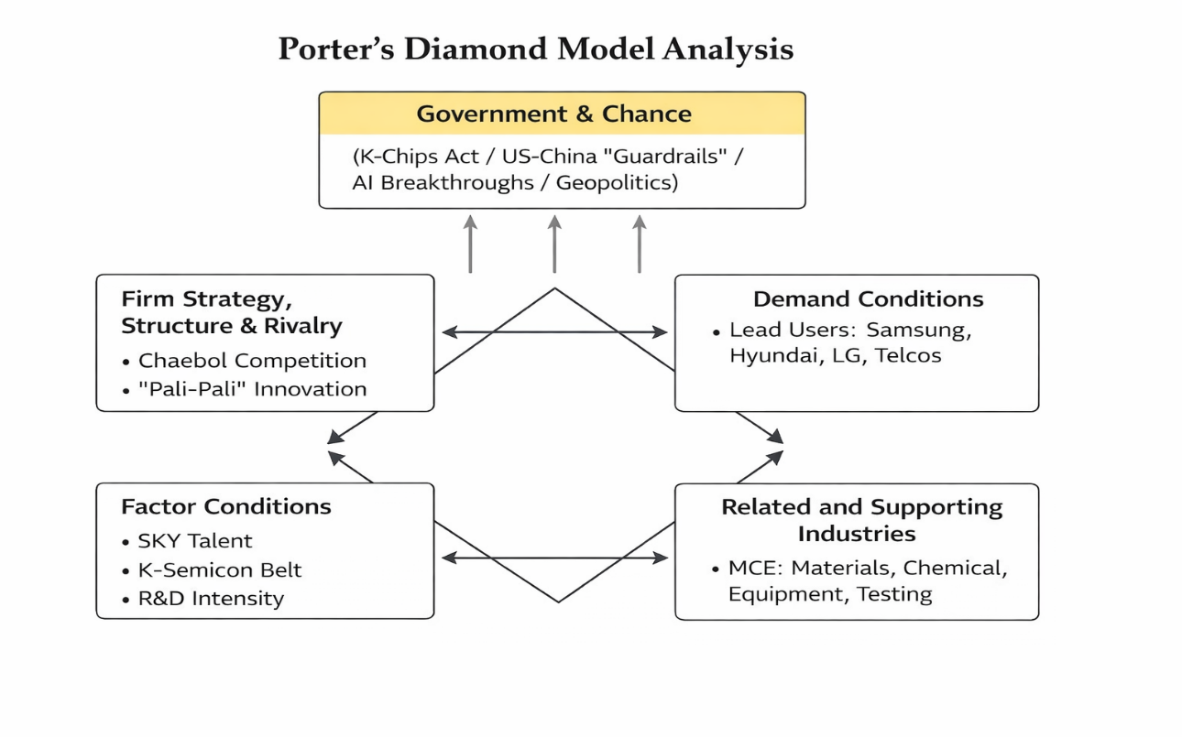
Section 1: Strategic Evaluation

1. Introduction
Intel Corporation has been regarded as a dominant force in global microprocessor design (Intel Corporation, 2023). However, it is currently confronted with a transformative period shaped by its "IDM 2.0" strategy, which was introduced in 2021 to re-establish the company as a top-tier competitor against TSMC and Samsung. Engagement with South Korea is central to this pivot, as the nation has been recognised as the epicentre of the global memory semiconductor market and as an emerging powerhouse in advanced logic foundries (Intel Corporation, 2021). Efforts to reclaim manufacturing leadership have been undertaken by Intel, and South Korea has been positioned both as a critical partner in the high-bandwidth memory (HBM) supply chain and as a formidable competitor in the sub-3nm fabrication race (Intel Corporation, 2021). The secure supply of HBM has become a core element of global AI competition. In this report, a comprehensive strategic evaluation of the South Korean semiconductor industry and of Intel's positioning is presented. Through the application of Porter's Diamond Model (Kotler, 1998), the drivers underpinning South Korea's national advantage are assessed. A detailed framework is also employed to analyse the variables like political, economical, social, legal and cultural which are influencing Intel's operational success. By synthesising industry data with strategic management theory, Intel's future viability is evaluated with in a market characterised by intense domestic rivalry and increasing geopolitical sensitivity (Jurevicius et.al, 2013).

2. Industry and Country Overview

2.1. The South Korean Semiconductor Landscape
Semiconductors are regarded as the vital component of the South Korean economy, and they are relied upon as the primary driver of national industrial policy and global trade. The industry is not merely considered a sector but is protected as a strategic asset by the "K-Semiconductor Strategy," by which the nation's status as a global leader by 2030 is sought to be solidified (CMC Global,2024).
Macroeconomic Contribution: Approximately 19% of South Korea's total exports are represented by semiconductors. In 2023, despite a cyclical downturn in memory prices, between 7% and 10% of the national GDP was contributed by the industry, by which its foundational role in the country's economic stability is illustrated (Kyung,2022).
Market Dominance: A "super-gap" in memory technology is maintained by South Korea, with over 60% of the global market share for Dynamic Random Access Memory (DRAM) and NAND Flash being controlled by the nation (Neves,2026).
The Mega Cluster Initiative: A 622 trillion KRW (approximately $470 billion) investment plan was recently announced by the South Korean government, by which a "Semiconductor Mega Cluster" in southern Gyeonggi Province is intended to be created (Son, J. ,2024). This cluster is projected to be the world's largest, and 37 components, equipment, and manufacturing plants are expected to be housed within it by 2047 (Yonhap News Agency, 2024b).
Export-Led Vulnerability: Due to its heavy reliance on exports—particularly to China, by which roughly 40% of South Korean chip exports is accounted for—the industry is rendered highly susceptible to US-China trade tensions and to global demand shifts in the consumer electronics and data center markets (Heung-Kyu Kim, 2022).

2.2. Competitive Landscape (Multinational vs. Domestic Rivals)
The competitive dynamics in South Korea are characterized by a unique blend of "coopetition." Intel must navigate a landscape where its primary competitors are also its most essential supply chain partners (Samsung-Nvidia, 2025).
The South Korean semiconductor industry is recognized as having a profound influence on the national and global technology landscape. In 2025, semiconductors were reported as accounting for about one-quarter of exports, reaching $173.4 billion and contributing over half of GDP growth (Bank of Korea, 2025). A structural vulnerability has been created due to dependence, with stronger macroeconomic impact from semiconductor downturns noted by authorities (Bank of Korea, 2025). Competition between MNCs and domestic firms is characterized by coopetition where partnership and rivalry are simultaneously maintained. Domestic firms maintain leadership in memory chips, with Samsung holding 36.6% DRAM and 28% NAND, while SK Hynix leads HBM with 62% share (Samsung Electronics, 2025; SK Hynix, 2025). Foundry market dominance has been observed by TSMC at 70.4%, compared with Samsung Foundry at 7.1% (TSMC, 2025). Intel’s South Korean market presence is treated as strategic, with 40% of AI PC processor share being held domestically (Intel, 2025). Intel’s global share has been reduced to about 6%, while SK Hynix has been elevated to the third-largest semiconductor company globally. Interdependence has been observed as domestic firms supply advanced memory while competing simultaneously in logic and foundry services globally. This ecosystem is increasingly being reinforced globally.
A comparison of Intel, Samsung, and SK Hynix is presented in the table based on market focus, strategies, and positioning. Intel’s strength in logic chips is highlighted, while a competitive yet interdependent relationship with dominant memory leaders is emphasized within the semiconductor industry.

Company Name | Market Segment Focus | Core Strategy | Relative Market Positioning
Intel | Logic (CPUs/GPUs), Foundry Services (IFS) | IDM 2.0: Expanding manufacturing capacity for internal and external (Foundry) customers (Intel Corporation, 2023) | Dominant in PC/Server Logic; Challenger in the Foundry space vs. Samsung.
Samsung Electronics | Memory (DRAM/NAND), Foundry, System LSI | Vision 2030: Maintaining memory dominance while investing $150bn to lead in Logic/Foundry (Samsung-Nvidia,2025). | Global Memory leader; #2 global Foundry; primary vertical integration rival.
SK Hynix | Specialized Memory (HBM), NAND Flash | AI First: Focusing on High Bandwidth Memory (HBM) for AI accelerators/GPUs (Yonhap News Agency, 2024). | Secondary Memory leader; dominant in high-margin AI-specific memory solutions.

Table: 01 Competitive Landscape among Intel, Samsung & SK Hynix

2.3. Strategic Positioning Analysis
The strategic positioning of the South Korean semiconductor industry is characterised by established global leadership in memory technologies, an expanding role in advanced logic and foundry services, and exposure to geopolitical and demand-cycle risks. A dominant position in the global memory market is maintained, with over 60% of DRAM and NAND Flash share being controlled by domestic firms, reinforcing a sustained “super-gap” advantage (Neves, 2026). This position has been strengthened through continuous capital investment and government-supported R&D initiatives, including the K-Semiconductor Strategy (CMC Global, 2024). Furthermore, a strategic shift toward artificial intelligence and high-bandwidth memory applications has been observed, with leadership in HBM being established by SK Hynix (Samsung-Nvidia & SK Hynix, 2025). However, export dependency on China has been identified as a critical vulnerability, increasing exposure to geopolitical tensions (Heung-Kyu Kim, 2022; Yonhap News Agency, 2024b).

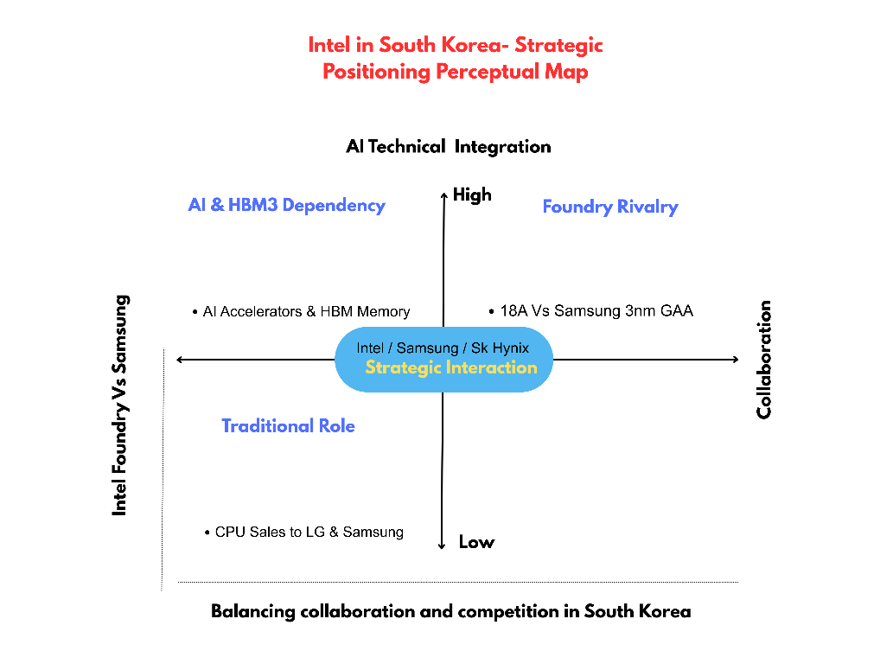

Fig: 01 Strategic Positioning analysis for Intel in South Korea

3. Porter’s Diamond Model Analysis
A strategic framework has been developed to explain sustained national competitive advantage in specific industries. Unlike traditional theories, advantage is argued to be created through four determinants: factor conditions, demand conditions, related industries, and firm rivalry, influenced by government and chance (Porter, 1990).

3.1. Porter’s Diamond Model Factors and Application to the Semiconductor Industry in South Korea
Porter’s Diamond Model was applied to systematically evaluate South Korea’s semiconductor competitiveness, whereby national advantage was explained through factor conditions, demand conditions, related industries, and firm rivalry (Porter, 1990). The influence of government and chance was also considered, and ecosystem-specific dynamics were analysed (Kotler, 1998; Intel Corporation, 2021).

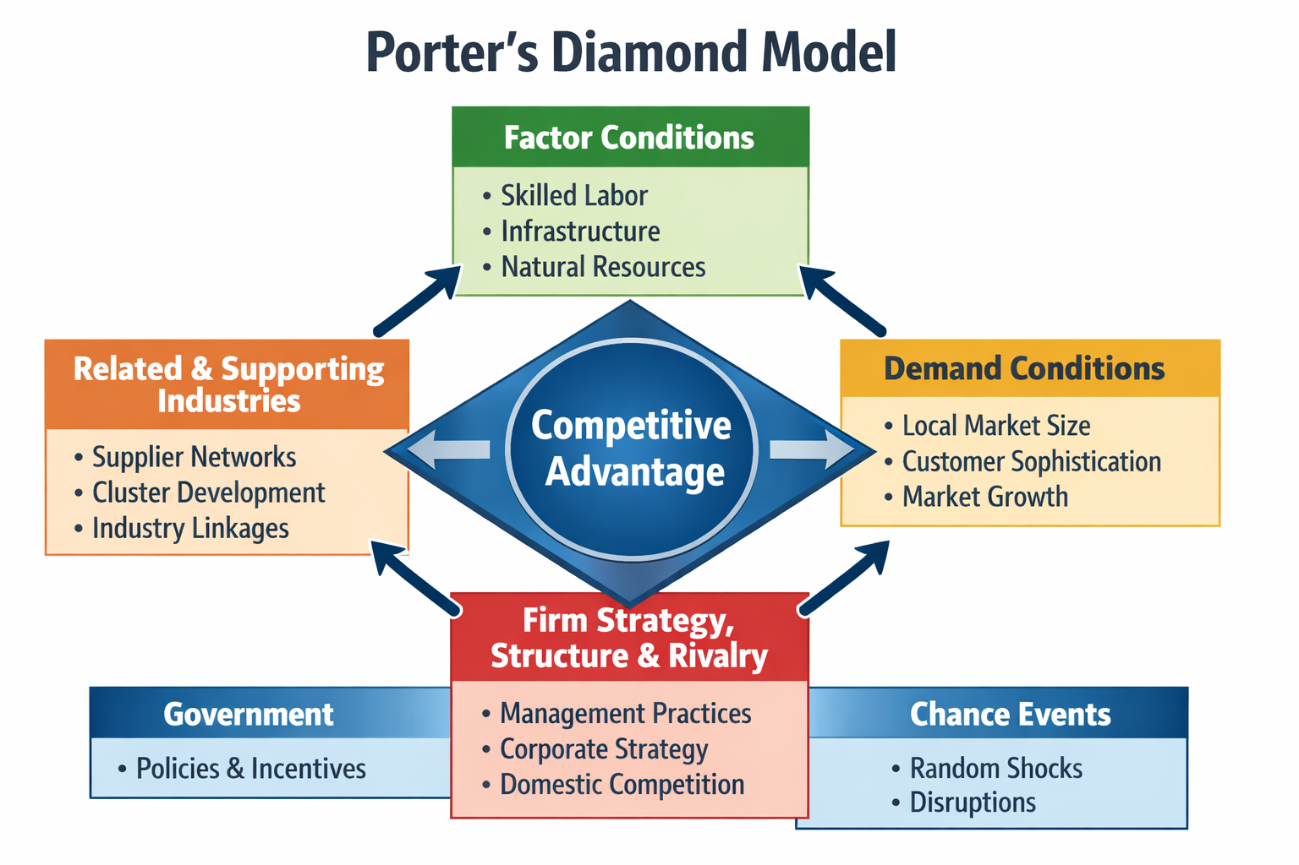

Fig: 02 Poter’s Diamond Model analysis for Semiconductor Industry in South Korea

3.1.1. Factor Conditions
The availability of skilled labour, infrastructure, and technological resources is regarded as central to competitive advantage in semiconductor production. Greater importance is attributed to advanced and specialised factors than to basic endowments for sustaining long-term competitiveness. In South Korea, highly advanced factor conditions are demonstrated within the semiconductor industry. A substantial pool of semiconductor engineering talent is developed through “SKY” universities, while government-funded programmes have been introduced to address a projected shortage of 30,000 engineers (Intel Corporation, 2021; Hwang et al., 2025). Additionally, world-class infrastructure has been provided through the K-Semiconductor Belt, by which fabrication efficiency is enhanced and operational constraints are reduced (The Korean Times, 2021). Consequently, innovation capacity is strengthened and global competitiveness is reinforced.

3.1.2. Demand Conditions
The nature of home-market demand in the semiconductor sector is characterised by the presence of highly sophisticated domestic buyers, by whom continuous innovation and superior product quality are required (Kim, 2022). In South Korea, the existence of “lead users” is identified as a defining industry feature. Major conglomerates such as Samsung Electronics, Hyundai, and LG are recognised as advanced benchmark setters, by whom cutting-edge and energy-efficient semiconductor components are demanded (Porter, 1990). The South Korean semiconductor market is estimated to have been generated at USD 124.83 billion in 2025 and is projected to be increased to USD 267.01 billion by 2035 (Statista, 2025). Furthermore, through the early commercialisation of 5G technology, a high-bandwidth environment was established, by which demand for advanced processors was significantly stimulated (OECD, 2023). As a result, sustained pressure for innovation and rapid technological upgrading is continuously exerted.

3.1.3. Related and Supporting Industries
The presence of internationally competitive supplier industries and related sectors is recognised as a key determinant of national advantage in semiconductors. Greater efficiency, speed, and innovation are facilitated through proximity to advanced suppliers, as close collaboration is enabled within integrated ecosystems. In South Korea, a robust and localised supply chain for semiconductor materials, components, and equipment (MCE) has been strategically developed (Ou et al., 2024). Following the Japan–South Korea trade dispute, industrial clustering was accelerated, through which lead times were reduced and innovation costs were lowered via agglomeration economies (Zhang et al., 2024; Moon, 2016).

3.1.4. Firm Strategy, Structure, and Rivalry
The conditions under which semiconductor firms are established, organised, and managed, as well as the intensity of domestic competition, are defined by this factor. Intense rivalry is recognised as a key driver of innovation and sustained competitiveness, as continuous improvement is enforced (Philip Kotler, 1997). In South Korea, a distinctive competitive environment is created by the chaebol structure, where rivalry between Samsung Electronics and SK Hynix is intensified, particularly in memory semiconductors (OECD, 2025). Technological advancement is accelerated through persistent competition, especially in DRAM, NAND, and HBM. A rapid “pali-pali” culture is fostered, through which speed, efficiency, and large-scale investment are prioritised (Lee, 2024).

3.1.5. Role of Government and Chance
Government and chance events are identified as exogenous influences capable of reshaping the determinants of national competitive advantage in semiconductors. Government intervention is characterised as a catalytic force through the implementation of policies, strategic investment, and regulatory frameworks. In South Korea, the “K-Semiconductor Strategy” and the 622 trillion KRW “Semiconductor Mega Cluster” initiative have been introduced to strengthen factor conditions and supporting industries (CMC Global, 2024; Yonhap News Agency, 2024b). Furthermore, chance events, such as the 2019 Japan–South Korea trade dispute, have been observed to accelerate domestic supply chain development, through which external shocks have been transformed into sustained competitive advantages.

4. MNC Evaluation: Intel in South Korea
A Multinational Corporation (MNC) is defined as a company by which operations are conducted across multiple countries, where production, investments, and business activities are managed within global markets while adaptation to diverse economic, political, and cultural environments is achieved. An MNC evaluation is conducted to assess how Intel’s operations in South Korea are influenced by external factors, including political, economic, cultural, technological, and legal environments, through which strategy, performance, and long-term competitiveness are shaped.

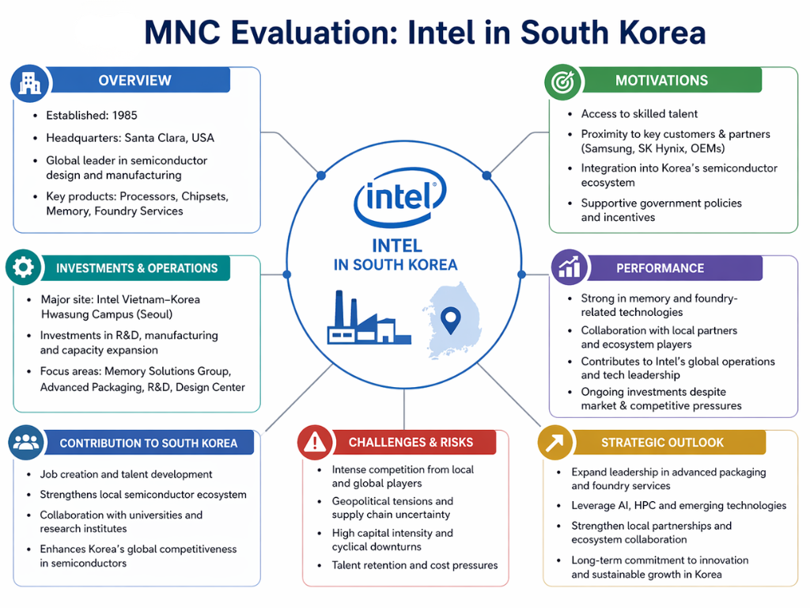

Fig: 03 MNC Evaluation of Intel in South Korea

4.1. Political Factors
Intel's political environment has been shaped by the South Korean K‑Chips Act and the US‑led Chip 4 Alliance (Ha & Lee, 2025). A strategic “sweet spot” regarding subsidies has been found to be occupied by Intel; however, US “guardrail” rules have been imposed, by which Samsung and SK Hynix are restricted from expanding advanced capacity in China (PwC Korea, 2026). Additional complexity has been added by South Korea’s balanced diplomacy with China (Kim, 2021). Partial success has been achieved: tax incentives have been benefited from, but vulnerability to US‑China trade tensions remains a significant operational challenge (Hwang & Yoon, 2025).
A key strength has been identified in access to R&D tax credits under the K‑Chips Act, by which operational costs are reduced (PwC Korea, 2026). However, high exposure to geopolitical friction has been observed as a weakness, by which component supply from Samsung and SK Hynix may be disrupted (Yoon, 2023). Diversification of memory suppliers beyond Samsung and SK Hynix is recommended, and strengthened government relations with proactive policy monitoring should be implemented (CSIS, 2024; Wei & Xiong, 2023).

4.2. Economic Factors
Currency translation risk has been faced by Intel due to Korean Won volatility against the USD (Park et al., 2013). A weak Won makes local operations cheaper but raises prices for imported processors, potentially reducing demand; South Korea’s export‑led growth and cyclical “Silicon Cycle” also affect the total addressable market (The Diplomat, 2025). Counter‑cyclical stability has been provided by the government’s 622 trillion KRW AI infrastructure investment, from which steady demand is supported (Ministry of Science and ICT, 2025). Moderate success has been observed: AI infrastructure investments have been leveraged, yet currency fluctuations remain persistent threats (Lee, 2024).
A strength in counter‑cyclical stability has been demonstrated by South Korea’s massive AI infrastructure investment, supporting steady demand (Ministry of Science and ICT, 2025). However, exposure to KRW volatility has been identified as a weakness, by which price competitiveness against local logic designers may be eroded (Park et al., 2013). Natural hedging is recommended through increased local sourcing and production in South Korea, and flexible pricing models linked to exchange rate movements should be adopted (Atkinson, 2025).

4.3. Cultural Factors
South Korea’s “Pali‑Pali” (hurry‑hurry) culture and hierarchical corporate structures have been recognised as defining characteristics (De Mente, 2014). Faster, more localised decision‑making has been enabled by Intel at its Korea branch, yet slower consensus‑driven processes have been observed as a weakness (Choi et al., 2023). Partial success has been achieved: young talent is attracted through reduced hierarchy and better work‑life balance, but the pace of decision‑making still lags behind local “Pali‑Pali” norms (OECD, 2025).
A cultural strength has been reflected in Intel’s ability to attract engineers by offering a less hierarchical, more flexible work environment compared to chaebols (Hofstede, 2001). However, slower consensus‑driven decision‑making has been identified as a weakness, struggling to match South Korea’s rapid innovation cycles (Lee, 2024). Greater local autonomy is recommended to be granted to Intel Korea for time‑sensitive decisions, and agile project management methodologies should be adopted, with cultural liaisons embedded within global teams (Choi et al., 2023). The hierarchical nature of corporate structures within South Korea also influences business interactions, where respect for authority, seniority, and structured decision-making processes are emphasised. Therefore, adaptation to these cultural norms is required by Intel to ensure effective collaboration and relationship management within the local business environment (Hofstede, 2001).
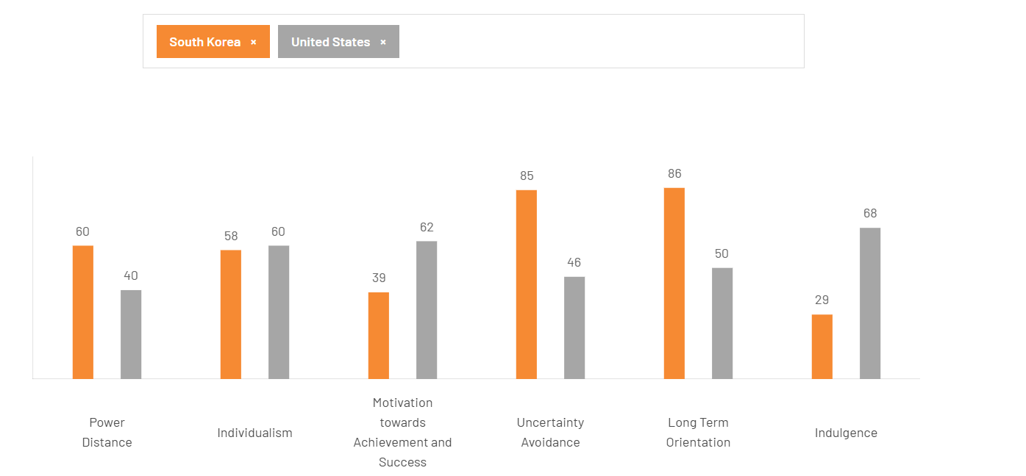

Fig: 04 Hofstede cultural dimension analysis between USA & South Korea
Cultural differences between South Korea and the United States are reflected across Hofstede’s dimensions. Higher power distance is observed in South Korea (60) than in the US (40), while individualism is lower (58 vs. 60) (Hofstede, 2001). Greater emphasis on achievement is shown in the US (62) compared to South Korea (39). However, stronger uncertainty avoidance (85 vs. 46) and long-term orientation (86 vs. 50) are demonstrated by South Korea, whereas indulgence is lower (29 vs. 68), indicating a more restrained culture (Hofstede, 2001).

4.4. Technological Factors
The technological landscape has been dominated by the race for sub‑3nm process technology, by the adoption of Extreme Ultraviolet (EUV) lithography, and by the integration of High Bandwidth Memory (HBM) into AI logic (Uh, Kim et al., 2024). A technological race has been engaged in by Intel and Samsung for the implementation of the “18A” (1.8nm) node. While a leading position in backside power delivery (PowerVia) has been claimed by Intel, the first commercialization of Gate‑All‑Around (GAA) transistors was accomplished by Samsung (Uh, Kim et al., 2024). Intel’s success in South Korea has been tied to “technological interoperability” (Choi, Chung & Cho, 2023). Intel’s South Korean R&D centers have been described as “co‑engineering” hubs, where through‑silicon via (TSV) technology and advanced packaging standards (EMIB, Foveros) are collaboratively developed, by which Intel’s logic tiles are enabled to be stacked with South Korean memory tiles (MIST, 2025; Lee, J., 2024). Moderate success has been achieved: advanced PowerVia and co‑engineering R&D hubs have been established, and technological synergy with Samsung and SK Hynix has been maintained. However, dependence on domestic rivals for HBM integration has remained a persistent risk, and it has been warned that any failure to maintain interoperability could lock Intel out of the future AI data center market in Asia (Choi, Chung & Cho, 2023).
A technological strength has been represented by advanced PowerVia technology and dedicated co‑engineering R&D hubs in South Korea, through which close collaboration on TSV and advanced packaging has been facilitated. However, high dependence on Samsung and SK Hynix for HBM3e and HBM4 memory integration has been identified as a weakness, creating lock‑out risks if South Korean firms develop native ARM‑based logic processors that are more tightly integrated with their own memory (Choi, Chung & Cho, 2023). It is recommended that dependency be reduced through in‑house HBM development or through strategic partnerships with alternative memory suppliers (Intel Corporation, 2023). Furthermore, the standardisation of interoperability interfaces should be accelerated, by which architectural neutrality can be maintained and lock‑out from the Asian AI data center market can be prevented.

4.5. Legal Factors
Robust intellectual property protection has been provided by South Korea, by which Intel’s high‑value R&D is secured (MIST, 2025). However, significant operational burdens have been posed by environmental regulations under K‑REACH, requiring rigorous registration and testing of chemicals, often slower than US standards (K‑REACH, 2025). Evolving labour laws such as: the 52‑hour work week; also limit operational flexibility for 24/7 fab operations (Korea Herald, 2025). Partial success has been achieved: IP protection is a clear advantage, but K‑REACH compliance creates operational delays affecting manufacturing timelines (Yoon & J., 2023).

A key legal strength has been provided by the strong IP legal framework, through which Intel’s R&D investments are safeguarded and local innovation is encouraged (UNFCC, 2020). However, K‑REACH regulatory delays have been identified as a weakness, increasing time‑to‑market for new manufacturing processes (K‑REACH, 2025). A dedicated local regulatory compliance team is recommended to be established for proactive work with Korea’s Ministry of Environment, and investment in green chemistry alternatives should be made to simplify registration and align with long‑term net‑zero targets (Yoon & J., 2023).

5. Conclusion
The South Korean semiconductor industry is characterised as a high-stakes, high-reward environment that is regarded as indispensable to Intel’s “IDM 2.0” transformation strategy. Through the application of Porter’s Diamond Model, a strong national competitive advantage is observed to be created by coordinated government policy, advanced infrastructure, and highly specialised human capital (Kotler, 1997; OECD, 2025). A government-led semiconductor mega-cluster strategy, a concentrated “SKY” university talent pool, and a sophisticated lead-user demand environment are collectively recognised as forming one of the world’s most efficient ecosystems for semiconductor production and integration (Korean Times, 2021).
For Intel, a relationship of asymmetric interdependence is increasingly identified, in which continued leadership in logic processors is maintained while growing reliance on Samsung Electronics and SK hynix for advanced memory, packaging, and AI-related technologies is being observed (Samsung-Nvidia & SK Hynix, 2025). Furthermore, strategic performance is understood to be shaped by political tensions involving China, currency volatility in the Korean won, rapid innovation expectations, the global sub-3nm technology race, and compliance obligations under environmental and chemical regulations such as K-REACH (Deloitte, 2026).

Final Judgment: Intel’s future viability in South Korea is considered to be secure, provided that a strategic transition from a traditional seller role to a collaborative co-innovator model is sustained. Direct dominance over Samsung in the memory segment is not expected to be achieved, nor is displacement of Samsung’s strong domestic foundry position considered likely, given its established technological leadership and market share (OECD, 2025). Instead, competitive advantage is anticipated to be realised through positioning as a preferred logic and innovation partner supporting national priorities in artificial intelligence and automotive semiconductors. Although the risks associated with coopetition are recognised, continued presence in South Korea is widely regarded as strategically essential for global competitiveness (Deloitte, 2026).

SECTION 2: REFLECTIVE ACCOUNT

6. Research and Preparation Process (Gibbs Reflective Cycle)
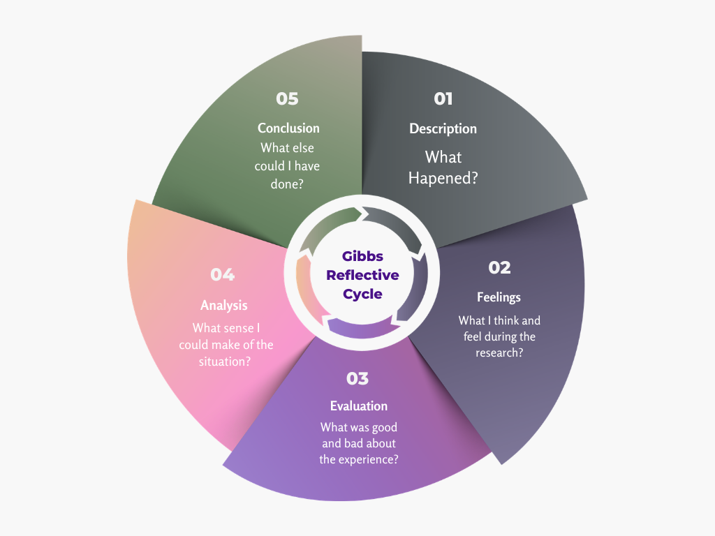

Fig: 04 Gibbs Reflective Cycle Analysis (Self-analyzed – designed with canva)

6.1. Description
The objective of this assignment was defined as the production of a Level 7 strategic management report in which Intel’s operations within the South Korean semiconductor industry were systematically evaluated. The research process was structured into three distinct phases, namely initial secondary data collection, framework application, and critical synthesis. Quantitative indicators relating to South Korea’s gross domestic product and export performance were collected from recognised industry databases, including Statista and Gartner (Statista, 2025; Gartner, 2023). In addition, official policy documentation issued by the Ministry of Trade, Industry and Energy was reviewed to interpret the national K-Semiconductor Strategy (Yonhap News Agency, 2024). Subsequently, Porter’s Diamond Model and the PESTC framework were applied to the compiled evidence to ensure structured strategic analysis (Kotler,1997).

6.2. Feelings
At the beginning of the research phase, a significant sense of intellectual intimidation was experienced due to the opaque and technically complex nature of the semiconductor industry, where advanced concepts such as backside power delivery and HBM3e integration are frequently discussed (Intel Corporation, 2023; Samsung Electronics, 2023). Concerns were initially held that the analysis might remain overly high-level and fail to align with the expectations of a Senior Strategic Consultant perspective. However, greater confidence was developed as academic literature was systematically cross-referenced with corporate disclosures and sustainability reports. The structured framework of the Gibbs Reflective Cycle was subsequently utilised to manage early uncertainty by dividing the research process into clear reflective stages, thereby enabling a stronger emphasis to be placed on synthesis rather than simple data accumulation (Gibbs, 1988).

6.3. Evaluation
The most successful aspect of this analysis was the triangulation of multiple data sources, through which government projections were systematically compared with independent market analyses to enhance analytical reliability and validity. By contrasting the South Korean government’s optimistic semiconductor “mega cluster” projections with more cautious forecasts produced by international research organisations such as Gartner, a more critical and nuanced narrative was developed (Gartner, 2024; Yonhap News Agency, 2024). A significant methodological challenge was created by the information lag commonly associated with secondary data, particularly as national budget figures were being revised in real time during the research period. This limitation was managed by prioritising the most recent official press releases from key institutions such as MOTIE and the Bank of Korea, which are widely recognised as authoritative economic sources (Bank of Korea, 2024).

6.4. Analysis
A research methodology aligned with Level 7 standards was designed, in which emphasis was placed on critical evaluation rather than description. In Section 4, strategic implications of regulations such as K-REACH for Intel’s capital expenditure and time-to-market were analysed. Alignment with advanced cognitive skill requirements, including systematic and creative problem-solving, was thereby demonstrated (Moon, 2013; Biggs et.al, 2013).
A limitation in the methodology was identified in the reliance on secondary data sources. Potential risks to validity and reliability were acknowledged, particularly due to possible marketing bias within industry reports and corporate disclosures (Yin, 2018). To mitigate this, contradictory evidence on yield rates and node delays was examined to maintain objectivity. It is recognised that greater analytical depth, especially regarding social and cultural factors, could have been achieved through primary data, such as executive interviews (Saunders et al., 2019).

6.5. Conclusion
In conclusion, the research process was conceptualised as a rigorous exercise in “strategic synthesis,” through which complex theoretical frameworks were applied to a dynamic high-technology industry. It was determined that the value of advanced analytical reports lies not in raw data, but in the interpretation of strategic implications, such as the impact of export performance on long-term regional viability (Kotler, 1997). However, limitations in early-stage data filtering were identified, as excessive attention was allocated to technical details with limited relevance. It is recommended that future research be guided by a strategic relevance filter to enhance analytical efficiency (Saunders et al., 2019).

6.6. Action Plan
For future modules, a more structured and systematic approach will be adopted to enhance research effectiveness and academic rigor. Advanced Boolean search techniques will be utilised within academic databases to retrieve more targeted and relevant scholarly sources. Greater emphasis will be placed on the early use of reputable industry databases to obtain high-quality data on market dynamics and competitive positioning. An iterative, framework-first drafting approach will be implemented to ensure clarity, coherence, and sustained critical evaluation throughout the analysis. Additionally, consistent reference to foundational theoretical models will be maintained in order to preserve an appropriate academic tone across all sections of the work (Gibbs, 1988).

Conclusion
In conclusion, South Korea’s semiconductor ecosystem is identified as indispensable to Intel’s IDM 2.0 transformation. A strong national competitive advantage is observed through coordinated policies, advanced infrastructure, and intense rivalry. Future viability is considered secure if co-innovation is sustained. Direct dominance over Samsung is not expected; instead, positioning as a preferred logic partner is recommended, and continued presence is regarded as strategically essential despite coopetition risks.

Reference List
Kyung, Heekwon and Lee, Jun (2026). Changes in Semiconductor Geopolitics and the Way Forward for Korea. Korea Institute for Industrial Economics and Trade Research Paper.
Deloitte, (2026). Global Semiconductor Industry Outlook. London: Deloitte Insights. Available at: https://www.deloitte.com/us/en/insights/industry/technology/technology-media-telecom-outlooks/semiconductor-industry-outlook (Accessed 8 April 2026).
Neves, M.S., (2026) Technology geoeconomics and geopolitics: The case of South Korea. In The Geopolitics and Geoeconomics of Technology (pp. 52-62).
Bank of Korea (2024) Economic Statistics and Press Releases. Seoul: Bank of Korea. Available at: https://www.bok.or.kr/eng/stats/statsPublictSchdul/listKnd.do?menuNo=400360 (Accessed 8 April 2026)
Biggs, J., Tang, C. and Kennedy, G., 2022. Teaching for quality learning at university 5e. McGraw-hill education (UK).
Son, J. (2024) 'Yoon throws full weight behind W622tr chip cluster plan', The Korea Herald. Available at: https://www.koreaherald.com/article/3303731 (Accessed: 6 April 2026).
Yonhap News Agency (2024b) 'S. Korea unveils plan to build 'semiconductor mega cluster' by 2047. Available at: https://en.yna.co.kr/view/AEN20240115004800315 (Accessed: 6 April 2026).
Porter, M.E. (1990) The Competitive Advantage of Nations
Gibbs, G, (1988). Learning by Doing: A Guide to Teaching and Learning Methods. Oxford: Oxford Polytechnic.
Hofstede, G. (2001). Culture’s Consequences: Comparing Values, Behaviors, Institutions and Organizations Across Nations. 2nd ed. Sage Publications.
Heung-Kyu Kim, 2022. South Korea’s Strategic Dilemma Amid US-China Competition. Available at: https://www.stimson.org/2022/south-koreas-strategic-dilemma-amid-us-china-competition. (Accessed: 06 April 2026)
Samsung-Nvidia, SK hynix-Intel partnerships open new fronts in chip rivalry (2025) Korea JoongAng Daily, 19 December. Available at: https://koreajoongangdaily.joins.com/news/2025-12-19/business/tech/SamsungNvidia-SK-hynixIntel-partnerships-open-new-fronts-in-chip-rivalry/2481331 (Accessed: 6 April 2026).
Statista, (2025). Real gross domestic product (GDP) of South Korea in 2024, by industry. Hamburg: Statista. Available at: https://www.statista.com/statistics/1200219/south-korea-gdp-by-sector (Accessed 8 April 2026)
Samsung Electronics (2023) Samsung Sustainability Report 2023. Suwon: Samsung Electronics. Available at: https://www.samsung.com/global/sustainability/media/pdf/Samsung_Electronics_Sustainability_Report_2023_ENG.pdf (Accessed 8 April 2026)
Saunders, M.N.K., Lewis, P. and Thornhill, A. (2019) Research Methods for Business Students. 8th Edition, Pearson, New York
Intel Corporation (2021) 'Intel CEO Pat Gelsinger Announces "IDM 2.0" Strategy for Manufacturing, Innovation and Product Leadership', Intel Newsroom, 23 March. Available at: https://www.intel.com/content/www/us/en/newsroom/news/idm-manufacturing-innovation-product-leadership.html (Accessed: 6 April 2026).
Intel Corporation (2023). 'Intel Provides Update on Internal Foundry Model', Intel Newsroom, 21 June. Available at: https://newsroom.intel.com/corporate/intel-provides-update-on-internal-foundry-model (Accessed: 6 April 2026).
Intel Corporation (2026). CES 2026: Intel Core Ultra Series 3 Debuts as First Built on Intel 18A. Available at: https://www.intc.com/news-events/press-releases/detail/1757/ces-2026-intel-core-ultra-series-3-debuts-as-first-built (Accessed: 6 April 2026
Jurevicius, O., 2013. PEST & PESTLE analysis. Strategic management insight, 13, p.2013.
Kotler, P. (1997). Marketing Management: Analysis, Planning, Implementation, and Control. International Series in Marketing.
CMC Global (2024) 'South Korea's AI Semiconductor Aspirations: Challenges and Possibilities', Available at: https://cmc-apac.sg/it-insights/south-koreas-ai-semiconductor-aspirations-challenges-and-possibilities/ (Accessed: 6 April 2026).
Lee, M., (2024) Accessing the Threat: Chinese and South Korean Memory Chip Sector. Stanford University Libraries. Stanford Digital Repository. Available at: https://purl.stanford.edu/dj267ty3434 (Accessed: 6 April 2026).
Moon, H.-C. (2016) “The Strategy for Korea's Economic Success.” Oxford University Press. doi: 10.1093/ACPROF:OSO/9780190228798.001.0001.
Moon, J.A., 2013. Reflection in learning and professional development: Theory and practice. Routledge.
Hwang, Y. and Yoon, H., (2025). South Korea’s Policy Developments in the Semiconductor Industry. In Technology Rivalry Between the USA and China (pp. 207-223). Cham: Springer Nature Switzerland.
Rizi, A.D., Roy, A., Noor, R., Kang, H., Varshney, N., Jacob, K., Rivera-Jimenez, S., Edwards, N., Sorger, V.J., Dalir, H. and Asadizanjani, N., 2023. From talent shortage to workforce excellence in the chips act era: Harnessing industry 4.0 paradigms for a sustainable future in domestic chip production.
The Korean Times, (2021). Korea to create world's largest chip manufacturing complex. News available at: https://www.koreatimes.co.kr/business/tech-science/20210513/korea-to-create-worlds-largest-chip-manufacturing-complex (Accessed: 7 April 2026).
The Columbus Dispatch, 2025. Amid Intel delays, state lawmakers call for public updates and fiscal accounting. https://eu.dispatch.com/story/news/2025/08/14/intel-ohio-factory-chips-delays-lawmakers-public-updates/85657944007/ (Accessed: 7 April 2026).
Ministry of Science and ICT (MSIT), (2025). ﻿MSIT Accelerates Future Growth with a Transition to a Pioneering R&D System. 2026 R&D investment blueprint: AI‑driven innovation and national growth. Government of the Republic of Korea. Available at: https://www.msit.go.kr/eng/bbs/view (Accessed 7 April 2026).
Hong, P., Hwang, D., Park, Y.S. and Coelho Martins Ferreira, F., (2026). Benchmarking national semiconductor strategies: advancing innovation systems and policy learning for global competitiveness. Benchmarking: An International Journal, pp.1-27.
Von Hippel, E., (1986). Lead users: a source of novel product concepts. Management science, 32(7), pp.791-805.
Ju-min Park, (2019). S.Korea first to roll out 5G services, beating U.S. and China. Reuters. Available at: https://www.reuters.com/article/business/skorea-first-to-roll-out-5g-services-beating-us-and-china (Accessed: 7 April 2026)
Ou, Suhua & Yang, Qingshan & Liu, Jian. (2024). The global production pattern of the semiconductor industry: an empirical research based on trade network. Humanities and Social Sciences Communications. 11. 10.1057/s41599-024-03253-5.
Ou, J., Zheng, Z., Ou, X. and Zhang, N., 2024. Smart city construction, artificial intelligence development, and the quality of export products: A study based on micro-level data of Chinese enterprises. Sustainability, 16(19), p.8640.
Choi, H., Chung, C.S. and Cho, Y., (2023). Changes in planning approach: a comparative study of digital government policies in South Korea and Denmark. European Planning Studies, 31(5), pp.905-924.
OECD Digital Government Studies, (2025). Digital Government Review of Korea. Harnessing Digital and Data to Transform Government, OECD Digital Government Studies, OECD Publishing, Paris, https://doi.org/10.1787/9defc197-en.
Ha, B. and Lee, T.C., (2025). The Chip 4 Alliance and Technological Geopolitics: Taiwan and South Korea’s Economic Security Responses.21(3), pp.79-117.
Yoon, J., (2023). Supply chain security in the age of techno-geopolitics:‘Fab 4’case in the semiconductor industry.
Yin, R.K. (2018) Case Study Research and Applications. Sage Publications.
Kim, Min-hyung. (2021). Hedging between the United States and China? South Korea’s ideology-driven behavior and its implications for national security. International Relations of the Asia-Pacific. 23. 10.1093/irap/lcab020.
PwC Korea,(2026). Republic of Korea Corporate - Tax credits and incentives. Available at: https://taxsummaries.pwc.com/republic-of-korea/corporate/tax-credits-and-incentives (Accessed: 07 April 2026)
CSIS (Center for Strategic and International Studies), (2024). Transatlantic Cooperation on Semiconductors and AI in 2024. Available at: https://www.csis.org/analysis/transatlantic-cooperation-semiconductors-and-ai-2024 . (Accessed: 07 April 2026)
Wei Xiong,David D. Wu &Jeff H. Y. Yeung. Semiconductor supply chain resilience and disruption: insights, mitigation, and future directions. Pages 3442-3465.
Atkinson, R. D. (2025). Korea’s $700b export record Is an achievement, not a growth strategy. Available at: https://itif.org/publications/2025/12/25/korea-s-usd700b-export-record-is-an-achievement-not-a-growth-strategy/ (Accessed 07 April 2026)
Park,Young Ryeol,Song,Sangcheol,Rhee, Eun Kyoung,(2013). Do multinational corporations flexibly respond to exchange rate fluctuations? A tale of two Korean MNCs. Journal of Asia Business Studies.7.262-277.
Park, J.-m. (2019). South Korea launches world’s first 5G networks. Reuters.
The Diplomat. (2025). South Korea’s semiconductor dependence is becoming a structural economic risk. Available at: https://thediplomat.com/2025/11/south-koreas-semiconductor-dependence-is-becoming-a-structural-economic-risk/ (Accessed 07 April 2026)
De Mente, B.L., 2014. Korean way in business: Understanding and dealing with the South Koreans in business. Tuttle Publishing.
Lee, J., 2024. The role of institutional logics in shaping sustainable talent management: A comparative study of two south korean conglomerates. Systems, 12(7), p.227.
Uh, S., Kim, D., Park, D., Son, S., Kim, J. and Kim, I., (2024). Sub-3nm gate-all-around process incoming control and application of advanced EUV overlay strategy enhancing productivity. In Optical and EUV Nanolithography.
K-REACH. (2025). Act on Registration and Evaluation of Chemical Substances (K-REACH). Korean Ministry of Environment. Available at: https://www.cirs-group.com/en/chemicals/south-korea-updates-k-reach-regulations-easing-notification-requirements-for-new-chemical-substances (Accessed 8 April 2026).
Korea Herald. (2025). Labor ministry revisits 52-hour work week exceptions for semiconductor sector. Available at: https://www.koreaherald.com/article/10700319 (Accessed 8 April 2026).
UNFCC- United Nations Climate Change, (2020). 2050 Carbon Neutral Strategy of the Republic of Korea. Available at: https://unfccc.int/documents/267683 (Accessed 8 April 2026)
Von Hippel, E. (1986). Lead Users: A Source of Novel Product Concepts. Management Science, 32, 791-805.
https://doi.org/10.1287/mnsc.32.7.791
Zhang, Y., et al, (2024). Relevant industry analysis details

