

Module Name: Well-being, care and healthy living
Module Code: (ECEY5009/C)
Student ID: 2400171
Module Leader Paul Darby

Health, Well-being and Lifestyles in Early Childhood
Application to Early Years Practice
Early years practitioners have a key role to play in promoting health, well-being and healthy lifestyles. Having safe, inclusive and nurturing environments, practitioners support the holistic development of children. This includes offering balanced meals, encouraging physical activity, supporting emotional expression and encouraging positive relationships.
Practitioners are also role models of healthful behaviours, and they work in partnership with parents and caregivers. Sharing information, offering guidance and signposting support services is helpful to ensure that there is consistency between home and early years settings. Frameworks such as the Early Years Foundation Stage (EYFS) emphasise on safeguarding, well-being and healthy development.
Observation and assessment help practitioners to identify children who may need additional support so they can be helped in the early stages before their challenges become more serious. Inclusive practice is a way of ensuring that all children, regardless of their background or ability, have the same opportunities to succeed (Bright, 2025).






Understanding Health
Health is a complex, multidimensional concept that is not limited to physical functioning. The World Health Organization (2025), defines health as a state of complete physical, mental and social well-being, and not merely the absence of disease or illness. This definition emphasises the need to consider different aspects of health and acknowledge that people can live with long-term conditions and be healthy as long as they feel supported, capable and included socially. Physical health is in fact defined as the effective functioning of the body and its systems. It is affected by such factors as nutrition, physical activity, sleep, hygiene and access to healthcare services. Adequate nutrition helps in growth, immune function and brain development whereas regular physical activity aids in cardiovascular health, muscle strength and fitness. Sleep is also necessary to both physical restoration and cognitive functioning, especially among young children whose brains and bodies are developing faster than ever. Mental health includes emotional regulation, being resilient, having high self-esteem and being able to cope with stress and challenges. Good mental health allows individuals to manage emotions, to build relationships and adapt to change. Social health has to do with relationships, communication, inclusion and a feeling of belonging in families and communities. Strong social connections and supportive relationships are linked to better mental health, lower stress levels and an increased level of life satisfaction. Health outcomes are importantly determined by social determinants such as income, education, housing, employment and access to healthcare. Children raised in poverty or unstable environments are more likely to have poor health outcomes including developmental delays, chronic illness and mental health problems. Limited access to healthy food, safe housing and healthcare services can also contain health inequalities. As a result, health should be interpreted as an individual and societal responsibility and should involve coordinated efforts from families, communities, practitioners and policymakers.
Introduction
Health, well-being and lifestyle are closely related concepts that play an important part in determining human development throughout the life course. In contemporary society there is increased recognition that health outcomes are determined not only by biological factors, but also by personal behaviours, family environments and wider social and economic conditions. Increasing attention is therefore being paid to the effects on physical, emotional and mental health of daily routines, social relationships, education, income and access to services.
Health is no longer viewed as the absence of illness or disease, but as a holistic state of well-being in which individuals are able to function effectively, feel fulfilled and participate effectively in society.
This poster investigates the relationship between health, well-being and life style, having a special focus on early childhood. Early childhood is a crucial time of development when foundational habits, attitudes and behaviours are formed. Experiences in the early years have a long-lasting influence on physical growth, emotional resilience, cognitive development and social competence. The poster highlights the importance of why early years practice is paramount in promoting positive outcomes for children, families and communities, and emphasises the importance of taking a holistic and preventative approach to health and well-being from an early age (Schramme, 2023).





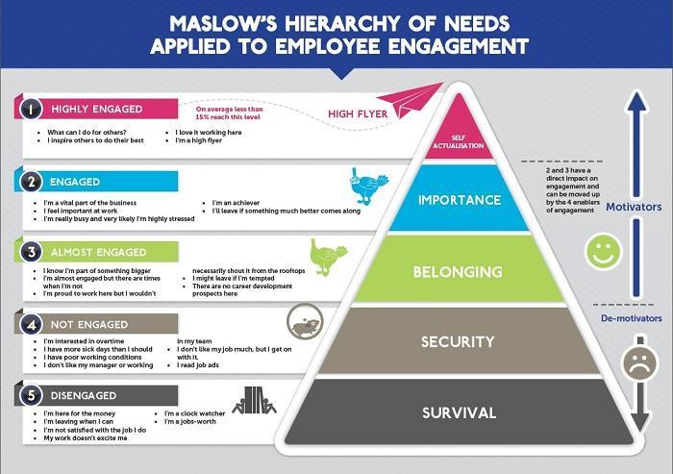

Defining Well-being
Well-being is the way people feel and judge about their lives and includes emotional, psychological and social aspects. Emotional well-being is linked to happiness, positive emotions, life satisfaction as well as the capability to handle one's feelings successfully. Psychological well-being includes personal growth, autonomy, self-acceptance, purpose in life and a sense of meaning. Social well-being is related to supportive relationships, social inclusion and feeling valued as a part of a community.
Two important views of well-being are usually discussed: hedonic and eudaimonic well-being. Hedonic well- being is about pleasure, happiness and the avoidance of pain or displeasure. From this perspective, well-being is attained by individuals experiencing positive emotions and low distress. In contrast, eudaimonic well-being focuses on meaning, on personal development and the fulfilment of one's own potential. It has to do with living a purposeful life, acquiring skills and contributing to society.
In the beginning stages of childhood, both sides are important. Young children require positive emotional experiences, comfort and enjoyment, but they also benefit from having opportunities to explore, learn and develop a sense of competence. Secure relationships and responsive caregiving play a central role in children's well-being since they offer emotional security and facilitate healthy development. On the other hand, exposure to chronic stress, neglect or instability can have a negative impact on emotional regulation, attachment and mental health, which can increase the risk of difficulties later in life (Ryan and Deci, 2001).
Lifestyles and Daily Practices
Lifestyle is the habits of individuals and family in terms of behaviour and daily routines. These include diet, physical activity, sleep routines, screen use, social interaction and later in life, substance use. Lifestyle choices are determined not only by individual preferences, but by the culture, socioeconomic status, education and resources. This means that not all families have the same opportunity to live healthy lives.Environmental factors such as housing conditions, neighbourhood safety, access to green spaces and availability of recreational facilities also play an important role in the development of lifestyle behaviours. Families who live in disadvantaged areas may encounter some barriers to healthy living, such as limited access to affordable healthy food or safe places to play outside.Healthy lifestyles have been linked to better physical health, emotional wellness and lowered risk of chronic illness. In early childhood - Habits of lifestyle developed during young age often continue until adulthood and therefore early intervention is important. Regular physical activity helps motor development, coordination and physical fitness, while adequate nutrition means adequate nutrients to allow growth and brain development.Adequate sleep and consistent routines lead to emotional regulation, concentration and learning.In contrast, poor diet, sedentary behaviour, too much screen use and poor routines may play a role in obesity, anxiety, low self- esteem and poor academic performance. These patterns of lifestyle have long term implications for health and well-being, especially if they are established early in life (Centers for Disease Control and Prevention, 2024).

Maslow’s Hierarchy of Needs Applied to Employee Engagement(Valvano, 2016)
The Link Between Health, Well-being and Lifestyle
Health, well-being and lifestyle are interdependent and have complex interactions. Lifestyle behaviours like physical activity, diet and sleep have a direct impact on physical health, while they also influence emotional and mental well being. For example, regular exercise helps cardiovascular health, builds stronger muscles and bones and is linked to better mood and lower symptoms of anxiety and depression. Physical activity also encourages social interaction and confidence, especially when the children are in group play. A healthy diet ensures proper physical growth and brain development, making a positive impact on concentration, memory and control of feelings. Nutritional deficiencies during early childhood can negatively impact cognitive development and raise the risk of developing health problems later in life. Adequate sleep is equally important, too, for it helps with immune system, emotional stability and cognitive processing. Sleep deprivation in children is linked to behavioural difficulties, decrement of attention and learning. When unhealthy lifestyle patterns continue long term, they can result in physical illness, fatigue and mental health problems such as anxiety and depression. This brings the importance of taking a holistic approach to supporting children and families, making sure that physical, emotional and social needs are addressed, rather than separately (Mental Health Foundation, 2021).



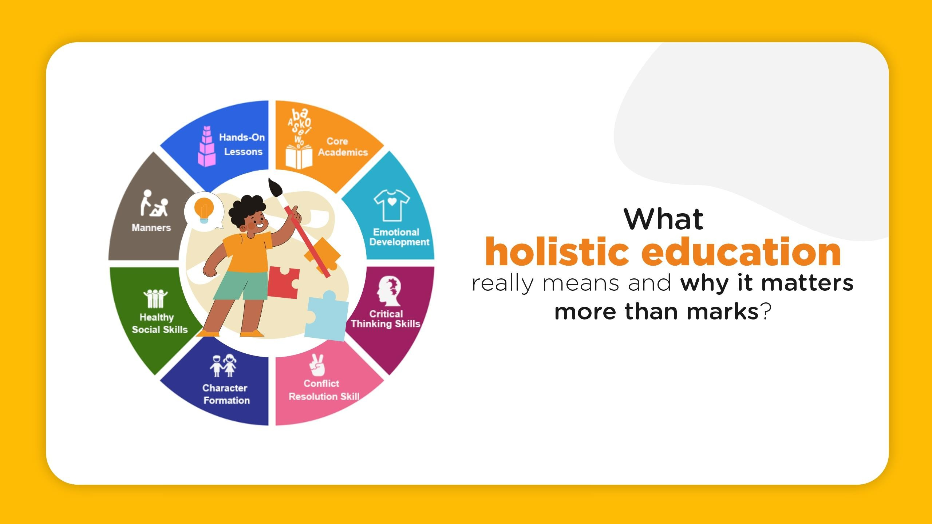



Impact on Early Childhood Development
Early childhood is an important period in laying the foundations for health, well-being and lifestyle behaviours. During this stage, children undergo rapid physical, cognitive and emotional development and are therefore especially sensitive to their environments and experiences. Positive early experiences may have long term benefits and adverse experiences may have long term consequences for health and development.Healthy lifestyles in early childhood promote physical growth, brain and emotional development. Play based learning helps with creativity, problem solving and social skills, as well as nurtured relationships forming emotional security.However, exposure to chronic stress, family conflict or poverty can have a negative impact on mental health and emotional development that can put children at risk of having problems later in life. Early intervention is therefore a key requirement in reducing inequalities and supporting positive developmental outcomes (Shonkoff and Phillips, 2000).
Theoretical Perspectives
Maslow's Hierarchy of Needs
Maslow's hierarchy of needs is a good model for understanding health and well-being. The theory is that people must have their basic physiological needs satisfied, such as food, water, shelter and rest, before they can be concerned with higher needs such as belonging, self-esteem and self- actualisation. In early childhood, it is important to meet these basic needs in order for a child to develop healthily.Children who are experiencing hunger, neglect or insecurity may have difficulty engaging in learning, regulate emotions or form positive relationships. For example a child who has insufficient nutrition or sleep is going to have a hard time concentrating or participating in activities. This theory brings out the importance of meeting children's basic needs as a basis for well-being and learning (Maslow, 1943).
Attachment Theory
Attachment theory emphasises the importance of good attachments between children and caregivers. Secure attachments are the source of emotional safety, resiliency and basis for healthy social and emotional development. Children who have consistent, responsive and nurturing care have a greater chance of developing confidence, being emotionally regulated and trusting others. Early relationships also play a role in brain development, specifically in those centers that are involved in emotion regulation and stress response (Mcleod, 2025).
Government Policy and Social Support
Government policies have a key role to play in the outcomes of health and well-being at both individual and population levels. Public health initiatives that encourage healthy eating, physical activity and reduce inequalities are important in supporting families and communities. Access to healthcare, early years services and community resources is a way to reduce disparities in health and to support positive lifestyle choices.
Targeted programmes such as free school meals, health visitor services and immunisation campaigns are particularly successful in supporting vulnerable children and families. These programmes help to identify health and developmental needs early to enable timely intervention. Investment in early childhood education and care helps children's cognitive, social and emotional development and enables parents to take advantage of employment or training opportunities.
Policies related to poverty, housing and employment show the importance of addressing the broader social determinants of health to help address long-term outcome and inequalities across generations (Local Government Association, 2010).



What Holistic Education Really Means (admin, 2025)

References
- admin (2025). What Is Holistic Education and Why It Matters More Than Just Marks | Blog. [online] Narayana Schools - Reading Corner. Available at: https://www.narayanaschools.in/blog/what-holistic-education-really-means-and-why-it-matters-more-than-marks/ [Accessed 26 Dec. 2025].
- Bright, B. (2025). Supporting Emotional Wellbeing in the Early Years: Building Resilience from the Start - Foundation Years. [online] Foundation Years - Latest news, policy and resources for early years professionals. Available at: https://www.foundationyears.org.uk/2025/11/supporting-emotional-wellbeing-in-the-early-years- building-resilience-from-the-start/.
- Centers for Disease Control and Prevention (2024). Social determinants of health (SDOH). [online] CDC.gov. Available at: https://www.cdc.gov/about/priorities/why- is-addressing-sdoh-important.html.
- Local Government Association (2010). Marmot review report – fair society, healthy lives. [online] Local.gov.uk. Available at: https://www.local.gov.uk/marmot- review-report-fair-society-healthy-lives.
- Maslow, A. (1943). A Theory of Human Motivation. [online] Psychological Review. Available at: https://psychclassics.yorku.ca/Maslow/motivation.htm.
- Mcleod, S. (2025). Attachment Theory in Psychology. [online] Simply Psychology. Available at: https://www.simplypsychology.org/attachment.html.
- Mental Health Foundation (2021). Physical activity and mental health. [online] www.mentalhealth.org.uk. Available at: https://www.mentalhealth.org.uk/explore- mental-health/a-z-topics/physical-activity-and-mental-health.
- Page, S. (2022). Why Do Social Determinants of Health Matter At Work? [online] info.totalwellnesshealth.com. Available at: https://info.totalwellnesshealth.com/blog/social-determinants-of-health.
- Ryan, R. and Deci, E. (2001). On Happiness and Human potentials: a Review of Research on Hedonic and Eudaimonic well-being. Annual Review of Psychology, [online] 52(1), pp.141–166. doi:https://doi.org/10.1146/annurev.psych.52.1.141.
- Schramme, T. (2023). Health as Complete Well-Being: the WHO Definition and beyond. Public Health Ethics, [online] 16(3), pp.210–218. doi:https://doi.org/10.1093/phe/phad017.
- Shonkoff, J.P. and Phillips, D.A. (2000). From Neurons to Neighborhoods: The Science of Early Childhood Development. [online] PubMed. Available at: https://pubmed.ncbi.nlm.nih.gov/25077268/.
- Valvano, L. (2016). Maslow’s Hierarchy of Needs Applied to Employee Engagement. [online] The Stress Management Society. Available at: https://www.stress.org.uk/maslows-hierarchy-needs-applied-employee-engagement/.
- World Health Organization (2025). Health and Well-Being. [online] World Health Organization. Available at: https://www.who.int/data/gho/data/major- themes/health-and-well-being.

Conclusion
Health, well-being and lifestyle are intricately linked and have a lot to do with human development, especially in early childhood. Health goes beyond physical functionality to encompass both mental and social well-being, while well-being is emotional, psychological and social experiences that affect the way individuals interact with the world. Lifestyle behaviours, which are shaped by individual choices and broader social factors, have an important role in determining health outcomes throughout the life course.
This discussion points to the importance of taking a holistic approach to recognise the interdependence of these concepts. Early childhood experiences, relationships and environments have a long lasting impact on development.

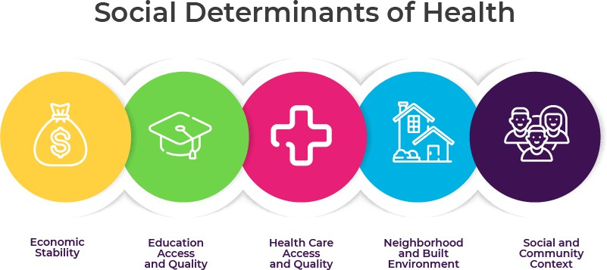

Social Determinants of Health: Why They Matter in the
Workplace(Page, 2022)

