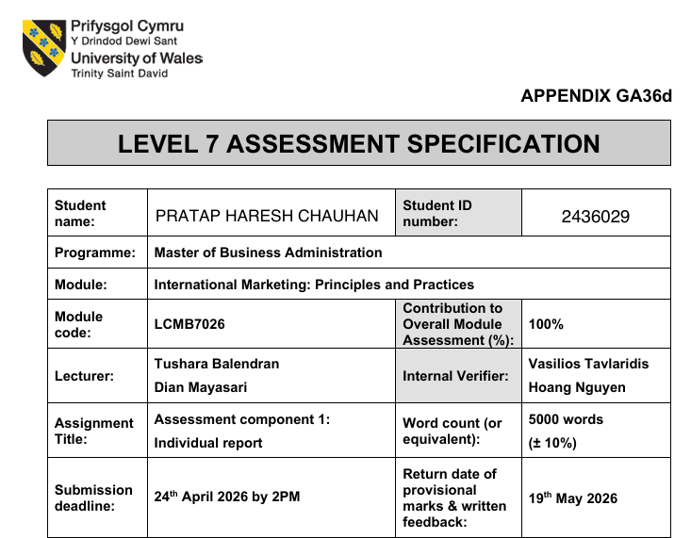

MASTER OF BUSINESS ADMINISTRATION (MBA)

ASSESSMENT TITLE:
International Marketing Mix Analysis of Zara in the United Kingdom and India

WORD COUNT: 5000
Table of Contents
1. Introduction 4
2. Company Overview and Market Entry 5
3. Market Analysis (PESTEL + Culture) 6
3.1 Political and legal factors 6
3.2 Economic Factors 7
3.3 Socio-Cultural Factors 7
3.4 Technological Factors 8
3.5 Environmental Factors 8
4. STP Strategy Comparison 9
4.1 Segmentation 9
4.2 Targeting 10
4.3 Positioning 10
5. Comparison of marketing mix (7Ps) 11
5.1 Product 11
5.2 Price 12
5.3 Place (Distribution) 12
5.4 Promotion 13
5.5 People 13
5.6 Process 14
5.7 Physical Evidence 14
6. Directional Strategy (Ansoff Matrix – India) 15
7. Ethical Issues 16
8. Recommendations 17
SECTION 2 — REFLECTION 18
1. Description 18
2. Feelings 18
3. Evaluation 19
4. Analysis 19
5. Conclusion 19
6. Action Plan 20
References 21
APPENDICES 24
Appendix A: PESTEL Comparison (UK vs India – Zara) 24
Appendix B: STP Summary (Zara – UK vs India) 24
Appendix C: 7Ps Marketing Mix Comparison (Summary) 25

1. Introduction
Zara is a top fashion retailer in the world and is an operation of Inditex Group and known to react quickly to evolving consumer trends with a highly integrated and responsive supply chain. In contrast to conventional fashion stores, Zara is designed to operate on speed, flexibility and responsiveness to customers, making the company take weeks, instead of months to get designs out of the concept stage to retailer shelves (Jonwal,2025). This has enabled Zara to have a good competitive edge in the global fashion industry whilst constantly adjusting to the changing consumer preferences.
A powerful brand position and innovative marketing strategies that target the use of limited quantities of products, a high turnover of inventory and a smooth combination of the offline and online retail stores also contribute to the global success of Zara (Zhang,2024). The brand also increased its digital marketing capacities in recent years through its use of social media platforms and e-commerce to connect with more digitally savvy consumers, though research indicates that more work is needed to enhance the level of interactive engagement to reinforce customer relationships (Wang,2023).
This report aims at comparatively analysing Zara international marketing strategies in two different markets; United Kingdom and India. These nations offer a lot of variation in terms of economic growth, cultural beliefs and consumer behaviour and therefore are a perfect context to study the patterns of how international brands can tailor their strategies in different markets.
To do this, the report employs some of the most important international marketing concepts such as PESTEL analysis to analyse macro-environmental forces, STP (Segmentation, Targeting, and Positioning) to analyse market strategies, the 7Ps marketing mix to analyse tactical decisions, and Ansoff Matrix to analyse growth strategies.
This report is a critical comparison of the marketing strategy of Zara in the United Kingdom and India which aims at determining the effect of cultural, economic and environmental differences on its strategic choices and overall success in the market.
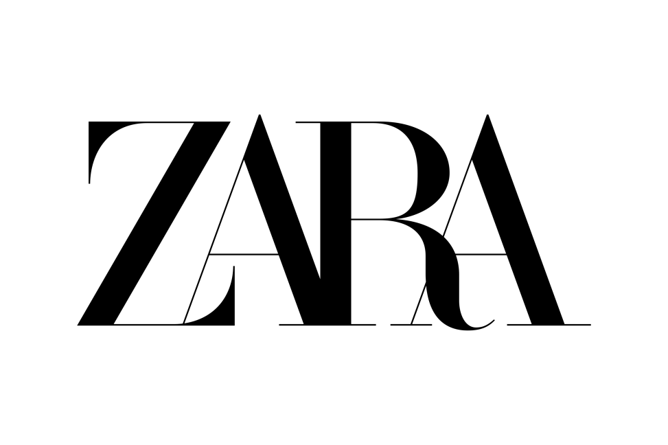
Figure 1. Zara
Source: (Zara, 2026)

2. Company Overview and Market Entry
Zara has become one of the most recognizable fashion retailers worldwide, being a part of the Inditex Group and commonly recognised as a trailblazer of the fast fashion concept. Zara in contrast to the conventional apparel retailers who engage in lengthy processes of product development has created a highly responsive and vertically integrated supply chain that allows it to design, produce and deliver new products within a few weeks. In this fast fashion model, the velocity, flexibility and instantaneous customer feedback are the driving factors that enable the company to keep its products updated on a regular basis, as well as keep its clientele highly engaged (Jobaaj Learnings,2025). The integrated information systems and effective inventory management used by the firm also facilitate rapid response to the market trends since the firm is able to replenish its stocks frequently and minimize the risks of stock shortage (Ji,2025).
A mixture of centralised control and a local responsiveness has defined the approach of global expansion by Zara. The company has vertically integrated organisational structure where major functions of the company, including design, production and logistics are coordinated centrally, which ensures consistency and efficiency in its operations in the international markets. Meanwhile, Zara is a market-oriented company, where store-level data is used to make product decisions to ensure that they reflect the local consumer preferences (Camara,2025). This mixed strategy combines the aspects of global standardisation and local adaptation that enables Zara to have brand consistency and to react efficiently to various market conditions.
As regards market entry, Zara has implemented various strategies based on the nature of the countries of entry, and these are in line with the international market entry theories. Zara used the direct investment approach as the main method of operation in the United Kingdom where it has wholly owned subsidiaries and retail outlets as a way of ensuring high degree of control over operations and brand positioning. This is a common practice in the developed markets, whereby infrastructure and regulatory conditions are favorable to foreign direct investment. On the contrary, Zara has entered India in form of joint venture with the Tata Group (Trent Ltd), which is a strategy alliance approach that minimizes the risk and taps into the local market expertise. Recent events show that Inditex has enhanced its presence in India through expanding its ownership as well as the retail network which is showing a gradual transition of more control as the market becomes more familiar with it (Riaño,2025).

3. Market Analysis (PESTEL + Culture)
The comparative analysis of the macro-environment reveals that the United Kingdom and India have some major differences in their macro-environments that directly impact the international marketing strategies of Zara. The PESTEL framework can be successfully applied to analyse these differences; the socio-cultural factors are especially significant when it comes to the consumer behaviour in the fashion industry.

3.1 Political and legal factors
United Kingdom offers a stable political and legal climate that is typified by clear regulations, good protection of intellectual property and predictability of business. This stability contributes to foreign direct investment and enables international retailers like Zara to have a relatively low regulatory risk.
India, on the contrary, has a more complicated regulatory situation. Traditionally, the high import quotas and prohibitions on foreign investments in retail enhanced the cost of operation of the international brands. Indicatively, the tariffs on imported fashion goods have been much higher restricting the prices. Nevertheless, there are certain changes in the meantime like the India–UK Free Trade Agreement that are intended to decrease trade barriers and provide a better access to markets (Vogue Business, 2025).
In comparison, Zara enjoys less regulated environment in UK whereas in India it has implemented strategies like joint ventures to mitigate risk and make sure that it complies with the local regulations.

3.2 Economic Factors
The two markets are quite different in the economic environment. The UK is a high-income, developed economy, with a fairly steady purchasing power. But the current trends have shown that people have turned out to be cautious consumers because of inflation and an increase in the cost of living. The spending on fashion has decreased and is below the levels of post-pandemic due to less discretionary spending (InternetRetailing, 2024).
India, on the other hand, is an emerging market with high growth rate. The clothing industry has become a multi-billion dollar industry surpassing 100 billion USD and is projected to keep on growing with increase in disposable income and the middle-income group population (IBEF, 2025). Despite this expansion, consumers have been very price-sensitive and this presents a challenge to up-market-priced international brands like Zara.
In general, the UK has stable, but low growth and India has high growth prospects but must exercise attentive pricing approaches since the purchasing power is low and price elasticity is high.

3.3 Socio-Cultural Factors
The most influential factor on the marketing strategies of Zara is the socio-cultural differences. UK is a society that is mostly individualistic and consumers focus on self-expression, personal style and trends. The global trends and social media have a strong impact on fashion consumption and, therefore, the market is highly compatible with the fast fashion model of Zara.
On the other hand, India is a more collectivist society, as the family, traditions and social norms affect the purchasing decision. Although the Western fashion is becoming popular, traditional dressing including sarees and kurtas is significant especially during cultural and social events. Affordability, brand perception and cultural relevance influence the consumer behaviour. Studies have shown that cultural preferences and price sensitivity limit fast fashion consumption in India, but trends and the influence of the internet drive the consumption (Ramya, 2025).
Also the young population of India and their exposure to fashion globally is enhancing the acceptance of western styles. But localisation is imperative. This comparison indicates that the standardised approach used by Zara is appropriate when it comes to the UK customers but needs to be modified in India to meet the cultural diversity and conservative needs.

3.4 Technological Factors
There are also great differences in technological development. The UK has developed digital infrastructure and e-commerce high penetration and, therefore, omnichannel retail experiences are smooth to conduct. Customers are seeking to have both online and offline services, and digital interactions are at the core of Zara strategy.
Despite the fact that India is still developing, there has been a high-rate of digital growth due to the rise in smartphone usage and penetration of the internet. Digital platforms are becoming a key influencer of consumer behaviour with over 500 million internet users (Rawshot.ai, 2026). Moreover, a significant percentage of customers are inclined towards hybrid shopping experience which involves online and offline shopping (TechSci Research, 2026).
Therefore, with the UK being highly digitalised, India is one of the digital marketplaces that are rapidly expanding and Zara needs to keep investing in the omnichannel strategies.

3.5 Environmental Factors
The markets are becoming more and more environmentally conscious at various levels. Sustainability is a key issue in the UK, and the demand towards ethical fashion and second-hand garments is on the rise. This is an indication of an increased environmental awareness among consumers (InternetRetailing, 2024).
Sustainability is increasing in awareness in India, especially among the urban consumers, but secondary to price and availability. The environment is not a major factor in the buying choices.
This comparison indicates that Zara is more pressured to implement sustainable business in the UK, but in India sustainability can be put as a long-term strategic project and not an urgent competitive advantage project.
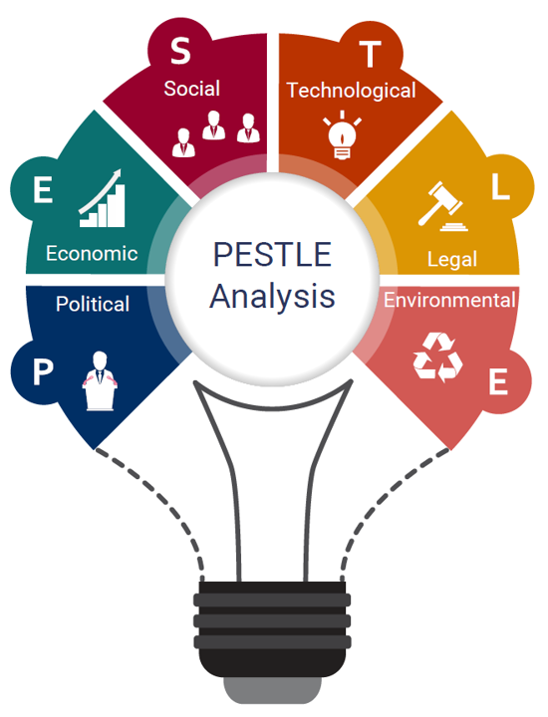
Figure 2. PESTLE Analysis
Source: (IBISWorld, 2020)

4. STP Strategy Comparison
The Segmentation, Targeting and Positioning (STP) strategies adopted by Zara in the United Kingdom and India are vastly different owing to the differences in economic factors, cultural attitudes, and consumer behaviour. These variations show the way international brands realign their strategies to the local market environments instead of the sole use of standardisation.

4.1 Segmentation
Zara uses a demographic and psychographic blend in the UK. The brand is mostly aimed at young to middle-aged consumers, trend setters, fashion conscious and highly social media and global fashion trends oriented. The consumers of the UK are inclined towards individuality, and have a tendency to keep on changing their wardrobes and would be very compatible with the fast fashion model of Zara. It has been discovered that fast fashion consumption is highly influenced by the lifestyle orientation, trend sensitivity, and social influence, especially among younger consumers (Manivel, 2024).
Segmentation in India, on the other hand, is income based and more location based. Although demographics like age are still being considered, Zara lays more stress on the urban consumer in metropolitan cities such as Mumbai, Delhi and Bangalore where people have more disposable income and have wider exposure to global fashion. Income is an important segmentation variable in India because of the unequal purchasing power distribution.
Also, there is cultural influence in psychographic segmentation in India. As much as western fashion is increasing, traditional clothes are also significant especially in cultural and social occasions. This is unlike in the UK where western fashion prevails and segmentation is more geared towards lifestyle and personal identification.

4.2 Targeting
The targeting strategy Zara uses in the UK is relatively broad-based as it targets a large group of young and middle-income customers, who want to dress in fashionable clothing at relatively low prices. The UK market favors this strategy because of the increased purchasing power, extensive fashion consciousness, and a culture of high frequency of clothing consumption. Consumers are also willing to test the trends and this enables Zara to operate well in a mass market segment.
In India, Zara employs a more discriminating targeting approach because it mainly targets middle and upper-middle-class consumers in urban areas. This more restrictive strategy is indicative of cost limitation and increased price elasticity. The pricing of Zara restricts access of a significant percentage of the population, and there is a need to appeal to consumers that have higher disposable income and international brand exposure.
This comparison underlines the effects of market maturity on targeting: the UK allows using a mass-market approach, whereas India needs a niche strategy because of the differences in incomes and consumption.

4.3 Positioning
The two markets also have a big difference in the positioning of Zara. Zara has established itself as a high street fast fashion retailer of fashionable designs at affordable prices in the UK. It is linked to rapidity, novelty, and fashionable trends, which is in line with the consumers who value personalisation and following trends. A sense of exclusivity and urgency is enhanced by its approach of fast product rotation and little advertising.
Zara is also a more upscale and aspirational global brand, as opposed to a mass-market retailer, in India. This change is majorly fueled by the rise in prices due to importation taxes and operation expenses in comparison with the levels of income. This in turn makes Zara appear to be more expensive than the local options.
This positioning is further supported by cultural aspects. International brands in India are more of a status, quality, and international exposure which can affect consumer perceptions and purchasing behaviour. Contrastingly, in the UK, Zara is competing in a highly competitive fast fashion industry with H&M and Primark in the same segment and thus it is in the mid-market segment.
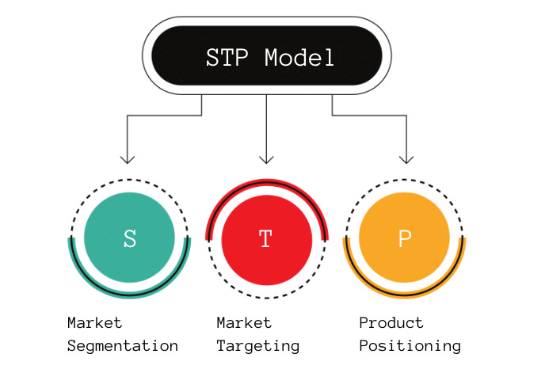
Figure 3. STP Strategy
Source: (Product Mindset, 2024)

5. Comparison of marketing mix (7Ps)
The marketing mix of Zara represents a very dynamic and integrated fast fashion model. Nonetheless, there are several distinctions between the United Kingdom and India because of the differences in economic environment, culture and market maturity. Such variations necessitate Zara to strike a balance between standardisation of operations globally and local adaptation.

5.1 Product
Zara in the United Kingdom has a highly standardised product approach in line with the global fashion trends. The brand also launches new collections quite often, which is backed by the vertically integrated supply chain, which allows responding quickly to the evolving preferences of the consumers (Advergize, 2026). Being extremely fashionable and affected by social media, consumers in the UK are easy to sell the standardised products of Zara.
Zara is more adaptive in its product approach in India. Though the basic designs are used worldwide, modifications are made to meet the local preferences, such as weather, culture and body structures. As an example, the use of lighter fabrics, conservative styles, and seasonal changes are more evident. Such adaptation is an indication of the Western and traditional fashion taste coexisting in India.
Therefore, the concept of product standardisation is effective in the UK, but in India, the company needs to do it through localisation to make it culturally relevant.

5.2 Price
The pricing strategy of Zara will be very different in the two markets. In UK, Zara is poised as a medium-range brand that sells trendy products at moderate prices. This is in line with increased purchasing power and high consumption rates. Design, quality, and brand image are key factors that drive perceived value (Fibre2Fashion, 2024).
On the other hand, the price of Zara in India is comparatively higher because of importation charges, operations and currency variations. Through this, the brand is seen as high-end as opposed to the local substitutes. This poses a challenge, with Indian consumers being typically more price-sensitive and value-conscious.
Nevertheless, Zara does not lower its prices as it wants to avoid brand positioning and perceived quality. This indicates the difference in economies: the consumers in the UK have the opportunity to make purchases on a regular basis, and Indian consumers see Zara as a brand of aspiration.

5.3 Place (Distribution)
Zara has a well-established e-commerce platform that has enabled it to establish a robust distribution network in the UK with a high presence in major cities. The omnichannel approach it uses allows a perfect combination of online and offline platforms, satisfying the needs of consumers in the context of convenience and accessibility.
Zara in India uses a selective distribution approach, targeting metropolitan cities like in Delhi, Mumbai and Bangalore. This is an indicator of disparities in infrastructure, buying power, and concentration of demand. Zara is able to tap into well-exposed consumers with high disposable income by accessing major urban centers where consumers are exposed to the global fashion trends.
In India, physical outlets are especially crucial with in-store experience as a key factor in the decision to buy. The location of the stores, design of the stores and ambience are some of the factors that contribute to the premium brand perception that Zara has.
Generally, the concept of wide distribution works in the UK, but India needs more targeted and strategic distribution.

5.4 Promotion
What makes the promotional strategy of Zara unique is that it is least dependent on the use of conventional advertising. Rather, it concentrates on the product visibility, store experience, and quick inventory turnover to create demand (Advergize, 2026).
This strategy is very successful in the UK as there is good brand recognition and familiarity with fast fashion by the consumers. Digital platforms and frequent products releases make Zara use digital platforms and social media, and repeat visits are promoted.
However, in India, Zara puts more focus on brand awareness and experiential marketing. Being a relatively new brand, it uses premium store locations, visual merchandising and aspirational branding to appeal to consumers. The image of Zara as an international brand adds to its attractiveness among urban consumers that want international style.
This disparity indicates market maturity: Zara will be able to count on the existing brand equity in the UK whereas in India it will have to actively create awareness and desirability.

5.5 People
The cultural differences are reflected in the people aspect of the marketing mix of Zara. Customer service in the UK is generally efficient and transactional and in line with consumer preference of speed and convenience. The aspect of self-service is widespread and is backed by store designs and online technologies.
Customer service in India is more personalised and interactive. The consumers usually seek service especially in high-end retail outlets. This makes Zara more focused on employee engagement and quality of in-store service.
This indicates the wider cultural variations: the individualistic countries such as the UK value their independence, and the collectivist ones such as India value intercourse and service.

5.6 Process
Zara process strategy is founded upon efficiency, speed and responsiveness with the aid of its advanced supply chain. This enables a quick development of products and regular update of inventory in both markets.
The UK has a well-developed logistics system and digitalization, which facilitates quick delivery, convenient returns, and inventory tracking in real-time. This will provide a smooth channel customer experience.
In India, the basic process is the same, but infrastructure constraints and complexity in supply chains may impact efficiency. Nevertheless, Zara still invests in digital platforms and logistics to enhance service delivery, and to uphold global standards.
Therefore, the process is highly standardised, but its performance is different in different markets based on the conditions in the local market.

5.7 Physical Evidence
The store design and branding are part of the physical evidence that is a key element of the marketing approach at Zara. Both markets have a minimalistic and modern design of the stores, which supports the brand image of Zara worldwide.
Store layouts in the UK promote individualized shopping experience, whereby they keep updating products frequently, which promotes discovery.
Physical evidence is still more important in India. The atmosphere of the stores and high-end locations help Zara in positioning itself as an aspirational global brand. Big-box stores with a big design make shopping a luxe experience that makes the consumer market associate world brands with prestige and quality.
This is where physical retail space in the emerging markets comes in as it is one of the few touchpoints in establishing brand image and consumer trust.
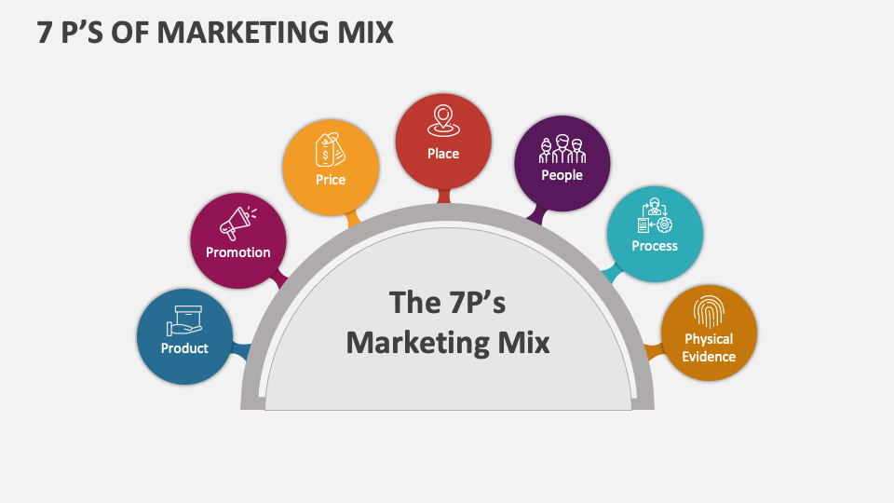
Figure 4. Marketing Mix 7p’s
Source: (Collidu, 2023)

6. Directional Strategy (Ansoff Matrix – India)
Ansoff Matrix can be used to critically analyse the growth strategy of Zara in India, especially in the context of the market development where a product that is already existing in the market is launched in a new market or emerging market. India is a strategic growth market of Zara owing to its rising middle, growing urbanisation and growing demands of global fashion brands. Because of this, Zara has been keen on expanding its influence in India but retained its fast fashion model.
The growth of Zara in India is an indication of a market development strategy, since the company is still launching its international standardised product line in a market which is still under penetrated. As of late, it has been observed that Zara has been aggressively growing its retail operations with more than 20 stores in India being operational in major cities and active investments in opening up new stores, remodeling, and digitizing its stores to maximize customer experience (Sharma,2025). This growth comes alongside an increasing omnichannel approach, in which digital platforms are combined with the physical store to enhance accessibility and convenience to people.
Along with physical growth, the strategy of Zara also reflects the aspects of strategic development in Ansoff. Having first gained access into the Indian market via a joint venture to minimise risk and understand the local market, Zara has over time competed to take more and more control through ownership and entrenchment of its operations in India (Riaño,2025). Such a change implies a shift in the strategy of careful entry, towards a more aggressive growth strategy as the market becomes familiar with the company and trusts it (Chaubey,2025).
Nonetheless, there are difficulties in the market development strategy of Zara in India. Although the company has growth opportunities, there are reduced growth rates in revenue and an increasing pressure on competition with both international and local brands and this underscores the complexities of operating in an emerging market.
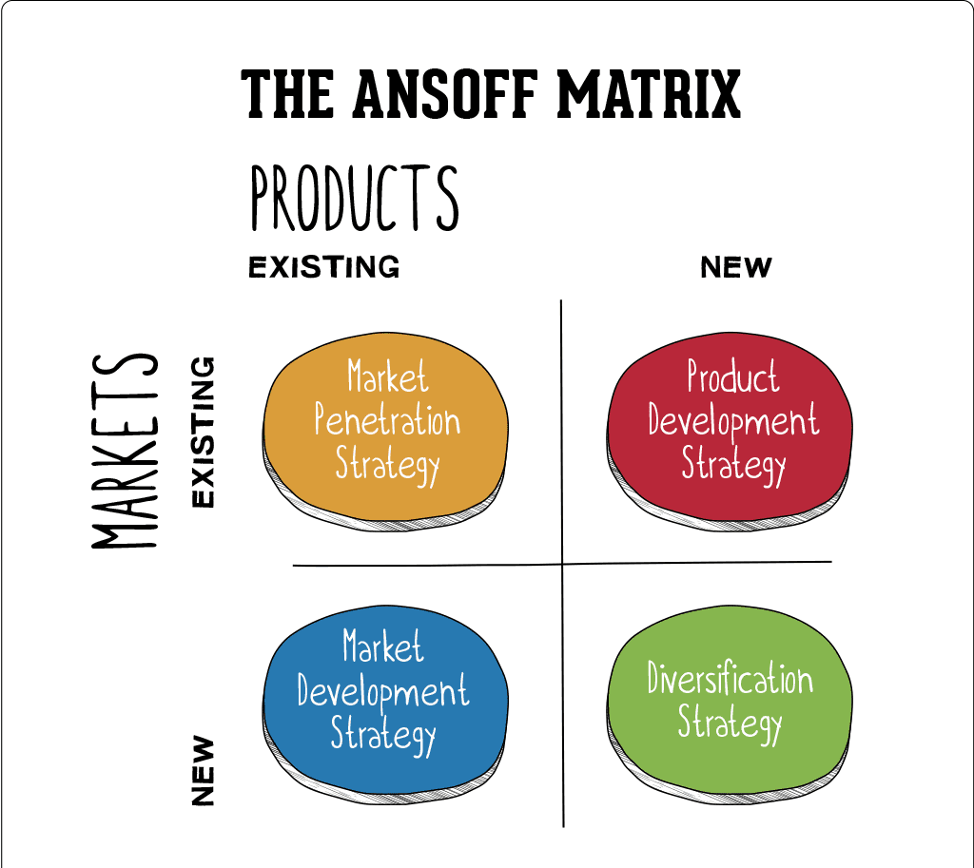
Figure 5. Ansoff Matrix
Source: (Hanlon, 2021)

7. Ethical Issues
The business model of Zara, a major fast fashion retailer is associated with serious ethical issues of sustainability, labour policies and excessive consumption. Environmental sustainability is one of the most crucial issues. Mass production and short product life cycles are the main contributors to the fact that the fast fashion industry contributes about 10 per cent of carbon emissions and high water usage worldwide (Maiti,2025). Zara, being one of the participants of this model, adds to these environmental pressures, especially because of large volumes of production and fast turnover of inventories.
Moreover, it has raised concerns about the transparency and labour conditions in the supply chain of Zara. As far as there is evidence indicating that there is less transparency concerning working conditions and wage norms in global manufacturing networks, it poses an ethical concern regarding the exploitation of workers (Sustainably Chic,2026). Moreover, the use of air freight by the brand has exacerbated transport emissions and tensions between operational efficiency and environmental responsibility are in the spotlight (Reid,2025).
The other significant ethical concern is overconsumption. The fast fashion concept promoted by Zara promotes buying and disposing clothes regularly, which adds to the excessive textile waste and the amount of landfills (Greenpeace,2026).

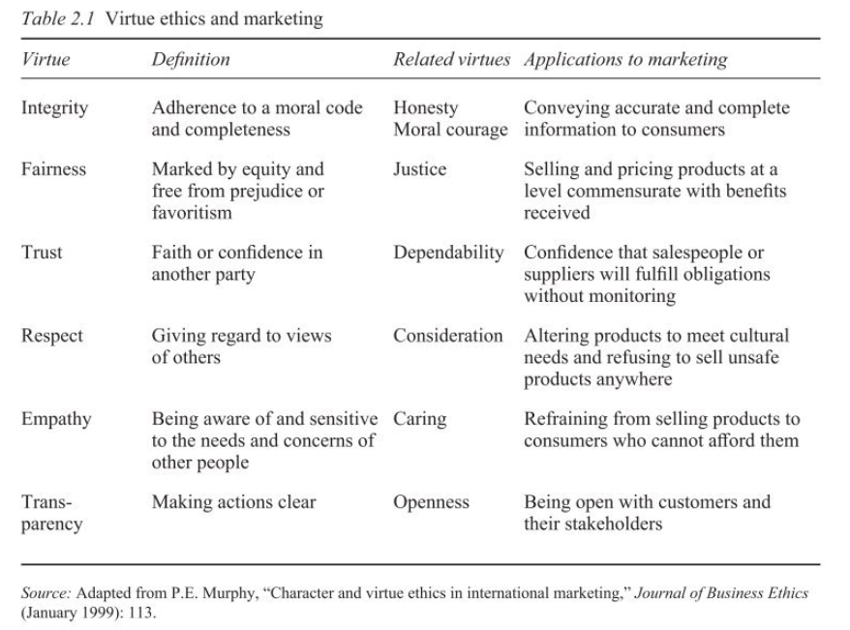

8. Recommendations
Through the comparative analysis, Zara needs to be more localised and sustainable in order to enhance its competitive position in both markets especially in India. To start with, there is a need to have increased product localisation. Since many Indian people wear traditional clothes and the culture of culture is diversified, Zara must increase the variety of its weather-related and culturally-modified designs to become more in tune with local consumer demands. This is in line with studies that note the need to change global strategies to local market conditions in emerging economies.
Second, Zara needs to re-invest in its sustainability efforts, not only with the incremental gains, but with systemic changes. Although the company has implemented several programmes like the Join Life programme and more utilization of recycled materials, the overall environmental performance has been low with a sustainability rating of less than 50% (Eco-Stylist,2024). Moreover, the wider fast fashion sector still has a lot to do with the process of environmental destruction, such as the emission of carbon and use of resources (Maiti,2025). Thus, Zara needs to invest in the circular fashion model, minimize production volumes or work on supply chain transparency.
Lastly, Zara ought to adopt market-specific prices in India to cope with price sensitivity. This may involve launching low-cost product lines or changing the price to make it more accessible without compromising the brand value. This would enable Zara to increase the number of its customers and retain its premium status.
Altogether, these suggestions indicate the necessity of the global efficiency and local responsiveness and ethical responsibility.

SECTION 2 — REFLECTION
Using Gibbs Reflective Cycle
The Reflective Cycle by Gibbs is a systematic model to analyse experiences in six steps; description, feelings, evaluation, analysis, conclusion, and action plan (The University of Edinburgh,2024). The model is broadly applied to academic and professional development since it promotes critical thinking and lifelong learning (Simply Psychology,2025).

1. Description
This assignment was an in-depth international marketing study of Zara, where my comparison was between the strategies of this company in the United Kingdom and India. This involved the use of various theoretical models among them being the PESTEL analysis, STP strategy, 7Ps marketing mix and the Ansoff Matrix. I have started by choosing the right countries that would exhibit significant economic and cultural differences, which would result in a significant comparative analysis.
The data collection procedure entailed the use of academic journals, industry reports and reliable web information. I logically interpreted macro-environmental factors, consumer behaviour and marketing strategies in the two countries, making sure that every part of the report had been correlated with the requirements of the assignment. The last step was to synthesise the results and come up with recommendations out of the analysis.

2. Feelings
My level of confidence at the start of the assignment was that I would have no problems grasping the theoretical frameworks but have some doubts in how to effectively apply them to a real-life brand. This was complicated by the fact that it was not easy to compare two countries at the same time, especially when it came to making sure that the analysis was critical, as opposed to being descriptive.
I felt a bit frustrated during the research stage since good and current scholarly sources were difficult to find, and the necessity to refer to current sources restricted the choice of sources. Nevertheless, further on, I was more confident in my skills to critically assess sources and use them in my arguments.
At the completion of the assignment, I was surprised because I could create a structured and analytical report that proved to have more knowledge of the concepts of international marketing.

3. Evaluation
The good application of theoretical frameworks to organize the analysis was one strength of this assignment. The implementation of such models as PESTEL and STP helped to structure the material in a logical order and make sure that the discussion did not go outside of such important marketing concepts. Also, the comparison of the two countries that included the United Kingdom and India provided an opportunity to make a deeper analysis and identify the impact of cultural and economic differences on the marketing strategies.
Nevertheless, it also had some spheres that could have been enhanced. As an example, it was difficult to keep a balance between the two countries on a regular basis during the report. In some instances, a single market was covered in more detail than the other and this might have an impact on the quality of the overall comparison. Also, it was necessary to be keen when combining various sources and still have a coherent argument and sometimes this could not be easily controlled.

4. Analysis
The process of filling in this assignment helped to affirm the significance of reflective learning as a practice that relates theory to practice. Reflective practice helps one to critically analyze their experiences and enhance future practice by determining their strengths and weaknesses.
This assignment has helped me to gain a better insight into the way in which international marketing strategies should be localized. To illustrate, the pricing and positioning strategies of Zara in UK and India pointed out the effects of economic and cultural aspects on consumer behaviour. This proved that global brands cannot just afford to stick to standardisation and they need to take a hybrid style of balancing global uniformity and local modulation.
Furthermore, applying the Reflective Cycle as developed by Gibbs in itself improved my skills of self-critically evaluating my learning process. The fact that the model was structured made me not only think about what I did, but also why I did it and what I could do better in the future. It has been proposed that academic work with structured reflection enhances critical thinking and professional development (Praveena et al.,2025).

5. Conclusion
On the whole, this assignment has contributed greatly to my knowledge of international marketing and the intricacies that are inherent in doing business in various markets. My analytical abilities have been enhanced especially in making comparisons and contrasts between various environments and application of theoretical concepts to practical situations.
The main lesson that has been learned in this experience is that international marketing in order to be successful has to be flexible, culturally sensitive and adaptive to strategies. It is imperative to be able to critically assess both internal and external factors in order to make informed marketing decisions. Also, I have been taught the necessity of employing academic sources that are credible to prove points and improve the quality of analysis.

6. Action Plan
To enhance my future academic and professional outcomes, I will concentrate on a number of main aspects. To begin with, I will develop my research competencies in the following ways: I will be able to locate and assess high-quality academic sources more effectively. This will help me to come up with better arguments and enhance the overall quality of my work.
Second, I will focus on enhancing my critical writing, meaning that I will always make my analysis go beyond the description. This involves paying more attention to explaining why and how as opposed to just giving information.
Third, I will learn to manage my time better to enable me to devote more time to revising and editing my work. This will assist in creating more coherence and richness in all parts of the assignment.
Lastly, I will remain committed to using reflective practice in my learning since it has become a powerful instrument to personal and career growth. Through constant self-reflection, I will be in a position to determine areas where I need to improve and improve my overall performance.

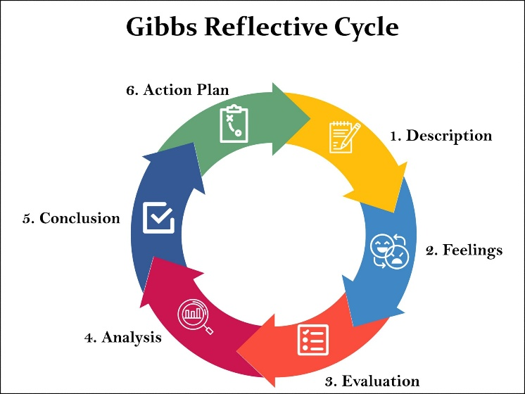
Figure 6. Gibbs reflective Cycle
Source: (Simply Psychology, 2025)

References
Jonwal, S. (2025) Zara Case Study: The Fast Fashion Giant’s Winning Strategy. Young Urban Project. Available at: https://www.youngurbanproject.com/zara-case-study
Zhang, E., 2024. Behind Zara’s success: An analysis of brand marketing and management in fast fashion. In SHS Web of Conferences (Vol. 199, p. 02005). EDP Sciences. https://www.shs-conferences.org/articles/shsconf/pdf/2024/19/shsconf_iclrc2024_02005.pdf
Wang, J. (2023) ‘Research on Zara’s Social Media Marketing Strategy in the Context of New Media’, Advances in Economics, Management and Political Sciences, 56(1), pp. 131–138. Available at: https://doi.org/10.54254/2754-1169/56/20231088
Jobaaj Learnings (2025) Zara’s Fast Fashion Strategy: A Case Study on Supply Chain Success. Available at: https://www.jobaajlearnings.com/casestudies/Zaras-Fast-Fashion-Strategy-A-Case-Study-on-Supply-Chain-Success
Ji, Y. (2025) ‘Research on Zara’s Supply Chain System’, Advances in Economics, Management and Political Sciences, 211(1), pp. 36–43. Available at: https://doi.org/10.54254/2754-1169/2025.CAU26083
Camara, D. (2025) How Zara’s Supply Chain Delivers Speed and Agility at Scale. The Future Factory. Available at: https://www.thefuturefactory.com/insights/zara-lean-supply-chain-agility.
Riaño, P. (2025) Inditex strengthens its presence in India with the purchase of an 80% stake in Zara’s joint venture. Modaes. Available at: https://www.modaes.com/global/companies/inditex-strengthens-its-presence-in-india-with-the-purchase-of-an-80-stake-in-zaras-joint-venture
Vogue Business (2025) What the India–UK trade agreement means for fashion. Available at: https://www.vogue.com/article/what-the-india-uk-trade-agreement-means-for-fashion
InternetRetailing (2024) UK Fashion Sector Report 2024. Available at: https://internetretailing.net/report-hub/uk-fashion-sector-report-2024/
India Brand Equity Foundation (IBEF) (2025) Fashion forward: An analysis of India’s growing apparel market. Available at: https://www.ibef.org/blogs/fashion-forward-an-analysis-of-india-s-growing-apparel-market
Ramya, S.S. (2025) Consumer buying behavior towards fast fashion: A study on H&M with special reference to Coimbatore. Available at: https://www.researchgate.net/publication/390558954
Rawshot.ai (2026) Indian fashion industry statistics. Available at: https://rawshot.ai/statistic/indian-fashion-industry
TechSci Research (2026) India Fashion Retail Market – By Product Type, Distribution Channel, Forecast & Opportunities, 2020–2030. Available at: https://www.techsciresearch.com/report/india-fashion-retail-market/26993.html
Manivel, R., 2024. Perception, Preference and Satisfaction of Gen Z Towards Fast Fashion in Coimbatore City. Available at SSRN 4752755. https://dx.doi.org/10.2139/ssrn.4752755
Advergize (2026) Zara marketing mix: How the 4Ps power fast fashion. Available at: https://www.advergize.com/zara-marketing-mix/
Fibre2Fashion (2024) Motivational factors behind Zara purchases: An empirical study. Available at: https://www.fibre2fashion.com/industry-article/10287/motivational-factors-behind-zara-purchases-an-empirical-study
Sharma, A. (2025) Zara India boosts tech innovations for growth amid stagnant sales. The Economic Times – Retail. Available at: https://retail.economictimes.indiatimes.com/news/apparel-fashion/apparel/zara-india-boosts-tech-innovations-for-growth-amid-stagnant-sales/123183007
Chaubey, A. (2025) Zara India Q4 FY25 earnings results out: Company reports 23% profit growth. Angel One. Available at: https://www.angelone.in/news/market-updates/zara-india-q4-fy25-earnings-results-out-company-reports-23-profit-growth
Maiti, R., 2025. The environmental impact of fast fashion, explained. earth. org, 20. https://earth.org/fast-fashions-detrimental-effect-on-the-environment/
Sustainably Chic (2026) Is Zara fast fashion? Sustainability & ethics explained. Available at: https://sustainably-chic.com/blog/is-zara-fast-fashion/
Reid, H. (2025) Zara owner Inditex’s transport emissions jump in 2024. Reuters. Available at: https://www.reuters.com/business/retail-consumer/zara-owner-inditexs-transport-emissions-jump-2024-2025-03-14/
Greenpeace (2026) The hidden cost of fast fashion: SHEIN, Temu, Zara. Available at: https://www.greenpeace.org/international/story/82296/the-hidden-cost-of-fast-fashion-shein-temu-zara/
Eco-Stylist (2024) How sustainable is Zara in 2025? Available at: https://www.eco-stylist.com/how-sustainable-is-zara/
The University of Edinburgh (2024) Gibbs’ reflective cycle. Available at: https://reflection.ed.ac.uk/reflectors-toolkit/reflecting-on-experience/gibbs-reflective-cycle
Simply Psychology (2025) Gibbs’ Reflective Cycle. Available at: https://www.simplypsychology.org/gibbs-reflective-cycle.html
Praveena, K.S., Juslin, F., Patil, C.M. and Bhargavi, K., 2025. Using gibb's reflective model approach for enhancing project-based learning among students through reflective assessment. Journal of Engineering Education Transformations, pp.148-155. https://doi.org/10.16920/jeet/2025/v38is2/25018
Zara (2026) Zara India: New collection online. Available at: https://www.zara.com/in/
IBISWorld (2020) How to conduct a PESTLE analysis. Available at: https://www.ibisworld.com/blog/3-step-pestle-analysis/99/1127/
Product Mindset (2024) STP model: Segmentation, targeting and positioning. Available at: https://productmindset.substack.com/p/stp-model-segmentation-targeting
Collidu (2023) 7 P’s of marketing mix. Available at: https://www.collidu.com/presentation-7-p-of-marketing-mix
Hanlon, A. (2021) The Ansoff model. Smart Insights. Available at: https://www.smartinsights.com/marketing-planning/create-a-marketing-plan/ansoff-model/
Simply Psychology (2025) Gibbs’ reflective cycle. Available at: https://www.simplypsychology.org/gibbs-reflective-cycle.html

APPENDICES

Appendix A: PESTEL Comparison (UK vs India – Zara)
Factor | United Kingdom | India | Implication for Zara
Political/Legal | Stable regulations, strong IP protection | Complex regulations, past FDI restrictions, tariffs | UK = smooth operations; India = need for joint ventures & compliance strategies
Economic | High income, stable but slow growth, inflation pressure | Rapid growth, rising middle class, price sensitivity | UK = stable demand; India = growth potential but pricing challenge
Socio-cultural | Individualistic, trend-driven consumers | Collectivist, culturally influenced, price-conscious | UK = standardisation; India = localisation required
Technological | Advanced digital infrastructure, high e-commerce use | Rapid digital growth, increasing internet penetration | UK = mature omnichannel; India = growing digital opportunity
Environmental | High sustainability awareness | Growing awareness but secondary to price | UK = strong pressure for sustainability; India = long-term positioning

Appendix B: STP Summary (Zara – UK vs India)
Element | United Kingdom | India
Segmentation | Demographic + psychographic (young, trend-focused consumers) | Income + geographic (urban, metro cities)
Targeting | Broad mass market (young/middle-income consumers) | Niche (urban middle & upper-middle class)
Positioning | Affordable fast fashion | Premium/aspirational global brand

Appendix C: 7Ps Marketing Mix Comparison (Summary)
Element | UK Strategy | India Strategy
Product | Standardised global fashion | Adapted for climate & culture
Price | Mid-range | Higher relative pricing
Place | Wide distribution + strong e-commerce | Selective metro presence
Promotion | Minimal advertising, product-led | More experiential & aspirational
People | Transactional service | More personalised service
Process | Highly efficient, advanced logistics | Similar but affected by infrastructure
Physical Evidence | Functional, modern stores | Premium, aspirational store experience

