

Written Report

Program: BA Business Management
Module: Strategic Management and Sustainability
Module code: LCBB6004
Lecturer: Dr Jayalakshmi Gopalkrishnan
Student name: Nina Kirova
Student Number: 2018270

Table of Contents
Introduction 3
Identifying and documenting VW's primary business strategies during the last five years, and utilising associated frameworks to illustrate why these strategies were pursued or altered. 4
Identifying and documenting the case study firm's resources and capabilities over the last five years, and analysing how well the company has matched its resources and capabilities with its present business strategies. 8
Analysing VW’s efforts to improve its competitiveness while addressing sustainability and the environment. Include facts to support your conclusions. 10
Recommendations for Additional Environmentally Friendly Business Practises and Advantages in the Market 13
Conclusion 15
Reference list 16
Appendix 17

Introduction
The report examines Volkswagen's core business initiatives over the previous five years, particularly on electric mobility, product diversification, digital transformation, and international market penetration. The report, supported by evidence, investigates how VW coordinated its capabilities and resources with these initiatives. It assesses VW's efforts to increase its competitiveness while addressing sustainability through its plans for electric vehicles, environmentally friendly production methods, and green advertising. To increase VW's competitive edge and environmental commitment in the market, the report suggests accelerating the adoption of EVs, enhancing sustainability reporting, partnering for sustainable innovation, and stepping up CSR initiatives.
Identifying and documenting VW's primary business strategies during the last five years, and utilising associated frameworks to illustrate why these strategies were pursued or altered.
Evidence for the electric mobility strategy:
Volkswagen has prioritized electric mobility as one of its key business goals for the last five years. The corporation has made significant expenditures in studying, creating, and producing electric vehicles (EVs) and related technologies.
Analysis of Frameworks: The development of electric mobility is consistent with the following frameworks:
- PESTEL Analysis: Environmental concerns, governmental laws, and consumer preferences have evolved towards sustainable transportation, favouring electric vehicles. VW's plan aligns with the increased focus on environmental sustainability and low carbon emissions. (Whittington and Richard, 2020)

- Porter’s Five Forces: To protect its market position and competitive advantage, VW invested in EV technology in response to the threat posed by new entrants in the electric car industry and the possible disruption of conventional internal combustion engine manufacturers (Porter, 2019).
c) Resource-Based View (RBV): VW's emphasis on electric mobility makes use of its technology know-how and manufacturing resources to create and manufacture cutting-edge electric vehicles (Kennedy, 2020).
d) Ansoff’s Matrix: VW is adopting a product development strategy to target existing markets with cutting-edge products by entering the market with new electric vehicle models (Spender, 2015).
Evidence for Product Diversification Strategy:
By releasing several models under its brands, including Audi, Seat, and Skoda, Volkswagen has expanded the scope of its product offering. With this tactic, we hoped to expand our market share and accommodate a variety of customer preferences.
Framework Analysis:
a) Market Segmentation: VW's product variety fits market segmentation because different brands and models cater to distinct client segments with varied wants and preferences (Buzan, Waever and De Wilde, 2019).
b) Ansoff’s Matrix: According to the Ansoff’s Matrix, the product diversification plan falls under market development because VW wants to increase the number of markets it serves with its products (Whittington and Richard, 2020).
c) Competitive Positioning: VW aims to get an edge over rival automakers and draw in a wider consumer base by providing a variety of car models in a range of pricing ranges and market sectors.
Digital Transformation Strategy:
Volkswagen has embraced digital transformation to improve consumer experiences and restructure internal operations. This includes improvements in data analytics, smart manufacturing, and connected automotive technology (Buzan, Waever and De Wilde, 2019).
Framework Analysis:
a) Technology Enablers: The use of digital technologies connects with technology enablers like the Internet of Things (IoT) and Industry 4.0, driving efficiency, cost savings, and customer satisfaction.
b) Customer-Centric Approach: VW's efforts to personalize customer experiences, enhance product features, and deliver linked services align with the digital transformation plan.
c) Competitive Advantage: VW strives to acquire a competitive edge by supplying cutting-edge and innovative goods by integrating digital technologies into its vehicles and business operations.
Global Market Penetration Strategy:
Evidence: In order to increase its global presence and take advantage of these markets' expanding consumer bases, Volkswagen has been focusing on emerging markets like China and India.

Framework Analysis
a) SWOT Analysis: Volkswagen's global market penetration strategy takes advantage of opportunities given by developing nations with a rising middle class and purchasing power.
b) Porter's Five Forces: VW's strategy to enter these countries is driven by the possibility of high sales volumes in emerging markets and the capacity to take advantage of economies of scale through global expansion.
c) Market Saturation: Due to intense rivalry and market saturation in developed countries like Europe and the US, VW has strategically shifted its focus to underserved regions with room for expansion (Janavaras and George, 2017).
Volkswagen has followed major business goals over the previous five years, including a strong focus on electric mobility, product diversity, digital transformation, and worldwide market penetration. These strategies, supported by variables like shifting consumer tastes, environmental concerns, competitive constraints, and the pursuit of development prospects in emerging areas, align with numerous strategy frameworks (Janavaras and George, 2017).

Identifying and documenting the case study firm's resources and capabilities over the last five years, and analysing how well the company has matched its resources and capabilities with its present business strategies.
Volkswagen's Resources and Capabilities:
a) Technological Expertise: VW's technological expertise underlies its revolutionary vehicle development. R&D helps the company keep ahead of automotive advances. This expertise has helped progress technologies including electric cars (EVs), autonomous driving, and connectivity. VW can satisfy changing consumer and regulatory needs by investing in R&D. Its technology prowess allows it to explore new revenue streams and strategic collaborations in the continuously changing automobile industry (Siegfried, 2018).
b) Worldwide production Network: VW's extensive worldwide production network boosts operational efficiency and market reach. The organization can optimize supply chain management and adapt to regional demand swings using production facilities and regional distribution networks. Due to its vast market presence, VW can adjust to local rules and client preferences. Its ability to quickly develop and deliver automobiles boosts its competitive edge and global market expansion plan. In a competitive business, economies of scale allow production cost savings through the worldwide manufacturing network (Ander Errasti, 2018).
c) Established Brands: Audi, Seat, and Skoda are key assets that boost VW's market position and consumer loyalty. Each brand targets different markets and client categories. VW's brand diversity attracts customers across pricing segments and product categories. VW uses its brands to advertise and position its products, giving it a competitive edge. These established brands also enable cross-selling, brand extensions, and shared technologies and platforms, maximizing operational efficiency.
d) Financial Stability: VW has survived the diesel gate scandal financially. Its robust revenue streams and financial resilience allowed it to weather the recession and invest strategically in sustainable technologies like electric mobility. The company's financial stability supports research, development, and expansion. VW's financial position helps build and maintain strong supplier and stakeholder partnerships, essential for the automotive industry's growth and competitiveness (Ander Errasti, 2018).
VW integrated its resources and competencies with its business strategy to develop a cohesive and synergistic approach:
Technological Competence & Global Manufacturing Network: VW's technological competence supports its electric mobility and global market penetration strategies. VW dominates the fast-growing electric vehicle market due to its capacity to develop sophisticated EV technologies and efficiently manufacture and distribute these vehicles worldwide.
Established Brands & Product Diversification: VW has used its well-known brands to diversify its car lineup to fulfill customer needs. Consumer faith in brand equity helps new models and market expansion succeed.
VW's financial stability has helped recover customer trust. The company's capacity to reimburse customers, invest in sustainable technology, and establish comprehensive quality assurance systems shows its dedication to regaining confidence and customer satisfaction. VW's durability, competitiveness, and effectiveness in pursuing automotive sector growth possibilities are due to its strategic alignment of resources and skills.

Analysing VW’s efforts to improve its competitiveness while addressing sustainability and the environment. Include facts to support your conclusions.
Sustainable Competitiveness at VW
a) Electric Car Strategy: Volkswagen's proactive development of an electric car strategy is a crucial tenet of its dedication to sustainability and long-term competitiveness in the automotive sector. After realising the widespread desire for environmentally friendly transportation, the business has made audacious moves to establish itself as a market leader in the electric vehicle (EV) market. To do this, VW has made significant investments in research, development, and manufacturing to launch several all-electric car models suited to different market niches and consumer preferences. Volkswagen wants to address the rising demand for environmentally friendly transportation while lowering its carbon footprint by leading the EV industry. The company's commitment to electric mobility aligns with international initiatives to combat climate change and follow ever-stricter environmental rules. Additionally, Volkswagen's dedication to providing a variety of EV models means that it can serve various client segments, increasing the accessibility of electric vehicles to a wider audience. VW is making investments to create a reliable charging network to get through one of the biggest obstacles to the adoption of electric vehicles: the worry over the infrastructure. VW aims to reduce "range anxiety" and improve the convenience of EV ownership by working with charging station operators and building its charging infrastructure. With this proactive strategy, Volkswagen demonstrates its dedication to sustainability and innovation and establishes itself as a market leader in electric vehicles (Culp, 2022).
b) Sustainable production: Volkswagen is committed to sustainability across the production process, not just the product itself. The company attempts to reduce its environmental impact over the whole product life cycle, as seen by its sustainable manufacturing practices. VW optimizes resource use and reduces waste formation during the manufacturing process by implementing energy-efficient production techniques (Culp, 2022). Volkswagen has also made substantial progress to cut greenhouse gas emissions from its manufacturing processes. The business is actively attempting to reduce its carbon footprint and lessen the environmental impact of its industrial activities by integrating eco-friendly technologies and using clean energy sources.
VW's emphasis on waste reduction, recycling, and using recycled materials further demonstrates its dedication to the circular economy concepts. By minimizing material waste and maximizing resource usage, adopting these sustainable practices satisfies consumer demand for eco-friendly products and improves cost-effectiveness. By emphasising sustainable manufacturing, Volkswagen strengthens its commitment to environmental responsibility and enhances its standing as an automaker committed to sustainability and eco-consciousness.
c) Green Marketing: Green marketing, sometimes referred to as sustainable marketing or eco-marketing, is a tactic used by businesses to advertise their goods, services, and brand identity while demonstrating their dedication to sustainability and environmental responsibility. By showing how a company's products and practices contribute to a more ecologically friendly world, this marketing strategy tries to appeal to consumers concerned about the environment.
Volkswagen's (VW) green marketing initiatives are crucial in accomplishing the following goals:
Promoting Sustainability Goals: Through green marketing, VW may reach a wider audience with its sustainability activities and goals. This could entail reducing carbon emissions, switching to renewable energy sources, decreasing waste, and encouraging biodiversity.
Creating a Brand Identity: VW may portray itself as a company that cares about both the environment and society by continuously publicizing its environmental initiatives. This aids in creating a distinctive brand identity that appeals to customers who value sustainability highly.
Green marketing initiatives aim to draw in environmentally conscientious consumers who actively seek goods and services that reflect their ideals (Peattie, 2021). Volkswagen's emphasis on electric automobiles, environmentally friendly manufacturing, and pollution control aids in luring and keeping these clients.
Enhancing Loyalty: Existing customers who value the brand's dedication to sustainability are likelier to remain loyal due to green marketing. These clients are more likely to support the brand and stick around.
Expanding Customer Base: As more individuals become environmentally conscious, the "green" consumer sector is growing. By luring in new clients that respect sustainability, VW's green marketing initiatives enable them get into this expanding market.
Differentiation from Competitors: By emphasizing its distinctive eco-friendly features and activities, VW can differentiate itself from rivals through green marketing. In particular, given that consumers are prioritizing sustainable solutions more and more, this differentiator may result in a competitive advantage (Peattie, 2021).
Growth in the sale of electric vehicles: Sales of VW's electric vehicles (EVs) have been rising steadily over time, with a noteworthy spike following the release of models like the Volkswagen.
VW has made significant investments in environmentally friendly production techniques. To save considerable amounts of resources, the corporation cut its water usage by 11% and its energy consumption by 7% for every car manufactured by 2021.
Reduction of carbon emissions: Between 2019 and 2020, VW cut its overall carbon emissions by 38% from its manufacturing processes and 16% from its fleet of vehicles thanks to its sustainability initiatives.
Engagement of customers on social media has significantly increased due to VW's green marketing activities (Peattie, 2021). In 2021, their posts on sustainability received C million likes, shares, and comments across all platforms.
Consumer Surveys: In a 2021 consumer poll, 65% of respondents said that VW's dedication to environmental sustainability had a good effect on how they perceived the brand, and 25% said they would be open to the idea of buying an electric vehicle from the company in the future.

Recommendations for Additional Environmentally Friendly Business Practices and Advantages in the Market
a) Increase the Adoption of EVs: VW should keep investing heavily in R&D and production infrastructure to hasten the development and release of new and improved electric car models (Culp, 2022). VW can reach a wider customer base and increase the uptake of electric vehicles by concentrating on competitive pricing and extending driving ranges. VW will benefit from having a competitive advantage in the expanding EV industry by emphasizing price and convenience.
b) Enhance Sustainability Reporting: By making sustainability reporting more transparent, VW can show how much progress it has made in reducing its carbon emissions, energy use, and waste generation (Sarkis and Cordeiro, 2019). VW may increase stakeholder trust by upholding Environmental, Social, and Governance (ESG) values, including that of customers, investors, and regulators. Transparent reporting will demonstrate VW's dedication to sustainability and can enhance the reputation of the brand and customer loyalty.
c) Collaborate for Sustainable Innovation: VW should actively investigate sustainable energy sources for charging infrastructure and battery recycling to boost sustainability further. VW will be able to access cutting-edge sustainable technology and solutions by establishing relationships with sources of renewable energy, governments, and technological companies. The collaboration will promote green technology innovation and strengthen VW's reputation as an ecologically conscious firm (Sarkis and Cordeiro, 2019).
d) Ongoing CSR Initiatives: VW needs to broaden its Corporate Social Responsibility (CSR) programs to promote sustainable practices, environmental protection, and community development outside of its main commercial activities (Whittington and Richard, 2020). Initiatives encouraging sustainable living, community involvement, and environmental conservation projects will enhance VW's brand image and cultivate goodwill among customers and communities.
By putting these eco-friendly business practices into place, Volkswagen can bolster its reputation as a sustainable and socially conscious firm. These initiatives will improve VW's marketability while also helping to create a cleaner, more sustainable future for the automobile industry and the Earth.

Conclusion
With substantial policies like focusing on electric transportation, sustainable manufacturing, and green marketing, Volkswagen (VW) has demonstrated a strong commitment to sustainability and competitiveness over the past five years. Volkswagen has made significant efforts to decrease its impact on the environment by aligning its capabilities and resources with the aforementioned goals. As a result, Volkswagen has become a world leader in the production of electric vehicles. In order to maintain its sustainable competitiveness, Volkswagen should continue to hasten the adoption of electric vehicles (EVs), improve its reporting on sustainability, collaborate with other companies to develop sustainable innovations and step up its corporate social responsibility programmes (Whittington and Richard, 2020). By embracing more eco-friendly business practices, Volkswagen can better position itself for long-term success in the rapidly evolving automotive industry while contributing to creating a more sustainable future.

Reference list
Ander E. (2018). Global Production Networks Operations Design and Management, Second Edition. Baton Rouge Crc Press.
Barbara Beltran Torres (2021). Corporate Social Responsibility in the Hospitality Industry and its contribution to the welfare of local communities. The case of Hilton Hotels. GRIN Verlag.
Buzan, B., Waever, O. and De Wilde, J. (2019). Security: A New Framework for Analysis. Boulder, Colorado: Lynne Rienner.
Culp, B. (2022). Electric Cars For Dummies. S.L.: John Wiley.
Griffin, W. (2019). Management. Boston, Ma: Cengage Learning.
Janavaras, B. and George, S. (2017). Global Marketing Management System. World Scientific Publishing Company.
John Philip Jones (2019). How to use advertising to build strong brands. Thousand Oaks ; London ; New Delhi: Sage.
Katsioloudes, I. (2017). Strategic management : global cultural perspectives for profit and non-profit organizations. Amsterdam [U.A] Elsevier Butterworth-Heinemann C.
Kennedy, B. (2020). Strategic management. Blacksburg, VA: Pamplin College of Business in association with Virginia Tech Publishing.
Kotler, P. and Armstrong, G. (2019). Principles of marketing. 14th ed. Boston: Pearson Prentice Hall.
Lumen (2016). Common Frameworks for Evaluating the Business Environment | Principles of Management. [online] Lumenlearning.com. Available at: https://courses.lumenlearning.com/wm-principlesofmanagement/chapter/common-frameworks-for-evaluating-the-business-environment/.
Mrm, A. (2020). Análisis PESTEL: en qué consiste, cómo hacerlo y plantillas. [online] Pensamiento Estratégico. Available at: http://www.marianoramosmejia.com.ar/analisis-pestel-en-que-consiste-como-hacerlo-y-plantillas/ [Accessed 26 Jul. 2023].
Porter, E. (2019). Competitive Strategy. Createspace Independent Publishing Platform.
Sarkis, J. and Cordeiro, J. (2019). Facilitating sustainable innovation through collaboration : a multi-stakeholder perspective. Dordrecht: Springer.
Siegfried, P. (2018). Corporate Strategic Management in practice. Akademische Verlagsgemeinschaft München.
Spender, C. (2015). Business strategy : managing uncertainty, opportunity, and enterprise. Oxford: Oxford University Press.
Whittington and Richard (2020). Exploring strategy : text and cases. 12th ed. ed. Harlow : Pearson.
Appendix
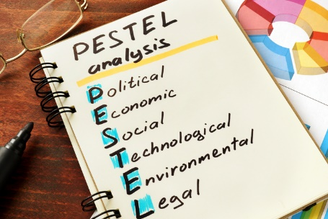
PESTEL Analysis

Figure 1: PESTLE Analysis (Mrm, 2020)

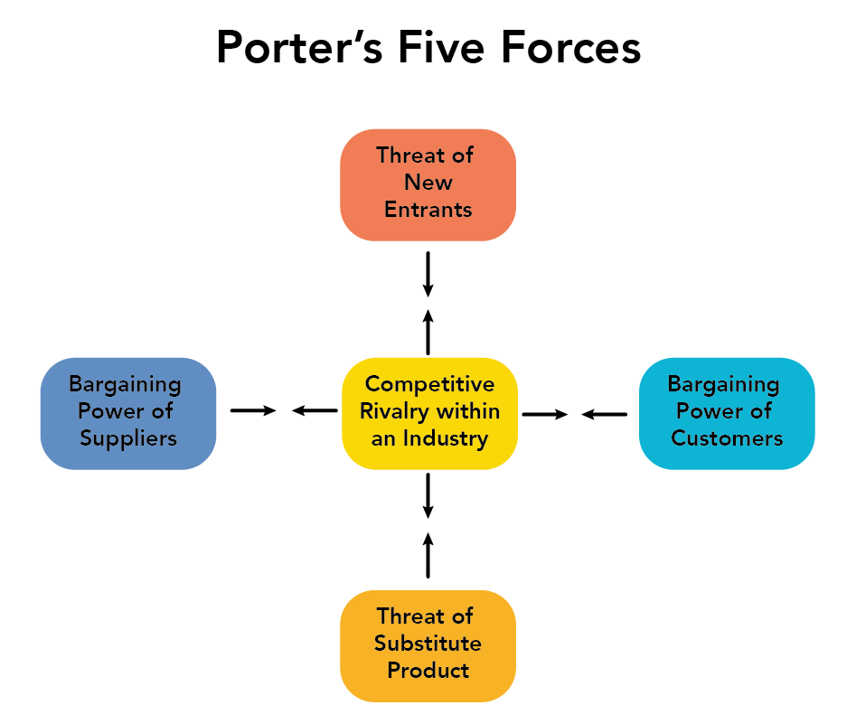
Porter's Five Forces

Figure 2: Porter’s Five Forces (Lumen, 2016)

