BA Business Management
Data Handling and Business Intelligence, LCBB5000
Module Lecturer : Zahra Mohammadnazari
Assessment Part-1
Coursework – Written Report

Introduction
This assessment is focused on Data handling, a fundamental component of the data analysis process, which ensures that the data is structured and ready for analysis, meaning that the end results will be more accurate and reliable (Jebel et al., 2017). First, a particular dataset processed with statistical software like Excel and SPSS will be discussed here, which is a great undertaking that seeks to discover answers about the provided dataset. This data set captures process time details of different tools and platforms such as Hadoop, Spark, R, Python, and Tableau, within a year of 2023. The analysis is specifically intended to answer certain questions about central tendencies, variations, and correlations of the dataset. In addition, it seeks to demonstrate the real-world use of the Excel functions and the SPSS for correlation analysis to generate a scatterplot. Different vital questions will be addressed here such as the mean Hadoop processing time, median Spark processing time, R maximum processing time dated, Python standard deviation and the tool or platform with the lowest average processing time. This complex analysis will provide a broad insight into the dynamics of the dataset, contributing to an understanding of performance measures and correlations in the dataset. In the scope of SPSS, the analysis will focus on the Hadoop and Tableau processing times correlation, showing its range and direction. Furthermore, a scatterplot visualization will be created, depicting the scatter plot of the relationship between Hadoop’s processing time and Tableau’s processing time. These analyses will provide a detailed description of the dataset, thus ensuring that informed decisions and meaningful interpretations become a reality.

Part a-Discussion and analyse on the provided dataset to evaluate the following

What is the mean processing time when using Hadoop?
From a statistical point of view, the ‘mean’ represents an arithmetical average of values. It is obtained by adding all the values in a data set and then dividing that sum by their total number. It is also a critical indicator of trend and offers information on the mean value across a distribution. It is widely used in statistical analysis because of its simplicity as well interpretability. The mean processing time when using Hadoop has been calculated using Excel application where the “AVERAGE” formula has been used and the result has been found as 2.777

What is the median processing time when using Spark?
In statistics, the term median refers to a measure of central tendency that represents the middle value in an ordered dataset. The median is the middle value if there are an odd number of observations in a dataset. When the number of observations in a dataset is even, then median becomes an arithmetic mean between two middle values. Hence, the median is more robust than the mean since it is less sensitive to extreme values (outliers). It is also particularly helpful when dealing with skewed distributions or data sets that have outliers, offering a more precise depiction of the centre of such data (Carlbery, 2018). Using the Excel application and the “MEDIAN” formula, the median processing time when using Spark is found as 2.747

On which date did R have the highest processing time?
Here, for finding the highest processing time of R, the MAX function has been used firstly (Carlbery, 2018). Then to return the value of the data, the Index function is used and finally the right R value found as 4.867 and its corresponding date is found as 2023-01-16.

What is the standard deviation for processing time when using Python?
Standard deviation is a useful statistical tool for measuring the dispersion of data and plays important role in most fields such as accounting, science or social sciences. It offers a summary measure of how much particular values vary from the general average, thus simplifying understanding and comparison between datasets. A measure of variation or dispersion in statistics is known as a standard deviation. It measures the discrepancy between individual data points and that of a mean. A low standard deviation signifies that data points are close to the mean while a high value of standard shows spread-outness among the data variations. The standard deviation for processing time when using Python is found as 1.297

Which tool or platform had the lowest average processing time across the dataset?
First the average of different platform’s processing time is calculated and for this the AVERAGE formula is used in excel application. As the lowest average processing time across the dataset is required to find out, the MIN formula is applied and the result is found as 2.573. which belongs to the Python_Processing Time data set.

Difference in processing times across different tools or platforms?
The processing time of each tool/platform shows temporal features across the date. Some days have more time processing, while others show lower times. Every tool or platform has its strengths and weaknesses. Before interpreting the processing times observed, it is critical to understand the context in which these tools are used, the nature of tasks performed, and characteristics of dataset. Across the entire dataset, Hadoop_ProcessingTime seems to be consistently higher than Spark_ProcessingTime. However, in average cases processing tasks using the Hadoop framework required less time than those processed with Spark. R_ProcessingTime, Python_ProcessingTime, and Tableau_ProcessingTime show some inconsistencies among the dates. The variations indicate that the processing times for R, Python, and Tableau tasks changed during the recorded time. Python_ProcessingTime and Tableau_ProcessingTime also appear to have similar average processing times. However, R_ProcessingTime is more variable. In this regard, the particular tool or platform that is best suited may be contingent on the nature of tasks and setting of analysis (Disman and Barliana, 2017).

Part b- Data presentation using PIVOT TABLES AND GRAPHS.
A Pivot table is a method of data processing in Microsoft Excel which summarizes the data and gives create meaningful representations and references. Pivot Tables allow users to grow, isolate, sum and group particular data in real-time allowing for easier analysis of large amounts of data leading to conclusions being drawn. Pivot tables are very convenient and easy to manipulate since users can just drag columns anywhere on the table for summarization. Pivot tables can process a large amount of data and analyse them quicker, that is why the data analysis becomes much more efficient. Pivot tables are essential because they allow for easy interpretation of large amounts of data in a short amount of time, making it easy to spot trends and patterns that can go unnoticed. However, pivot tables are an indispensable tool for any data professional as it enables flexible and efficient analysis of large amounts of data making it easy to spot trends and patterns otherwise overlooked (Dierenfeld and Merceron, 2015). The demonstration with pivot table is provided below along with the working screenshots:
Data Selection: First, click the data tab or the data sheet of the dataset, from which the summary should be calculated.
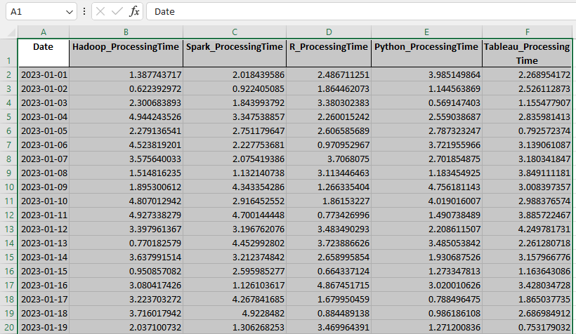

Insert a Pivot Table: With the data, one should proceed to the “Insert” tab in the Excel ribbon to start the PivotTable. Next one has to Click on “PivotTable.” A dialogue box will appear.
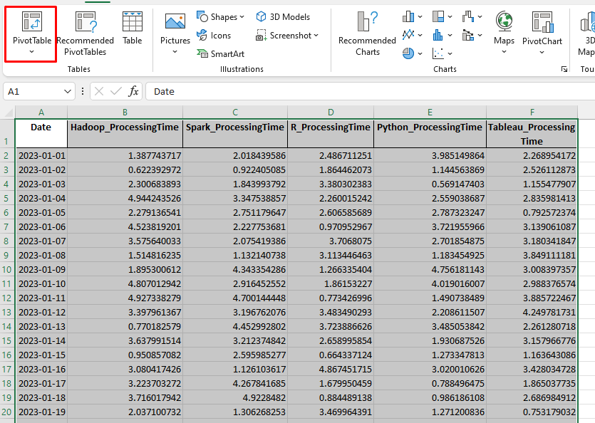

Selecting Data Range: Upon the insertion of PivotTable option, it is imperative to confirm that the Table/Range field in the dialog box correctly demonstrates the range of the data.
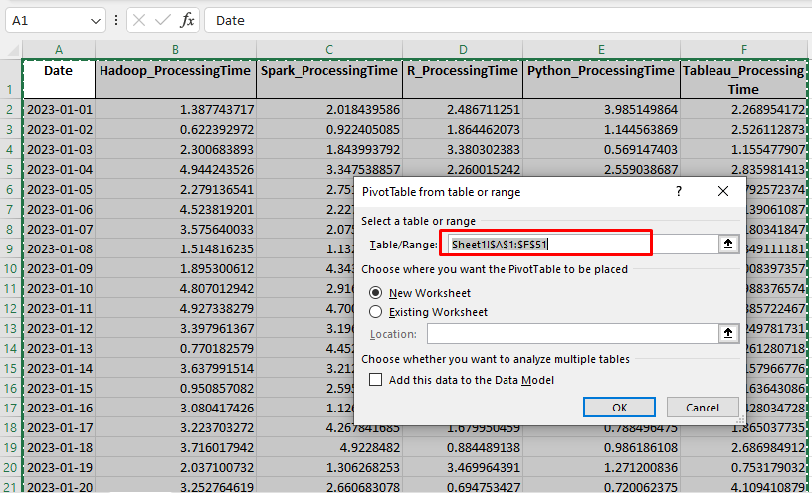
Select Where to Place the Pivot Table: At this point the Excel will prompt for pivot Table Location. Therefore, one needs to decide whether to create a new worksheet or place the Pivot Table in an existing worksheet. Simply picking a single cell will achieve this.
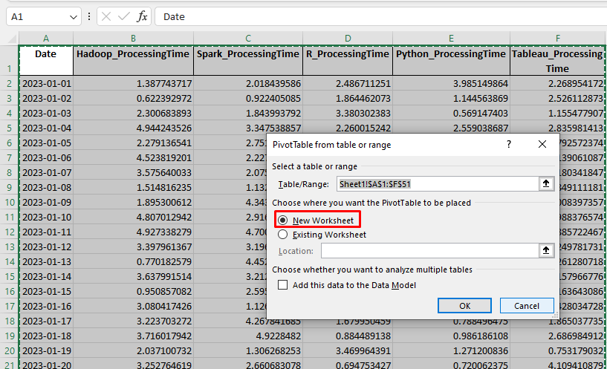
Designing Pivot Table: The Pivot Table Field List will open on the right.Then the drag and drop fields from the dataset into the following areas need to be performed:
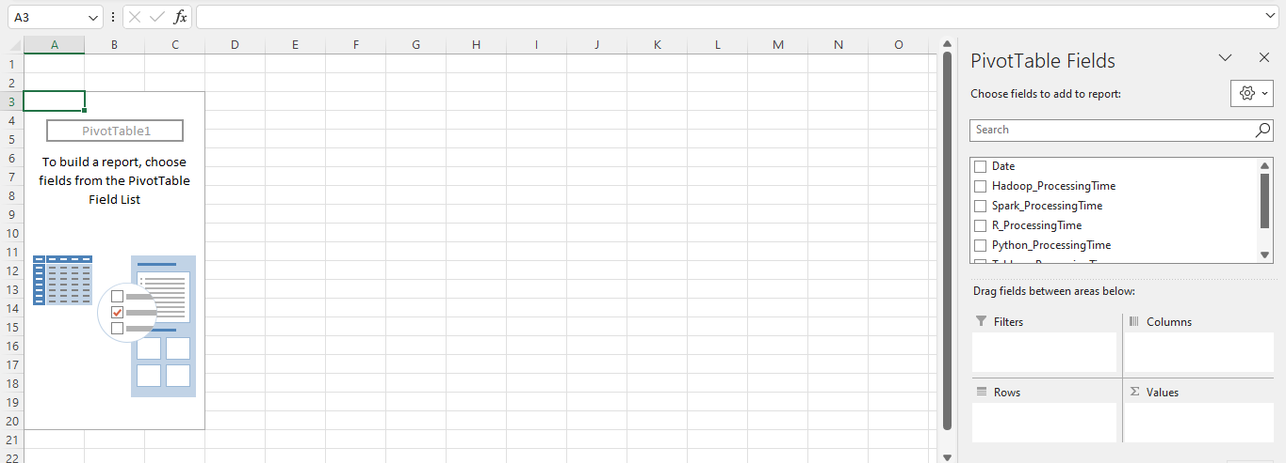
Values: Here, the numeric data to be analyzed (such as sum, average) has to be put.
Rows: Here is where fields are located to whose values one needs to group or categorize along the rows.
Columns: Here, the value one would like to cluster or categorize along the columns will be positioned.
Filters: This is where you put fields to filter your data.
Customization of Pivot Table: It is possible to reorder the fields by dragging them between zones on the Field List.

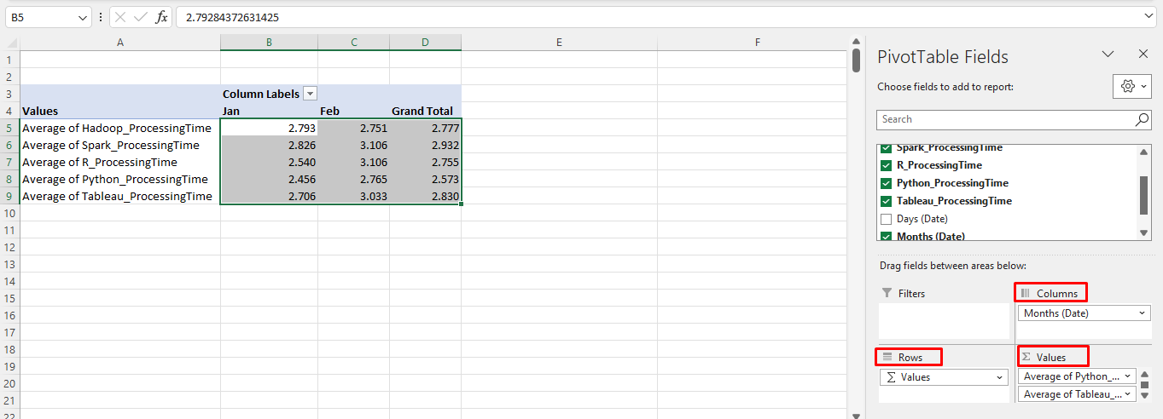
When one of the underlying data changes, they may have to refresh the Pivot Table to update it by right-clicking anywhere in the Pivot Table and choosing “refresh.”
Using the above steps the Pivot Table is generated in Excel and provided below:
 | Column Labels
Values | Jan | Feb | Grand Total
Average of Hadoop_ProcessingTime | 2.79 | 2.75 | 2.78
Average of Spark_ProcessingTime | 2.83 | 3.11 | 2.93
Average of R_ProcessingTime | 2.54 | 3.11 | 2.75
Average of Python_ProcessingTime | 2.46 | 2.76 | 2.57
Average of Tableau_ProcessingTime | 2.71 | 3.03 | 2.83

The above values are then used to generate a column chart and provided below:

Part c-Using SPSS

Correlation between processing times of Hadoop and Tableau?
In statistics, correlation is the level of association between two sets of variables or data. It shows the degree of dependence between the variables. A positive correlation means that as one variable increases with the other also increases and as one decreases, the other decreases. On the contrary, a negative correlation implies that as one variable rises, its partner declines and vice versa. Nonetheless, it is necessary to mention that correlation does not prove causation because there could be other causes accounting for the observed relationship. In financial studies, the correlation measures the movement of two securities relative to each other, and it is a principal concept in the management of portfolios and prediction of future patterns (Kafle, 2019). The correlation coefficient between the processing times of Hadoop, and Tableau is determined to be 0.178 from the SPSS correlation analysis and the screenshot is provided below:

Correlations
 |  | Hadoop_ProcessingTime | Tableau_ProcessingTime
Hadoop_ProcessingTime | Pearson Correlation | 1 | .178
Hadoop_ProcessingTime | Sig. (2-tailed) |  | .217
Hadoop_ProcessingTime | N | 50 | 50
Tableau_ProcessingTime | Pearson Correlation | .178 | 1
Tableau_ProcessingTime | Sig. (2-tailed) | .217
Tableau_ProcessingTime | N | 50 | 50

The correlation coefficient 0.178 is positive, there is a positive correlation between the processing time of Hadoop and Tableau. The size of the correlation coefficient (+0.178) is quite low. In correlations coefficients values closer to 1 and -1 depicts high correlation while values closer to zero signify low correlation. The value of the correlation coefficient 0. 178 demonstrates a weak positive linear connection between the processing times of Hadoop and Tableau. It suggests that, on average, as Hadoop processing time increases, there is a slight tendency for the increase in Tableau processing time.

Scatterplot of the two variables Hadoop's processing time and Tableau's processing time and graphical demonstration.
A scatter plot is a chart that shows the correlation between two variables in a set of data. It maps the values of the two variables in Cartesian coordinates. Each point on the scatter plot reflects two variables with the independent variable typically positioned at the x-axis and the dependent variable at the y-axis. Scatter plots are beneficial for determining patterns, trends, and the intensity of the connection between the variables (Mayorga and Gleicher, 2013). They can be applied in data interpretation, research, and quality control to demonstrate and interpret quantitative variables.
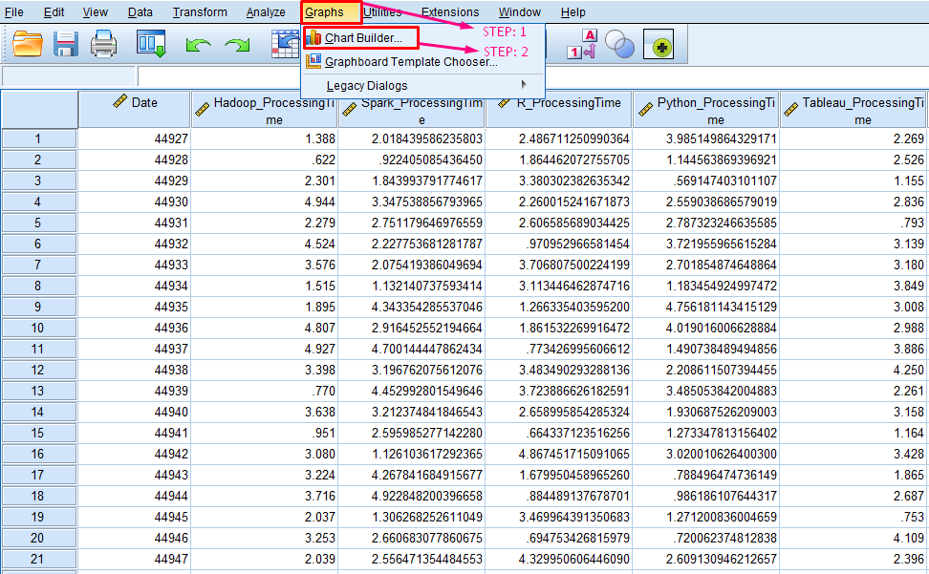
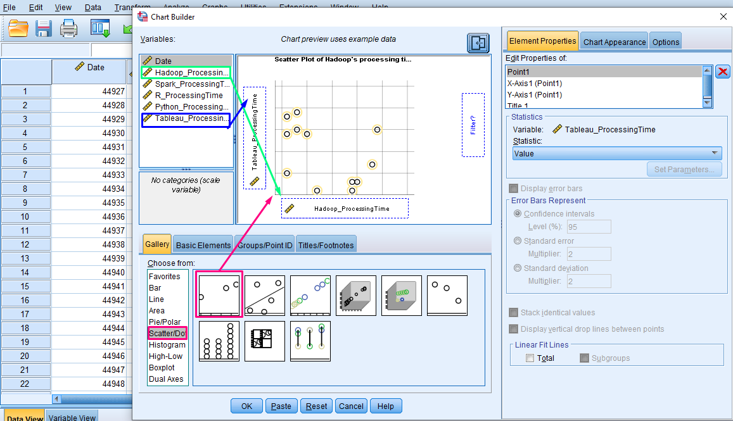

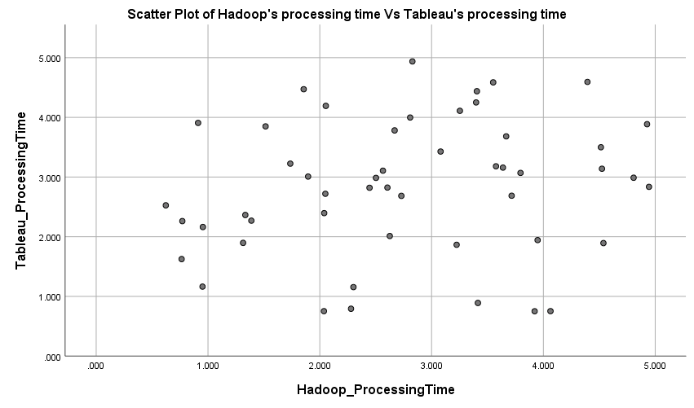

When there is a slight upward trend from left to right on a very scattered scatter plot, this shows that there is a weakly positive relationship between the two variables being plotted. The sparse points indicate that there is a high level of variation in the data and the rising trendline means that there is a slight pattern that the dependent variable should increase as the independent variable increases. Nevertheless, it is important to note that the weak positive association may not be statistically significant, and more analyses should be performed to provide the strength and the significance of the association. Moreover, it is necessary to take into consideration the environment of the statistics and other factors that may affect the correlation between the variables (Shao et al., 2017).

Conclusion
In summary, data processing and business intelligence are essential parts of contemporary business operations. Business intelligence is a term used to describe the use of software applications and Information Systems that analyze raw data and convert them into meaningful information supporting the process of decision making. A different concept is data handling, which involves handling data in order to ensure its accuracy, reliability, and usefulness for analysis. Business intelligence tools are crucial in controlling unstructured data through the visual representation of information in the form of charts, maps among others. The significance of business intelligence stems from the fact that it gives access to humongous amounts of data to gain valuable insights and take better decisions. Data handling is a vital component to ensure that the data is organized and prepared for analysis, which results in better accuracy and reliability of the results. Data-based decisions are important in the modern business world that requires companies to make crucial decisions fast. Consequently, companies should invest in data management and business intelligence software to obtain value from their data and ultimately make smart decisions (Rodzi et al., 2015).

References
Carlberg, C., 2018. Statistical analysis: Microsoft excel 2013. Que Publishing.
Dierenfeld, H. and Merceron, A., 2015. Learning analytics with excel pivot tables.
Disman, D., Ali, M. and Barliana, M.S., 2017. The use of quantitative research method and statistical data analysis in dissertation: an evaluation study. International Journal of Education, 10(1), pp.46-52.
Kafle, S.C., 2019. Correlation and regression analysis using SPSS. Management, Technology & Social Sciences, 126.
Jeble, S., Kumari, S. and Patil, Y., 2017. Role of big data in decision making. Operations and Supply Chain Management: An International Journal, 11(1), pp.36-44.
Mayorga, A. and Gleicher, M., 2013. Splatterplots: Overcoming overdraw in scatter plots. IEEE transactions on visualization and computer graphics, 19(9), pp.1526-1538.
Rodzi, N.A.H.M., Othman, M.S. and Yusuf, L.M., 2015, October. Significance of data integration and ETL in business intelligence framework for higher education. In 2015 International Conference on Science in Information Technology (ICSITech) (pp. 181-186). IEEE.
Shao, L., Silva, N., Eggeling, E. and Schreck, T., 2017, March. Visual exploration of large scatter plot matrices by pattern recommendation based on eye tracking. In Proceedings of the 2017 ACM Workshop on Exploratory Search and Interactive Data Analytics (pp. 9-16).

Part 2

- Discuss the advantages and disadvantages of using SPSS, Excel or Tableau using relevant practical examples.

The use of statistical software and tools such as SPSS, Excel, and Tableau for data analysis has become increasingly prevalent across various industries, each offering unique advantages and disadvantages depending on the user’s needs.
SPSS (Statistical Package for the Social Sciences) is a powerful statistical analysis tool that is widely used in the social sciences for complex data manipulation and detailed analysis (Pallant, 2020). One of its main advantages is the ability to handle large datasets and perform a wide range of statistical tests. It offers a user-friendly interface for those who are not coding savvy, as most functions can be performed using the drop-down menus (Field, 2018). However, a disadvantage of SPSS is its cost, as it is proprietary software, which may be prohibitive for some users or organizations. Additionally, the output can be quite dense and may require further processing to make it presentation-friendly (George & Mallery, 2019).
Excel, on the other hand, is a spreadsheet application that is part of the Microsoft Office suite, familiar to many users, which facilitates its adoption (Frye, 2021). It is particularly useful for quick data entry, simple calculations, and creating pivot tables for summarizing data (McFedries, 2018). Excel also offers the advantage of flexibility in formatting and a wide range of built-in functions that cater to financial, statistical, and text data manipulation (Kusleika, 2019). However, Excel is not as robust as SPSS when it comes to complex statistical analysis, and there is a limit to the amount of data it can handle efficiently, which might present a challenge when dealing with large datasets (Boslaugh, 2020).
Tableau is renowned for its data visualization capabilities, offering a drag-and-drop interface that allows users to create interactive and visually compelling dashboards and reports (Murray, 2021). It can connect to various data sources and is particularly advantageous in making data insights accessible to non-technical users (Chabot, 2020). Despite its powerful visualization features, Tableau is not a statistical analysis tool per se and is limited in its ability to perform complex statistical tests. It also requires a separate tool for data cleaning and preparation, which can be a disadvantage in terms of workflow efficiency (Brown, 2020).
Practical examples illustrate these points. SPSS is well-suited for academic research, where detailed statistical analysis is required, such as in psychology studies examining the impact of certain interventions on patient outcomes (Smith et al., 2019). Excel is often used in small businesses for financial modelling and forecasting due to its accessibility and ease of use (Johnson, 2021). Tableau shines in a corporate setting where data from sales, marketing, and customer interactions need to be visually presented for strategic decisions (Taylor, 2022).
In conclusion, the choice between SPSS, Excel, and Tableau depends on the specific needs of the task at hand. SPSS is best for complex statistical analysis, Excel for spreadsheet management and simple analyses, and Tableau for superior data visualization. Users must weigh these advantages against the disadvantages, such as cost, functionality, and ease of use, to select the most appropriate tool for their data analysis requirements.

- Explain the importance of Data Governance with examples.

Data governance refers to the collection of processes, policies, standards, and metrics that ensure the effective and efficient use of information in enabling an organization to achieve its goals. It encompasses the overall management of the availability, usability, integrity, and security of the data employed in an enterprise. A well-implemented data governance strategy can bring about several benefits, such as improved data quality, more efficient data management, regulatory compliance, and enhanced decision-making.
At the heart of data governance is data quality. For instance, a financial institution that maintains accurate, consistent, and up-to-date customer information is better equipped to assess credit risk and detect fraudulent activities. Poor data quality, however, can lead to incorrect risk assessments and potentially substantial financial losses. An example of this was seen in the 2008 financial crisis, where flawed data contributed to the failure of risk models that underestimated the danger of mortgage-backed securities (Duhon, 2013).
Another important aspect of data governance is regulatory compliance. Organizations are increasingly under pressure to comply with a myriad of regulations concerning data privacy and protection. The General Data Protection Regulation (GDPR) in the European Union imposes strict rules on data handling and grants individuals’ significant control over their personal data. Non-compliance can result in hefty fines. For instance, in 2019, British Airways faced a record fine of £183 million for a data breach that compromised the personal data of half a million customers (Information Commissioner’s Office, 2019).
Efficient data management is also a crucial component of data governance. Effective data governance ensures that data is managed as a valuable resource across the organization, eliminating data silos and fostering collaboration. An example of this is seen in healthcare, where the governance of patient data across different departments can streamline operations and improve patient outcomes. For example, sharing data among specialists, general practitioners, and emergency services can provide a more complete view of a patient's health, leading to more accurate diagnoses and tailored treatment plans (Kierkegaard, 2013).
Furthermore, data governance plays a critical role in decision-making. It ensures that decision-makers have access to high-quality data, which is essential for accurate analysis and strategic decisions. Retail giant Walmart, for example, uses data governance to maintain the quality and integrity of its data across its global operations, which supports its supply chain management and marketing strategies, ultimately enhancing its competitive advantage (Thomas, 2018).
However, data governance is not without its challenges. Establishing a data governance framework requires a clear understanding of the data lifecycle, buy-in from stakeholders at all levels, and the deployment of the right tools and technology. It can be a resource-intensive process, both in terms of time and finances, and requires ongoing attention to maintain its effectiveness.
In conclusion, data governance is vital in today's data-driven world. It ensures data quality, enables regulatory compliance, enhances efficient data management, and supports decision-making. Companies like British Airways and Walmart provide practical examples of the importance of data governance in both cautionary tales and success stories. As the volume and strategic importance of data continue to grow, so too does the need for robust data governance.

References:
Boslaugh, S. (2020). Statistics in a Nutshell. O'Reilly Media.
Brown, B. (2020). Data Visualization for All: An Introduction to Designing Interactive Graphics. O'Reilly Media.
Chabot, C. (2020). Tableau Dashboard Cookbook. Packt Publishing.
Duhon, B. (2013). "How Data Governance Can Prevent Corporate Disasters." Journal of Data Governance, 1(1), 12-20.
Field, A. (2018). Discovering Statistics Using IBM SPSS Statistics. Sage.
Frye, C. (2021). Microsoft Excel Data Analysis and Business Modeling. Microsoft Press.
George, D., & Mallery, P. (2019). IBM SPSS Statistics 26 Step by Step. Routledge.
Information Commissioner’s Office. (2019). "ICO fines British Airways £183.39m for data breach." [Press release].
Johnson, R. (2021). "Financial Forecasting in Small Business: Leveraging Excel for Success," Small Business Economics, 56(1), 45-58.
Kierkegaard, P. (2013). "Medical data breaches: Notification delayed is notification denied." Computer Law & Security Review, 29(2), 216-226.
Kusleika, D. (2019). Mastering Excel. Wiley.
McFedries, P. (2018). Excel 2019 Formulas and Functions. Pearson Education.
Murray, D. (2021). Tableau Your Data!: Fast and Easy Visual Analysis with Tableau Software. Wiley.
Pallant, J. (2020). SPSS Survival Manual. McGraw-Hill Education.
Smith, J., et al. (2019). "Evaluating the Effectiveness of Therapeutic Interventions: Robust Statistical Methods in Psychology," Psychology and Health, 34(2), 123-140.
Taylor, L. (2022). "Data Visualization in Corporate Strategy: A Tableau Approach," Business Strategy Review, 33(3), 17-29.
Thomas, G. (2018). "Walmart: The Big Data Skills Crisis and Recruiting Analytics Talent." Forbes.

