PROGRAMME: MASTER OF BUSINESS ADMINISTRATION
MODULE: MARKETING MANAGEMENT
MODULE CODE: LCMB7024
ASSIGNMENT TITLE: MARKETING ENVIRONMENT ANALYSIS OF TATA STEEL
LECTURER’S NAME: TAONGA KAONGA SOBERE-SNITHERS
STUDENT NAME: KRISH AVADABHAI ODEDRA
STUDENT ID: 2603808
FINAL WORD COUNT: 2640 WORDS
SUBMISSION DATE: 22ND OCTOBER 2026

Table of Contents
Task 1: Marketing Environment Analysis 3
1.1 Company overview 3
1.2 Analysis of market environment actors 3
1.2.1 Political, legal, and environmental (PEL) actors influencing Tata Steel’s transition towards lower-carbon products 3
1.2.2 Environmental factors pushing towards transition 7
Task 2: Strategic Growth and Competitive Positioning 9
2.1 Strategic Growth Strategy 9
2.1.1 Applying the Ansoff Matrix 9
2.1.2 Critical evaluation supported by PLC 9
2.1.3 Business unit or portfolio level analysis 11
2.1.4 Risk-adjusted Ansoff evaluation 11
2.2 Competitive Advantage and Positioning 12
2.2.1 Applying Porter’s Generic strategies 12
2.2.2 Strategic competitor matrix 12
2.3 Brief Strategic Synthesis 14
Task 3: Managerial and Professional Reflection 15
3.1 Rationale for Company Selection 15
3.2 Reflection on Environmental Analysis Decision 15
3.3 Reflection on Strategic Growth Decisions 15
3.4 Limitations and Gaps in the Analysis 16
3.5 Information Required Before Final Recommendation 16
3.6 Professional Learning and Reflection 16
Reference list 17

Task 1: Marketing Environment Analysis

1.1 Company overview
Tata Steel is recognised as one of the highest-valued companies in the global metal and mining sector, with consolidated revenue exceeding ₹2,32,140 crore and 6% YoY growth (Tata Steel, 2026). However, external actors, including environmental, political, and legal factors, are putting serious pressure on Tata Steel to transition to low-carbon products to capture market opportunities in green steel.
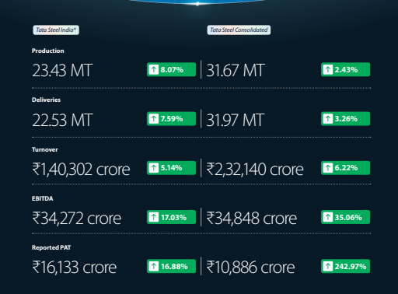
Figure 1: Economic output of Tata Steel in FY26
(Source: Tata Steel, 2026)

1.2 Analysis of market environment actors

1.2.1 Political, legal, and environmental (PEL) actors influencing Tata Steel’s transition towards lower-carbon products
Political environmental actor
India’s Ministry of Steel launched the “Green Steel Initiative” and classified green steel as finished steel that generates less than 2.2 tonnes of CO₂e per tonne of finished steel. The Ministry of Steel launched a star rating system in the green steel taxonomy, reserving 5-star for <1.6 t-CO₂e/tfs, 4-star for 1.6 to 2.0 t-CO₂e/tfs, and 3-star for 2.0 to 2.2 t-CO₂e/tfs. This Green Steel initiative created a political catalyst for Tata Steel, which reported 2.22 t-CO₂e/tcs in GHG emission intensity, to transition toward low-carbon initiatives.
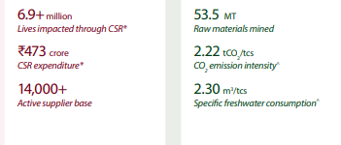
Figure 2: CO₂ emission intensity of Tata Steel in FY26
(Source: Tata Steel, 2026)
Internationally, the European Union’s Carbon Border Adjustment Mechanism (CBAM) and the USA’s 25% Section 232 tariff are major political actors that are motivating Tata Steel to transition toward low-carbon products. CBAM subjects steel imports to $54 per ton of CO2 in 2030 and $147 per ton of CO2 in 2034, creating a financially non-viable scenario for Tata Steel (Global Efficiency Intelligence, 2026). To overcome political barriers, Tata Steel sought UK government funding of £500 million as part of its estimated £1.25 billion investment in the Port Talbot plant to replace the carbon-intensive blast furnace with an electric arc furnace (EAF), which is expected to be functional by 2029 (Yahoo Finance, 2026).
On the other hand, dependence on government funds reveals a strategic flaw in the decarbonisation strategy, as the advancements will be directly intertwined with the evolution of the political climate. In India, Tata Steel made a ₹3,200 crore investment in Ludhiana, Punjab, with a capacity of 0.75 MTPA, employing 50% renewable energy and a Zero Effluent Discharge system, intending to limit the GHG footprint to less than 0.3 tCO₂/tcs (IBEF, 2026).

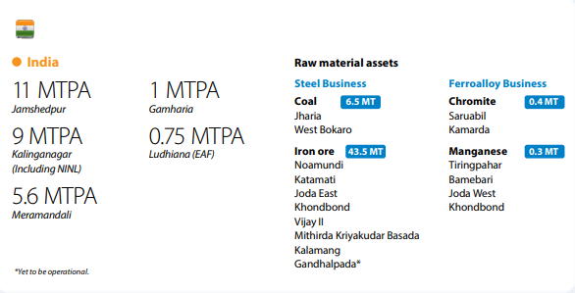
Figure 3: Ludhiana EAF plants expected output efficiency
(Source: Tata Steel, 2026)
Legal environmental actor
Domestically, as per Securities and Exchange Board of India (SEBI) obligations, top Indian firms must publish a Business Responsibility and Sustainability Report (BRSR) annually. In the FY26 BRSR disclosure, Tata Steel reported Scope 1 and 2 emissions of 26,723,790 tonnes of CO₂e (Scan X News, 2026). As a corrective course of action, Tata Steel recycled approximately 4.6 million tonnes of scrap steel. Internationally, the GHG disclosure led to a €20 million in Dutch subsidiary, TSN, with threats of revoking operational permits in the Netherlands in case of failing to meet decarbonisation targets (Upadhyay, 2026).
Therefore, regulatory actors create immediate pressure on Tata Steel to transition toward a low-carbon product portfolio to continue its operation in overseas markets. Threats of revoking operating permits act as regulatory pressure on Tata Steel to concentrate on the circular economy, committing to increase scrap use from 17% to 30% at TSN as part of its decarbonisation strategy (Tata Steel, 2026).

Environmental actor
This is one of the most critical and foundational factors that creates immediacy for Tata Steel to undergo green transformation. The Ministry of India’s Iron and Steel Scrap Recycling initiative aims to meet average global standards of 31% scrap reutilisation by 2031, which serves as another regulatory actor that helped to accelerate scrap reutilisation benchmarks for Tata Steel (Recycling International, 2026).
Scrap reutilisation, a highly accessible resource, can accelerate Tata Steel’s decarbonisation rate by 70-75%. However, Tata Steel is facing challenges regarding other critical corrective pathways. For example, the implementation of hydrogen-based Direct Reduced Iron (DRI) technology faces infrastructural hurdles due to high investment costs, as only 2.8% of national planned green hydrogen capacity is functional (Chintan Research Foundation, 2026).
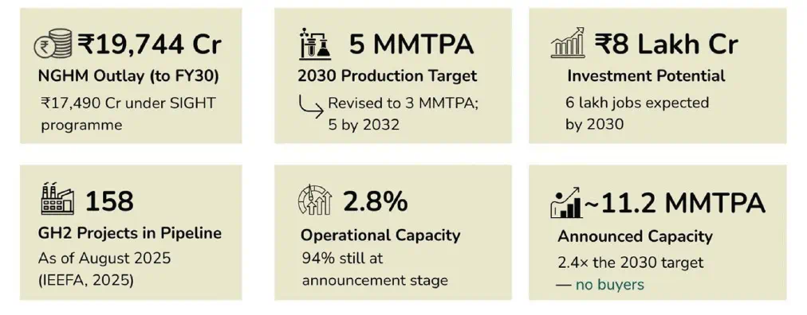
Figure 4: Present state of lack of functionality of planned production capacity of green hydrogen
(Source: Chintan Research Foundation, 2026)
Automotive consumers, such as Jaguar Land Rover, are demanding a sustainable supply chain to meet their net-zero goals and reduce Scope 3 emissions by 54% from their average vehicle value chain (RMI, 2026). As steel is an integral manufacturing component, upstream suppliers like Tata Steel need to accelerate decarbonisation plans to be able to offer certified low-carbon products as soon as possible. Failing to offer certified low-carbon products may lead to weakening competitive positioning and losing premium clients.
ESG-driven pressure can permeate into macroeconomic factors, and in the global market, industry positions are undoubtedly volatile, especially in the case of firms that are failing to meet external environment expectations. For example, Tata Steel observed a 20% drop in its stock price, from ₹185 in Q4 FY25 to ₹148 in Q1 FY26 despite satisfactory economic output (Acumen Group, 2026). From an environmental perspective, importing steel components that exceed the GHG emission benchmark can reduce access to the EU market due to violations of CSDDD.

1.2.2 Environmental factors pushing towards transition
The global conventional steel industry is one of the most energy-intensive industries in the world, accounting for a total of 11% of global CO₂ emissions in 2025 (Global Efficiency Intelligence, 2026). Hence, a shift toward decarbonised steel manufacturing with energy-efficient upgrades, such as incorporating EAF and green hydrogen-based DRI, has become a justifiable approach.
- Resource scarcity
It is another environmental factor that is driving Tata Steel’s transition toward low-carbon products. Scarcity of high-quality ores is also compelling industry leaders, such as BHP to replace 62% iron content with 60.8% in their product range (Fastmarkets, 2026).
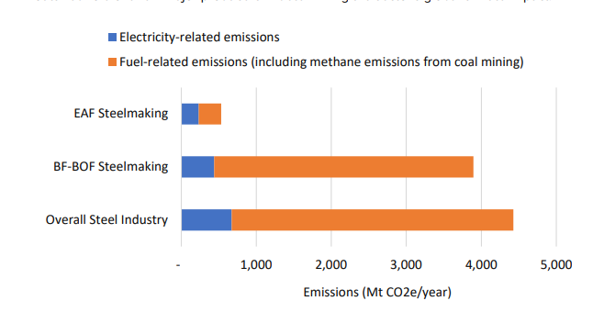
Figure 5: EAF steelmaking vs. conventional steelmaking GHG emissions comparison
(Source: Global Efficiency Intelligence, 2026)

Opportunity
The reutilisation of scrap helps Tata Steel to reduce 10-15% GHG emission compared to traditional steelmaking and leverage 100% metal efficiency, which leads to improving the star rating in the Green Steel Initiative Taxonomy and avoiding economic penalties in different EU markets (PIB, 2026; Scan X News, 2026).
Challenge
Reliance on a highly fragmented and informal supply chain network to get access to adequate steel scraps can lead to inconsistent production output.
- Environmental pollution
Conventional mining and metal activities are linked with environmental pollution, as one-third of these facilities contaminate water and 38% of these facilities contribute to baseline water stress (Paul, 2026). Tata Steel anticipated 0.30 kg/tcs stack dust emission in FY26-27, which can degrade ecosystems and compromise air quality (Tata Steel, 2026). For Tata Steel, freshwater consumption has been another factor driving its transition toward low-carbon products as the company exhausted <1.1 m3/ tcs freshwater in FY26. Hence, shifting to a sustainable production model ensures regulatory compliance.
Opportunity
The shift will help Tata Steel to avoid regulatory fines regarding air pollution, water contamination, and resource consumption.
Challenge
The initiative to implement Zero Liquid Discharge at all steelmaking sites can be capital-intensive for Tata Steel, tightening its profit margins.
From a critical viewpoint, environmental pressures overpower traditional pressure pints of price, quality, and quick ROI, as failing to transition toward low-carbon products may threaten operational resilience fir Tata Steel in the long term.

Task 2: Strategic Growth and Competitive Positioning

2.1 Strategic Growth Strategy
Ansoff Matrix determines the right directions of growth, whereas the Product Life Cycle (PLC) theory is determined to evaluate the development of the traditional and low-carbon steel products.

2.1.1 Applying the Ansoff Matrix
Strategy vector | Relevance | Core strategic rationale
Product development | High (primary vector) | Capitalises on existing B2B clients, addressing Scope 3 emission reduction with products such as Zeremis mass-balanced steel and Ludhiana EAF scrap-based steel as new carbon products
Market development | Medium–high (secondary vector) | Penetrating EU market as a carbon-regulated region with decarbonised steel variant
Market penetration | Low–medium (baseline) | Conventional steel-oriented cash generation and tightening carbon taxes with legal bodies
Diversification | Low (unfavourable) | Operational risk and high capital intensity diverting resources
Table 1: Ansoff matrix application
(Source: Influenced by Zugay, 2023; Tata Steel, 2026)

2.1.2 Critical evaluation supported by PLC
The vital growth venture for Tata Steel is the product development strategy. Applying the Product Life Cycle (PLC) Theory, the maturity/decline stage is achieved with conventional blast-furnace steel that highlights carbon penalisation. On the other hand, the Introduction/Growth stage is obtained with verified green steel such as Zeremis, EAF-based steel (Tata Steel Nederland, 2026).
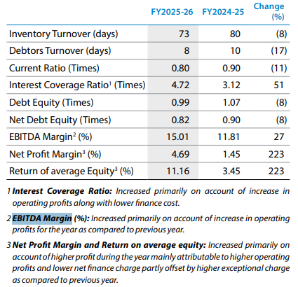
Figure 6: EBITDA margins with focused differentiation strategy
(Source: Tata Steel, 2026)
It can be aligned with the Focused Differentiation strategy of Porter’s Generic Model, where premium pricing is ensured for green steel commands by offering verified carbon traceability along with Scope 3 compliance (Mundkur and Iyengar, 2026). The secondary enabler, Market Development, is achieved with market entry into new geographic markets. The differentiation strategy highlighted heavily regulated zones that may create high entry barriers for high-carbon competitors like SAIL and HBIS Group & Ansteel Group. On the other hand, Market Penetration reduces profit returns, while diversification creates risks by diverting capital away from EAF and hydrogen infrastructure.

2.1.3 Business unit or portfolio level analysis
Category | Product line | Strategic action
Cash cows | Legacy BF-BOF Carbon Steel | Cash cow flow harvestment for investing in decarbonisation operations
Stars | Certified Low-Carbon Steel (Zeremis, Ludhiana EAF) | Market security and share management with heavy investment to support expansion of green steel sector
Question marks | Green Hydrogen Direct Reduced Iron (DRI) | Selective R&D-related investment for commercial viability check
Dogs | High-emission legacy assets | Controlling carbon liabilities with decommissioning
Table 2: Growth-share strategies of Tata Steel
(Source: Tata Steel, 2026; Mahapatra et al., 2024)

2.1.4 Risk-adjusted Ansoff evaluation
Risk adjustment after evaluation of expansion strategies of Tata Steel through the Ansoff matrix can be evaluated as below:
- Product development risk: Guaranteed B2B demand and innovative technology can moderate the risks of capital expenditure (CapEx) (38% increase) along with scrap procurement constraints (PTI, 2026).
- Market development risk: Collaboration with authoritative bodies will help control regulatory uncertainty, such as CBAM adjustments and trade protectionism.
- Strategic verdict: Product development is designed to optimise the risk-return profile, while increasing ROE by 11.44% with minimised market expansion conflicts (Tata Steel, 2026).

2.2 Competitive Advantage and Positioning

2.2.1 Applying Porter’s Generic strategies
The transformation from Cost leadership to a focused differentiation strategy has gained access to a low-carbon portfolio. The green products from the 0.75 MTPA Ludhiana EAF plant included Zeremis mass-balanced steel and scrap-based products, which is built with a ~₹3,200 crore investment and delivered sub-0.3 tCO₂e/tcs carbon intensity (Tata Steel, 2026). Price competition is controlled with this premium positioning that is strengthened with certified carbon traceability against high-emission companies such as SAIL (2.55 tCO₂/tcs) (CII, 2026). It aided in obtaining heavy decarbonization CapEx. For example, a £500M UK Government grant is achieved in the £1.25 billion Port Talbot project through green price premiums from Scope 3-conscious B2B buyers (Business Today, 2026).

2.2.2 Strategic competitor matrix
Metric | Tata Steel | JSW Steel
Deliveries / Revenue | 31.97 MT / ₹2,32,140 Cr | 29.63 MT / ₹1,85,470 Cr
EBITDA / OPM | ₹34,848 Cr (~15.0%) | ₹29,821 Cr (~16.1%)
CO₂ Intensity Target | <0.3 tCO₂/tcs (Ludhiana EAF) | ~1.95 tCO₂/tcs target (FY30)
Table 3: Competitive market scenario
(Source: Tata Steel, 2026; JSW Steel, 2026)
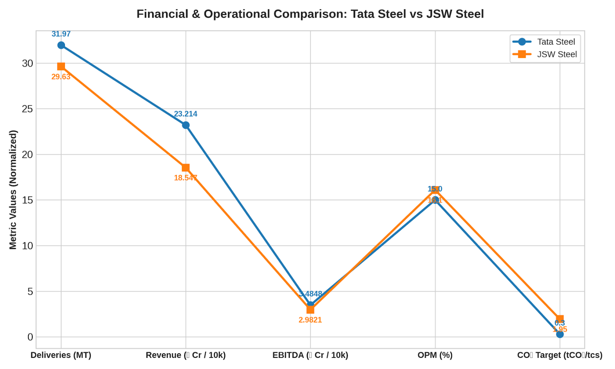
Figure 7: Comparing Tata Steel with JSW Steel
(Source: Self-developed)
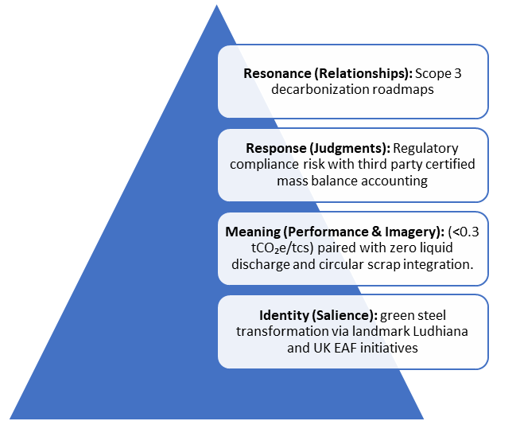
Figure 8: Applying Keller’s Customer-Based Brand Equity (CBBE) Pyramid
(Source: Influenced by Bukhari and Bukhari, 2025)
The data indicates that top-line scale is effective for cash flow generation while reserving funds for green CapEx. On the other hand, high operational profitability is the main driving factor for EAF and CCUS research and development. Nonetheless, the Ludhiana EAF has established an industry benchmark in low-carbon steel production.

2.3 Brief Strategic Synthesis
Tata Steel operates through first-mover green initiatives following the Climate Action framework that establishes market salience while driving technical performance and certified regulatory compliance. The systematic progression helped to develop B2B trust and climate risk control while achieving long-term co-development partnerships to integrate the customer decarbonisation roadmaps.

Task 3: Managerial and Professional Reflection

3.1 Rationale for Company Selection
The selection of Tata Steel is supported by its high-impact performance involving carbon-intensive production that helped to navigate strict global decarbonisation mandates. The multiregional operations, target of Net Zero by 2045 and transition from coal-based Blast Furnace to Electric Arc furnaces (EAF) provided a strong empirical business scenario to evaluate ESG strategies supported by industrial decarbonisation pathways. Tata Steel is aiming to decrease the CO2 emission by 2 tonnes per tonne of crude steel.

3.2 Reflection on Environmental Analysis Decision
As external environmental actors, political, legal, and environmental actors have been chosen to understand how external factors are forcing Tata Steel to adopt energy-efficient steelmaking methods. As I engaged in evaluating my actions in this assignment, I understood that these three external environmental actors are interconnected. Especially, political agenda enact legal actions, such as compliance fees, taxes, or restricted access to a highly-profitable market, which help businesses comprehend the repercussions of their environmental actions, and develop an effective decarbonisation framework.

3.3 Reflection on Strategic Growth Decisions
Mapping out strategic growth applying the Ansoff matrix helped to identify risks associated with both product and market development. Also, application of the Product Lifecycle theory helped to comprehend the feasibility of EAF to replace conventional blast-furnace. Most importantly, the application of the theoretical frameworks underscored the importance of undergoing a strategic transformation by mitigating risk. The Gibbs reflective model helped me to identify and evaluate the recent strategy followed by Tata Steel. Gibbs reflective model has helped me to describe and analyse the marketing environment position of Tata Steel in recent times. Also Gibbs reflective model has also helped me to come down to the conclusion that Tata Steel must advance its technological capacity to implement green hydrogen-based DRI and develop its own supply chain to procure adequate scrap steel to implement the circular economy.

3.4 Limitations and Gaps in the Analysis
While developing this report, I understood that instead of adopting a secondary research creates certain gaps in the finding, as the findings are presented based on the information published in the industry reports, Tata Steel’s sustainability report, and annual reports. There is always a possibility that industry reports and Tata Steel’s internal audits would be motivated to conceal repercussions of strategic decisions and their drawbacks, highlighting only positive aspects of sustainability initiatives. Therefore, secondary research may have led to a limited and biased overview of the decarbonisation initiatives. I conclude that primary research would have helped to overcome these limitations by collecting insights and opinions directly from the employees, stakeholders, and managers to understand how external factors are compelling Tata Steel to transition to environment-friendly products.

3.5 Information Required Before Final Recommendation
In a practical scenario, I would strongly suggest a real consultant to evaluate the growth scope of green steel components against required CapEx, industry trends, durability of the energy-efficient products, compare ROI expectations, and conduct a thorough competitor benchmarking to ensure that Tata Steels transition to green and carbon-neutral products are successful. Also, a consultant must consider the highly fragmented nature of India’s supply chain networks and conduct financial growth projections before presenting final recommendations to a real-life firm.

3.6 Professional Learning and Reflection
Professionally, I think it is critical to learn to make sense of financial data correctly to properly understand industry trends and identify challenges. Personally, I would like to strengthen my decision-making capability and data synthesising.

Reference list
Acumen Group, (2026). Tata Steel Share Price Analysis 2026: Fundamentals, Valuation, Risks & Investment Outlook . [Online]. Available at: https://acumengroup.in/tata-steel-share-price-analysis/ [Accessed on: 17/09/2026]
Bukhari, S.N.Z. and Bukhari, S.A.A., (2025). Customer-Based Islamic Brand Equity (CBIBE) Pyramid. Journal of Climate and Community Development, 4(1), pp.78-90.
Business Today (2026). Tata Steel seeks fresh UK government funding as Port Talbot project faces delays. [Online]. Available at: https://www.businesstoday.in/latest/corporate/story/tata-steel-seeks-fresh-uk-government-funding-as-port-talbot-project-faces-delays-556642-2026-09-19 [Accessed on: 13/09/2026]
Chintan Research Foundation, (2026). The Missing Half of India's Green Hydrogen Strategy: Why demand-side policy is essential to realize the NGHM's industrial decarbonization potential. [Online]. Available at: https://www.crfindia.org/publications/issue-brief/the-missing-half-of-indias-green--hydrogen-strategy [Accessed on: 20/09/2026]
CII (2026). Catalysing Demand for Green Steel through Public Procurement in India. [Online]. Available at: https://climatecatalyst.org/wp-content/uploads/2026/02/Catalysing-Demand-for-Green-Steel-through-Public-Procurement-in-India-Report.pdf [Accessed on: 12/09/2026]
Fastmarkets, (2026). Iron ore quality decline meets green steel ambitions. [Online]. Available at: https://www.fastmarkets.com/insights/iron-ore-quality-decline-meets-green-steel-ambitions/ [Accessed on: 18/09/2026]
Global Efficiency Intelligence, (2026). Steel Climate Impact 2025. [Online]. Available at: https://static1.squarespace.com/static/5877e86f9de4bb8bce72105c/t/68f30ceebdbccf7dc6b7c877/1760759022538/Steel+benchmarking+-10.10.2025-E.1.pdf [Accessed on: 20/09/2026]
Global Efficiency Intelligence, (2026). The Impact of the EU CBAM on Global Steel Trade. [Online]. Available at:. https://www.globalefficiencyintel.com/the-impact-of-the-eu-cbam-on-global-steel-trade [Accessed on: 21/09/2026]
IBEF, (2026). Tata Steel inaugurates first scrap-based Electric Arc Furnace with Rs. 3,200 crore (US$ 341.62 million) investment. [Online]. Available at: https://www.ibef.org/news/tata-steel-inaugurates-first-scrap-based-electric-arc-furnace-with-rs-3-200-crore-us-341-62-million-investment [Accessed on: 21/09/2026]
JSW Steel (2026). JSW Steel annual report 2025-26. [Online]. Available at: https://www.jswsteel.in/jsw-steel-annual-report-2025-26/index.html [Accessed on: 14/09/2026]
Kritish Upadhyay, (2026). Tata Steel Nederland Faces Potential Permit Revocation And €20 Million in Fines from Dutch Environment Agency. [Online]. Available at: https://tradebrains.in/tata-steel-nederland-faces-potential-permit-revocation-and-e20-million-in-fines-from-dutch-environment-agency/ [Accessed on: 21/09/2026]
Madhumita Paul, (2026). Two-thirds of global mining facilities face significant water risk, ICMM report says. [Online]. Available at: https://www.downtoearth.org.in/environment/two-thirds-of-global-mining-facilities-face-significant-water-risk-icmm-report-says [Accessed on: 19/09/2026]
Mahapatra, D., Roy, K. and Saha, B., (2024). Tata Steel’s Acquisition of Bhushan Steel: Steeling the Competition. Vikalpa, 49(2), pp.167-180.
Mundkur, J.P. and Iyengar, S.R., (2026). Sustainability and Competitive Advantage: Text and Cases. Taylor & Francis.
PIB, (2026). Indian Steel Sector Maintains Growth Momentum in April 2026; Prices Recover. Across Categories. [Online]. Available at: https://www.pib.gov.in/PressReleasePage.aspx?PRID=2258314&reg=48&lang=2 [Accessed on: 22/09/2026]
PTI (2026). Tata Steel aims to spend Rs 20,000 cr in FY27 on expansion, adoption of technologies. [Online]. Available at: https://cfo.economictimes.indiatimes.com/news/strategy-operations/tata-steel-aims-to-spend-rs-20000-cr-in-fy27-on-expansion-adoption-of-technologies/132192706 [Accessed on: 14/09/2026]
Recycling International, (2026). India doubles down on scrap to fuel steel growth. [Online]. Available at: https://recyclinginternational.com/business/business-news/india-doubles-down-on-scrap-to-fuel-steel-growth/62990/ [Accessed on: 21/09/2026]
RMI, (2026). Steel: Tata Steel UK - JLR Pilot Test. [Online]. Available at: https://rmi.org/case-study-steel-tata-steel-uk-jaguar-land-rover/ [Accessed on: 17/09/2026]
Scan X News, (2026). Tata Steel files BRSR for FY26, details ESG performance. [Online]. Available at: https://scanx.trade/stock-market-news/companies/tata-steel-files-brsr-for-fy26-details-esg-performance/42043438 [Accessed on: 20/09/2026]
Tata Steel (2026). 119th Year Integrated Report and Annual Accounts 2025-26. [Online]. Available at: https://www.tatasteel.com/media/25904/tatasteel-iar-2025-26.pdf [Accessed on: 15/09/2026]
Tata Steel (2026). Tata Steel Inaugurates its first Scrap-based Electric Arc Furnace in India. [Online]. Available at: https://www.tatasteel.com/newsroom/press-releases/india/2026/tata-steel-inaugurates-its-first-scrap-based-electric-arc-furnace-in-india/ [Accessed on: 15/09/2026]
Tata Steel Nederland (2026). Move forward on CO₂ reduction. Starting today. [Online]. Available at: https://products.tatasteelnederland.com/services/sustainable-solutions/zeremis [Accessed on: 15/09/2026]
Tata Steel, (2026). Integrated Report and Annual Accounts 2025-26. [Online]. Available at: https://www.tatasteel.com/media/25904/tatasteel-iar-2025-26.pdf [Accessed on: 20/09/2026]
Yahoo Finance, (2026). Tata Steel seeks new government funding as industry crisis deepens. [Online]. Available at: https://uk.finance.yahoo.com/news/tata-steel-seeks-government-funding-081100944.html [Accessed on: 19/09/2026]
Zugay, B., (2023). Ansoff matrix. SAGE Publications, Inc..

