Rahima khatun
ANALYZING THE CHALLENGES FACED BY THE MARRIOTT BONVOY ESCAPES IN MANAGING EMPLOYEE ENGAGEMENT DURING PANDEMIC
Kathyrn Roberts

Task 1
Introduction
The hospitality industry is a broad sector in the service industry which includes food, lodging, event planning, travel, tourism and more. The hospitality industry includes hotels, restaurants, and tourism agencies. In the current scenario, the hospitality industry, especially hotels, is facing challenges in managing its employee turnover. Due to the pandemic COVID-19, the hospitality sector is facing a large number of challenges, and due to the lockdown, the tourism industry has been affected drastically, which eventually impacted the hotel business. Therefore, the present study highlights the issues regarding employee engagement and motivation by considering the Marriott Bonvoy Escapes hotel, a UK-based hospitality organization.
Background of the hotel
Marriott Bonvoy Escapes hotel is a reputed name associated with the hospitality industry of the UK for several years. The hotel organization has been seen to provide an effective staying facility to the customers with all kinds of amenities that help the customers to be satisfied with the services and benefits they get (Marriott, 2022). The hotel is renowned in the UK for the reason of the lowest price offered and the views it provides inside the hotel premises and rooms. Marriott Bonvoy Escapes hotel is known for its online tourism services in which it facilitates the customers with visits to local places to provide scenic beauty. The hospitality company not only provides hotels to the customers, it even provides homestays and villas for the beautiful day outs with an effectively lower price range.
Highlighted issues
The concerned hotel has been seen to face several issues regarding employee engagement and retention during the covid pandemic period. The lack of an effective and talented workforce has been witnessed by the organization due to forced lockdown, and the hotel faced a reduced number of customer presence. The challenges faced by the employee lifecycle and the benefits of retaining the workforce will be identified in this study. Over the last two years, the issues and challenges have had a severe impact on the lifecycle of an employee within the hotel industry around the world, including in the UK. These challenges result in a huge employee turnover which is affecting the hotel industry. The strategies to retain talented employees and how to develop a team moreover its impact on the hotel business will be discussed in this study. This study will evaluate several challenges that are faced by the concerned hotel and the hospitality industry in the UK at present and also analyse employee retention and its impact on business performance.

Task 2
The present research study will focus on the application of the positivism philosophy of research as it will conduct a primary survey method involving participants from the mentioned hotel in the positions of mid-level employees and managers. Although the application of the primary quantitative research process can be time taken, it will be able to provide the most relevant and updated data regarding the employee retention cycle and related issues that the Marriott Bonvoy Hotel is facing (Mohajan, 2018). A total of 15 questions will be developed as paper on the Likert scale, which will be given to a total of 25 participants belonging to the mentioned hotel. The survey questionnaire will be developed in the Google Form, and the link will be sent to them, and participants will have to complete the survey within 10 minutes (Newman and Gough, 2020). The employees will get a consent form and an ethical form for acknowledging methodological authenticity. The data analysis process will be done statistically by developing charts and graphs highlighting the responses.

Task 3
Discussion
Overview of employee engagement and retention
Over the past few years, the hotel industry has been facing a lot of challenges in retaining its employees, and for this reason, the employee life cycle is affected hugely during this pandemic. An employee life cycle refers to the various stages an employee goes through while engaging in a company. According to Cattermole (2019), the stages include attraction, recruitment, onboarding, development, retention and separation, and this cycle is heavily hampered due to the effect of COVID-19. The whole world has faced a huge economic crisis during a pandemic; moreover, restrictions are there for people regarding travelling. This caused a large number of customer crises in the hotels, and the industry went through severe economic challenges. This leads to huge employee turnover to conquer the economic burden of companies. Around 7.6 million jobs which are 24% of the workforce of the UK are at risk of job turnover (Mckinsey, 2020). The employees have extensively faced the issues regarding payments, work-life balance, health, job assurance and more. Therefore, the employees in the concerned hotel Marriott Bonvoy Escape have also faced extensive levels of employee turnover during the pandemic situation.
The management of the workplace is hampered due to the restrictions, and the integrative process is damaged due to remote work as hotels lacked customers during the pandemic and faced a huge loss. It is reported by the HM revenue and customs that under 1650000 employees in the hospitality sector fall to 590000 employees due to the impact of COVID-19, which means 25% of employee turnover happens due to the pandemic (Ons.gov.uk, 2021). It is reported by HMRC that during the pandemic, the hospitality industry, especially hotels, closed, falling from 81% to 54%. The hotel industry is mainly dependent on customers, and due to the restrictions of the pandemics, the industry faced a loss of customers. It is reported that the hospitality industry lost 1.3 trillion revenue in from 2020 to 2021 due to the impact of covid-19 (Business-standard, 2021). Hence, the concerned hotel faced monetary as well as workforce loss due to the lack of enough tourists and due to this, it lost its potential employees for the reason of workforce hampering.
Issues of employee engagement in Marriott Bonvoy Escapes Hotel
Due to the closure of the hotel, the process of recruitment of new employees slowed down in the concerned hotel. The employees faced a number of problems and pressure regarding the new norms of the government to conquer the pandemic. During the pandemic, the mentioned hotel organization faced a lot of challenges regarding employee relations. One of the main reasons for employee turnover is dissatisfaction with the salary, and it is seen that the employees continuously search for new opportunities as they do not get the right incentives. Silaban and Syah (2018) opined that most the employees leave their job for a 10% hike offered by another company, and they expect retirement benefits, health insurance and sick leave policies as a part of their packages.
Experienced employees of the hotel expected bonuses and rewards as an appreciation of their work, and this led to job satisfaction and also wanted work-life balance. As stated by Silaban and Syah (2018), employees who are not satisfied with their salary are more vulnerable to leaving jobs and companies are facing a huge challenge regarding salary in retaining the employee. Hence, huge competition in the hospitality industry is a major challenge for the hotel organization and for this challenge; the company faces losing employees and face problems related to customer retention.
Impacts of employee turnover on the hotel
The United Kingdom has experienced a lot of challenges due to COVID-19 in the accommodation and food industry. It is reported that there is a decrease in footfall due to the ongoing pandemic. As reported in August 2020, there is a 65% decrease in the food and accommodation business in footfall due to the ongoing pandemic and only 10.6% of the industry was increased in footfall (Statista, 2020). During these pandemic years there is a daily change in restaurants for seated dinners due to the Coronavirus pandemic in the UK. Customers are forced to stay at home and for this reason, they dine out less due to the social distancing and general cautions of public places. Therefore, the hotel has also witnessed the issues of dining and seating regarding the customer presence at its restaurants and hotels due to which it faced severe business loss.
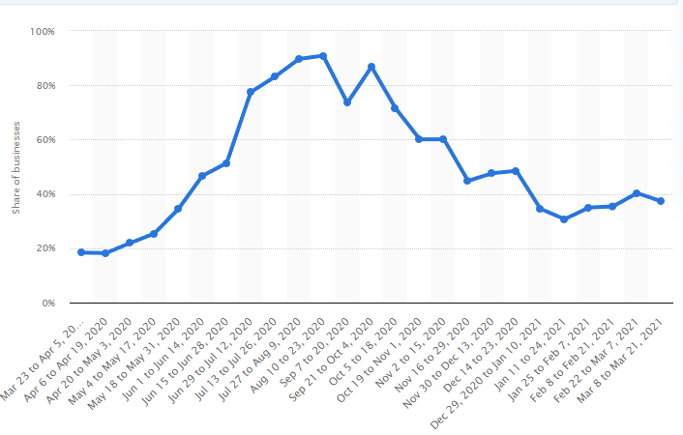
Figure 1: Drastic decrease in the hospitality and accommodation industry of the UK
(Source: Statista, 2020)
Due to the Coronavirus pandemic customers are more likely to be attracted to the hotels that follow the health regulations of the government. The hotel implements technologies for sanitization and they are focusing more on the cleanliness of hotels. In today's world, maintenance of sustainability to protect the environment is an important factor and business organizations including the hospitality industry are keeping it in mind as it will attract more customers. As stated by Alipour et al. (2019) sustainable practices are hugely implemented in the hotel industry and they are adopting green technologies for adapting sustainable management. Sustainable management in the hospitality industry needs the development of new strategies and technologies.
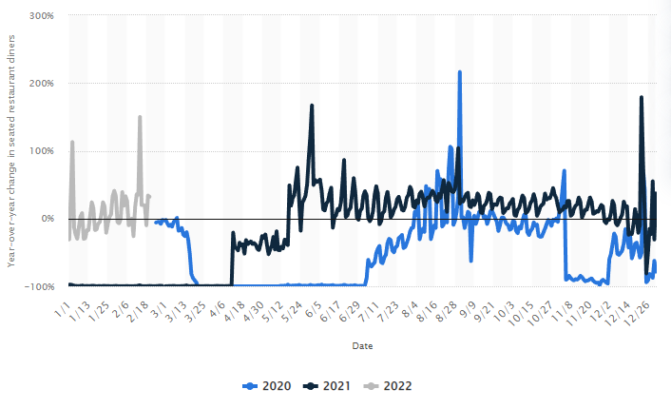
Figure 2: Seated dinner ratio in UK hotels from 2020 to 2022
(Source: statista, 2022)
The employee dissatisfaction regarding the workplace environment and others can be the main reason for poor employee engagement in the hotel. As per the reports, the seated dinners in the UK was 32% in 2020 compared to 2019 (Statista, 2022). Therefore, the hotel has faced a number of losses regarding its business and operations due to the poor life cycle of the employees during the covid pandemic situation.
Recommendations for employees retention regarding Marriott Bonvoy Hotel
Employee retention is associated with the hiring process and it is essential to hire the right individuals in the hotel industry. The organization has faced huge challenges while recruiting new employees as they do not find trained individuals who are suitable for the available post. The recruitment of inexperienced employees and talents may lead to turnover of the employee as they are unable to meet the needs of the mentioned hotel organization. In this context, Raghavan et al. (2020) stated that hiring the right candidates is critical for an organization to keep up its productivity and reputation. The organization needs to be realistic regarding the expectations from the employee however; unrealistic expectations can lead to employee turnover. High pressure, workload and unreasonable quality requirements can be the reasons for which employees leave their job in respect to the hotel. Implementation of sustainability requires experienced and trained employees and for this reason, it is important for the hospitality industry to retain its employees.

Task 4
Evaluation and Conclusion
The overall study has highlighted the issues of employee engagement and retention in Marriott Bonvoy Hotel of the UK during the pandemic situation and has recommended several strategies in respect to this. The accommodation and food industry has faced a lot of challenges during the pandemic COVID-19. For this reason, the industry is facing huge challenges regarding employee turnover which has a negative effect on the hotel industry. This study addresses the challenges faced by the hotel industry to retain its employees. It is identified that covid-19 has a great impact on this industry as its share and revenue get lower during this period. It is identified that salary dissatisfaction, unreasonable expectations and lack of appreciation are the reasons for employee turnover.
Additionally, in this competitive market, there are a lot of opportunities for an individual and an employee always searches for better opportunities to upgrade their career. Hotels that fail to deliver career development tend to lose their employees. Moreover, in today's world, sustainable practices can heavily attract customers which can be beneficial for the hotel to increase its economic status. The effect of pandemics on the accommodation and food business in the United Kingdom is discussed in this study. This study highlights the challenges faced by hotels in the UK in order to reduce employee turnover.
It can be stated that the Marriott Bonvoy Escape hotel has faced a number of issues and challenges during the pandemic situation due to lack of customer and poor employee life cycle. However, the workforce tends to leave the job as they do not get these facilities as a part of their package. A trained and experienced employee can adapt and learn the technologies for sustainable practices better compared to new employees. This will attract more customers and eventually, it will increase the economic status of the company, which is correlated to employee retention. Therefore, it can be said that the mentioned hotel operating in the UK has witnessed a huge loss in regard to employee engagement and retention due to the impact of covid pandemic.

References
Aguinis, H. and Burgi-Tian, J., 2021. Talent management challenges during COVID-19 and beyond: Performance management to the rescue. BRQ Business Research Quarterly, 24(3), pp.233-240.
Alipour, H., Safaeimanesh, F. and Soosan, A., 2019. Investigating sustainable practices in hotel industry-from employees' perspective: Evidence from a Mediterranean island. Sustainability, 11(23), p.6556.
Business-standard.com, 2021. Hotel industry says it lost Rs 1.3 trillion revenue in FY21, seeks help. [Online]. Available athttps://www.business-standard.com/article/economy-policy/fhrai-says-indian-hotel-industry-revenue-hit-in-fy-21-seek-govt-support-121051600214_1.htmlhttps://www.business-standard.com/article/economy-policy/fhrai-says-indian-hotel-industry-revenue-hit-in-fy-21-seek-govt-support-121051600214_1.html (Accessed on: 22nd June, 2022)
Cattermole, G., 2019. Developing the employee lifecycle to keep top talent. Strategic HR review.
Lee, S., 2018. Employee turnover and organizational performance in US federal agencies. The American Review of Public Administration, 48(6), pp.522-534.
Marriott. 2022. Home. Available at https://www.marriott.com/loyalty/earn/reward-partners.mi [Accessed on 24 June 2022]
Mckinsey.com, 2020. COVID-19 in the United Kingdom: Assessing jobs at risk and the impact on people and places. [Online]. Available from https://www.mckinsey.com/industries/public-and-social-sector/our-insights/covid-19-in-the-united-kingdom-assessing-jobs-at-risk-and-the-impact-on-people-and-places (Accessed on: 22nd June, 2022)
Mohajan, H.K., 2018. Qualitative research methodology in social sciences and related subjects. Journal of Economic Development, Environment and People, 7(1), pp.23-48.
Newman, M. and Gough, D., 2020. Systematic reviews in educational research: Methodology, perspectives and application. Systematic reviews in educational research, pp.3-22.
Ons.gov.uk, 2021. Coronavirus and its impact on UK hospitality: January 2020 to June 2021. [Online]. Available athttps://www.ons.gov.uk/businessindustryandtrade/business/activitysizeandlocation/articles/coronavirusanditsimpactonukhospitality/january2020tojune2021https://www.ons.gov.uk/businessindustryandtrade/business/activitysizeandlocation/articles/coronavirusanditsimpactonukhospitality/january2020tojune2021 (Accessed on: 22nd June, 2022)
Raghavan, M., Barocas, S., Kleinberg, J. and Levy, K., 2020, January. Mitigating bias in algorithmic hiring: Evaluating claims and practices. In Proceedings of the 2020 conference on fairness, accountability, and transparency (pp. 469-481).
Silaban, N. and Syah, T.Y.R., 2018. The influence of compensation and organizational commitment on employees’ turnover intention. IOSR Journal of Business and Management, 20(3), pp.1-6.
Stamolampros, P., Korfiatis, N., Chalvatzis, K. and Buhalis, D., 2019. Job satisfaction and employee turnover determinants in high contact services: Insights from Employees’ Online reviews. Tourism Management, 75, pp.130-147.
Statista.com, 2022. Share of accommodation and food service businesses trading during the coronavirus pandemic in the United Kingdom (UK) from March 2020 to March 2021. [Online]. Available at https://www.statista.com/statistics/1168552/share-of-hospitality-businesses-trading-in-the-uk/https://www.statista.com/statistics/1168552/share-of-hospitality-businesses-trading-in-the-uk/ (Accessed on: 22th June, 2022)
Statista.com, 2022. Year-over-year daily change in seated restaurant diners due to the coronavirus (COVID-19) pandemic in the United Kingdom (UK) from February 24, 2020 to February 20, 2022. [Online]. Available athttps://www.statista.com/statistics/1104991/coronavirus-restaurant-visitation-impact-united-kingdom-uk/https://www.statista.com/statistics/1104991/coronavirus-restaurant-visitation-impact-united-kingdom-uk/ (Accessed on: 22th June, 2022)
Velikorossov, V.V., Filin, S.A., Genkin, E.V., Maksimov, M.I., Krasilnikova, M.A. and Rakauskiyene, O.G., 2020. HR systems as a new method for the automatization of business processes in the organization. In 2nd international conference on pedagogy, communication and sociology (ICPCS (No. 2020, p. 415).
Wang, Y., Xu, S. and Wang, Y., 2020. The consequences of employees’ perceived corporate social responsibility: A meta‐analysis. Business Ethics: A European Review, 29(3), pp.471-496.

