

Rory Bowen

The Application of Computer-Aided Engineering Processes

University of Wales Trinity Saint David
L5 - Computer Aided Engineering (ACDB5007)

Academic Year: 2025 - 2026

Supervisor: Andrew Noble
Associate Supervisor: Dr Kevin Rogers
May 2026

© UWTSD 2026. All rights reserved. No part of this publication may be reproduced without the written permission of the copyright owner.

Academic integrity declaration
I declare that:
- The thesis submitted has been written by me alone.
- The thesis submitted has not been previously submitted to this university or any other.
- that all content, including primary and/or secondary data, is true to the best of my knowledge.
- that all quotations and references have been duly acknowledged according to the requirements of academic research.
I understand that knowingly submitting work in violation of the above statement will be considered academic misconduct by examiners.

Abstract
CAD and CAE software have become a foundation in modern engineering design process. The software enables the design, modelling, and simulation of physical systems, with a reduce need for expensive experimental testing. This report aims to critically evaluates the limitations of CAE software, Ansys’s CFD program Fluent. This evaluation was conducted by modelling a Fluid Flow of a supersonic projectile with different mesh densities to analyse the importance of mesh sizing.
A surface geometry was first developed in CAD software, Fusion, and then imported into Ansys Workbench, where it was prepared for CFD analysis. The report assesses the accuracy, reliability, and limitations of Fluent CFD simulations, with an emphasis on mesh dependence, boundary-condition sensitivity, and numerical modelling assumptions.
Following this, a mesh independence study was conducted using three different mesh sizes (0.05m², 0.03m², and 0.01m²) to examine the influence of different densities on solution accuracy. The results showed a strong correlation of increasing accuracy with mesh refinement, however at a significantly higher computational cost. While the 0.01m² mesh produced the most stable and consistent results, complete mesh independence was not achieved, reinforcing the inherent limitations of numerical discretisation.
The report further explored how the definition of boundary conditions affects simulation outcomes. It found that variations in boundary groups, such as symmetry, walls, and inlet could lead to noticeable differences in results. This helped to reinforce the sensitivity of CFD models to user-defined inputs. Due to some of the simulation needing user input it highlights a critical limitation of CAE tools, in which the simulation accuracy is strongly dependent on user decision rather than solely on the solver capabilities.
A broader evaluation of CAE tools identified key limitations, including discretisation errors, turbulence modelling assumptions, geometric simplifications, and a lack of experimental validation. All these factors contribute to increased uncertainty in simulation outputs and must be managed within the engineering design process.
The findings demonstrate that, while CAE tools provide valuable insight into system behaviour, they should not be considered fully dependable without the appropriate experimental verification and validation. Recommendations to improve simulation reliability include the use of advanced meshing techniques, improved specification of boundary conditions.
Overall, this report concludes that CAE CFD tools are highly effective for supporting engineering analysis and design optimisation, however there are limitations to the software. This requires critical evaluation and informed application of the simulation results. The accuracy of simulation results is dependent on modelling choices, which highlight the need for careful interpretation and application in real-world engineering contexts.

Acknowledgements
Thank you to Andrew Noble and Dr Kevin Rogers for their preparation and delivery of materials used to advise in the creation of this report.
The use of Generative AI in the Assessment was used to structure and proofread of this report as allowed in the ASSESSMENT SPECIFICATION

Table of Contents
Academic Integrity Declaration I
Academic integrity declaration i
Abstract ii
Acknowledgements iii
List of Figures v
List of Abbreviations vii
1 Introduction 8
2 Fundamentals of Computer-Aided Design and Engineering 9
2.1 CAD 9
2.2 CAE 9
3 Model Review 11
3.1 Geometry 11
3.2 Mesh 12
3.3 Setup 14
4 Results Analysis and Validation 18
4.1 Results 18
4.2 Analysis of Results 26
5 Mesh Independence Study and Critical Analysis 28
6 Limitations of the Ansys Fluent Software 30
6.1 Modelling Assumptions 30
6.2 Discretisation and Mesh 30
6.3 Computational Cost 30
6.4 Solver and Feature Limitations 31
6.5 User and Modelling Error 31
6.6 Validation Gaps 31
7 Conclusion 33
8 References 34

List of Figures
Figure 1 - CAD Sketch of Supersonic Projectile 12
Figure 2 - CAD Sketch of Model to use CFD to Investigate External Compressible Flows 12
Figure 3 - Setup of Energy and Viscous Models 14
Figure 4 - Fluid Material Properties 14
Figure 5 - Fluid Viscosity Properties 15
Figure 6 - Solid Material Properties 15
Figure 7 - Velocity Inlet Components 16
Figure 8 - Residual Monitors and Absolute Criteria Convergence 16
Figure 9 - Number of Iterations for each Calculation Run 17
Figure 10 - Graph of Scaled Residuals showing Convergence against Iterations for the Global Mesh Size 0.01m² 18
Figure 11 - Pressure Visualisation of Supersonic Projectile with a Mesh size of 0.01m² 19
Figure 12 - Cropped Pressure Visualisation of Supersonic Projectile with a Mesh size of 0.01m2 19
Figure 13 - Velocity Visualisation of Supersonic Projectile with a Mesh size of 0.01m2 20
Figure 14 - Cropped Velocity Visualisation of Supersonic Projectile with a Mesh size of 0.01m2 20
Figure 15 - Graph of Scaled Residuals showing Convergence against Iterations for the Global Mesh Size 0.03m2 21
Figure 16 - Pressure Visualisation of Supersonic Projectile with a Mesh size of 0.03m2 21
Figure 17 - Pressure Visualisation of Supersonic Projectile with a Mesh size of 0.03m2 22
Figure 18 - Velocity Visualisation of Supersonic Projectile with a Mesh size of 0.03m2 22
Figure 19 - Cropped Velocity Visualisation of Supersonic Projectile with a Mesh size of 0.03m2 23
Figure 20- Graph of Scaled Residuals showing Convergence against Iterations for the Global Mesh Size 0.05m2 23
Figure 21 - Pressure Visualisation of Supersonic Projectile with a Mesh size of 0.05m2 24
Figure 22 - Cropped Pressure Visualisation of Supersonic Projectile with a Mesh size of 0.05m2 24
Figure 23 - Velocity Visualisation of Supersonic Projectile with a Mesh size of 0.05m2 25
Figure 24 - Cropped Velocity Visualisation of Supersonic Projectile with a Mesh size of 0.05m2 25

List of Tables
Table 1 - Mesh size against Number of Cells 13
Table 2 - Comparison of Mesh Size and Iterations to Converge 26

List of Abbreviations
BC | Boundary Conditions
CAD | Computer-Aided Design
CAE | Computer-Aided Engineering
CFD | Computational Fluid Dynamics
FEA | Finite Element Analysis
RAM | Random Access Memory

Introduction
Computer-Aided Engineering (CAE) is a fundamental component of modern engineering. CAE enables the simulation and evaluation of complex physical systems before physical prototyping [1] [2]. By using computational methods such as Computational Fluid Dynamics (CFD) and Finite Element Analysis (FEA), CAE tools enable engineers to predict performance, optimise designs, and reduce both development time and cost. [3] [4].
Despite these advantages, CAE tools rely on assumptions, simplifications, and numerical methods that can heavily affect the accuracy and, therefore, the reliability of simulation results. [5] [6]. Factors such as mesh density, boundary conditions, and solver selection introduce uncertainties. These limitations require careful consideration by the user during the engineering design process to ensure accuracy of the simulations. [2] [7]. This report presents a comprehensive investigation of the limitations of a CAE tool for modelling CFD, Ansys’s Fluent.
The report analyses how varying mesh sizes (0.05 m², 0.03 m², and 0.01 m²) affect the simulation accuracy and assesses the sensitivity to boundary conditions. Additionally, a mesh independence study was completed to validate the numerical results, in accordance with established CFD verification and validation practices. [5] [6].
The primary objective of this report is to critically evaluate the effectiveness and limitations of Ansys Fluent while showcasing a real-world engineering problem. [1] [3] [8]. The report first assesses achievable simulation accuracy, identifies key limitations encountered during simulation, and analyses the importance of modelling decisions for the results. [2] [7]. Subsequently, it also examines the integration of CAE within the broader engineering design cycle, highlighting both strengths and limitations. [4] [9].

Fundamentals of Computer-Aided Design and Engineering

CAD
CAD is the use of computer software to create, modify, analyse, and document engineering designs [10]. CAD replaces manual drawing and drafting with precise digital geometry, improving accuracy and repeatability, and reducing errors.
Modern CAD systems are predominantly geometry-controlled through dimensions, constraints, and joint relationships that help define the design intent. [11]. Modern CAD systems, such as Fusion, allow sketches and models to be updated efficiently by modifying components while maintaining their functional relationships.
CAD models typically begin with 2D sketches, which can be converted into 3D features such as extrusions, revolves, sweeps, and lofts [10]. Solid modelling forms the basis of most mechanical CAD systems, which enables the calculation of mass properties, interference checking, and manufacturability assessment. [12]. This ability to calculate potential properties directly leads to the use of CAE software to further analyse and evaluate the system, all at minimal cost.
Effective CAD practice focuses on robust constraint definition, logical feature order, and clean model structure to prevent failures during design changes. Data management and version control are essential, as CAD models are shared across design, manufacturing, and quality functions. CAD, therefore, acts as the central geometric database throughout the product lifecycle, supporting communication and integration between engineering disciplines [12].

CAE
Computer-Aided Engineering (CAE) refers to the use of computer-based software to simulate and predict the performance of engineering designs under real-world conditions. CAE is now a fundamental technique in engineering design, such as solid mechanics, heat transfer, and fluid mechanics, and is implemented through numerical methods rather than expensive experimental testing.
The typical CAE workflow begins with a CAD model, which is imported into CAE software, where it is discretised into a mesh of small elements connected by nodes for finite element analysis (FEA) [9]. This integration enables detailed CAD geometries to be analysed using mathematical models. However, due to the complexity of some models, mathematical models can start to break down due to the increased computational power required. Boundary conditions are then applied to represent loads, constraints, temperatures, or pressures, while material properties define structural and physical behaviour. [13].
The solver produces results such as stress, strain, and displacement, and post-processing tools are used to visualise them and identify critical zones. CAE does not provide exact solutions, though it offers estimates that depend on mesh quality, assumptions, and correct loading; it helps make an engineering judgment early in development. [9].
CAE is frequently used early in the engineering design process to reduce physical testing, development time, and cost. Typical applications of CAE include, but are not limited to, structural strength analysis, fatigue assessment, thermal management, vibration analysis, and CFD. When checking analytical calculations or experimental data, it is common to identify design weaknesses early and optimise performance, weight, safety, and reliability. [13].

Model Review

Geometry
The CAD model was designed in Fusion and is based on a wide range of current supersonic projectiles used in the MoD line of armaments. The dimensions of the projectile can be seen in Figure 1 seen below.
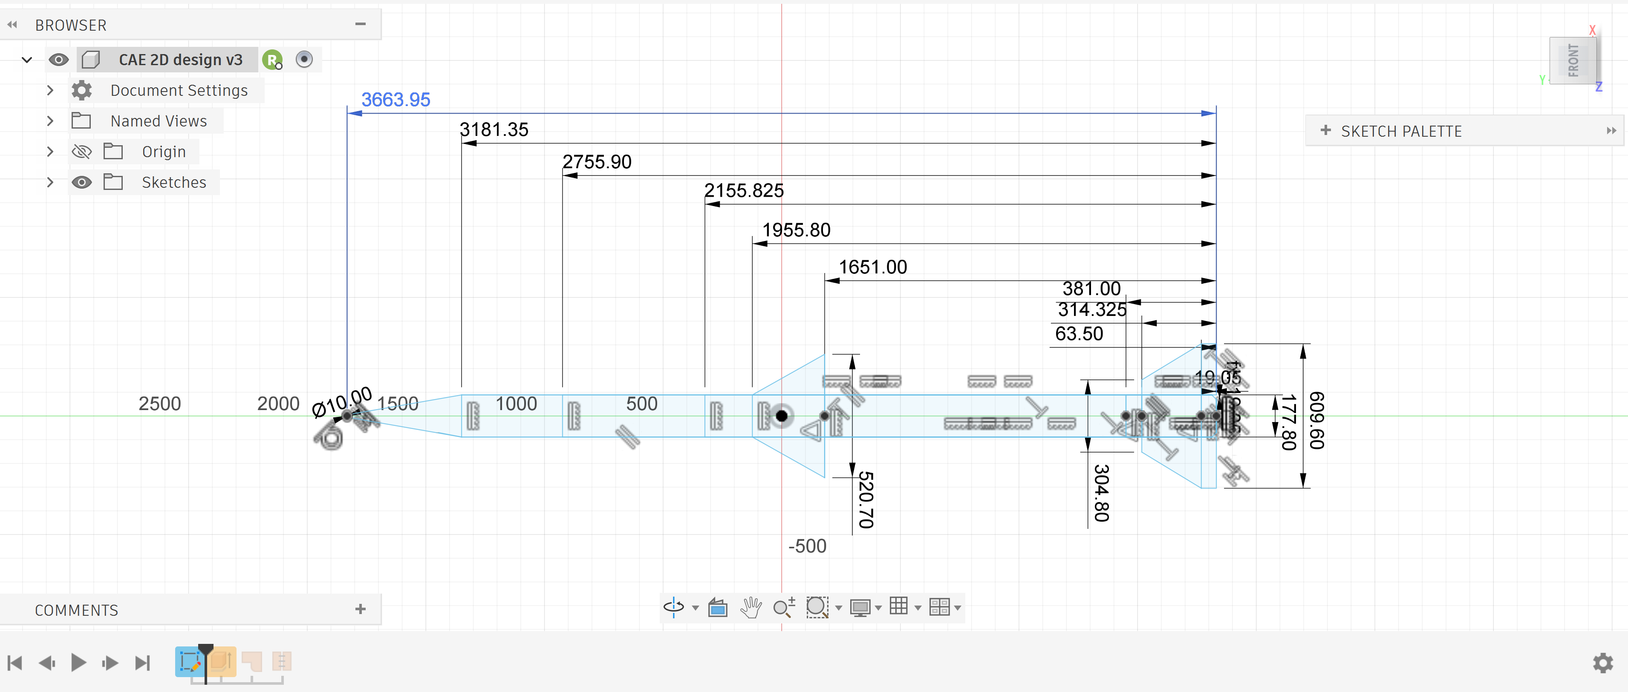
Figure 1 - CAD Sketch of Supersonic Projectile
The design was then used to make a negative cut in a surface to investigate the external compressible flows as seen in Figure 2.
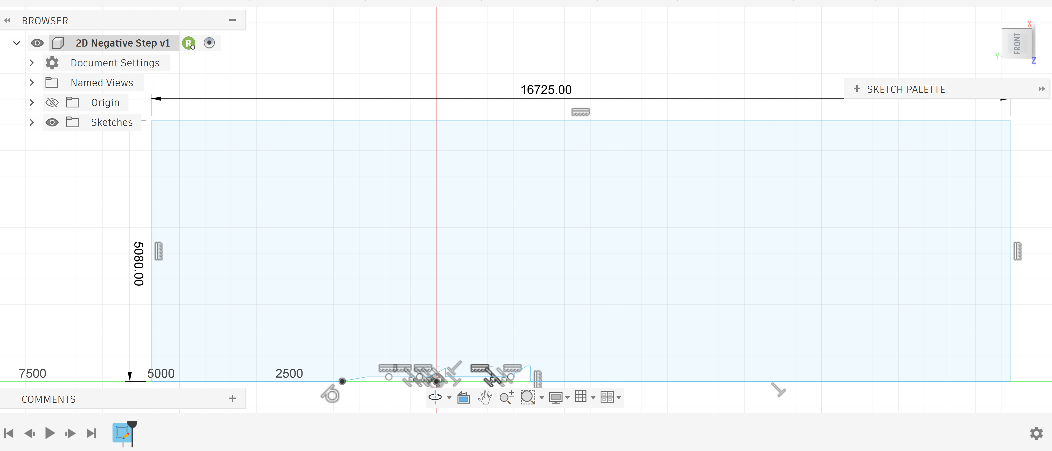
Figure 2 - CAD Sketch of Model to use CFD to Investigate External Compressible Flows
The CAD model shown in Figure 2 was then meshed at different resolutions to illustrate the importance of mesh sizing in CFD software.

Mesh
The chosen mesh sizes were 0.05 m², 0.03 m², and 0.01 m², to show a coarse-to-fine progression. The hypothesis behind these sizes was that minimal refinement of the 0.05 m² mesh would reduce the maximum pressure to a lesser extent than the finer 0.01 m² mesh. The finer mesh, which is five times denser, would allow for a more gradual pressure gradient, helping to show the higher refinement in key areas.
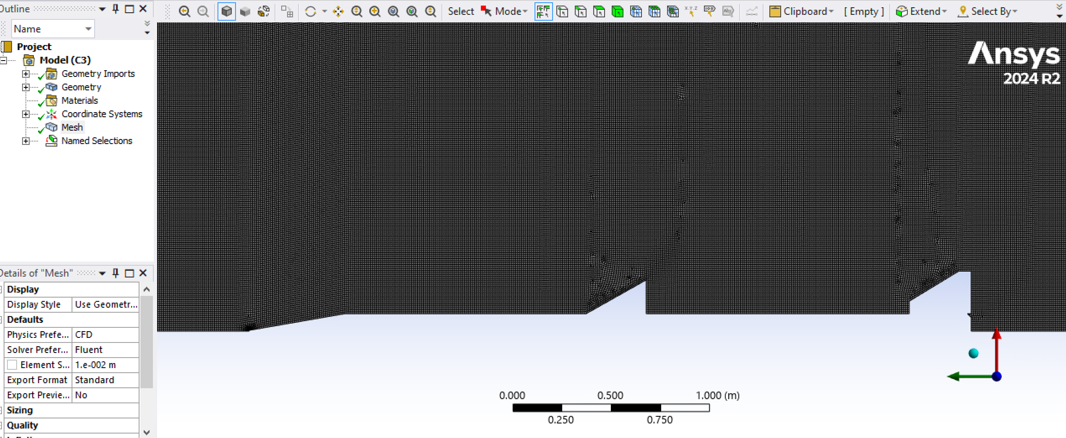
Figure 3 - Mesh Size of 0.01m
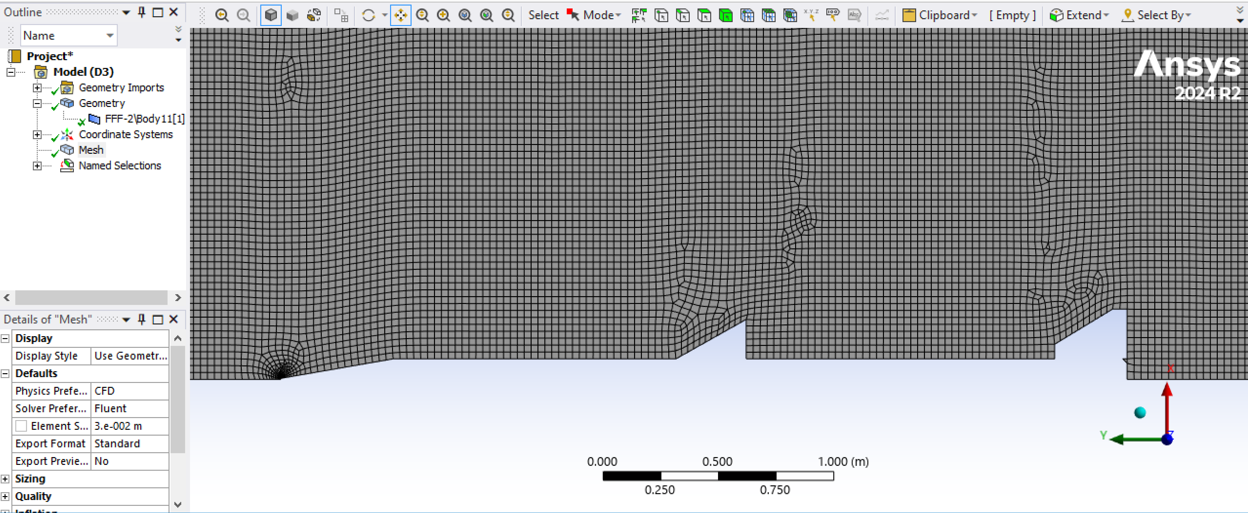
Figure 4 - Mesh Size of 0.03m
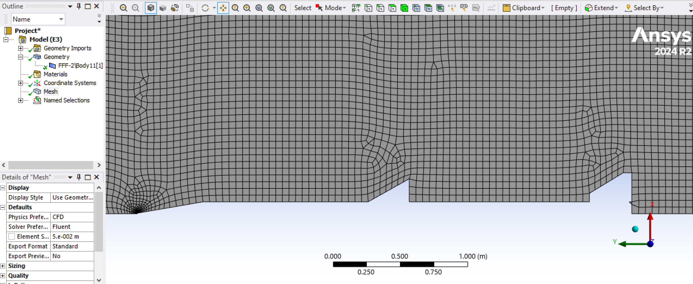
Figure 5 - Mesh Size of 0.05m

Table 1 - Mesh size against Number of Cells
Mesh Size | Number of Cells
0.01m² | 8458
0.03m² | 2819
0.05m² | 1691
The total surface area was 84.5828 m², and the smallest mesh element size across all models was 6.9954e-3 m², focused on the tip of the projectile. This consistency across all models will help reduce the number of variables.
The edges of the models were set up to behave as
- Velocity Inlet
- Pressure Outlet
- Wall
- Symmetry
- Air
The boundary edges were created in SpaceClaim and then imported into Ansys Fluent CFD.

Setup
As discussed in section 3.2, after setting up the boundary conditions in SpaceClaim, the density-based simulation was set up as follows.
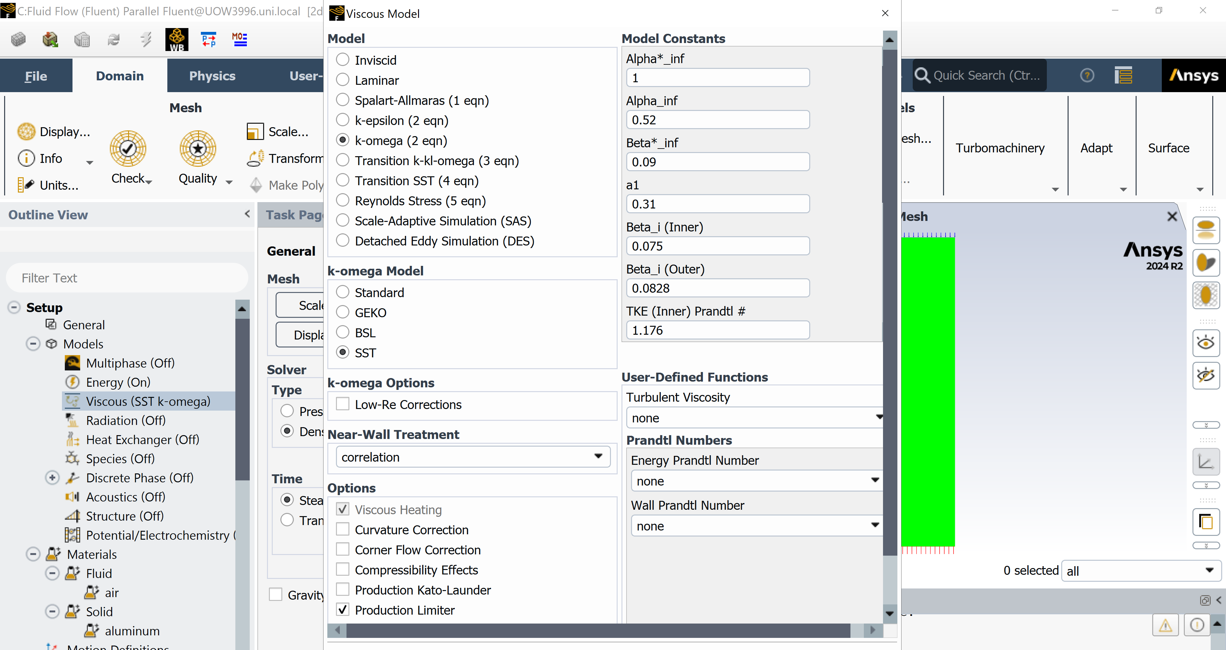
Figure 6 - Setup of Energy and Viscous Models
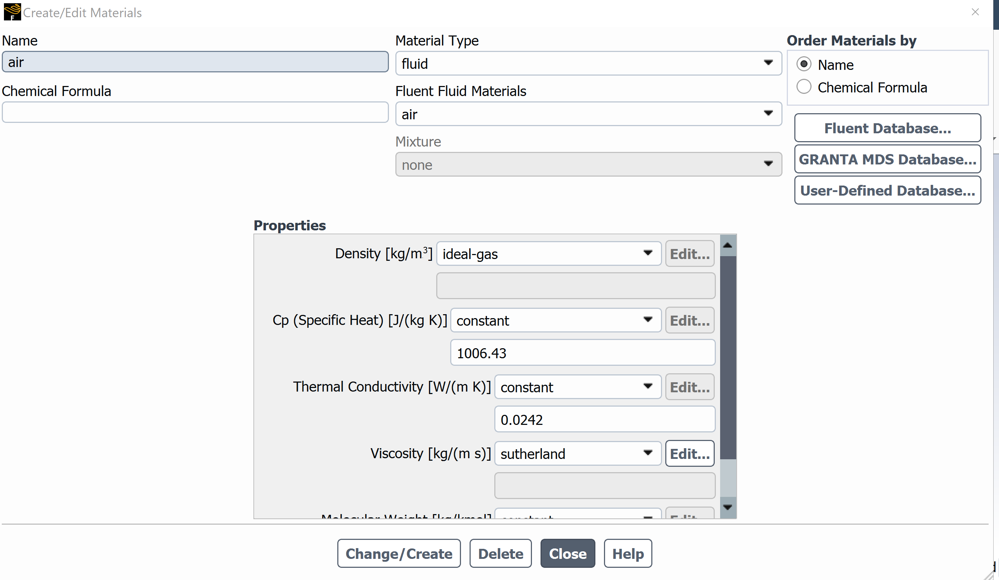
Figure 7 - Fluid Material Properties

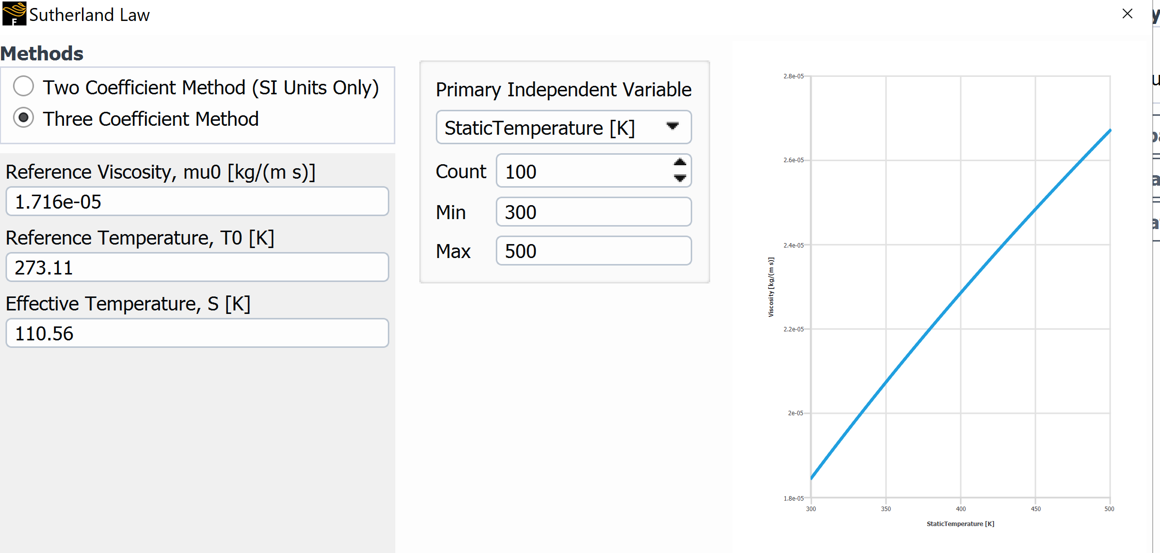
Figure 8 - Fluid Viscosity Properties

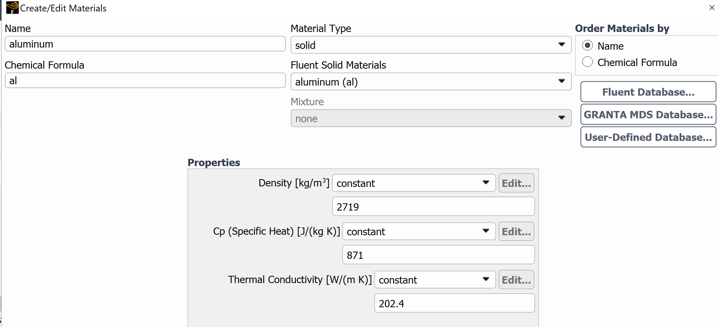
Figure 9 - Solid Material Properties

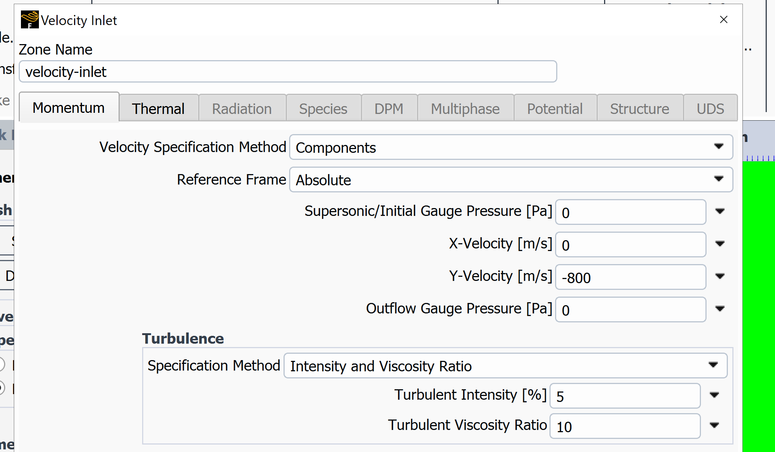
Figure 10 - Velocity Inlet Components

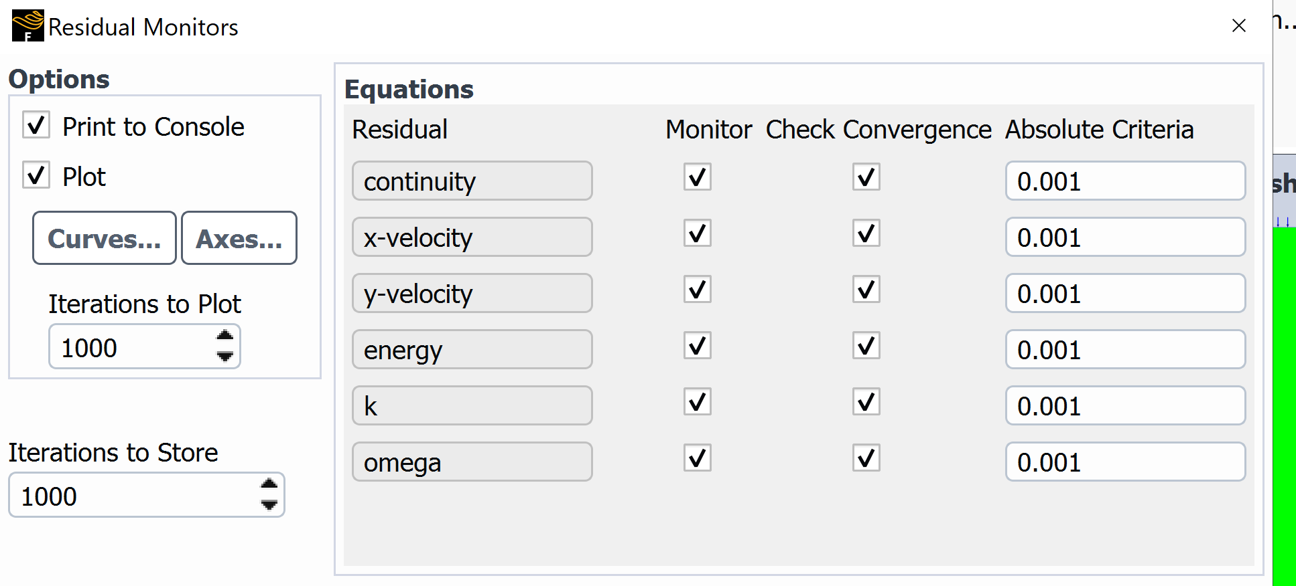
Figure 11 - Residual Monitors and Absolute Criteria Convergence

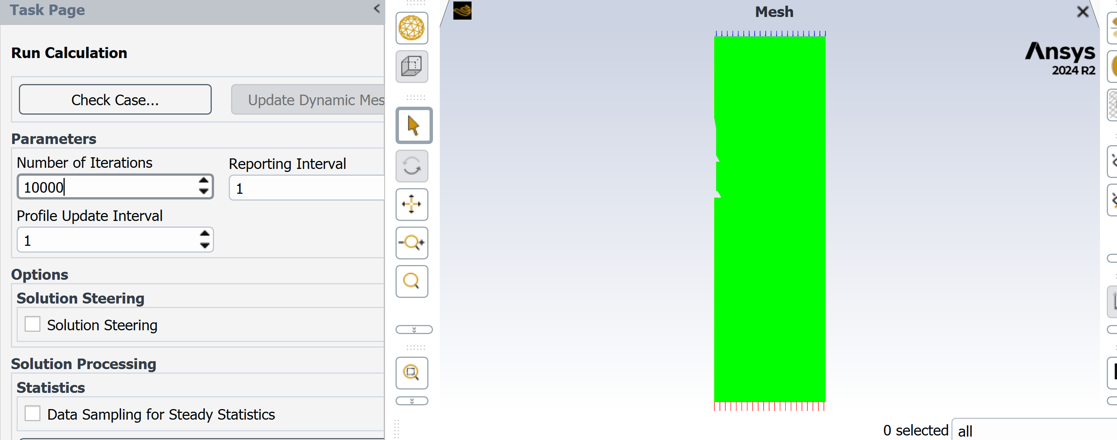
Figure 12 - Number of Iterations for each Calculation Run
The fluid was modelled as an ideal gas as a simplification to allow easier computation and more consistent results across the three models. Similarly, this is also the case for the fluid viscosity, following the Sutherland law, when the temperature changes.
After the setup, the simulations were initialised to perform calculations and solve 10,000 iterations. 10,000 iterations were chosen based on the assumption that all three models would converge before then.

Results Analysis and Validation

Results
The scaled residuals featured in Figure 10 Figure 15 Figure 20 show how, over time, the decrease in the deviation of values helps to reach convergence.
All the visualisations are produced using the Colour map – Aero, which has one thousand contours, allowing a steady colour gradient from high to low pressure.

Mesh 0.01m²
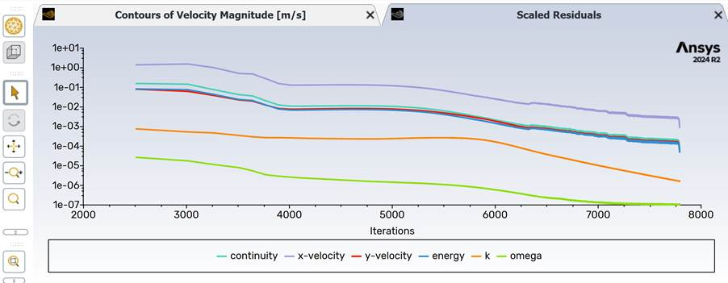
Figure 13 - Graph of Scaled Residuals showing Convergence against Iterations for the Global Mesh Size 0.01m²
The CFD simulation, with a mesh size of 0.01 m^2, converged at iteration 7792. Due to the mesh size, the computational cost of running the dense-mesh simulations was higher than that of the coarse-mesh simulations.
The following visuals highlight the pressure waves and velocities. From the figures, we can see that the highest velocities are found in the area of lower pressure.

Pressure Waves
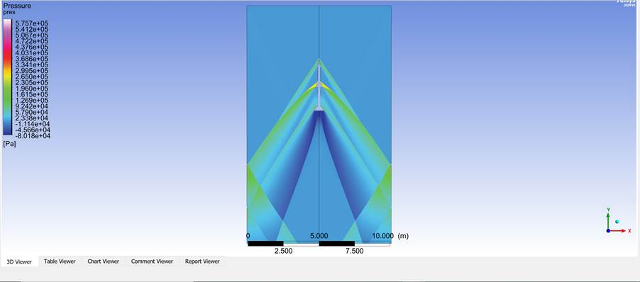
Figure 14 - Pressure Visualisation of Supersonic Projectile with a Mesh size of 0.01m²
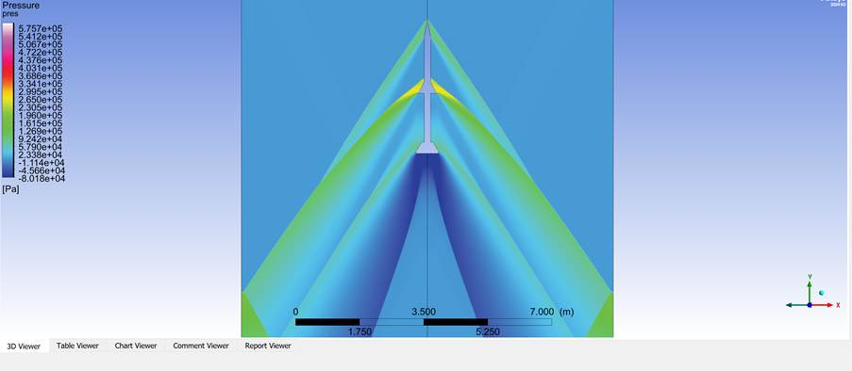
Figure 15 - Cropped Pressure Visualisation of Supersonic Projectile with a Mesh size of 0.01m2

Velocity
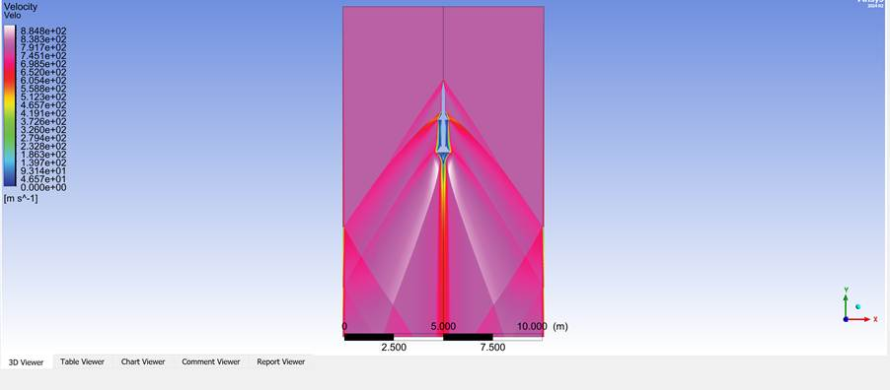
Figure 16 - Velocity Visualisation of Supersonic Projectile with a Mesh size of 0.01m2
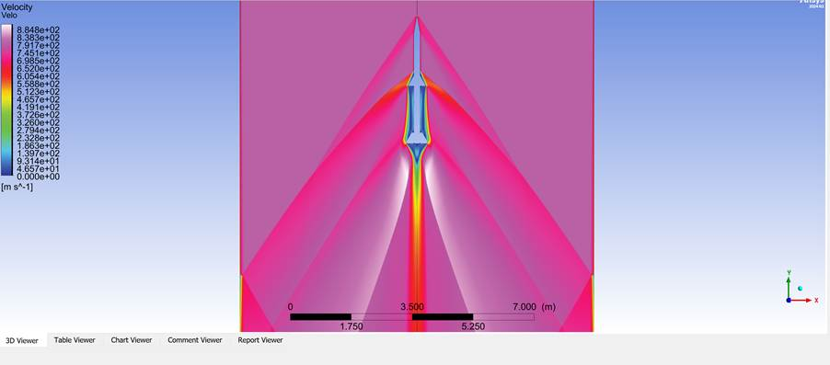
Figure 17 - Cropped Velocity Visualisation of Supersonic Projectile with a Mesh size of 0.01m2

Mesh 0.03m²
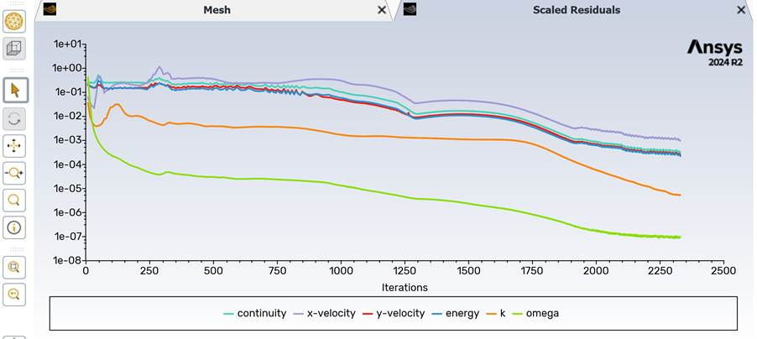
Figure 18 - Graph of Scaled Residuals showing Convergence against Iterations for the Global Mesh Size 0.03m2
The CFD simulation, which had a mesh size of 0.03 m^2, converged at iteration 2329. This mesh size had a reduced computational cost due to its lower mesh density compared with the 0.01 m^2 mesh. This was reflected in the reduced time required to complete the simulation.
The following visuals show results similar to those from the 0.01 m2 simulation, with increased velocity in areas of low pressure. However, due to the decrease in the number of elements caused by differences in mesh densities, the colour gradient is less gradual and harder to define.

Pressure Waves
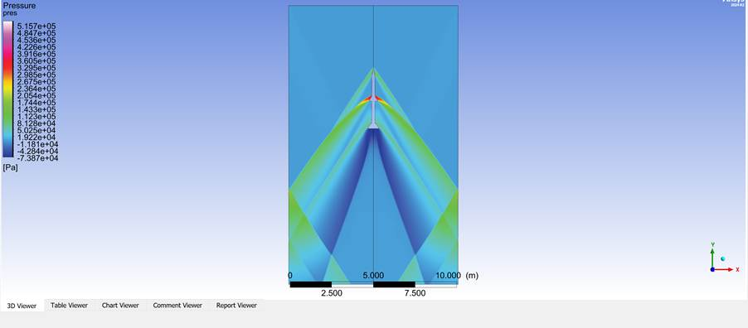
Figure 19 - Pressure Visualisation of Supersonic Projectile with a Mesh size of 0.03m2
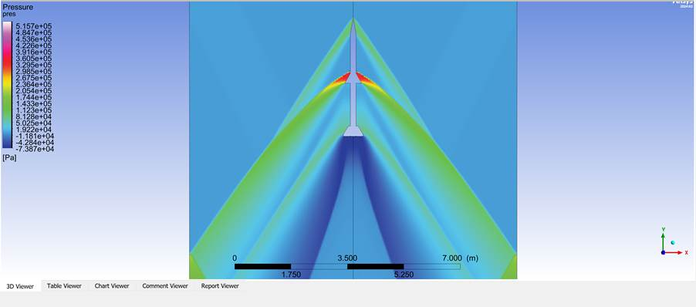
Figure 20 - Pressure Visualisation of Supersonic Projectile with a Mesh size of 0.03m2

Velocity
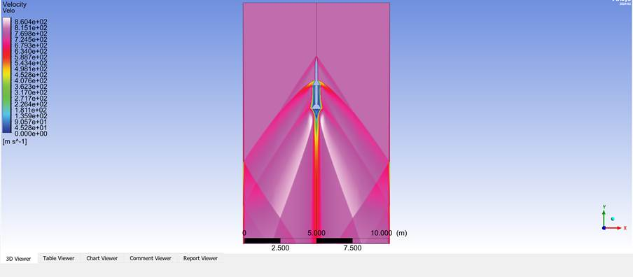
Figure 21 - Velocity Visualisation of Supersonic Projectile with a Mesh size of 0.03m2
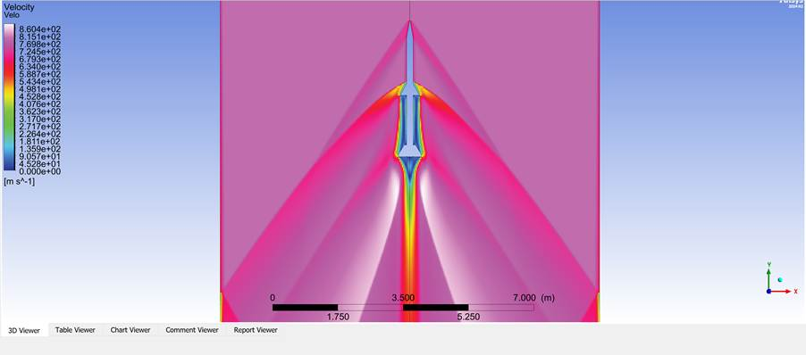
Figure 22 - Cropped Velocity Visualisation of Supersonic Projectile with a Mesh size of 0.03m2

Mesh 0.05m²
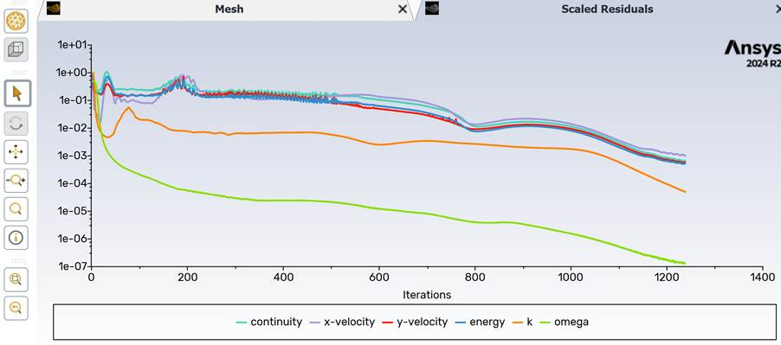
Figure 23- Graph of Scaled Residuals showing Convergence against Iterations for the Global Mesh Size 0.05m2
The CFD simulation, with a mesh size of 0.05 m^2, converged at iteration 1238. This mesh size further reduced computational cost due to its lower mesh density compared with the 0.03 m^2 and 0.01 m^2 meshes. This was reflected in the reduced time required to complete the simulation. The following visuals highlight the distorted colour gradient and reduce top pressure and velocity values.

Pressure Waves
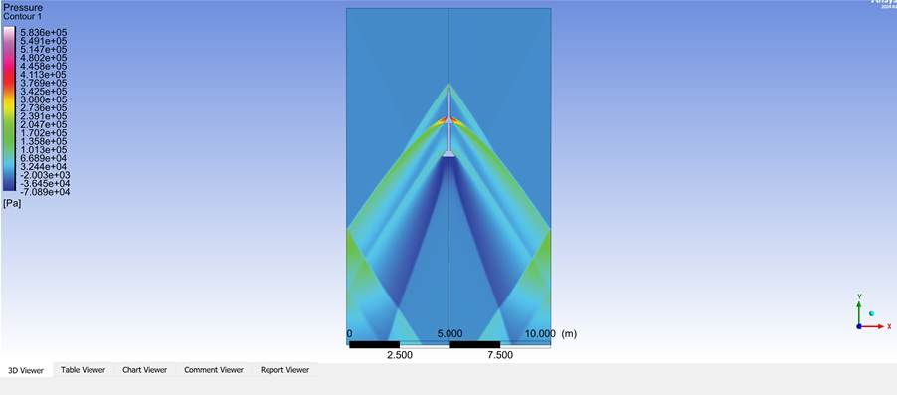
Figure 24 - Pressure Visualisation of Supersonic Projectile with a Mesh size of 0.05m2
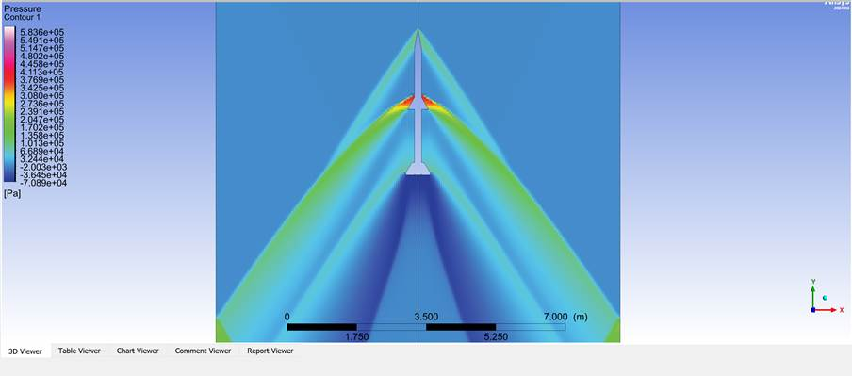
Figure 25 - Cropped Pressure Visualisation of Supersonic Projectile with a Mesh size of 0.05m2

Velocity
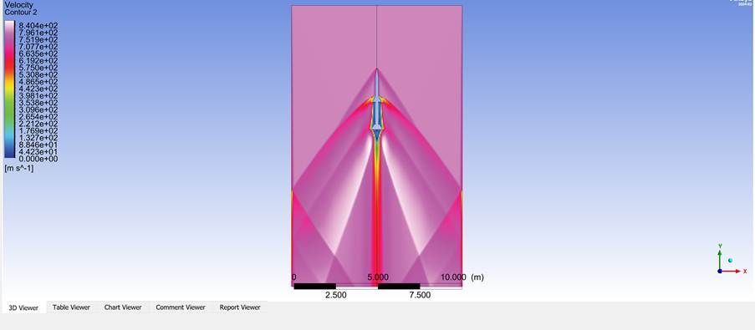
Figure 26 - Velocity Visualisation of Supersonic Projectile with a Mesh size of 0.05m2
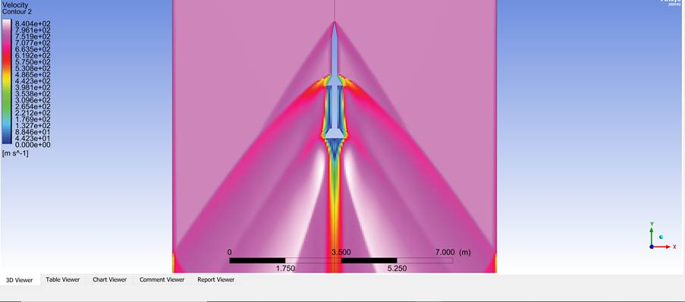
Figure 27 - Cropped Velocity Visualisation of Supersonic Projectile with a Mesh size of 0.05m2
The maximum velocity increases with mesh refinement, particularly near walls and in regions with high gradients. This suggests that a coarse mesh underestimates velocity and pressure gradients and introduces numerical deviation due to the same model used.

Analysis of Results
Table 2 - Comparison of Mesh Size and Iterations to Converge
Mesh Size | Iterations to Converge
0.01 | 7792
0.03 | 2329
0.05 | 1238

Accuracy vs Computational Cost Trade-off
The results clearly highlight the fundamental trade-off in CFD. Finer meshes yield higher accuracy but entail increased computational costs; conversely, coarser meshes yield lower accuracy but are more computationally efficient. This is further illustrated by the fact that the 0.01 m² mesh required 7792 iterations, whereas the 0.05 m² mesh required only 1238 iterations, thereby demonstrating the computational advantage and cost savings associated with coarser grids. Nonetheless, this advantage can be offset by reduced simulation reliability and usability when advancing the design/model through the engineering design process.

Mesh Independence Study and Critical Analysis
A mesh independence study was conducted to assess the sensitivity of the simulation results to mesh density. Three mesh sizes were tested: 0.05 m², 0.03 m², and 0.01 m². The purpose of the study was to determine whether the solution converged to a stable value as the mesh was refined. This was a fundamental requirement to ensure the solution was valid in the CFD simulations. All simulations were designed to converge when the deviation among all results fell below 1e-3.
The results showed a clear dependence on mesh size. The coarse mesh (0.05 m) produced results that deviated from those of the finer meshes, particularly in regions with high gradients, such as the boundary layers and the areas of fluid separation.
Mesh Density | Top Velocity Value (m/s) | Top Pressure Value (Pa)
0.05 m² | 8.404 e+2 | 4.468e+5
0.03 m² | 8.604 e+2 | 4.947 e+5
0.01 m² | 8.848 e+2 | 5.402 e+5
Figure 28 - Top Value of Pressure and Velocity of each Mesh size. Collected by the probe tool.
This behaviour was also consistent with established CFD theory, where insufficient mesh density leads to numerical diffusion and an inaccurate representation of flow features. [2] [6].
Refining to a 0.03m² mesh yielded clear improvements, with reduced errors and better capture of velocity and pressure transitions. However, small variations remained relative to the finest mesh (0.01m²), indicating that full mesh independence had not yet been achieved at the medium resolution. The 0.01m² mesh produced the most stable and consistent results, suggesting convergence towards a mesh-independent solution.
Despite this, achieving complete mesh independence was impractical due to computational constraints. Computational time, RAM, and resource requirements increased significantly with mesh refinement, highlighting a key trade-off in CFD between accuracy and efficiency. This is consistent with findings in the academic literature, which suggest that mesh density is directly proportional to improved accuracy but also rapidly increases computational cost. [4].
Another important observation was that mesh refinement alone does not ensure higher accuracy. While the finer mesh improved accuracy, other factors, such as boundary conditions, also influenced the results. For instance, the choice of CFD software can lead to significant errors and discrepancies. This could be due to an inappropriate selection of BCs, which could fail to capture key features of the Fluid Flow. Therefore, the assumption that a finer mesh automatically leads to a “correct” solution is misleading. Instead, the mesh density should be considered alongside comparison with other limiting factors, which can be confirmed by analytical and experimental data. [5].
Furthermore, local mesh refinement strategies, such as a sphere of influence, were not implemented in this study. The uniform mesh was applied across the model, which was inefficient because it allocated computing resources equally to regions of both low and high importance. In practical engineering applications, adaptive meshing or boundary-layer mesh refinement can also be used to improve accuracy in critical regions without incurring the same high computational cost.
Overall, the results support the importance of conducting mesh sensitivity analysis as part of any CFD project to ensure that conclusions drawn from simulations are accurate and dependable.

Limitations of the Ansys Fluent Software

Modelling Assumptions
The simulation assumed an ideal gas with constant flow against smooth walls. In real-world engineering simulations, the flows may be transitional or turbulent and not ideal. As each modelling assumption is incorporated into the simulation, it restricts the applicability of the results to a real-world model. For example, neglecting relevant physical phenomena, such as compressibility or phase change, can significantly reduce simulation accuracy. [14]. The simulations did not include many real-world factors, such as gravity, yaw, pitch, and material response to aerodynamic heating.
In further simulations, a full 3D model would be needed to show the full effects of stress and strain forces, as well as other factors missing from a simple 2D model that looks only at external compressible flows.

Discretisation and Mesh
A discretisation error remains unless the mesh is infinitely refined. The mesh independence study and further academic convergence studies reveal diminishing returns on the resources invested. As refinement increases, the difference in error elimination decreases exponentially, all while increasing computational cost. As a result, CFD solutions can only approximately reach a true real-world solution. Additionally, the mesh quality issues, such as skewness and non-orthogonality, can introduce inaccuracies or hinder convergence. [15].

Computational Cost
As discussed before, the higher accuracy simulations require substantially more computational resources. In this study, the finest mesh density required significantly longer computation time than the coarse mesh, which in turn limited the degree of mesh refinement. In engineering, running large simulations for product design can be impractical. These increased computational costs introduce compromises, such as using a less refined mesh with fewer cells, simplifying physical models, or adopting ideal-state assumptions instead of fully transient simulations. While very fine meshes are feasible, they are often impractical for three-dimensional models due to their complexity. [16] High-end computers are needed to run high-definition 3D models, further increasing costs sometimes beyond the cost of actual experimental trials and data.

Solver and Feature Limitations
Every CAE solver, such as Ansys’s Fluent, possesses certain features and limitations. For example, the Fluent solver does not support all functionalities, such as certain radiation models or hypersonic boundary conditions [17].
In some solvers, modelling phenomena like laminar-turbulent transition or detailed fluid separation remains challenging. The nature of CFD solvers requires users to rely on the software’s internal algorithms, which can obscure numerical issues arising from artificial dissipation or linearization errors in the simulation. [15].In order to reduce the solver limitations it is recommended to research and use situation specific CAE software to better reduce the solver limitations when simulating certain models.

User and Modelling Error
According to CFD literature, “usage errors” arise when the code is applied improperly. [15]. This includes mis-specifying material properties, neglecting important forces, or misapplying boundary conditions.
Human error can introduce incorrect inputs or interpretations; however, this is not a limitation of the software but of the CAE process. The need to input values or information, or to correct them by humans, inevitably leads to mistakes and human-factor errors. To help combat the human factors that affect the accuracy and reliability of CAE tools, users in training must be trained to recognise CAE pitfalls [18].

Validation Gaps
Even after careful setup, simulation results must be treated as provisional until validated against experimental data or an established number of analytical solutions. For example, in the context of the hypersonic projectile, validation would involve comparing simulated velocity and pressure profiles with experimental measurements from a test setup.
Alternatively, simulated results could be assessed against analytical solutions, such as the Hagen-Poiseuille equation for laminar flow, to assess their accuracy. The use of ‘hand calculations’ for validation remains a good method for verifying simulation solutions. Due to the decreased design process time, simple validation methods can be useful for ensuring that parameters are set up correctly.
Simulation precision is highly dependent on user-defined inputs such as boundary conditions and solver settings. Incorrect assumptions can result in inaccurate results despite numerical convergence. [10].

Conclusion
The report demonstrates that ANSYS Fluent can accurately produce CFD behaviours when applied appropriately. The convergence of Fluent solutions towards the results with mesh refinement confirms the validity of the simulation. [16]
Beyond 0.01 m2, mesh refinement became inefficient because meshing took longer and cost more than simulating with 0.01 m2. Further, increases in mesh resolution yielded only marginal improvements in accuracy while exponentially increasing computational costs.
Overall, these findings indicate that although CAE tools are effective at simulating real-world situations, their successful application requires balancing accuracy and computational efficiency. This analysis reaffirms that the reliability of CAE results depends on the software model. Simplifying assumptions, such as fluid flow, not including thermal conductivity, and not showing the numerical discretisation, fundamentally limit real-world usability and accuracy. [15].
All simulation models are inherently approximations; therefore, there is a degree of inaccuracy. The simulations were verified for numerical accuracy through a mesh independence study and subsequently validated against analytical solutions or experimental data.
In summary, although CAE tools offer valuable insights, their limitations in capturing model differences and in the use of computational resources require careful interpretation of simulation results. The recommendation for adaptive meshing helps directly address some of these computational limitations by enhancing simulation accuracy and reliability. By implementing advanced meshing techniques, CAE users can reduce the risks associated with validation gaps and fully take advantage of CAE tools to guide engineering design processes while also accounting for underlying uncertainties. [18].

References

[1] | J. D. Anderson, Computational Fluid Dynamics: The Basics with Applications, New York: McGraw-Hill, 1995.
[2] | H. K. Versteeg and W. Malalasekera, An Introduction to Computational Fluid Dynamics: The Finite Volume Method, Harlow: Pearson Education, 2007.
[3] | T. J. Chung, Computational Fluid Dynamics, Cambridge: Cambridge University Press, 2010.
[4] | F. Moukalled, L. Mangani and M. Darwish, The Finite Volume Method in Computational Fluid Dynamics, Cham: Springer, 2016.
[5] | National Institute of Standards and Technology, Verification and Validation in Computational Fluid Dynamics, Gaithersburg: NIST, 2016.
[6] | P. J. Roache, Verification and Validation in Computational Science and Engineering, Albuquerque: Hermosa Publishers, 1998.
[7] | S. V. Patankar, Numerical Heat Transfer and Fluid Flow, New York: Hemisphere Publishing, 1980.
[8] | ANSYS, Inc, ANSYS Fluent Theory Guide, Canonburg: ANSYS Inc, 2023.
[9] | O. C. Zienkiewicz, R. L. Taylor and J. Z. Zhu, The Finite Element Method: Its Basis and Fundamentals, Oxford: Elsevier, 2013.
[10] | J. L. Encarnacao, R. Lindner and E. G. Schlechtendahl, Computer-Aided Design: Fundamentals and System Architectures, Berlin: Springer-Verlag, 1990.
[11] | W. R. Nyemba, Computer Aided Design: Engineering Design and Modelling Using AutoCAD, Boca Raton: CRC Press, 2022.
[12] | J. Hoschek and D. Lasser, Fundamentals of Computer Aided Geometric Design, Wellesley: A K Peters, 1993.
[13] | X. Le, 'Fundamentals of Finite Element Analysis' in Simulation-Based Mechanical Design, Cham: Springer, 2024.
[14] | Y. Liao and D. Lucas, “Possibilities and Limitations of CFD Simulation for Flashing Flow Scenarios in Nuclear Applications,” Energies - Engineering Fluid Dynamics, vol. 10, no. 1, p. 139, 2017.
[15] | J. W. Slater, “NPARC Alliance CFD Verification and Validation,” NASA, 10 February 2021. [Online]. Available: https://www.grc.nasa.gov/www/wind/valid/tutorial/errors.html#:~:text=The%20discretization%20error%20is%20of,singularities%2C%20and%20zonal%20boundary%20interfaces. [Accessed 23 April 2026].
[16] | R. Gasparini, “Mesh Sensitivity Study for CFD Simulations,” SIMSCALE, 26 April 2022. [Online]. Available: https://www.simscale.com/knowledge-base/mesh-sensitivity-cfd/#:~:text=For%20a%20mesh%20sensitivity%20study%2C,false%20impression%20of%20mesh%20independence. [Accessed 23 April 2026].
[17] | ANSYS.INC, “Ansys Fluent User's Guide,” ANSYS.INC, Canonsburg, 2025.
[18] | R. Doyle and K. Case, “CAE Software in Manufacturing Engineering Education,” Computers in Education, vol. 15, no. 1-3, pp. 277-288, 1990.

