LCLM4002_BIRM Digital Skills Task 3
Website Evaluation

Student Number | 2519263 | Student Name |  | Przemyslaw Maksymowicz
Website Chosen | The Cooking Academy
Insert hyperlink to website | https://www.thecookingacademy.co.uk
Evaluation
Respond to each question
Section 1 – Usability

(75 words maximum for each answer)
Question 1a - How quickly and easily does the website load?

Answer:
The website loads, but performance can be inconsistent. A Lighthouse desktop audit scored Performance 34/100, with Largest Contentful Paint about 9.1s and Total Blocking Time about 1,090ms, which suggests some users may experience delays before the main content becomes usable (Google Lighthouse, 2026). On faster Wi-Fi it may feel fine, but on mobile data the large images and scripts could make it feel slower.
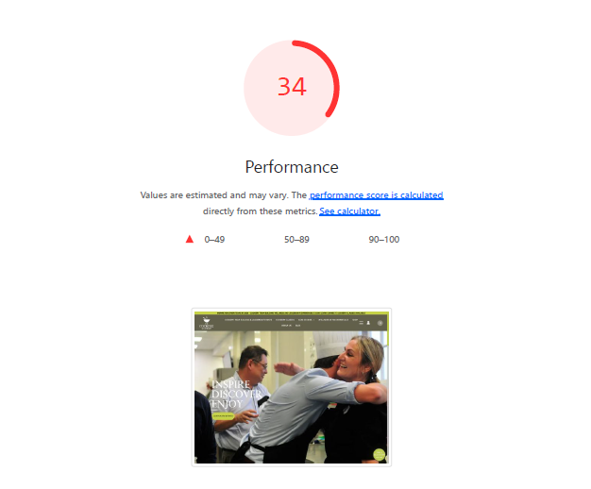
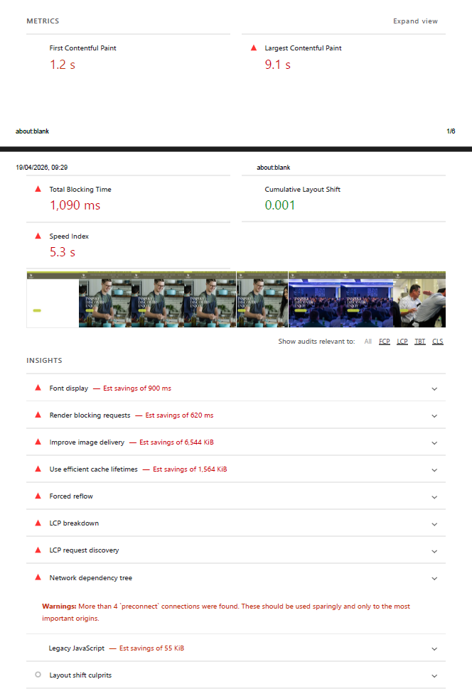
Question 1b - Does the website contain many sub-pages? How does a prospective customer navigate these?

Answer:
Yes, the website has many sub-pages, such as cookery classes, corporate events, wellness, blog, shop, and contact pages. Customers can navigate using the main menu at the top of the page. The site also uses clear buttons like “Find a class”, plus headings and links that take you to more detail. This makes it straightforward to move around without getting lost.
Question 1c - Can a customer make a booking via the webpage?

Answer:
Yes. The website encourages customers to “Book now” and “Find a class”. Each class page includes information and a clear route to booking, so customers can choose a class and reserve a place online. This is helpful because users do not need to call or email to start the booking process.
Question 1d - What improvements could be made to the usability of the website?

Answer:
To improve usability, I would focus on speed and clarity. Lighthouse highlights opportunities such as improving image delivery, reducing unused JavaScript, and removing render-blocking resources, which could reduce load delays (Google Lighthouse, 2026). I would also make the primary “Book now” call-to-action consistent and avoid multiple competing primary buttons, as guidance suggests one main call to action helps users know what to do next (GOV.UK Design System, n.d.).

Section 2 – Pleasure – Customer Experience

(75 words maximum for each answer)
Question 2a – How pleasant does the webpage look? Are there any differences in appearance on a mobile phone versus a computer?

Answer:
The webpage looks professional and welcoming, mainly because it uses high-quality food imagery and clear sections. On mobile the layout stacks into a single column, which makes it easy to scroll, while desktop shows more options at once. This matches the idea that visual design supports usability and “pleasure”, which then influences perceived value and the intention to reuse/recommend (Jongmans et al., 2022).

Question 2b - How does the website use imagery, video and colour?

Answer:
The website uses high-quality photos to show food, classes, and the overall experience. Colour is used in a calm, professional way, with buttons and headings standing out clearly. Imagery is the main tool to attract attention and to help customers understand the service quickly. Where used, visuals support the message of learning, health, and international cooking.
Question 2c – Has the website made use of an online chat tool on the website? How effective is this to enquire about the product or service?

Answer:
I did not see a clear live chat tool on the pages I reviewed. Instead, the site relies on contact and enquiry options. That can work, but it is slower for quick questions (e.g., dietary needs, availability, vouchers). Adding live chat or a chatbot could strengthen business-to-customer communication by giving real-time support and reducing drop-offs during booking (Kotler et al., 2018).

Question 2d – How effective are the social media links on the website?

Answer:
The social media links support trust and customer engagement because users can view recent photos, comments and updates outside the website. They are also useful for marketing because social platforms can link users back to the website in one click and help target the right audience (Kotler et al., 2018). To improve effectiveness, I would place the icons consistently (header/footer) and add a short prompt such as “Follow us for new class dates”.

Section 3 – Perceived Value

(75 words maximum for each answer)
Question 3a - How are the services offered by the company made clear to customers?

Answer:
The services are made clear through the main menu and the home page sections. The site separates offers into clear areas such as cookery classes, corporate events, and wellness in the workplace. Each section has a short explanation and buttons that take customers to more details. This helps customers quickly understand what they can book and whether it is for personal learning or for a business event.
Question 3b - How are customer reviews made available? Are these up to date?

Answer:
Customer reviews are available in two ways. First, the website has a “Testimonials” area where customers share feedback about classes and products. Second, reviews can be found on third-party sites such as Trustpilot and Tripadvisor. These external sites include dates and show that people are still leaving reviews recently, which suggests the business is active (Trustpilot, 2026; Tripadvisor, 2026). It would help if the website also showed dates next to each testimonial.
Question 3c – How is the service presented as high quality? For what reasons would you use the company’s service or recommend to a friend or family member?

Answer:
The service is presented as high quality through professional design, detailed class descriptions, and strong customer testimonials (The Cooking Academy, 2026). The website also highlights specialist areas like nutrition and wellness, which makes it feel more expert than a basic cookery class. I would use or recommend the service because it offers hands-on learning, a wide choice of cuisines, and a focus on healthy cooking. It also looks suitable for individuals and corporate groups.
Question 3d - Are prices made clear to customers? If yes, do the prices reflect the quality of service shown? If no, why do you think the company has chosen not to include prices?

Answer:
Some pricing information is shown, but prices are not always obvious from the first page a customer lands on. Often you need to click into a specific class or enquiry page to see full costs. This may be because prices can change based on group size, private bookings, corporate events, or dates. Making a simple “Prices from…” guide could reduce customer uncertainty and encourage faster bookings.
Section 4 – Searchability

Question 4a - What three words would you type into Google to find this type of service? |  |  | 1. Cookery classes
 |  |  | 2. Cooking school
 |  |  | 3. London cookery
Question 4b - When you type these words into google, does the company’s website appear in the top ten websites?

Answer:
When I tested the search, The Cooking Academy website did not appear in the top ten Google results. This suggests that, for generic keywords like “cookery classes,” the competition is strong and the site may not be as visible to new customers searching broadly. However, a Lighthouse audit gave the site an SEO score of 92/100, which means the basics—like crawlable content and technical SEO—are mostly in place (Google Lighthouse, 2026). In practice, the site is more likely to appear near the top when searches include the brand name and location (for example, “The Cooking Academy London” or “The Cooking Academy Rickmansworth”). To improve visibility for generic searches, the website should continue to enhance speed, accessibility, and relevant content, which can help support overall search ranking.
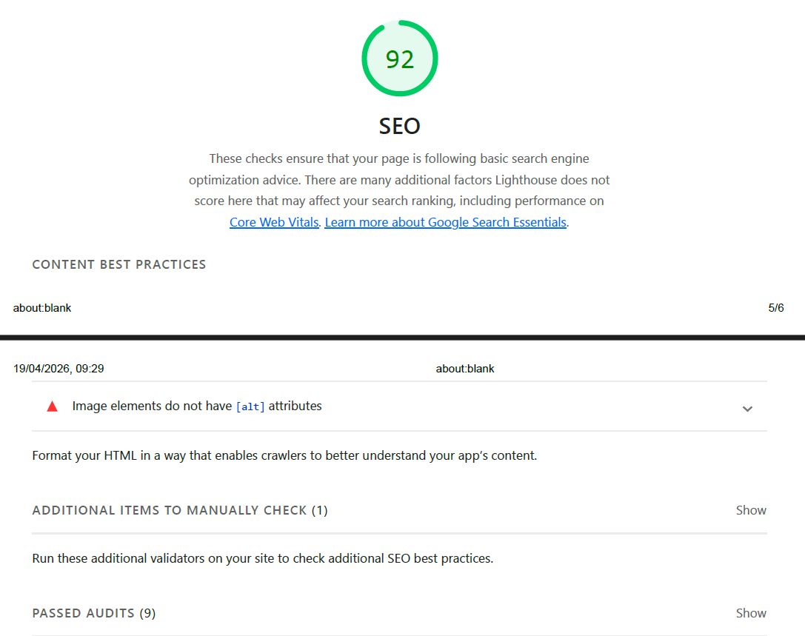

Section 5 – Reflection and conclusion

(120 words maximum for each answer)
Question 5a - Do you feel that websites still have relevance in modern UK business? Explain your answer.
Answer:
Yes, websites are still very relevant in modern UK business. Social media is useful for quick updates, but a website is the main place where customers expect to find full information, prices, booking details, and contact information in one trusted space. A good website also helps a business look professional and improves visibility on Google. For services like cookery classes, customers often want to read details before they spend money, such as dates, what is included, location, and FAQs. A website can also support online payments and collect enquiries, which saves time for both customers and staff.
Question 5b - If you were to make one recommendation about how to improve the website of your chosen company, what would it be? Why have you suggested this improvement?

Answer:
My one main recommendation is to improve the class search and filtering. For example, add filters for location (Rickmansworth/London), date, cuisine type, skill level, and price range, plus a clear search bar. This matters because the website offers many different classes and services, so new customers may feel unsure where to start. Better filtering would help users find the right class faster, reduce time spent clicking through pages, and increase the chance they will complete a booking. It would also make the site easier to use on mobile, where people prefer quick choices.

Reference List
The Cooking Academy (2026) The Cooking Academy: Master the Art of Cooking | Book now. Available at: https://www.thecookingacademy.co.uk/ (Accessed: 12 April 2026).

Trustpilot (2026) Thecookingacademy Reviews. Available at: https://uk.trustpilot.com/review/thecookingacademy.co.uk (Accessed: 12 April 2026).
Google Lighthouse (2026) Lighthouse report for https://www.thecookingacademy.co.uk/ (captured 19 April 2026). Available via: Chrome DevTools Lighthouse.

Chrome for Developers (n.d.) Lighthouse performance scoring. Available at: https://developer.chrome.com/docs/lighthouse/performance/performance-scoring/ (Accessed: 19 April 2026).

Jongmans, E. et al. (2022) ‘Impact of website visual design on user experience and website evaluation: the sequential mediating roles of usability and pleasure’, Journal of Marketing Management, 38(17–18), pp. 2078–2113.

Tripadvisor (2026) The Cooking Academy - Rickmansworth: Reviews. Available at: https://www.tripadvisor.co.uk/Attraction_Review-g1096773-d7349821-Reviews-The_Cooking_Academy-Rickmansworth_Hertfordshire_England.html (Accessed: 12 April 2026).
GOV.UK Design System (n.d.) Button. Available at: https://design-system.service.gov.uk/components/button/ (Accessed: 19 April 2026).
World Wide Web Consortium (W3C) (2023) WCAG 2 Overview. Available at: https://www.w3.org/WAI/standards-guidelines/wcag/ (Accessed: 19 April 2026).
Talero-Sarmiento, L., Gonzalez-Capdevila, M., Granollers, A., Lamos-Diaz, H. and Pistili-Rodrigues, K. (2024) ‘Towards a refined heuristic evaluation: Incorporating hierarchical analysis for weighted usability assessment’. Big Data and Cognitive Computing, 8(6), 69. Available at: https://www.mdpi.com/2504-2289/8/6/69 (Accessed: 12 April 2026).
Li, W., Zhou, Y., Luo, S. and Dong, Y. (2022) ‘Design factors to improve the consistency and sustainable user experience of responsive interface design’. Sustainability, 14(15), 9131. Available at: https://www.mdpi.com/2071-1050/14/15/9131 (Accessed: 12 April 2026).

