Report

Coaching and Mentoring
within an
organisational context.

2,500 words
Submitted on 9/12/2022
Module BMSW6105_SWAN

Executive summary
In this report, the author examines the similarities and differences between coaching and mentoring intervention within an organisational context and the tangible and intangible impact of these employee development activities on personal and corporate resilience. Moreover, the researcher scrutinised the merits and demerits of coaching and mentoring implementation in the work environment and critically discussed the potential barriers that must be considered during the process.
The research unveiled the direct correlation betwixt organisational learning culture, employee motivation, engagement and resilience. Furthermore, the report confirms the crucial line manager's role in forming employees' growth mindset through coaching and mentoring activities.
Additionally, the researcher identified that change is an imminent factor that drives continuous organisational improvement if embraced and perceived as a beneficial opportunity. Therefore, effective and well-structured change management can provide controlled organisational transformation while adapting to the internal and external context.
Furthermore, following a practical demonstration of the coaching skills, the report's author presented his self-reflection assessment and a personal development plan to identify weaknesses and create a roadmap of self-improvement actions.
The report concluded that organisations must inculcate coaching and mentoring activities to build resilience, support a learning culture, stay profitable and achieve competitive advantage in the current volatile reality.

Table of Contents

1.0 Introduction 1
2.0 Main Findings 2
2.1 Evaluation of Coaching and Mentoring 2
2.2 Line Manager as a Coach 4
2.3 Building resilience and dealing with change 5
2.4 Peer coaching exercise reflection 6
3.0 Conclusions 8
Reference list 9

List of Figures

- Figure 1: Gibb's Reflective Model…………………………………………………………………………………….. 6

- Figure 2: Personal Development Plan.………………………..……………......................................... 7

1.0 Introduction

Pavlo Gladkyi has created this individual report to demonstrate the obtained knowledge and skills from the coaching and mentoring module and as his reflection after the practical implementation of learned coaching techniques in the organised peer coaching exercise that took place on 9/11/2022.
This exercise was performed in a class environment within a group of three, where each participant had a chance to be a coach, coachee and observer. As agreed, all the coaches used Landsberg's Instant Pay-off coaching model to meet the assignment requirements and gain the essential knowledge and experience to complete the individual academic report (Landsberg, 2015).
The report was submitted via Turnitin on deliberated date and time on 9/12/2022 by Pavlo Gladkyi in person.
The Senior Lecturer of the Institute of Management and Health at the University of Wales Trinity Saint David Brynach Heffernan is the primary report requester and provided all needed learning material to ensure a profound understanding of the presented in this report subject.
Within this report, Pavlo presented his findings along with a critical evaluation of organisational coaching and mentoring learning interventions, their tangible and intangible benefits, and the correlation between these activities and personal and corporate success in a highly volatile business environment.
Additionally, the report's creator critically discussed the role of leaders and line managers in coaching and mentoring activities in a personnel and organisational development context.
This report was compiled using various credible research materials, including, but not limited to, books, articles, blogs, organisational websites, and official social media pages.

2.0 Main Findings
Today organisations face emerging challenges related to the various internal and external factors that force businesses to scrutinise existing organisation development strategies and adapt and deploy effective solutions to overcome current radical changes in the worldwide economic downturn (Guénette, Kose and Sugawara, 2022).
Similarly, Friedman (2009) states that this worldwide crisis is not the first deep recession that has indicated some fundamental issues regarding the human understanding of the root causes that have much more profound meaning. He contends that the exponential growth model created over the last 50 years and inadequate leveraging of the planetary resources will imminently collapse further economic development and tangibly impair the ecology if no changes are made in living, working and coexisting approaches. It is hard to disagree with the author that these unambiguous signals increasingly compel organisations and businesses to seek further adjustments to be more resilient and socially responsible while implementing sustainable changes that will create a robust response to the impending crisis (Kose, 2022).
Hawkins and Smith (2013) argue that today's crisis has four incontrovertible fundamental forces that must be considered by leaders and managers, as they will set further organisational development context. These particular forces are greater demand, higher expectations of quality of services, fewer resources and The Great Disruption.
In response, organisations increase their effort to evaluate performance gaps to align their staff learning and development strategies to achieve their business goals, remain relevant and valuable and create a learning culture within the organisation (Hayden, 2021). Furthermore, the inculcating and regular overhauling of the company learning culture can facilitate personal and corporational change, creating a buffer of resiliency while confronting eventualities or planned changes (Young, 2020). Hence, coaching and mentoring are the adaptivity tools that can reinforce organisational learning strategies through coaching culture practices.

2.1 Evaluation of Coaching and Mentoring
According to Yadav (2021), coaching is a fast-growing industry with over 6,280,000 registered coaches worldwide, with a significant 13,200% growth from 2009 to 2020. Moreover, the rapidly expanded and high-demand market dictates the coaching popularity rise due to digital organisational transformation, global economic recession and perpetual change.
Clutterbuck (2003) determines coaching as a time-bound, focused interaction between the coach and coachee that helps the coachee expand their imagination of greater possibilities and facilitates their achievement through solution-focused and result-orientated collaboration. He states that coaching implies helping solve a specific problem or find the most plausible cost-effective solution by posing the catalytic questions and facilitating a coachee to reveal the answer they already carried. Therefore, the coach is a facilitator, not an expert in the specific business area. Moreover, coaching is a creative and thought-provoking process that uses inspiration to maximise the coachee's self-reliance and personal and professional potential (ICF, 2022).
On the other hand, mentoring is usually a longer-term upskilling arrangement when a more experienced person, usually an expert in their field of activity, has a direct interest in another person's development. A mentor guides and supports the mentee's personal growth while improving self-awareness and confidence (Cronin, 2022).
Similarly, Abbajay (2019) stated that mentoring could be formal or informal, where through the learning interaction, a more experienced and qualified mentor exchanges his knowledge with a less knowledgeable mentee.
According to CIPD (2021), coaching and mentoring have considerable similarities because both relate to learning and development methods that improve employees' interpersonal skills, confidence, motivation, engagement, retention and, as a result, overall organisational performance. Additionally, both rely on a trustworthy relationship between providing and receiving parties, confidentiality and inspiration while influencing an employee's behaviour change (Sheridan and Johnson, 2021).
Therefore, the behavioural change that coaching and mentoring activities provide is crucial in expanding employees' capabilities. Additionally, coaching supports the development of a growth mindset and limits a fixed mindset. As a result, a growth mindset will make employees achieve perseverance and resilience. Moreover, they will be more agile when dealing with failure because they will take it as a self-improvement opportunity to unleash innovation, further development and build confidence in the face of change (Dweck, 2014).
Although coaching and mentoring may seem to have identical functions at a glance, apparent differences could be easily distinguished (Cronin, 2022). According to the author, the fundamental difference between coaching and mentoring relies on objectives-achieving methods. For instance, coaching usually has a well-structured non-directive approach; coaches instruct, offer suggestions, ask questions and reflect.
On the contrary, Sword (2021) argues that mentoring has a directive approach, and mentors tell, advise, provide feedback and raise awareness.
Furthermore, during the coaching interaction coachee will answer thought-provoking questions. On the other hand, mentoring sessions imply the mentee questions a mentor to gather needed knowledge. Additionally, workplace coaching mainly targets employees' performance improvements and mentoring, aiming at the development and career advancements (Sheridan and Johnson, 2021).
However, despite their similarities and differences, coaching and mentoring activities are beneficial, as they unlock employees' potential, enable effective behaviour change at the workplace and incentivise the creative delivery of organisational goals (McNamara et al., 2014). Moreover, both activities can be easily inculcated into the organisational structure (Mason, 2019).
According to Ibarra and Scoular (2019), modern managers must be ready to use a coaching and mentoring approach when dealing with the rapidly changing business environment. Moreover, today's trends push companies to forego traditional command and control practices and adopt new strategies where managers are committed to providing support and guidance to their subordinates, facilitating them to go through the change.
Hence organisations must consider the tangible and intangible benefits of practical deployment of coaching and mentoring concerning returning on investment matters.
Hagen (2021) declares that coaching return on investment (ROI) is a methodology that creates a positive workplace culture by improving people's motivation and engagement through workshops and coaching conversations. As a result, it will make people feel better at the workplace and strengthen their confidence. This methodology targets employees' mental wellbeing and does not concentrate directly on employee performance. However, instead, aiming to improve their motivation, inspiration and teamwork skills.
Additionally, Hagen (2021) stated that ROI measures contain the number of times the investment has been made, feedback return on investment, motivation return on investment, emotional return on investment, happiness return on investment, team return on investment and relationship return on investment.
In contrast, Grant (2012) contests that the financial ROI measure of the coaching outcome is insufficient and lacks metrics precision and suggests using more comprehensive and meaningful coaching outcome assessing frameworks such as the Well-being and engagement framework (WBEF) or Goal attainment.
However, undoubtedly, coaching is a critical investment that must be measured on various levels to monitor its effectiveness as an add-value activity (Licht, 2018).

2.2 Line Manager as a Coach
The line manager's role in the organisational context is to manage subordinates while ensuring safety, quality and productivity in their department (Paul, 2019). However, Downey (2003) appends that the line manager is the authorised person who keeps abreast of the relationship between the employee and the organisation. Thus, the author confirms that today the line manager's role also comprises elements of leadership and coaching, as the successful relationship between employees and organisation is when the individual goals of the employee and corporate goals are satisfied.
Folkman (2016) concedes that the practical embracing of management, leadership and coaching practices is beneficial for the organisation. Furthermore, he states that it will streamline tasks and activities by setting clear goals, providing on-the-spot feedback, developing employees, leading by example with integrity and optimising needed skills to overcome challenges. Similarly, Wales (2022) stated that the two main focal points of line manager coaching activities comprise employees' performance and empowerment.
However, the line manager's sudden application of the coaching approach has some apparent barriers. Furthermore, every change in the workplace immediately causes pushback from the team members, as it challenges the status quo and makes them feel out of their comfort zone. Similarly, the team might feel manipulated when the line manager adopts a simple coaching approach. Hence, the line manager must consider the development between them and team norms of behaviour that, after some period of working together, sets a system of how they interact.
According to Clutterbuck (2012) system always try to equilibrate its-self in case of any introduced change. To overcome this resistance, the line manager must avoid using simplistic and limited in these circumstances coaching models such as GROW and instead undertake a complex approach where the creation of a coaching culture environment enables a mindset change.
Therefore, the line manager, as a coach, needs to establish a trustful and collaborative relationship with their team members and use a cross-coaching where all team members, including the line manager, can coach each other through the feedback and personal development needs-sharing process. Thus, to mitigate possible barriers, the coaching environment within the team must be supported through relevant learning conversations and reflection sessions to enable coaching and have a tangible effect on the team's performance, job satisfaction and mental wellbeing (Evans, 2021).
Moreover, they must prioritise and fulfil their team's longer terms development objectives instead of concentrating on short-term tasks, which might be pretty difficult considering their day-to-day organisational duties and critical process task objectives (Ferrar, 2006). Additionally, most managers are driven by productivity and metrics, believing that coaching is the most unfavourable approach as this employee development tool is considerably time-consuming. Consequently, rather than coach, managers seek to get what they have already decided. Moreover, the author states that due to their relationship and authority, they might face difficulty abstracting and being impartial while coaching their employee.
As a result, a coach can provoke employee resistance and defensive answers by asking leading questions and failing to ask open-ended questions. Hence, this barrier must be considered, as it prevents companies from developing a learning culture (Work Foundation, 2003).
That is why, as a coach, the line manager is morally and legally accountable. Moreover, he has to consider ethical behaviour while staying emotionally detached and treating everyone equally with absolute confidentiality (GOV.UK, 2018). Hence, a line manager as a coach must demonstrate ethical awareness, appropriate use of intuition and logic, and high standard competency such as effective verbal and nonverbal communication (Connor, 2012).

2.3 Building resilience and dealing with change
According to (Herrman et al., 2011), resilience is a mental capacity to deal with external and internal stress factors through a positive adaptation. Moreover, resilience is a complex psychological defence mechanism that helps people overcome adversity. Due to its complexity, studying the concept of resilience includes interaction between environmental, personal and genetic factors. Therefore, resilience at the workplace is significant, as organisational continues improvement implies a perpetual change that will have a collateral impact on workforce wellbeing if implemented and mismanaged.
Palmer (2004) defines change management as a continuous complex process with a structured approach to identifying, planning, delivering and solidifying organisational changes.
It is useful to consider some existing and emerging change drivers, such as growth opportunities and market expansion, legal changes or requirements, new technologies, competitors and suppliers, new business strategies and customers' needs (Riley, 2015). Therefore, adaptation to rapid change aims to improve organisational agility, as an efficient response in internal and external contexts will create profitable, diversified potential and competitive advantage.
However, Czichos (2014) argues that poorly managed change, on the other hand, will have a significant negative impact on the workforce, as this approach will reduce their motivation and engagement, trust in management and, as a result, cause a brain drain and decline of organisational culture. Moreover, it will contribute to the workforce pushback, as they will lack understanding of the change necessary, have no coherent guides and organise change implementation structure. Moreover, insufficient support throughout the change will imminently lead to the change implementation failure. Hence, coaching and mentoring, as resistance prevention activities, are essential in change management (Rees and French, 2016).
Work Trend Index (2022) unveils that over 40% of corporate employees are ready to change their occupation due to the lack of workplace flexibility, stress and anxiety. Moreover, this research also demonstrates the importance of coaching and mentoring as personnel resilience-creation tools that can help organisations stay future-fit. Furthermore, coaching and mentoring as people developing tools can enhance corporate culture preparing employees to go through the transition state, mitigating their resistance and eliminating impediments to implementing change (Lewin and Heider, 2015).
For instance, Merrick (2020) narrates how internal coaches and mentors supported businesses during the COVID pandemic by helping them identify the most critical focal points of needed changes. Moreover, he confirmed that coaching and mentoring activities helped organisations deal with uncertainty and employees' demised motivation by building resilience against this sudden change and assisting in adjusting their processes to a new business reality to remain profitable. Similarly, Arora (2020) confirmed that Amazon and DoorDash are excellent examples of effective coaching and mentoring application as a response to the COVID pandemic threat.

2.4 Peer coaching exercise reflection
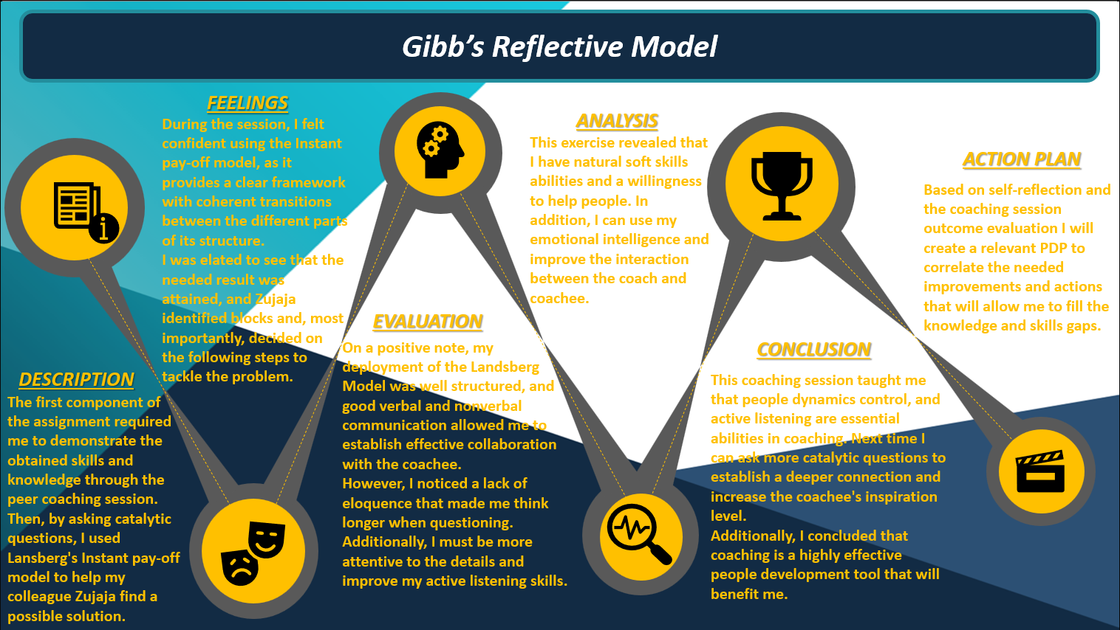

Figure 1: Gibb's Reflective Model.
During preparation for the coaching session, I noticed the apparent similarity between researched coaching models such as OSCAR, GROW, Visionary and Instant pay-off. They have a similar structure and use the same technique to achieve the result. This fact makes me conclude that all coaching theories use an identical fundamental approach.
However, I think the Instant pay-off coaching model is more suitable for short coaching sessions and, due to its simplicity, appropriate for me to use daily at my workplace.
Additionally, as Figure 1 indicates, my in-class coaching experience revealed points for further improvement that I addressed in the personal development plan, as illustrated in Figure 2.

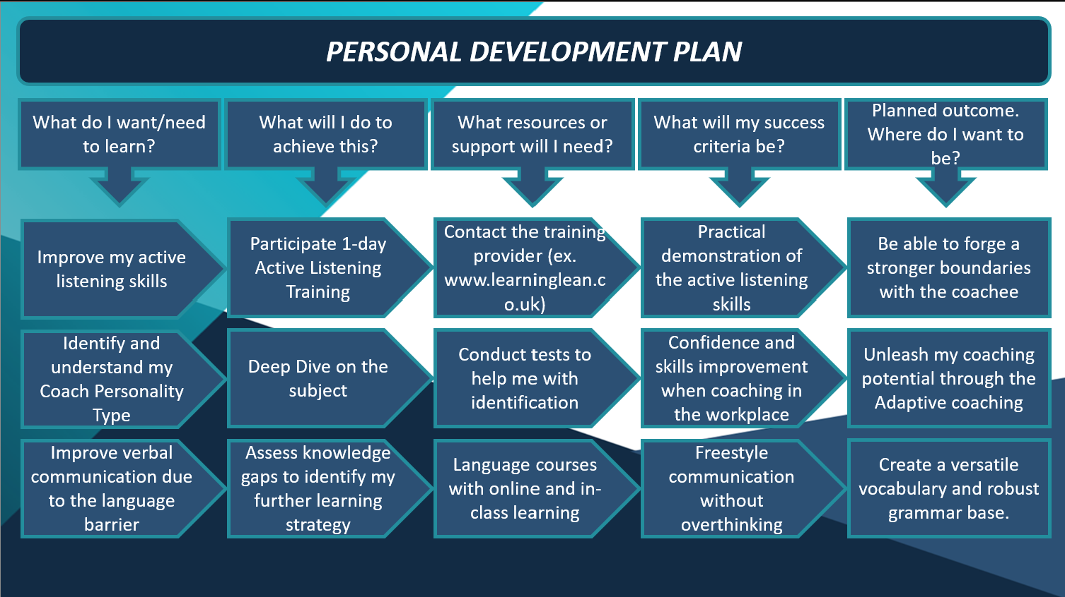

Figure 2: Personal Development Plan.

3.0 Conclusions

To recapitulate, the report's author believes that coaching and mentoring activities are beneficial at all deployment levels for all involved parties within the organisation as they transform employees' competencies into capabilities while expanding personal capacities. However, it was concluded that precisely identifying the knowledge or skills gaps is essential for adding value to coaching and mentoring activities. Moreover, today's leaders and managers must excel in mastering coaching and mentoring skills to ensure employees' personal and career development, empowerment, engagement and satisfaction and create a robust well-integrated coaching culture.
Unequivocally, coaching and mentoring activities are not only the employees' development practices that improve organisational productivity but also the essential tools that tangibly contribute to personal and corporate resilience and adaptivity to sudden or planned change.
Hence, organisational agility is the key to a successful business where change can be effectively controlled and embraced to create a more versatile and resilient workplace with a strong learning culture, morale and ethic, and leadership and management abilities of the employees.
Additionally, obtained valuable practical experience during the in-class peer coaching session endowed the report’s author with insightful acquaintance into the research subject and provided ground for further self-improvement.

Reference list

Abbajay, M. (2019). Mentoring Matters: Three Essential Elements Of Success. [online] Forbes. Available at: https://www.forbes.com/sites/maryabbajay/2019/01/20/mentoring-matters-three-essential-element-of-success/?sh=11bd104e45a9 [Accessed 30 Nov. 2022].
Arora, R. (2020). Which Companies Did Well during the Coronavirus Pandemic? [online] Forbes. Available at: https://www.forbes.com/sites/rohitarora/2020/06/30/which-companies-did-well-during-the-coronavirus-pandemic/?sh=3dc733a87409 [Accessed 7 Dec. 2022].
‌CIPD (2021). Coaching and Mentoring | Factsheets | CIPD. [online] CIPD. Available at: https://www.cipd.co.uk/knowledge/fundamentals/people/development/coaching-mentoring-factsheet [Accessed 5 Dec. 2022].
Clutterbuck, D. (2003). Managing work-life balance : a guide for HR in achieving organisational and individual change. London: Chartered Institute Of Personnel And Development.
Clutterbuck, D. (2012). Line Manager Coaching | David Clutterbuck Partnership. [online] davidclutterbuckpartnership.com. Available at: https://davidclutterbuckpartnership.com/why-line-manager-coaching-often-doesnt-work-and-what-to-do-about-it/ [Accessed 30 Nov. 2022].
Connor, M.P. (2012). Coaching and Mentoring at work. Milton Keynes: Open University Press.
Cronin, N. (2022). What Is A Mentor? Definition, Purpose & More. [online] www.guider-ai.com. Available at: https://www.guider-ai.com/blog/what-is-a-mentor [Accessed 30 Nov. 2022].
Czichos, R. (2014). Change Management. Freiburg Im Breisgau Haufe-Lexware.
Downey, M. (2003). Effective coaching : lessons from the coaches’ coach. New York ; London: Texere.
Dweck, C. (2014). The power of yet | Carol S Dweck | TEDxNorrköping. YouTube. Available at: https://www.youtube.com/watch?v=J-swZaKN2Ic [Accessed 1 Nov. 2022].
Evans, R. (2021). Employee well-being: Why It Matters & How Coaching helps? [online] CoachHub. Available at: https://www.coachhub.com/en/blog/employee-wellbeing-why-it-matters-how-coaching-helps/ [Accessed 3 Dec. 2022].
Ferrar, P. (2006). The Paradox of Manager as Coach: Does Being a Manager Inhibit Effective Coaching? Oxford Brookes University.

Folkman, J. (2016). 7 Clues You’re Not as Good a Coach as You Think. [online] Forbes. Available at: https://www.forbes.com/sites/joefolkman/2016/06/29/7-clues-youre-not-as-good-a-coach-as-you-think/?sh=247004c766fc [Accessed 3 Dec. 2022].
Friedman, T.L. (2009). Opinion | Thomas L. Friedman: The Great Disruption. The New York Times. [online] 8 Mar. Available at: https://www.nytimes.com/2009/03/08/opinion/08iht-edfriedman.1.20672274.html [Accessed 31 Oct. 2022].
GOV.UK (2018). Data Protection Act. [online] gov.uk. Available at: https://www.gov.uk/data-protection [Accessed 30 Nov. 2022].
Grant, A.M. (2012). ROI is a poor measure of coaching success: towards a more holistic approach using a well-being and engagement framework. Coaching: An International Journal of Theory, Research and Practice, 5(2), pp.74–85. doi:10.1080/17521882.2012.672438.
Guénette, J.D., Kose, M.A. and Sugawara, N. (2022). Is a Global Recession Imminent? Equitable Growth, Finance, and Institutions Policy Note. [online] Available at: https://openknowledge.worldbank.org/bitstream/handle/10986/38019/Global-Recession.pdf [Accessed 31 Oct. 2022].
Hagen, T. (2021). Council Post: How To Calculate Your Coaching Return On Investment. [online] Forbes. Available at: https://www.forbes.com/sites/forbescoachescouncil/2021/11/15/how-to-calculate-your-coaching-return-on-investment/?sh=3f2abaf93401 [Accessed 1 Nov. 2022].
Hawkins, P. and Smith, N. (2013). Coaching, mentoring and organizational consultancy : supervision, skills and development. Maidenhead: Open University Press, pp.3–8.
Hayden, D. (2021). Evaluating Learning & Development | Factsheets | CIPD. [online] CIPD. Available at: https://www.cipd.co.uk/knowledge/fundamentals/people/development/evaluating-learning-factsheet [Accessed 1 Nov. 2022].
Herrman, H., Stewart, D.E., Diaz-Granados, N., Berger, E.L., Jackson, B. and Yuen, T. (2011). What Is resilience? Canadian Journal of psychiatry. Revue Canadienne De Psychiatrie, [online] 56(5), pp.258–65. doi:10.1177/070674371105600504.
Ibarra, H. and Scoular, A. (2019). The Leader as Coach. [online] Harvard Business Review. Available at: https://hbr.org/2019/11/the-leader-as-coach [Accessed 1 Nov. 2022].

ICF (2022). The Gold Standard in Coaching | ICF - Frequently Asked Questions (FAQs). [online] International Coaching Federation. Available at: https://coachfederation.org/faqs?fwp_faqs_categories=icf-and-professional-coaching [Accessed 3 Nov. 2022].
Kose, A. (2022). Is a Global Recession Imminent? [online] World Bank. Available at: https://www.worldbank.org/en/news/video/2022/09/15/video-is-a-global-recession-imminent [Accessed 1 Nov. 2022].
Landsberg, M. (2015). The tao of coaching : boost your effectiveness at work by inspiring and developing those around you. London: Profile Books Ltd.
Lewin, K. and Heider, F. (2015). Principles of Topological Psychology. United States: Martino Fine Books.
Licht, C. (2018). How does Executive Coaching add value? 7 key points | Euro Business Coach. [online] Euro Business Coach. Available at: https://euro-businesscoach.com/how-does-executive-coaching-add-value-7-key/ [Accessed 2 Nov. 2022].
Mason, G. (2019). External Coach Vs Internal mentor: Pros and Cons. [online] www.linkedin.com. Available at: https://www.linkedin.com/pulse/external-coach-vs-internal-mentor-pros-cons-greg-mason [Accessed 5 Dec. 2022].
McNamara, M.S., Fealy, G.M., Casey, M., O’Connor, T., Patton, D., Doyle, L. and Quinlan, C. (2014). Mentoring, coaching and action learning: interventions in a national clinical leadership development programme. Journal of Clinical Nursing, 23(17-18), pp.2533–2541. doi:10.1111/jocn.12461.
Merrick, L. (2020). Internal Coaching and Mentoring to Support through Covid-19. [online] Coach Mentoring. Available at: https://www.coachmentoring.co.uk/blog/2020/04/internal-coaching-and-mentoring-to-support-through-covid-19/ [Accessed 5 Dec. 2022].
Palmer, B. (2004). Making Change Work : Practical Tools for Overcoming Human Resistance to Change. Milwaukee, Wisc.: Asq Quality Press.
Paul, E. (2019). Who Are Line Managers? What Is Their Role in Employee Management? [online] EMP Trust Solution. Available at: https://www.emptrust.com/blog/the-role-of-line-managers-in-employee-management/ [Accessed 30 Nov. 2022].

Rees, G. and French, R. (2016). Leading, Managing and Developing people. 5th ed. London: Chartered Institute of Personnel and Development.
Riley, J. (2015). Change Management (Overview). Available at: https://www.youtube.com/watch?v=9yysOwXbzRA [Accessed 5 Dec. 2022].
Sheridan, C. and Johnson, E. (2021). Mentoring Vs Coaching: the Key Differences and Benefits. [online] PushFar. Available at: https://www.pushfar.com/article/mentoring-vs-coaching-the-key-differences-and-benefits/ [Accessed 30 Nov. 2022].
Sword, R. (2021). What Is Coaching and Mentoring? | Differences, Principles & Benefits. [online] The Hub | High Speed Training. Available at: https://www.highspeedtraining.co.uk/hub/what-is-coaching-and-mentoring/ [Accessed 30 Nov. 2022].
The University of Edinburgh (2020). Gibbs’ Reflective Cycle. [online] The University of Edinburgh. Available at: https://www.ed.ac.uk/reflection/reflectors-toolkit/reflecting-on-experience/gibbs-reflective-cycle [Accessed 5 Dec. 2022].
Wales, A. (2022). The Role of Line Managers in Coaching and Mentoring. [online] Learning Resources. Available at: http://andrewwaleslod.co.uk/the-role-of-line-managers-in-coaching-and-mentoring/ [Accessed 5 Dec. 2022].
Work Foundation (2003). Coaching and mentoring. London: Work Foundation.
Work Trend Index (2022). Hybrid Work Is Just Work. Are We Doing It Wrong? [online] www.microsoft.com. Available at: https://www.microsoft.com/en-us/worklab/work-trend-index/hybrid-work-is-just-work [Accessed 1 Nov. 2022].
Yadav, A. (2021). Coaching Industry: Global Opportunities, Market and Growth. [online] xMonks. Available at: https://xmonks.com/coaching-industry-global-opportunities-market-and-growth/ [Accessed 3 Nov. 2022].
Young, A. (2020). Why is learning culture so important? [online] Accenture Banking Blog. Available at: https://bankingblog.accenture.com/why-is-learning-culture-so-important [Accessed 1 Nov. 2022].

