Student Name: Lauren Evans
P Number: 1703142
Programme of study: surface pattern design
Module: ADAD5001C
Word count: 2288
Gwenllian Beynon

Introduction

Second year of university has been overwhelming as I’ve learnt so much about the design industry and the problems facing designers of the future. Starting with sustainable design, and how designing working from a problem is compelling, as well as good for the environment in most cases in the 21st centaury. Working with an office-furniture company gave me a better understanding of the waste being produced and what good can come out of it instead of bad. Supplying myself with a different work ethic as I go into my final year of study, focusing on sustainable products. These products will take inspiration from fractal deigns in nature, as I’ve discovered reoccurring shapes are good for mindfulness which will add another angle for me to explore. I believe my 3 key words have a strong connection due to the environment connections, with shapes, materials and impact.

Sustainability
As a designer in the 21st centaury I think it’s important to always consider the environmental and social impact of a product or design. Going into my third year of university, expanding my knowledge of the subject is important. Sustainability according to the oxford dictionary is, the “avoidance of the depletion of natural resources in order to maintain an ecological balance.” People are becoming more aware of the environmental impact its having and they want to see more being done. It is important to me that my products are somewhat sustainable, in order to be responsible and succeed in the ongoing industry.
Whilst researching the topic I found Cradle to Cradle to be an interesting method of designing without using all of nature’s resources. “Cradle to cradle tries to put human beings in the same “species” picture as other living things— and to us, a misuse of material resources is not just suicidal for the future human generations but catastrophic for the future of life.” - Braungart & McDonough (2009, p3).
Cradle to cradles approach to the future is, that we should not damage non-renewable resources that we can pass onto our future generations, they believe we should focus on how we can heal the environment and avoid an environmental disaster. They’ve come up with a production system, inspired by nature, that mimics natures model to be an advantage commercially and environmentally efficient. The cycle of a product and materials must be evaluated continuously through its life cycle, from production to transportation, to monitor its impact on the environment. This helps a designer revaluate the product to become more sustainable. By using the cradle to cradle process little waste is created and it supports a more circular economy building towards a more sustainable future.
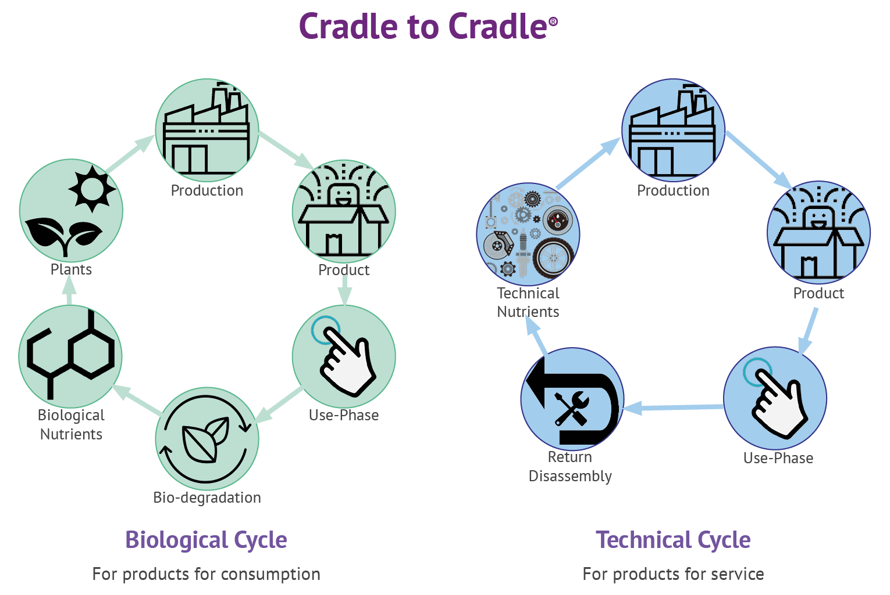

Lumsden, F Cradle to Cradle: 4 success stories, from countertops to fabrics, 2014.

This diagram shows the ideas of cradle to cradle, it explains the technical cycle which is when products can return to manufactures after their use phase to be dissembled and reused again. One company who has adopted this idea is Orangebox, a furniture design company that is focusing on being more sustainable in the future, working towards a circular economy. This is also an example of product stewardship which means companies such as Orangebox have agreed to stay responsible for their products even after purchasing meaning that they can re-use elements of the furniture to create new products without using raw materials.
“furniture like that made by Steelcase and Orangebox is designed for disassembly time and time again, and the materials are chosen for their nearly infinite capacity to be reused.” Braungart & McDonough (2009, p6). This method is completely different to say the single use recycling. They have made their products so they can be returned and reused when no longer required or damaged, they only reuse certain parts at the moment e.g. The framework but are aiming to develop this. The welsh office-furniture company Orangebox are featured in the book cradle to cradle twice, in the 2008 edition alongside some other companies. Taking circular economy into consideration when designing, manufacturing, processing and distributing. Alongside the problems that must be considered when designing you also have the problem of consumption. I believe consumption is one of the biggest problems the economy faces as things are made, never used and then thrown away.
“Consumption as an economic category is incommensurate with it as an ecological category. No matter the way in which products are acquired and used or whether consumption is thought and theorized as an economic activity, the fact is that all durable products at the end of useful life have not been consumed.” Fry (2009, p192). This further adds to my point and it is clear to me that no matter what a designer does to be sustainable the consumer needs to decide what to do with the product at the end of its life and the consumer must become a more responsible purchaser. For example, recycle or return to the company/ manufactures if possible, going back to what the furniture company Orangebox have been doing. Although this is not always the case as consumers believe it is easier just to get rid of a product and buy new. Because the consumers think like this you could say designers aren’t that considered of the materials they use. One because of the cost but also if a product isn’t going to be used for a long period of time they usually choose a fast manufacturing material like plastic that then later is hard to reuse or recycle.

Humans are consuming the planets recourses at an alarming rate and the textile industry plays a significant part of this due to the way textiles are made and the amount of waste It produces daily. Orangebox are guilty of creating 50 tons of waste fabric a week that gets incinerated. This is a big problem for their circular economy even though they are reusing some materials again. I would say this goes back to what we consume, the company is obviously consuming more fabric than they need due to patterns and sizing. They should be more efficient with the amount they use, to prevent waste and save money and work towards their goal which is designing out waste completely. Recently the company have teamed up with university of Wales trinity saint David to see if the surface pattern students can reimaging the waste. This could significantly reduce the amount of waste produced if more collaborations like this took place. The textile waste they are incinerating is great quality and often the waste is large pieces of fabric that could be made into something.

Fractal
Throughout my practice I have been fascinated by modular designs and the repetition of the same forms. When researching about biophilia and mindfulness I came across the word fractal. The meaning of the word given by Oxford dictionary is “a curve or geometrical figure, each part of which has the same statistical character as the whole. They are useful in modelling structures (such as snowflakes) in which similar patterns recur at progressively smaller scales, and in describing partly random or chaotic phenomena such as crystal growth and galaxy formation”. I see fractal patterns as a strong unit of the same shape, naturally designed to create one object for example honeycomb we often come across fractal patterns in nature.

As a designer, the environment is something I frequently take inspiration from, and by using the reoccurring shapes such as hexagons it can be positive for the consumers mind. “The results of many studies show that exposure to fractal patterns in nature reduce people’s levels of stress up to 60%.” Lambrou (2012) When designing office furniture like Orangebox, it is important to take the wellbeing of the workers into consideration. By creating geometric patterns for their furniture, inspired by the reoccurring shapes in nature it’s a way of bringing the outdoors in. Creating a calmer work environment as certain architectural designs and landscapes can incorporate fractal patterns that resonate with relaxation.

When designing from the waste Orangebox supplied, I created a modular hexagon fabric, designed for upholstery. The modular aspect for me is important as the design is aesthetically pleasing and can be altered to suit the client. But more importantly for sustainable design it can be changed quickly and efficiently if warn or torn, preventing more textile waste and increasing the longevity of a product.
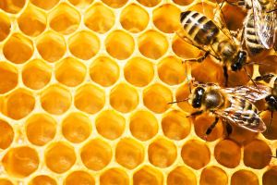
Weltman, A. Natural Geometry, Hex, and Sacred Geometry (2013)

This photo above shows the fractal hexagon design of honeycombs. I take a lot of inspiration from this shape when designing work, I like the symmetry and find that it’s easier to connect with multiples of the same shape. This is because the aesthetic is pleasing. “The aesthetic aspect of experience.” writes Prall (1936) For me the aesthetic experience of fractal design comes from, the relaxation I feel when outdoors. Nature is what does this so it would be a shame to use all of its recourses on things we don’t need or use.

Design
The definition of design from Oxford dictionary is “a plan or drawing produced to show the look and function or workings of a building, garment, or other object before it is made. “Designers and design students report quite commonly that they often feel the need not to draw.” Lawson (1997, P.256) I would argue that I agree with the statement as I believe design isn’t just drawing. As a maker on the surface pattern course I find designing hands on with materials much more exciting rather than sticking to pen and paper. You could say it refines you. Drawing on paper and doesn’t feel very creative and often you don’t think about problems until its being made. “Drawing does not show or suggest answers to questions which are not being asked at the time.” Lawson (1997, p.242) These unknown problems when designing can later lead to unsustainable designs, meaning poor responsibilities from the designer concerning the environmental impact it may have.
There is no set way on how to design, most people including myself design from a problem, in order to create a solution. In my case it prevents me from using materials from natures recourses and think about what can be created from things like waste. Especially textile waste as it is often incinerated, even after its taken so much time and resources that are vital to make it. Waste such as silk and cotton. This creates a link to sustainability and the project I done with Orangebox. Although sometimes it’s difficult to respond and help the situation as it could accelerate the problem if the wrong decision is made. Meaning designers failed to take responsibility or recognise the ethical implications. This is where we see a problem with how designers are expected to know about all these problems and ethics when we don’t, as were not taught it. “Design ethics is massively underdeveloped and even in its crudest forms remains marginal within design education” Fry (2009, p.3) This brings it back to sustainable design and how important it is to design by the cradle to cradle method. I believe you discover these methods when designing from a problem. “Green design, green architecture, environmental design, eco-design, sustainable design, sustainable products, Eco efficiency and sustainable consumption- all these have claimed to bring design, ecology and environment together over the past two decades.” Fry (2009, p.183) We don’t often get taught about ethical problems but over the past two decades it’s heard more, by not only designers but consumers too. Which is why I’m wanting to better my understanding of the subject.

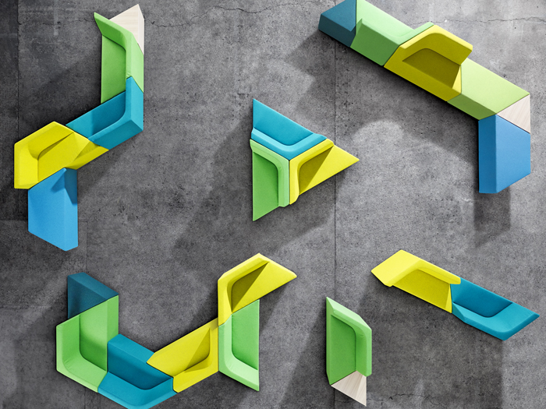
Lotersztain, A. Prisma, designed for Derlot Editions (2013)

Keeping in mind fractal properties, this image shows one shape repeated to create a modular design that can be altered to suit the area. Changing the aesthetic and bringing the concept of naturel forms into designs like this can alter the way a person might feel in the area without the knowing. I believe this because of the information I found about fractal patterns reducing stress of up to 60% from Lambrou. Although this statistic is strong, there is currently not much information about the topic to compare. Although it is mentioned in books about aesthetic. Including the Structure of Aesthetics by Sprashott (1963)

Conclusion

To conclude I plan on taking forward all 3 of these key words in my dissertation and in my practice. I believe they have a strong connection which is clear to me after researching. I have discovered a lot about the cradle to cradle method, but I would like to explore cradle to grave in my next year of study and compare the differences. I think this will be good to consider what can happen if sustainable design isn’t taken seriously, by me as a designer but also consumers who don’t believe it has anything to do with them. The circular economy can’t work without their contribution as they produce waste that isn’t being reused or recycled. Orangebox the furniture design company are in the process of being sustainable and I’ve learnt a lot about the methods they’ve used but also the problems industrial manufacturer face.
Designing from a problem is helpful for the environment and also encourages designers to think outside the box instead of giving the consumers more things to consume, that they don’t even use. I enjoy researching the benefits of fractal design and the effect they have on humans. This relates to nature which then links to sustainable and design. The modular aspect of design is something I want to explore further in my practice as it excites me. I could do this while exploring fractal designs and the effects it has on the mind, whilst also bring the outside in creating innovative spaces and products.

Bibliography

Braungart, M & McDonough, W (2009) Cradle to Cradle remaking the way we make things. London: Vintage. Page 3.

Fry, T (2009) Design Futuring sustainability, ethics and new practice. Oxford: Berg. Page 192.

Lawson, B (1997) How Designers Think the design process demystified. Oxford: architectural press. Third edition, page 256.

Prall, D (1936) Aesthetic Analysis. New York: Crowell. Page 21.

Sparshott, F,E (1963) The Structure of Aesthetics. Canada: University of Toronto Press.

Websites and Articles

Florence Lumsden (Thursday, March 20, 2014) Cradle to Cradle: 4 success stories, from countertops to fabrics.
Available at:
https://www.greenbiz.com/blog/2014/03/20/4-cradle-cradle-certified-product-breakthroughs
(Accessed on Wednesday 17th of April)

Joye, Y. Steg, L. Ünal, A B. Pals, R. (31 /08/2015) When complex is easy on the mind: Internal repetition of visual information in complex objects is a source of perceptual fluency.
Available at:
https://web-a-ebscohost-com.ezproxy.uwtsd.ac.uk/ehost/detail/detail?vid=1&sid=a14f8323-d7b1-423d-8481-260b09af3860%40sdc-v-sessmgr04&bdata=JnNpdGU9ZWhvc3QtbGl2ZQ%3d%3d#AN=2015-39647-001&db=pdh
(accessed on Monday 22nd of April)

Lambrou, P (Sep 07, 2012) Fun with Fractals? Why nature can be calming.
Available at:
https://www.psychologytoday.com/us/blog/codes-joy/201209/fun-fractals
(Accessed on Tuesday 18th of April)

Lotersztains, A (9th September 2013) Design/curial. SIX OF THE BEST: MODULAR DESIGN.
Available at:
http://www.designcurial.com/news/six-of-the-best-modular
(Accessed on Monday 22nd of April)

https://www.orangebox.com/about/responsibility
(Accessed on Tuesday 30th of April)

Oxford English Dictionary
Available at:
https://en.oxforddictionaries.com/definition/aesthetic
https://en.oxforddictionaries.com/definition/design
https://en.oxforddictionaries.com/definition/sustainable
(Accessed on Wednesday 17th of April)

Weltman, A (18th June 2013) Natural Geometry, Hex, and Sacred geometry
Available at:
https://mathmunch.org/2013/06/18/natural-geometry-hex-and-sacred-geometry/
(Accessed on Tuesday 30th of April)

