
BMSW4003
Digital Skills and Research Methods
WIZZ AIR-A STUDY ABOUT THE APPROPIATE USE OF CONTEMPORARY TECHNOLOGIES TO IMPROVE WORKPLACE EFFICIENCY AND EMPLOYABILITY
Olusoyi Ashaye

Students:
- Ramona Jantea – 1916897
- Diana Dodoi – 1915911
- Dariusz Rzepecki –1916895
- Alexandru Bucur –1915902
- Tiberiu Grigoras – 1916657

1.
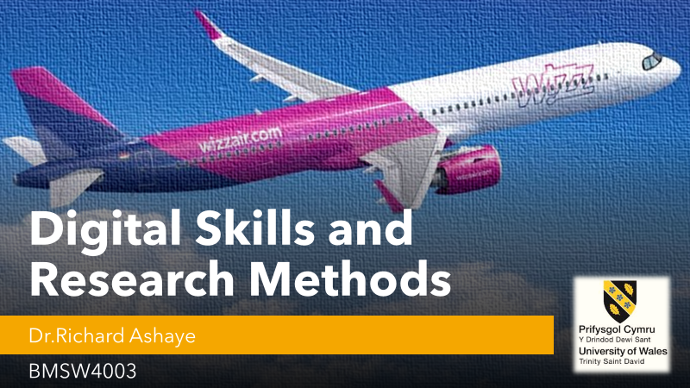

2.
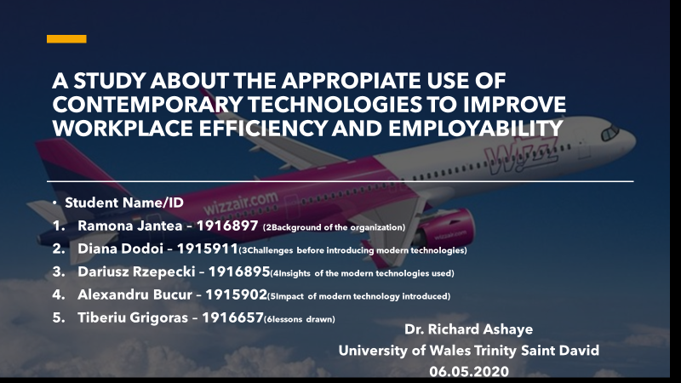
3.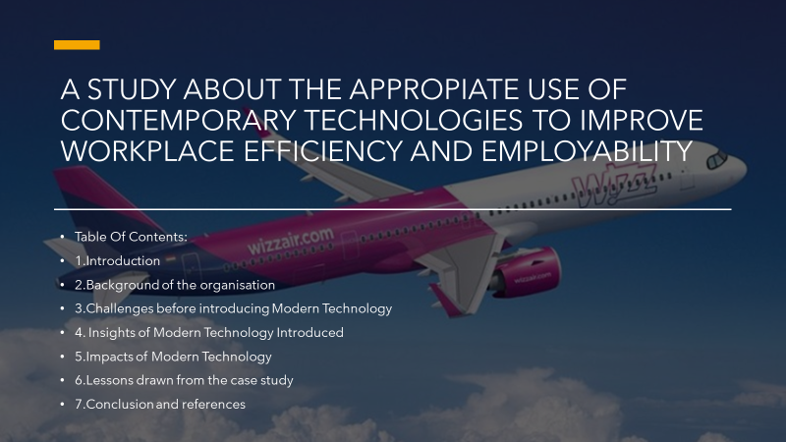

4. 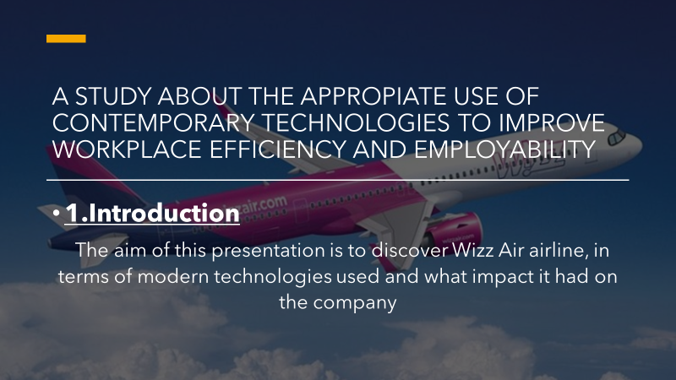

5.Ramona Jantea
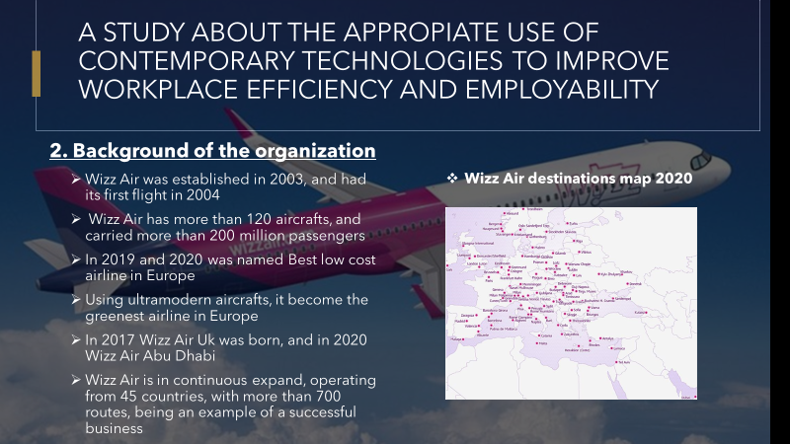
Background of the organisation
  - History of the Organisation – Wizz Air started to function as a registered Company in 2003, and their first ever flight took off on 19th of May 2004, from Poland (Katowice) and United Kingdom (London Luton). Till 2006 the company manage to carry around 5 million passengers, reaching 10 million passengers carried in 2010. In 2014, after 10 years on the market, Wizz Air carried 15 million passengers, and had a fleet of 50 aircrafts (Airbus A320). Slowly they became one of the largest low-cost airlines in Central and Eastern Europe, in 2016 being recognise as “Value Airline of the year” by Air Transport World magazine. In 2017 Wizz Air UK was born, and next year company already had 100 aircrafts and 200 million passengers carried. In 2019, with a fleet of 120 Ultramodern aircrafts, the company was included in top 10 safest airlines, but also thanks to new generation of engines, Wizz Air becomes the greenest airline in Europe, with “the smallest environmental footprint per passenger”. According to AirlineRatings, the company is recognised as Best low-cost airline In Europe, for two consecutive years, 2019 and 2020. (wizzair.com)
  - Aim & Objectives of the Organisation
One ambitious project is subsidiary Wizz Air Abu Dhabi, Wizz Air becoming first European low-cost carrier to fly in this region. According to livemint.com, the company will start flying in 2020 with 3 aircrafts and 50 more to come in next 10 years. The targeted destinations will be at first cities in Europe and Russia, and later Middle East, Africa and the Indian subcontinent.

  - Scope/Purpose of the Organisation
“We challenge ourselves daily to be the most loved low cost airline. Some might say that’s ambitious, but in 15 years we’ve defied the odds, becoming Europe’s fastest growing and greenest airlines.” (wizzair.com).
The purpose of the company is to expand, in order to carry more and more passengers, so Wizz Air is in continuous search for opportunities in order to make available more destinations and provide lowest fares on the market.

  - Current status & Services of the Organisation
According to Wizz Air website, the company manage to build “a successful business around this simple mission - offering more affordable travel opportunities to discover Europe and beyond.”
In 2020 the airline has a fleet of 120 aircraft, and ordered another 269 in upcoming years, connecting 154 airports from 45 countries, having a total of 710 routes, and more than 4500 of employees.

6.Diana Dodoi
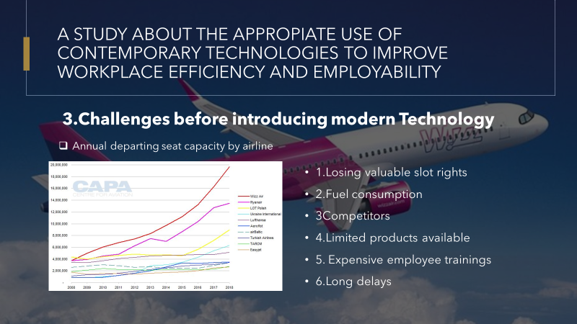
For sure the Impact of new technology introduced it was huge, Wizz Air expansion depending mainly on the innovative solutions implemented, they had no choice but to adapt as fast as possible to new aviation demands.
One of the companies challenges it was the booking slot system, so a new partnership with a specialised company (in 2019) with a long airline commercial history, it was inevitable. This helped the company to increase its productivity and revenue, but also made more people to think about Wizz Air as first option when about flying.
Fuel consumption
Although Wizz Air fleet has new aircrafts only, mainly Airbus A320 and Airbus A321, a better opportunity occurred for the company, by ordering more efficient aircrafts, still from A320 Family. In comparison with the previous aircrafts, the new ones burn 16% less fuel, they have 16% less CO2 emissions. Can fly 16% further, are lowering the noise with 43%, and also they are helping in lowering unit costs with 20%.

Competitors
Competitors is one of key risks to the business in general, but for Wizz Air too. Although they can't reduce competitors they constantly monitor the competition and try to deliver a superior service and build a loyal customer base, they believe that in tough market conditions lowest cost wins so, having that in mind, they had to find solutions in order to keep the fares low and accessible for more people.
Long delays
As low-cost company, it was hard to deal with long delays, which was caused by overbooking, flight restriction, so on. So, they had to find solutions in order to minimise the delays and keep the passengers satisfied.
Limited products available
A huge change occurred in 2017, when the company renewed their websites, after a partnership with WeLocalise. This alliance made the customer journey more satisfying and complete, as they had the chance not only to buy a ticket from point A to point B, but also to complete their journey with booking a hotel, renting a car, adding airport transfer, or find an airport parking. This made Wizz Air website to be the eighth most visited airline website in the world back in 2017. Now in 2020 Wizz air is the world's only safety and product rating website.
Expensive employee trainings
One of the company biggest achievements is the Wizz Air Simulator and Training Centre, located in Budapest, it cost the company 30Million euro, being one of the most performant and advanced in Europe. The new Centre has a capacity of 300 trainees daily, and is used both by pilots and cabin crew, for flight and cabin simulation exercises, but classroom trainings too.

7.Dariusz Rzepecki
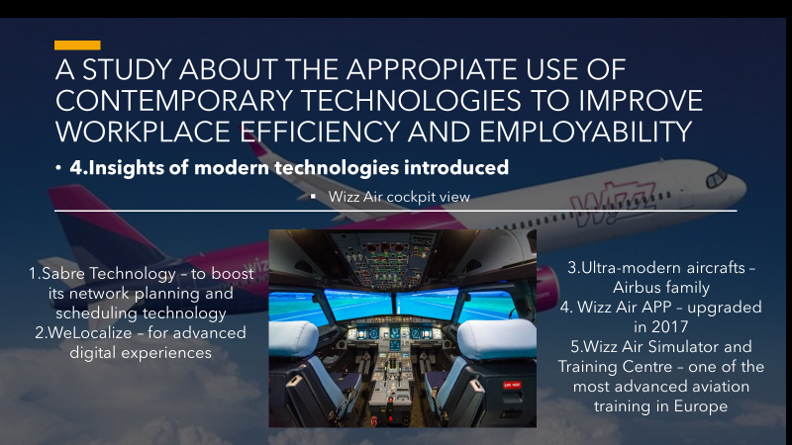
Sabre is the leading technology provider to the global travel industry Wizz Air find in the corporation a strategic partner, in order to enhance its network planning and scheduling technology.
Thanks to intelligent planning and scheduling solutions, airlines achieve up to 9% incremental operating profit and up to 12% increase in productivity.
Sabre technology is connecting all bussines partners in one big travel web giving customers lots of opportunities to plane their trips, holliday completly. Using WizzAir website, customers can also book an accomodation, the company have an agreement with booking.com, one of the largest platform for finding a hotel or appartament in their destination, with a disscounted price. Also there are other services available, like airport transfers, airport parking, bus tickets or car rental. Having all this options together on one website only is a huge advantage for potential customers, as is saving money and time, and also make the journey more comfortable.

We localize – This platform based on the cloud is not simply translating the website content from one language to another, but also transform the content in order to can speak to customers across different markets, cultures, and contexts. WeLocalize transforms content across platforms, devices, and channels so that it resonates locally and delivers a superior customer experience worldwide to ensure that the content is relevant and culturally appropriate at every step. This platform helps Wizzair to reach customers around the world and develop business in such a way as to be more attractive and suited to different customer groups(welocalize.com)

WIZZ app- This application take a customer easly and simply trought the booking process, jurney timeline, inn-app offline boarding card and all facilities that the customer can use on the wizzar website in a simple form, being available on the phone, in 18 languages(wizzair.com)
Modern aircrafts – In 2019, wizzaris began introducing its fleet of innovative 320neo and 321 neo aircraft models powered by Pratt & Whitney PW1100G-JM engines. These engines are the most environmentally friendly and quietest in their class and provide fuel savings of 20% delivering per seat fuel improvements, along with additional range of up to 500 nautical miles/900 km,or 2 tonnes of extra payload, compared to their 321ceo predecessor. In the 321 neo model thanks to optimised use of cabin space, increased exit limits and a new cabin door configuration incresed numbers of seats , to 244 while maintaining the standard 18-inch position width. (airbus.com) “Wizz Air started to operate its first Airbus aircraft 14 years ago. Today WIZZ has become a true success story, and we are proud to have played a major role in this journey, providing the most efficient aircraft with the lowest operating costs combined with unbeatable comfort in the widest single aisle cabin in the skies, ” said Eric Schulz, Airbus Chief Commercial Officer. In 2023, wizzari will enrich its fleet of 20 new aribuses A321XLR The A321XLR variant will be operated with 239 seats, the same as the A321neo to ensure full fleet commonality with Wizz Air’s existing fleet. The XLR aircraft can also be utilized on Wizz Air’s existing network with the same efficiency "The A321XLR is the most cost efficient aircraft of its type and represents a significant opportunity for Wizz Air to further expand its network and connect points on the WIZZ map that are currently out of reach, given the enhanced range capability of the aircraft. Today, we are flying a number of 5-6 hour routes with great satisfaction to our customers, so the XLR will extend our outstanding value and service proposition on routes of 7-8 hours of flying.” - said József Váradi, CEO of Wizz Air (wizzair.com)
When talking about modern technology, is hard not to mention Wizz Air Training centre, which has 2 fully equiped flight simulators and cabin trainer, with a full cappacity of 300 trainees daily. The new centre, which is one of the most advanced and modern from Europe, is marking “an important milestone in the history of the airline”(wizzair.com).

8.Alexandru Bucur
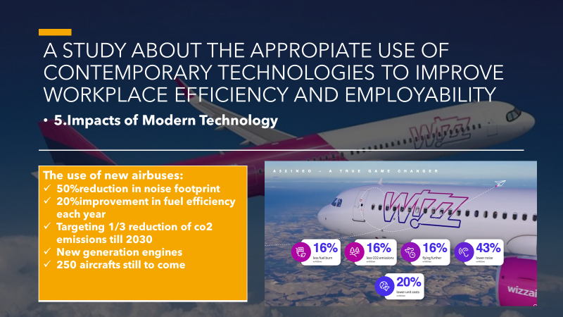
9.
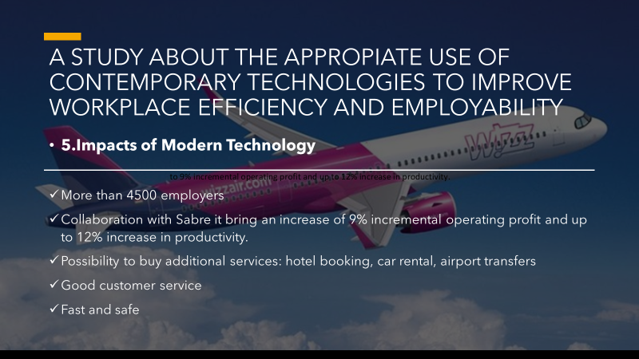
The partnership between WizzAir Uk and Sabre Corporation, which is the most known technology provider to travel business around the globe, it helped the company to achieve up to 9% incremental operating profit and up to 12% increase in productivity. (Sabre.com) The new modern technology implemented, helped the airline to get important slot rights but also a fast response to rescheduling its flights, which in the end had a significant impact on productivity and revenue and efficient operation overall.
The collaboration with Welocalize, came as a result of fast expansion of the company. As first experience with airlines is buying the ticket, it was obvious a need of implementing new innovative technologies for digital content. Welocalize made the whole experience of using Wizz Air website an amazingly fast and easy one, also they solve the language and culture challenge of entering New Markets, by not just translating words, but by adapting to new cultural requirements. Also, this create the experience complete, as passengers has the possibility to buy additional services in order to facilitate their journey, like airport transfers, hotel bookings, car rental, and to boost the company revenue too.
The best use in modern technologies is Wizz Air airplanes, with Airbus A320 and Airbus A321 still in use, WizzAir has ordered new airplanes from the Airbus A320 family: Airbus A320NEO and Airbus A321NEO. Talking about A321NEO, on the official Airbus page is stated that: “The new generation aircraft is powered by two Pratt & Whitney GTF engines and features the widest single-aisle cabin with 239 seats in a single class configuration and offers operators maximum flexibility, fuel efficiency and low operating costs”. In addition to this, “The A320neo also offers significant environmental benefits with nearly a 50% reduction in noise footprint compared to previous generation aircraft(…)It has pioneered and incorporated the latest technologies, including its new generation engines and the industry's reference cabin design, delivering 20% fuel cost savings alone” (Airbus.com, 2019)
The impact of all this partnerships, but also implementing new technologies as self-service desk(introduced in 2019) renewed mobile app, etc, made the airline more profitable and safer, and for more and more people first option when talking about choosing a low cost company for travelling, Wizz Air being awarded “the best low-cost airline-Europe 2020” according to AirlineRatings, winning this prize for two consecutive years.

10.Tiberiu Grigoras
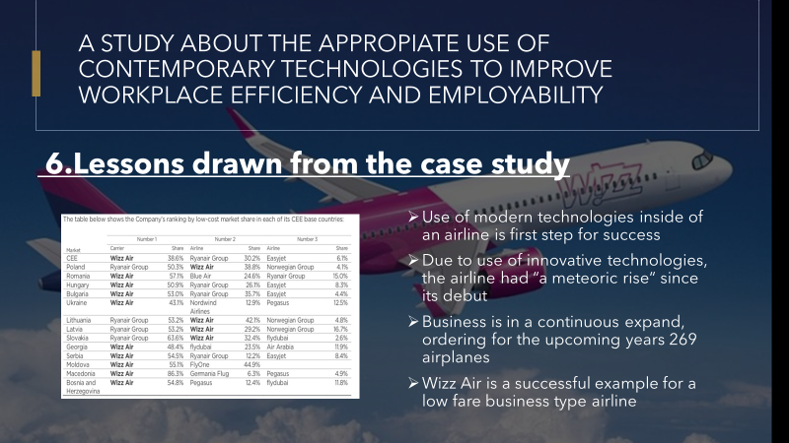
The expansion and efficiency of airlines industry is not possible without the use of modern technologies. For airlines to be efficient, safe and profitable, companies need to adapt to new technologies available on the market very quick. It is especially important to have the right tools when talking about ambitious projects, CEO of WizzAir, Jozsef Varadi declared many times he wants his company to be first option when talking about choosing to fly, so without innovative modern technologies on his side, it might be difficult in this domain. Since founding the company in 2003, “Wizz Air has undergone a meteoric rise” (thisismoney.com, 2020).Also “Since the 2014 financial year, it has more than doubled passenger, aircraft fleet and revenue numbers, and more than tripled net profit” and “Expected yearly profits for the company are now expected to range between €350million to €355million” according to thisismoney.com.
Wizz Air plans to expand even more, the carrier ordered another 70*A320 NEO, 179*A321NEO and 20*A321XLR, last ones will make possible the entry on farer markets such as North America or India, “Wizz Air is becoming unstoppable”, CEO adding that “The inherent aircraft economics of the Airbus A321XLR will widen our competitive advantage for stimulating demand for air travel in Central and Eastern Europe and beyond while minimizing our environmental footprint. The A320neo family aircraft are game-changing aircraft that enhance Wizz Air’s low fare model and undisputed cost leadership in Europe.” (simpleflying.com, 2019).
Also using of all innovative technologies, the company succeed to expand its network to 45 countries, 154 destinations, with more to come soon, more than 700 routes across Europe mainly and beyond, and 41.5 million passengers carried in 2019. In only one year, the capacity growth was 16%, from 36.6 millions seats on sale in 2018, to 42.6 millions seats in 2019, according to wizzair.com.
When about Wizz Air Uk, company managed to stay strong even Brexit situation put in danger other airlines: “Both Ryanair and Lufthansa have addressed concerns in their financial filings, but a growing low-cost competitor based in Hungary—Wizz Air—is well-positioned to make the most of a bad situation.”(Forbes.com). To be in this position, the company invested in innovative modern technologies, in order to make travel experience safer, faster, more friendly, in order to increase the number of passengers flying, so its revenue.
11.
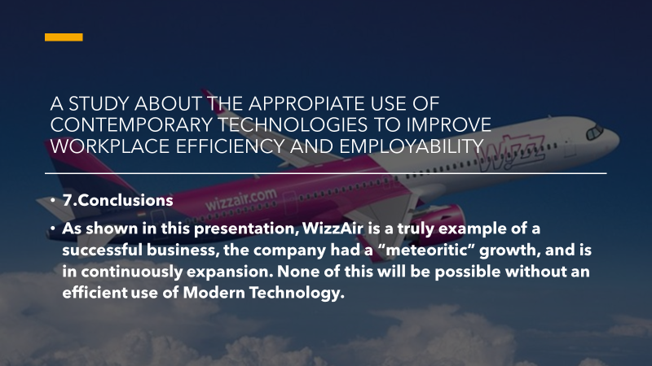
12.
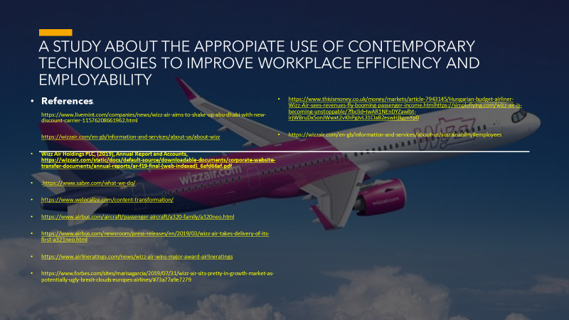
References:
- References:
- https://www.livemint.com/companies/news/wizz-air-aims-to-shake-up-abu-dhabi-with-new-discount-carrier-11576208661962.html
- https://wizzair.com/en-gb/information-and-services/about-us/about-wizz
- Wizz Air Holdings PLC, (2019), Annual Report and Accounts, https://wizzair.com/static/docs/default-source/downloadable-documents/corporate-website-transfer-documents/annual-reports/ar-f19-final-(web-indexed)_6afd66af.pdf
- .https://www.sabre.com/what-we-do/
- https://www.welocalize.com/content-transformation/
- https://www.airbus.com/aircraft/passenger-aircraft/a320-family/a320neo.html
- https://www.airbus.com/newsroom/press-releases/en/2019/03/wizz-air-takes-delivery-of-its-first-a321neo.html
- https://www.airlineratings.com/news/wizz-air-wins-major-award-airlineratings
- https://www.forbes.com/sites/marisagarcia/2019/07/31/wizz-air-sits-pretty-in-growth-market-as-potentially-ugly-brexit-clouds-europes-airlines/#73a77a9e7279
- https://www.thisismoney.co.uk/money/markets/article-7943145/Hungarian-budget-airliner-Wizz-Air-sees-revenues-fly-booming-passenger-income.htmlhttps://simpleflying.com/wizz-air-is-becoming-unstoppable/?fbclid=IwAR1NEnDYZawlbt-irjWBruDx5onJWwxt2vKhPgJvL31CIaB2eswHJkgmYp0
- https://wizzair.com/en-gb/information-and-services/about-us/sustainability#emp

