ACCA5026 Databases and Application Development
Part B Report: PHP Database-Driven Website
System: Library Management System
Narcis Valentin Gorgos
Student ID 2407130

Lecturer: Mohd Syafiq Bin Zolkeply
Submission Deadline: 31 july

1. Introduction
Part B is for an open web application. Library members can search the book catalog without any authentication, and with the use of the Library Management System, the library administrator can manage books, members, loans, and categories by using a protected admin interface, which was created with PHP 8 and MySQL 8.0. This is, in fact, the primary way in which relational data is made accessible to non-technical users, as described by Elmasri and Navathe [1].
The PDO library is used to connect the application layer to the MySQL database in PHP. All queries containing user data are prepared, meaning that they are separated from the data to greatly reduce the risk of the most common SQL injection attack vectors cited on the OWASP SQL Injection Prevention Cheat Sheet [2]. This report includes schema design, normalization, PHP implementation, security architecture, and an in-depth SQL injection analysis.
2. Database Design
2.1 Entity Identification and Schema
The library_db database includes five tables, each of which represents a different object in the Library domain. Categories is a list of classification taxonomies for books. The foreign key to Categories is in Books. Members record borrower information. Loans record the borrowing and lending relationship between books and members, with details of when they were issued, when they were due, when they were returned, and the status of a loan. AdminUsers keep sensitive administrative account information separate from member information.

Table | Primary Key | Key Attributes
Categories | category_id (PK) | category_name UNIQUE
Books | book_id (PK) | title, author, isbn UNIQUE, category_id (FK), available, added_date
Members | member_id (PK) | first_name, last_name, email UNIQUE, phone, joined_date
Loans | loan_id (PK) | book_id (FK), member_id (FK), loan_date, due_date, return_date, status ENUM
AdminUsers | admin_id (PK) | username UNIQUE, password_hash
Table 1: Entity Identification and Schema
Surrogate primary keys (as AUTO_INCREMENT integer keys) are used instead of natural keys (like ISBN or email address). Natural keys also change: An ISBN could be reissued, or an email could be changed — and these changes would cascade across multiple tables if they were used as join columns. Including email addresses as foreign key values also increases the attack surface for personal data exposed by UK GDPR guidelines on data minimization [3]. Join columns do not contain personal information, thanks to surrogate keys.
2.2 Relationships and Cardinalities
There is a one-to-many relationship between Categories and Books: one category can have many books, but a book cannot have more than one category, the constraint is enforced by a foreign key constraint fk_book_cat ON DELETE RESTRICT. Books have a one-to-many relationship with Loans: books have many loan records throughout their life, but there is a limit of one loan record that can be ACTIVE for a book at any given time. Each book that a member borrows will be a row in Loans, and there is a one-to-many relationship between Members and Loans. The Loans table can therefore be seen as a resolution entity for the many-to-many relationship between Books and Members, which is the most common method used to decompose a many-to-many relationship in relational schemas, as described by Coronel and Morris [4].

2.3 Entity Relationship Diagram
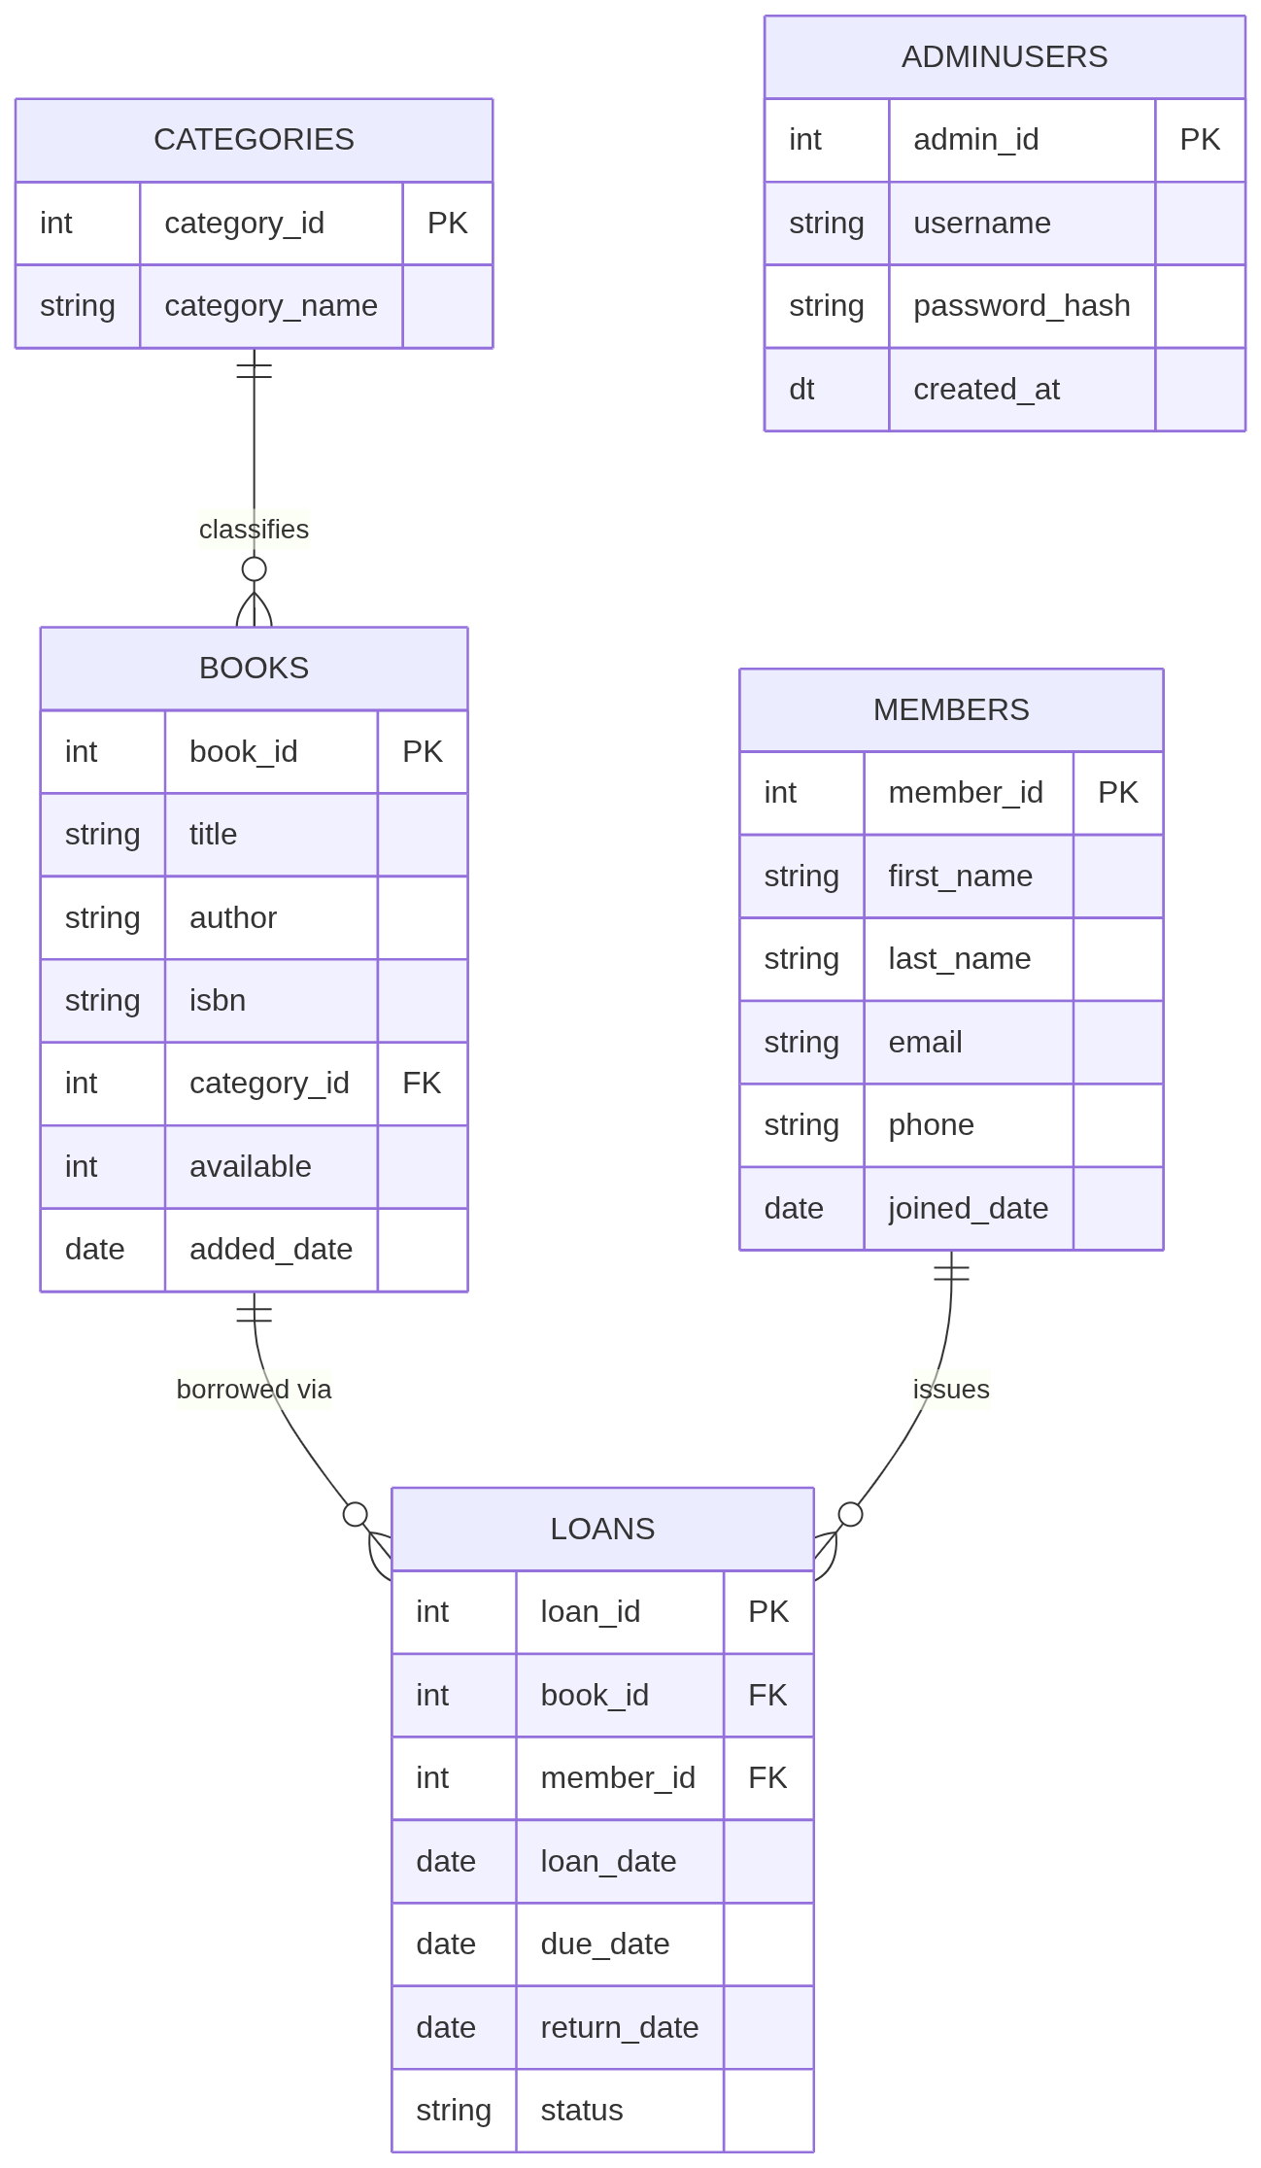
Figure 1 Entity Relationship Diagram

2.4 Normalization to 3NF
All attributes in the schema are atomic. Loans.status is not a list of states, but rather a single ENUM value from the set (‘Active’, ‘Returned’, ‘Overdue’). Book authors are stored as one VARCHAR string; a future extension that would require multi-authored books would require an Authors junction table as well as a BookAuthors association table, but a single author field is sufficient for the current scope.
Single column surrogate primary keys are used for all five tables, and it's impossible for partial dependencies to form by definition. Each attribute other than the key is dependent on the entire loan_id: loan_date, due_date, return_date, and status—each of these are attributes of the specific loan transaction identified by loan_id, and don't refer to a subset of a composite key. category_name is not repeated in Books table and is stored in the Categories table. The book_id – category_id – category_name transitive dependency that is needed in Books would be generated. This is the same dependency that occurred with the Department/Doctor in Part A that would be created in Books. Changes to category name will only need to update 1 Categories row and will not affect any update anomalies to book records. Silberschatz, Korth and Sudarshan [5] describe this transitive dependency as the main reason why decomposition is needed for third normal form.
2.5 System Architecture
It runs on a 2-tiered architecture with XAMPP providing the apache services. The public facing tier exposes index.php, for unauthenticated book search. The admin tier includes PHP files in the /admin/ directory which are guarded by the auth.php session guard. Both tiers are completely bound to MySQL 8.0 via PHP's PDO layer, where each query which affects the user is actually a native prepared statement. Apache handles routing of the HTTP protocol, PHP runs the business logic, and MySQL keeps and queries the data.
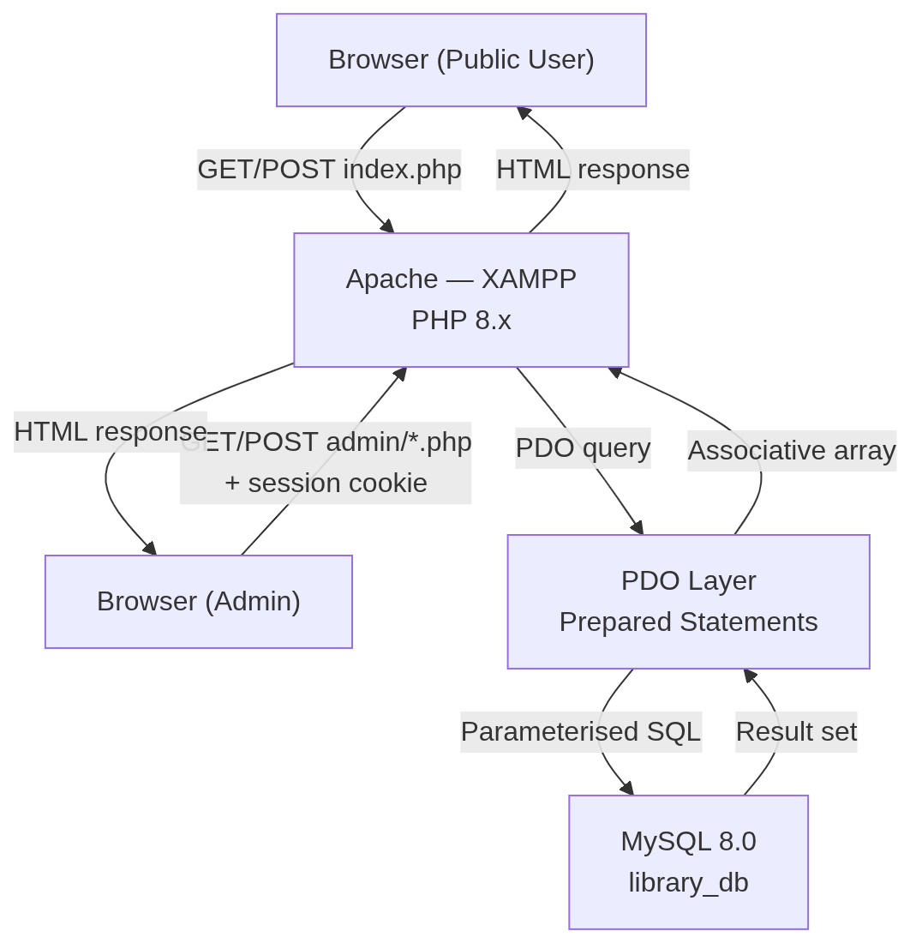
Figure 2 — System architecture diagram
3. Implementation Documentation
3.1 Database Connection and Configuration
The file includes/db.php initializes the PDO connection just once and stores the $pdo object for use by all files which include it. There are three options that are set at construction. PDO::ATTR_ERRMODE => PDO::ERRMODE_EXCEPTION sets the attribute on PDO so that it will throw a PDOException on any error that happens in the database, instead of returning false without a warning. PDO::ATTR_DEFAULT_FETCH_MODE => PDO::FETCH_ASSOC retrieves result rows as associative arrays, with keys being the column names instead of duplicated integer keys that make code more difficult to read. PDO::ATTR_EMULATE_PREPARES => false will tell PDO not to emulate prepared statements in the client, instead it will send the prepared string statements to the database. This configuration is recommended as the default secure configuration of PHP [6] for PDO.
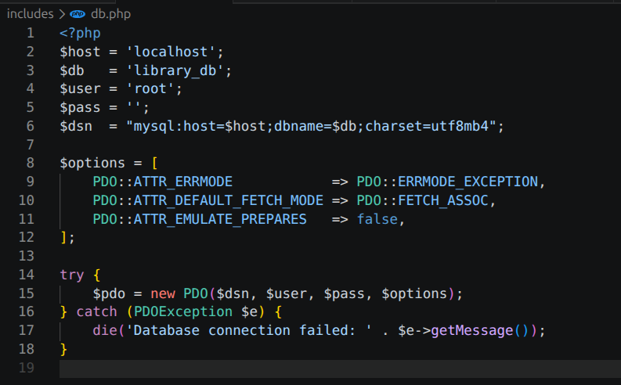Screenshot 1 — includes/db.php: PDO connection with options array
3.2 Public Book Search (index.php)
The public search page supports 2 optional GET parameters: a text string to match in Books.title and Books.author using LIKE? with %term% and a category_id integer to filter by category. Both parameters are bound using prepared statements—neither parameter is ever added to the SQL string. The "query" joins Books with Categories to show the category_name in each result row. If both inputs are empty, the WHERE clause will only include 1=1 as a condition and all books will be returned. Books available is displayed in the results table as a Bootstrap badge with a green background if the book is available and a red background if the book is on loan.
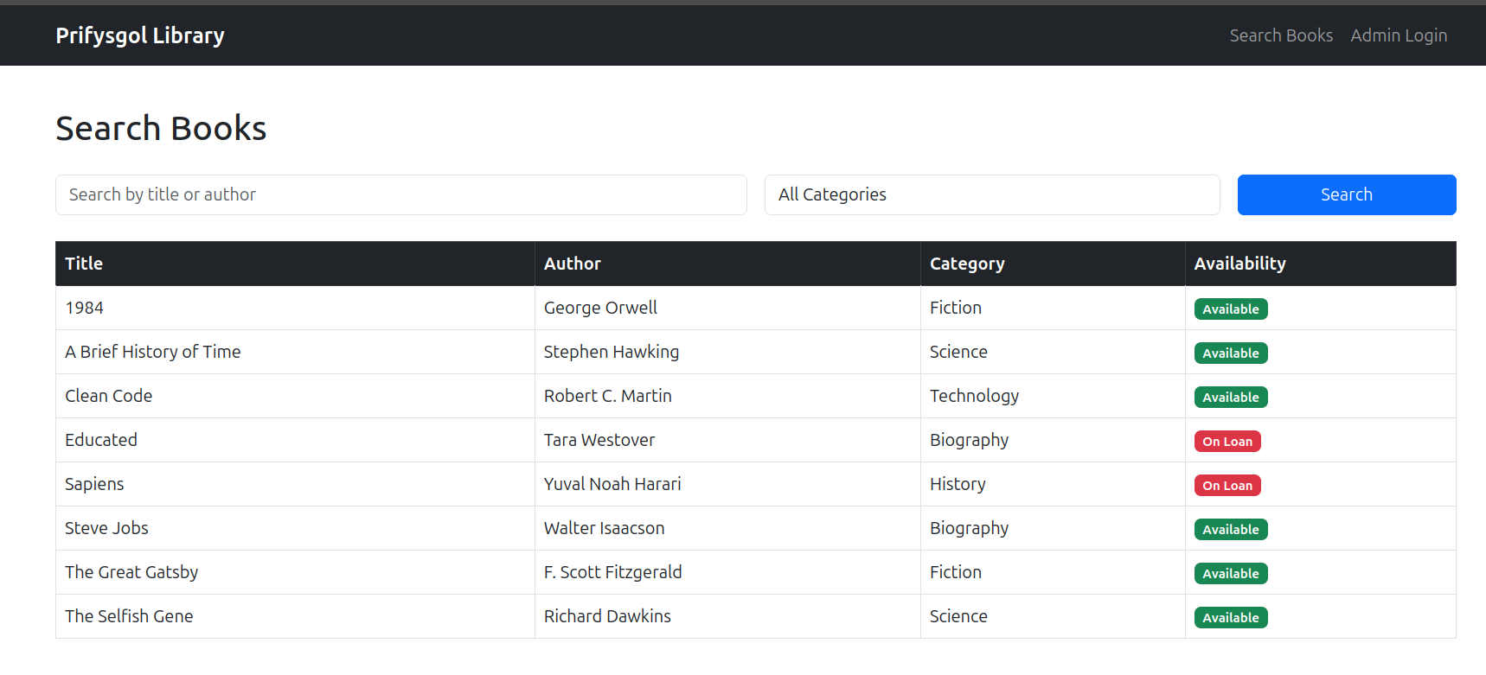
Screenshot 2 — index.php: public book search showing all books with availability badges
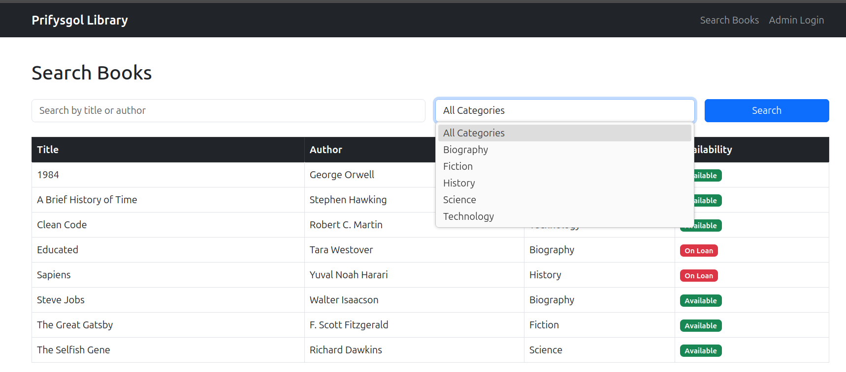
Screenshot 3 — index.php: search filtered by title keyword or category dropdown
3.3 Admin Authentication
The AdminUsers row that matches the username entered in the form is retrieved from the database using a prepared statement in login.php: SELECT admin_id, username, password_hash FROM AdminUsers WHERE username = ?. If no row is found, the page shows ‘Invalid credentials’ but doesn't indicate whether the username or password was incorrect, which obviates the ability to discover the username. If it is located, password_verify() will compare the password provided to the one stored in the bcrypt hash. session_start() is used to start the session if it is successful, the admin's primary key is stored in $_SESSION[‘admin_id’]. Each file within /admin/ has the line auth.php as its first line, which performs the function of calling session_start and redirects to login.php with a 302 header if the variable $_SESSION[‘admin_id’] is empty, prior to any page output.
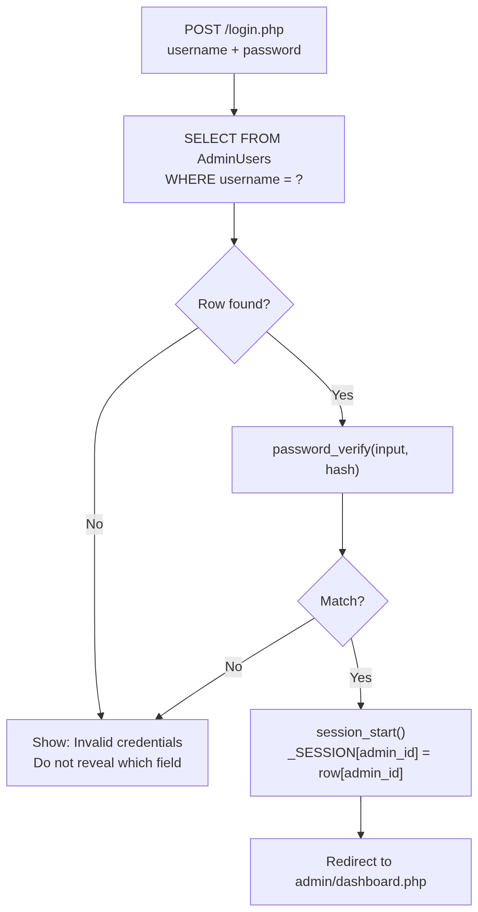
Figure 3 — login flow diagram

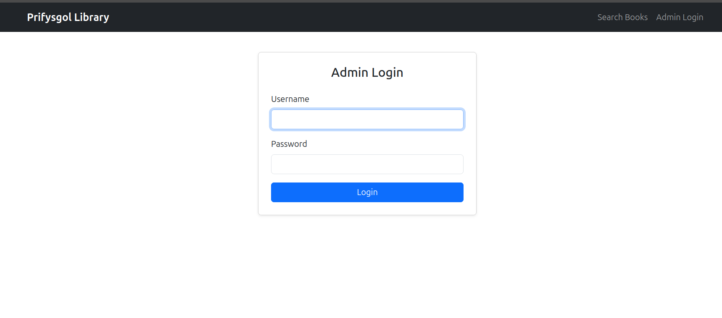
Screenshot 4 — login.php: admin login form
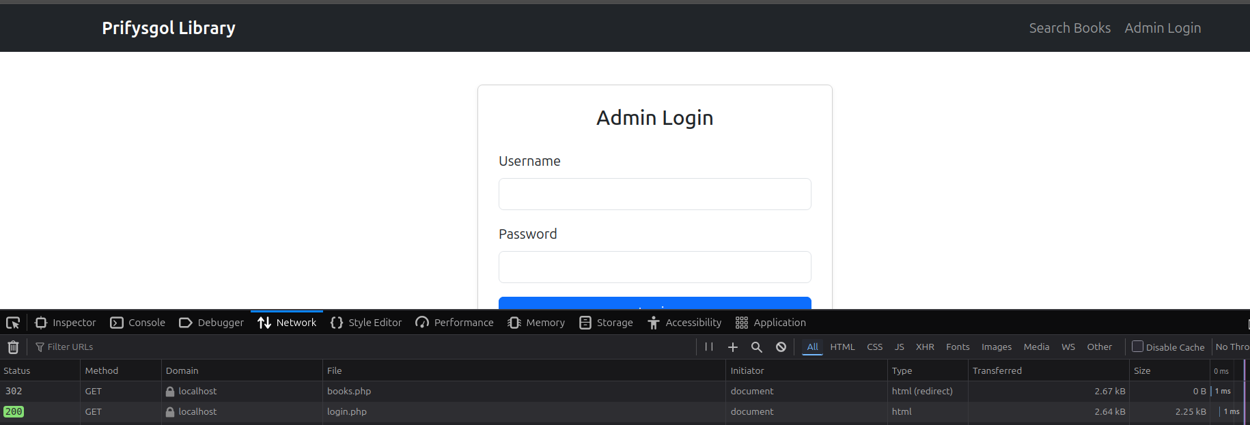
Screenshot 5 — auth.php: session guard showing 302 redirect in browser DevTools Network tab when accessing admin page without login
3.4 CRUD Operations
The books joined to Categories are displayed in the list of books in admin/books.php. The Add and Edit forms are of the same HTML structure, both pre-populating the fields with SELECT FROM Books WHERE book_id = ?. Before it is deleted, the handler queries the Loans table to see if any loans exist with the same book_id by executing the SELECT COUNT() FROM Loans WHERE book_id = ? statement. If any of them are found, they are considered to be blocking the operation, and AND status will be 'Active', which will prevent the operation. admin/members.php is another CRUD application.
Referential integrity is maintained at both application and database level by a foreign key constraint on the member_id field – deletion is denied if active loans refer to the member_id field. The single category_name field is managed by admin/categories.php. Deletion is prevented if there are orphaned records (books that are marked as part of a category, but not being deleted from it). There is no CRUD interface in AdminUsers, and it already has a table filled with a bcrypt-hashed password at its setup. If the admin session is hijacked, it would be easy to perform privilege escalation if admin account management is exposed in the same interface.
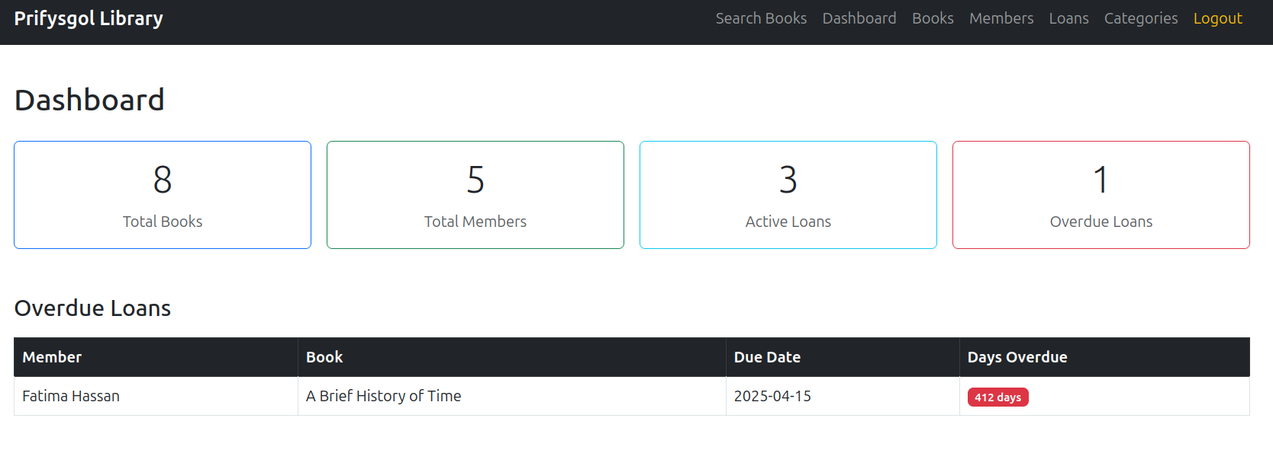Screenshot 6 — admin/dashboard.php: four summary cards and overdue loans table
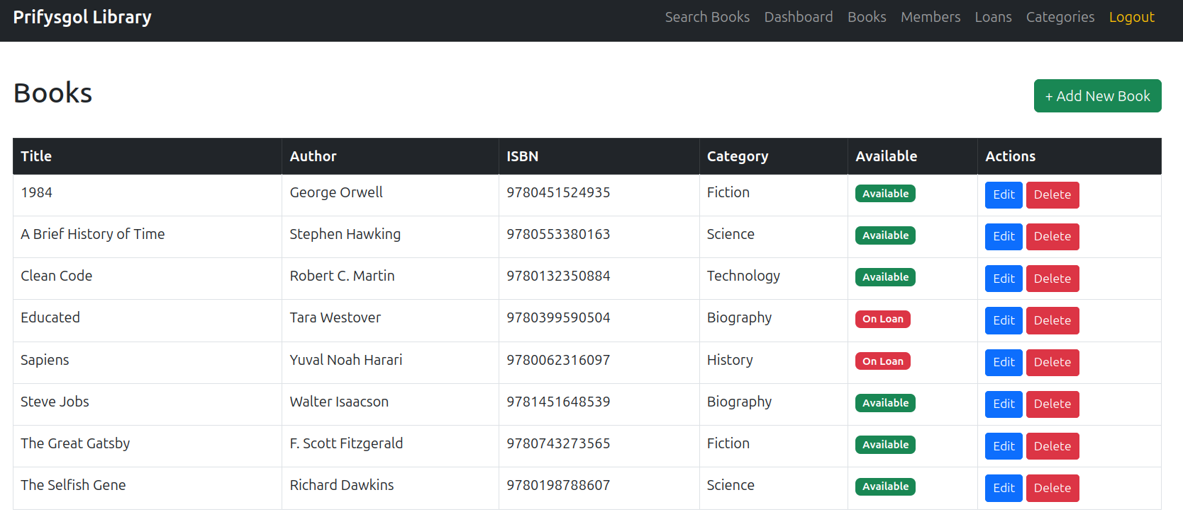Screenshot 7 — admin/books.php: full book list with Edit and Delete buttons
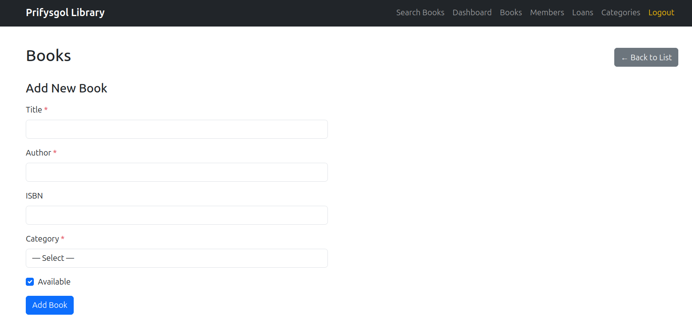Screenshot 8 — admin/books.php: Add Book form with category dropdown
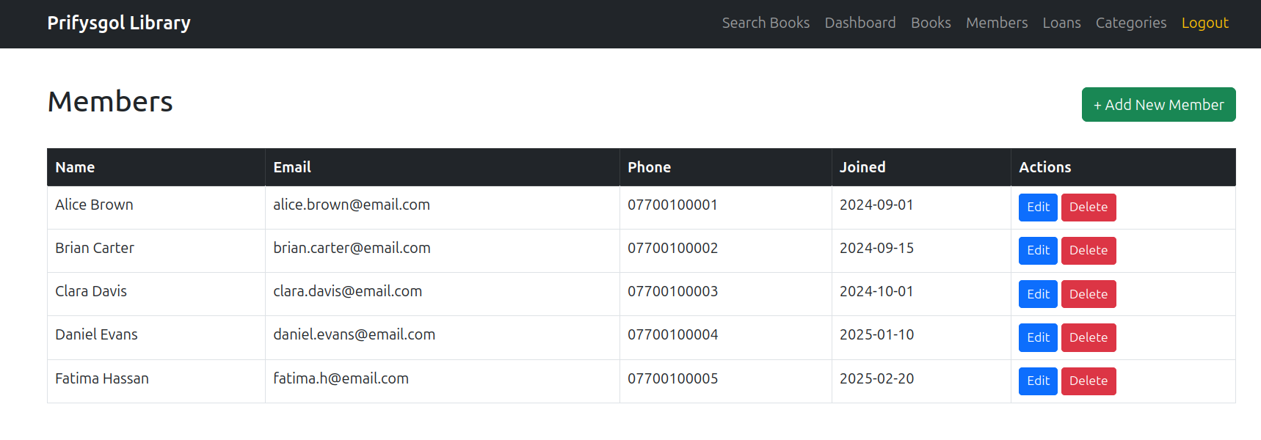Screenshot 9 — admin/members.php: member list
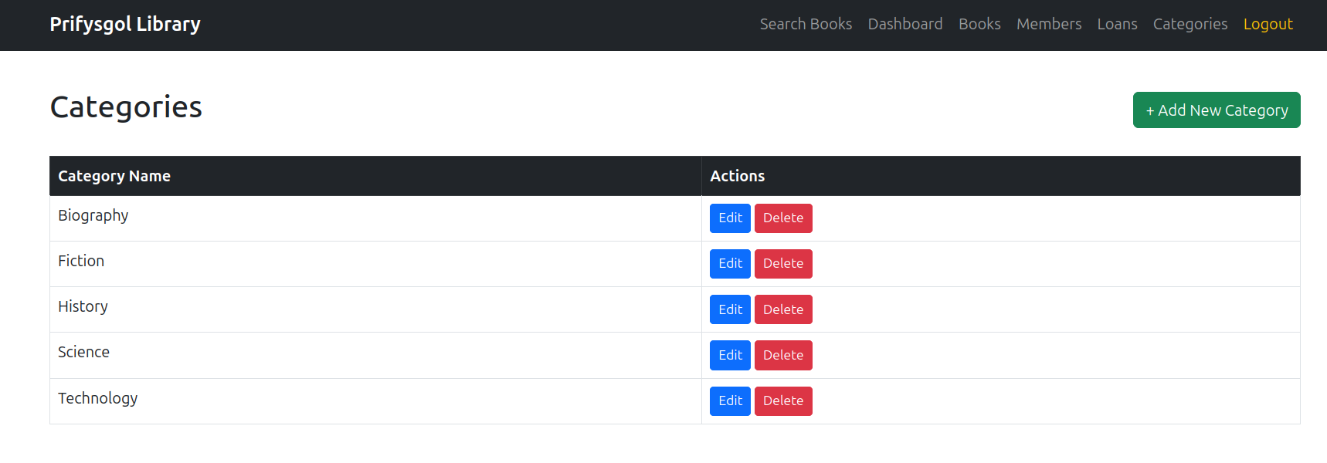
Screenshot 10 — admin/categories.php: category list with Add form
3.5 Loan Transactions
There are two coordinated writes required when issuing a loan: INSERT into Loans and UPDATE on Books setting available = 0. The PHP handler encloses the two operations in a PDO transaction. $pdo->beginTransaction() starts the transaction, the INSERT and UPDATE are run as separate prepared statements, and $pdo->commit() commits both of them atomically. In case one of the two statements fails with a PDOException, the catch block calls $pdo->rollBack() which rolls back the incomplete change and shows the admin a error message. FOR UPDATE — will test availability within the transaction prior to the INSERT, thus blocking a second concurrent loan on the same book.
When a book is returned, it returns_date is set to CURDATE() and Loans.status is set to Returned, and Books.available is set to 1. Both writes are within the same PDO transaction structure. The book_id is read from the Loans row before the UPDATE so that the AND is not in the UPDATE SQL itself, making it readable enough and the lock window short.
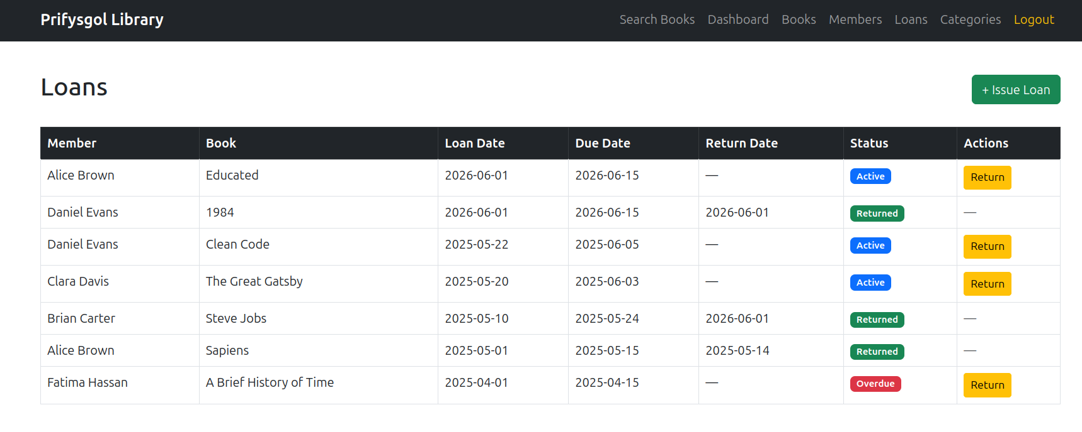
Screenshot 11 — admin/loans.php: loan list with Active, Returned, and Overdue status badges
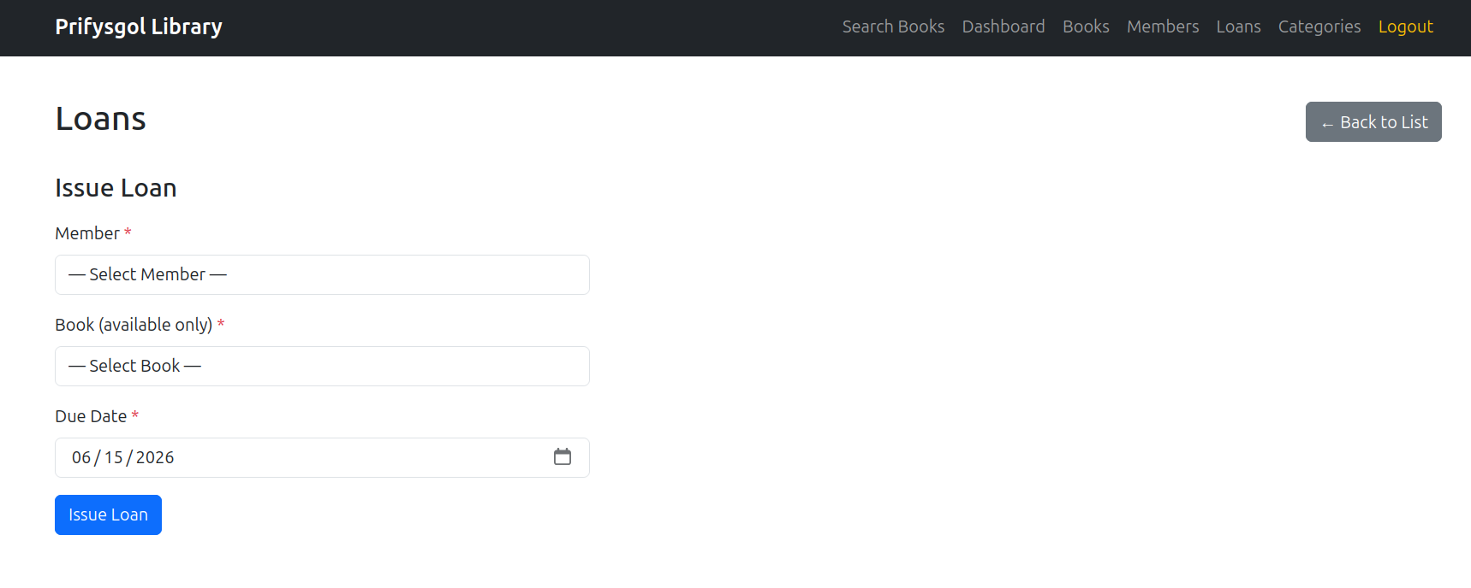
Screenshot 12 — admin/loans.php: Issue Loan form showing only available books in dropdown
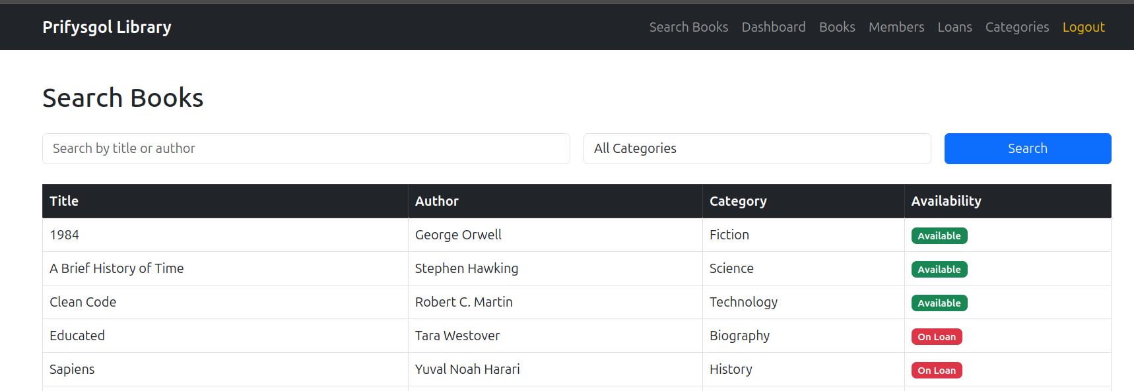Screenshot 13 — admin/loans.php: successful loan issue — book now shows as On Loan in public search
4. Security Implementation
4.1 SQL Injection Prevention
SQL injection attacks take advantage of applications that build database queries by directly concatenating the user input into a SQL string. An vulnerable book search that was created as: "SELECT FROM Books WHERE title LIKE '%" . $_GET['q'] . If an attacker types in '%' then it can also type in ' OR '1'='1', which changes the WHERE clause to 'WHERE title LIKE '%' OR '1'='1%', and returns every row in the Books table, no matter what was being searched for. If the payload was '; DELETE FROM Books; --' then it would stop the first command and run another one to delete all the items from the catalogue. SQL Injection is always in the Top 10 of the OWASP [2] Top 10 Most Dangerous Web Application Security Errors.
By separating the structure of a query from the data, PDO prepared statements eliminate injection. This statement is for searching the collection. This is a search statement: SELECT FROM Books WHERE title LIKE? OR keyword LIKE? is passed to the MySQL query parser first, and then it is compiled into an execution plan, before any data is sent to the user. The term entered by the user is then bound as a parameter, and sent separately. MySQL confuses the bound value with a string literal and not SQL syntax. A single quote in a search term is not a statement terminator, but rather a literal quote, in the results filter. This is the same for all the parameters-based queries in the system: DELETE by ID, INSERT for new loan records and SELECT for admin authentication.
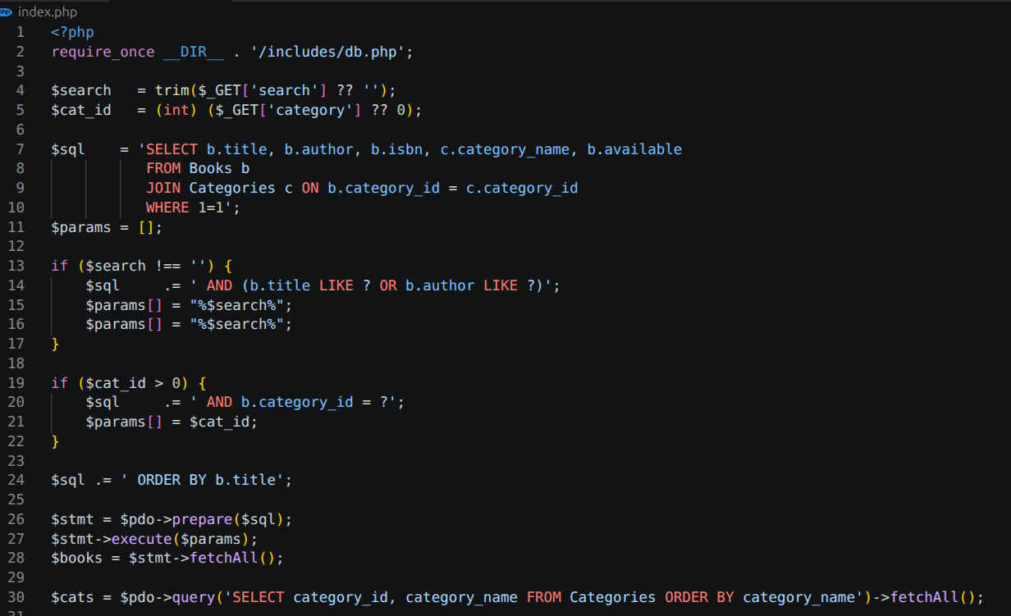
Screenshot 14 — index.php: prepared statement code for the book search query
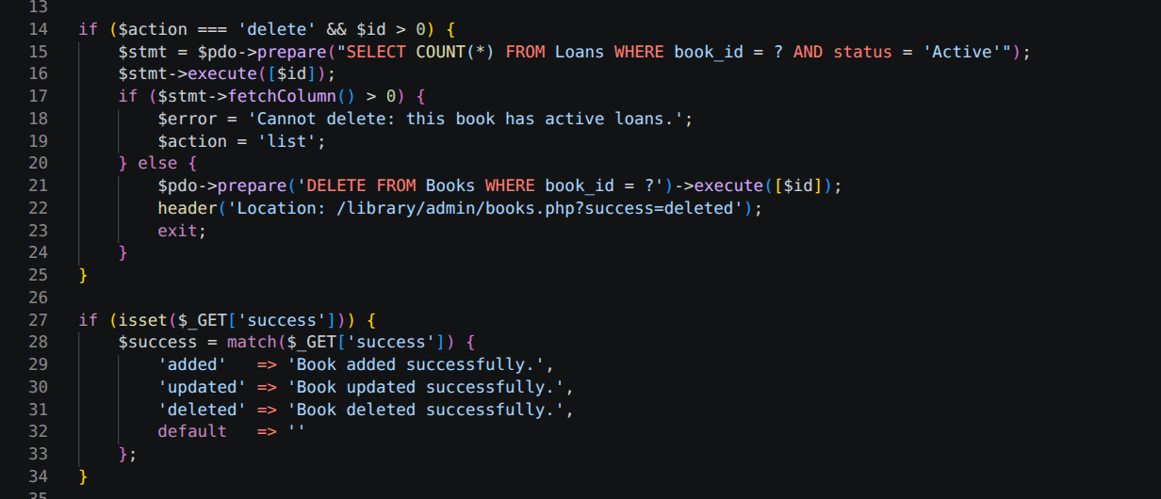
Screenshot 15 — admin/books.php: prepared statement code for DELETE with integer cast on ID
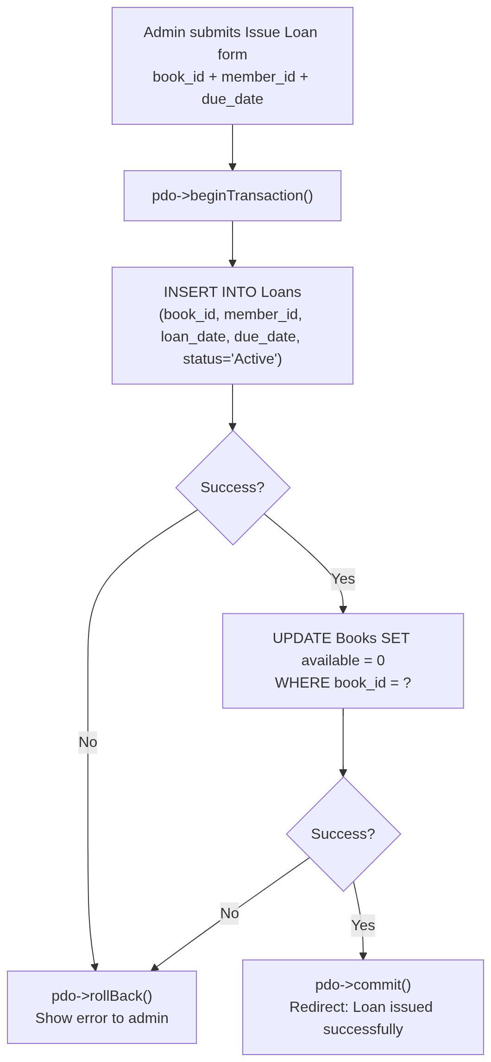
Figure 4 — loan transaction flow
4.2 Password Security
Passwords are stored as bcrypt hash codes created with PHP's password_hash($password, PASSWORD_DEFAULT). The stored hash is of the form generated by the PASSWORD_DEFAULT constant, which is 60 characters long and contains a hash of the algorithm identifier and cost factor, along with a random hash salt. password_verify() retrieves the hash salt and cost factor from the stored hash value, and calculates the hash again from the submitted password. No plain-text password is stored, logged, or sent anywhere other than the POST request. This is the recommended way to store credentials in PHP applications as described in the PHP manual [6]. NIST SP 800-63B recommends adaptive hashing functions, like bcrypt, for password storage, but independently, the cost factor can be raised as technology advances.
4.3 Session Management
Sessions are initialised with session_start() on the line immediately following successful password_verify() — not before, to avoid creating a session for unauthenticated requests. The session data is destroyed on admin's logout using logout.php, thus making it impossible to replay the session cookie after admin has signed out. The guard is called as the first line of every admin page, prior to output sent to the browser, therefore saving the possibility of admin page content appearing before the redirect header is sent, causing admin page markup to leak to the browser.
5. Performance and Design Reflection
5.1 Index Strategy
Books.isbn and Members.email are UNIQUE constraints – UNIQUE constraints are automatically created B-tree indexes by MySQL. These include the most widely used lookups such as ISBN lookup during cataloguing and email lookup during member management. The Loans.status column can be considered the secondary index for this dashboard, because there are often queries that need to look through the entire table Loans to find rows where status = ‘Overdue’. With the volume of data, performing a full scan of the Loans table is a small price to pay, but if the system approaches several thousand records in the Loans table, an index on status will be created. In Oracle's MySQL 8.0 Reference Manual [8] it is described, that secondary indexes of low cardinality columns are useful when the indexed value is found in a small percentage of the rows – Overdue loans at any particular time are a small percentage of all loans.
5.2 Design Decisions and Alternatives
Loans.status does not have a separate lookup table for LoanStatuses, instead it is using ENUM(‘Active’, ‘Returned’, ‘Overdue’). With an ENUM constraint, the values of the column are restricted at the storage engine level, and an additional join is not necessary for each query to the table loans. A LoanStatuses table would let new values of the status be added with an INSERT instead of an ALTER TABLE, and would add a join cost for all queries accessing loan data. For this scope, an ENUM is the correct one to use at three known states for which there is no stated need for user-defined additions. Admin credentials will be stored in the AdminUsers table using bcrypt, instead of being hardcoded into a PHP configuration file. A config-file approach would disable runtime password changes and would fix the problem that credentials would be tied to the source code and would be visible in any version control repository. The database approach permits various admin accounts and permits to change password with a potential future admin interface without altering the source files. All credentials in the database are also backed up, restored, and controlled in the same way as all other library data.
6. Conclusion and Reflection
The Loans table is a many-to-many relationship between Books and Members. A return_date column in Loans would be nullable (otherwise the query becomes more complicated), with a null value indicating the book is still on loan and a populated value indicating the book is returned. If we convert returns into a separate table, it would introduce a join for every loan status query, but there would be no gain in the level of normalisation, because a loan will typically have only one return event. The two-step loan transaction (INSERT into Loans and UPDATE of Books.available) called for error handling in two prepared statements.
The PDO rollback pattern is identical to the sp_record_consultation stored procedure in Part A, except that the transaction boundary is switched to PHP instead of the database engine. Both of the methods ensure atomicity, the PHP-layer transaction is more portable to other database platforms that do not support stored procedures. If status is not going to be set correctly at the time the loan is issued, then it could be updated to ‘Overdue’ by an automated cron job that would compare CURDATE() with the due_date when the status becomes overdue. A date comparison query would then be needed to determine which loans are overdue, but with the current system no scheduled UPDATE would keep the status column up-to-date without manual effort, and the overdue count on the dashboard would be a "best-effort" real-time estimate.
7. SQL Injection: Threat Analysis and Mitigation
7.1 What SQL Injection Is
SQL injection is a method of attacking a database by entering SQL commands into the input data sent from the user's browser to the server's application. According to OWASP [2] SQL injection is the most severe security flaw found in Internet application systems, which can lead to data disclosure or even full data loss and does not require any special tools. The book search is the most visible attack surface in the Library Management System, because it is implemented using string concatenation which could lead an attacker to submit ' OR '1'='1' to the title field, thus turning WHERE title LIKE '%' OR '1'='1%' into WHERE title LIKE '%' OR 1=1', always returning all books. A destructive payload — ';' DELETE FROM Books; -- , will terminate the SELECT statement and add a DELETE that will remove all data from the catalogue.
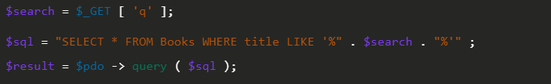
Screenshot 16 — Vulnerable query example: string concatenation approach
7.2 Prepared Statements as the Primary Defence
PDO calls the query template to MySQL's query parser before any user data is provided. MySQL compiles the template — SELECT FROM Books WHERE (title LIKE ? OR author LIKE ?) AND category_id = ?, in an execution plan, the structure of the SELECT clause, and WHERE conditions, and parameter slots. This is the point at which the structure of the query remains unchanged. Afterwards, user data will be bound as typed parameters, and sent to the database engine as values to be inserted into the pre-compiled slots, rather than SQL text to be processed.
The book search prepares the statement with $pdo->prepare(SQL), and then executes the statement with $stmt->execute($params). The ? placeholders are used as string literals, no matter what is put in them, by MySQL. A single quote in the search term is retained as a literal character in the LIKE operand and can't terminate the string or introduce a new clause or change the structure of the query. A similar thing occurs with all queries that depend on a user input: the $id URL argument is first converted to an integer with (int) $_GET[ ‘id’ ] then bound, which means that any query that contains 1; DROP TABLE Books will be shortened to 1 before the prepared statement is formed.
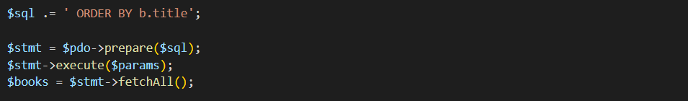
Screenshot 17 — index.php prepared statement: highlight the prepare() and execute() calls]
7.3 Implementation Evidence Across the System
All main input vectors use prepared statements. In index.php, the book search is using $stmt -> execute($params) to bind text and category_id. The DELETE handler in admin/books.php does the same and casts the parameter id to an integer prior to creating the query. A parameterised INSERT and UPDATE are executed using a single PDO transaction in admin/loans.php, ATTR_EMULATE_PREPARES => false to ensure native MySQL compilation.
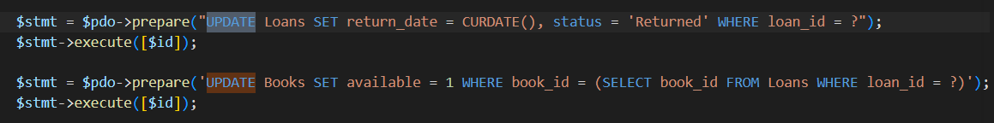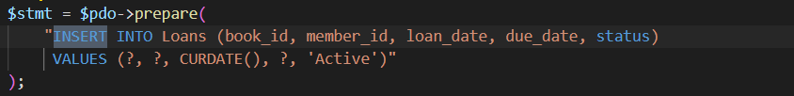
Screenshot 18 — admin/loans.php: PDO transaction with prepared INSERT and UPDATE showing parameterized binding
7.4 Additional Security Measures
The passwords are bcrypt hashed and checked against using password_verify(). Only login pages are visible – all admin pages are secured by session authentication and destroyed on logout. ERRMODE_EXCEPTION prevents browser from reporting any database errors, ATTR_EMULATE_PREPARES => false prevents the database from using prepared statements anywhere else.
7.5 Limitations and Further Recommendations
Prepared statements can only prevent SQL injection, not Cross-Site Scripting. All the values that are passed to the browser with this system are passed through htmlspecialchars(), which encodes any characters that are HTML special characters such as <, >, and ’ before they are outputted — a user saving a book title with a script tag will get the book title as text and not as script. The existing web admin interface uses a shared admin account; a production deployment would need to also include an admin account per user, role-based access control, and an audit log that logs who did what on each piece of data, similar to the AuditLog trigger in Part A. The ICO guidance on access control for personal data [3] suggests that everyone needs to be responsible for their own access to personal data, but the current single-account model does not comply with this guidance.

References
[1] R. Elmasri and S. B. Navathe, Fundamentals of Database Systems, 7th ed. Hoboken, NJ: Pearson, 2018.
[2] OWASP Foundation, “SQL Injection Prevention Cheat Sheet,” OWASP, 2023. [Online]. Available: https://cheatsheetseries.owasp.org/cheatsheets/SQL_Injection_Prevention_Cheat_Sheet.html. [Accessed: June 2026].
[3] Information Commissioner’s Office, “Guide to the UK General Data Protection Regulation (UK GDPR),” ICO, 2023. [Online]. Available: https://ico.org.uk/for-organisations/uk-gdpr-guidance-and-resources/. [Accessed: June 2026].
[4] C. Coronel and S. Morris, Database Systems: Design, Implementation & Management, 14th ed. Boston: Cengage Learning, 2023.
[5] A. Silberschatz, H. F. Korth, and S. Sudarshan, Database System Concepts, 7th ed. New York: McGraw-Hill Education, 2020.
[6] The PHP Group, “PHP Manual: PDO — PHP Data Objects,” PHP Documentation, 2024. [Online]. Available: https://www.php.net/manual/en/book.pdo.php. [Accessed: June 2026].
[7] National Institute of Standards and Technology, “Digital Identity Guidelines: Authentication and Lifecycle Management,” NIST SP 800-63B, 2020. [Online]. Available: https://pages.nist.gov/800-63-3/sp800-63b.html. [Accessed: June 2026].
[8] Oracle Corporation, “MySQL 8.0 Reference Manual: Optimization and Indexes,” Oracle Corporation, 2024. [Online]. Available: https://dev.mysql.com/doc/refman/8.0/en/optimization-indexes.html. [Accessed: June 2026].

