

Community Engagement
Coursework-Portfolio

BA (Hons) Business Management
Lecture name: Charles Oham
Student name: Kostadinka Stoyanova
Student ID: 2309383

Table of Contents
Introduction 1
Element 1: Report of Community Outreach 2
Selected community 2
Arranging the Outreach 2
Conducting the outreach 2
Ethical considerations taken into account 3
Evaluation 3
Key Insights 4
Element 2: Stakeholder Mapping Exercise 5
Categories of Stakeholders 5
Communication Channels 6
Element 3: Community Engagement Plan 8
Introduction 8
Objectives and Goals 9
Guiding Principles 9
Strategies for Community Participation 11
Measuring the Performance 11
Element 4: Practical Discussion 13
Practical Techniques, principles and Standards 14
Recommendations 15
Conclusion 16
References 17

Introduction
The well-being of the community and solving issues within the regions is an integral part of social growth for both professionals and the members of the community. The importance of Including stakeholders to foster an environment of social unity and sustainable development is discussed in the current studies. Effectively engaging the communities may culminate in improved public safety, provide better means of education to society and efficient local governance (Taylor and Buck, 2019). Inclusive engagement tactics can be implemented to improve the overall impact of community projects and their outcomes. It's important to design inclusive engagement tactics by taking into consideration the different needs and perspectives of the members of the community who come from different backgrounds (Aldrich and Meyer, 2015). To solve the particular concerns that exist in the community it is important to understand the dynamics on which the community stands, integrating the cultural aspects and socio-economic factors of the community. The techniques for engagement must be personalised according to the different needs of different groups of people (Smith et al., 2017). The report consists of four parts that are a comprehensive plan for encouraging the community to participate, mapping the stakeholders to understand the different needs of different groups of stakeholders and a practical discussion where the implementation of these strategies and the outcome of those are discussed.

Element 1: Report of Community Outreach

Selected community
To conduct this report, I engaged with my local community and I reached a wide variety of professional segments within my local community such as local businesses, Job holders and general residents. People I reached had different financial incomes, different expectations from the community and different perspectives towards life in general. This helped me to understand a wide range of perspectives and understand how one person's life can significantly differ from another person's due to their cultural, social and economic background (Bowen et al., 2020).

Arranging the Outreach
To arrange the outreach, I first identified the important individuals who act as important stakeholders for a business such as local business owners, general citizens of the locality and leaders of community associations. I prepared a survey questionnaire where the questions were designed to help me understand the different perspectives, needs and challenges faced by each of the stakeholders. The comprehensive approach of the questions helped me to explore the socioeconomic concerns, cultural aspects of the community, financial problems faced by people from different financial backgrounds, and the positive and negative aspects of the community. an inclusive incentive program was designed as well to raise the interest of the respondents in participating in the survey (Chaskin, 2021).

Conducting the outreach
The most focused place for contacting the outreach was parks where people went to relax and had plenty of time in their hands to respond to the questions of the survey. I also visited some offices and businesses where I Collected responses during lunchtime and other free times. Get the answers to the questions mentioned in the survey Informal interviews were taken where the participants did not have to maintain formality and could just speak their minds. The interviews were documented and some important pieces of information were written down in the form of bullet points to use for further research. The face-to-face interviews conducted had a humanitarian touch to them and the participants felt comfortable answering the survey questions due to the convenience of the method. The conversations were recorded in a way that respects the privacy of the participants (Coombs and Holladay, 2014).

Ethical considerations taken into account
In the process of conducting the outreach, ethical considerations were given the highest priority in each step of the process. Participants received a consent form where they were informed about the pieces of information needed in the survey and how that information would be used in future research work. Social and cultural guidelines and standards of the community were followed to ensure that the sentiment of the community was not getting hurt in the process. The pieces of information were collected anonymously and no personal information was asked for during the interview. The information was stored in a safe file maintaining the confidentiality of the participants. Participation of the community was encouraged by building mutual trust and upholding the authenticity of the research process by implementing ethical principles (Smith et al., 2017).

Evaluation
Demographics
The diversified local community included people spanning various generations, cultural origins, and socio-economic circumstances. A democratic breakdown provides a combination of middle-aged individuals, senior citizens, and people who just started their families. This diversity necessitates the customization of the engagement techniques to satisfy the particular requirements of each group (Evans and Shields, 2020). As each group showcases particular requirements and expectations from life and community, it is important to first identify those needs and demands and then design The engagement technique according to those requirements. This is the most optimal way of making the engagement techniques most efficient as irrelevant community engagement plans would only spend the resources without any positive outcome (Cornwall, 2018).
Socio-Economic Factors
The most noticeable socio-economic issues were: How greatly the economic stability can impact the businesses, and the high cost of living and the high unemployment rates add to the serious effects of the instability. Many companies stated that it is becoming more challenging for them to continue the operations of the business due to low funds. The company also stated that they cannot incorporate advanced technology in their businesses as they do not have access to such a big amount of budget, which is another reason that the customer flow is low (Dempsey et al., 2018).
Cultural Factors
The community takes pride in its rich cultural heritage and engages in the arrangement of a number of festivals and events throughout the year. But the festivals are arranged in accordance with the culture of those who are the majority. Minority groups need to be included in the festivals and events by arranging more inclusive activities so that each member of the community feels included and participates in the betterment of the community (Donaldson and Franc, 2016).

Key Insights
Exploring the different aspects of the community provided a clear picture of the community's strengths, weaknesses and Areas where improvement initiatives can be taken where identified. The community has a strong sense of Unity And an eagerness to work in collaboration to solve any challenges that may arise. The cultural activities of the community do not include all people of the community especially the minorities which is a major weakness of the locality observed. The locality observed is not economically stable as well which creates several issues for the businesses and general public in their day-to-day lives. The inclusive initiatives can be expanded to introduce a network of collaboration throughout the neighbourhood and improve the overall community (Fawcett et al., 2020).

Element 2: Stakeholder Mapping Exercise
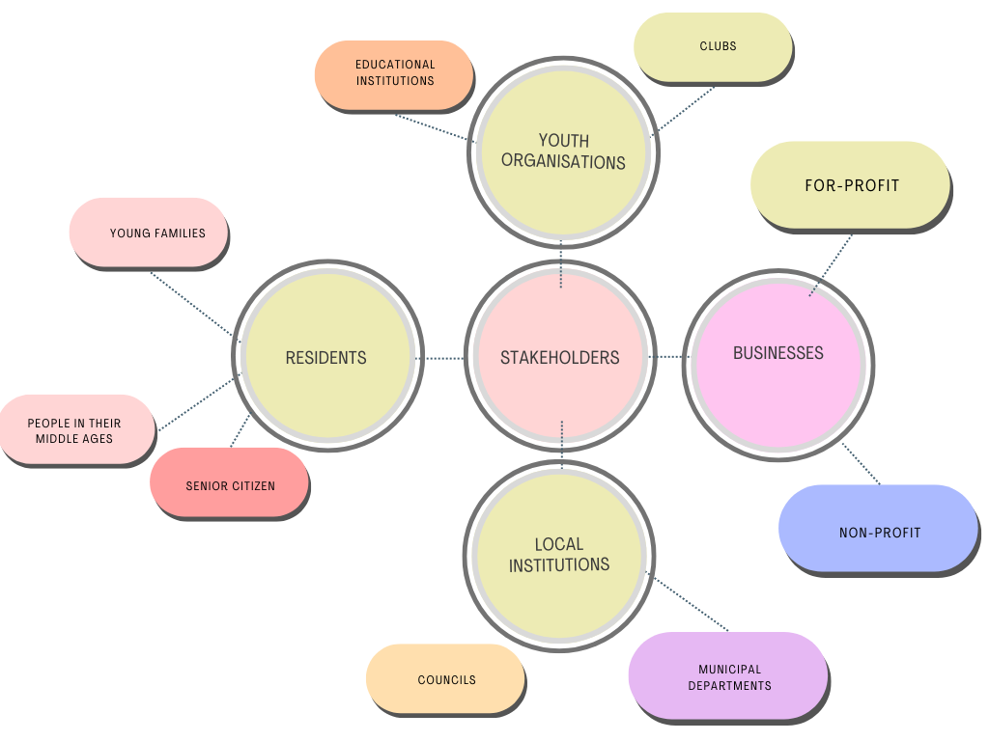
Figure: Stakeholder Mapping
Source: Author of this Report

Categories of Stakeholders
Residents
The stakeholders in the resident category include elderly people, people in their midyears, and youthful families. The residents can also be categorised according to their employment status.
Business
The businesses include retail shops, service suppliers such as software companies, restaurants and other local businesses
Non-Profit Organisations
Nonprofit organisations include support service providers and cultural groups that work to revive and protect the culture.
Youth Organisations and Clubs
The youth organisations include local educational institutions and other clubs in the localities such as book clubs, football clubs etc.
Local Government
Councils, public institutions, and local municipal departments are some examples of stakeholders in the local government category.
Health Service Providers
Local hospitals and clinics are also an important stakeholder of the community engagement initiative.
Associations for elderly
Associations for the elderly include retirement homes and activity centres where seniors can participate.

Communication Channels
Depending on the stakeholders, various communication channels must be implemented to ensure effective communication. As elderly people still read printed newspapers and community bulletin boards, this can be an effective communication method for contacting them. In-person meetings can also be conducted to reach senior citizens and work effectively as senior citizens prioritise face-to-face communication. To engage the senior citizens, events that focus on seniors and explain their challenges and problems can be arranged. The members of young families are mostly busy due to their jobs and lead a very hectic life. Hence, to reach the members of young families email newsletters can be used. The youth of the modern world also actively engage in social media, so social media can be used to reach them. Local parenting groups can be arranged to increase the engagement of the parents and also alleviate their responsibilities. To contact the people in their middle ages, newspapers and emails can be used. To effectively engage people in their 40s or 50s, neighbourhood associations can be arranged. To communicate with businesses, emails can be used as businesses regularly check their emails for collaboration opportunities and other factors. To engage businesses, networking events can be arranged as networking is an important element for the success of any business. Along with that collaborative initiatives can be encouraged and necessary guidelines can be provided for collaboration. Nonprofit organisations can be engaged through volunteer recruitment programs. As the web of stakeholders is quite complex, stakeholder mapping helps to identify the stakeholders effectively and design the engagement plans according to their individual needs. Stakeholder mapping is an important element in making community engagement initiatives relevant to different groups of stakeholders (Fung, 2016).

Element 3: Community Engagement Plan

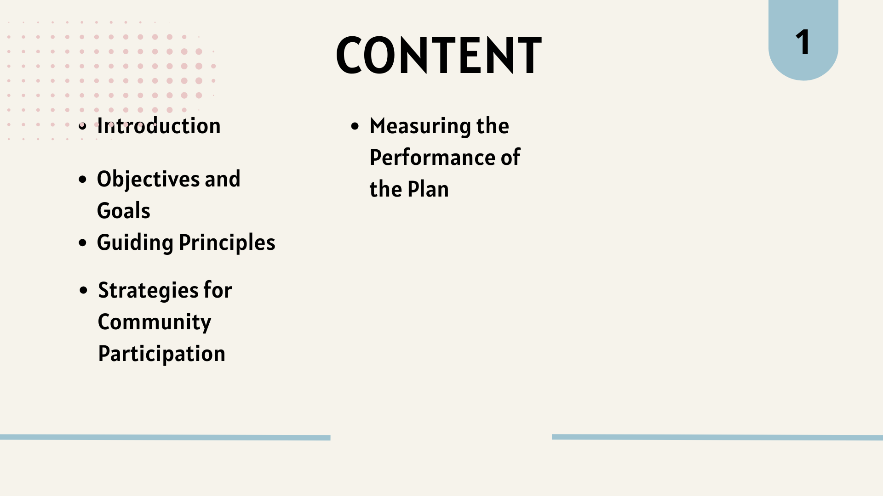

Introduction
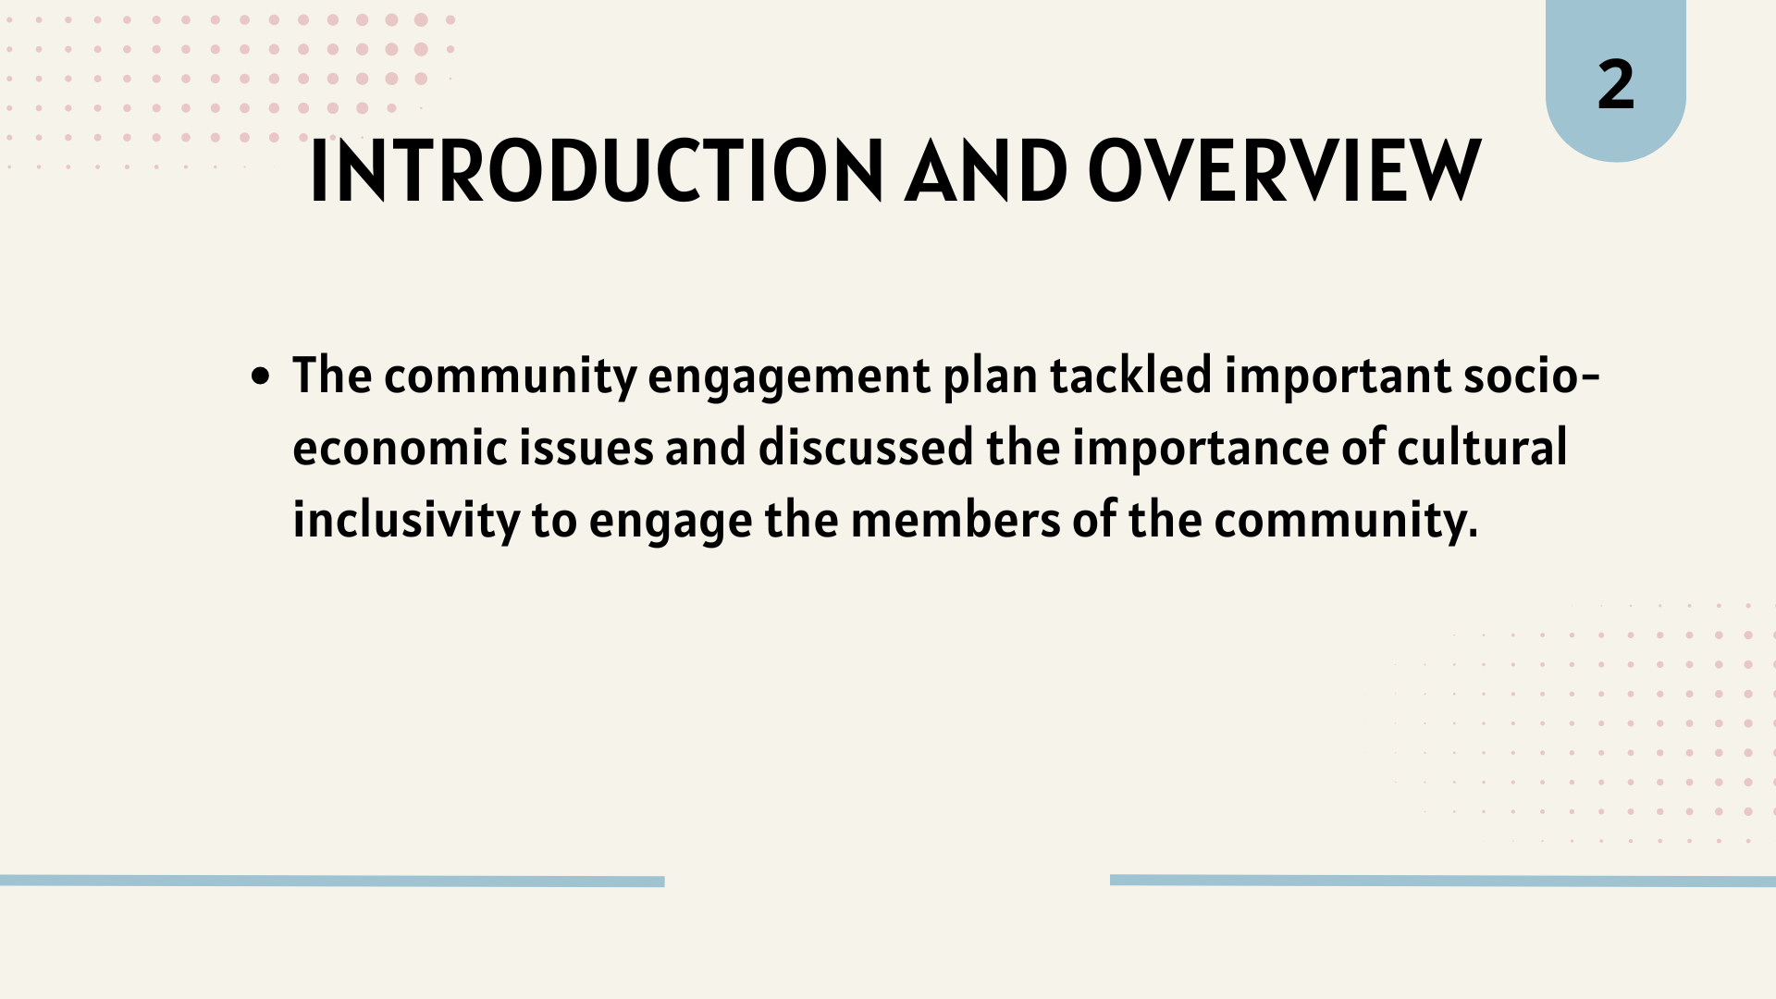
The community engagement plan tackled important socio-economic issues and discussed the importance of cultural inclusivity to engage the members of the community. The engagement plan clearly defines the goals and provides flexible techniques to achieve those schools.

Objectives and Goals
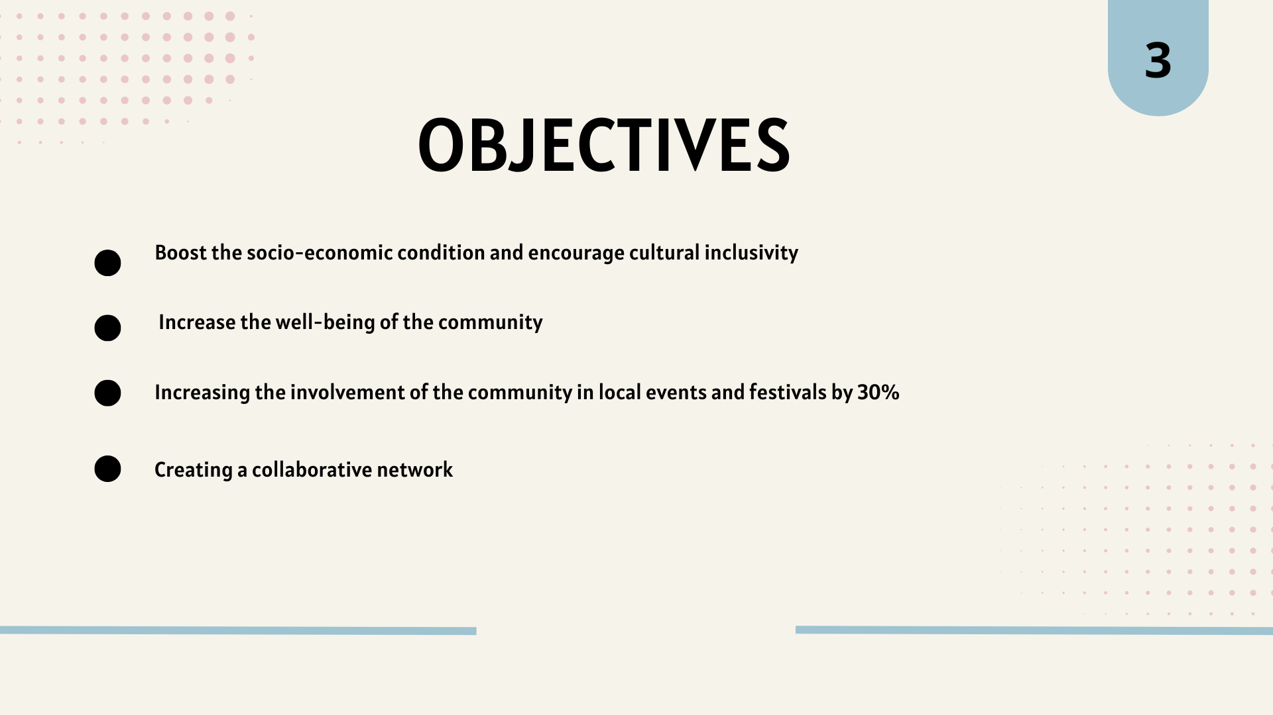
The main objective of the plan is to boost the socio-economic condition and encourage cultural inclusivity to increase the well-being of the community. Other objectives of the community engagement plan include increasing the involvement of the community in local events and festivals by 30%. Creating a collaborative network so that the members of the community can easily receive help and fight economic distress is another goal of the plan.

Guiding Principles
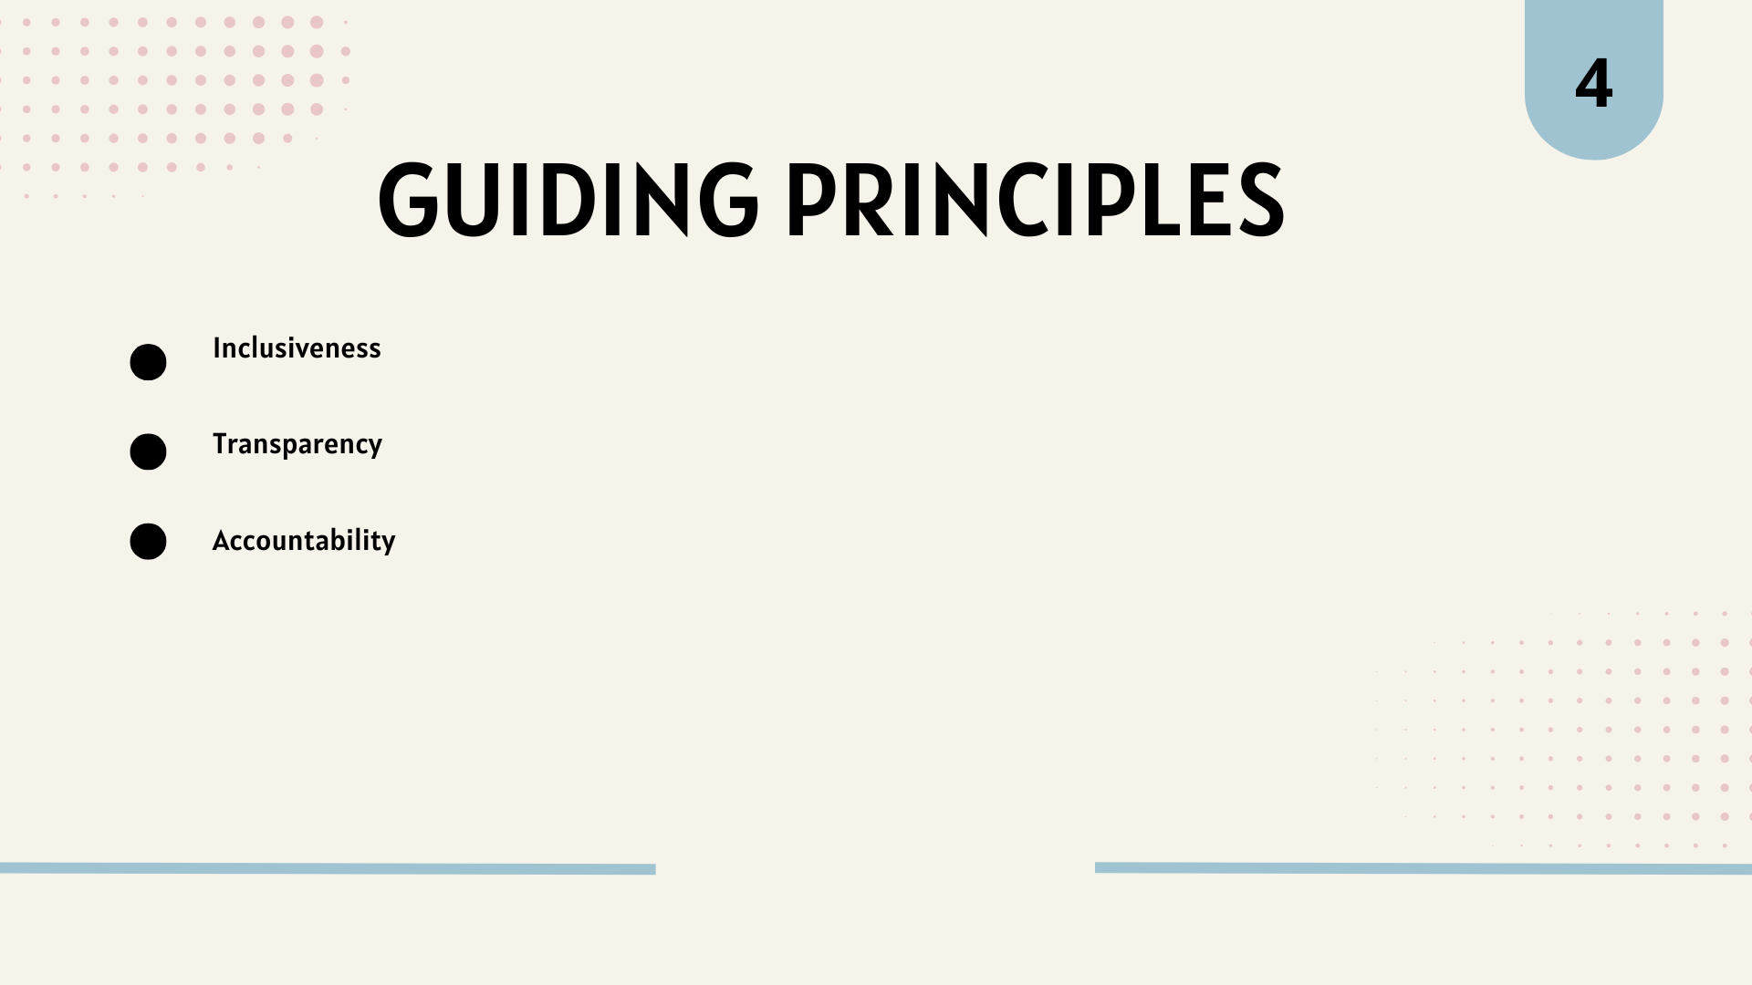
The activities of the community engagement plan are designed by considering some guiding principles such as inclusiveness, transparency and accountability. The community engagement plan strives to ensure that all community members, especially those from minority groups, can participate in the community events and benefit from them. The plan promotes transparency in the activities of the community. Ability is promoted as well so that stakeholders maintain integrity in their actions (Gaventa and Barrett, 2014).

Strategies for Community Participation
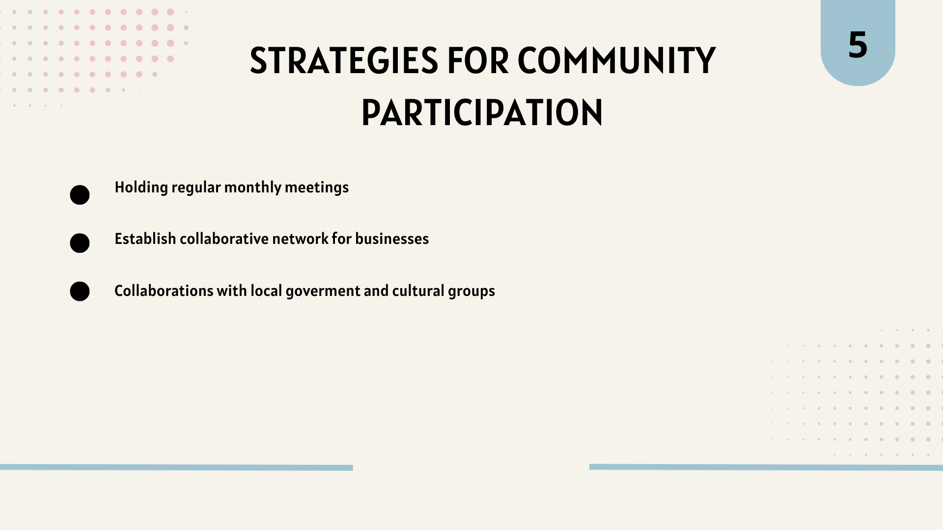

Measuring the Performance
The strategies to enhance community participation include holding regular monthly meetings where the stakeholders will provide feedback regarding the engagement plan and how effective it is in achieving its goals. The strategy is to establish a collaborative network where the businesses can share their resources in the locality and ensure greater success. Collaborations can be done with the local government and various cultural groups to facilitate the development of the community. Governments can also provide funds for building educational institutions and health service institutions to enhance the overall lifestyle of the people of the community (Goodwin and Grix, 2014).
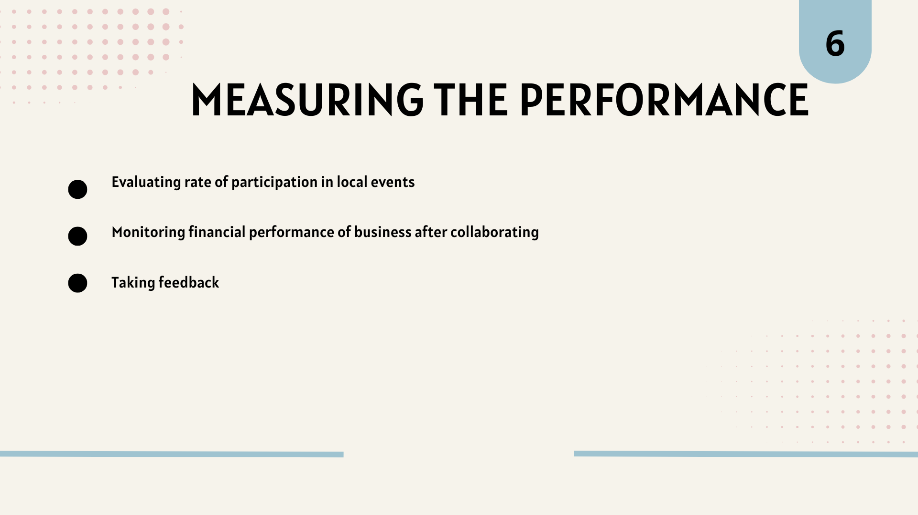
The performance of the plan can be measured by evaluating the rate of participation in local events and festivals. The effectiveness of creating a network for the businesses can be measured by monitoring the financial performance of the businesses and their profitability. Movies can be used to get inside about how satisfied the stakeholders are with the current community engagement plan. Opinions can be taken regarding how the commenting engagement plan is evicting the welfare of society.
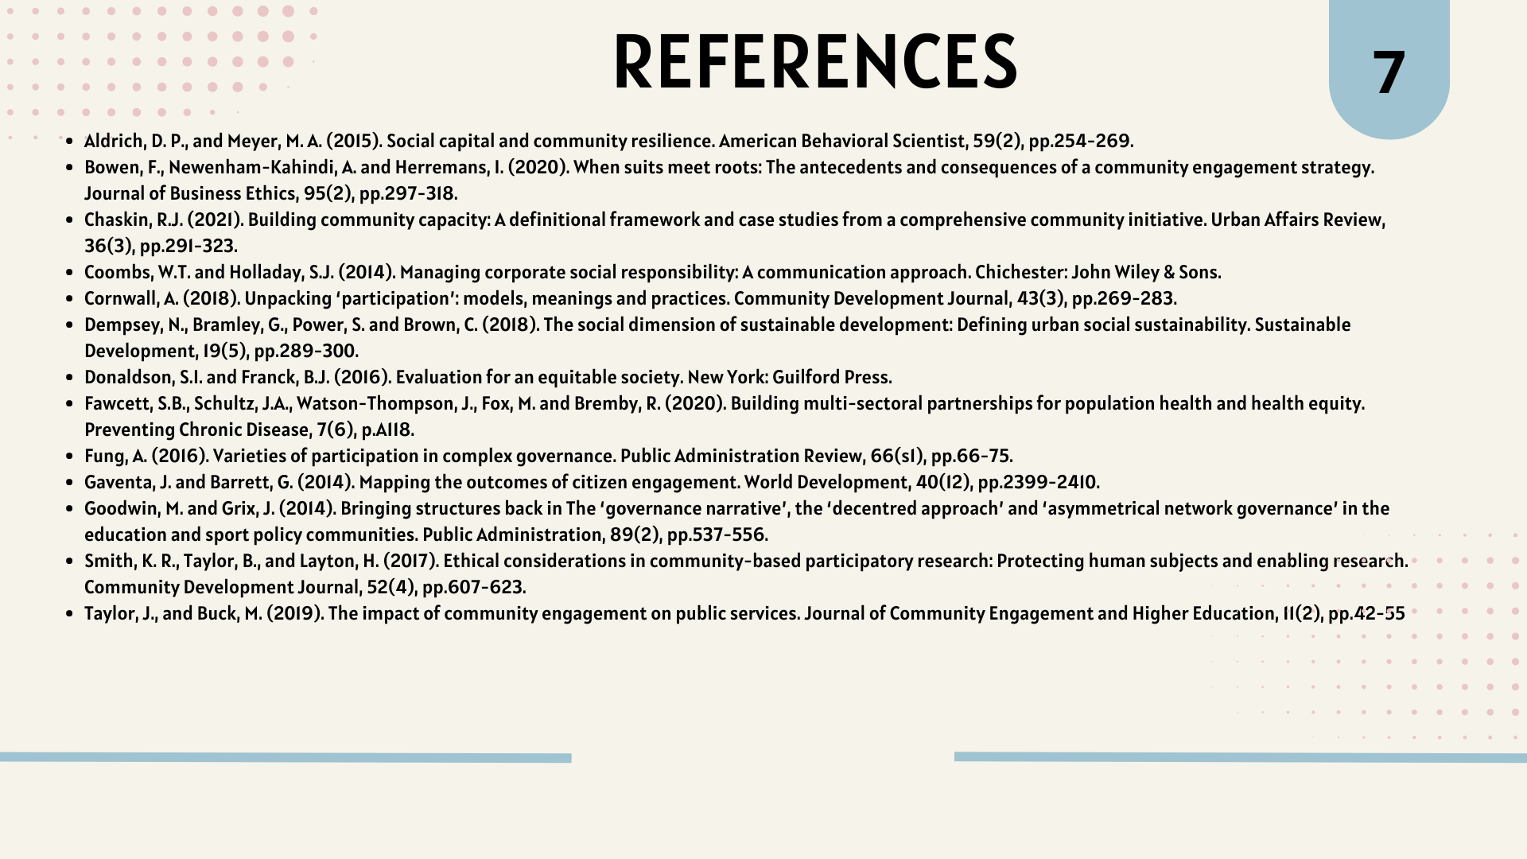

Element 4: Practical Discussion
The decision to integrate stakeholders in community engagement operations effectively provides several advantages to the community. The advantages include improving the unity in the community and Sustainability of any project undertaken by the community. The sustainability of the projects is possible because in a United community, the whole community works together towards achieving a common goal and it has a higher chance of success. Element 4 evaluates the beneficial techniques, recommendations, and Standards and methods required to successfully manage the community. The discussion uses the literary concepts and experiences of the author to provide evidence for the suggested techniques and standards.
Advantages of Stakeholder Engagement
The community receives a sense of ownership towards a project if the stakeholders are involved in the process of the project. A sense of ownership makes the community more dedicated towards the project and increases commitment. The rate of success and sustainability of the project increases significantly if the whole community is united to achieve the goals of the project. Also, engaging the whole community allows the project owner to collect a range of opinions, pieces of information and resources from the community which ensures the success of the project. The projects undertaken for the welfare of the community generally require the whole community to be aware of the issues and implement the methods expressed in the project to fight these challenges effectively (Reed et al., 2019). For example, if the project is regarding reducing waste in the community, the whole community needs to put waste in the dustbins to make the project a success. The collective knowledge of the community can help in solving complex problems of the project and provide fresh insights into the solutions.
Personal Insight and Opinion
Based on my active involvement as a community member, I Believe that stakeholder involvement can bring transformational changes to the community. Involving the members of the community in the decision-making process of a project, increased the chances of success of the project and enhanced the project results. It also reinforced the social bonds and increased the trust in the neighbourhood. Through the participation of the community members, it was ensured that the project was in alignment with the demands and overall welfare of the society as the society members also protested against any of the project outcomes that might not be in the best interest of the community.

Practical Techniques, principles and Standards
Techniques
Techniques used to ensure the participation of all community members in the projects included stakeholder mapping and constant communications. The stakeholder mapping helped in identifying and categorising stakeholders according to their different areas of interest and different perspectives and needs. A colder mapping clearly defined the differences between different groups and Provided guidelines for how the engagement efforts can be designed to ensure the most efficiency. Clear communication channels were established so that the community members could clear any doubts they had and the utmost level of transparency was maintained in the project processes. By establishing clear communication channels, the participation of community members in the decision-making processes was made easier and more convenient
Principles
The principles given the most importance in designing community engagement initiatives are inclusivity and the presence of adaptive leadership. Implementing the principles of inclusivity ensured that all community members felt important and actively provided their opinions. On the practitioner's end, the practice of inclusivity ensures that the practitioner is listening to all the opinions without keeping any biases, particularly towards minority groups. Inclusivity promoted equality and social justice in the community which helped establish fair practices in the community. Adaptive leadership is the most relevant leadership in managing a community as the dynamics of the community can continuously change and the preferences, demands and requirements of the community members change on a regular basis as well. Adaptive leadership allows the leader to understand the situation and take action In the best interest of the situation and community members.
Standards
The standards followed in designing the engagement plan, Ethical standards were implemented and the principle of accountability was promoted. The ethical standards ensured that the confidentiality of the participants was maintained so the participants could speak their minds without any kind of fear or pressure. Promoting the concept of accountability in designing the community engagement plan, ensured integrity in the stakeholders' and participants' actions.

Recommendations
Several recommendations can be provided to improve the rate of involvement of the community based on the insights discussed earlier. The first recommendation is to create collaborative platforms where members from all classes of the community can engage in problem-solving activities and can effectively engage to solve challenges together. Integration of opinion from both the majority and minority groups of the community in decision-making processes can be another recommendation that will work as a milestone in increasing community engagement. The community members can be provided with skill-building training where their knowledge will be enhanced to ensure effective participation in the projects and decision-making. Evaluation and feedback must be taken from the participants and the community members, and that feedback must be implemented in improving the community management initiatives.

Conclusion
In conclusion, it can be said that effective community participation is the base for inclusive and strong communities. In the portfolio, our locality is selected and the strengths and weaknesses of the locality are explored. Along with that, the opportunities for improvement in the locality are also explored and a comprehensive community engagement plan is devised. The benefits of stakeholder engagement for a community are discussed in detail and the strategies to enhance the engagement are discussed as well.

References
Aldrich, D. P., and Meyer, M. A. (2015). Social capital and community resilience. American Behavioral Scientist, 59(2), pp.254-269.
Bowen, F., Newenham-Kahindi, A. and Herremans, I. (2020). When suits meet roots: The antecedents and consequences of a community engagement strategy. Journal of Business Ethics, 95(2), pp.297-318.
Chaskin, R.J. (2021). Building community capacity: A definitional framework and case studies from a comprehensive community initiative. Urban Affairs Review, 36(3), pp.291-323.
Coombs, W.T. and Holladay, S.J. (2014). Managing corporate social responsibility: A communication approach. Chichester: John Wiley & Sons.
Cornwall, A. (2018). Unpacking ‘participation’: models, meanings and practices. Community Development Journal, 43(3), pp.269-283.
Dempsey, N., Bramley, G., Power, S. and Brown, C. (2018). The social dimension of sustainable development: Defining urban social sustainability. Sustainable Development, 19(5), pp.289-300.
Donaldson, S.I. and Franck, B.J. (2016). Evaluation for an equitable society. New York: Guilford Press.
Fawcett, S.B., Schultz, J.A., Watson-Thompson, J., Fox, M. and Bremby, R. (2020). Building multi-sectoral partnerships for population health and health equity. Preventing Chronic Disease, 7(6), p.A118.
Fung, A. (2016). Varieties of participation in complex governance. Public Administration Review, 66(s1), pp.66-75.
Gaventa, J. and Barrett, G. (2014). Mapping the outcomes of citizen engagement. World Development, 40(12), pp.2399-2410.
Goodwin, M. and Grix, J. (2014). Bringing structures back in The ‘governance narrative’, the ‘decentred approach’ and ‘asymmetrical network governance’ in the education and sport policy communities. Public Administration, 89(2), pp.537-556.
Smith, K. R., Taylor, B., and Layton, H. (2017). Ethical considerations in community-based participatory research: Protecting human subjects and enabling research. Community Development Journal, 52(4), pp.607-623.
Taylor, J., and Buck, M. (2019). The impact of community engagement on public services. Journal of Community Engagement and Higher Education, 11(2), pp.42-55.

