ECAD7003 – Where am I teaching? Part B
How a school develops one aspect of its SDP: a report that critically reflects on the actions, impact, and evidence base.
Table of Contents
Introduction 2
Literature Review 2
Developing an action point 4
Reflection and Evaluation 7
Conclusion. 8
References 9
Appendices 11
Appendix 1 11
Appendix 2 13

Introduction
Throughout this document will be explained the importance of School Development Plan (SDP). A specific SDP will be explored, looking at a chosen focus priority. The chosen SDP has been analysed and the focus priority that has been chosen for this specific document is wellbeing. It will be closely analysed how school X places a focus on promoting family wellbeing.
Wellbeing has been chosen as a focus subject throughout this document as Welsh Government (2017) places an emphasis on how they want to ensure all children in Wales are given the best possibility of a starting life. It is important for families in Wales to be supported and guided in ways that ‘build and create resilience and self-resilience’ (Welsh Government, 2017, p.3).
School X is a junior school based within South Wales, in an area that has been described as ‘deprived’ residential area with a high level of unemployment. School X has 192 pupils on roll. There are 7 classes, all of which are mixed ability classes. There are a total of 23 adults who work within the school, all of which have different roles around the school premises. Mostly all children who attend school X are said to be living in the surrounding area and community, with a third being within the catchment area.

Literature Review
A school development plan (SDP) is an individual schools’ strategic plan that is put in place for improvement(s). It is vital for head teachers and stakeholders to put energy towards delivering school development and improvement plans in order to deliver the best possible experiences for their pupils, closely relating to the outcomes of the Curriculum for Wales (Welsh Government, 2022a).
In accordance with Harris (2013), school improvement has been actively around for some time, taking dominance in education reform and development. According to Welsh Government (2014), SDPs are in place to allow schools and stakeholders to develop priority targets that improve learner outcomes; whilst also identifying how these targets will be/have been met through the process of self-evaluation.
The process of evaluating a schools’ progress should include a variety of methods and strategies, with information retrieved from evidence from school activity. Self-evaluation is a strong start that schools should follow for developing improvements. Thus, meaning that self-evaluation process is one of the most effective parts of processing a SDP, as it allows schools to look at progression and how the school has been designed (Welsh Government, 2022b).
Stated by Welsh Government (2021), through the guidance from stakeholders and the process of professional reflection, professional learning and professional discussions, the SDP process will allow schools to identify strengths as well as any areas of improvement whilst making these a reality.
School development process can be a compacted process to go through, therefore it is important for school leaders to receive help and support from inside and outside of the school environment, including teachers, students, governors, and parents/families (McAleavy, Riggall and Fitzpatrick, 2016). Thus, suggesting that the SDP is developed from work brought together by a number of people, all with one common goal.
Estyn (2020) researched that during the self-evaluation process of developing a SDP, by including all staff throughout this part of developing an SDP can increase the impact of encouragement for teachers to reflect on their own practice which then leads to an increase in professional learning and development.
However, it is vital for schools to be committed and inspired when going through a development process. Schools and all those involved (stakeholders) in the schooling environment need to be motivated to ensure they continuously work towards the priorities set in their SDP (Goldstone, retrieved from BERA, 2022) and having good partnerships throughout the school environment and community is essential for development to be maintained (Brighouse and Woods, 2005).
The health and well-being of children and staff as a whole is widely recognised as being priorities throughout many SDPs. In recent years there has been an increase of a priority needing to be addressed to the subject matter of wellbeing in children and staff in schools (Graham, et al, 2017).
There are many concerns throughout policies and documents placing a strong emphasis on promoting wellbeing in schools. Welsh Government (2010) emphasises that wellbeing is a ‘crucial core element of the work of education settings’ (Welsh Government, 2010, p.1). Having wellbeing as a priority throughout an SDP can allow schools to have an improved atmosphere throughout; thus, leading to higher chances of progression and development in children’s education and learning, as well as learning experiences given by teachers (Welsh Government, 2010).
It has recently been identified that thousands, approximately 11,500 children are receiving support from counselling support services each year in Wales. Thus, being a very large number of children, presenting how wellbeing in schools should be made a priority and how much support children may need throughout their education years (Welsh Government, 2021).
Wellbeing and mental health as a whole seem to be deteriorating in all ages, over the years. Factors during school-life, in children can be seen as having impacts on mental health later on in life, into adulthood. Poor wellbeing and mental health in teachers can affect the individual long-term and it can have an impact on children’s school experiences too (Harding, et al, 2019).
There is evidence to suggest that early interventions to poor wellbeing in schools can have significant benefits (Brown, et al, 2023). Due to wellbeing becoming a strong subject that needs to be supported, in Wales there are now many services that support the promotion of wellbeing in schools. There are many wellbeing advisors that are currently working with schools to provide many resources and advice to promote the wellbeing of children as well as staff.
Welsh Government (2023) states that schools need to be prioritising wellbeing and mental health in both staff and children in order for them all to thrive. Teachers and leaders within schools are the individuals who encourage children to thrive and develop therefore it is just as important to promote the wellbeing of staff as it is the children; Welsh Government (2023) stating that effective wellbeing is central to achievements occurring throughout a school. Consequently, meaning having poor mental health in teachers causes an impact on children’s wellbeing and experiences.

Developing an action point
It is important for schools to challenge targets. When schools plan for improvement they need to consider short-term and long-term plans, linking to stimulating targets. An SDP will set out the schools structured plans, containing improvement priorities, showing how and when they hope to achieve these priority targets (Welsh Government 2014)
School X has identified that they want to ensure that the wellbeing of all staff, families and children is a priority for all within the school. As previously mentioned, wellbeing is a common topic that is mentioned throughout schools in Wales and throughout the UK. School X identified within this priority the school needs to focus on developing ‘families wellbeing’ (appendix 1).
School X has assigned a member of staff as the designated Family Engagement Officer (FEO). The FEO based within school X deals with any direct enquiries and concerns that families have in relation to children’s wellbeing and safety. The FEO has been given the job role of ensuring that the wellbeing of children and their families is maintained, and they work with any outside agencies that the families are involved in, ensuring that the school provides support for these families.
School X identified the need to implement this strand within its priority as it previously identified that nearly all families that need support have been provided with the correct support they need, from outside agencies whom which they work closely with. Multi-agency working will bring all relevant professionals together to provide support for children and families, creating a plan of action that will be suitable for children’s and their family’s needs (Welsh Government, 2016).
Through the process of self-evaluation, school X and its stakeholders, including the FEO identified impacts that the role of the FEO has on children and families who attend the school. During the self-evaluation process, the school reflected upon the performance of the FEO and identified the areas of strengths the position has on children and families’ wellbeing. Looking closely at the relationships the children and families have gained between each other and the outcomes have been positive for the children. Thus, being an important aspect of the self-evaluation process, identifying the role of the FEO has been working for many families within the school. It is vital for school X to be continuously evaluating the use of the FEO and the impact they have on children and their family as they can identify any gaps in the role and also it can be reflected upon the difference that the role make for children and their wellbeing. When children’s wellbeing is supported in school, it makes a drastic difference to their progression and outcomes to their education (Welsh Government, 2022c).
It was also through the use of data analysis meetings that school X identified the need to support children and families’ wellbeing. School X identified from previous reports retrieved from parents, outside agencies, and organisations that within the number of children they have on roll at the school, a number of these children are either on the Child Protection Register, have a Care and Support Plan and/or have Resilient Family Services support. It was identified through data analysis that there has been an increase in the number of vulnerable pupils. According to School X, around a third of their pupils are identified as vulnerable through their ‘Vulnerability Profile’ (appendix 2).
Critiquing, it could be said that the number of children included in these statistics could change throughout the academic year; therefore, it is vital that the school are continuously using data analysis to ensure the number of children involved in these categories is up-to-date and all need-to-know staff and adults are aware of these statistics (Welsh Government, 2022c).
Through strategic planning, school X was able to develop specific, suitable plans to promote the wellbeing of children and their families. The school developed a number of plans to which they were going to follow to promote wellbeing throughout the whole school, but developed specific plans of how they were going to develop the wellbeing of families. During the planning process, the head teacher and other stakeholders looked at the fundings in which they needed and identified that little funding was going to be needed. However, it would be important for school X to keep funding in mind in regard to training staff and the FEO. They may need to keep up to date with relevant strategies that promote wellbeing in children and families (Welsh Government, 2022).
To measure the impact of this priority strand, the head teacher states in the SDP that the key evidence will come from parents’ knowledge of the role of the FEO. Thus, showing the importance of the FEO and they need to be actively involved with the families in need. However, it could be argued that this may not measure the wellbeing of the children and their families. Although it can be difficult to measure wellbeing, it may be useful to have meetings with involved multi-agencies and organisations to remain up to date with family circumstances and wellbeing, if necessary (Kempf, 2018).
By schools identifying change or adaptation to areas is needed will encourage the school to develop its teaching and management; however, they all need careful consideration and effective time to ensure these changes and developments are effective for all (Thompson, 2010).

Reflection and Evaluation
In reflection of the strategies that the school have endured to improve ‘families wellbeing’ I believe that the school have made major progress in relation to this, through some effective strategies and activities they have carried out. However, I still believe there are some areas of improvement in which school X could undertake. Thus, to keep promoting the wellbeing of families throughout the school.
The wellbeing of children and families is ongoingly reviewed throughout the academic year within school X. There are many review sessions planned throughout the academic year where key stakeholders will meet and look at what has been achieved in relation to wellbeing.
With the use of having the FEO in place and actively involved in families, supporting their wellbeing, the school have been able to show a positive development in their communication.
Firstly, there is a much clearer understanding between the school and individual families through the use of better communication. By having a FEO assigned to these families, it has given the FEO and families opportunities to work closely together, building positive relationships where the families have felt like they are understood, and their cases are adhered to.
School-parent communication can often bring conflict due to many factors; however, having the FEO actively involved for issues is proving to help these conflicts deteriorate (Education Support, date unknown). Actively, the school should be considering home-school sessions where the families are able to come into the school and FEO is able to visit the home if/when needed, engaging in developing a strong relationship between the home and school environment.
Moreover, the school developed policies in relation to family engagement and wellbeing in relationship to this priority. Throughout the policy the school stated they would be implementing family engagement and wellbeing sessions throughout the academic year. The school held opening evenings, academic progress evenings, home-school reading activities and so on. From this, the school have identified they have seen an increase in families’ wellbeing, throughout the whole school and not just those involved with the FEO.
Family engagement has many benefits for the family as well as the child/learner. When schools develop relationships with families it enables learners to improve their achievements (Henderson and Mapp 2002). Therefore, from this, the school should be considering involving parents in decision-making processes where they are actively involved in designing the curriculum, bringing knowledge of their understanding of their children’s academic level and experiences.
Lastly, the school could be developing extra-curricular activities for families and their children to participate in, which include all children and families and not just those involved with the FEO. Extra-curricular activities develop several opportunities for social interactions, with the development of specific skills and/or knowledge (Metsäpelto and Pulkkinen, 2014). From knowledge in relation to Vygotsky’s theory of mind, social interactions have ‘cognitive and affective dimensions’ (Pearlman-Avnion, et al, 2018, p.369). Maslow (1943; Pearlman-Anvion, et al, 2014) states that social interactions are a basic human need, and these can have detrimental impacts on mental health and wellbeing of all individuals. Therefore, suggesting that school X could improve wellbeing through different social interactions having extra-curricular activites in place for all families.

Conclusion.
To summarise, it has been clear to understand that SDPs are essential for schools to undertake. SDPs enable schools to identify any areas of improvement through the stages of self-evaluation, strategic planning, making improvement/action point and reviewing the impact (Welsh Government, 2014).
It is essential for schools to be promoting wellbeing throughout and it has been clear to see how school X has made wellbeing a priority within their SDP (appendix 1). However, it is vital that school X are continuously reviewing the impact their strategies are having on families’ wellbeing and it is important that they are promoting wellbeing throughout the home-school environments and not just those involved with the FEO.
For future reference, I now have the knowledge and understanding of the importance of understanding SDPs and the importance they have on teacher knowledge and how to work towards the priorities that have been set by the individual school I would work in, as a professional.
I will also carry forward the knowledge gained on the importance of family engagement and the impact these have on child achievement. Within my practice, I will continue to continuously work with parents, guardians, and families to ensure the wellbeing of all is maintained and I will work towards promoting wellbeing as a whole using strategies and knowledge gained from this particular research.
Word count: 2674

References
- Brighouse, T. and Woods, D., (2005). How to improve your school. Routledge.
- Brown, R., Van Godwin, J., Edwards, A., Burdon, M. and Moore, G., (2023). A qualitative exploration of stakeholder perspectives on the implementation of a whole school approach to mental health and emotional well-being in Wales. Health Education Research, p. cyad002.
- Education Support. (Date unknown). How schools and families can work better together. Available at: https://www.stmarysnewmills.srscmat.co.uk/wp-content/uploads/sites/30/2021/12/How-School-and-Families-can-work-better.pdf Accessed on: 11th April, 2023.
- Estyn. (2020). Including all staff in the self-evaluation process. Available at: https://www.estyn.gov.wales/effective-practice/including-all-staff-self-evaluation-process Accessed on: 9th April, 2023.
- Goldstone, R. (2022) “School self-evaluation for school improvement: Principles of effective practice,” BERA. Available at: https://www.bera.ac.uk/blog/school-self-evaluation-for-school-improvement-principles-of-effective-practice (Accessed: April 9, 2023).
- Graham, A., Powell, M.A., Thomas, N. and Anderson, D., (2017). Reframing ‘well-being ‘in schools: The potential of recognition. Cambridge Journal of Education, 47(4), pp.439-455.
- Harding, S. et al. (2019) “Is teachers’ mental health and wellbeing associated with students’ Mental Health and wellbeing?” Journal of Affective Disorders, 242, pp. 180–187. Available at: https://doi.org/10.1016/j.jad.2018.08.080.
- Harris, A., (2013). School Improvement: What's in it for Schools? Routledge.
- Henderson, A. and Mapp, K. (2002). A new wave of evidence: the impact of school, family, and community connections on student achievement. Available at: https://sedl.org/connections/resources/evidence.pdf Accessed on 10th April 2023.
- Kempf, A., (2018). The challenges of measuring wellbeing in schools.
- McAleavy, T., Riggall, A. and Fitzpatrick, R. (2016). Rapid School Improvement. Available at: https://www.educationdevelopmenttrust.com/EducationDevelopmentTrust/files/2c/2cf47b83-39d7-402f-929f-4858539c123a.pdf Accessed on: 9th April, 2023.
- Metsäpelto, R.L. and Pulkkinen, L., (2014). The benefits of extracurricular activities for socioemotional behaviour and school achievement in middle childhood: An overview of the research. Journal for educational research online, 6(3), pp.10-33.
- Welsh Government. (2010). Thinking positively: Emotional health and well-being in schools and Early Years settings.p.1. Available at: https://www.gov.wales/sites/default/files/publications/2018-12/thinking-positively-emotional-health-and-well-being-in-schools-and-early-years-settings.pdf Accessed on: 10th April, 2023.
- Welsh Government. (2014). School Development Plans. Available at: https://www.gov.wales/sites/default/files/publications/2018-03/school-development-plans.pdf Accessed on: 9th April, 2023.
- Welsh Government. (2016). Developing community partnerships and multi-agency working. Available at: https://www.gov.wales/sites/default/files/publications/2018-12/theme-5-developing-community-partnerships-and-multi-agency-working-resources-1-2.pdf Accessed on: 10th April, 2023.
- Welsh Government. (2017). Families First: Programme Guidance. Available at: https://www.gov.wales/sites/default/files/publications/2019-07/families-first-guidance-for-local-authorities_0.pdf Accessed on: 11th April, 2023.
- Welsh Government. (2021). Framework on embedding a whole-school approach to emotional and mental well-being. Available at: https://www.gov.wales/sites/default/files/publications/2021-03/framework-on-embedding-a-whole-school-approach-to-emotional-and-mental-well-being.pdf Accessed on: 10th April, 2023,
- Welsh Government. (2022a). School improvement guidance: framework for evaluation, improvement, and accountability. Available at: https://hwb.gov.wales/evaluation-improvement-and-accountability/school-improvement-guidance-framework-for-evaluation-improvement-and-accountability/ Accessed on: 9th April, 2023.
- Welsh Government. (2022b). School improvement guidance: impact assessment. Available at: https://www.gov.wales/school-improvement-guidance-impact-assessment-html. Accessed on 9th April 2023.
- Welsh Government. (2022c). Wellbeing of Wales, 2022: children and young people’s wellbeing. Available at: https://www.gov.wales/wellbeing-wales-2022-children-and-young-peoples-wellbeing-more-equal-wales-html Accessed on: 10th April, 2023.
- Welsh Government. (2022d). Wellbeing of Wales 2022: children and young people’s wellbeing. Available at: https://www.gov.wales/wellbeing-wales-2022-children-and-young-peoples-wellbeing-prosperous-wales-html. Accessed on 10th April 2023.
- Welsh Government. (2023). School Wellbeing Service extended as part of £600k funding package. Available at: https://www.gov.wales/school-wellbeing-service-extended-part-600k-funding-package Accessed on: 10th April, 2023.

Appendices

Appendix 1

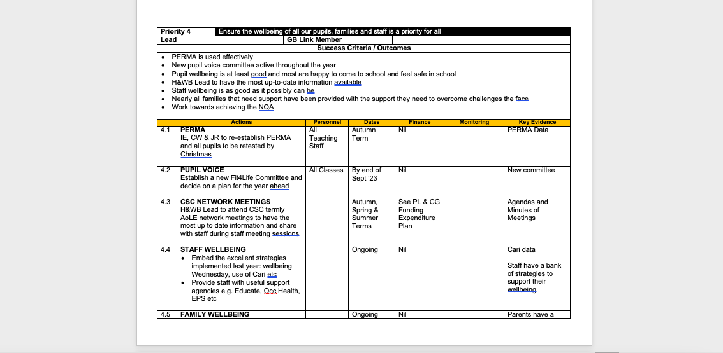
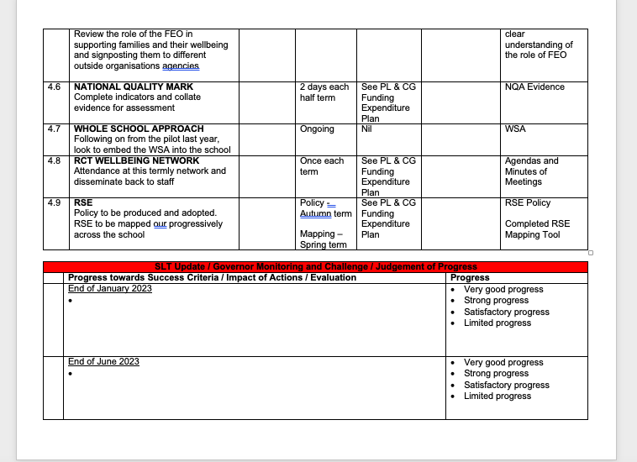

Appendix 2


