MSc Applied Computing

Managing Information Systems Projects

Assignment 2
Managing a Project

Paige Harris
P145700

Contents
1.0. Introduction 4
2.0. Project Plan 4
2.1. Evaluation of the Suitability of Microsoft Project 8
3.0. Group Evaluation 9
3.1. Team Members Project Roles and Responsibilities Evaluation 9
3.2. Management of Change 10
3.3. Evaluation of recommendations from the literature for an IT project. 10
4.0. Risk Management 11
4.1. Risk Factors 11
4.1.1. Project risks 11
4.1.2. Technical risks 12
4.1.3. Business risks 12
4.2. Causal Map 14
4.3. Pert Analysis 15
5.0. Sustainability 18
5.1. Green Drivers Table 18
5.2. Sustainability Issues for the Project 19
6.0. Ethical Issues 22
6.1. Public Interest 23
6.2. Professional Competence and Integrity 24
6.3. Duty to Relevant Authority 25
6.4. Duty to the Profession 26
7.0. Legal Issues 27
7.1. Data Protection Act 2018 27
7.2. Overseas sales 28
Power Distance 28
Individualism 28
Masculinity 28
Uncertainty Avoidance 29
Long-term orientation 29
Indulgence 29
Why would this system be helpful to a university in china? 29
7.3. Intellectual Property 30
7.4. Computer Misuse 30
References 31

Figure 1- Project Plan 5
Figure 2- Gantt chart 1 6
Figure 3- Gantt Chart 2 7
Figure 4- Pert chart 1 15
Figure 5- Pert chart 2 15
Figure 6- Pert chart 3 16
Figure 7-- Pert chart 4 17
Figure 8- Seven Well-being Goals [13] 20
Figure 9- Five sustainable development principles [14] 21
Figure 10- Hofstede's Country Comparison [23] 28

Introduction
This report will explain the way in which the project will be implemented and the new plan which will take place to create the software for Student Services. There will then be an evaluation of the suitability of the project management tool used. The report will then look into the risk management factors of the project showing a causal map along with the PERT analysis. The project has also considered the sustainability factors using Lami’s Green IT framework. The report will also explain the Ethical and Legal issues, which are being considered to develop the programme.

Project Plan
The project plan has been created using Microsoft Project, each task that has been completed to create the prototype as well as if the prototype gets approved by the stakeholder, the full project implementation. Each task has a name, a start date, duration and end date, and states any predecessors, meaning the task cannot be started until the numbered task in the predecessor column is complete. Resource names have been added to the majority of tasks, stating all the resources, which were required to complete the task. Notes have also been added to the majority of tasks, to state in further detail the objectives.
When using the project plan to help with the timekeeping of the prototype creating stage, it was found that by having the plan, it was made easier to keep in time and ensure that all elements of the project are completed and not forgotten.
By following this plan exact, the estimated completion and implementation data for this project is the 11/07/2019.
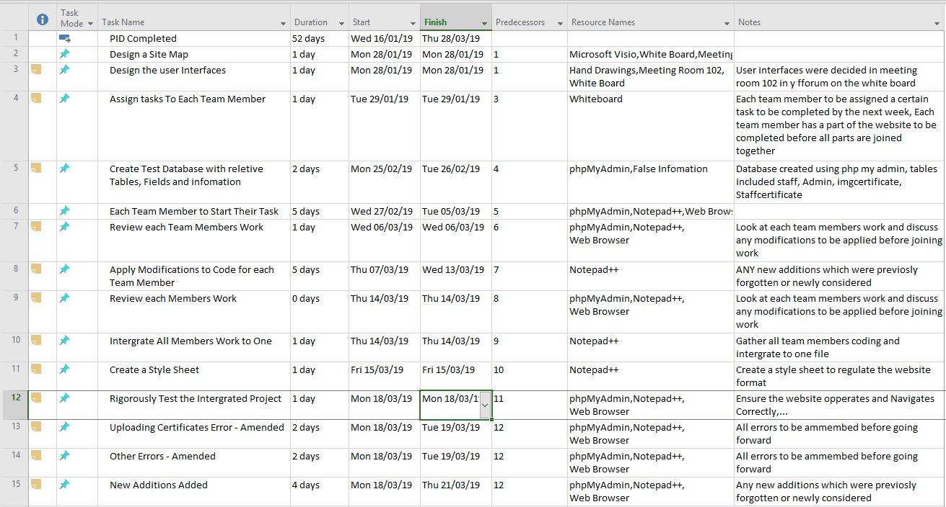
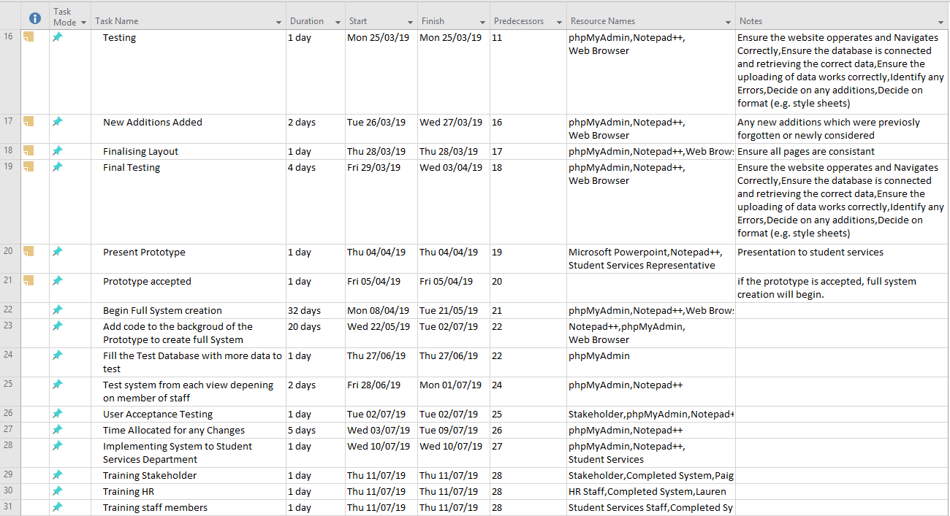
Figure 1- Project Plan

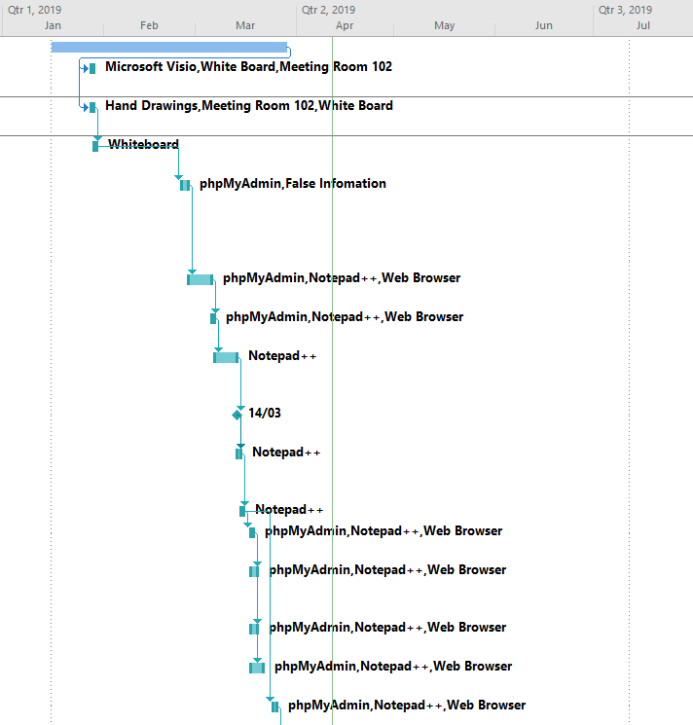
Figure 2- Gantt chart 1
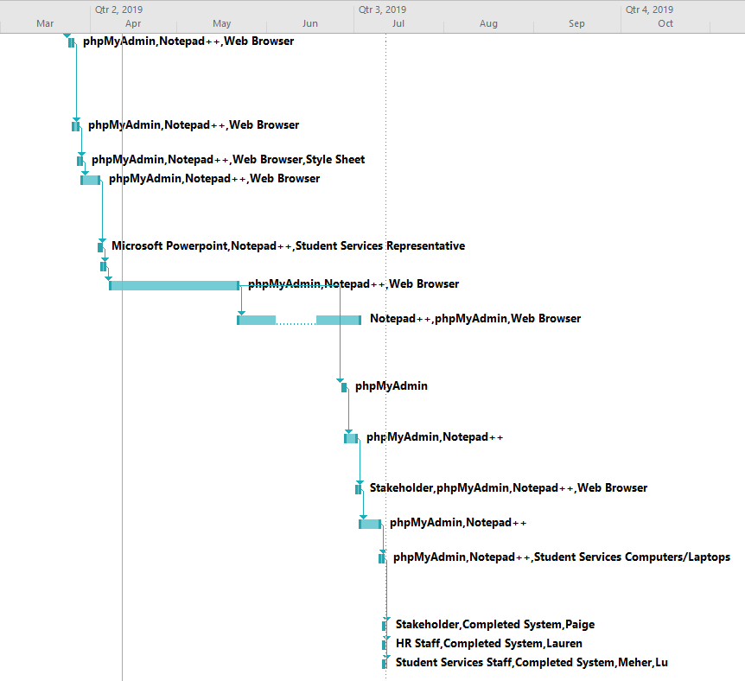
Figure 3- Gantt Chart 2

Evaluation of the Suitability of Microsoft Project
Microsoft project is a helpful tool to keeping any projects on track, “Microsoft Project helps you get started quickly and execute projects with ease. Built-in templates and familiar scheduling tools help project managers and teams stay productive.” [1]. Microsoft project was used within this project to help the team members and the work on track. There are built in templates that can be selected before beginning to design a project plan, depending on the type of project that is being undergone. In this case, the ‘Simple Project Plan’ template was used. Microsoft Project is a familiar tool as it has been used to complete other project plans previously, therefore reducing the time needed to train how to use the software tool. Predecessors are also used to identify the tasks that need to be completed before another begins, “In project management, a predecessor is an activity that precedes another activity – not in the chronological sense but according to their dependency to each other.” [2] A number of activities can have the same predecessor, as they might not be reliant on one another to be completed. The tool automatically creates Gantt chart and network diagrams, which are visual representations of the project plan. Microsoft Project also allows the user to identify the resources that will be needed in order to complete the task. This is helpful to identify all the resources before beginning the project to make sure they are readily available.

Group Evaluation
This section will discuss the group and how they worked together to create the prototype. It will discuss the responsibilities each team member was given, leaving all team members project roles to complete. It will also discuss how any changes were managed.

Team Members Project Roles and Responsibilities Evaluation
The team member roles had been discussed and agreed to during the completion on the project initiation document.
Project Manager - Lauren Collins
Website Programmer - Paige Harris
Website Designer - Meher Arasada
Database Analyst - Lu Han
When creating the project initiation document, each member of the team was assigned a section of the document they would work the majority on, this was easy to implement as the document was based on word. However, for the creation of the prototype it was made much more difficult to assign members of the team a large sum of work as all members needed to access the same PHP my admin, same coding files from notepad++, and the same images used. It would also mean that the team could not work on it at the same time, separately. Because of this, the team decided that each member would begin work on a couple of pages each and then the team would meet up to join the pages together and create the website. Team members were given the pages to complete and were told to start them to have a page that could be joined ready for the next team meeting (the next week). Considering Lu had previously been assigned as the Database Analyst, she did not put her name forward to create the prototype database; therefore, Paige decided to take on the task.
When meeting the following week, Paige and Lauren had completed the pages that had been assigned to them, as well as Paige who had also created the database. Meher had completed his pages, but had also created the same as Paige as well as the database. This shows that he did not pay attention to the instructions given by the team manager. Lu did not complete any of her assigned pages.
Due to Meher’s database being already being connected to the website coding, as a team we decided to use his database, making the database that Paige had created, obsolete.
After joining Paige, Lauren’s and Meher’s work together, the three team members worked together to ensure the website flowed correctly and showed all the prototype elements which were wanted to present to the stakeholder. Paige begin work on the CSS style sheet so the website had the same style throughout making it more user friendly. The CSS style sheet then had to be added to every page of code. Lauren added more test data to the database so there was more information to show on the prototype. Meher ensured the upload of the images for the certificates was working for the prototype demonstration. All other elements of the website were worked on by the three-team members.
Lu did not participate in any element of the creation of the prototype.

Management of Change
After the team had met after the first week of individual working, change had occurred as some of the team members had not followed instructions, and a new plan to work together to complete the prototype had been made. The team had met up more often than originally anticipated, as the initial amount of work was not completed during the first week of creation. The team also had to readjust the workload between them, as one member of the team was not participating in the prototype; therefore, it went from a team of four, to a team of three. Comparing the group work to the project initiation document, where the team met up for team meetings every week but were each assigned their own task to complete. The team then had to pull together and meet up more often to create the prototype, which had to be done using one machine and one-team member’s login details as all the data was being stored on Lauren’s account.

Evaluation of recommendations from the literature for an IT project.
Project management is “the application of processes, methods, knowledge, skills and experience to achieve the project objectives.” [3]. This project has been completed from a team of four, one member of the team to be a project manager, organising each member of the team. “Project management activity I mean leading the team in figuring out what the project is (planning, scheduling, and requirements gathering), shepherding the project through design and development work (communication, decision making, and mid-game strategy), and driving the project through to completion (leadership, crisis, management and end-game strategy)” [4]. All these elements have been tackled within this project so far, from the beginning when the team was collecting the requirements and deciding how they were to go about creating the Project Initiation Document. Then onto the Design and Development stage of the prototype, and then moving through to completion of the prototype and end presentation. Schedules have been used within the project to ensure the project is completed within the timescale. This literature states there are three main purposes for using scheduling, the first being to “make commitments about when things need to be done. The schedule provided a contract between every person involved, confirming what each person is going to deliver over a particular period of time.” [4] Although the team has a project plan in place, and each member of the team was told what elements of the prototype he or she needed to complete, not everyone had listened causing work to be incomplete or two versions of the same part completed. However, the team caught up with the schedule and the prototype was completed on time. The literature states that the schedules are “often focused externally, outside the project team rather than within, because they are used to help close a deal or comply with a customer’s timeline.” [4] The team had created a project plan and allowed the stakeholder to see; however, in this case the plan was mainly for their benefit. S. Berkun’s second purpose is the schedule helps to “encourage everyone to see her efforts as part of a whole and to invest in making her pieces of work with the others. Until there is a draft schedule, suggesting specific dates and times for when things have to be ready, it is unlikely that connections of dependencies will be noticed. Without a schedule, everyone will focus on her own task and not think about how her work will impact others.” [4] This means the groups needed to work together as they all we dependant on each other, for example, you couldn’t show information for the student services department on a website, without have a database with information stored to be displayed. S. Berkun’s third purpose states that scheduling helps to manage the workload and track the progress of the project. “Breaking things down into a one – or two-day size, helps people understand what they need to do… from a PM’s perspective, a good schedule give clearer view of the project, flushes out challenges and oversights early, and increases odds that good things will happen. The larger and more complex the project, the more important schedules are.” [4] The schedules for creating the prototype was detailed to ensure each element was mentioned and completed.

Risk Management
This section will identity how the group will manage the risk of the project, including how the risk can be avoided, reduce the chance of the risk occurring, as well as the impact of the risk and how the team can recover from the effect of the risk happening. “Risk management is the process of identifying, assessing and controlling threats … These threats, or risks, could stem from a wide variety of sources, including financial uncertainty, legal liabilities, strategic management errors, accidents and natural disasters. IT security threats and data-related risks, and the risk management strategies to alleviate them, have become a top priority for digitized companies. As a result, a risk management plan increasingly includes companies' processes for identifying and controlling threats to its digital assets, including proprietary corporate data, a customer's personally identifiable information and intellectual property.” [5]

Risk Factors
The main risks within the project were identified within the Project Initiation Document. “Business risk is the exposure a company or organization has to factor(s) that will lower its profits or lead it to fail.” [6] This is an updated analysis of the factors identified in the PID. Where it may not be possible to prevent an identified risk from occurring, it is possible to identify ways in which the business can reduce the effect a risk has on the project. Each risk has previously been assessed by risk projection, risk assessment (scale of impact), and risk management (risk avoidance and reductions, transfer and retention). The risks will now be updated and discussed about in regards to whether or not the risk occurred or not.
The risks that were previously identified in the Project Initiation Document along with any newly identified risks are as follows.

Project risks

Scheduling and timekeeping
The team used Microsoft project to keep on track with the scheduling and timekeeping. This method of tracking was positive as the team did not struggle for time and all elements that were desired to be within the prototype were completed within the presentation date.

Becoming over budget
During the project initiation document, an estimated cost for 80 days of work for four team members was £31,488. The estimation made for the initial input costs and training cost was £6,700. Totalling the whole implementation of the project at £38,188. After reassessing the project plan, it was estimated the project would take the team 102 days from beginning the prototype to the completion of the full system including installation and training of the new system to the Student Services Department. It is now estimated that the total cost of labour is £40,147.20 and the input costs at £6,700 totalling the project at £46,847.20. This means that the initial costing from the project was underestimated and the project will go over budget by £8,659.20.

Personal matters
There was one instance within the period when the prototype was being created where one member of the team fell ill and a team meeting had to be rescheduled. The team meeting was rescheduled from the Tuesday to the following Thursday, meaning not too much time was lost as the meeting only two days after.

Customer changes the specifications
There was no instances where the stakeholder changed the specifications of the system that were discussed in the preliminary meeting.

Insufficient productivity from team member(s)
One member of the team’s productivity was extremely low; therefore, Paige, Lauren and Meher had to complete extra work to make up for the lack of effort from Lu. Lu had zero work ethic, did not involve herself in any of the meetings, and did not attempt to create any of the elements of the prototype. Productivity and work ethic from the other team members was high and they were engaging with one another, there was also an enjoyment to the work being created.

Technical risks

Design changes
The team initially met up for the first meeting after the presentation of the project initiation document. During this meeting, designs were discussed on the website as well as the design of the database. These designs were never agreed on with the stakeholder making it easy to change ourselves. Changes were made to suit the coding abilities of the team and the flow of the website. After fully creating the prototype, buttons were used instead of hyperlinked text to make the website more user-friendly; this coding had to be changed throughout the website. Changes were made to the initial database structure to suit the needs to the website once the team understood how the website would work.

Implementation Issues
As the system is yet to be implemented, there are currently no issues to discuss further from the Project Initiation Document.

Maintenance
The system has not fully been created and implemented to the student services department; therefrom there is no maintenance due.

Security
The information being stored on all the staff members within the student services department will be stored on PHP MyAdmin. Only the department manager should be able to access this information, as it is sensitive. The Data Protection Act 2018 should be considered. This would be spoken in more depth in Legal Issues. Different members of staff within the student services department will have different access rights and will only be able to see certain information. Ensuring the correct members of staff can only see the information they are allowed to see in extremely important. There will also be an option on the completed system for users to change their password every 3 months ensuring the passwords have capital letters, numbers and special characters in an attempt to prevent hacking.

Business risks

The Market Changes
The likelihood of the market changing within the IT project is extremely low. As it is a bespoke system being created, the stakeholder has requested certain elements that now, cannot be accessed through a software system to be purchased.

The Need Becomes Out Of Date
The system that is being created is a computerised system of the paper system the student services department is currently using. The need will only come out of date if the student services department no longer exists.

Competitor
During the prototype presentation to the stakeholder, the team had competition as there was another team presenting their prototype on the same day. After both teams presenting their prototypes, the team including the members, Lauren, Paige, Meher and Lu had successfully accomplished the task.

Financial Risk
After analysing the new estimated cost for the implementation of the project, the initial estimation is under by £8,659.20. The student services department will have to agree the increase is suitable for them, and ensuring that a 50% upfront payment is taken before the project begins and the remaining 50% upon completion and implementation of the system.

Causal Map
A Causal map has been used to identify areas of a project where things might go wrong. “A causal map is a type of concept map in which the links between nodes represent causality or influence. Causal mapping is the process of creating a causal map. When done by an individual to clarify his or her own thinking, it is referred to as “cognitive mapping”. It may be called “oval mapping” when done by a group, named after the small oval pieces of paper containing each idea.” [7] Casual mapping is good as it represents the strategic thinking and planning, which needs to occur before projects begin.
Advantages to using a Casual map include:
- “Structures thinking through capturing chains of argumentation
- Presents information in a graphical rather than a linear format which allows it to be shared more easily
- Allows a more objective stance to be taken by having people focus on creating and structuring information
- Enables complex information such as wisdom, knowledge and experience to be captured
- Helps manage complexity by allowing the information that has been captured to be analysed and structured into a clear strategy model.” [8]
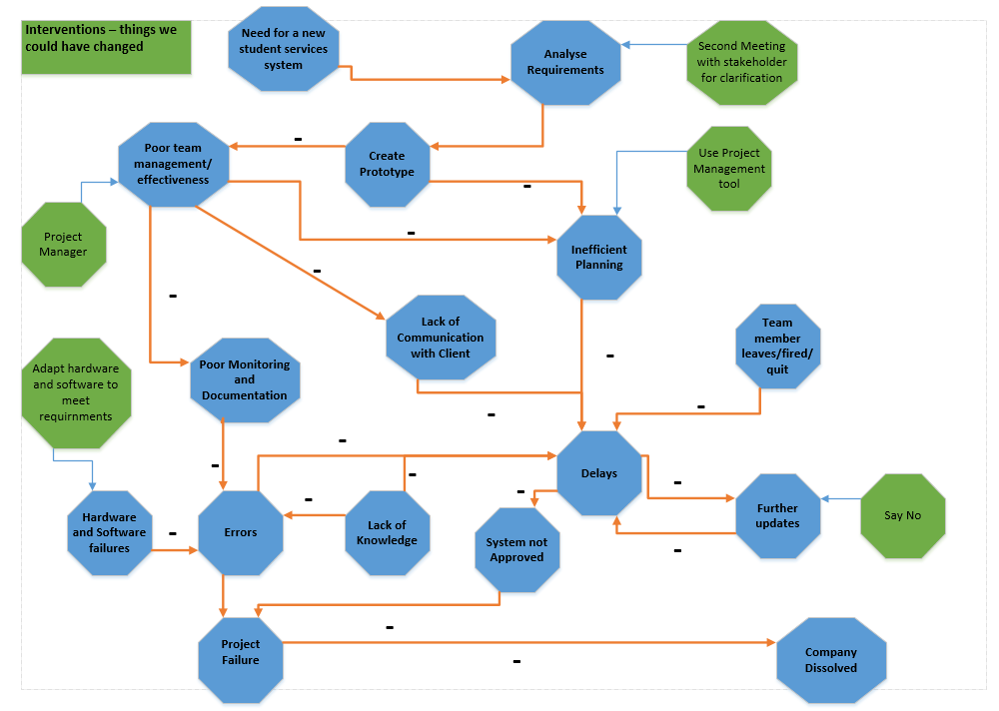
The casual map, which has been created for this project, can be seen below. The blue octagons represent the main elements that could go wrong within the project and the Green octagons in this case are interventions, things that could have been changed in an attempt to stop a negative effect having an impact on the project.

Pert Analysis
The pert analysis shows all of the tasks that were stated within the Gantt chart in a different view, this view could be found on Microsoft Project under Network Diagram. “Is a method used to examine the tasked that are in a schedule and determine a variation of the Critical Path Method (CPM). It analyses the time required to complete each task and its associated dependencies to determine the minimum time to complete a project.” [9]
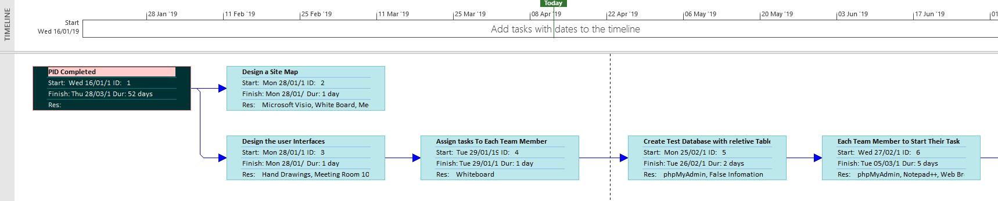
Figure 4- Pert chart 1
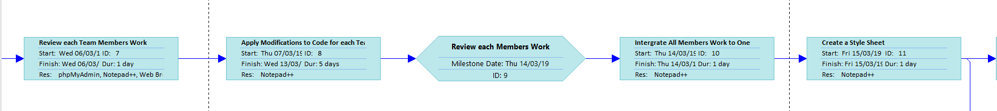
Figure 5- Pert chart 2
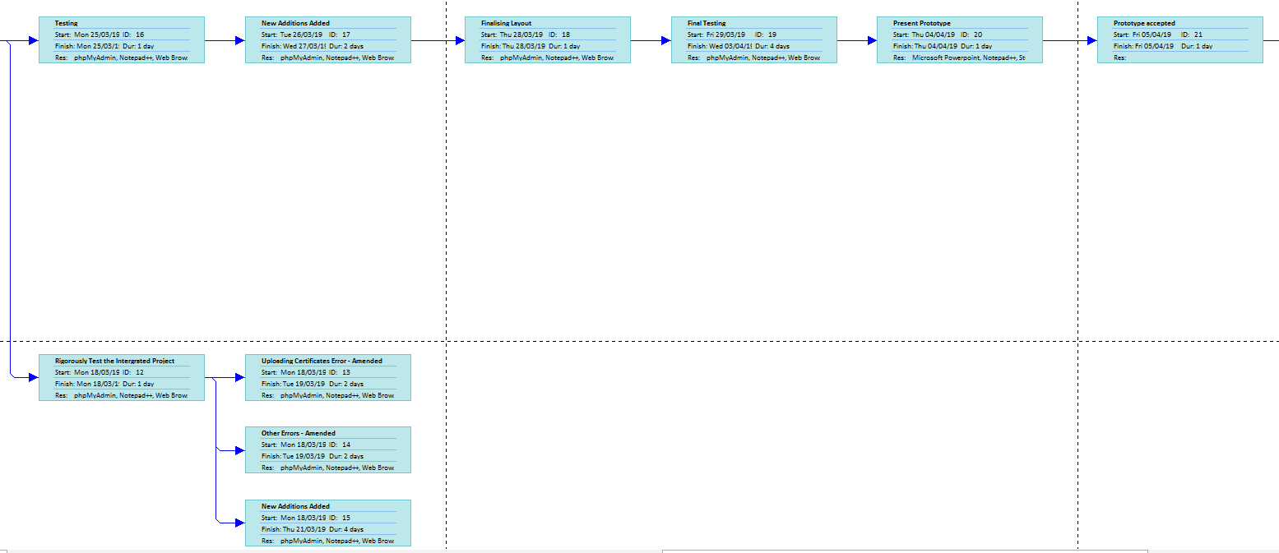
Figure 6- Pert chart 3
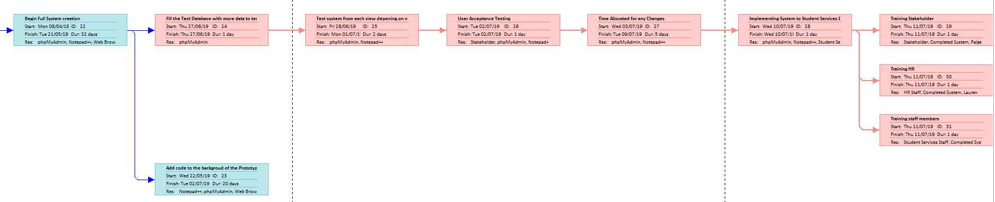
Figure 7-- Pert chart 4

Sustainability
Sustainability is “The maintenance of the factors and practices that contribute to the quality of environment on a long-term basis.” [10] This will be analysed using Lami’s Green Drivers table along with the analysis of those identified using industry guidelines.

Green Drivers Table
A green Drivers table is used to identify the main drivers for sustainability within the project.
Green Drivers | Power | Effort/Time | Paper | Fuel
People
Stake holder | Remote Working | Less time manually remind staff about certificates,  Easy access to staff timetable saving time to find them. |  | Remote access
Student Services Staff | Remote Working |  | Scanned Certificates and timesheets, less need to store on site | Remote access
Admin Team | Remote Working |  |  | Remote access
Managers | Remote Working |  |  | Remote access
Project Content
Resources | Some resources readily available, only hardware can be used. |  | Paperless | Energy to run technology
Technology | New technology needed for Kim and David |  | Paperless
Development
Project Methodology | Use of UNI equipment | Travel time | Needed for meetings | Getting to uni, car/train

Sustainability Issues for the Project
After using Lami’s Green Drivers Table to identify the main drivers for sustainability within the project, now they will be discussed further with relation to their appropriate industry guidelines and legislation. By looking into the sustainability issues of the project, it helps to reduce a business’s carbon footprint, “the amount of carbon dioxide released into the atmosphere as a result of the activities of a particular individual, organization, or community.” [11]
When looking into the ISO 14001 Environmental Management systems, it shows the different aspect of a business it can be applied. “It provides a framework through which an organisation can deliver environmental performance improvement in line with its environmental policy commitments.” [12] The standard helps to achieve the following outcomes:
- “Identify and understand the environmental aspects of its activities, products and services and associated environmental impacts.
- Understand how significant aspects can be managed, implement necessary controls and set clear objectives to improve environmental performance.
- Establish its environmental policy and objectives.
- Manage its obligation to comply with applicable legal and requirements and other stakeholder obligations, and to regularly check the compliance status.
- Continually improve the management system to enhance its environmental performance.” [12]
The ISO 9001 helps businesses to mould their future by firstly, identifying the sustainability issues the business currently has, and what the business want to achieve. The Remote working and remote access both are way in which student services can help the environment. The system that is being created will allow the staff members of student services to remotely access the system via the internet. By the use of remote access, it reduces the emissions that will be used for the staff member to access the system (i.e. coming into work) when they are able to access it remotely through their home PC, laptop or after a possible future development, mobile device. In addition, by allowing the staff members to access the system from their home computers, it reduces the energy needed for the university to run the equipment. By going paperless, the student services department, in theory, will eventually need no paper. At the beginning, the transfer from the paper system to the new electronic system, might take time, however the paper that is currently being used will be destroyed and some of the new features within the system will allow for there not to be any need for paper. The Waste Electrical and Electronic Equipment recycling (WEEE), is a specialist-recycling department that recycles electronic waste that includes a battery or have a plug. There are 10 different categories within the WEEE that recycle different types of electronic equipment, such as; large household appliances, small household appliances, IT and telecommunications equipment, lighting etc. there will be no need to dispose of any electronic equipment as the university is new, and so is the electrical equipment being used.

As both GetitrIT and the student services department at the University of Wales Trinity Saint David are both located in wales, they should both be attempting to follow the Sever Well-being Goal that have been set out by the Future Generations Commissioner or Wales. This is an Act which was created in 2015 to “gives us the ambition, permission and legal obligation to improve our social, cultural, environmental and economic well-being.” [13] This act is about improving the well-being of Wales’ social, economic, environment and culture. The seven well-being goals identified within the act can be seen below.

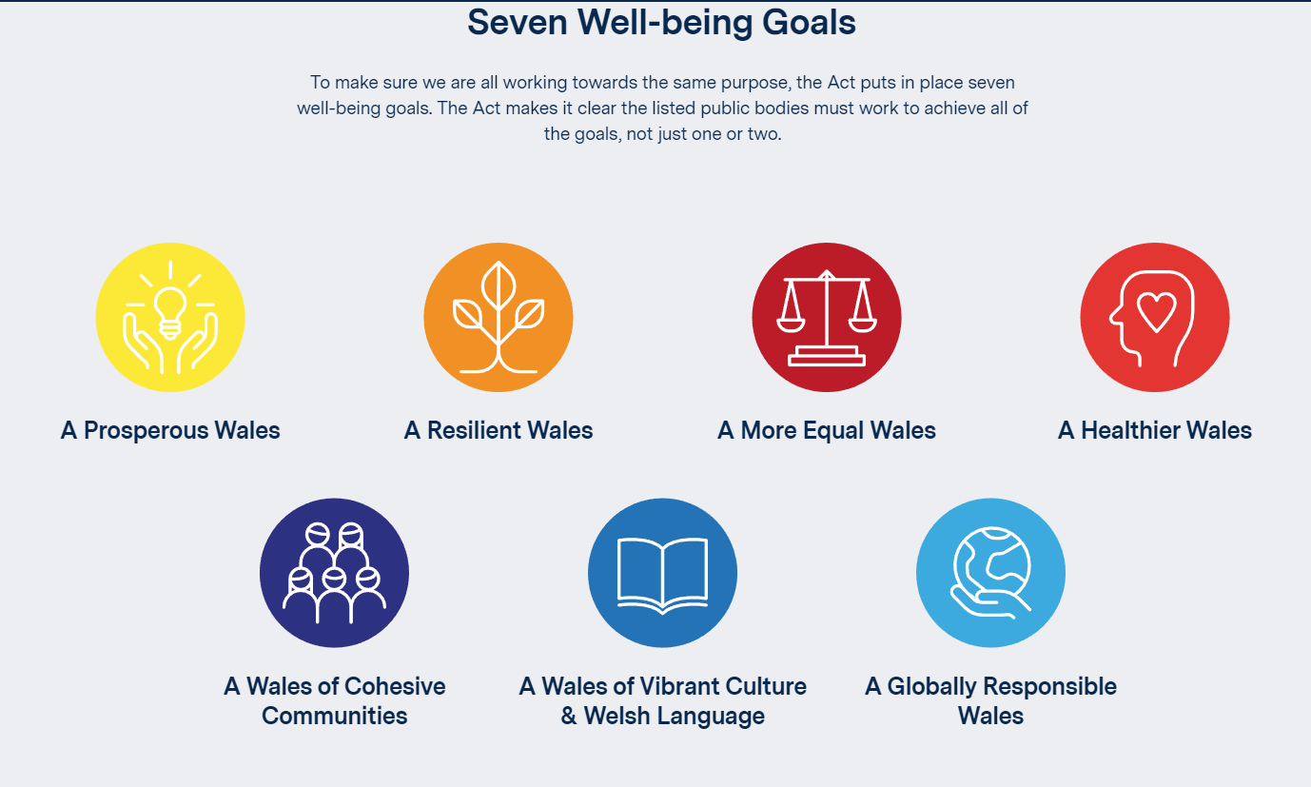
Figure 8- Seven Well-being Goals [13]
This law is needed to ensure that the future for Wales gives a good quality of life to those living there. “Wales faces a number of challenges now and in the future, such as climate change, poverty, health inequalities and jobs and growth. To tackle these we need to work together. To give current and future generations a good quality of life we need to think about the long-term impact of the decisions we make. This law will make sure that our public sector does this.” Within the act, there is a Sustainable Development Principle. “In this Act, any reference to a public body doing something “in accordance with the sustainable development principle” means that the body must act in a manner which seeks to ensure that the needs of the present are met without compromising the ability of future generations to meet their own needs.” [14] The five ways public bodies are looking to implement the sustainable development principle, are as follows.

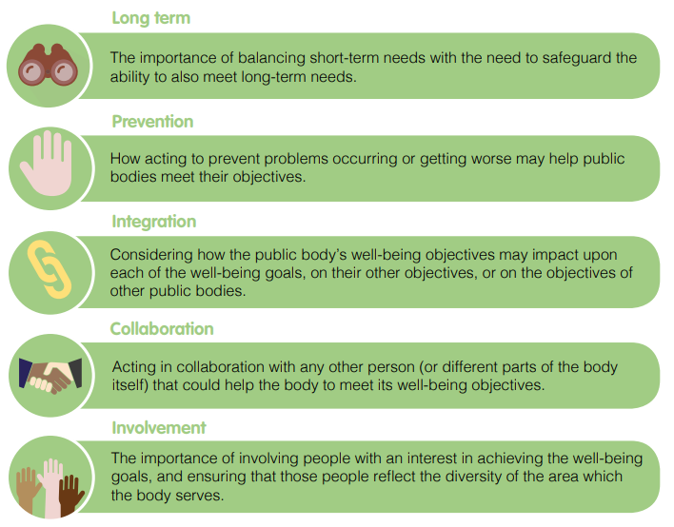
Figure 9- Five sustainable development principles [14]

Ethical Issues
Ethical issues must be considered when creating a system such as the one being created for student services. There are five Legal and Ethical issues that are highly effecting IT work. These include:
- Privacy
Personal data will be stored within the new student services system, before it was being stored on paper files, now it will all be stored electronically, not just the personal details about the staff member will be store, but also digital copied of the certificates, timetable and timesheets between them and students. This data should not be access by anyone who is not authorised to view it. To help manage this risk the information will be stored in a secure database and each member of the student services department will have access to their information by the use of their own usernames and passwords.
- Digital Ownership
Digital ownership is the property rights somebody has over a digital asset. As the internet ensures that data can move around the world within seconds, legal protection for intellectual property and copyright must be in place to ensure the information is not stolen.
- Data Gathering
When gathering the data to be entered to the database, the team will be unable to view the data that is being held on the staff members. For the prototype, the database was filled with false data to ensure the prototype would work properly and the presentation could be seen with data included. A meeting with the stakeholder will be arranged to decide on whether they will enter the data themselves to the database store (PHPmyadmin), or they would like a add new member of staff page to the system. This prevents the data that is being stored on the staff members being accessed by the team from GetitrIT
- Security Liability
Digital security is extremely important for this project as sensitive data will be stored on the database. Security will help to prevent the data being access from any unauthorised person access the data.
- Access Costs
Access costs refer to when a business is asking the user to pay to view certain information being held on the internet. This does not affect the system that is being created for the student services department.
Issues that could also affect the project could include hacking, “A hacker is an individual who is knowledgeable enough to gain access without authorization to computer systems to identify security flaws.” [15] If a hacker were to break into the student services system, they could be doing so for a number of reasons, such as, to cause damage to the system, access the information being held on the system for sale or exposure. This then leads onto the use of malicious code within the system that could cause the data being held to be damage or lost. The three types of coding attacks include viruses, Trojan horse and worms. A virus could be sent via e-mail or via a link through a website, “A computer virus is malicious code that replicates by copying itself to another program, computer boot sector or document and changes how a computer works.” [16] A Trojan horse is a type of malware; this malware could be disguised as a piece of software, in this case the new system that GetitrIT is implementing. “Trojans can be employed by cyber-thieves and hackers trying to gain access to users' systems…Trojans can enable cyber-criminals to spy on you, steal your sensitive data, and gain backdoor access to your system. These actions can include:
- Deleting data
- Blocking data
- Modifying data
- Copying data
- Disrupting the performance of computers or computer networks” [17]
A worm however does not need to be attached to a piece of software or be interactive with any human in order to cause any damage, they can be sent vie emails or instant messages.
In conclusion, if any of these viruses were to attack, the student service’s new system the security of the data would be low as well as being at risk of malicious acts including unlawful usage for identity theft.
The British Computer Society has a code of conduct that should be used, it covers four main areas, and these are:
- Public Interest
- Professional Competence and Integrity
- Duty to Relevant Authority
- Duty to the Profession
These key points have been analysed along with recommendations on how the team can manage the issues and the risks that follow.

Public Interest
The public interest section of the British Computer Society’s code of conduct includes the following points, these have been analysed and referred to for the project.

“Have due regard for public health, privacy, security and wellbeing of others and the environment.” [18]
When creating the system, security measures must be in place to ensure there is no chance of un-authorised access to the data being held on the system. Only members of staff shall be able to access the data then can view, edit and delete. As there are different levels of staff using the system, each staff member will have their own login details to ensure they are viewing only what they should be.

“Have due regard for the legitimate rights of Third Parties.” [18]
This means to protect the personal data being help of the system to ensure there is no way for unlawful disclosure of the information and/or identity theft. It also means that the code in which the team are using to complete the system has need been stolen, respect for the copyright law must be considered.

“Conduct your professional activities without discrimination on the grounds of sex, sexual orientation, marital status, nationality, colour, race, ethnic origin, religion, age or disability, or of any other condition or requirement.” [18]
There must be no discrimination within the team; each team member should be treated equally. As the team in very diverse, some communication issues could arise, the team must work through this and aid each other is one does not understand.

“Promote equal access to the benefits of IT and seek to promote the inclusion of all sectors in society wherever opportunities arise. “ [18]
All members of the Student Services department will need to access the new IT system. Extra training may be required for those who are not familiar with computing systems. Ensuring all members of the department are completely able to use the system also means creating a user-friendly environment that the user is able to understand quickly.

Professional Competence and Integrity
The Professional Competence and Integrity section of the British Computer Society’s code of conduct includes the following points, these have been analysed and referred to for the project.

“Only undertake to do work or provide a service that is within your professional competence.” [18]
The team will only continue to complete work, which they have an understanding. For example, security within this project must be high as there will be various sensitive data being held within the system. The team must ensure that to do the security measure that they must be working correctly.

“Not claim any level of competence that you do not possess.” [18]
This means that the team will not propose l to complete any work they are not able to do. This could been claiming that a certain feature will be added to the new system, however the team do not have the knowledge to do so.

“Develop your professional knowledge, skills and competence on a continuing basis, maintaining awareness of technological developments, procedures, and standards that are relevant to your field.” [18]
Ensuring the team is aware of any new technological developments that could affect the project and the system being created. Keeping up to date will help prevent any hackers entering the system through new hacking techniques. Also, keep up to date with standards that need to be meet that may be relevant to the system.

“Ensure that you have the knowledge and understanding of legislation* and that you comply with such legislation, in carrying out your professional responsibilities.” [18]
Legislation should be known to ensure that the system that is being produces on compliant. If the system is not compliant then fines could be issued to both the creators and the department.

“Respect and value alternative viewpoints and, seek, accept and offer honest criticisms of work.” [18]
Respect all team members’ opinions and criticisms as well as the opinions of the stakeholder as that is whom the system is being created. Testing is an essential way to gain criticism and it encourages to right changes to be made to ensure the user-friendliness of the system.

“Avoid injuring others, their property, reputation, or employment by false, malicious, or negligent action or inaction.” [18]
When creating the system, it will be completed to the highest standard to ensure the reputation of GetitrIT is sustained. When implementing it to the student services computers, there will be no access to any of the files and data stored on those computers. There will be no viruses downloaded to the computers and there will be no damage to the hardware of the student services department.

“Reject and will not make any offer of bribery or unethical inducement.” [18]
No bribery will be accepted to ensure the system is as secure as it can be as well as ensuring the project is completed on time and to the standard required by the stakeholder.

Duty to Relevant Authority
The Duty to Relevant Authority section of the British Computer Society’s code of conduct includes the following points, some of these have been analysed and referred to for the project.

“Carry out your professional responsibilities with due care and diligence in accordance with the Relevant Authority’s requirements whilst exercising your professional judgement at all times.” [18]
For this project, the stakeholder has selected requirements that need to be implemented to the new system.

“Seek to avoid any situation that may give rise to a conflict of interest between you and your Relevant Authority.” [18]
As the stakeholder has multiple requirements for the system, if there are any that cannot be done due to lack of knowledge, the stakeholder must be informed prior to the implementation within the student services department. A meeting should be arranged to discuss any issues and any adaptations to the requests must be discussed. If the team is aware that the project is going to run over time and become over budget they must ensure the stakeholder is aware of this to prevent any conflict.

“Accept professional responsibility for your work and for the work of colleagues who are defined in a given context as working under your supervision.” [18]
The work that was completed for the prototype was completed by three members of the team. Each member is held responsible for the work completed and if anything is missing or inadequate the whole team is to blame.

“NOT disclose or authorise to be disclosed, or use for personal gain or to benefit a third party, confidential information except with the permission of your Relevant Authority, or as required by Legislation.” [18]

“NOT misrepresent or withhold information on the performance of products, systems or services (unless lawfully bound by a duty of confidentiality not to disclose such information), or take advantage of the lack of relevant knowledge or inexperience of others.” [18]
The system will be fully explained to the stakeholder and the member of staff that will be using the system. This will ensure that the system is being used to its full potential and the stakeholder will be fully aware of how the system works.

Duty to the Profession
The Duty to Profession section of the British Computer Society’s code of conduct includes the following points, some of these have been analysed and referred to for the project.

“Accept your personal duty to uphold the reputation of the profession and not take any action, which could bring the profession into disrepute.” [18]
As the team are members of the British Computer Society, professionalism is key to ensure the work completed is to a high standard and is not to effect the reputation of GetitrIT or the BCS.

“Seek to improve professional standards through participation in their development, use and enforcement.” [18]
Computing is ever growing and new standards should be met, the team must ensure that the professional standards are met throughout the work being done for the student services department.

“Uphold the reputation and good standing of BCS, the chartered institute for it.” [18]

“Act with integrity and respect in your professional relationships with all members of BCS and with members of other professions with whom you work in a professional capacity.” [18]

“Notify BCS if convicted of a criminal offence or upon becoming bankrupt or disqualified as a company director and in each case give details of the relevant jurisdiction.” [18]
If any team member is convicted of, a criminal offence when working within GetitrIT the British Computer Society will be notified.

“Encourage and support fellow members in their professional development.” [18]
All team members will be members of the BCS; if possible, an attempt for the staff at the Student Services department will be encouraged to develop their professional knowledge within the BCS to help ensure ethics are met within the workplace.

If all of the above statements are followed correctly the system which will be a put in place will be, secure and a responsible piece of computing software will be created for the Student Services department.

Legal Issues
Some of the legal issues, which will effect this project, will be discussed within this section. The Data Protection Act 2018, Intellectual Property and Computer Misuse will all be analysed in relation to the project and some to Brexit.

Data Protection Act 2018
The data protection act was updated from the 1998 act in May 2018; it applies the EU’s GDPR (General Data Protection Regulation) standards that help to prepare Britain for Brexit. “By having strong data protection laws and appropriate safeguards, businesses will be able to operate across international borders. This ultimately underpins global trade and having unhindered data flows is essential to the UK in forging its own path as an ambitious trading partner.” [19]
The new data protection law has been updated to fit in with the more digitally reliant the world has become. It ensures that the data protection laws are fitting to the digital age where more and more data is being stored and then processed on people across the world each day. It will empower people to take control of their data, and understand more clearly how their data will be used. It also helps to ensure that the United Kingdom is ready to leave the European Union.
This regulation has changed the way data is stored throughout the UK, more so that it took 2 years to enforce it. The GDPR is designed to;
- “Harmonize data privacy laws across Europe,
- Protect and empower all EU citizens data privacy
- Reshape the way organizations across the region approach data privacy.” [20]
The GDPR’s key privacy and data protection requirements are;
- “Requiring the consent of subjects for data processing
- Anonymizing collected data to protect privacy
- Providing data breach notifications
- Safely handling the transfer of data across borders
- Requiring certain companies to appoint a data protection officer to oversee GDPR compliance” [21]

Overseas sales
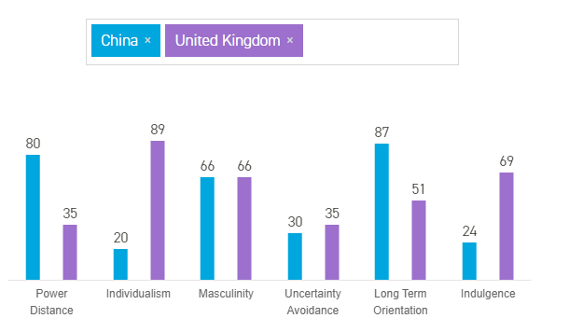
This system could potentially be sold overseas; therefore, an analysis must be completed using Hofstede Cultural Dimensions to analyse the cultural differences between the United Kingdom and China. “The Hofstede model of national culture consists of six dimensions. The cultural dimensions represent independent preferences for one state of affairs over another that distinguish countries (rather than individuals) from each other.” [22]

Figure 10- Hofstede's Country Comparison [23]
Hofstede’s Cultural Dimensions are made up of six key points, these are:
- Power Distance
- Individualism
- Masculinity
- Uncertainty Avoidance
- Long-term orientation
- Indulgence

Power Distance
In comparison between the United Kingdom and China, it is clear that China are more accepting to the inequalities within society, whereas the United Kingdom believes that in inequalities between people should be minimised.

Individualism
When comparing individualism between China and the United Kingdom, shows that China’s people are more group orientated, where they will act in the interest of their group more than themselves. The UK however are highly individualists, private people, who think for themselves from a young age Personal fulfilment, is important to the British.

Masculinity
China and the United Kingdom’s masculinity dimension is identical, and both are classed as masculine societies meaning both are success orientated, having clear ambitions. Chinese are known to sacrifice leisure time to work. “Another example is that Chinese students care very much about their exam scores and ranking as this is the main criteria to achieve success or not.” [23]

Uncertainty Avoidance
China and the UK’s uncertainty avoidance are very similar, only five points between them. This is the way that society deals with the “fact that the future can never be known” [23]. As both countries have a low score, both are comfortable not knowing what the day will bring and are flexible to the changes that might occur throughout the day or project.

Long-term orientation
China has a high score for this dimension, meaning the culture is pragmatic, believing “that truth depends very much on situation, context and time. They show an ability to adapt traditions easily to changed conditions, a strong propensity to save and invest, thriftiness, and perseverance in achieving results.” [23] The UK has a score of 51, so they cannot be determined.

Indulgence
The UK has a high score for the indulgence dimension, therefor they “they place a higher degree of importance on leisure time, act as they please and spend money as they wish.” [23] China however, with a score of 24, has the perception that indulgence is wrong and like stated in masculinity, will put leisure time aside.

Why would this system be helpful to a university in china?
If this system was to be exported to universities within china, there are many benefits for doing so, these include:
- “largest country in the world by population with over 160 cities of more than a million inhabitants
- fast growing consumer market resulting from increasing number of middle income consumers
- growth ensured by Chinese monetary policy
- forecast to become the world’s largest luxury goods market by 2020” [24]
There is 942 high education institutions within china, a big market to sell. However, there are some challenges that need to be addressed when doing business with china. These include:
- “large parts of the economy are still closed to full foreign participation
- strong competition from well-resourced and positioned state-owned enterprises
- finding and retaining the right skills in the local workforce
- complex business culture
- language barriers
- need for patience to build up trust and networks
- significant time difference
- weather extremes across the country and high levels of pollution in certain urban centres
- anti-monopoly legislation in relation to foreign firms” [24]
If the right people are in charge of the migration of the system to chine, for example, those people who are able to speak the foreign language.

Intellectual Property
Intellectually property is “creations of the mind, such as inventions; literary and artistic works; designs; and symbols, names and images used in commerce.” [25] This property is protected by the law via copyright, trademarks and patents. For this project, as the system is bespoke, created solely for the student services department at UWTSD, it is protected. The owner of the system will be GetitrIT; no individual from the team will be the owner as he or she are not self-employed. “You usually won’t own the intellectual property for something you created as part of your work while you were employed by someone else.” [26]
“You own intellectual property if you:
- created it (and it meets the requirements for copyright, a patent or a design)
- bought intellectual property rights from the creator or a previous owner
- have a brand that could be a trade mark, e.g. a well-known product name
Intellectual property can:
- have more than one owner
- belong to people or businesses
- be sold or transferred” [26]

Computer Misuse
The Computer Misuse Act 1990 is “An Act to make provision for securing computer material against unauthorised access or modification; and for connected purposes.” [27] This act also ties into the ethical issues stated in section 6.0.
Computer misuse offences include the following:
- “Unauthorised access to computer material.
- Unauthorised access with intent to commit or facilitate commission of further offences.
- Unauthorised modification of computer material.” [27]
Types of computer misuse include the following.
- “Computer fraud
- Unauthorised obtaining of information from a computer -
  - Computer "hacking"
  - Eavesdropping on a computer
  - Making unauthorised use of computers for personal benefit
C. Unauthorised alteration or destruction of information stored on a computer
- Denying access to an authorised user
- Unauthorised removal of information stored on a computer.” [28]
This comes into the project as when the system will be implemented to the student services department; it must be secure enough that these offences cannot happen. For example, only the department manager is able to view all details on each member of the staff at student services, meaning no member of staff is authorised to access any details on another member of staff and no member of staff should be able to edit details that are not their own.

References

[1] | “project-management,” products.office, [Online]. Available: https://products.office.com/en-gb/project/project-management. [Accessed 26 04 2019].
[2] | “Predecessor,” InLoox, [Online]. Available: https://www.inloox.com/project-management-glossary/predecessor/. [Accessed 26 04 2019].
[3] | “What is project management?,” apm, [Online]. Available: https://www.apm.org.uk/resources/what-is-project-management/. [Accessed 30 04 2019].
[4] | S. Berkun, Making Things Happen - Mastering Porject Managment, 2008.
[5] | “risk-management,” techtarget, [Online]. Available: https://searchcompliance.techtarget.com/definition/risk-management. [Accessed 26 04 2019].
[6] | “businessrisk,” investopedia, [Online]. Available: https://www.investopedia.com/terms/b/businessrisk.asp. [Accessed 26 04 2019].
[7] | “causal-mapping/,” pictureitsolved, [Online]. Available: https://pictureitsolved.com/resources/practices/causal-mapping/. [Accessed 26 04 2019].
[8] | “what-is-causal-mapping,” 21TwelveConsulting, [Online]. Available: https://2112consulting.co.uk/what-is-causal-mapping. [Accessed 04 26 2019].
[9] | “Schedule Development,” AcqNotes, [Online]. Available: http://acqnotes.com/acqnote/tasks/pert-analysis. [Accessed 12 04 2019].
[10] | “environmental-sustainability,” businessdictionary, [Online]. Available: http://www.businessdictionary.com/definition/environmental-sustainability.html. [Accessed 29 04 2019].
[11] | “What is a carbon footprint - definition,” timeforchange, [Online]. Available: https://timeforchange.org/what-is-a-carbon-footprint-definition. [Accessed 29 04 2019].
[12] | “ISO 14001 - Environmental Management System,” DNV.GL, [Online]. Available: https://www.dnvgl.co.uk/services/iso-14001-environmental-management-system-3360?gclid=EAIaIQobChMIovC3w8z14QIV5pXtCh2pUgLWEAAYASAAEgKWnvD_BwE. [Accessed 29 04 2019].
[13] | “Well-being of Future Generations (Wales) Act 2015,” futuregenerations.wales, [Online]. Available: http://futuregenerations.wales/about-us/future-generations-act/. [Accessed 30 04 2019].
[14] | “futuregenerations,” [Online]. Available: https://futuregenerations.wales/wp-content/uploads/2017/02/150623-guide-to-the-fg-act-en.pdf. [Accessed 30 04 2019].
[15] | A. O. M. (. UGBOGBO.S.N (Ph.D), “ETHICAL ISSUES IN INFORMATION TECHNOLOGY- A,” 08 2016. [Online]. Available: https://www.iuokada.edu.ng/journals/5B6AA29B40ADBA7.pdf. [Accessed 29 04 2019].
[16] | “virus,” techtarget, [Online]. Available: https://searchsecurity.techtarget.com/definition/virus. [Accessed 29 04 2019].
[17] | “What is a Trojan Virus?,” kaspersky, [Online]. Available: https://www.kaspersky.co.uk/resource-center/threats/trojans. [Accessed 29 04 2019].
[18] | “conduct,” bcs, [Online]. Available: https://www.bcs.org/upload/pdf/conduct.pdf. [Accessed 29 04 2019].
[19] | C. M. &. S. Department for Digital, “Data Protection Act 2018,” [Online]. Available: https://assets.publishing.service.gov.uk/government/uploads/system/uploads/attachment_data/file/711162/2018-05-23_Factsheet_1_-_Act_overview.pdf. [Accessed 30 04 2019].
[20] | “The EU General Data Protection Regulation (GDPR) is the most important change in data privacy regulation in 20 years.,” EU GDPR.ORG, [Online]. Available: https://eugdpr.org/. [Accessed 30 04 2019].
[21] | “What is the General Data Protection Regulation? Understanding & Complying with GDPR Requirements in 2019,” DATAINSIDER, [Online]. Available: https://digitalguardian.com/blog/what-gdpr-general-data-protection-regulation-understanding-and-complying-gdpr-data-protection. [Accessed 30 04 2019].
[22] | “national-culture/,” hofstede-insights, [Online]. Available: https://www.hofstede-insights.com/models/national-culture/. [Accessed 07 05 2019].
[23] | “country-comparison/china,the-uk/,” hofstede-insights, [Online]. Available: https://www.hofstede-insights.com/country-comparison/china,the-uk/. [Accessed 07 05 2019].
[24] | “exporting-to-china,” gov.uk, [Online]. Available: https://www.gov.uk/guidance/exporting-to-china. [Accessed 07 05 2019].
[25] | “What is Intellectual Property?,” wipo, [Online]. Available: https://www.wipo.int/about-ip/en/. [Accessed 30 04 2019].
[26] | “intellectual-property-an-overview,” gov, [Online]. Available: https://www.gov.uk/intellectual-property-an-overview. [Accessed 30 04 2019].
[27] | “Computer Misuse Act 1990,” [Online]. Available: https://www.legislation.gov.uk/ukpga/1990/18/pdfs/ukpga_19900018_en.pdf. [Accessed 30 04 2019].
[28] | H. M. S. OFFICE, “Computer Misuse,” [Online]. Available: https://s3-eu-west-2.amazonaws.com/lawcom-prod-storage-11jsxou24uy7q/uploads/2016/08/No.110-Computer-Misuse.pdf. [Accessed 30 04 2019].

