

Title: Assignment 1: Feasibility Plan for an International Meeting.
Individual Presentation
Student Name: Andreea Maria Crozolo
Student ID :2226837
School of Hospitality and Tourism Management
BA International Hotel Management
Module code: BMIH6007
Level 6
Module Lead: Kathryn Flynn

I confirm that I have not used any AI tools in the research and creation of this assignment. I confirm that I have not presented any AI generated materials as my own work. I confirm I have copies of my drafts, notes, and other resources I used, which I may be asked to provide in evidence.

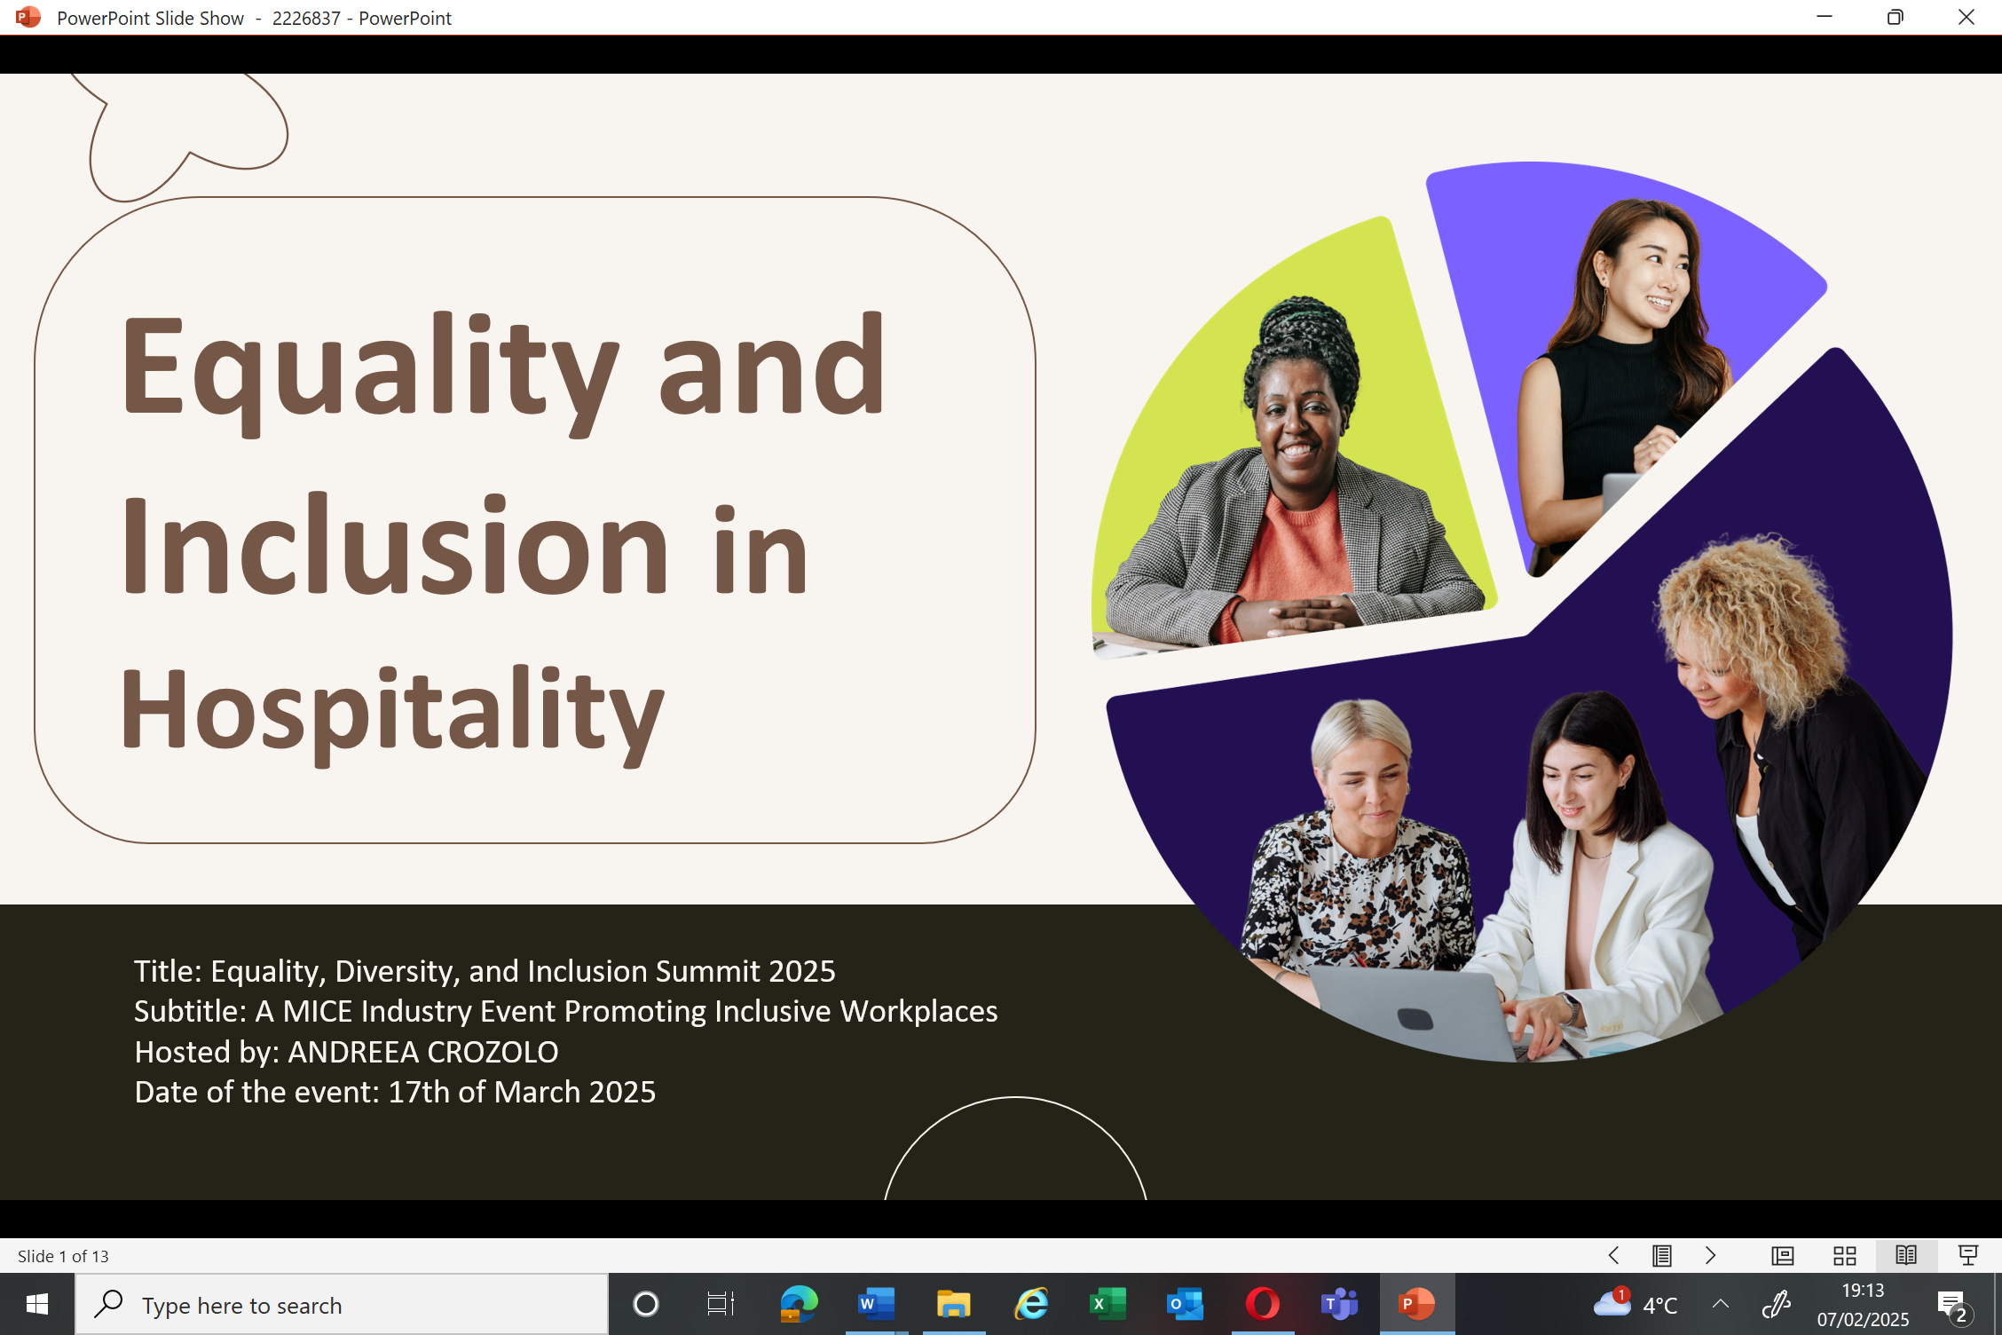
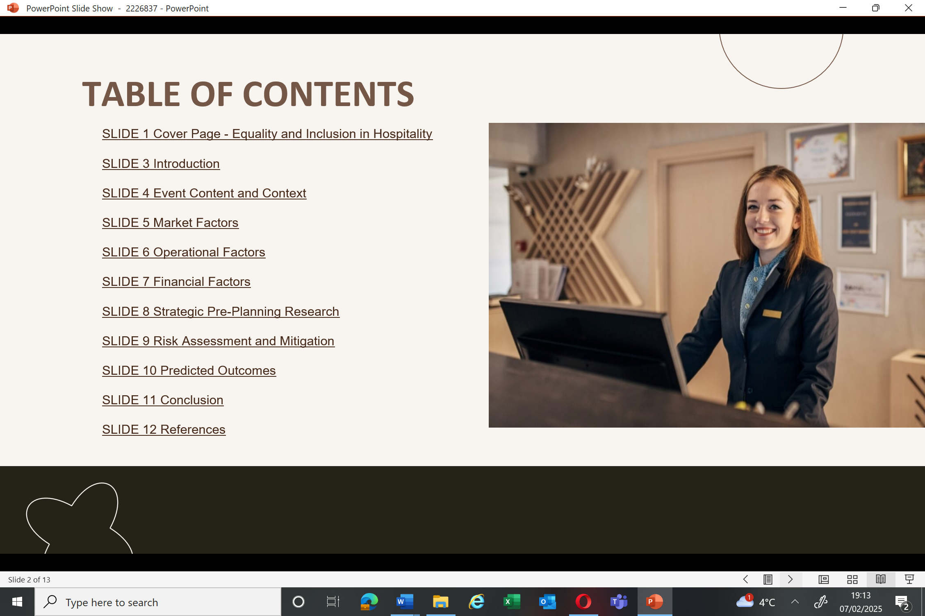
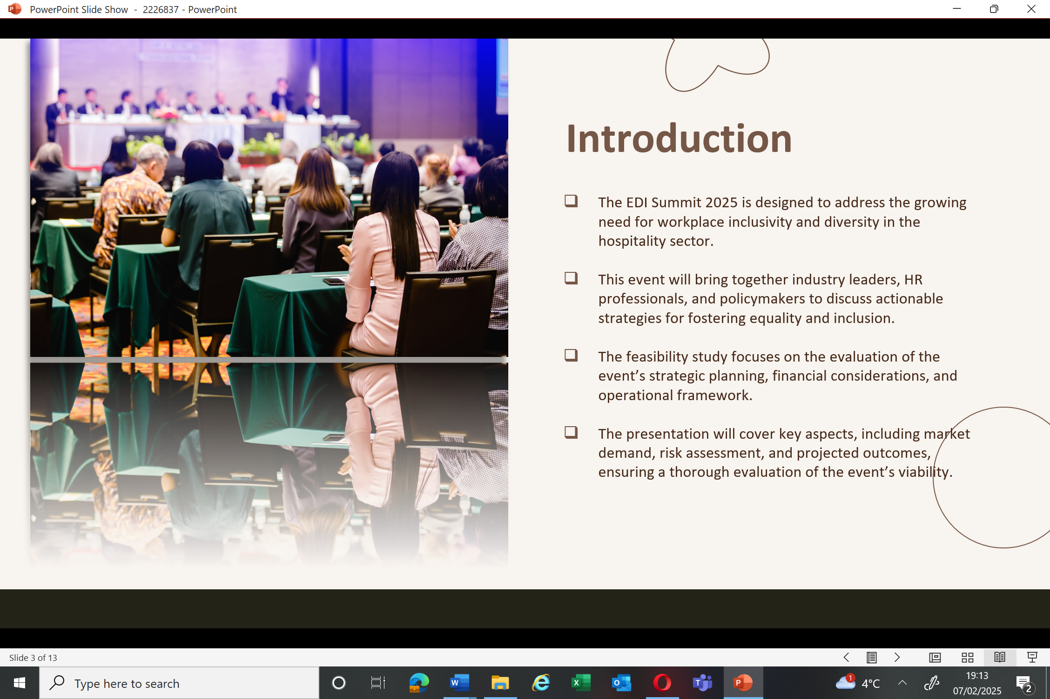
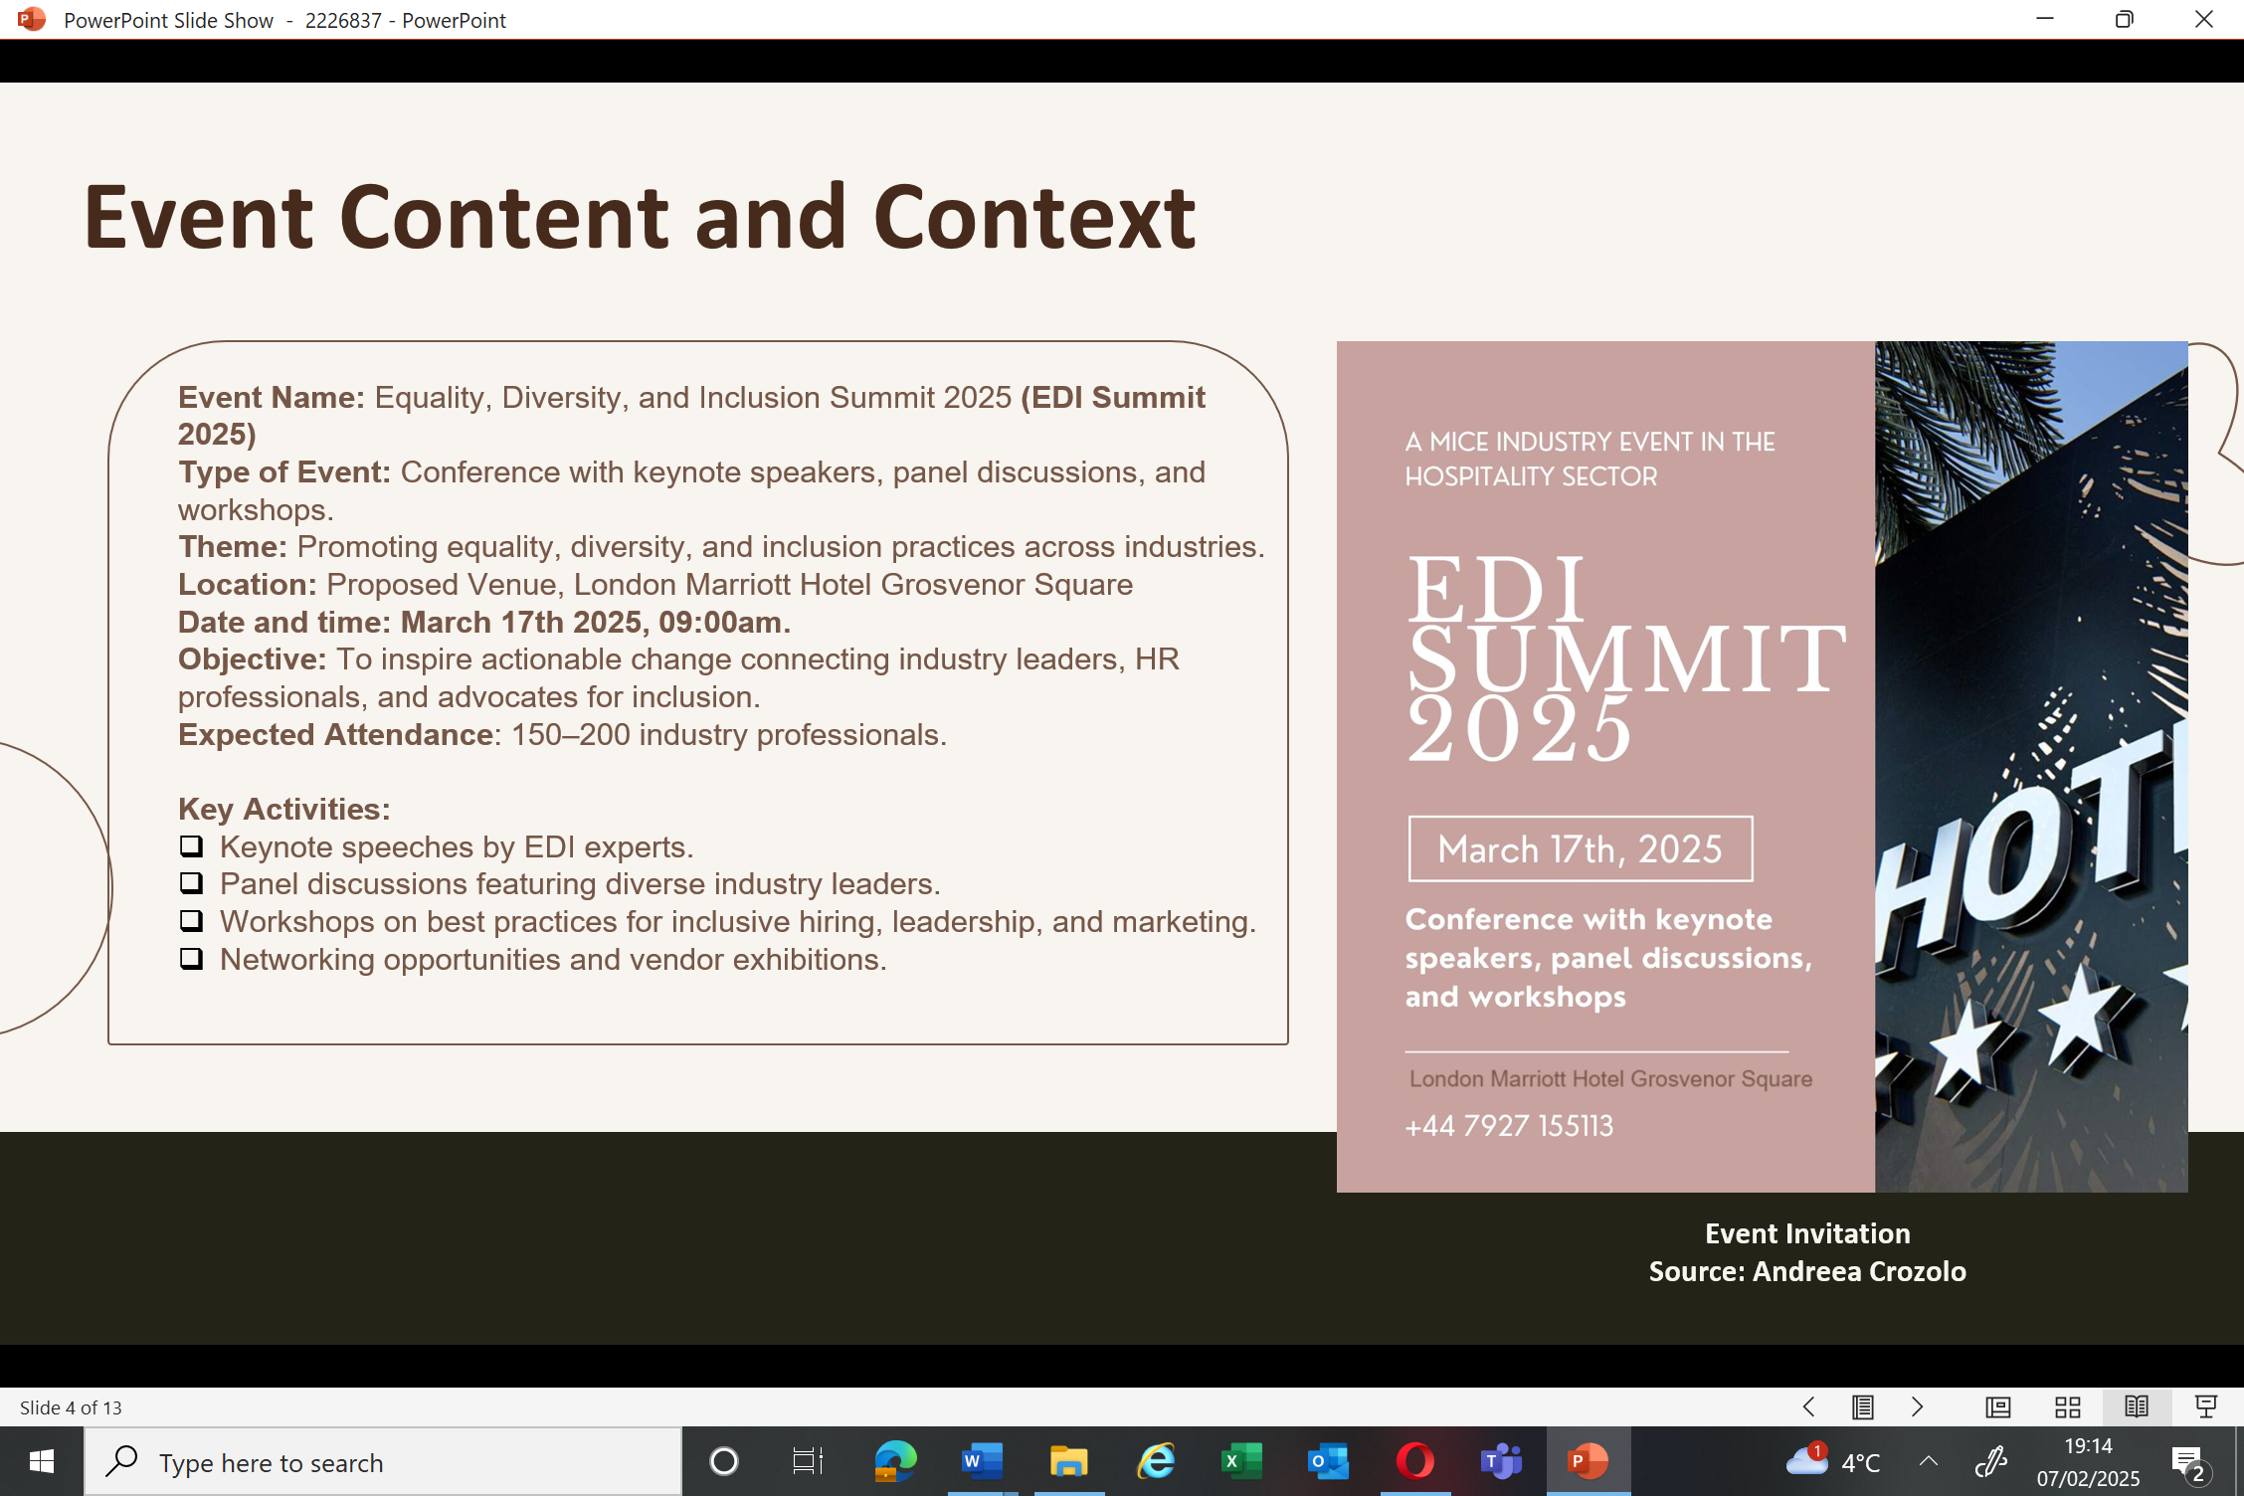
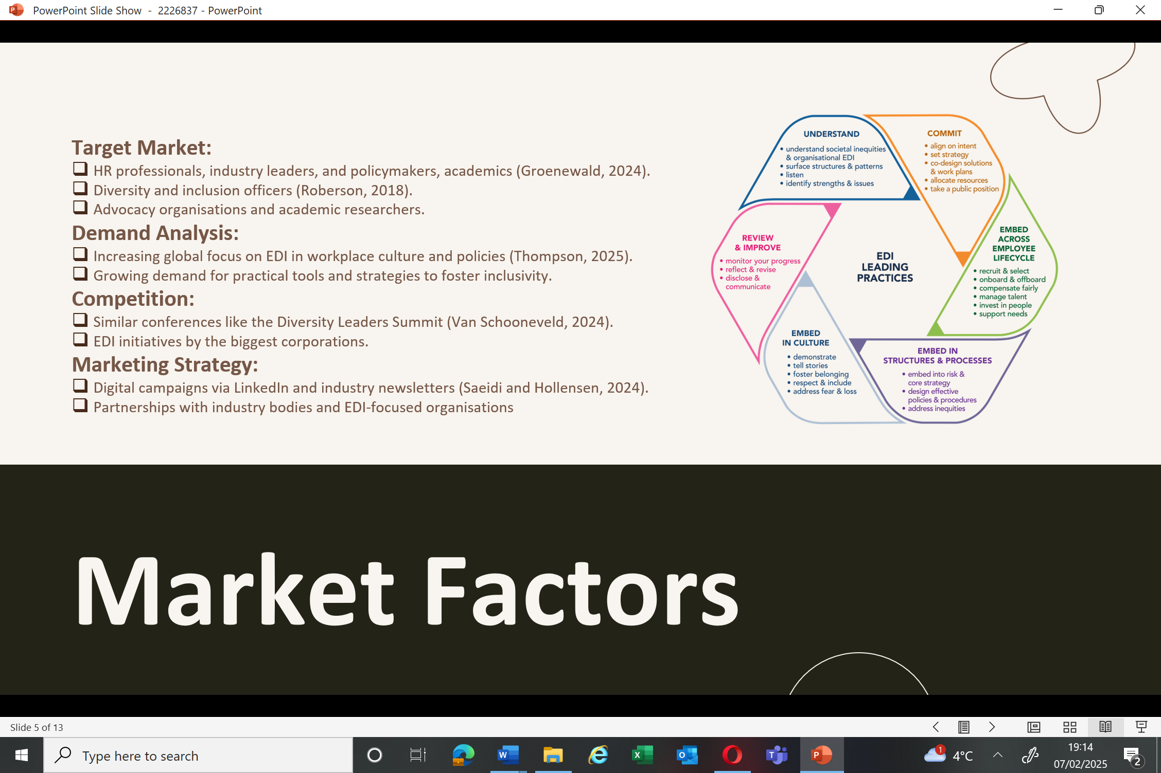
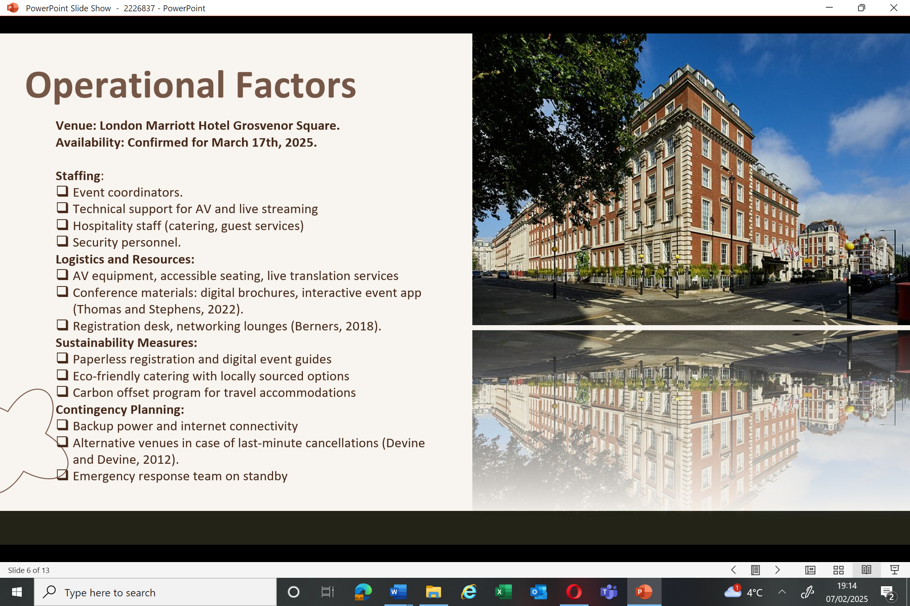
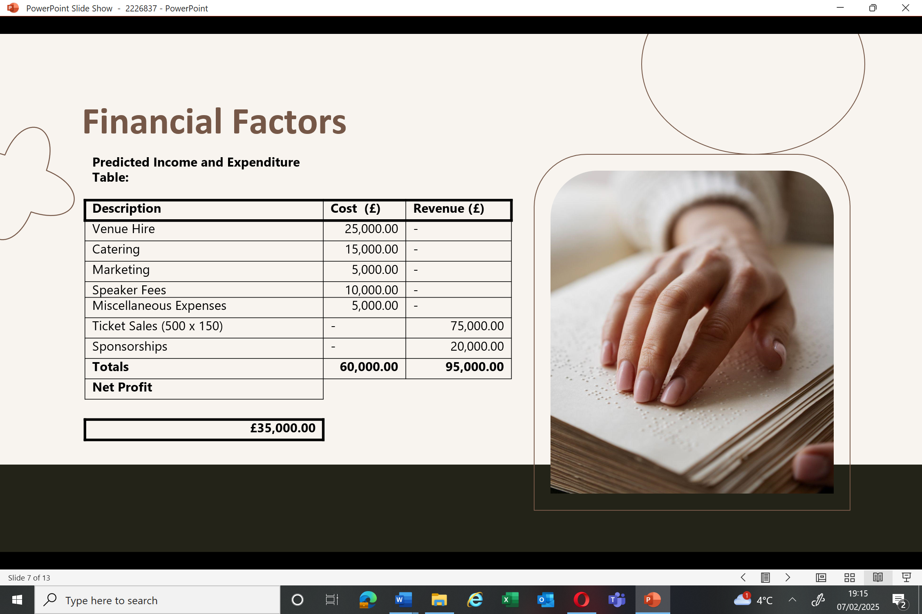
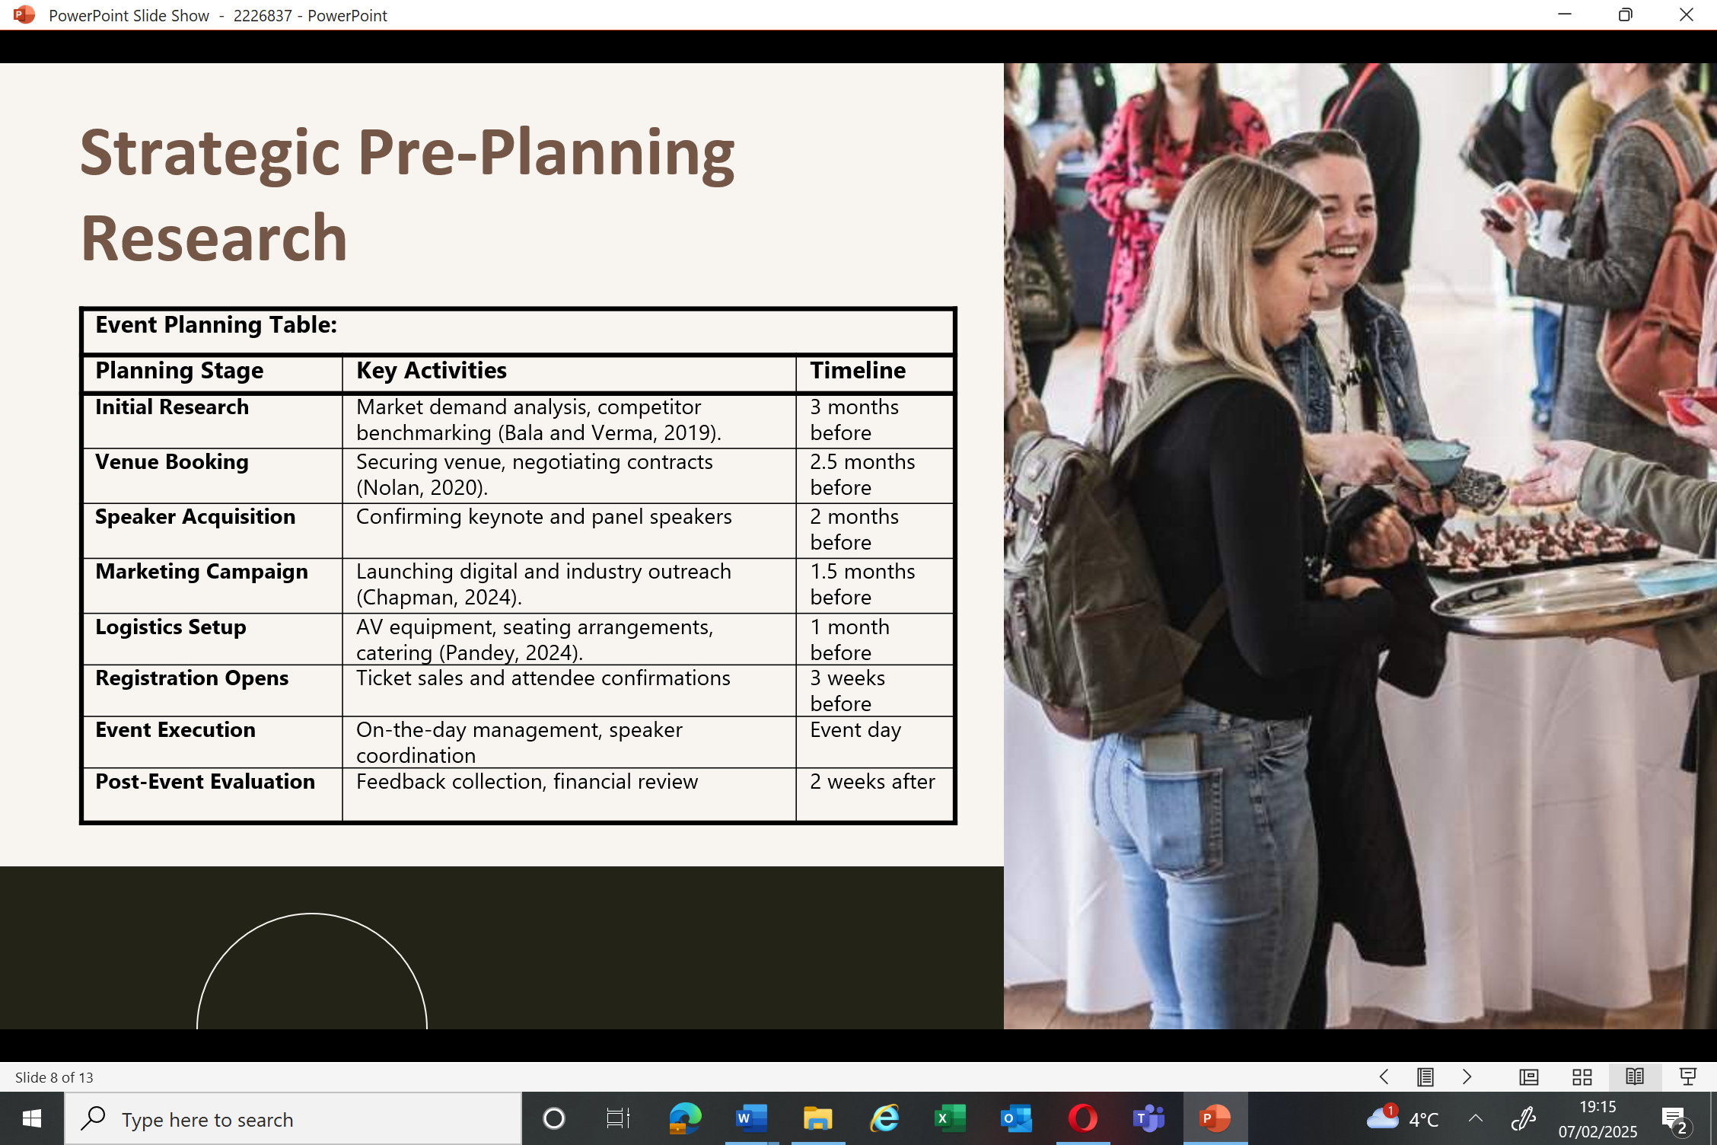
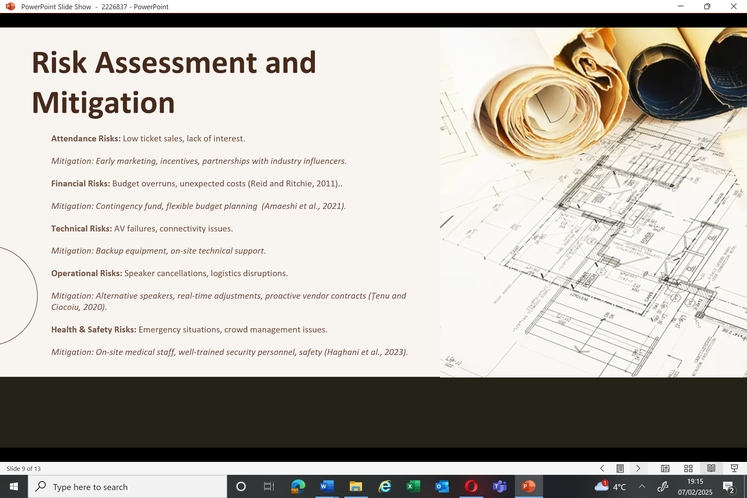
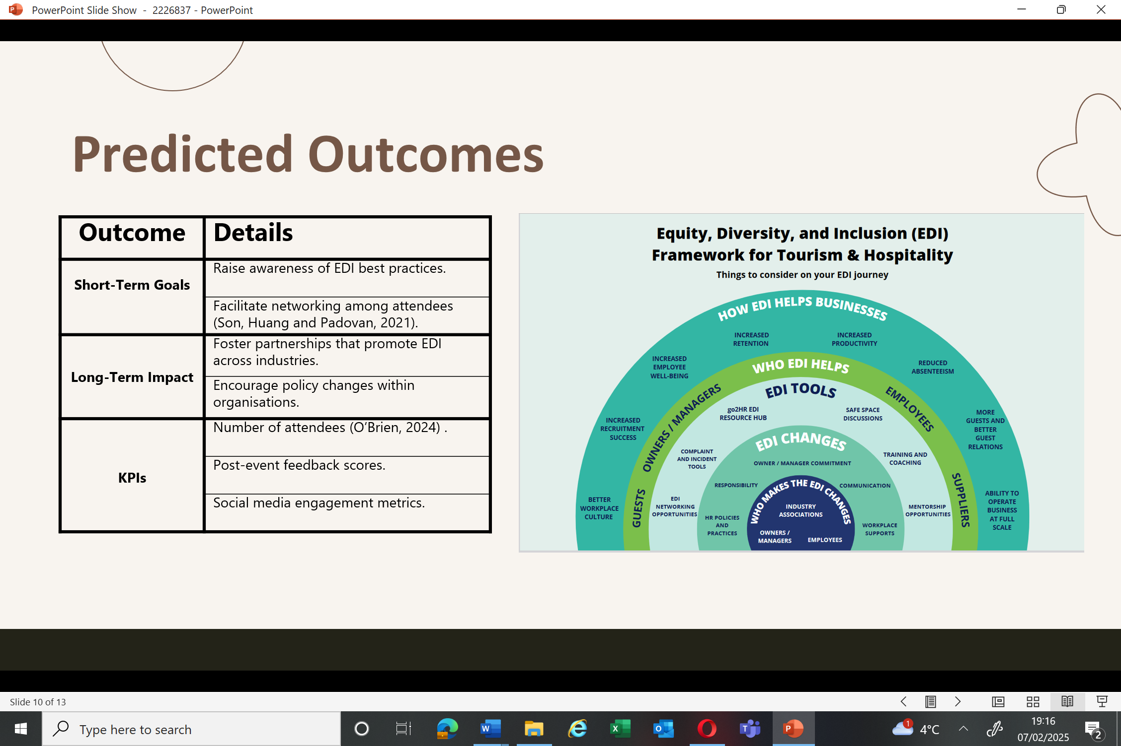
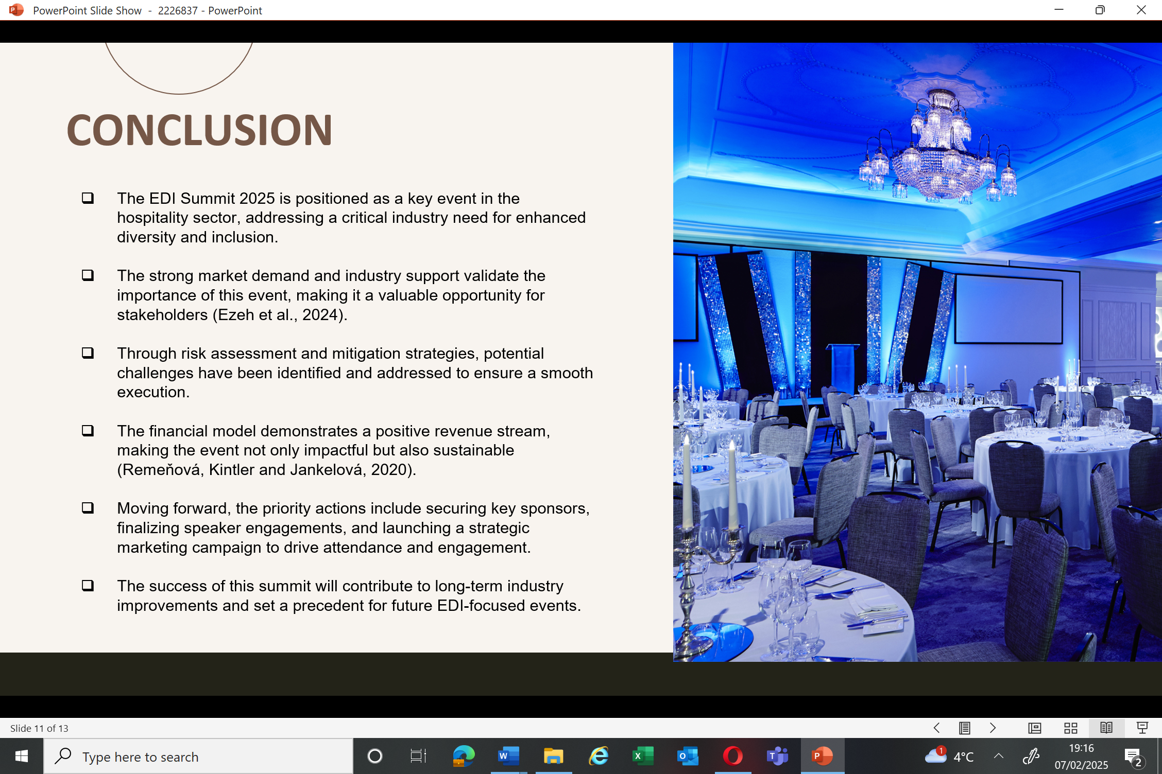

References
Amaeshi, U.F. et al. (2021) Project risk management in events planning and management in Nigeria, PM World Journal, X(IV), pp. 1–13. https://www.pmworldjournal.com.
Bala, M. and Verma, D. (2019) Market and demand analysis, Market and Demand Analysis. https://doi.org/10.13140/RG.2.2.25258.77767.
Berners, P. (2018) The Practical Guide to Managing Event Venues, Routledge eBooks. https://doi.org/10.4324/9781351045599.
Chapman, M. (2024) Digital Marketing: today’s key to greater outreach. https://www.linkedin.com/pulse/digital-marketing-todays-key-greater-outreach-micah-chapman-hwnxc/.
Devine, A. and Devine, F. (2012) The challenge and opportunities for an event organiser during an economic recession, International Journal of Event and Festival Management, 3(2), pp. 122–136. https://doi.org/10.1108/17582951211229681.
Ezeh, N.M.O. et al. (2024) Stakeholder engagement and influence: Strategies for successful energy projects, International Journal of Management & Entrepreneurship Research, 6(7), pp. 2375–2395. https://doi.org/10.51594/ijmer.v6i7.1330.
Groenewald, E. (2024) Assessing the Role of Leadership in shaping EDI policies and initiatives in Hospitality Industries: A Systematic review and Meta-analysis review, Nternational Multidisciplinary Journal of Research for Innovation, Sustainability,and Excellence, 1(1).
Haghani, M. et al. (2023) A roadmap for the future of crowd safety research and practice: Introducing the Swiss Cheese Model of Crowd Safety and the imperative of a Vision Zero target, Safety Science, 168, p. 106292. https://doi.org/10.1016/j.ssci.2023.106292.
Nolan, E. (2020) Understanding and negotiating contracts with venues, in Advances in logistics, operations, and management science book series, pp. 84–102. https://doi.org/10.4018/978-1-7998-3230-0.ch005.
O’Brien, M. (2024) 11 key hospitality KPIs to Track. https://www.netsuite.com/portal/resource/articles/business-strategy/hospitality-kpis.shtml#:~:text=In%20hospitality%2C%20KPIs%20include%20occupancy,performance%20against%20that%20of%20competitors.
Pandey, T. (2024) Event logistics: key elements, benefits, challenges, and more. https://travelitecargo.com/blog/event-logistics/.
Reid, S. and Ritchie, B. (2011) Risk Management: event managers’ attitudes, beliefs, and perceived constraints, Event Management, 15(4), pp. 329–341. https://doi.org/10.3727/152599511x13175676722528.
Remeňová, K., Kintler, J. and Jankelová, N. (2020) The general concept of the revenue model for sustainability growth, Sustainability, 12(16), p. 6635. https://doi.org/10.3390/su12166635.
Roberson, Q.M. (2018) Diversity in the Workplace: A Review, Synthesis, and Future Research agenda, Annual Review of Organizational Psychology and Organizational Behavior, 6(1), pp. 69–88. https://doi.org/10.1146/annurev-orgpsych-012218-015243.
Saeidi, S. and Hollensen, S. (2024) Digital Marketing on LinkedIn: In-Depth Strategies for Lead Generation, American Journal of Industrial and Business Management, 14(05), pp. 655–668. https://doi.org/10.4236/ajibm.2024.145033.
Son, I.S., Huang, S. and Padovan, D. (2021) Realising the goals of event leveraging: The tourism and hospitality SME perspective, Journal of Hospitality and Tourism Management, 49, pp. 253–259. https://doi.org/10.1016/j.jhtm.2021.09.018.
Țenu, A. and Ciocoiu, C.N. (2020) Risk management for events and festivals, Trivent Publishing. journal-article. http://trivent-publishing.eu/.
Thomas, K. and Stephens, S. (2022) Understanding the management theory in event management, SSRN Electronic Journal [Preprint].
Thompson, P. (2025) EY report highlights diversity initiatives as DEI comes under scrutiny in Trump’s first weeks in power. https://www.businessinsider.com/ey-report-how-to-implement-dei-initiatives-donald-trump-2025-1?utm_source=chatgpt.com.
Van Schooneveld, A. (2024) The 5 Best Leadership Conferences to Help you Grow. https://globalleadership.org/articles/best-leadership-conferences.

