Student Name:
P Number:
Programme of Study:
Module: M4X01560

Tasks in the order I received them:
Task One: Semiotic Analysis (Ryan task) = 519 words
Task Two: Manifesto (Julia Task) = 481 words
Task Three. (Scott Task) = 501 words

Task One: Semiotic Analysis (Ryan’s task)

In an age defined by the production of ‘false narratives’ (Phillips, 2018), ‘fake news’ (Carson, 2018) and ‘alternative facts’ (Blake, 2017), where does this leave our ability to read images, when images deceive as much as reveal? More importantly, how can we deconstruct the underlying production of these false narratives? This first task will deconstruct a popular, contemporary advertising campaign, whilst making reference to theories of semiotics and advertising, in an attempt to offer new ways of seeing.

From birth, we are taught how to read signs and symbols (Berger, 1972). We are taught the arbitrary relationship between language (the signifier of meaning), and their concepts (the signified meaning) (Barthes, 1977). The colour red means ‘stop’, the colour green means ‘go’. The word ‘cat’ relates to the furry creature we physically know as being a cat. How words and signs generate concepts is the basis of semiotic analysis. Semiotics lays forth how we know how we know. Signs can take the form of words, images, sounds, smells, taste or objects, but these signs are empty vessels until we invest them with meaning. As the forefather of semiotics, Charles Peirce Sanders states, ‘Nothing is a sign unless it is interpreted as a sign’ (1931: 58).

In Roland Barthes seminal publication, Image, Music, Text (1977), Barthes proposes to set out a basic semiotic model for communication. Following on from the founders of semiotics, Barthes makes distinctions between the ‘denoted’, or literal reading of a sign, and the ‘connoted’, its implied meaning. He introduces the concept of Photographic Paradox, which ‘breaks the photographic image into two’ (1977:88), on one side, the objective, on the other the symbolic. Beyond this basic level of the ‘denoted’ and ‘connoted’, lie further signifying chains. In order to discuss these further signifying chains, we will introduce a recent Tesco advertising campaign.

In January 2017, the supermarket Tesco launched, Food Love Stories brought to you by Tesco. The campaign focuses on the narratives of ‘everyday’ people. Whereas our identification of models in advertising campaigns normally relies on glamour to sell a concept of idealisation, as proposed by John Berger in Ways of Seeing (1972), here we are confronted with what Barthes terms as ‘Naturalism’ (1977:67). Naturalism functions on the connection between an audience and a product, and here, the concept of naturalism is compounded by the choice of models, who represent multiple ethnicities and genders. The message is clear that anyone can identify with the models.
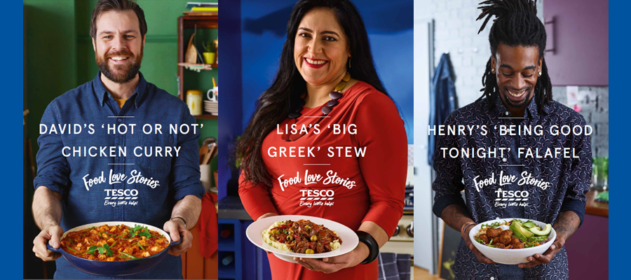

Food Love Stories, Tesco Advertising Campaign, 2017

In recent years, brand logos have taken a secondary position to ideological narrative. The narrative as promoted in the title of this campaign, Food Love Stories, uses words as metaphors for emotional connection. Through associative connection with the concept of home cooking, we get to; nostalgia, comfort, warmth, safety. The cultural code and vision behind this campaign then is the selling of the idea of ‘comfort’.

This basic semiotic analysis of images can be applied to any form of sign. An understanding of semiotics can help the audience to deconstruct the metaphoric, intertextual or metonymic construction of meaning, which is often presented in the false narratives we find ourselves surrounded by on a daily basis.

Bibliography

Barthes, R. (1977) Image, Music, Text. London, Fontana Press.
Berger, J. (1972) Ways of Seeing. London, Penguin.
Blake, A. (2017). "Kellyanne Conway says Donald Trump's team has 'alternative facts.' Which pretty much says it all". The Washington Post, 22nd January. Available at https://www.washingtonpost.com/news/the-fix/wp/2017/01/22/kellyanne-conway-says-donald-trumps-team-has-alternate-facts-which-pretty-much-says-it-all/?noredirect=on&utm_term=.c3dc92148083 (Accessed 15th October 2018)
Carson, J. (2018) Fake news: What exactly is it – and how can you spot it? The Telegraph, 28th September. Available at https://www.telegraph.co.uk/technology/0/fake-news-exactly-has-really-had-influence/ (Accessed 15th October 2018)
Peirce, C. S. (1931): Collected Writings (8 Vols.) in Charles Hartshorne, Paul Weiss & Arthur W Burks [Eds.]. Cambridge, MA: Harvard University Press.
Phillips, M. (2018) How Journalists should not cover an online conspiracy theory. The Guardian, 6th August. Available at: https://www.theguardian.com/commentisfree/2018/aug/06/online-conspiracy-theory-journalism-qanon (Accessed 15th October 2018)

(NB. There are only three books here, but your bibliography should include all relevant research for this task. The bibliography will inform your reader/ marker of the breadth of your research. Check Harvard referencing: https://www.uwtsd.ac.uk/media/uwtsd-website/style-assets/content-assets/documents/library-and-learning-resources/Harvard-eng.PDF)

Task Two: Manifesto (Julia’s Task)
- Burn newspapers that propagate anti-Semitic viewpoints.
- In the so-called era of ‘post truth’ and ‘alt. facts’, we must strive to question, subvert and challenge the mediation of images. We reassert the role of deconstruction in understanding the production of false narratives and meanings.
- Always make an effort to ‘be in the world’ instead of being somewhere else (virtually).
- The role of art and design in the commodity age is to make things visible. In order to break habitual ways of seeing/creating/making, we have to give ourselves time to stop ‘using’ and start ‘contemplating’ the world and how we inhabit it.
- Do not use Facebook as a means to ask questions or get answers. Go direct to the source. Rumours fly. Truth prevails.
- We must recognise that all categories of knowledge can change according to time, place, and use. Meaning oscillates.
- You don’t need prior knowledge when ‘reading’ an artwork. Emotional response is a valid response.
- Passivity has no place here.

Keywords & Images

Post Truth

Vote Leave Bus, 2016.
2. In the so-called era of ‘post truth’ and ‘alt. facts’, we must strive to question, subvert and challenge the mediation of images. We reassert the role of deconstruction in understanding the production of false narratives and meanings.

The Oxford English Dictionary announced their 2016 word of the year as ‘Post-truth’ (Midgely, 2016). Brought to the fore by the UK’s ‘in out referendum’ to leave the European Union, and the United States Presidential election between Hilary Clinton and Donald Trump. Our relationship to notions of truth have become contested and pushed to their limit. Whereas modernity favours the universal, postmodernism savours the singular and idiosyncratic. As discussed in in John D. Caputo’s book, Truth (2013), “If you ask a postmodernist, ‘what is truth’ they are likely to squint and say, ‘It depends’”. (2013: 34). Our relationship to the truth is never a given, meaning oscillates. Our contemporary world has taken this to new extremes.

Keyword: Making Visible

- The role of art and design in the commodity age is to make things visible. In order to break habitual ways of seeing/creativing/making, we have to give ourselves time to stop ‘using’ and start ‘contemplating’ the world and how we inhabit it.



The Eyes of Gutete Emerita, Alfredo Jaar

In an age that often feels defined by division, compounded by unfair representations of ‘otherness’ (Channel 4’s, Poverty Street, Donald Trump retweeting far right hate group ‘Britain first’), representation is cruelly used to make rhetorical points that have nothing to do with anyone’s ethnic or cultural background. Photojournalists often attempt to tell stories about the lives of others, but in Alfredo Jaar’s (2004) The Eyes of Gutete Emerita, Jaar doesn’t make atrocity into a spectacle, instead Jaar uses representation to completely overthrow how we speak for others. Over a five month period in 1994, more than one million Rwandans, mostly members of the Tutsi minority, were systematically slaughtered as the world closed its eyes to genocide. Here, Jaar tells the story of 30 year old Rwandan, Gutete Emerita, who was attending mass with her family when a massacre began, Gutete’s husband and two sons were killed before her eyes. Somehow, Gutete was able to escape. Here Jaar, instead of attempting to depict such atrocity that Gutete witnessed, takes one image of Gutete’s eyes, which are repeated to the same number of deaths she witnessed. A subversive work of art.

Keywords: Emotional Response

You don’t need prior knowledge when ‘reading’ an artwork. Emotional response is a valid response.
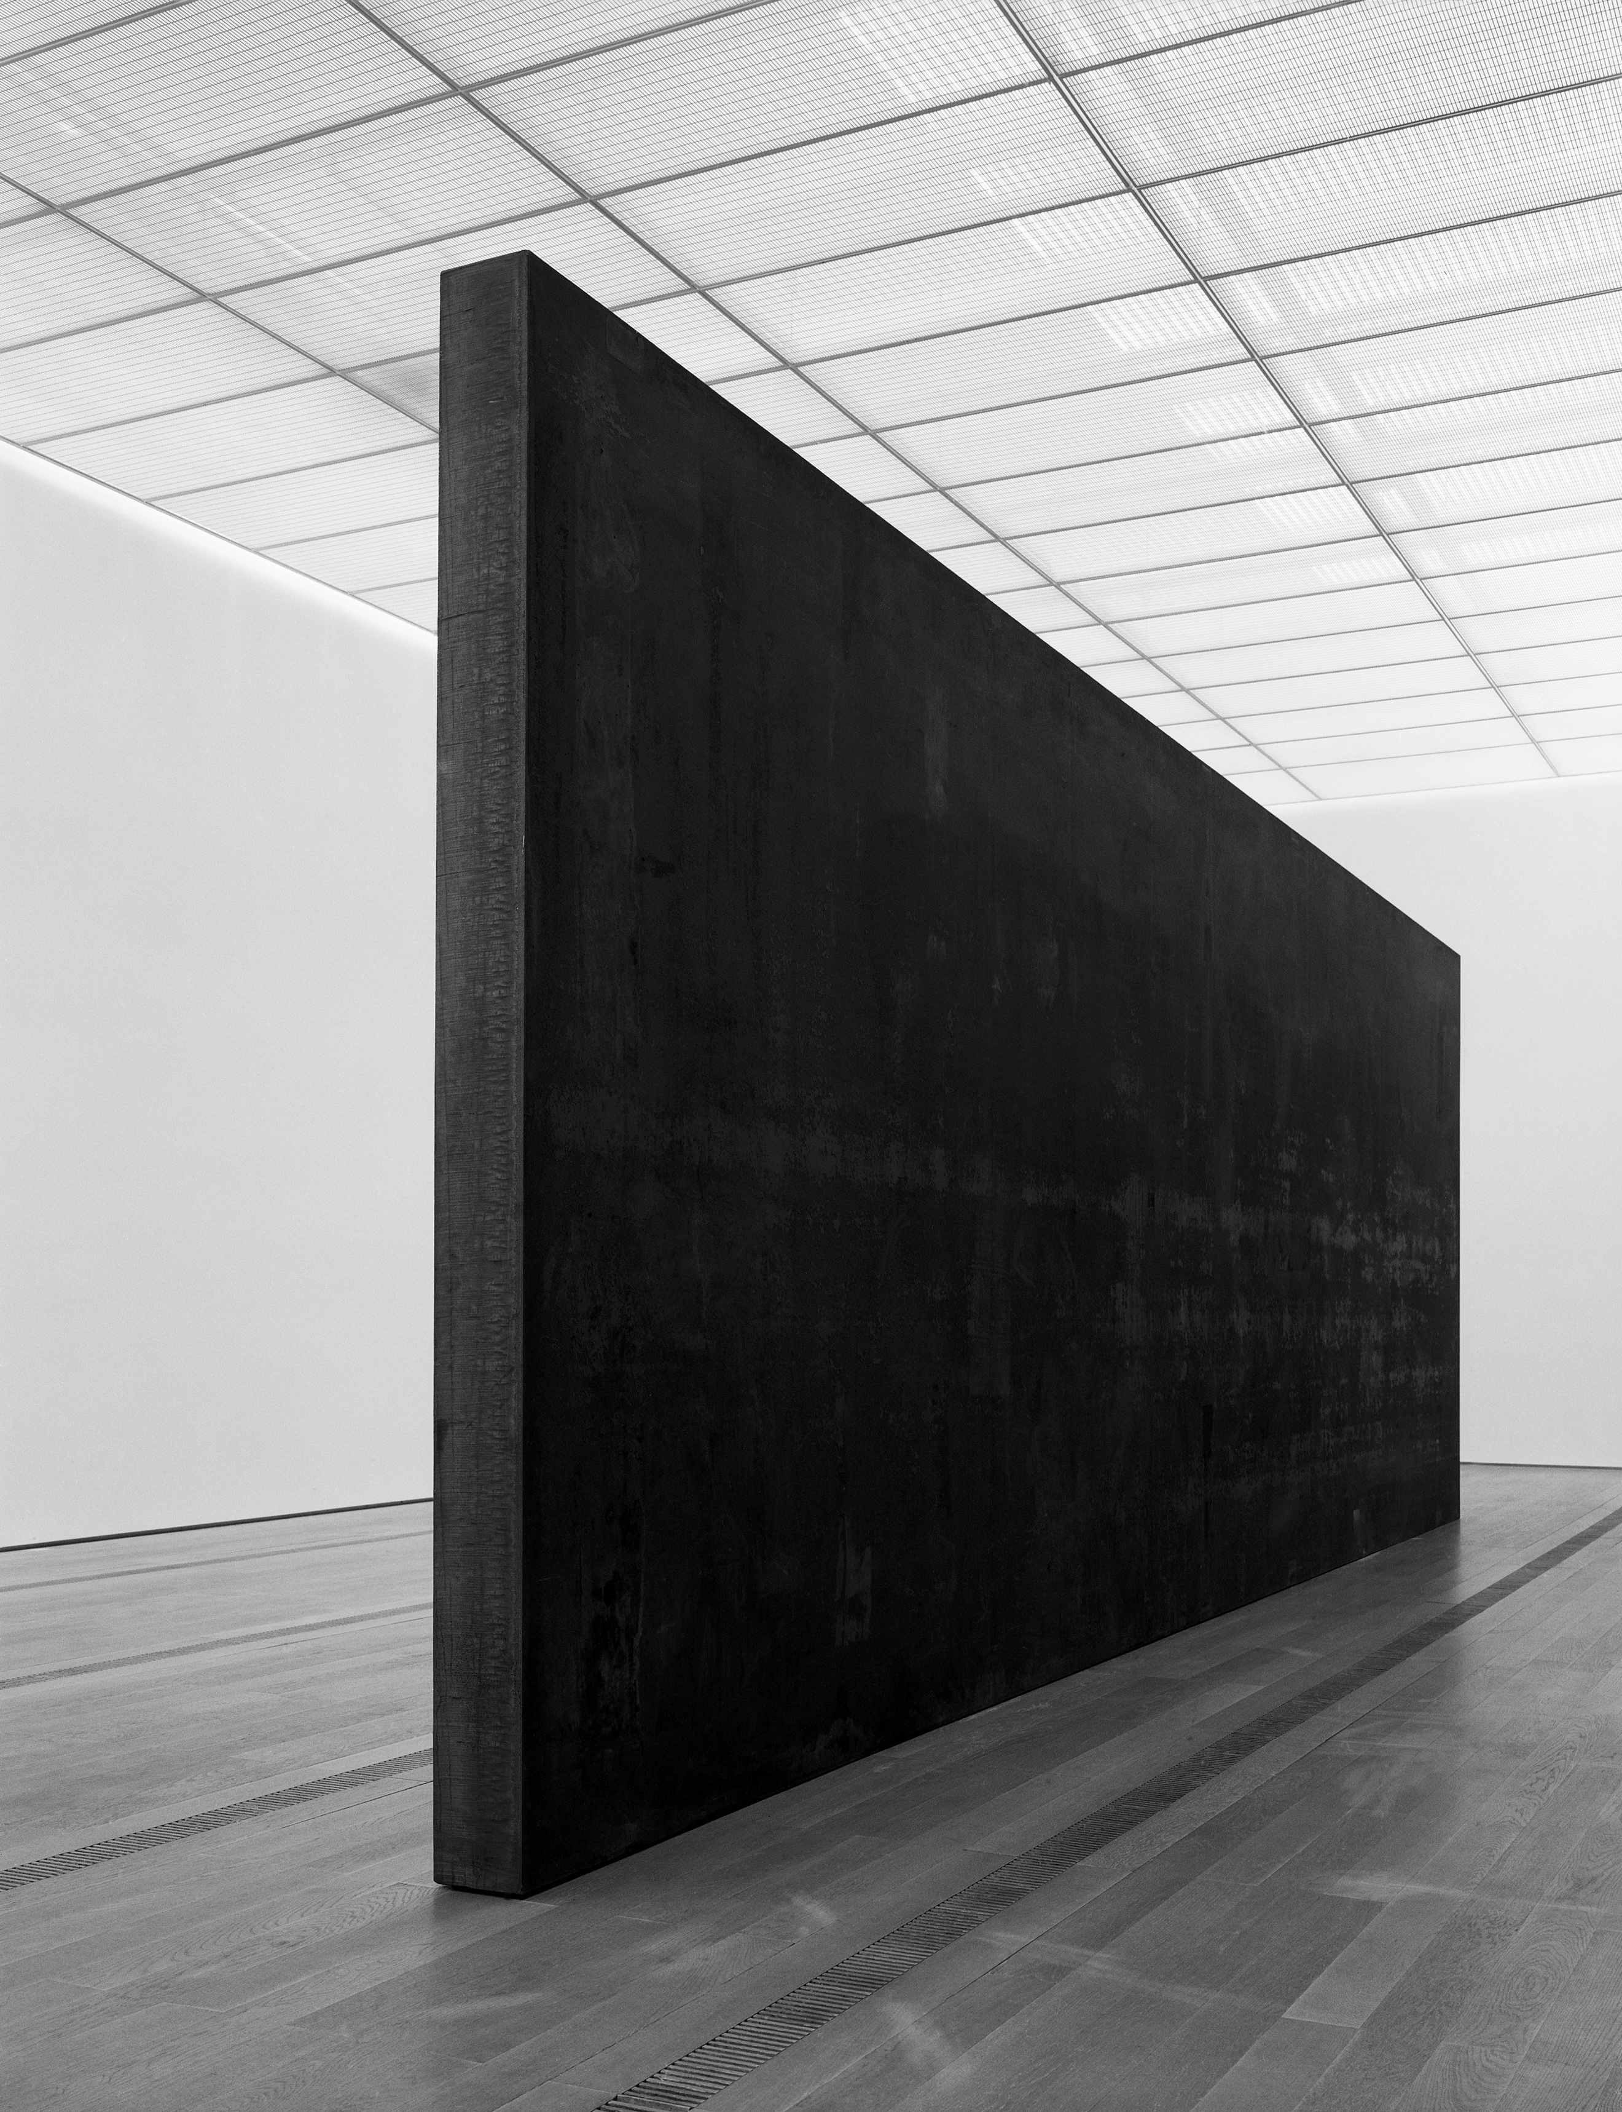

Fernado Pessoa, Richard Serra, 2007-8
Encounters with art do not always go as well as they might. We are likely to leave highly respected museums and exhibitions feeling underwhelmed, or even bewildered and inadequate, wondering why the transformational experience we had anticipated did not occur. It is natural to blame oneself, to assume that the problem must come down to a failure of knowledge or capacity for feeling. As Alain de Botton points out in his book, Art As Therapy (2013); ‘it lies in the way that art is taught, sold and presented by the art establishment. Since the beginning of the twentieth century, our relationship to art has been weakened by a profound institutional reluctance to address the question of what art is for.’ (2013: 4). In Richard Serra’s Fernando Pessoa, a profound sense of sadness is present. In a world that often suggests we should be happy, all the time (#happiness), Serra’s work does not deny our troubles. It tells us, through its materials and form, that sorrow is written into the contract of life. This art work is accepting.

Bibliography
Caputo, J. D. (2013). Truth; Philosophy in Transit. London, Penguin.
De Botton, A. (2013). Art as Therapy. London, Phaidon.
Jaar, A. (2004). The Eyes of Gutete Emerita. New York, Foil.
Midgeley, N. (2016) The word of the year 2016 is… Oxford Living Dictionary [Website Oxford University Press]. Available at: https://en.oxforddictionaries.com/word-of-the-year/word-of-the-year-2016 (Accessed 15th October 2018)

(NB. There are only three books here, but your bibliography should include all relevant research for this task. The bibliography will inform your reader/ marker of the breadth of your research. Check Harvard referencing: https://www.uwtsd.ac.uk/media/uwtsd-website/style-assets/content-assets/documents/library-and-learning-resources/Harvard-eng.PDF)

Task Three. (Scott’s Task)
The childhood classic film the Wizard of Oz (Fleming, 1939) contains a culturally meaningful analogy in the form of the yellow brick road (YBR). The context of the YBR was established in the original novel (Baum, 1900). Investigation of the film-based YBR for this paper through drawing practice utilising coloured pencil led to a more targeted reflection on the YBR (see figure 1).
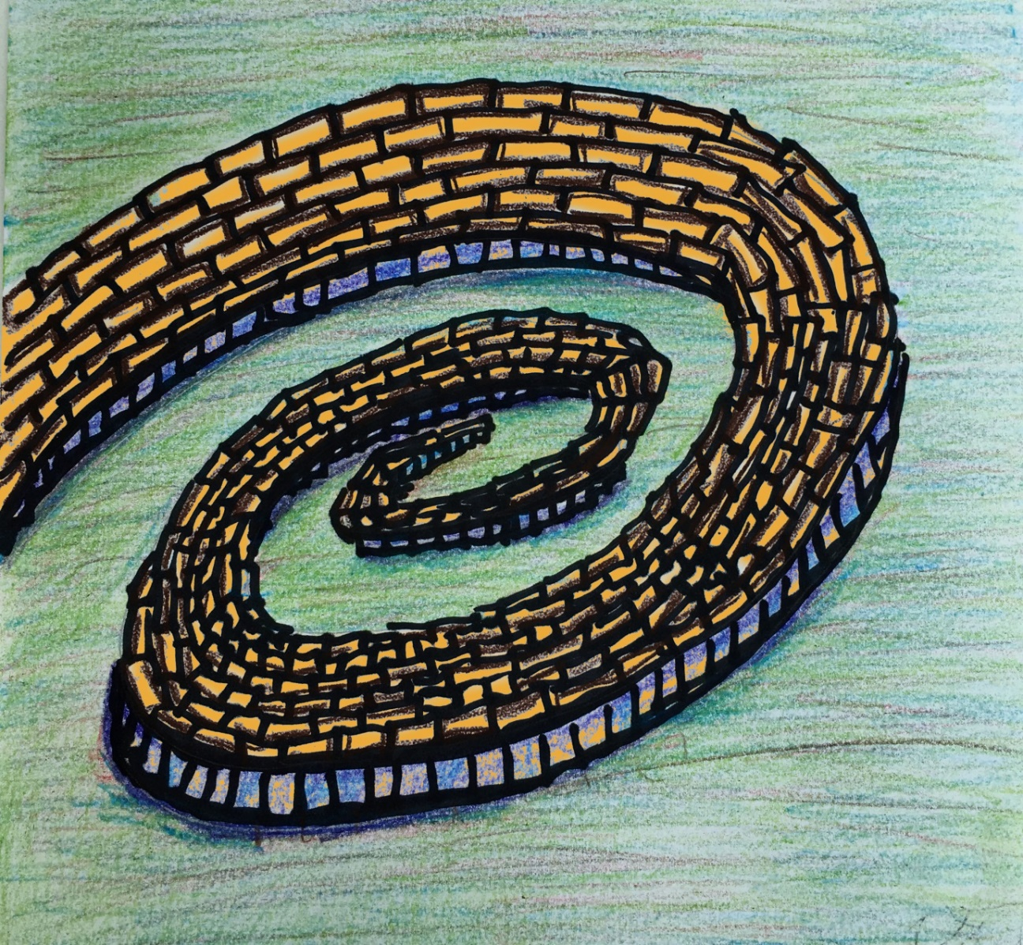
Figure 1. Beginning the Yellow Brick Road by the author (Smith, 2018)
Investigation of the YBR concept through creating a sketch, led to a realisation of an unacknowledged interest in the beginning of the YBR, as the drawing focused on the spiralling-out part of the road, where the main character begins her journey from the Munchkin town. Of course, it is not logical to physically build a road like this. Instead the representational choice indicates an analogy of beginning on a route toward achieving a desire. We do not always know how to begin moving toward the fulfilment of a desire, but when an intention has been formed—if we wish to return home, or be more courageous, or more intelligent, or kinder—we can start moving toward a goal and the path eventually straightens out. Besen (2003, p. 1) defines a core analogy for visual media as one that discovers ‘a correspondence between… a theme and a vehicle through which we will communicate that theme…the theme expresses the characteristics abstractly or figuratively while the vehicle expresses them physically or literally.’ Besen (2003, p. 1) observes that, ‘through analogy, the theme can now be expressed in the show me language of art’. We can understand the YBR’s wandering beginnings as a literal and physical device that shows the abstract theme of how we may start out moving toward our desires initially in roundabout ways, gaining direction and surety as we progress. Lauria (2017, p. 2) outlines the two classical approaches to understanding desire: the first sees desire as being a representation of that outcome as a perceived good; the second is that desire is essentially a motivational state, so that one may act in a way to obtain that outcome. Lauria (2017, p. 2) proposes that ‘the key to understanding desire is neither goodness nor motivation, but a deontic feature: norms of the “ought-to-be” type.’ His third proposal is that our ‘desires involve a specific way or manner of representing content: a deontic mode’. In this context, he might say that the Dorothy character takes advice to follow the YBR because she feels that she ‘ought-to-be’ back home in Kansas, likewise the scarecrow feels that he ‘ought-to-be’ more intelligent, and so on.
Ultimately in the story we see that the idea about following a predetermined path toward a destination was illusory, but nevertheless propelled the characters toward development and achievement of their desires, or a realisation that they possessed these attributes all along. This does not mean the analogical journey on the YBR was a wasted one, it was necessary to gain experience to realise their goals.
Bibliography
Baum, L.F., 1900. The Wonderful Wizard of Oz. George M. Hill Company, Chicago, New York.

Besen, E., 2003. Analogy and Animation: A Special Relationship: Part 1 — Show and Tell | Animation World Network. Animation World. Available at: https://www.awn.com/animationworld/analogy-and-animation-special-relationship-part-1-show-and-tell (Accessed: 15 October 2018).

Fleming, V., 1939. The Wizard of Oz. [Film]. Metro-Goldwyn-Mayer.

Lauria, F., 2017. The guise of the ought-to-be. A deontic view of the intentionality of desire, in: The Nature of Desire. Oxford University Press, New York.

Ritter, G. (1997). Silver Slippers and a Golden Cap: L. Frank Baum's The Wonderful Wizard of Oz and Historical Memory in American Politics. Journal of American Studies, 31(2), 171-202.

Smith, S. 2018. Beginning the Yellow Brick Road. [Coloured pencil on paper]. Available at: https://moodle.uwtsd.ac.uk/mod/resource/view.php?id=141471 (Accessed: 15 October 2018).

(NB. your bibliography should include all relevant research for this task. The bibliography will inform your reader/ marker of the breadth of your research. Check Harvard referencing: https://www.uwtsd.ac.uk/media/uwtsd-website/style-assets/content-assets/documents/library-and-learning-resources/Harvard-eng.PDF)

