MY SITE
Introduction
In this site, I will display my coffee shop commerce with the proposed title Impresso Espresso based in Bristol. Thereby this commerce presents the point of the proposed café as to endeavor and towards picking best conceivable endeavors to create the cafeteria into a place where the clients will have the opportunity to socialize with others in a really relaxing and comfortable environment, getting a charge out of the finest coffee in town.
This cafeteria is proposed to be built up keeping in intellect the improvement of such a place, where the individuals can visit to relieve them from the stresses or standard of living and to socialize with friends and cherished ones over a glass of coffee. This website primarily centers on the step by step planning required to construct up the café additionally incorporates portrayal on different operational viewpoints of the proposed company different items and administrations being given , different appealing pictures for creating an attractive and creative website.
Home Page
The first page of my website contains a gallery with three images with a variety of neutral colors and represents a major impact on my business success and can suit also my business promotions and services. In the picture gallery, I included an image with the main products of this coffee shop and also an image with a promotion fulfilling the customer's needs with a good quality product.
Our company is giving different sorts of rebates and offers to draw in clients. We ought to see after the strategy by which clients are exceedingly fulfilled. The company has got to make uniqueness over its products so that clients don't think almost the rival products. According to Peng (2017), a company has got to move forward the promoting methodology of the deals. This café should judge almost the distinctive buyer conduct to progress their technique of the trade and be able to total the match companies.
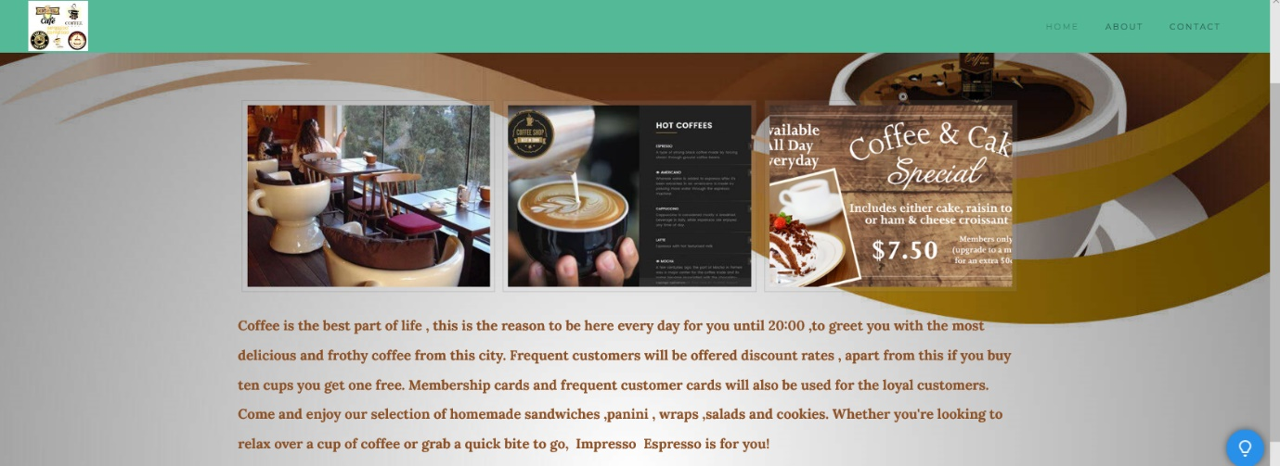

ABOUT
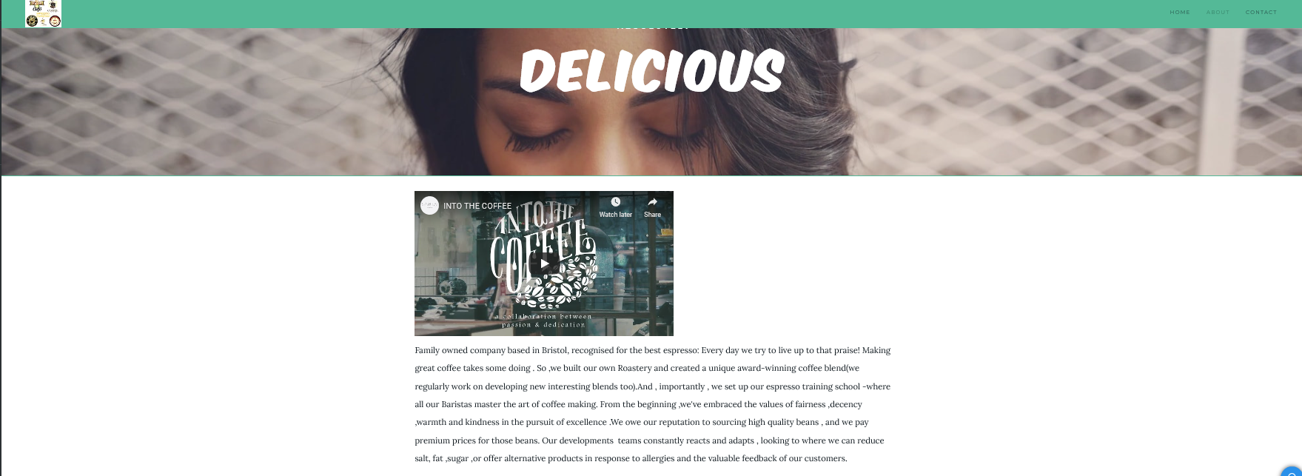
On this page, I used a variety of luxurious colors that emphasizes the quality and aroma of the coffee conducive to attract more customers.
Agreeing to Berner and Holmes (2014), food quality and taste must be the best lesson by which clients deliver company positive input. The quality of coffee and benefit empowers the clients to return to the café and involvement in the special service.
Together with quality eatables and refreshments,the clients would too be entitled to a comfortable and relaxed ambiance. This in turn will permit us to preserve the correct working and supportability of commerce.
The cafeteria is arranged in Bristol at a prime area on the banks of Harbourside with a grand see of the Waterway Avon. Next to shopping, numerous individuals visit the put to spend a few quality time with their close and expensive ones additionally appreciate the see.
The chosen location is very populated ,this creates a benefit for my business and will allow to maintain proper functioning and sustainability of the business.

References
Peng, S, 2017. Developing business plan for summer and winter schools for the Chinese market.
Berner, C. and Holmes, M.,2014. Successful Cooperative Ownership Transitions.
Log in details: 1908807@gmail.com
Password:dob25.11.91

