0


Career Development and Professional Practice Portfolio in Health and Social Care

Student ID:Rogers Nyanga
Institute:University Of Wales
Lecturer:Tsiwana Khomalo

Module: Changemakers: Building your Personal Brand for Sustainable Employment
Module code: BMHP5015
Component 1: Online portfolio
Date:09/03/2026

Table of Contents
Task 1: Personal Brand 2
Task 2 - Network Map and Rationale 3
Supporting Rationale 3
Task 3- Blog 5
Task 4- NHS Equality, Diversity and Inclusion Quiz 7
Task 5- A Letter to Yourself 9
Task 6- GANTT Chart 10
Explanation 11
Task 7- Making Changes- Report 12
Task 8- Self-Reflection 13
Reference List 14

Task 1: Personal Brand
My employment-related brand is based on my compassion, reliability, and professional motivation in the field of health and social care. I consider myself a person who appreciates empathy, professional ethics and lifelong learning. Personal branding is a concept applied in health and social care, wherein an individual can communicate a professional identity that aligns with their professional values, competencies, and career interests (Gorbatov, Khapova and Lysova, 2019). My goal is to establish myself as a practitioner who integrates evidence-based practice with emotional intelligence to provide high-quality care.
Nevertheless, I realise that my personal brand must be developed further. To make it more robust, I should improve my online presence, especially on professional platforms like LinkedIn, where my accomplishments, volunteer work, and academic advancement are mentioned and correlated with my career objectives. Empirical studies indicate that a competitive labour market is dominated by employability strategies such as strategic self-presentation and coherent messaging (Pandey et al., 2022). I will also take part in networking and get mentoring so that I can gain confidence and professional credibility. Personal brands can be optimised by focusing on my strengths and working to correct my weaknesses.

Task 2 - Network Map and Rationale
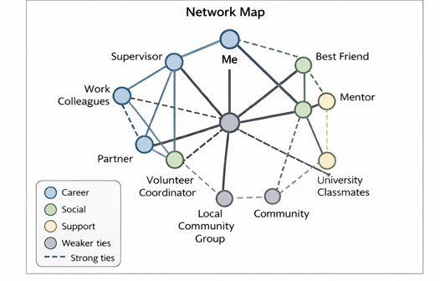
Figure 1: My network map

Supporting Rationale
My network can be characterised as selective since it is mainly comprised of close professional, social and supportive relationships which I ensure I uphold. Under the career dimension, I get associated with my supervisor, mentor and work colleagues who offer professional advice as well as workplace understanding. My social system comprises close family members and my partner, who provide emotional support. The social network that I have comprises friends and university classmates, and the community connections that I belong to are as a volunteer coordinator and a local community group.
Even though my network exhibits effective bonding social capital, which is characterised by close and trusting relationships, it is less effective in bridging and linking capital. Bonding capital makes emotional resiliency and sense of belonging stronger, and bridging capital, or ties to different groups, makes accessing new information and opportunities easier (Putnam, 2020). Linking capital includes relations with people in influential or powerful roles, which are significant when it comes to career advancement (Villalonga-Olives and Kawachi, 2017).
I should broaden my professional network by going to industry events, using online professional resources, and accessing senior leaders in the field of health and social care to improve. Increasing bridging and connecting capital will make me more diversified in terms of opportunities and increase my employability in the long term.

Task 3- Blog
Blog Title: Tackling NHS Waiting Times - What It Means to Patients in 2025
Target Audience: UK’s Adults who are awaiting NHS treatment.
You are not alone if you or someone you care about is waiting to receive NHS treatment. NHS waiting times are one of the largest challenges of the health and social care system of the UK in 2025. Millions of individuals are now on waiting lists for elective care, such as surgeries, appointments with specialists and diagnostic checks (Limiri, 2025).

Figure 2Millions of people are on waiting lists
Source: (Campbell & Duncan, 2021)
Why Are Waiting Times So Long?
These are some of the main reasons:
- Backlog after the pandemic - COVID-19 has affected regular services greatly.
- Workforce shortages- Staffing shortage is a persistent issue in nursing, GP and specialist work.
- Growing demand- The growing ageing of the population and the rise of long-term conditions indicate that more people will need care.
What Is Being Done?
The NHS has developed recovery plans that would minimise long waiting times, expand diagnostic centres and community-based services. In some locations, evening and weekend appointments are also being added. Nevertheless, the advancement differs by the location and the demand for the services.
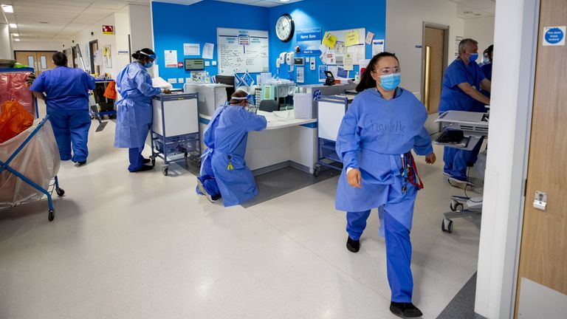
Figure 3: NHS Elective Recovery Plan
Source: (Morris, 2022)
What Can You Do as a Patient?
- Visit your GP regularly in case your condition deteriorates.
- Inquire about other providers in the NHS policy of the Right to Choose.
- Research community or voluntary sector support awaiting wellbeing.
Waiting may be frustrating and stressful, and knowledge of your choices will enable you to be an active participant in your care. In case you are not sure what to do further, call your GP practice or local NHS service to get some advice.

Figure 4: Consequences of NHS Waiting Times
Source: (Katie, 2025)
You have a right to timely, safe and effective care, and being informed is a way to help you advocate on your behalf and on behalf of other patients.

Task 4- NHS Equality, Diversity and Inclusion Quiz
1. What is the primary goal of the NHS Equality, Diversity, and Inclusion Improvement Plan?
The primary aim is to achieve a fair, inclusive, compassionate NHS workforce where all employees feel valued and respected and have equal chances to develop, eventually leading to patient care and inequality reduction.
2. How does the NHS EDI Improvement Plan propose to tackle the gender pay gap?
The plan suggests open pay reporting, fair procedures during recruitment and promotions, as well as specific leadership development programmes so that women can have equal opportunities to senior positions.
3. What is meant by the term ‘intersectionality’ as used in the NHS EDI Improvement Plan?
Intersectionality describes the ways various characteristics of protection like race, gender and disability interact and overlap, so that a person may experience combined forms of discrimination or disadvantage.
4. Why is it important for the NHS to create a psychologically safe work environment?
The psychological safety environment helps staff to raise their concerns, errors or discrimination without the fear of reproach, enhances wellbeing, learning and patient safety.
5. How does the NHS EDI Improvement Plan suggest improving the experience of internationally recruited staff?
It encourages formal orientation, pastoral care, career growth prospects, and non-tolerance of discrimination to make international employees feel that they are welcome and supported.
6. What role does leadership play in advancing EDI objectives according to the NHS Improvement Plan?
Leaders are supposed to be exemplary of inclusive behaviours and are accountable for EDI performance and take a lead to fight discrimination within their organisations.
7. Identify one way the NHS EDI Improvement Plan aims to reduce health inequalities within the workforce.
The plan will be used to eliminate inequalities by increasing the representation of underrepresented groups in senior positions and providing equal access to training and development.
8. Why does the NHS EDI Improvement Plan emphasise the importance of collecting and analysing data on protected characteristics?
Gathering information helps the NHS to find the gaps, track the progress and introduce evidence-powered interventions to mitigate the inequalities.
9. Explain how flexible working policies can contribute to equality and inclusion in the NHS workforce.
Flexible working helps employees who have caring needs, disabilities or health issues to mitigate employment and career advancement barriers.
10. What is one strategy mentioned in the NHS EDI Improvement Plan to combat bullying and harassment in the workplace?
Enhancement of Freedom to Speak Up procedures, and the introduction of effective reporting systems with strong measures taken against unfit behaviour are one of the strategies.

Task 5- A Letter to Yourself
Dear Younger Me,
I understand that this period is overwhelming. You are juggling between studies, duties and personal issues, and it seems you are continually failing. Your health is poor, and you are not entirely aware of why. You believe that being strong is doing everything on your own. I would like you to know that it does not.
What I now know about emotional intelligence would have been of great help to you at that time. Being emotionally intelligent means being aware of what you are feeling without being judgmental of yourself. You might have stopped and questioned yourself, why do I feel like this, instead of ignoring stress and frustration. Self-knowledge would have made you realise your boundaries. Instead of suppressing your emotions, you could have managed them, which would have stopped burning out.
I also realised that resilience does not mean that one never struggles. It is concerning adjusting, seeking assistance and not giving up. Asking to be helped was considered a sign of weakness at the time. I now know that it is a strength. Resilience building entails creating coping mechanisms, managing expectations and being ready to face failures as part of development.
If I could guide you, I would tell you to be kinder to yourself. Speak to yourself the way you comfort a friend. Reach out. Rest when you need to. Growth takes time.
You are better than you think, and what you are going through is making you a stronger person, more understanding and better equipped to face the future.
With understanding,
Me

Task 6- GANTT Chart
Timeline Key:
1. Colours = Task Duration
2. Done = Milestone
Tasks / Activities | 2024 Q1 | 2024 Q2 | 2024 Q3 | 2024 Q4 | 2025 Q1 | 2025 Q2 | 2025 Q3 | 2025 Q4 | 2026 Q1 | 2026 Q2
Complete Level 5 Coursework
Level 5 Completed |  |  |  | Done
Complete Level 6 Coursework
Level 6 Completed |  |  |  |  |  |  |  | Done
CPD Workshops / NHS Seminars
Volunteer / Placement
Extended Work Experience
Develop CV & LinkedIn
Request References
Apply for Roles
Interview Preparation
Secure Employment |  |  |  |  |  |  |  |  |  | Done
Key Dependencies:
- Level 6 coursework depends on successful completion of Level 5.
- Extended work experience depends on Level 6 progression.
- Job applications depend on completion of Level 6 and CV preparation.
- Securing employment depends on successful applications and interviews.

Explanation
The Gantt chart built on my career development illustrates a clear sequence of actions between January 2024 and April 2026, detailing my path to the accomplishment of my objective to get a job in the health and social care sector. The initial stage is concerned with academic completion. Level 5 coursework is offered between January and December 2024, then Level 6 between January and December 2025. The first dependency is that Level 5 is a requirement before proceeding to Level 6. My professional knowledge will be reinforced with the help of CPD workshops and NHS-related seminars from April 2024 to November 2025 to accompany my studies. Voluntary placement practice will be done between June and December 2024, and more extended work experience will be done between July and December 2025, subject to Level 6 progression. The last stage is based on job preparation. My CV will be made in December 2025, my LinkedIn profile will be updated, and I will ask people to give me references. The job applications will be received in January-February 2026, and then the interview preparation will be carried out. The last goal is to obtain a health and social care job in April 2026. This is a well-thought-out plan that provides realistic progress, definite deadlines, and correlation of academic success and career employment.

Task 7- Making Changes- Report
‌Change Proposals: A Digital Care Planning System.
As a manager of a care home, I suggest the implementation of a digital care planning and record-keeping system to substitute paper-based documentation. This transformation should help to enhance accuracy, good communication among staff, and safer and person-centred care. Digital systems are able to minimise errors and enhance audit procedures as well as facilitate regulatory compliance.
In order to successfully implement this change, I would use the Eight-Step Change Model of Kotter (1996). To begin with, I would instil a sense of urgency by showing evidence of documentation errors and inefficiencies. I would then create a guiding coalition team together with the senior carers and IT support to spearhead the change. The staff would be informed of a clear vision, which would include benefits to residents and workload management. The staff would be empowered to use the system through training, and brief wins would be shared to create momentum. Lastly, the change would be incorporated into everyday practice and policy.
Major abilities needed are emotional intelligence, communication, leadership and risk management. The key trait to listen to the staff concerns is emotional intelligence, and transparency during the process is guaranteed by clear communication (Coronado-Maldonado and Benitez-Marcquez, 2023).
The obstacles may be resistance to change, technology and financial fear. As per Force Field Analysis, restraining forces like staff resistance should be minimised through offering training, reassurance, and continued support (Dominic, 2024). The change can be implemented and maintained successfully through reinforcing driving forces and mitigating concerns at an early stage.

Task 8- Self-Reflection
Gibbs Reflective Cycle (1988) has been used to organise this reflection in the form of description, feelings, evaluation, analysis, conclusion and action plan.
Over the course of this module, I have gained a better idea of myself, especially in relation to emotional intelligence, resilience and professional identity. At first (description), I concentrated much on doing and getting things done (meeting deadlines). Nevertheless, I realised that I frequently underestimated the role of self-reflection and self-awareness in career development (feelings).
Assessing the progress, I can note that such activities as the task on personal brand and network mapping allowed me to realise not only my strong aspects but also areas of my professional growth. I found that I am goal-centred and organised, but not always confident in networking and self-promotion. Further analysis reveals that the improvement of emotional intelligence, specifically self-awareness and self-regulation, has enhanced my ability to respond to stress and feedback. This has been emphasised especially in health and social care, where empathy and communication are crucial.
To sum up, this module has not only enhanced my ability to reflect but also emphasised the need for life-long professional growth. I have now understood that resilience is developed by being flexible and learning when things go wrong instead of shunning the challenges.
My plan of action is to further practice reflectively in placements and during my employment, I will actively pursue feedback and widen my professional network. In my future health and social care practice, I can secure personal and professional development by using the Gibbs model frequently.

Reference List
Gorbatov, S., Khapova, S. N., & Lysova, E. I. (2019). Get noticed to get ahead: The impact of personal branding on career success. Frontiers in psychology, 10, 495947.
Putnam, R.D., 2020. The upswing: How America came together a century ago and how we can do it again. Simon and Schuster.
Villalonga-Olives, E. and Kawachi, I., 2017. The dark side of social capital: A systematic review of the negative health effects of social capital. Social Science & Medicine, 194, pp.105-127.
Gibbs, G., 1988. Learning by doing: A guide to teaching and learning methods. Further Education Unit.
Limiri, D. M. (2025). The impact of long wait times on patient health outcomes: the growing NHS crisis. Prem J Public Health, 3, 100020.
Kotter, J. (1996). John Kotter’s Eight-Step Change Model. https://portal.ct.gov/-/media/SDE/Turnaround/School-Improvement-Resources/Kotters_model.pdf
Dominic, A. (2024). Figure 4. Lewin’s (1951) forcefield analysis. Adapted from The theory... ResearchGate. https://www.researchgate.net/figure/Lewins-1951-forcefield-analysis-Adapted-from-The-theory-and-practice-of-change_fig4_358571831
Coronado-Maldonado, I., & Benítez-Márquez, M.-D. (2023). Emotional intelligence, leadership, and work teams: A hybrid literature review. Heliyon, 9(10), e20356. https://doi.org/10.1016/j.heliyon.2023.e20356
Campbell, D., & Duncan, P. (2021, December 9). Almost 6 million people are on waiting lists for hospital treatment in England. The Guardian; The Guardian. https://www.theguardian.com/society/2021/dec/09/almost-6-million-people-on-waiting-lists-for-nhs-surgery-in-england
Morris, S. (2022, February 8). NHS Elective Recovery Plan: Government unveils proposal to tackle record NHS waiting lists in England. Sky News; Sky. https://news.sky.com/story/nhs-elective-recovery-plan-government-unveils-proposal-to-tackle-record-nhs-waiting-lists-in-england-12536073
Pandey, V. K., Shukla, R., & Pandey, S. (2022, June 2). The Importance of Presentation Skills for Employability. https://www.researchgate.net/publication/361024780_The_Importance_of_Presentation_Skills_for_Employability
Katie. (2025, April 15). Understanding the Consequences of NHS Waiting Times. Stopwaiting.co.uk; StopWaiting. https://blog.stopwaiting.co.uk/nhs-waiting-times-consequences/

