

Knowledge and Information Management Skills for the Workplace
Submitted by
Student Name: SHAHZAD KHAN
Student ID:1604638

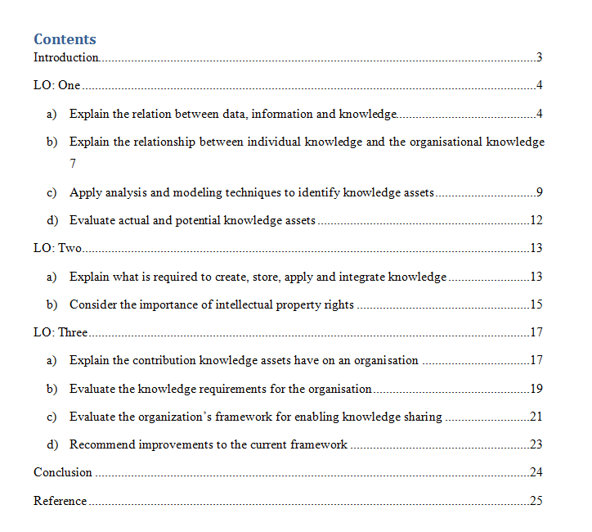

Introduction
Proper management of knowledge is essential for the organisations to make decisions. Being a customer-oriented organisation, John Lewis needs to ensure proper management of the knowledge through proper management processes. The knowledge management can work as key competitive advantages for the organisation as proper management ensure proper customer services. There are significant differences between data and knowledge. Data is associated with information and the information assists in gaining knowledge. Therefore, with proper knowledge making decisions become easier. Thus, data can be called as the core of knowledge. This is why John Lewis will process the data that the organisation will be able to have the meaningful information. The data will be turn into the meaningful information though processing the data. Now it is essential for the organisation to get the understanding about the meaning of the information to grow the knowledge
Definition of Data
Data is considered as the statistic or fact that is raw. The facts or data is obtained though considering different research or though doing the observation. Data that could be the series of number or that could be the series of symbol or that could be the series of words. Data do not have the value or it could have the little value as data is considered as the raw facts (Madura, 2018). Data will be able to have the value after processing data. Data will be turn into the information after processing the data. John Lewis will collect the data though considering the research and then will process the data that the organisation could turn into the information. The collected data will not be able to have any value and it will not help the organisation in the decision making process. That is why for collecting information and making efficient decisions, John Lewis needs data.
For Example: John Lewis collects information through different sources. The organisation can conduct market survey to obtain information regarding customers and their satisfactions. Besides, customer data base can also be a good medium to collect information. The organisation uses these obtained data to improve customer satisfactions through implementing more customer oriented tasks.
Definition of Information
Information is developed after processing the data. The duty of the information is to grow the knowledge of the individual on different things. Data is not meaningful but after processing the data information is developed and then the information provides the meaningful knowledge to the individual. (Meiners, Ringleb and Edwards, 2018). Thus, the organisation will be capable to develop knowledge about the competition of the market and customer demands.
For Example: the organisation and its management is able to know though processing the data into information that the 70% customers of UK love to get the service of the organisation though the online market (Meiners, Ringleb and Edwards, 2018). To improve the online services, these information are essential. The organisation needs to make sure that proper blending of existing customer satisfaction rate and the online customer satisfaction rates is happening, in order to come up with solid online customer services.
Definition of Knowledge
Knowledge is considered as the understanding on different things that the individual will have though the information. The duty of knowledge is to provide the clear understanding about the information though the information. The understanding on the information will help the individual to grow the knowledge. The information about the competitors will provide the understanding to John Lewis about the level of competition at the market. John Lewis will be able to grow the knowledge about the level of competition though the information and then can take required decision to get the competitive advantage.
For Example: Knowledge always give competitive advantages. However, knowledge come from data and information. That is why the management of John Lewis needs to make sure that proper and effective information and data are obtained, and thus proper knowledge about customer demands and satisfaction can be obtained. This is how, the organisation can easily make efficient and effective decisions for the customers.
Finding the Correlation between Knowledge, Information & Data
There are significant differences between data and knowledge. Data is associated with information and the information assists in gaining knowledge. Therefore, with proper knowledge making decisions become easier. Thus, data can be called as the core of knowledge. This is how these three terms are different from each other but the three terms are connected with each other. The three terms has the dependency on each other. Data is collected though the research and then data is processed that the information could be developed (Bratton and Gold, 2017). Finally, the understanding on the meaning of the information helps to grow the knowledge. This provides the clear idea the information will not be developed if the data will not be processed. The individual will not be able to grow the knowledge without having the understating on the meaning of the information. This is how the three terms are connected and dependent on each other.
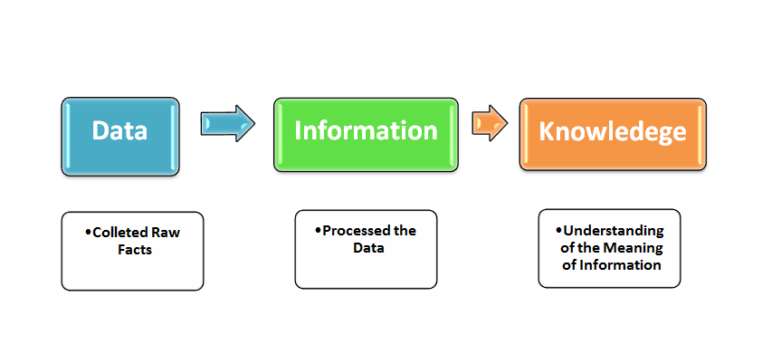
Figure 1: Relationship between Data, Information & Knowledge
Source: (Bratton and Gold, 2017)
John Lewis needs to have proper knowledge about the expectations of the customers to increase the number of the customers and to grow the business of the organisation. This is why John Lewis considered a survey at the market and the survey collected the data from the customers. The collected data are the raw facts and this collected data do not have the meaning. This is why John Lewis will process the data that the organisation will be able to have the meaningful information. The data will be turn into the meaningful information though processing the data. Now it is essential for the organisation to get the understanding about the meaning of the information to grow the knowledge (Bratton and Gold, 2017).

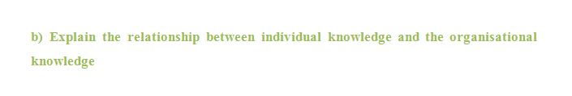
Explanation of Individual Knowledge
Individual knowledge indicates different facts that the individual is able to gain though doing the observation on different things or though the experience of the individual. The information that will grow the knowledge of the individual on which the individual will have the belief and the individual will consider that as the right or appropriate information. The individual consider the simple technique to gain the knowledge from the experience or from the observation (Rajaraman, 2018). The knowledge of the individual is not gained in an organized way. Both tacit and explicit can be the knowledge of the individual. Tacit and explicit are considered as the type of knowledge that the individual will have.
Tacit Individual Knowledge: The knowledge that will exist in the individual but the individual will not be able to express that. The tacit knowledge is not able to write or express in any ways. As like, the belief of the individual will be the tacit knowledge. The individual is able to have the belief though the experience or though doing observation. The belief will exist in the individual but the individual will not be able to express it.
Explicit Individual Knowledge: This is the knowledge that the individual will be able to express though writing or though different other ways. The individual will be able to share the knowledge with others. As like, the individual knows that London is the capital city of England. This gives an individual the capabilities of writing and sharing the knowledge with other individuals.
Explanation of Organisational Knowledge
Organisational knowledge is considered as the assets of the organisation that the organisation will provide to the employees to get the clear understating about the job roles and about the goals of the organisation (Tryon, 2016). Organisational knowledge is essential among the employees in order to understand the organisation situations. The employees of the organisation needs to understand how the organisational processes are being carried out. Besides, to ensure customer satisfactions, having proper organisational knowledge is essential for the employees. It is to note that both the tacit and explicit knowledge play crucial role in decision making and problem solving skills of the employees.
Relationship between Organisational and the Individual Knowledge
The individual is able to grow the knowledge though the experience and the observation. The individual is not able to get the knowledge in an organized way but the employee is able to get the organisational knowledge in an organized way. This expresses the differences between bot the knowledge. Both the knowledge has many differences but both the knowledge have the relation between them. In the case of John Lewis, individual knowledge of the employees always come handy in serving the customers (Cordes-Berszinn, 2014). Any store manager needs to have proper information related to customer demands and satisfaction. These information will help the store manager to organise and decorate the store-shelves accordingly. Therefore, the manager can ensure availability of customer demanded-products. Besides, the manager also needs to develop customer insights as part of his individual knowledge. Customer insights will help the manager understand the future trends and demands of the customers.
Knowledge Assets
In the organisational context knowledge assets indicates the resources though which the employee will be able to gather or gain the knowledge. Knowledge assets are considered as the drivers of the knowledge that performs to ensure the success of the organisation. The policies of John Lewis are the knowledge assets of the organisation. The guidelines, organisational documents and the database are also considered as the knowledge assets of the organisation (Erickson, 2014). Except this the information about different stakeholders of John Lewis is considered as the knowledge assets of the organisation. These will help the employees in developing the explicit knowledge. The employees of John Lewis will get the experience during the time of performing at the workplace of the organisation. The experience is also considered as the knowledge assets. This will allow the employees to have the tacit knowledge. John Lewis will be able to do the effective management of knowledge though the contribution of the knowledge assets. This is how the knowledge management will help John Lewis in doing the effective management of the knowledge. In addition, the knowledge assets will help John Lewis to have the improvement in the organisational performance and will help John Lewis in managing the value of knowledge.
Knowledge Assets Identification Techniques & Models
As per Nonaka and Takeuchi Model, an organisation can divide the knowledge assets into four different variations, which are being discussed below:
Experiential Knowledge Assets: The employees of John Lewis will have different experience during the time of performing in the workplace of the organisation (Nguyen, 2013). The experiences will help the employees to grow the knowledge. This is why the knowledge that the employees are able to gain though experience is considered as this. This will grow the tacit knowledge in the employees. The employees are able to share the knowledge with others. Conceptual Knowledge Assets: The knowledge about the product, about the design of product and about the brand equity is considered as the conceptual knowledge assets. This will allow the employees to get the explicit knowledge. This is why the knowledge is able to express though writing or though different other ways. The knowledge assets will allow the employees to have the effective and the required information about the products of John Lewis (Nguyen, 2013). The knowledge will help the employees in ensuring different effectiveness in the performance of the employees.
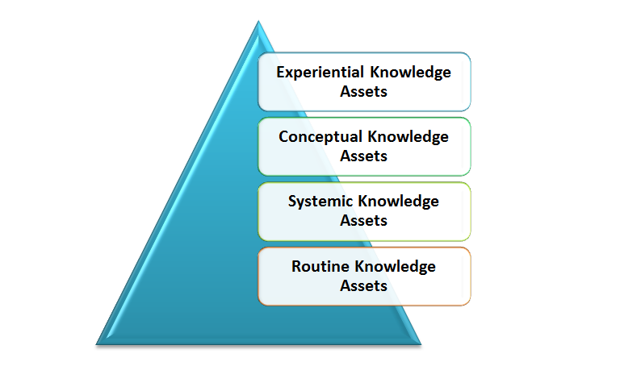
Figure 2: Knowledge Asset Model
Source: (Buckley and Jakovljevic, 2013)
Systemic Knowledge Assets: The organisational documents, database and manuals of John Lewis are considered as the systemic knowledge assets of the organisation. This will allow the employees to get the explicit knowledge. The employees of John Lewis will be able to deal the suppliers and the customers of the organisation successfully though using the knowledge.
Routine Knowledge Assets: The culture of John Lewis and the daily organisational activities of John Lewis are considered as the routine knowledge assets. This is considered as the tacit knowledge. This knowledge will help the employees to get the understanding about the organisational culture (Buckley and Jakovljevic, 2013). The knowledge will allow the employees to adopt the working environment in well manner. The daily activities will provide the knowledge about the routine of the working. The knowledge will help the employees to have the development in the performance and to ensure the development in the organisational performance.


Proper management of knowledge is essential for the organisations to make decisions. Being a customer-oriented organisation, John Lewis needs to ensure proper management of the knowledge through proper management processes. The knowledge management can work as key competitive advantages for the organisation as proper management ensure proper customer services (Buckley and Jakovljevic, 2013). Tacit actual and the potential knowledge assets will help John Lewis in doing the knowledge transfer process in the organisation. In addition, explicit actual and potential knowledge assets will also contribute to do the knowledge transfer process effectively.
The experiences of the employees and the skills of the employees are considered as the tacit actual and the potential knowledge. The employees will be able to share tacit actual and the potential knowledge in the organisation with the other employees. (Tryon, 2016). This will allow the organisation to get the competitive advantage. The organisation also will be able to do the knowledge management process in an organized way. This is why the organisation will be able to get different effectiveness in well manner.
The employees of John Lewis will get the experience during the time of performing at the workplace of the organisation. The experience is also considered as the knowledge assets. This will allow the employees to have the tacit knowledge. John Lewis will be able to do the effective management of knowledge though the contribution of the knowledge assets. This is how the knowledge management will help John Lewis in doing the effective management of the knowledge. In addition, the knowledge assets will help John Lewis to have the improvement in the organisational performance and will help John Lewis in managing the value of knowledge.

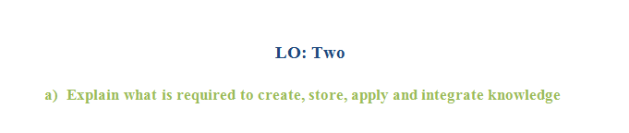 In the case of John Lewis, effective knowledge management by the employees always come handy in serving the customers. The managers need to have proper information related to customer demands and satisfaction. These information will help the managers to organise and decorate the store-shelves accordingly. Therefore, the manager can ensure availability of customer demanded-products. Besides, the manager also needs to develop customer insights as part of his effective knowledge experiences. Customer insights will help the manager understand the future trends and demands of the customers. (Goswami and Kumar, 2013). The employees of John Lewis will get the experience during the time of performing at the workplace of the organisation. The experience is also considered as the knowledge assets. This will allow the employees to have the tacit knowledge. John Lewis will be able to do the effective management of knowledge though the contribution of the knowledge assets. This is how the knowledge management will help John Lewis in doing the effective management of the knowledge. In addition, the knowledge assets will help John Lewis to have the improvement in the organisational performance and will help John Lewis in managing the value of knowledge.
Technology
Technology will help John Lewis to create the knowledge in well manner. Internet technology will collect different data and through processing the data information will be developed. This is how the knowledge will create though the information. This is how technology will contribute in creating the knowledge in well manner. Technology is required for the organisation to store the knowledge effectively and safely. John Lewis will be able to store the knowledge at the database of the organisation effectively though technology. In addition, technology plays the vital role to integrate the knowledge. This is why in creating and storing the knowledge technology is considered as the major requirement. Technology is also essential to integrate the knowledge in well manner.
People
People are considered as the important requirement for John Lewis as the people will contribute to create the knowledge, to share the knowledge and to apply the knowledge (Rajaraman, 2018). The people will contribute to get the understanding about the behavior and the culture of the employees. The understanding will allow the people to create the knowledge of providing motivation to the employees. This is how people will contribute in creating the knowledge. The created knowledge will be applied by the people. The people will use the knowledge to motivate the employees of the organisation. This is why people are considered as the important requirement for creating and applying the knowledge.
Process
Both the people and technology need to consider a process to create the knowledge, to store the knowledge, to apply the knowledge and to integrate knowledge. The technology will consider the process to turn the data into information and the technology could create the knowledge. The people will consider the process in getting the understating about the culture and the behavior of the employees and to create knowledge on motivating the employees (Peel, 2012). To store the knowledge in the database it is essential for technology to consider a process. The people need to apply the knowledge though considering a process. In addition, to do the effective management of knowledge it is essential for John Lewis to use or apply a process. This is why process is considered as the essential requirement for creating the knowledge. In addition, the process is required to store and apply the knowledge in well manner.

Intellectual Property
The intangible right of different ideas of the organisation is indicated by the intellectual property. Different organisation develops different innovative ideas and to secure the idea of the organisation intellectual property play the important role. As like, the logo of the organisation and the design of the organisation is secured by the term. In securing the intellectual property the copyright is developed and though the copyright the organisation is able to get the security of different ideas and other intangible elements (Griffin, Ying and Nair, 2013). This is why the third party will not be able use the idea of the organisation.
Importance of Intellectual Property Rights
- The name of the organisation is secured by the rights and this is why except John Lewis no other organisation is able to run the business with the same name.
- The logo of John Lewis is get secured though the IP rights and this is why no other organisation has the access of using the logo of John Lewis.
- The unique knowledge management system of John Lewis is secured by the IP rights and only John Lewis can use the system to do the knowledge management (Griffin, Ying and Nair, 2013).
- John Lewis consider the own model in running the business and the model is secured by IP rights. This is why other organisations will not be able to use the model in running the organisation.
- The intellectual property of John Lewis is get secured though the IP rights.
Intellectual property has different limitations also and these are highlighted below.
- Overridden is considered as the main limitation of the term. As like, John Lewis is the name of the organisation and that is secured by the term. But if any other organisation consider the overridden and use “The John Lewis” as the name of the organisation then the term will not be able to ensure the security. This is why the customers can get confused and the organisation will have to face the negative impact in the business.
- According to the term the other organisation will not be able to copy the design of the products of John Lewis. But the organisations have the right of producing same product in different design (Lester, 2013). This is why the organisation will be able to keep the design innovative and cannot keep the product innovative.
In the above discussion different importance of intellectual property rights are highlighted. The term performs to ensure different rights of the organisation but the term has different limitations also. The organisation has to face different barriers as for the limitations of the term.

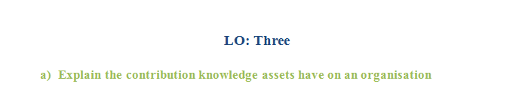 The employees of John Lewis will get the experience during the time of performing at the workplace of the organisation. The experience is also considered as the knowledge assets. This will allow the employees to have the tacit knowledge. John Lewis will be able to do the effective management of knowledge though the contribution of the knowledge assets. This is how the knowledge management will help John Lewis in doing the effective management of the knowledge. Contributions of knowledge assets in John Lewis is discussed below:
Improve Process Quality
John Lewis needs to consider a process to run and to operate the business. The process will help John Lewis to operate in structured way and to complete different organisational tasks successfully. Knowledge assets will contribute to improve the process of John Lewis (Haider and Shah, 2014). Being a customer-oriented organisation, John Lewis needs to ensure proper management of the knowledge through proper management processes. The knowledge management can work as key competitive advantages for the organisation as proper management ensure proper customer services
Contribute in the Business Performance
Knowledge assets are always helpful in improving business performances. In the case of John Lewis, effective knowledge management by the employees always come handy in serving the customers. The managers need to have proper information related to customer demands and satisfaction. This information will help the managers to organise and decorate the store-shelves accordingly. Therefore, the manager can ensure availability of customer demanded-products. Besides, the manager also needs to develop customer insights as part of his effective knowledge experiences. Customer insights will help the manager understand the future trends and demands of the customers.
Improve the Online Service Design
To improve the online services, this information are essential. The organisation needs to make sure that proper blending of existing customer satisfaction rate and the online customer satisfaction rates is happening, in order to come up with solid online customer services. Knowledge always give competitive advantages. However, knowledge come from data and information. That is why the management of John Lewis needs to make sure that proper and effective information and data are obtained, and thus proper knowledge about customer demands and satisfaction can be obtained (Portny, 2017).
Contribution in Retaining Customers and Increasing Customers
Knowledge assets are always beneficial for retaining customers and increasing customers. Proper management of knowledge ensures customer satisfactions. As a result, the old customer become loyal to the organisation and thus customer retention becomes easier for John Lewis. Similarly, the word-of-mouth of the old customers lead to arrival of new customers. Thus, knowledge management ensure increase in new customers.
Contribute to Customer Relationship
Customer relationship is an essential task for the organisations. Knowledge asset management helps organisations like John Lewis to ensure customer relationship management and development. The management process always comes up with customer data. The organisation can then organise these data to develop more customer centric approaches. As a result, customer satisfaction are ensured and the customer relationship is built up.
The abilities of the employees, the experience of the employees and the skills of the employees in combine considered as knowledge. This is why the organisation will be able to get the effective performance from the employees though ensuring the knowledge. As for this reason in the organisational context knowledge is crucial for the development of the organisation. The employees of John Lewis required different knowledge to grow the business of the organisation. The requirement of the knowledge are identified and explained in the below discussion.
Skills
The skills of the employees are considered as the tacit knowledge of the employees. The skills are the major requirement for the development of the organisation. The skills will help the employees to complete different organisational tasks successfully. The organisation will be able to make successful different projects and the operations of the organisation (Dennis, 2014). The organisation will be able to overcome different barriers though the problem solving skills. The communication skills will allow John Lewis to develop the effective communication channel. In addition, the team goal will be achieved though the leadership skills. Except this different other skills will increase the performance of the employees and as for this the productivity of the organisation will also increase. The employees are able to share the skills and this is how John Lewis will be able to increase the number of skilled employees. This is how this knowledge will ensure different effectiveness for John Lewis. As for this reason, the knowledge in considered as the major requirement for John Lewis.
Technological Knowledge
The technological knowledge is essential for John Lewis to do different administrative work of the organisation. In modern days the technologies are used in different administrative work to get the efficiency and to get the accuracy in the work (Hobbs, 2012). This is why to do the proper use of technology the organisation needs to have the technological knowledge. Except this John Lewis provide the online service as for this to maintain the online store the organisation need to grow the technological knowledge in well manner.
Documents
The knowledge on documentation is the essential requirement for John Lewis. This knowledge will allow John Lewis to keep the record of different business transactions of the organisation. John Lewis will be able to notify about different plan and strategies to the employees and the management though considering the internal documentation process (Rajaraman, 2018). On the other hand the organisation will be able to maintain the effective communication with the suppliers and the customers though the external documentation process. This is why the documentation knowledge is considered as the essential requirement for the organisation.
Database
In the database of John Lewis different organisational information is stored. In doing different organisational tasks the organisation needs to have different information. The organisation will be able to get the required information though accessing the database. The organisation needs to have the proper knowledge on the database to access the information in well manner. This is why the database knowledge is essential for John Lewis.
Products Concept
The knowledge on the products is considered as the explicit knowledge. The knowledge is able to express though writing or different other ways. The proper knowledge on the products is essential for John Lewis as this will allow the organisation to identify the quality and the lacking of the products (Russ, 2017). The organisation will be able to ensure the quality and the good product though using the knowledge. This is how John Lewis will be able to attract the customers and will get the chance of growing the business. This is why the proper knowledge on the product is required for the organisation.

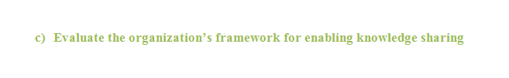To get the development in the organisational performance and to achieve different successes it is essential for John Lewis to have the productive performance from the employees. The knowledge will allow the employees to ensure the productive performance (Hobbs, 2012). This is why it is required to share the knowledge between the employees in well manner. To share the knowledge in an organized way the organisation need to consider a framework. The knowledge sharing framework of John Lewis is highlighted and explained in the below discussion.
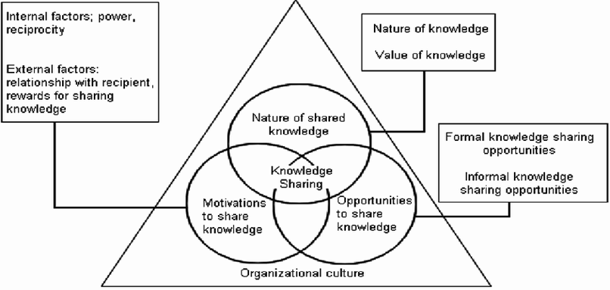
Figure 3: Knowledge Sharing Framework
Source: (Hobbs, 2012)
Nature of Knowledge Share
Nature of knowledge share framework is considered by John Lewis to share the knowledge in well manner. The tacit and the explicit knowledge are shared though considering the framework. Concept about the products, documentation knowledge, policies of John Lewis and manuals are the explicit knowledge that shared though considering the process. The skills and the experience are the tacit knowledge that also shared though considering the process of knowledge share (Russ, 2017). The employees are able to have the development in the performance though sharing the knowledge.
Opportunities for Knowledge Share
John Lewis creates different formal and the informal opportunities as the framework to share the knowledge in well manner. The employees are able to get the informal knowledge from the other employees to have the development in the performance and to complete different organisational tasks. The formal knowledge is shared by the organisation and in the formal knowledge the organisation provides the idea about goal of the organisation and about the responsibilities of the employees. In addition, the organisation shares the formal knowledge about the customers and the suppliers that through having the knowledge the employees can ensure the effectiveness for the organisation.
Motivation for Knowledge Share
John Lewis considers the internal and the external motivation as the framework that the knowledge will be shared in well manner. The employees share the knowledge with each other that the employees will be able to get the mutual benefits (Russ, 2017). This is considered as the internal motivation. The external motivation is provided by the organisation. The organisation offer different rewards and this motivate the employees to share the knowledge. This is how though considering the framework John Lewis is able to complete the process of sharing the knowledge in an organized way.


It is essential for John Lewis to have the development in the framework of the knowledge sharing. This will allow the organisation to get the effectiveness in the knowledge sharing process. The recommendations for the improvement in the knowledge sharing framework of John Lewis are provided below.
- John Lewis does not consider the technology in the process of knowledge sharing. The technology will help the organisation to share the knowledge effectively. In addition, the organisation will be able to share the knowledge in an organized way. This is why John Lewis needs to consider the technology in the knowledge sharing process of the organisation.
- The management should encourage employees on individual knowledge development. This is why the employees will get motivated in sharing the knowledge. This is why John Lewis needs to provide the consumptions to motivate the employees and to ensure the effectiveness in the knowledge sharing process of the organisation.
- It is essential for John Lewis to consider the structural dimension in the knowledge sharing process of the organisation. This will help the organisation to identify different opportunities of knowledge sharing in well manner. This is the organisation need to consider the structural dimension in the knowledge sharing process.
- John Lewis needs to avoid the organisational structure from the process of knowledge sharing. This is how the organisation will be able to avoid the complexity from the process of knowledge sharing. It will help the organisation to get different effectiveness and to complete the knowledge sharing process in an organized way.

Conclusion
Knowledge assets will allow the organisation to get the resources though which the employees will be able to get different knowledge. The knowledge will contribute to enhance the employees and the organisational performance. This is why the organisation needs to do the effective knowledge management process. The effective knowledge management process will help to provide the required knowledge and to share the knowledge between the employees in well manner. The organisation will be able to complete different organisational tasks successfully though doing the knowledge management process. In addition, the organisation will be able to increase the number of skilled employees at the workplace though doing the knowledge management process.

Reference
Bratton, J. and Gold, J. (2017). Human resource management. London: Palgrave Macmillan.
Buckley, S. and Jakovljevic, M. (2013). Knowledge management innovations for interdisciplinary education. Hershey, PA: Information Science Reference.
Cordes-Berszinn, P. (2014). Dynamic capabilities. [Place of publication not identified]: Palgrave Macmillan.
Dennis, M. (2014). The essentials of project management. Burlington: Ashgate Publishing
Erickson, G. (2014). Intelligence in action. [Place of publication not identified]: Palgrave Macmillan.
Goswami, M. and Kumar, A. (2013). Integrated framework for implementing knowledge management in contemporary organisations. Global Journal of Management and Business Studies. 3(6), pp. 611-618
Griffin, J., Ying, J. and Nair, A. (2013). Intellectual property. London: Routledge.
Haider, I. and Shah, M. (2014). Impact of external stakeholder’s engagement on project portfolio management success. Elixir International Journal. 72, pp. 25333-25337
Hobbs, B. (2012). Special issue on project portfolio management. International Journal of Project Management. vol. 30, pp. 523–524.
Lester, A. (2013). Project management, planning and control. 6th edition. Oxford: Butterworth-Heinemann.
Madura, J. (2018). International financial management. Boston, MA: Cengage Learning.
Meiners, R., Ringleb, A. and Edwards, F. (2018). Legal environment of business. Boston, MA, USA: Cengage Learning.
Nguyen, K. (2013). High school seniors' financial knowledge.
Peel, J. (2012). Knowledge Management. Delhi: Orange Apple.
Portny, S. (2017). Project management for Dummies. New Jersey: John Wiley and Sons.
Rajaraman, V. (2018). Introduction to information technology. New Delhi: PHI Learning Pvt. Ltd.
Russ, M. (2017). Human capital and assets in the networked world. Bingley: Emerald Group Publishing.

