Network Operating Systems and Services
Connor Michael Anthony Wilson
Student of University of Wales Trinity St David, Swansea, Wales
2011592@student.uwtsd.ac.uk

Table of Content
Introduction - Page 1
Task 1 - Page 2-10
Task 2 – Page 11- 30
Task 3 – Page 31- 33
References – Page 34

Introduction
During the initial task, an installation of 4 virtual machines will be built, configured, and deployed as virtual LAN (Local Area Network). The virtual machines will be used to simulate 2 server-based operating systems which will have to use an installation of Windows Server 2019 and then two client style machines that will use a basic copy of Windows 10. I will be documenting this with screenshots showing the process from start to finish annotations to explain what is happening at each stage to help demonstrate skills and knowledge through the task.
In the second task, I will be making use of the Active Directory feature in Microsoft Server 2019 to set up users and add the client VM to the domain and learning about a variety of features available in Active Directory during this process.
In Task 3 I will be going over some of the different technologies that are involved with networking and operating systems currently.

Task 1: BUILDING A VIRTUAL LAN USING TYPE 2 HYPERVISOR MANAGEMENT SOFTWARE
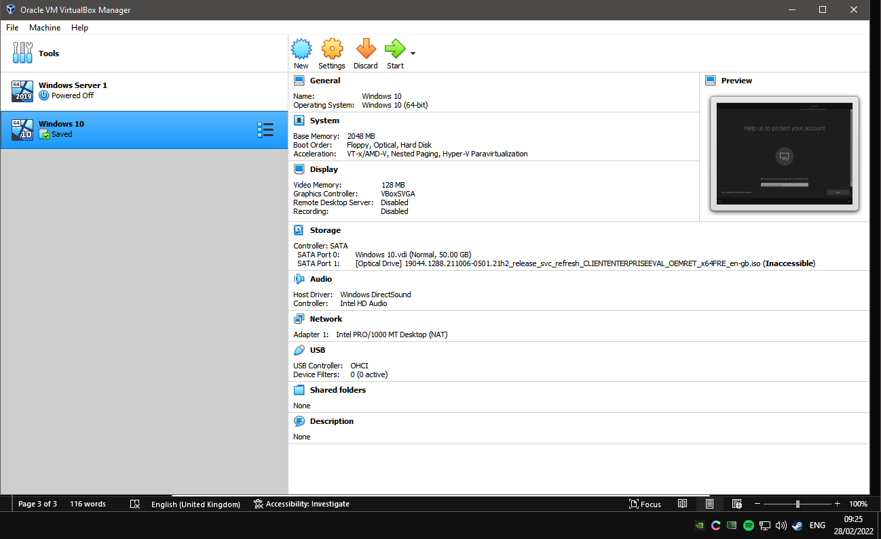
Figure 1 I have completed an installation of the virtual box software so that I can begin the installation of the virtual machines and one installation of the server based operating system (Windows Server 2019) has been installed onto the virtual machine and Client based operating system virtual machine has been setup (Windows 10).
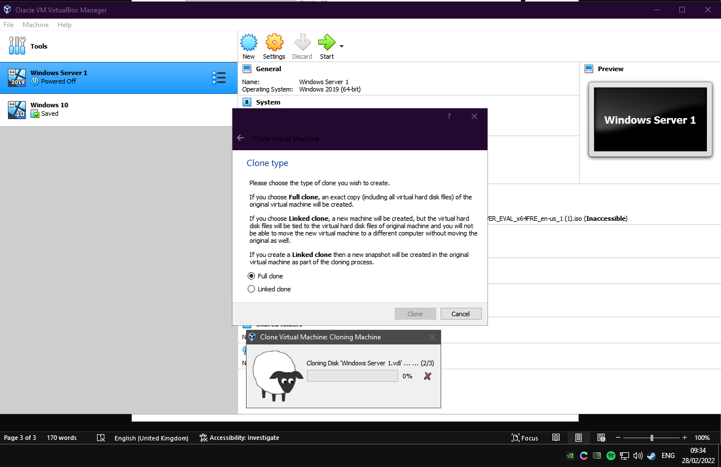
Figure 2 I have decided to clone machines after they have been setup as a fresh installation of their respective operating systems. This is to help save on time and keep things consistent between the installations. I have decided to use the full clone option as if anything was to happen the initial virtual machine or if there was any expansions made to this setup in the future it would not bottleneck it any way.
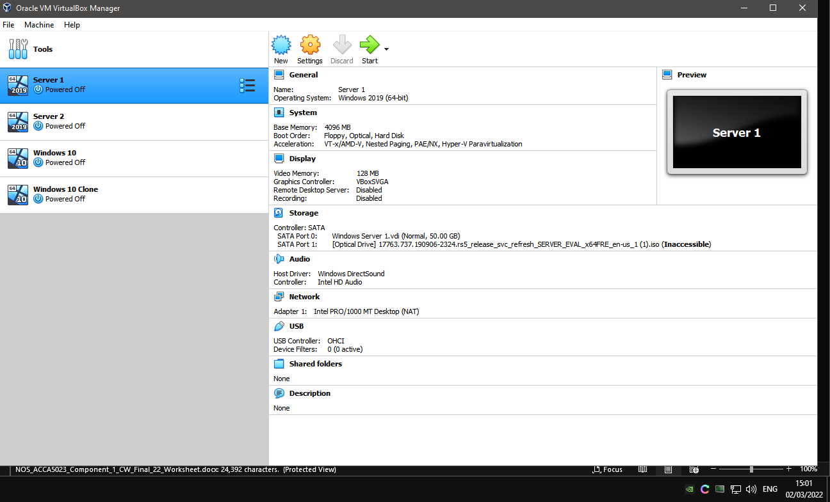
Figure 3 Machine has been configured in accordance with advised settings in the worksheet document and additional memory has been allocated to the windows 2019 server VM's

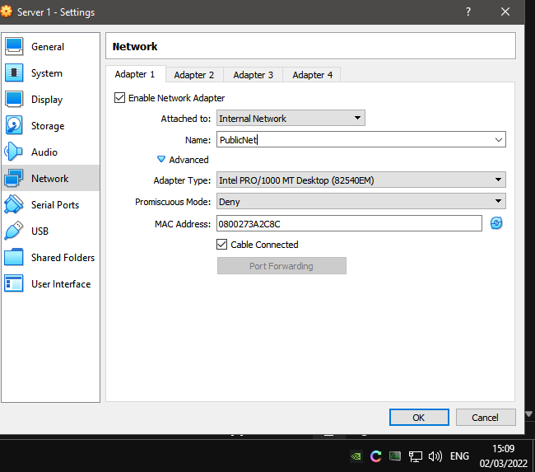
Figure 4 In the settings menu the network adapter has been changed to use the internal network options as the configuration will not be able to use the Internet Protocol addresses for the infrastructure that is currently being setup for as per the network addresses that are provided in the worksheet document. As default the adapter will be setup to use the NAT option which will use the internet connection of the machine that the VM’s and it offers other options as well with settings for cloud computing,etc so this can be accommodated for your needs.
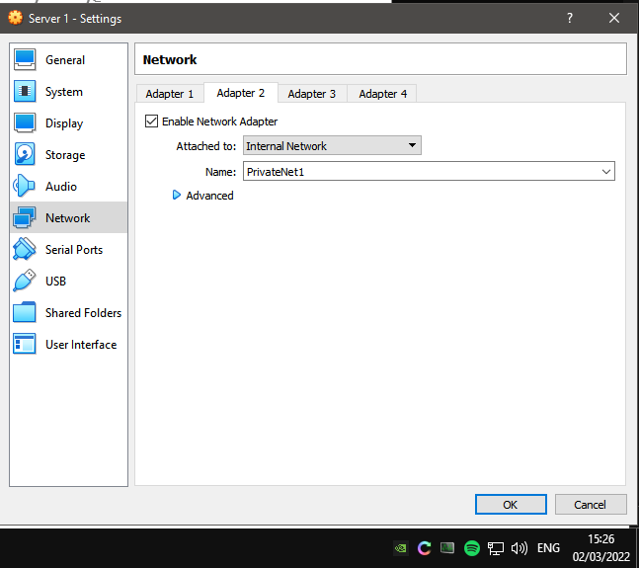
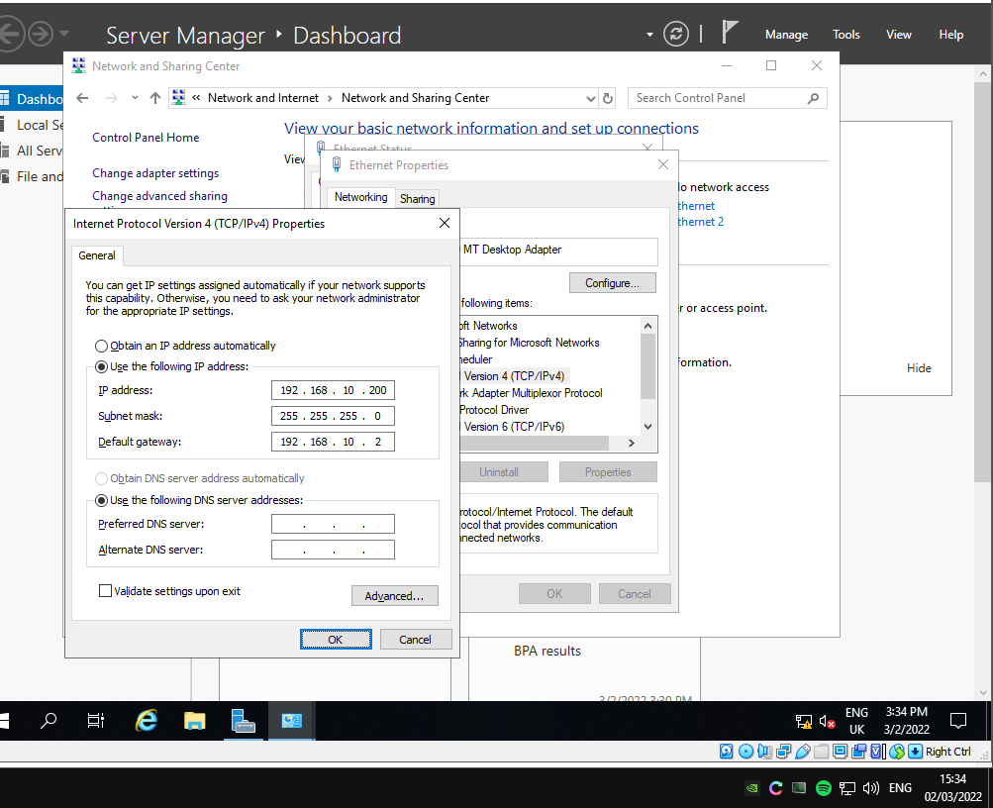
Figure 5 Within the Windows Server 2019 settings menu for network adapter options. I have applied the Ip address from the network table that was provided and this was configured for Ethernet 1 network adapter which the equivalent of adapter 1.
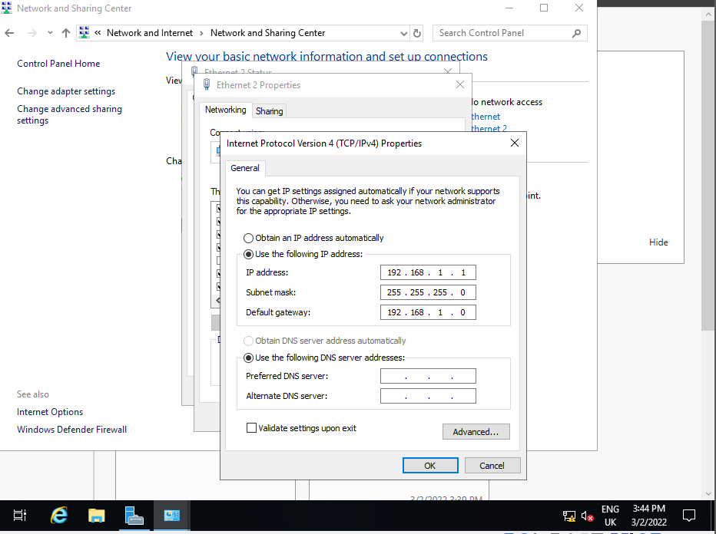
Figure 6 Configuration has been applied now for the second Ethernet adapter which is using the configuration for the PrivateNet1 IP address from the network table.
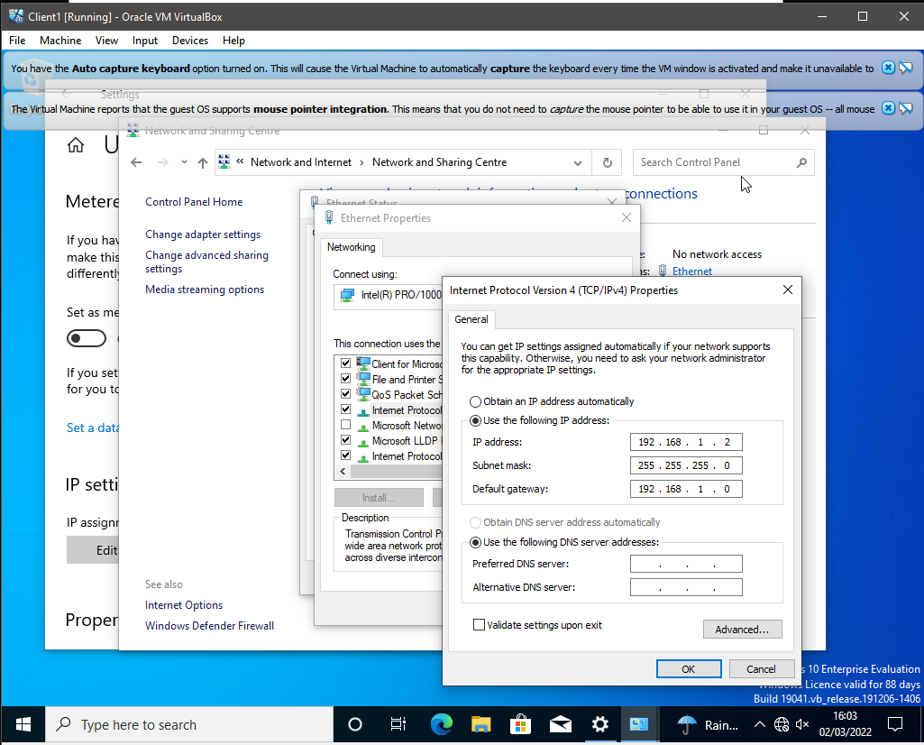
Figure 7 I have amended the network settings of the ethernet adapter for the Client 1 so that it can communicate with the Windows Server machine with the settings that have been configured on its network adapter previously.

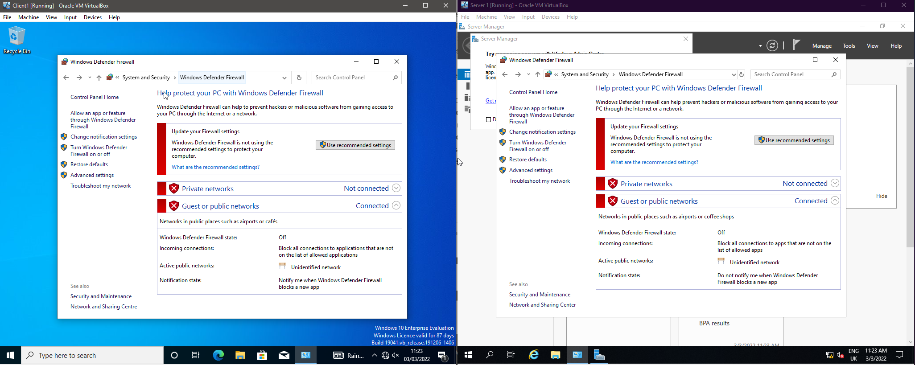
Figure 8 The firewall for both Client 1 and Server 1 have been disabled on both network types.

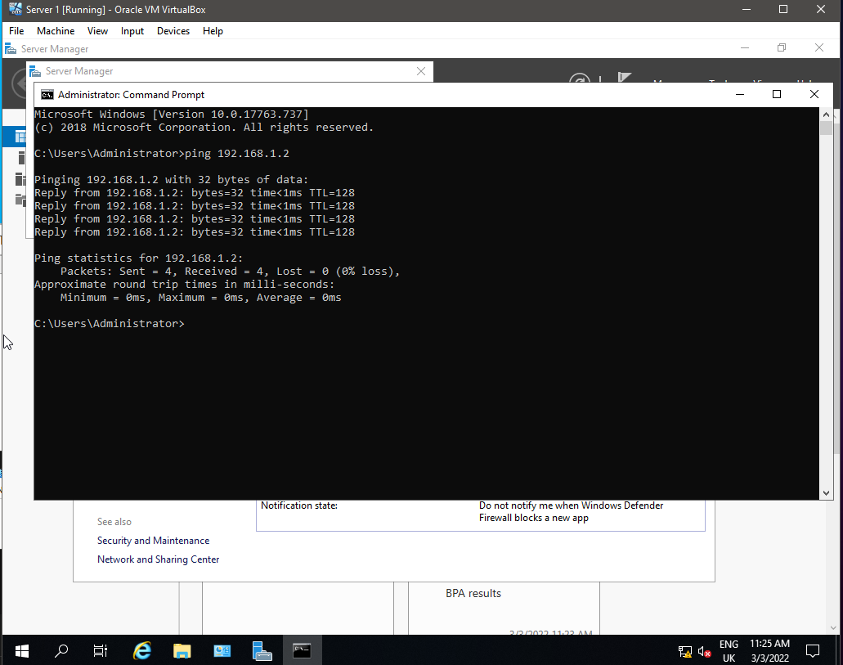
Figure 9 Ping was successful when pinging the IP address for the Client 1 Machine as full set of responses were received within the Command Line Console in Windows.
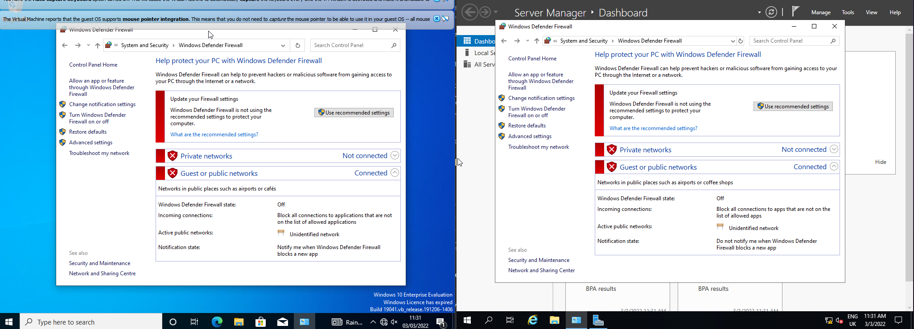
Figure 10 Disabled both firewalls on both of the Client 2 and Server 2 machines.

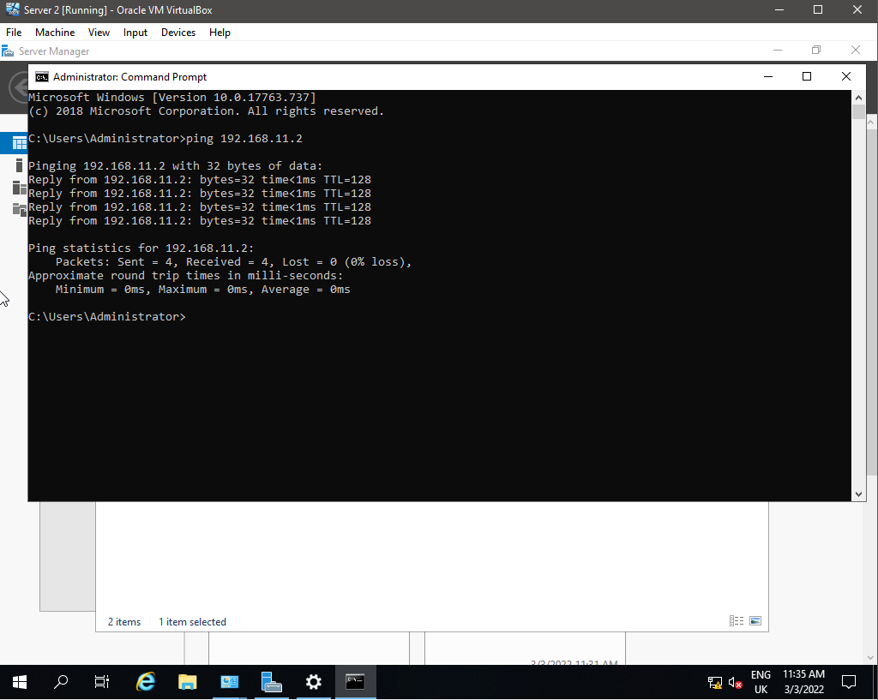
Figure 11 Completed a ping test to the Client 2 machines from the Server 2 machine and the ping was successful.

As seen in previous screenshots for the evidence no DNS has been configured to the any of the network adapters at this stage.
Task 2: DEPLOYING A NETWORK DIRECTORY SERVICE AND CREATING AND UNDERSTANDING ACTIVE DIRECTORY NETWORK OBJECTS

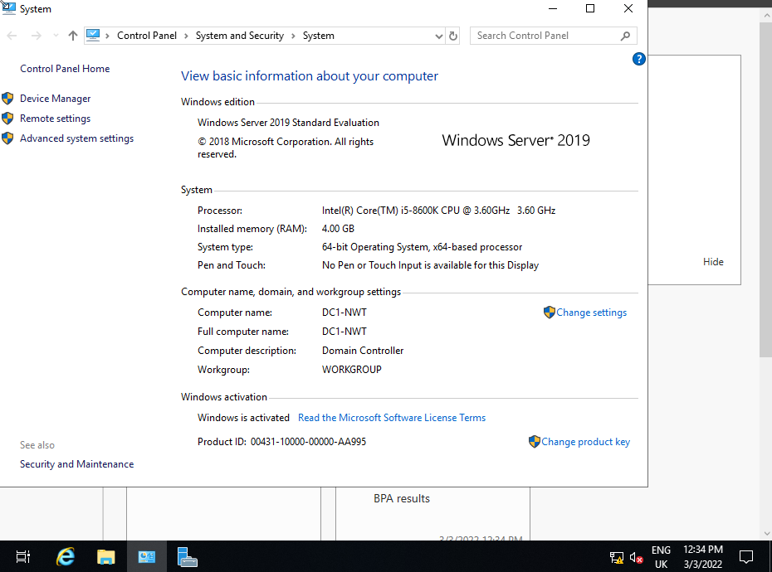

Figure 12 The name of the machine has been amended to "DC1-NWT" as instructed.
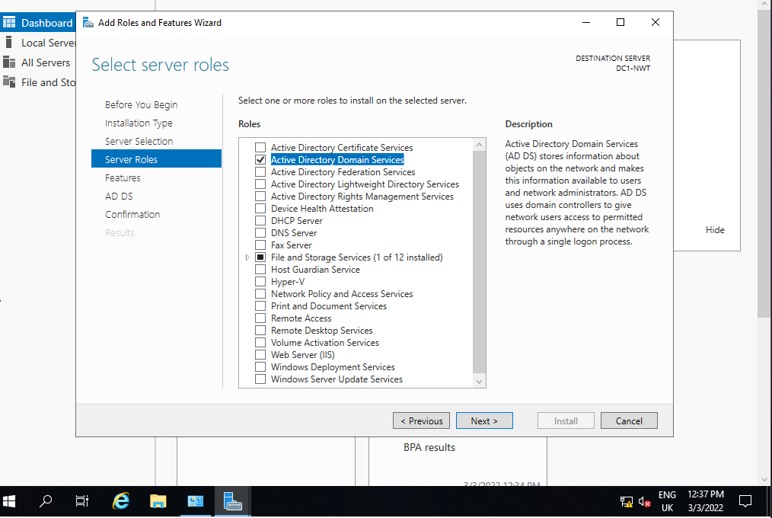
Figure 13 The process of configuring the Windows Server VM to be the Domain Controller for the network. In the Server roles window, I have selected the Active Directory Domain Services option so this can work correctly.
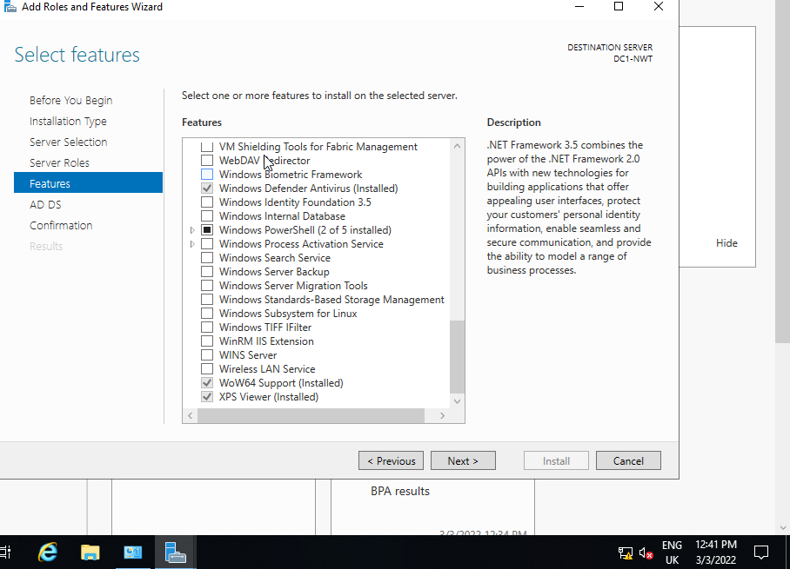

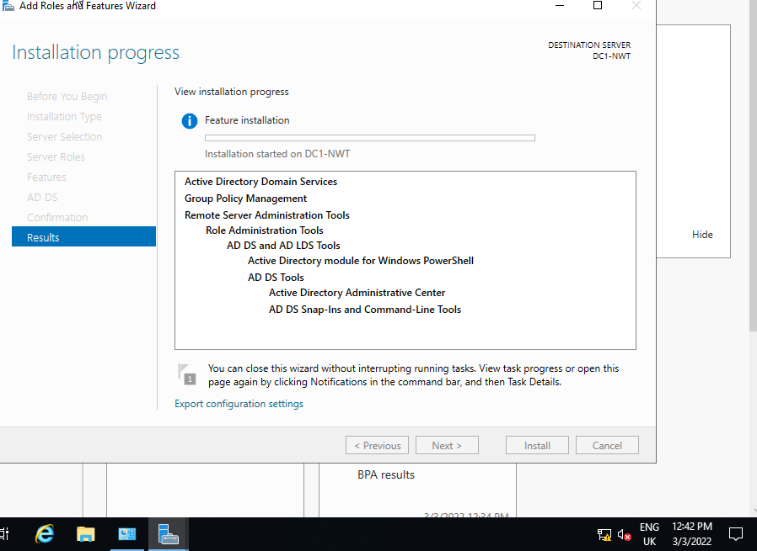
Figure 14 Installation of Active Directory has begun on the Windows Server machine.
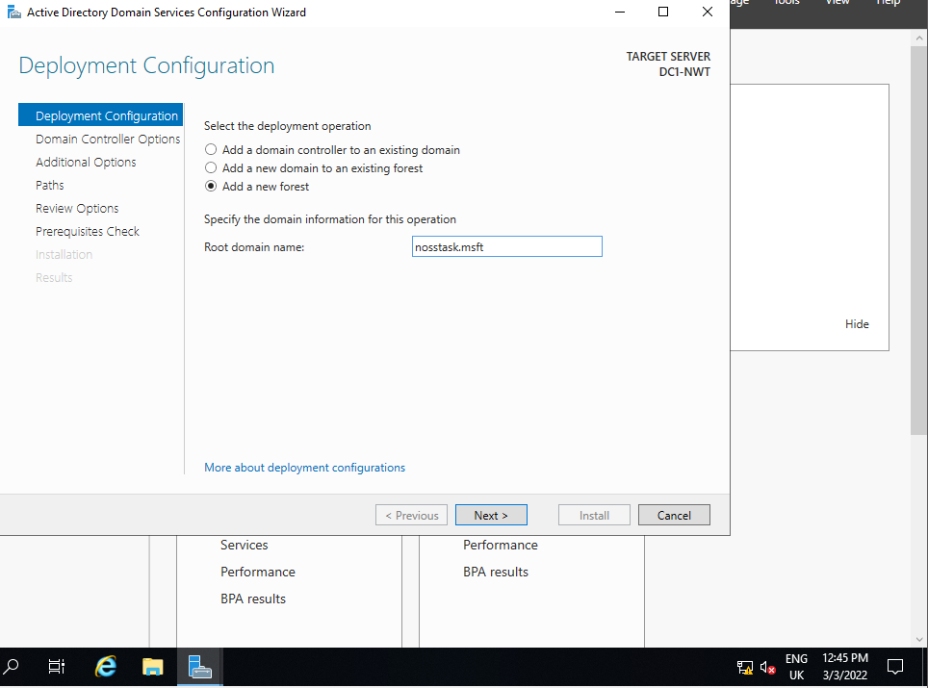
Figure 15 Installation of AD services has been completed and the configuration of the new forest on the machine has begun.
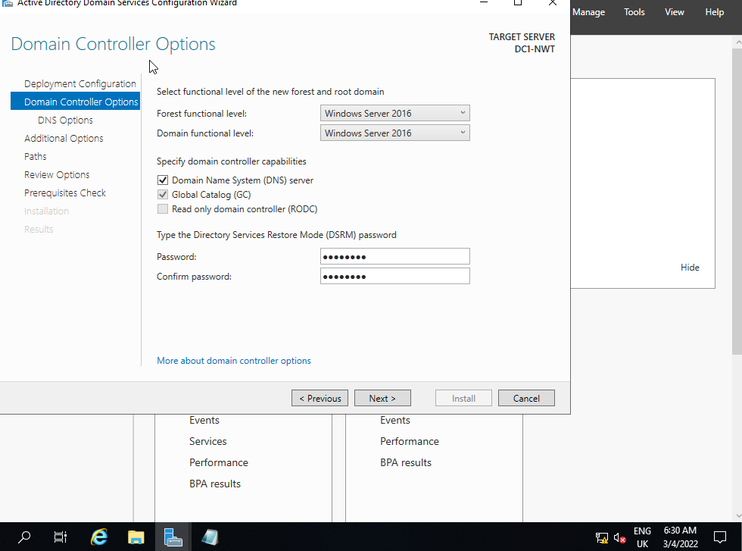
Figure 16 Domain controller options have been configured as instructed in the document. I have used the password that was outlined in the document.
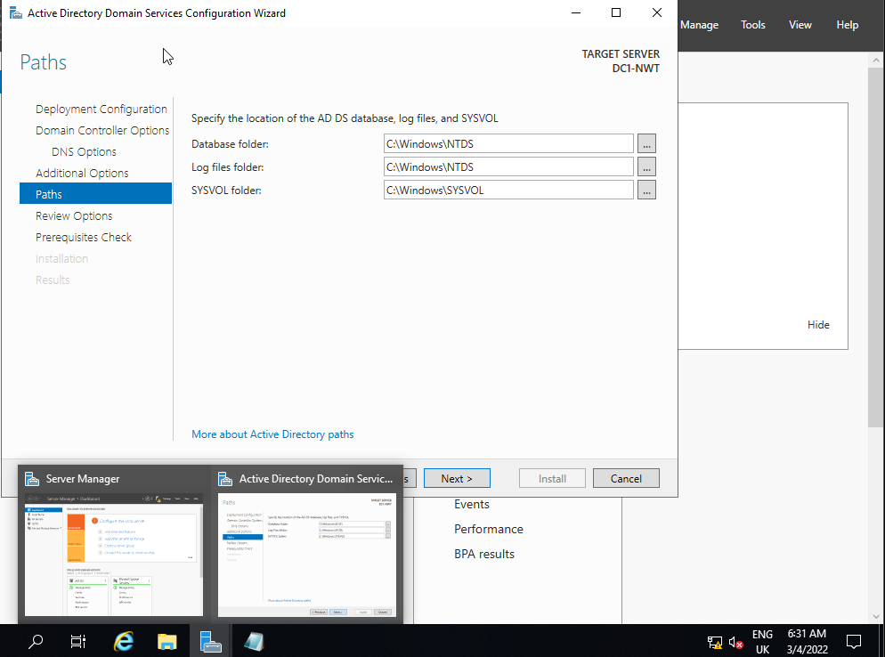
Figure 17 Paths options where the logfiles are stored for the domain controller has been left as default. This is just for ease of access as if you forget were these are stored using a custom location then it may be hard to locate them.
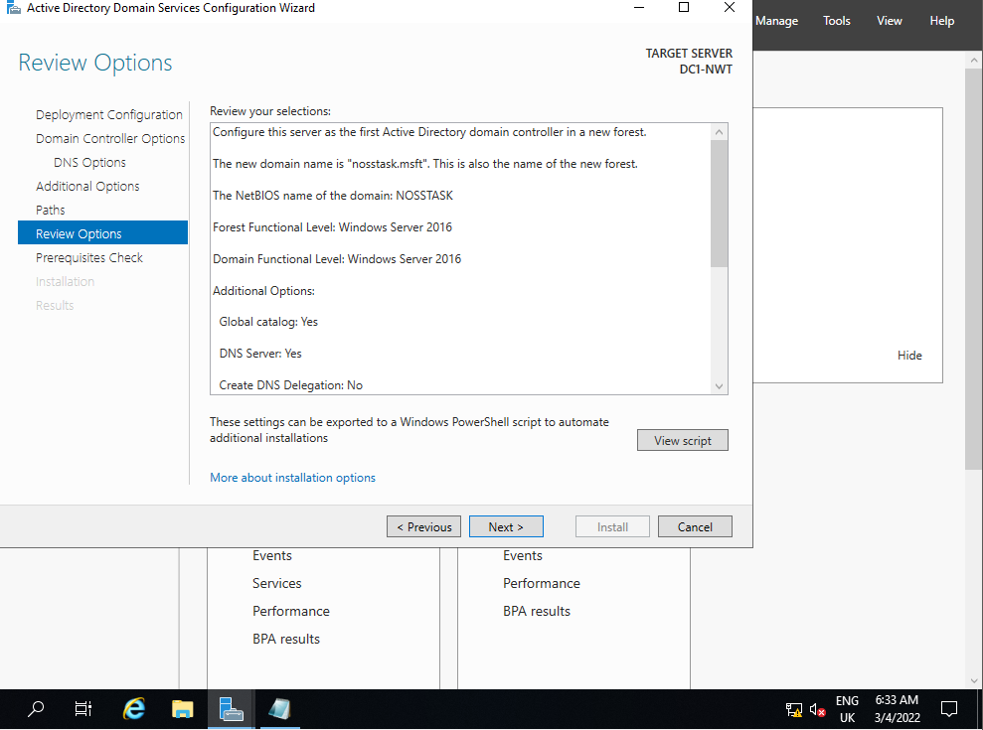
Figure 18 Left review options as default and continued.
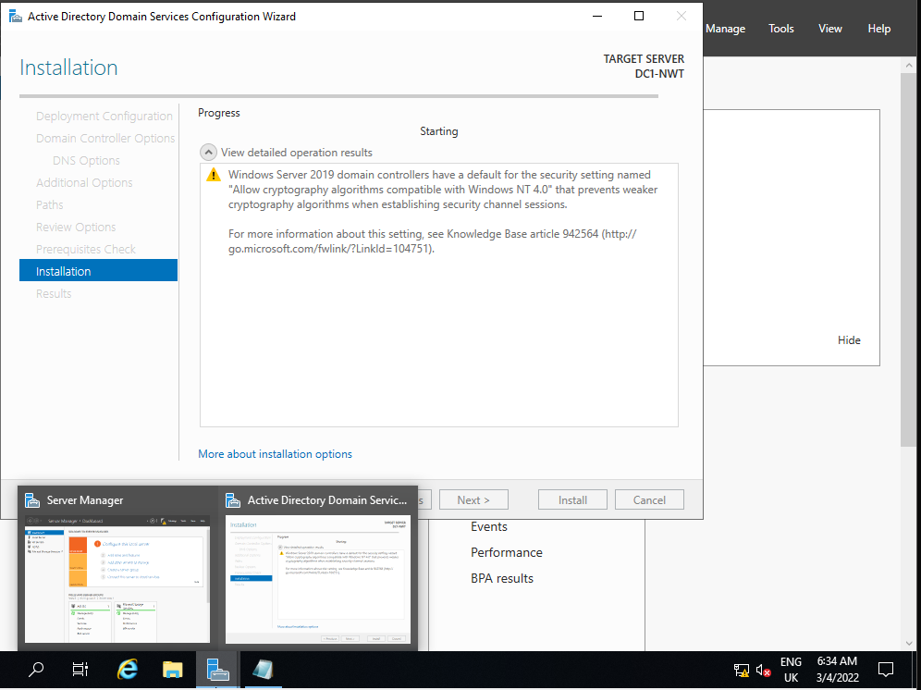
Figure 19 Started installation process for the AD on the machine.
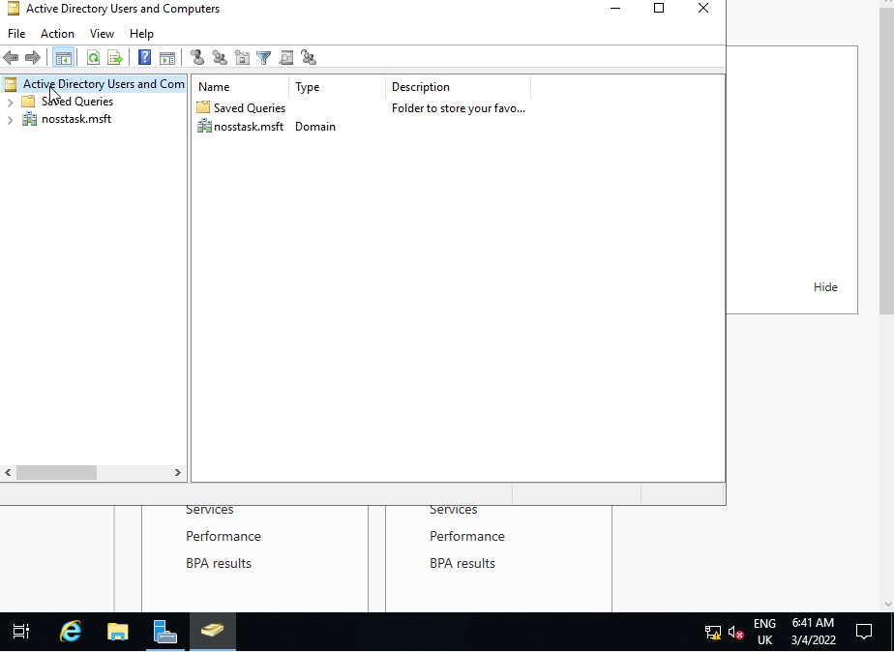
Figure 20 After the installation above was complete the machine restarted and then I opened Active Directory Users and Computers to start creating objects for the domain.
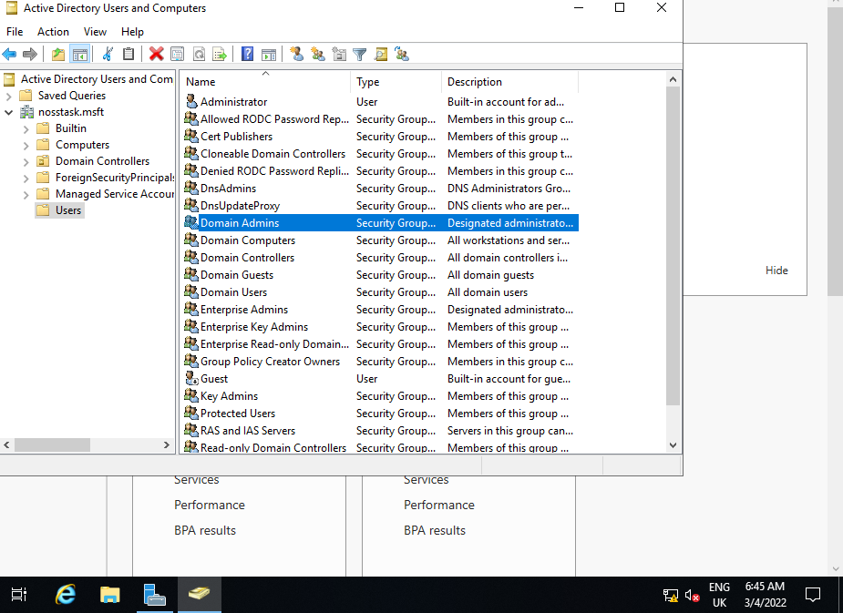
Figure 21 In the left-hand column we can see that the correct naming has been giving to the domain controller and I have navigated to the Domain Admins object with the user’s folder to begin configuration.
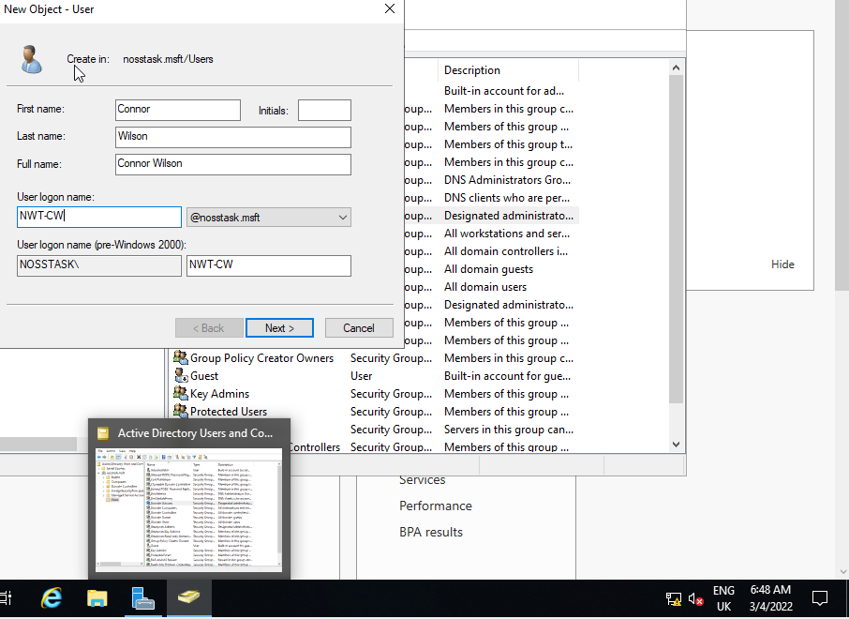
Figure 22 I have begun the creation of a new user object for the domain so I can make a failsafe encase the main account for the domain is compromised.
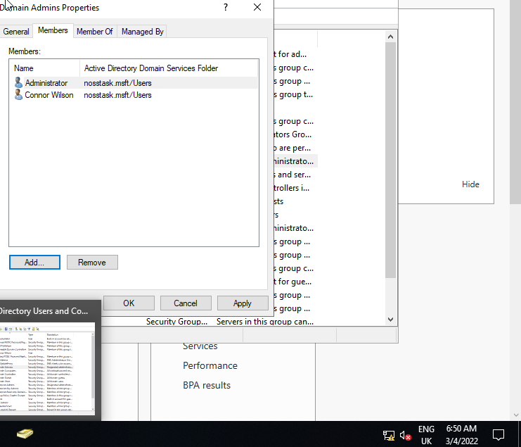
Figure 23 I have added the user object I created previous to the Domain Admins group.
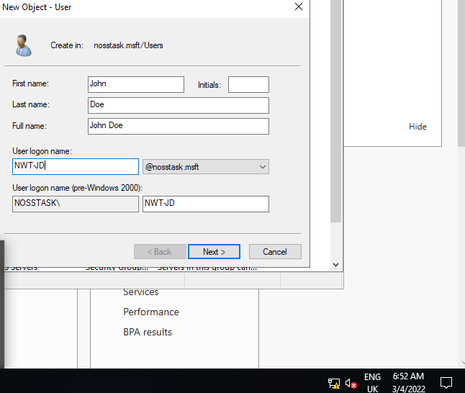
Figure 24I have created an additional user with the Users folder in AD.
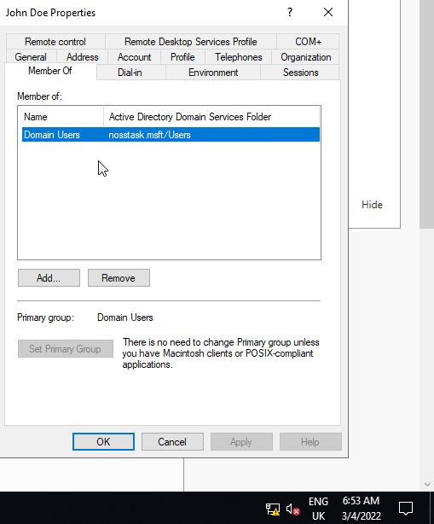
Figure 25 New user has been placed by default into the Domain Users Object within AD.
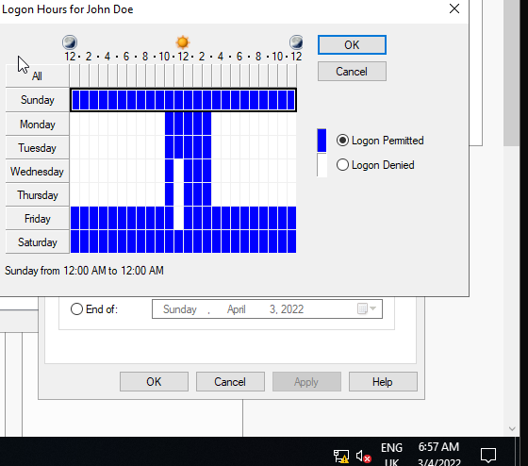
Figure 26 Login hours have been configured for the user within AD.
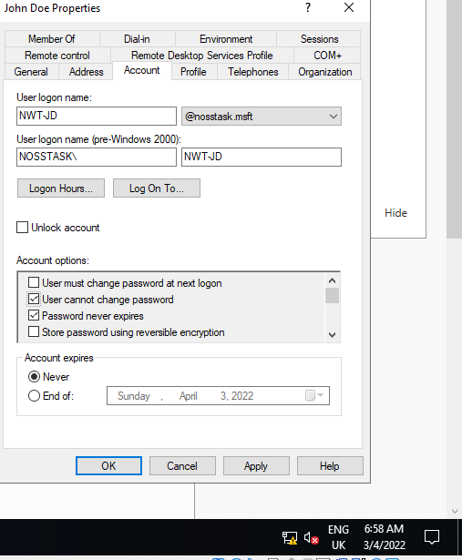
Figure 27 User cannot change password has been selected
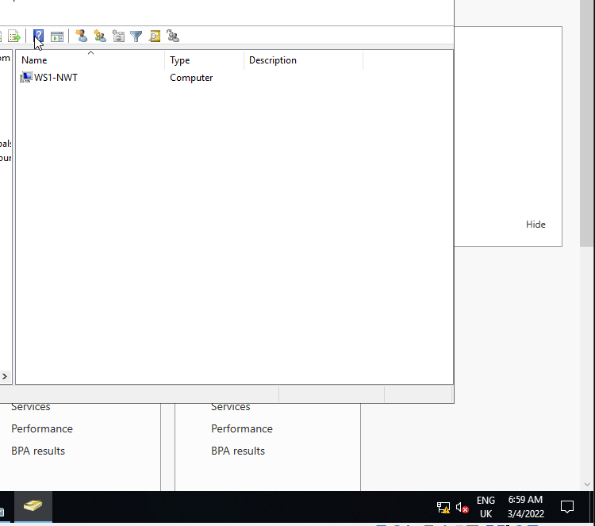
Figure 28 Computer account has been created for the machine within the domain.
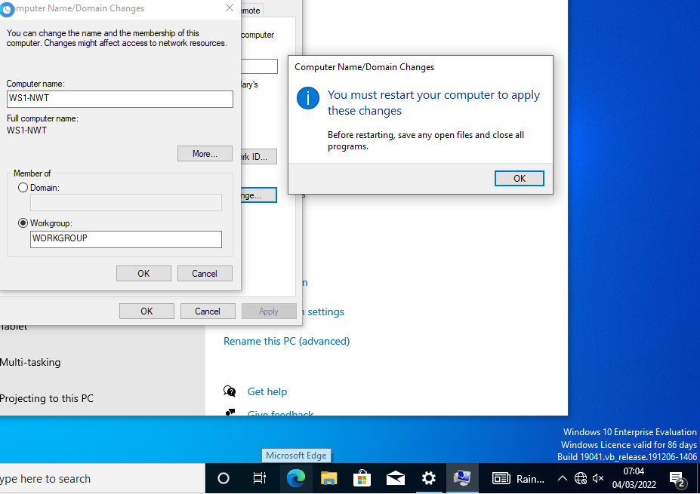
Figure 29 Machine name has been changed on the Client 1 machine.
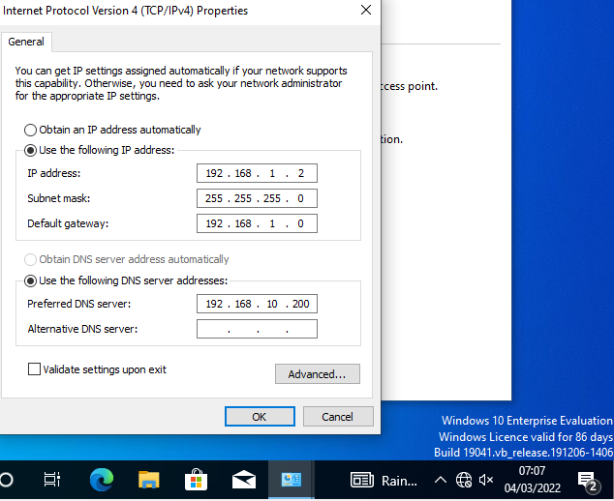
Figure 30 I have added the DNS server address within the network adapter configuration on Client 1.
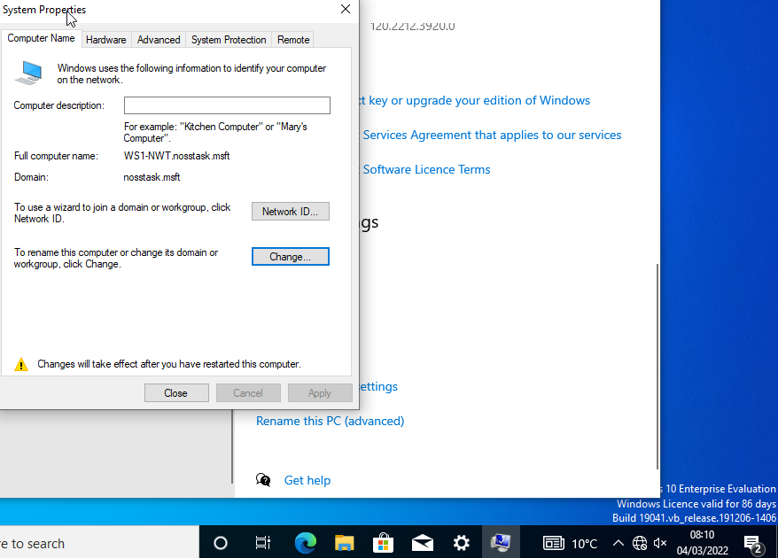
Figure 31 Machine has been added to the domain.
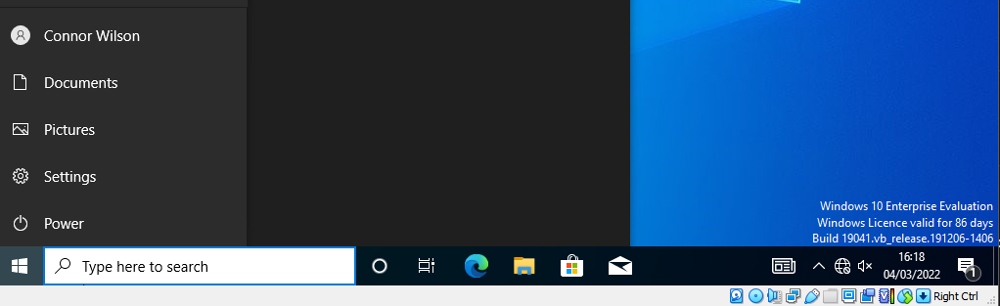
Figure 32 After the client machine had been rebooted after being added to the domain, I decided to login with one of the users accounts that had been created on the Active Directory Domain. The login was successful, and you can see the name below.

Task 3 (Observational Tasks)
What is Hypervisor and what are the differences between HV type 1 & 2.
For the use of Virtualization for VMs then a hypervisor needs to be used. What a hypervisor does is allow an individual or a collective to make use of a computer's hardware to host one or more VMs though this can also be used for storage, networking, servers, etc.
A hypervisor is a piece of software that runs that allocates and disrupts resources from the main machine to the different virtualisations that you want to run.
A type 1 Hypervisor (HV) is installed differently on top of the physical technology it makes direct use of the components of the machine.
A Type 1 hypervisor runs directly on the underlying computer’s physical hardware, interacting directly with its CPU, memory, and physical storage. A Type 1 hypervisor takes the place of the host operating system. [1]
The benefits of using a type 1 hypervisor are that they can make use of the host machine hardware very efficiently. It is also inherently quite secure due to the direct communication between the processor and the host machine.
One of the downsides with type 1 HVs is that they can sometimes require a separate machine from which VMs will be managed and used to control the host machine. This can increase the cost of having to have another machine.
Type 2 HVs are run through applications or software that can be installed onto a user’s machine. An example of this would be the VirtualBox which I have used in AD and networking configuration tasks in Task 1 and 2 of this assignment. Another example offered by Microsoft would be Hyper-V which comes with standardised versions of Windows.
An Advantage of using a Type 2 solution is that it can be good for users that are looking to run a small number of machines and do not want to spend money acquiring additional machines. This is always for access to say Linux without having to complete an entire install or having multiple OS installed on the same storage medium.
Using Type 2 HVs can introduce performance degeneration on machines due to making use of the same hardware that the operating system that the host is using at the same time. This can be a problem for users on the low end or less powerful machines. Another issue can be that if the host machine is compromised, they can access interfere with the Operating Systems that are installed on the VMs.
Cloud Computing
Cloud computing has changed the way we access information from home users taking advantage of services such as iCloud, Google Drive, etc to store additional files or backup information to enterprise-level organisations making use of Office 365 and azure services to provide infrastructure to their application-based services. [2][3]
One of the benefits is that it allows scalability within organisations or businesses for instance Azure. [4]
The service where you can rent a specified number of machines at a time could be great for fast-growth businesses or businesses with lots of staff turnover as they can add more machines or take away and are not reliant on having physical hardware available which could be an even larger issue currently due to lack of availability and the increased price of computer equipment currently due to the chip shortage.
The maintenance price is low as the user does not have to purchase the infrastructure. Up-front expenses of the companies get reduced by putting the information and computing centre into the cloud. [5]
A disadvantage is that cloud services are that they are reliant on an internet connection and usually one that is a high speed and reliable this can become an issue if you do not have access to a reliable internet connection say if you are in a part of the world with poor broadband or if there is poor coverage for the mobile data network.
DNS
Domain Name Service (DNS) is a service that allows for the quality of life for anyone that is making use of any sort of networking for example if we wanted to go to a website say google for instance if we were not using DNS then we would have to know the specific IP address of the website for it to be accessible.
This can be an issue very quickly as their hundreds of thousands of websites and you are not going to be able to recall more than a few IP addresses at any given time.
DNS will resolve the IP address of the given website to its web address so that when you attempt to connect to a website it will acquire and load the IP address for the website.
The importance of DNS within active director is important as it will resolve domain controller objects such as machines to the machine's respective IP address otherwise each machine would need to have its IP address statically defined within AD if this feature was not present.
Active Directory Domain Services (AD DS) uses DNS when Active Directory operations are performed, such as authentication, updating, or searching, computers use DNS to locate Active Directory domain controllers. [6]
The main role of the DNS is to act as a repository for information, and the initial assumption was that the form and content of that information were well understood. we knew that we would have to support multiple addresses for a single host, but we were drawn into long discussions of whether the addresses attached to a hostname should be ordered, and if so, by what metric. [7]
Critical Roles within a network
Other important roles in a network other than AD would be the physical infrastructure of a network so this would include the switches and configuration of addresses within the switches and routers, security via the console for instance the command-line console on Switch and cisco routers.
The security element of a network would make use of firewalls to make sure that ports and traffic going in and out of the network is protected as well as making sure that anti-virus is deployed across the network to help protect the machines in scenarios where attackers have bypassed the firewall.
Technologies and their purposes
There is a variety of techniques, methodologies that are deployed with technologies within network operating systems that will be discussed and the differences that there may be between Windows and other operating systems when it comes to this.
Ping – This command is used within the command line on an operating system, This function is useful for testing network connectivity between different devices, servers, websites, etc. The function sends packets of information that can be customised with commands to the destination which is defined by the address that is assigned to said device. It will show information of if the package was received and how long it takes to arrive at the destination in milliseconds. The only difference between this feature in Windows and Linux is that the command needs to be terminated in Linux as it will keep running.
Server Management – This feature lets you install server features through the Windows Server application which is not included with the regular installation of Windows 10. The feature lets you install packages like Active Directory onto the machine and allows you to promote a machine to a domain controller as demonstrated in the initial tasks that I completed. The differences between the Linux offering and Windows. One of the large differences is that Windows server is a piece of proprietary software compared to Linux server which is open-source this means anyone can develop this software and it is free to use. One of the issues is that Active Directory technology is not available on Linux Server distros and there is not a good alternative available for this software a large market share makes use of the Windows Server but have considered the increased cost of this operating system compared to the free alternative.
Reflection
This assignment was a refresher of my knowledge when it came to deploying users and services via Windows server as I had done a task identical to this as an apprentice some time ago before coming to uni.
I found the process quite straight forward except I had some issues with getting the Client machine to connect to the domain controller machine. This was due to the internal networking option being configured within VirtualBox which was preventing the machines from communicating with each other after the setting was amended to the bridged option, I was successfully able to add the client machine to the domain.
I am looking forward to widening my knowledge and learning more about the features of AD within the next worksheet.

References
[1] Hypervisors - United Kingdom | IBM. (n.d.). Retrieved March 4, 2022, from https://www.ibm.com/uk-en/cloud/learn/hypervisors

[2] Azure Fundamentals part 1: Describe core Azure concepts (AZ-900) - Learn | Microsoft Docs. (n.d.). Retrieved March 4, 2022, from https://docs.microsoft.com/en-us/learn/paths/az-900-describe-cloud-concepts/

[3] Google Docs: Free Online Document Editor | Google Workspace. (n.d.). Retrieved March 4, 2022, from https://www.google.co.uk/docs/about/

[4] Design for scaling - Microsoft Azure Well-Architected Framework | Microsoft Docs. (n.d.). Retrieved March 4, 2022, from https://docs.microsoft.com/en-us/azure/architecture/framework/scalability/design-scale

[5] Saini, H., Upadhyaya, A., & Khandelwal, M. K. (2019). Benefits of Cloud Computing for Business Enterprises: A Review. SSRN Electronic Journal. https://doi.org/10.2139/SSRN.3463631

[6] Various Contributions. (2022, January 10). Domain Name System (DNS) | Microsoft Docs. Microsoft. https://docs.microsoft.com/en-us/windows-server/networking/dns/dns-top

[7] Mockapetris, P. v., & Dunlap, K. J. (1988). Development of the Domain Name System. Symposium Proceedings on Communications Architectures and Protocols, SIGCOMM 1988, 123–133. https://doi.org/10.1145/52324.52338

