

Sustainable hospitality & tourism management

Report

Component 2
Submitted
by

Marina Boeva
Student ID : 2246384
The module title : Sustainable Hospitality and Tourism BMIH5006

Tutor : Kathryn Roberts
Word count , ex 2597
References & In-text citations

I confirm that I have not presented any AI generated text as my own work. I confirm I have copies of my drafts, notes, and other resources I used before, and after the use of AI tools which I may be asked to provide in evidence.

Executive Summary

This report has discussed hospitality transport and its impact on the environment. Air transport has been chosen among different hospitality transport and its detrimental effects are the primary focus of this report. Air transport is popular because it can connect travellers around the globe and offer the fastest journey. Yet, it causes severe harm to the environment and destroys the biodiversity. Harmful and powerful greenhouse gases are emitted from air transport which damage the ozone layer and cause sound pollution and air pollution. To reduce the impact of the damage two improvements are proposed in this report, one is using SAF and optimise the operational efficiency. Adopting SAF will reduce greenhouse gas emissions drastically and provide social and economic benefits. On the other hand, the optimised operation will decrease unnecessary fuel consumption and decrease the cost of operational activities. Different UK-based airlines, for example, British Airways, easyJet, and Delta Airlines have adopted these suggestions and shown the positive result. Adopting sustainability in the hospitality industry will help achieve Green Accreditation and fulfil the CSR commitment. To ensure long-term growth hospitality transports must adopt sustainability and promote sustainable tourism.

Table of Contents
Executive Summary 2
Introduction: 2
Chosen Mode of Transport Initiative: 3
Environmental, Social and Economic Impact: 4
Sustainability Theories: 6
Proposed Improvement: 6
Advantages of Proposed Solutions: 7
Conclusion: 8
Reference 10

Introduction
Hospitality transport is an integral part of the global hospitality industry. It connects travellers with destinations, accommodations, and attractions around the world. Transportation is the movement of people, animals, and goods from one location to another (Franklin et al.,2018). Thus, hospitality transport is defined as the movement of guests and goods related to hospitality service or tourism (Plyushteva, 2021). The hospitality transport services have different modes, for example, sir, sea, rail, and road. Effective transport systems assist guests in traveling as well as improve the experience of the travellers.
This report will discuss air transport which is one of the popular modes of travelling. Even the global industry is significantly dependent on this mode of travel. According to data, there are 4.96 billion air passengers worldwide (Garcia, 2024). Air transport has the ability to connect people quickly to destinations despite the distance. However, air transport has several detrimental impacts on the environment. Therefore, this report will primarily focus on the environmental consequences resulting from air transport, especially greenhouse gas emissions and climate change. The report will also suggest feasible ways to reduce the impact as much as possible. Overall, providing knowledge on sustainable practices in the hospitality sector will be the focus of this report.

Chosen Mode of Transport Initiative
As mentioned above, this report will focus on air transport. Air transport is one of the fastest and safest transportation with global connectivity (Wensveen, 2023). Because of these factors, air transport is one of the significant parts of the hospitality industry. It connects and assists the movement of travellers, business travellers, and employees around the world. In most cases, for international traveller airlines are the first choice because of the convenience and ability to connect geographically remote areas with the rest of the world. Around 195.6 6 million people travelled from internationally from UK airports (Department for Transport, 2023). However, air transport is one of the biggest contributors of greenhouse gases, especially carbon dioxide. Research evaluated that the Co2 gas emission rate has increased very high in 2000-2019 from other means of transports like, rail, ship, etc. (Kim and Teter, 2023). In the case of the UK, the civil aviation industry has been responsible for 1.4 million metric tons of greenhouse gas emissions (Statista, 2023). Thus, it is high time to address this issue to make sure sustainability in the hospitality industry. The below figure shows the carbon-di-oxide emission by aviation globally.
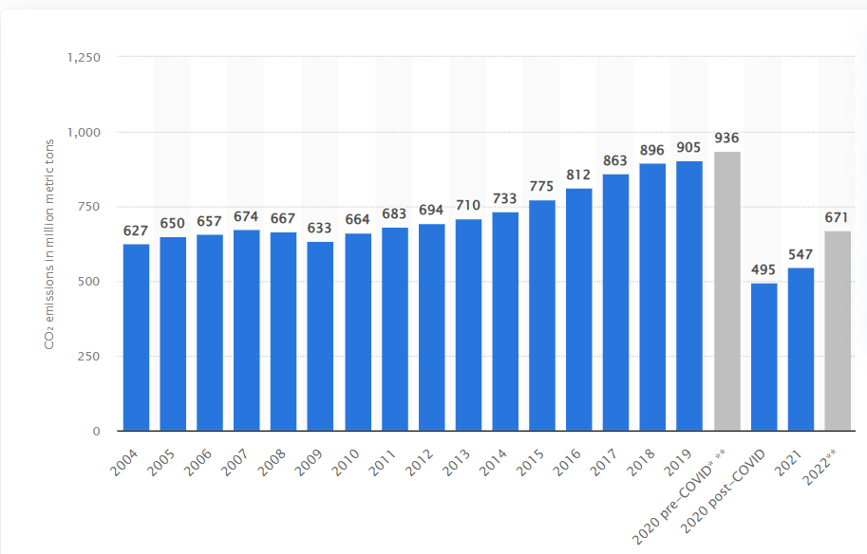
Figure 1: Statista (2023)

Environmental, Social and Economic Impact:
Air transport provides several benefits in the hospitality industry. As mentioned above, in the hospitality industry air transport is one of the popular modes of transportation. Data suggests that, the interest of people transportation method has significantly changed in recent time and there are more willing to select Air transport then rail, water and by road, As air transport growth is around 58% (Aviation, 2023). Yet air transport has significant environmental, social, and economic impacts.
Studies show that air transportation contributes 4% of the global warming and 2.5% of global Co2 gas emission rate (Ritchie, 2024). Aviation’s 2.05% share of the total human-induced CO2 emissions in 2023 was due to the burning of 348.75 billion litres of jet fuel (Air Transport Action Group, 2024). Along with CO2, other greenhouse gases are also emitted from air transport. These gases are released at high altitudes and damage the ozone layer of the atmosphere. Moreover, the emission of gases at high altitudes creates a situation called “Radiative Forcing” and contributes to higher global warming potential (Irfan et al.,2024).
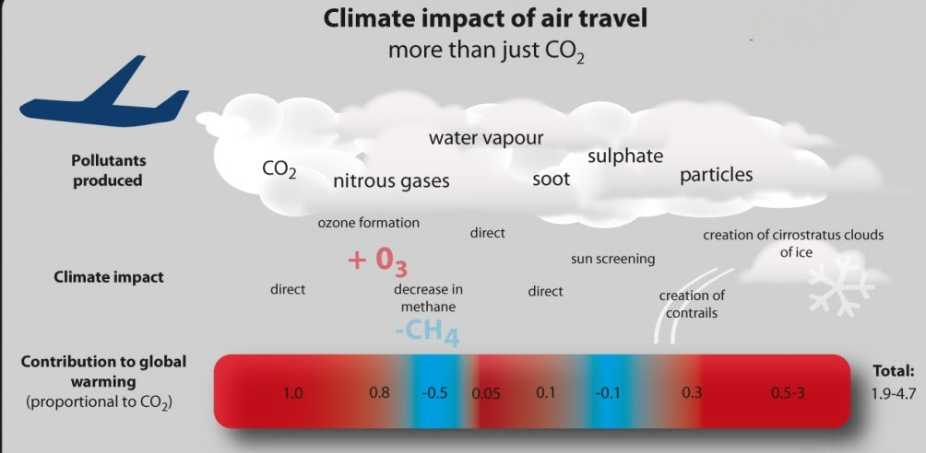
In the case of social impacts, air transport offers job opportunities in the hospitality and tourism industry and supports the local people economically (Brunett and Martínez, 2024). On the other hand, the noise pollution created by air transport significantly disturbs human lives. Even the air quality is also impacted by air transport. Aircraft engines affect air quality around airports. It found that emission of No2 could enormously harm the residential areas closed to civil aviation (Trebs et al.,2023). Moreover, the Environmental Noise is very high which cause people suffer from significant sleep disturbances (EASA, 2023). Air transport contributes to the global economy and GDP and creates job opportunities in the tourism and hospitality industry. In the UK 1.2% of total GDP comes from the employment of air industry (IATA, 2024). Conversely, the rising cost of operations including fuel and maintenance is risking the cost of air transport. It significantly impacts price-conscious travellers.
Figure 2: (Overton, 2022)

Sustainability Theories:
The air transport mode of travelling is facing major sustainability challenges due to the harmful impacts on the environment. Since the 1980s the dioxide emissions have doubled and by 2050 the is estimated that the emissions will be tripled (Ansari, 2022). Thus, it is necessary to adopt to green solution to balance economic advantages with environmental effects. Even though technology has advanced the industry is still facing issues to fully adopt sustainable practices.
The Green Key Initiative is a global eco-label certification program that encourages hotels to maintain high standard sustainability practices and get “Green Key” recognition (Green Key, 2023). This initiative focuses on promoting eco-friendly practices in the hospitality industry to reduce the harmful impacts on the environment. By implementing the Green Key principles, hospitality transport can also practice eco-friendly initiatives. Sustainable initiatives in the hospitality industry can include using renewable energy, reducing waste generation in airports, facilitating sustainable aviation fuels (SAF), and reducing noise and air pollution.
Additionally, CSR programs of a business is accountable to stakeholders, and the public (Wirba, 2024). Using this concept businesses engaged the internal and external stakeholders of the company through understanding their power and interest with the company. Therefore, by strongly aligning with CSR hospital industry can operate responsibly and work to reduce carbon emissions, and noise pollution. The growing demand for air transport infrastructure poses a significant threat to biodiversity and wildlife habitat loss (Kolawole and Iyiola, 2023). As a part of CSR activities air transport can invest in SAF and collaborate with different environmental organisations to reduce harmful impacts on the environment and save biodiversity.

Proposed Improvement:
The first suggested improvement is the adoption of the Sustainable Aviation Fuel (SAF). Air transport mode should expand SAF production to promote sustainability. It is an alternative fuel or biofuel made from petroleum feedstocks. It can be made from and can be created from agricultural residues, municipal waste, oils, and captured carbon dioxide (Shahriar and Khanal, 2022). Adapting to SAF is realistic because the current aircraft does not need too much modification to use this. However, it has high production costs, highly depends on feedstock availability, and needs advanced infrastructure. Even though, government subsidies and partnerships with companies can help reduce the cost of production.
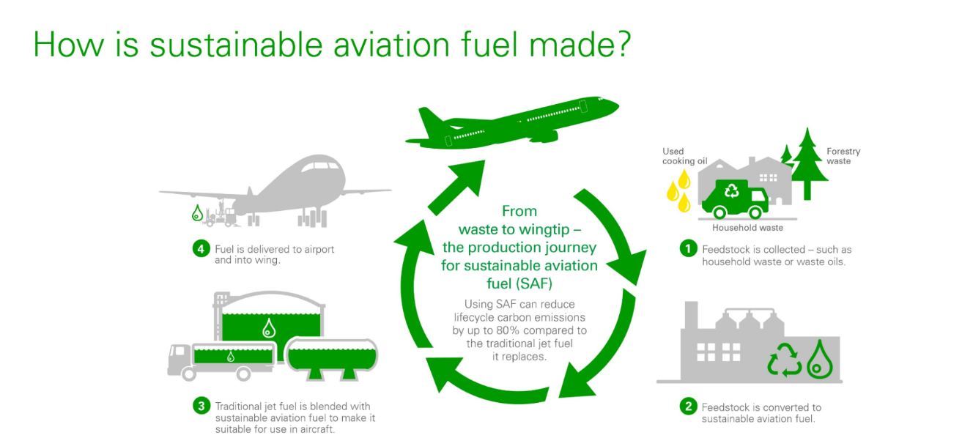
Figure 3: (Daglar Cizmeci, 2022)

Another suggested improvement is the optimisation of the Airline operations. This will include changes like optimising flight paths, decreasing the idling time in runways, and enhancing air traffic management. It is one of the cost-effective solutions because does not require a huge amount of investment. With the current technology, it can be started right away. Moreover, unnecessary fuel consumption can also be decreased and increase efficiency if implemented properly. It is a highly feasible suggestion if collaborative efforts are made with stakeholders.

Advantages of Proposed Solutions:
SAF offers several environmental benefits and it reduces the lifecycle of carbon emissions and reinforces the circular supply chain (Wang et al.,2024). Moreover, to decarbonise air travel in the UK, SAF is significant because it emits 70% fewer greenhouse gases than fossil jet fuels (Department for Transport, 2024). As a result, the formation of contrail will decrease that causes global warming as well as air quality will be improved. To promote sustainability the UK government has created SAF regulations. According to the SAF mandate, by 2025 at least 2% of aviation fuel must be from sustainable materials, by 2030 10%, and by 2024 22% (Department for Transport, 2024). Even, £86m will be accessible to airlines through the airport's SAF incentive scheme at Heathrow, targeting 3% of aviation fuel used to be SAF in 2025 (Heathrow, 2025). Additionally, SAF adoption also offers social and economic benefits. SAF will reduce carbon and other greenhouse gas emissions that will improve the health of the public especially people living near airports. Then, in rural areas, it will create economic opportunities because of feedstock production (Wang et al.,2024).
In the UK, British Airways was the first airline that used SAF for commercial flights. On 28 November 2023, Virgin Atlantic made a transatlantic flight on a Boeing 787 with Rolls-Royce Trent 1000 engines 100% powered by SAF from Heathrow to New York JFK (Parker, 2023).
Furthermore, by optimising airline operations, air transport can decrease fuel consumption. It will cut down carbon emissions instantly and reduce ground-level air pollution. Then, by decreasing the fuel intake, operation costs can be reduced. The experience of the guest and travellers can also be improved by efficient flight routes.
In the UK, Delta Airlines has incorporated advanced flight routing systems. By this, the company has been financially benefited (Delta, 2023). Moreover, easyJet uses the art of technology and successfully minimized Co2 gas emission arte (EasyJet, 2024).

Conclusion:
To conclude, air transport is one of the most popular hospitality transport all around the globe. It is used because of its ability to connect guests, and travellers from one corner of the world to another and the fastest mode of hospitality transport. Because of hospitality transport people can visit their desired destinations domestically and internationally. However, hospitality transport also has some disadvantages and causes severe environmental damage. Air transport causes severe damage to the ozone layer, emits greenhouse gases, causes sound and air pollution, and overall contributes to global warming. With time carbon emissions from air transport in increasing and it is forecasted that it will drastically increase if necessary actions are not taken. It is a must for businesses to follow Green Key principles and apply CSR practices. To reduce greenhouse gas emissions, air transport can start using SAF and optimise its operational activities. Along with providing environmental benefits, these improvements will also provide social and economic benefits. As a part of their commitment to sustainability UK based airlines has adopted different approaches. By adopting sustainability hospitality transports can advocate for sustainable tourism and ensure long-term growth.

Reference
Air Transport Action Group (2024). Facts & figures | ATAG. [online] atag.org. Available at: https://atag.org/facts-figures [Accessed 23 Jan. 2025].
Ansari, M.A., (2022). Re-visiting the Environmental Kuznets curve for ASEAN. Renewable and Sustainable Energy Reviews, 168, p.112867.
Aviation (2023). Climate impact. [online] Aviationbenefits.org. Available at: https://aviationbenefits.org/environmental-efficiency/climate-impact/ [Accessed 23 Jan. 2025].
Brunett, A.L.L. and Martínez, A.A.C., (2024). Development of the aviation industry and professionalization. Revista Repique, 6(2), pp.91-106.
Daglar Cizmeci (2022). 5 Air Cargo Carriers That Are Going Green Before 2050. [online] Daglar Cizmeci. Available at: https://daglar-cizmeci.com/air-cargo-carries/ [Accessed 24 Jan. 2025].
Delta (2023). Sustainability | Delta Air Lines. [online] Delta.com. Available at: https://www.delta.com/us/en/aboutdelta/sustainability?srsltid=AfmBOopfZXyPBwmEiyUDHNtsYuLXLPmqAbU-8mKdE5jhCy0RyffVaWQB [Accessed 24 Jan. 2025].
Department for Transport (2023). Transport Statistics Great Britain. [online] GOV.UK. Available at: https://www.gov.uk/government/statistics/transport-statistics-great-britain-2023/transport-statistics-great-britain-2022-international-travel [Accessed 23 Jan. 2025].
Department for Transport (2024). Sustainable aviation fuel initiatives. [online] GOV.UK. Available at: https://www.gov.uk/government/speeches/sustainable-aviation-fuel-initiatives [Accessed 24 Jan. 2025].
Department for Transport (2024). The SAF Mandate. [online] Available at: https://www.gov.uk/government/publications/about-the-saf-mandate/the-saf-mandate-an-essential-guide [Accessed 24 Jan. 2025].
EASA. (2023). Aviation Environmental Impacts | EASA. [online] Available at: https://www.easa.europa.eu/en/domains/environment/eaer/aviation-environmental-impacts [Accessed 23 Jan. 2025].
EasyJet (2024). Carbon offsetting. [online] www.easyjet.com. Available at: https://www.easyjet.com/en/sustainability [Accessed 24 Jan. 2025].
Franklin, R. S., van Leeuwen, E. S. and Paez, A., (2018). Transportation where people leave: An introduction. In Advances in Transport Policy and Planning (Vol. 2, pp. 1-14). Academic Press.
Garcia, M. (2024). Airlines Expect Record $996 Billion Revenue But Modest Profit. [online] 3 Jun. Available at: https://www.forbes.com/sites/marisagarcia/2024/06/03/airlines-expect-305-billion-net-profit-from-record-passengers/ [Accessed 24 Jan. 2025].
Green Key (2023). Unlocking sustainability in the hospitality industry. [online] Green Key. Available at: https://www.greenkey.global/ [Accessed 24 Jan. 2025].
Heathrow (2025). Heathrow accelerates Sustainable Aviation Fuel adoption. [online] Heathrow.com. Available at: https://mediacentre.heathrow.com/pressrelease/detail/21674 [Accessed 24 Jan. 2025].
IATA. (2024). THE VALUE OF AIR TRANSPORT TO THE UNITED KINGDOM. [online] Available at: https://www.iata.org/en/iata-repository/publications/economic-reports/the-value-of-air-transport-to-united-kingdom/ [Accessed 23 Jan. 2025].
Irfan, M., Musarat, M.A., Alaloul, W.S. and Ghufran, M., (2024). Radiative forcing on climate change. London: Elsevier.
Kim, H. and Teter, J. (2023). Aviation. [online] International Energy Agency. Available at: https://www.iea.org/energy-system/transport/aviation [Accessed 23 Jan. 2025].
Kolawole, A.S. and Iyiola, A.O., (2023). Environmental pollution. Singapore: Springer Nature Singapore.
Lohawala, N. and Wen, Z. (2024). Navigating Sustainable Skies. [online] Available at: https://www.rff.org/publications/reports/sustainable-aviation-challenges-strategies-policies-for-greener-aviation/ [Accessed 23 Jan. 2025].
Overton, J. (2022). The Growth in Greenhouse Gas Emissions from Commercial Aviation. [online] www.eesi.org. Available at: https://www.eesi.org/papers/view/fact-sheet-the-growth-in-greenhouse-gas-emissions-from-commercial-aviation [Accessed 23 Jan. 2025].
Parker, J.L. (2023). Virgin Atlantic Lands First Flight Powered By Biofuels. [online] Forbes. Available at: https://www.forbes.com/sites/jenniferleighparker/2023/11/29/virgin-atlantic-lands-first-flight-powered-by-biofuels-whos-next/ [Accessed 23 Jan. 2025].
Plyushteva, A., (2021). Commuting and the urban night: Nocturnal mobilities in tourism and hospitality work. In Tourism and the night (pp. 37-51). Routledge.
Ritchie, H. (2024). What share of global CO₂ emissions come from aviation?. Our World in Data. [online] Available at: https://ourworldindata.org/global-aviation-emissions [Accessed 23 Jan. 2025].
Shahriar, M.F. and Khanal, A., (2022). The current techno-economic, environmental. Fuel, 325, p.124905.
Statista (2023). CO2 emissions of airlines worldwide 2004-2021. [online] Statista. Available at: https://www.statista.com/statistics/1186820/co2-emissions-commercial-aviation-worldwide/ [Accessed 23 Jan. 2025]
Statista (2023). Topic: Air transportation in the UK. [online] Statista. Available at: https://www.statista.com/topics/5194/aviation-industry-in-the-united-kingdom/#topicOverview [Accessed 23 Jan. 2025].
Trebs, I., Lett, C., Krein, A. and Junk, J., (2023). Air quality impacts of aviation activities. Atmospheric Pollution Research, 14(3), p.101696.
Virgin Atlantic (2023). Virgin Atlantic flies world’s first 100% Sustainable Aviation Fuel flight from London Heathrow to New York JFK. [online] corporate.virginatlantic.com. Available at: https://corporate.virginatlantic.com/gb/en/media/press-releases/worlds-first-sustainable-aviation-fuel-flight.html [Accessed 23 Jan. 2025].
Wang, B., Ting, Z.J. and Zhao, M., (2024). Sustainable aviation fuels: Carbon Capture Science & Technology, 13, p.100263.
Wensveen, J., (2023). Air Transportation: A Global Management Perspective. Routledge.
Wirba, A.V., (2024). Corporate social responsibility (CSR):. Journal of the Knowledge Economy, 15(2), pp.7428-7454.

‌

‌

‌

